Supplementary information

Material and methods

A. Animals
Thirty adult male Sprague-Dawley rats (Charles River) initially weighing 180g (+/- 10g) were used (6 weeks old). They were housed under a normal dark-light cycle (lights off: 7:30pm-7:30am) and recorded during the light phase of the daily cycle. They were maintained following the guidelines set for the care and use of laboratory animals by European Union (directive 2010/63/EU), with temperature- and humidity-controlled conditions (22 ± 2 ̊C and 55 ± 10% respectively). Animals had free access to food and water, except during recording sessions and when their weight became higher than 400g, they were put under dietary restriction (only 15g a day of dry food). The protocol used to complete this study was reviewed and approved by the Ethical Committee of Grenoble Institute of Neurosciences (University Grenoble Alpes) and by the French Ministry for Research (APAFIS #33367-2021061011562048). Every effort was made to minimize the number of animals used and their suffering during the experimental procedure.

B. Surgical procedures

1. Lesion
Animals were allowed to acclimate to the facility for at least one week after their arrival. Then, they all went through a first surgery using aseptic surgical procedures. First, animals received buprenorphine just before surgery to reduce pain (5mL/kg, 0.05mg/kg, s.c.). Animals were treated 30 minutes before 6-OHDA injection with an injection of desipramine hydrochloride (reference D3900, Sigma-Aldrich, 1mL/kg, 15mg/kg, s.c.) which is a noradrenergic neuroprotectant and promotes the neurotoxin’s action. Then, animals were anesthetized with a mixture of ketamine and xylazine (100mg/kg and 15mg/kg respectively, i.p.) with body temperature maintained at 36°C. Ophthalmic gel was applied to avoid drying cornea and the rat was placed in a stereotaxic apparatus. A small hole was drilled in the skull at the desired coordinates (-5.4mm antero-posterior, ±1.8 mm medio-lateral and -8.1mm dorso-ventral, relative to bregma), and an injection cannula was lowered into the right substantia nigra pars compacta (SNc) (Paxinos and Watson 2009). 9µg of 6-hydroxydopamine (6-OHDA, reference H116, Sigma-Aldrich) dissolved in 3µL of sterile 0.9% NaCl supplemented with 0.2% ascorbic acid (6-OHDA group, N=17) or 3µL of sterile 0.9% NaCl (sham condition, N=13) was injected unilaterally in the SNc through the injection cannula, at a flow rate of 0.5µL/min using a Hamilton syringe linked to a micro-pump. Cannula was left in position for 3 minutes to allow the injected solution to diffuse and minimize the spread along the needle tract when removed. Cannula is then slowly removed, scalp is disinfected and skin sutured. Finally, animals were given at least one week to recover after surgery before electrode implantation. During this period, the habituation process took place to allow animals to become familiar with the recording environment. Two animals died during this first surgery, one in each group (1 6-OHDA and 1 sham).

2. Electrode implantation
All animals went through a second surgery for electrodes implantation as previously described (Gronlier et al. 2021). Briefly, all animals were anesthetized with isoflurane (3% induction, 2% maintain, 0.5L/min O₂) with body temperature maintained at 36°C. They received buprenorphine subcutaneously just before the surgery for reducing pain (0.05 mg/kg). The head was shaved, and the rat placed in a stereotaxic apparatus. Then, the scalp was swabbed with betadine and a central incision was made to expose the skull. Small holes were drilled in the skull at the desired coordinates, and four electrodes were lowered bilaterally into the somatosensory cortex and in the dorso-lateral part of the striatum. Electrodes used were custom-designed, as detailed in the manufacturing process in (Gronlier et al. 2021). For the somatosensory cortex, the coordinates used were: -2.92 mm antero-posterior, ±3 mm medio-lateral and -1.2 mm dorso-ventral, relative to bregma. For the striatum, the coordinates used were: +0.24 mm antero-posterior, ±3.6 mm medio-lateral and -4.6 mm dorso-ventral, relative to bregma (Paxinos and Watson 2009). Two skull screws were also added: one over the prefrontal cortex (used as ground and reference electrode) and one over the cerebellum for the output of the stimulation (E363/96/1.6/SPC, P1 Technologies, Roanoke, USA). The recording pedestal was secured to the cranium with dental acrylic using two skull screws as anchors. Finally, animals were housed individually and given at least one week to recover after surgery before beginning any experimental procedures. During this period, the habituation process took place to allow animals to become familiar with the recording environment.

C. Recordings
Subjects were tethered to the recording system via a commutator and allowed to move freely in the recording chamber. The latter consisted of a Plexiglas chamber placed within a sound-attenuating box. Electrical stimuli (biphasic square wave stimulation at 400 µA, 0.5 Hz, 0.5 ms per phase) was alternatively applied to one electrode while evoked responses were recorded on all other electrodes as described before in (Gronlier et al. 2021). The minus electrical connector was alternatively connected to the somatosensory cortex or to the striatum of one hemispheric side. The screw over the cerebellum was used as the positive terminal of the stimulation. During the recording session, the vigilance level was controlled by maintaining the animal awake.
Two different types of recordings were performed: injection-free recordings and recordings combined with the pharmacological challenge. As we were interested in the 6-OHDA model of PD, we decided to use the levodopa (L-DOPA) that remains the gold standard treatment for PD. L-DOPA condition consisted in L-DOPA (L-3,4-Dihydroxyphenylalanine methyl ester hydrochloride, reference D1507, Sigma-Aldrich, 6 mg/kg) and benserazide (reference B7283, Sigma-Aldrich, 12 mg/kg) dissolved in saline (0.9% NaCl) at the beginning of each experiment. And vehicle condition consisted in a mix of saline (0.9% NaCl) and benserazide (12 mg/kg). Benserazide is a dopa-decarboxylase inhibitor which allows reducing peripheral conversion to dopamine and so reduces side-effects of circulating dopamine such as nausea and hypotension. Volumes were administrated intra-peritoneally at 5 mL/kg body weight. At least one week of wash-out between two recordings was applied.

D. Data validation

1. Apomorphine selection
Four weeks after the lesion, animals were validated by the observation of induced rotations under apomorphine injection (apomorphine hydrochloride hemihydrate, reference A4393, Sigma-Aldrich, 0.2 mg/kg, 5 mL/kg, s.c.). As described by Ungerstedt, apomorphine induces rotation of 6-OHDA animals towards the unlesioned side and reflect the severity of dopamine depletion (Ungerstedt 1971). Animals were observed in their individual cage and rotations were counted 30 minutes after the injection for 5 minutes. Only animals reaching at least 7 rotations per minute were considered as validated and having a sufficient lesion severity to represent a model of PD.

2. Brain sampling
At the end of experiments, animals were sacrificed, and brains collected for histological evaluation as previously described (Gronlier et al. 2021). Animals were deeply anesthetized with isoflurane and an injection of pentobarbital (Exagon, 1.5 mL/kg i.p.) was performed. Under deep anesthesia, electrolytic lesions were realized: a 60 s anodic monophasic current of 100 μA was passed through all electrodes. The animals were then terminally transcardially perfused with a 0.9% saline solution and a solution of 4% paraformaldehyde (PFA), 200mL each. The brains were removed and placed in 4% PFA overnight before being cryoprotected by immersion in sucrose solution (20% in 0.1M PBS) for at least 36 hours. Finally, brains were snap frozen in isopentane at -60°C and stored at -80°C.

Electrode validation
One series of coronal sections (30 µm) from the somatosensory cortex and the dorso-lateral striatum were collected using a cryostat microtome (Leica, Germany) for electrode localization. Samples were stained with Nissl coloration and coverslipped. Analyses were conducted using a microscope (Nikon Eclipse 169 80i) to verify electrodes placement.

TH-immunohistochemistry and DA quantification
Immunohistochemical analysis was carried out to quantify striatal and SNc dopaminergic (DA) denervation. Four series of coronal sections (30 µm) from the striatum and SNc were cut on a cryostat (Leica, Germany) and collected in a cryoprotectant solution (30% ethylene glycol, 30% glycerol, 25% solution of Tris HCl / Tris Base at pH=7.5, 15% distilled water) for further immunohistochemistry processing. Free-floating sections were washed with 0.1M PB followed by 0.1M PB containing 0.3% Triton X-100 (PB-TX), 5% Normal Horse Serum (NHS) and 2.5% Bovine Serum Albumin (BSA) for 2 hours. Then, sections were incubated overnight in primary antibody solution (mouse anti-TH, diluted 1:3000). The next day, sections were washed with 0.1M PB and incubated for 2 hours in biotinylated secondary antibody (horse anti-mouse, diluted 1:1000, in PB-TX containing 2% NHS). After 30 min washing in 0.1M PB, sections were incubated with avidin-biotin-peroxidase complex reagent (ABC Elite Kit, Vector Labs, Burlingame, USA) for 2 hours (diluted 1:100 in PB-TX). The peroxidase associated with the tracers was revealed by reacting tissue with H₂O₂ for approximately 1 min using cobalt and nickel-enhanced diaminobenzidine (DAB) as the chromogen (black reaction product). Finally, sections were washed in 0.1M PB, mounted on gelatin-coated slides, dehydrated in a graded alcohol series, cleared in xylene and coverslipped in DPX. Then, slides were scanned and digitized with a slide scanner microscope (Zeiss Axio Scan.Z1, Oberkochen, Germany). TH immunoreactivity was visualized and optical density (OD) was measured with the CaloPix software (Tribvn Healthcare CaloPix V.2.9.2, Châtillon, France) in the striatum and the SNc. OD were measured for each brain sample, on the injected side (right) and on the other side (left). OD was expressed as percentages relative to the optical density obtained for the non-injected side. For 6-OHDA group, only animals with an OD score lesser than 10% in the SNc and 20% in the striatum were included in the analysis. For sham group, only animals with an OD score higher than 70% in the SNc and in the striatum were included in the analysis.

Results

A. Data validation

1. Model validation
2 animals were rejected from the 6-OHDA group due to an insufficient number of rotation after apomorphine injection.

2. Electrode validation
From the results of histological analyses, several electrodes were discarded from further analysis due to a bad localization or the inability to verify their position despite electrolytic lesion and Nissl staining (Supplementary
Implanted structure | Number of excluded electrodes
Right striatum | 3
Left striatum | 1
Right somatosensory cortex | 2
Left somatosensory cortex | 3
Supplementary Table ).
Implanted structure | Number of excluded electrodes
Right striatum | 3
Left striatum | 1
Right somatosensory cortex | 2
Left somatosensory cortex | 3
Supplementary Table 1: Details of excluded electrodes due to a bad localization or inability to localize.

3. TH immunohistochemistry
The DA quantification analysis allowed us to quantify the percentage of DA neuron loss comparing the lesioned and non-lesioned side of each animal. In the SNc, unilateral loss of TH was comprised between 0.44% and 8.82% for the 6-OHDA group (2.80% in average), and between 72.94% and 110.20% for the sham group (89.57% in average). In the striatum, unilateral loss of TH was comprised between 0.37% and 18.75% for the 6-OHDA group (3.59% in average), and between 81.78% and 114.36% for the sham group (92.64% in average). We performed a Mann-Whitney non-parametric test to statistically compare the percentage of surviving dopaminergic neurons between the two groups in the striatum and the SNc. The difference was statistically significant between the two groups in both structures (p≤0.0001, Supplementary 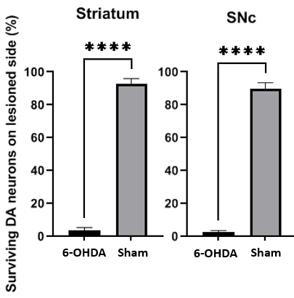
Supplementary Figure ). No animal was discarded due to this analysis.
Supplementary Figure 1: Quantification of dopaminergic losses in the striatum and the SNc, for 6-OHDA group (in black) and sham group (in grey). Values are expressed as means and standard error of the mean. Results come from a Mann-Whitney statistical test (**** means p≤0.0001, N_{6-OHDA}=11 , N_{sham}=10).

4. System saturation
Some electrodes were excluded due to the saturation of the recording system leading to non-physiological signals. This may be due to a bad cable connection or a displacement of the electrode with time. Electrode impedance measurements were around 22 kΩ on average (min: 16 kΩ; max: 30 kΩ). Finally, 12 sham and 12 6-OHDA animals were taken into account for injection-free recordings, and 10 sham and 12 6-OHDA (except one condition where 11) for pharmacological challenge (see Supplementary Figure 1).
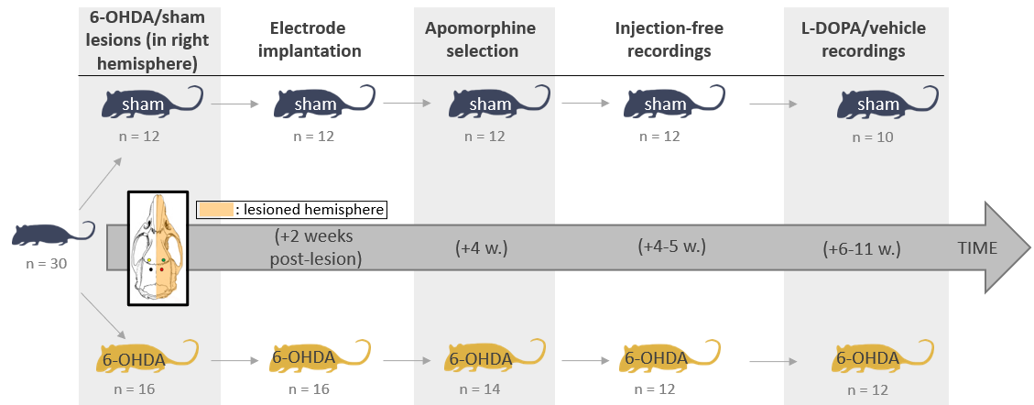
Supplementary Figure 1: Summary of the timeline of experiments and group sizes for each step of the process.
The following table describes the number of excluded electrodes in each condition (Supplementary
 | Stimulating site
 | Right somatosensory cx. |  | Left somatosensory cx. |  | Right striatum |  | Left striatum
Recording site | Left som. | 2 | Right som. | 1 | Right som. | 1 | Right som. | 0
Recording site | Left som. | 3 | Right som. | 3 | Right som. | 5 | Right som. | 4
Recording site | Right striatum | 2 | Right striatum | 2 | Left som. | 2 | Left som. | 2
Recording site | Right striatum | 6 | Right striatum | 4 | Left som. | 4 | Left som. | 4
Recording site | Left Striatum | 0 | Left striatum | 3 | Left striatum | 1 | Right striatum | 1
Recording site | Left Striatum | 4 | Left striatum | 5 | Left striatum | 2 | Right striatum | 2
Supplementary Table ). In red are the 6-OHDA and in blue the sham animals. In average, 2.6 electrodes were excluded among the recordings of all 24 animals (min: 0, max: 6, std: 1.6).
 | Stimulating site
 | Right somatosensory cx. |  | Left somatosensory cx. |  | Right striatum |  | Left striatum
Recording site | Left som. | 2 | Right som. | 1 | Right som. | 1 | Right som. | 0
Recording site | Left som. | 3 | Right som. | 3 | Right som. | 5 | Right som. | 4
Recording site | Right striatum | 2 | Right striatum | 2 | Left som. | 2 | Left som. | 2
Recording site | Right striatum | 6 | Right striatum | 4 | Left som. | 4 | Left som. | 4
Recording site | Left Striatum | 0 | Left striatum | 3 | Left striatum | 1 | Right striatum | 1
Recording site | Left Striatum | 4 | Left striatum | 5 | Left striatum | 2 | Right striatum | 2
Supplementary Table 2: Summary of the number of excluded electrodes, in red for 6-OHDA group, and in blue for sham group, for each implanted site.

B. Data preprocessing
The preprocessing step discards periods of signal with large movement artifacts or line noise from the downstream processing of evoked potentials. On average, 63 trials were kept for further analyses for striatum stimulation and 64 trials for somatosensory stimulation (minimum 61 and 60 for striatum and somatosensory cortex respectively) for each amplitude of stimulation. This corresponded to 82 % of recorded data in average.

