Supplementary file 3
Sensitivity analyses best-worst and worst-best scenarios Quality of life and diabetes distress

Quality of life, end of intervention (experimental (best), control (worst))
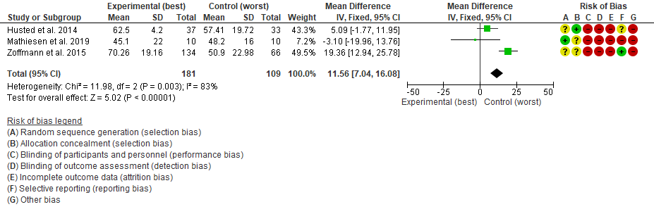

Quality of life, end of intervention (experimental (worst), control (best))
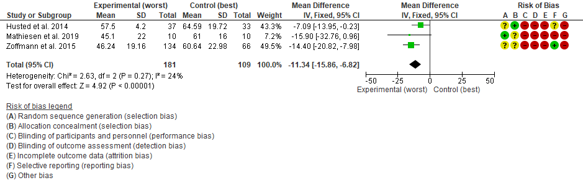

Quality of life, longest follow-up (experimental (best), control (worst))
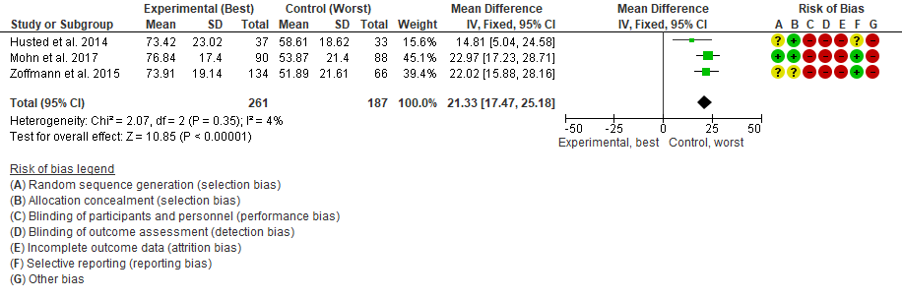

Quality of life, longest follow-up (experimental (worst), control (best))
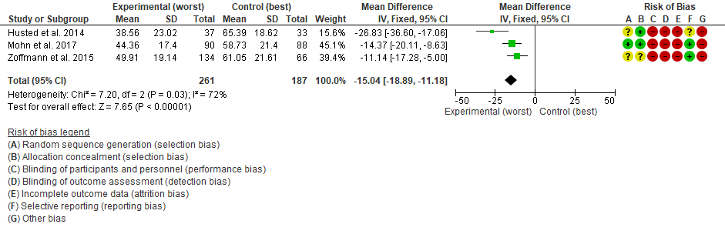

Diabetes distress, end of intervention (experimental (best), control (worst))
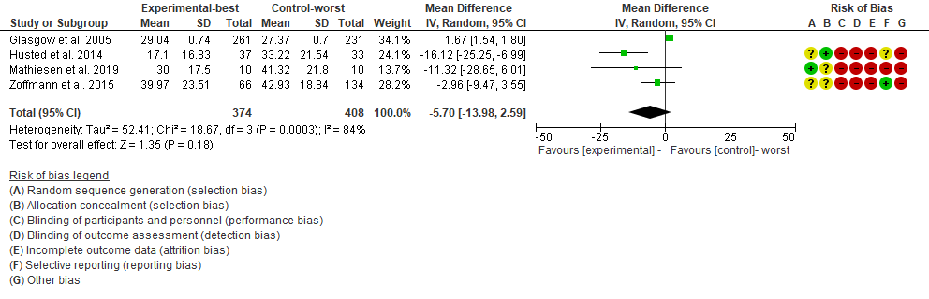

Diabetes distress, end of intervention (experimental (worst), control (best))
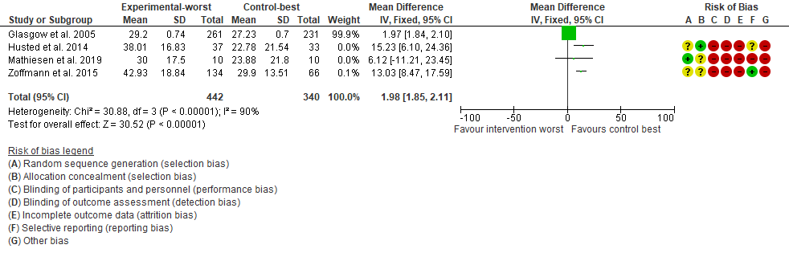

Diabetes distress, longest follow-up (experimental (best), control (worst))

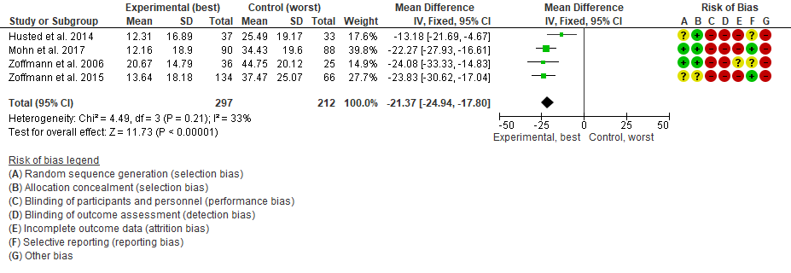

Diabetes distress, longest follow-up (experimental (worst), control (best))
