Extended Data Figures
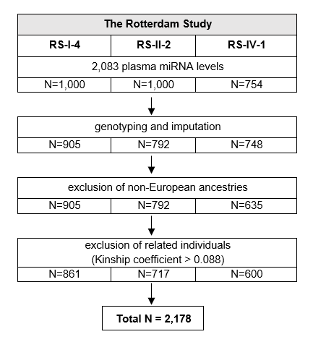

Extended Data Fig. 1. Selection of study participants in the Rotterdam Study.
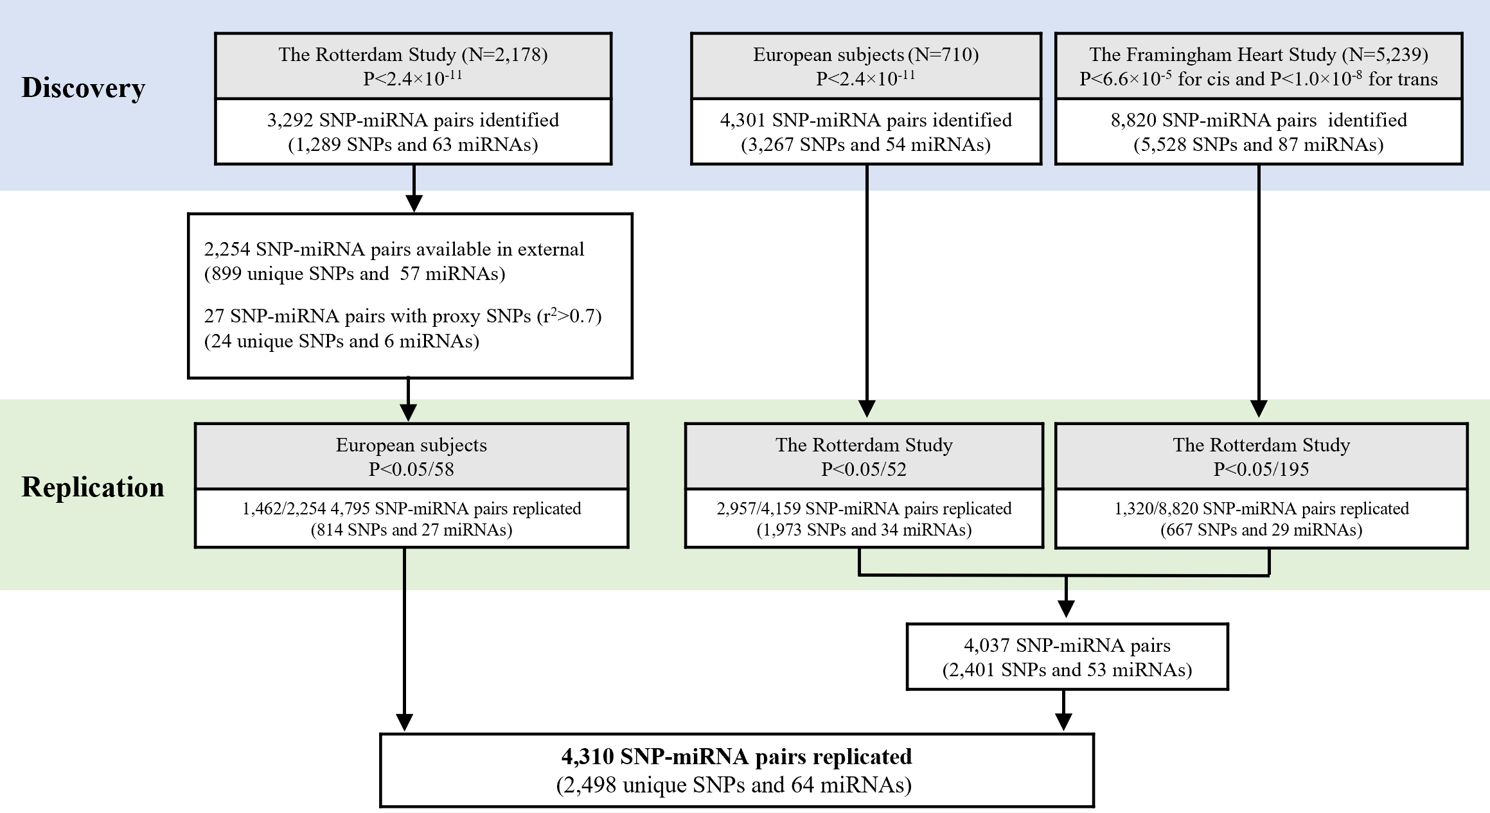

Extended Data Fig. 2. Identification of miR-eQTLs and replication in independent cohorts. In total, 3,292 significant associations were discovered for 63 miRNAs. Of those 1,462 out of 2,254 associations available in Nikpay et al. (9) were replicated for 27 miRNAs (P<0.05/58). On the other hand, 2,957 associations identified by Nikpay et al. (9) for 34 miRNAs were replicated (P<0.05/52) and 1,320 associations for 29 miRNAs identified in the Framingham Heart Study (10) were also replicated (P<0.05/195). Collectively, 4,310 associations for 64 miRNAs were successfully replicated across studies.

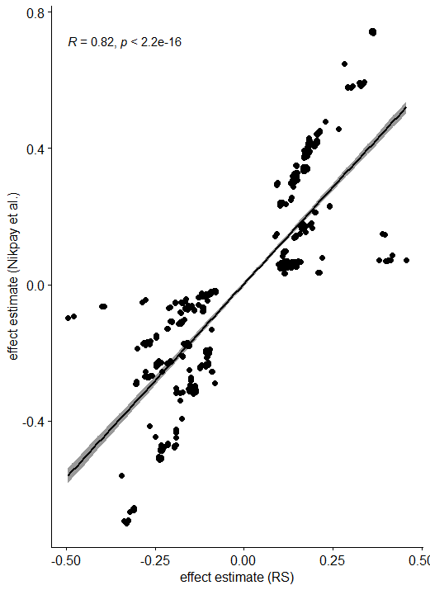

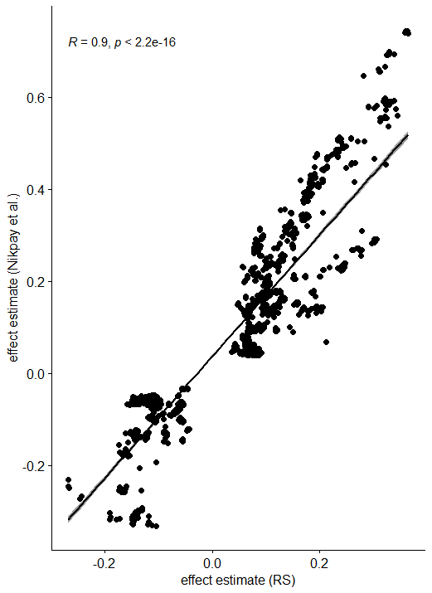
b.

c.

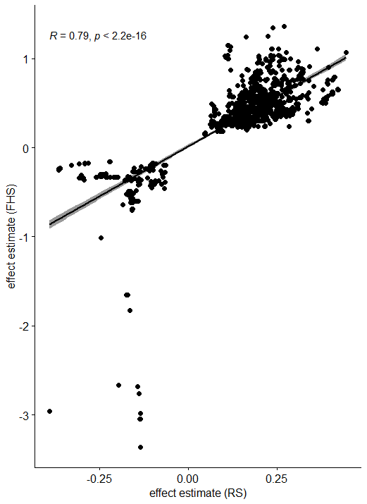

Extended Data Fig. 3. Correlation of effect estimates between discovery and replication of miR-eQTLs. a. Associations in the Rotterdam Study that were replicated in Nikpay et al.(9). b. Associations in Nikpay et al. (9) that were replicated in the Rotterdam Study. c. Associations in the Framingham Study that were replicated in the Rotterdam Study.

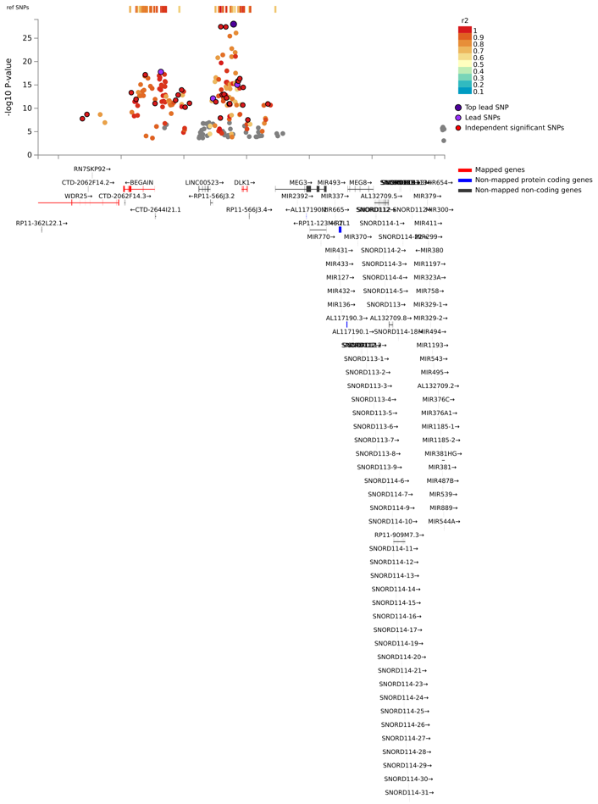

Extended Data Fig. 4. Regional plot for genomic risk loci in chr 14:100655022-101244293 harbouring cis-miR-eQTLs for 31 miRNAs that are clustered together. Plot was extracted from FUMA.

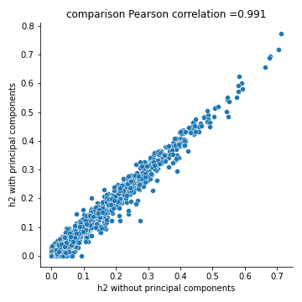

Extended Data Fig. 5. Pearson correlation of heritability estimates with and without principal components.

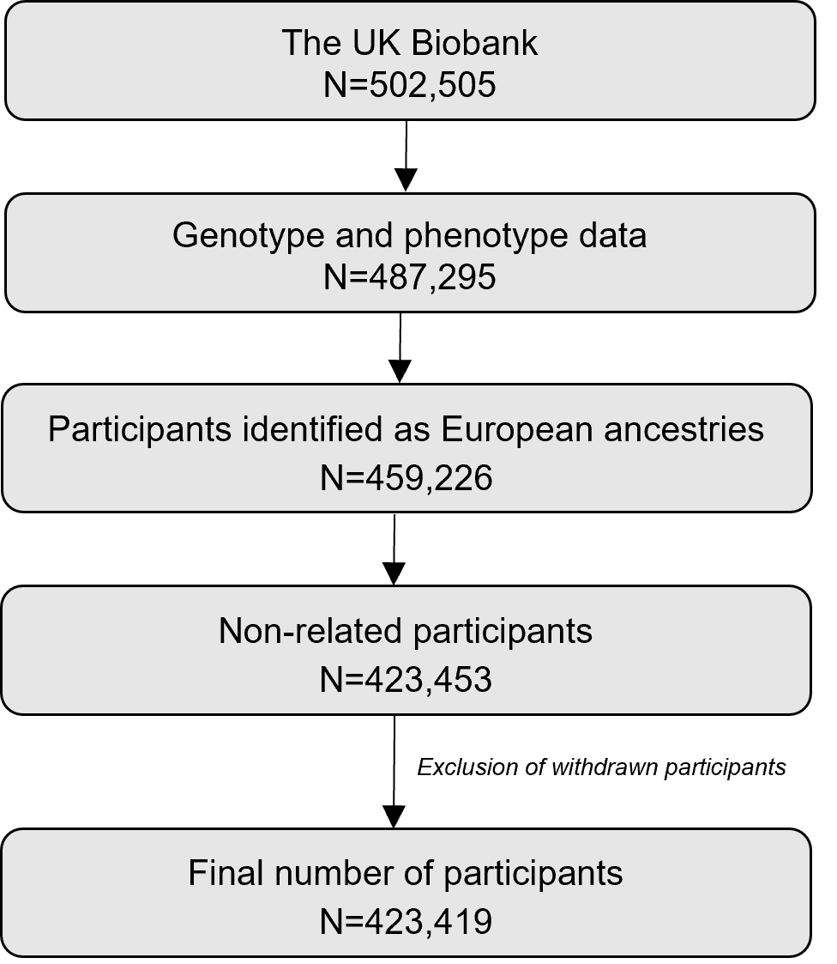

Extended Data Fig. 6. Selection of participants for PheWAS and MR-PheWAS in the UK Biobank.

a.
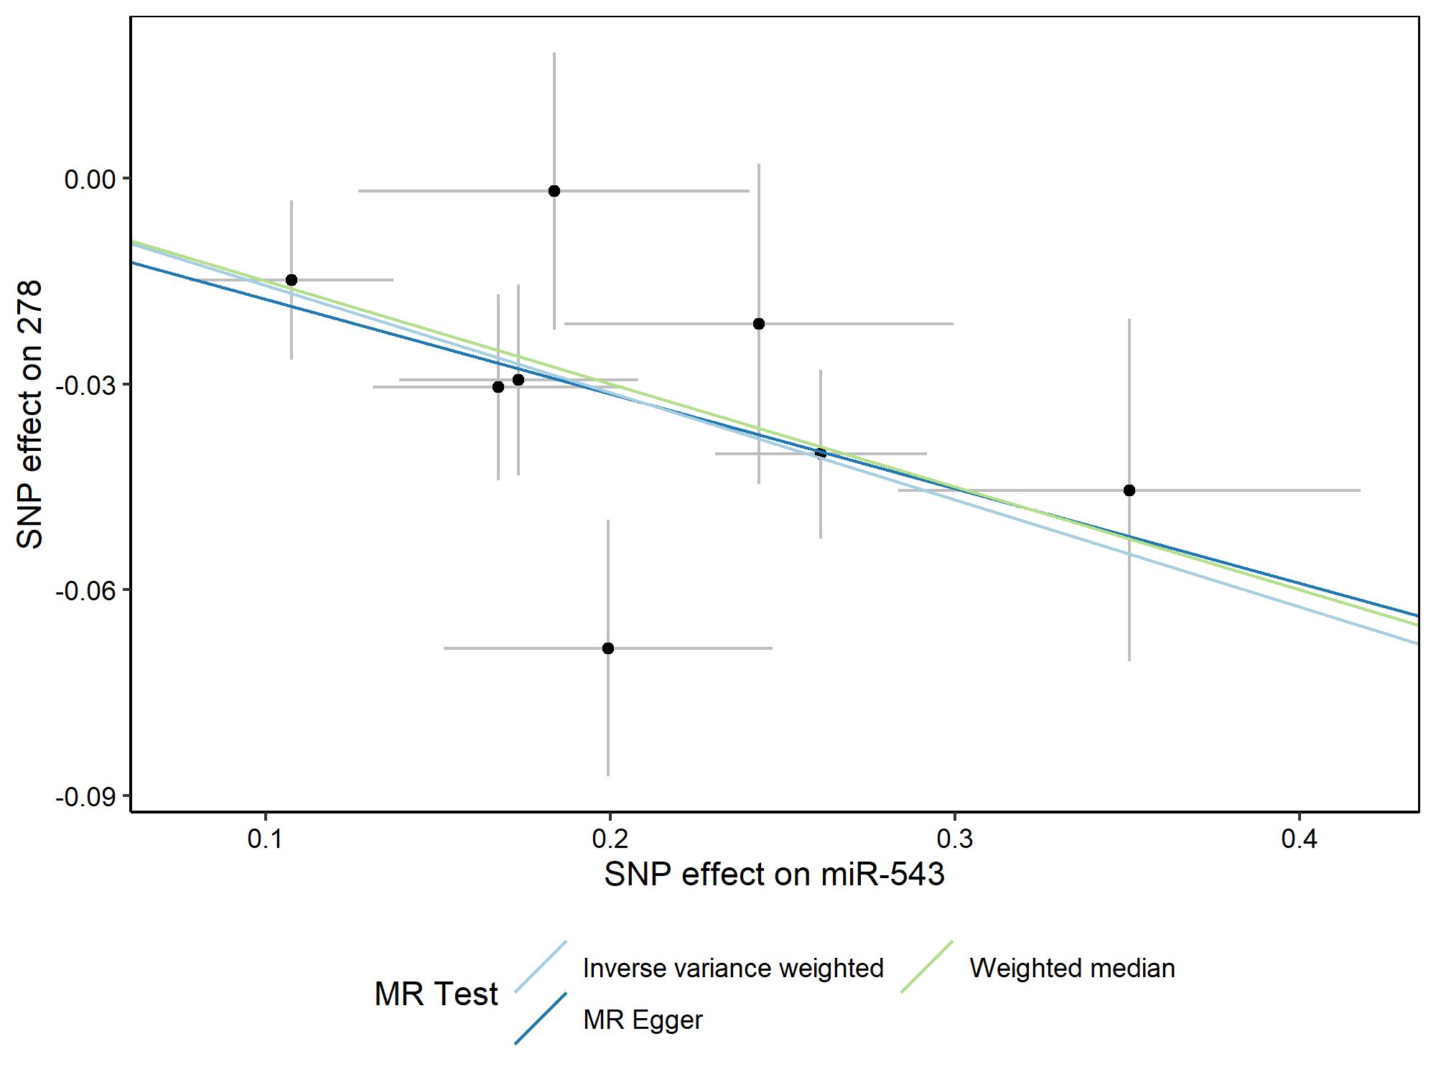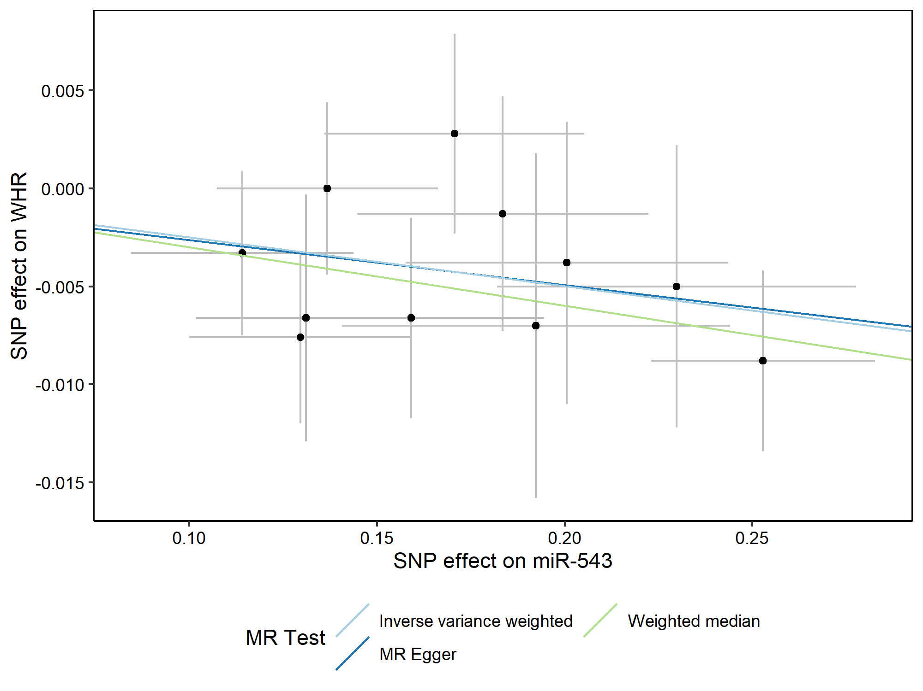
b.
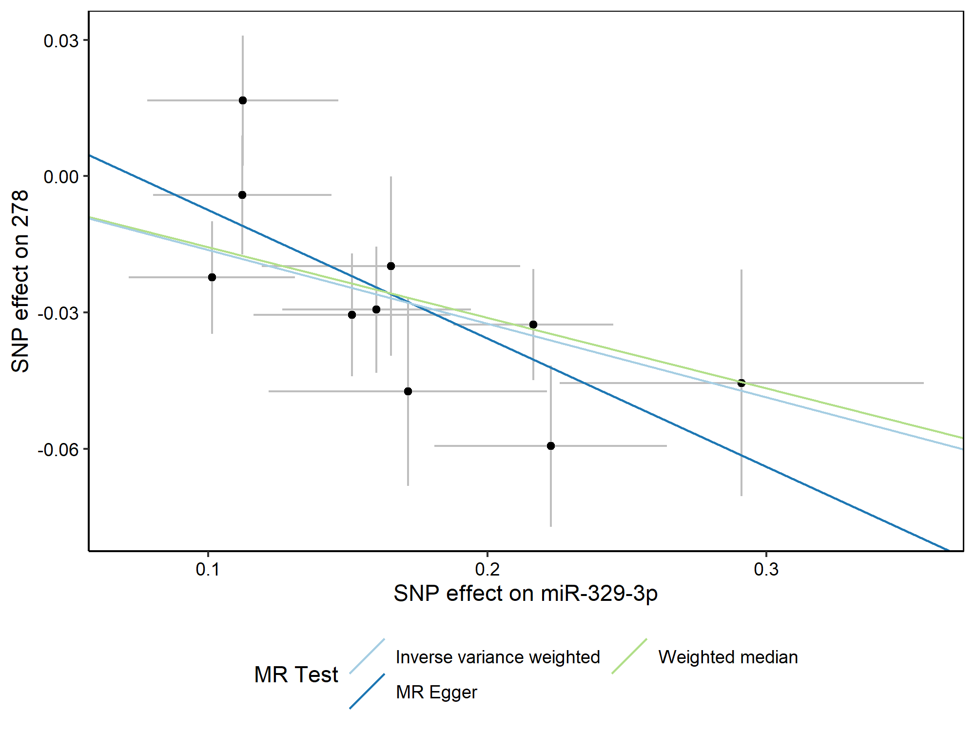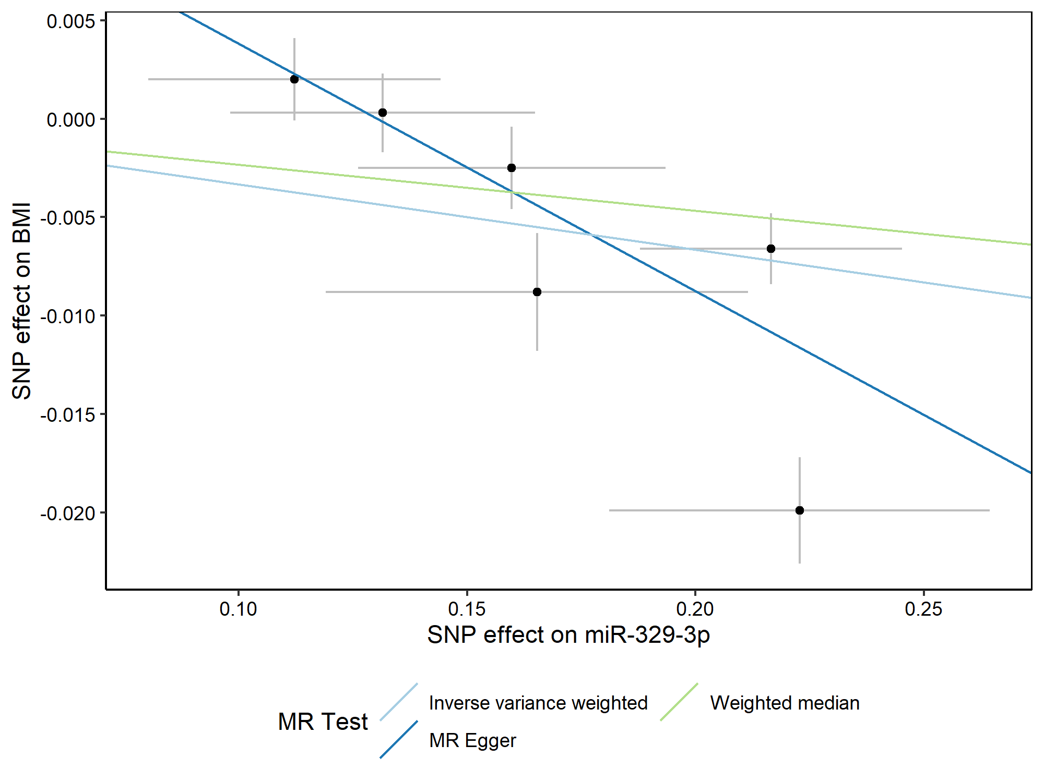

Extended Data Fig. 7. Scatter plots for MR-PheWAS and replication MR (bottom). a. miR-543 and obesity (left) and waist to hip ratio (right). b. miR-329-3p and obesity (left) and body mass index (right).

