Supplementary materials

The causal relationship between sleep traits and risk of end-stage kidney disease: a two-sample mendelian randomization study
Kaixin Li, Jiaxi Zhao, Huagang Lin, Wenjing Yang, Zhibin Ye

Supplementary Table 1. Detailed information on included traits in the present study
Phenotype | Year | Consortium | Sample size | Web link for data source
Sleeplessness/insomnia | 2017 | Neale Lab | 336965 | http://www.nealelab.is/blog/2017/7/19/rapid-gwas-of-thousands-of-phenotypes-for-337000-samples-in-the-uk-biobank
Sleep duration | 2017 | Neale Lab | 335410 | http://www.nealelab.is/blog/2017/7/19/rapid-gwas-of-thousands-of-phenotypes-for-337000-samples-in-the-uk-biobank
Non-snoring | 2017 | Neale Lab | 314449 | http://www.nealelab.is/blog/2017/7/19/rapid-gwas-of-thousands-of-phenotypes-for-337000-samples-in-the-uk-biobank
Daytime dozing | 2017 | Neale Lab | 336082 | http://www.nealelab.is/blog/2017/7/19/rapid-gwas-of-thousands-of-phenotypes-for-337000-samples-in-the-uk-biobank
Nap during the day | 2017 | Neale Lab | 337074 | http://www.nealelab.is/blog/2017/7/19/rapid-gwas-of-thousands-of-phenotypes-for-337000-samples-in-the-uk-biobank
Getting up in the morning | 2017 | Neale Lab | 336501 | http://www.nealelab.is/blog/2017/7/19/rapid-gwas-of-thousands-of-phenotypes-for-337000-samples-in-the-uk-biobank
Morning' person (chronotype) | 2017 | Neale Lab | 301143 | http://www.nealelab.is/blog/2017/7/19/rapid-gwas-of-thousands-of-phenotypes-for-337000-samples-in-the-uk-biobank
End-stage renal disease | 2019 | NA | 16405 | https://www.ebi.ac.uk/gwas/downloads/summary-statistics
Depression | 2018 | MRC-IEU | 460702 | https://data.bris.ac.uk/data/dataset/pnoat8cxo0u52p6ynfaekeigi
Hypertension | 2017 | Neale Lab | 337199 | http://www.nealelab.is/blog/2017/7/19/rapid-gwas-of-thousands-of-phenotypes-for-337000-samples-in-the-uk-biobank
Body mass index | 2017 | Neale Lab | 336107 | http://www.nealelab.is/blog/2017/7/19/rapid-gwas-of-thousands-of-phenotypes-for-337000-samples-in-the-uk-biobank
Diabetes | 2018 | MRC-IEU | 461578 | https://data.bris.ac.uk/data/dataset/pnoat8cxo0u52p6ynfaekeigi

Supplementary Table 2. The summary information for instrumental variables of sleeplessness/ insomnia.
Sort | Phenotype | SNP | effect_allele | other_allele | eaf | beta | se | pval
1 | Sleeplessness/insomnia | rs6690017 | G | T | 0.408 | -0.010 | 0.002 | 2.66E-08
2 | Sleeplessness/insomnia | rs11804386 | A | G | 0.333 | 0.010 | 0.002 | 3.59E-08
3 | Sleeplessness/insomnia | rs2644128 | G | C | 0.551 | 0.011 | 0.002 | 4.82E-10
4 | Sleeplessness/insomnia | rs7572387 | C | A | 0.429 | 0.011 | 0.002 | 6.21E-10
5 | Sleeplessness/insomnia | rs2863957 | A | C | 0.219 | -0.013 | 0.002 | 6.67E-10
6 | Sleeplessness/insomnia | rs113851554 | T | G | 0.057 | 0.048 | 0.004 | 1.16E-34
7 | Sleeplessness/insomnia | rs6744461 | C | A | 0.680 | 0.011 | 0.002 | 7.48E-09
8 | Sleeplessness/insomnia | rs4688760 | T | C | 0.692 | 0.012 | 0.002 | 1.06E-09
9 | Sleeplessness/insomnia | rs9878792 | T | G | 0.037 | -0.027 | 0.005 | 9.95E-09
10 | Sleeplessness/insomnia | rs9815484 | G | A | 0.818 | 0.013 | 0.002 | 5.64E-09
11 | Sleeplessness/insomnia | rs2132083 | C | T | 0.660 | -0.010 | 0.002 | 4.04E-08
12 | Sleeplessness/insomnia | rs1592757 | C | G | 0.356 | 0.010 | 0.002 | 1.24E-08
13 | Sleeplessness/insomnia | rs13186678 | T | C | 0.307 | 0.011 | 0.002 | 4.91E-09
14 | Sleeplessness/insomnia | rs3817576 | G | A | 0.525 | -0.010 | 0.002 | 2.81E-09
15 | Sleeplessness/insomnia | rs10280045 | G | C | 0.572 | 0.010 | 0.002 | 4.04E-08
16 | Sleeplessness/insomnia | rs10087341 | C | T | 0.159 | 0.015 | 0.002 | 7.74E-10
17 | Sleeplessness/insomnia | rs10156602 | G | A | 0.364 | -0.010 | 0.002 | 2.32E-08
18 | Sleeplessness/insomnia | rs224071 | A | G | 0.550 | 0.010 | 0.002 | 2.67E-08
19 | Sleeplessness/insomnia | rs3808937 | T | C | 0.208 | -0.014 | 0.002 | 2.59E-11
20 | Sleeplessness/insomnia | rs17879819 | T | C | 0.076 | -0.019 | 0.003 | 9.83E-09
21 | Sleeplessness/insomnia | rs2956278 | G | A | 0.214 | 0.012 | 0.002 | 2.03E-08
22 | Sleeplessness/insomnia | rs324017 | C | A | 0.705 | -0.012 | 0.002 | 8.83E-10
23 | Sleeplessness/insomnia | rs4886140 | G | A | 0.667 | 0.011 | 0.002 | 2.69E-09
24 | Sleeplessness/insomnia | rs4943439 | T | C | 0.387 | 0.010 | 0.002 | 4.75E-09
25 | Sleeplessness/insomnia | rs6561715 | A | T | 0.629 | -0.012 | 0.002 | 1.06E-11
26 | Sleeplessness/insomnia | rs1547630 | A | G | 0.652 | 0.010 | 0.002 | 1.23E-08
27 | Sleeplessness/insomnia | rs11635495 | C | T | 0.514 | 0.010 | 0.002 | 2.34E-08
28 | Sleeplessness/insomnia | rs1925501 | A | T | 0.220 | -0.012 | 0.002 | 1.54E-08
29 | Sleeplessness/insomnia | rs71373536 | A | G | 0.253 | 0.013 | 0.002 | 1.92E-11
30 | Sleeplessness/insomnia | rs11152363 | A | G | 0.185 | 0.014 | 0.002 | 2.54E-10

Supplementary Table 3. The summary information for instrumental variables of sleep duration.
Sort | Phenotype | SNP | effect_allele | other_allele | eaf | beta | se | pval
1 | Sleep duration | rs4642942 | G | C | 0.586 | -0.012 | 0.002 | 2.67E-10
2 | Sleep duration | rs915416 | G | C | 0.710 | -0.012 | 0.002 | 2.53E-08
3 | Sleep duration | rs6681755 | A | G | 0.199 | 0.014 | 0.002 | 2.21E-09
4 | Sleep duration | rs12567114 | A | G | 0.275 | 0.013 | 0.002 | 2.71E-09
5 | Sleep duration | rs74889896 | G | A | 0.086 | 0.022 | 0.003 | 2.63E-11
6 | Sleep duration | rs4667876 | G | A | 0.448 | 0.011 | 0.002 | 2.89E-09
7 | Sleep duration | rs56337305 | C | T | 0.378 | 0.011 | 0.002 | 2.58E-08
8 | Sleep duration | rs374153 | T | C | 0.841 | -0.015 | 0.003 | 9.35E-09
9 | Sleep duration | rs10496079 | C | G | 0.629 | 0.015 | 0.002 | 1.44E-14
10 | Sleep duration | rs80071665 | T | G | 0.120 | -0.016 | 0.003 | 1.75E-08
11 | Sleep duration | rs62158206 | C | T | 0.219 | 0.030 | 0.002 | 1.33E-39
12 | Sleep duration | rs113021516 | C | G | 0.336 | 0.011 | 0.002 | 2.79E-08
13 | Sleep duration | rs9810474 | T | C | 0.233 | -0.013 | 0.002 | 8.74E-09
14 | Sleep duration | rs12501164 | C | T | 0.497 | 0.011 | 0.002 | 2.05E-08
15 | Sleep duration | rs13107325 | T | C | 0.075 | -0.022 | 0.004 | 9.34E-10
16 | Sleep duration | rs180769 | C | T | 0.576 | -0.011 | 0.002 | 7.49E-09
17 | Sleep duration | rs6889592 | A | G | 0.335 | 0.011 | 0.002 | 3.23E-08
18 | Sleep duration | rs37021 | G | A | 0.443 | -0.011 | 0.002 | 2.86E-08
19 | Sleep duration | rs7764984 | G | A | 0.327 | -0.013 | 0.002 | 8.84E-11
20 | Sleep duration | rs4897409 | A | G | 0.305 | -0.011 | 0.002 | 4.50E-08
21 | Sleep duration | rs62444917 | C | A | 0.220 | 0.013 | 0.002 | 1.78E-08
22 | Sleep duration | rs4730640 | C | T | 0.616 | -0.013 | 0.002 | 1.69E-11
23 | Sleep duration | rs11982852 | T | C | 0.245 | -0.013 | 0.002 | 1.43E-09
24 | Sleep duration | rs448231 | A | T | 0.444 | 0.011 | 0.002 | 1.62E-09
25 | Sleep duration | rs7016314 | C | T | 0.657 | 0.011 | 0.002 | 1.22E-08
26 | Sleep duration | rs28375265 | T | A | 0.348 | -0.011 | 0.002 | 4.15E-08
27 | Sleep duration | rs4588900 | A | G | 0.517 | -0.010 | 0.002 | 2.84E-08
28 | Sleep duration | rs10973207 | T | G | 0.159 | 0.014 | 0.003 | 2.87E-08
29 | Sleep duration | rs1570203 | A | G | 0.525 | -0.012 | 0.002 | 1.90E-10
30 | Sleep duration | rs10510128 | A | G | 0.206 | 0.014 | 0.002 | 9.17E-10
31 | Sleep duration | rs925872 | G | C | 0.455 | -0.011 | 0.002 | 1.46E-09
32 | Sleep duration | rs61916239 | G | T | 0.350 | 0.011 | 0.002 | 4.26E-08
33 | Sleep duration | rs35186585 | C | A | 0.229 | -0.013 | 0.002 | 1.55E-08
34 | Sleep duration | rs7115462 | A | G | 0.073 | 0.021 | 0.004 | 4.85E-09
35 | Sleep duration | rs4767550 | G | A | 0.415 | 0.011 | 0.002 | 3.72E-08
36 | Sleep duration | rs11621908 | T | C | 0.082 | -0.019 | 0.003 | 3.23E-08
37 | Sleep duration | rs8029928 | T | C | 0.239 | -0.014 | 0.002 | 2.58E-10
38 | Sleep duration | rs3751813 | T | G | 0.542 | -0.012 | 0.002 | 9.04E-10
39 | Sleep duration | rs11643715 | G | C | 0.290 | 0.011 | 0.002 | 3.01E-08
40 | Sleep duration | rs802310 | G | A | 0.212 | 0.015 | 0.002 | 1.18E-10
41 | Sleep duration | rs17822558 | A | G | 0.323 | -0.011 | 0.002 | 2.51E-08
42 | Sleep duration | rs9895274 | T | C | 0.488 | -0.010 | 0.002 | 3.87E-08
43 | Sleep duration | rs11650677 | A | G | 0.338 | 0.012 | 0.002 | 5.85E-09
44 | Sleep duration | rs34786000 | T | G | 0.556 | 0.012 | 0.002 | 3.90E-10

Supplementary Table D. The summary information for instrumental variables of getting up in the morning.
Sort | Phenotype | SNP | effect_allele | other_allele | eaf | beta | se | pval
1 | getting up in the morning | rs12752290 | C | T | 0.442 | 0.011 | 0.002 | 3.19E-09
2 | getting up in the morning | rs12736689 | C | T | 0.030 | 0.052 | 0.005 | 6.62E-22
3 | getting up in the morning | rs10518446 | C | G | 0.164 | 0.021 | 0.003 | 6.84E-17
4 | getting up in the morning | rs6666373 | T | A | 0.272 | 0.011 | 0.002 | 4.27E-08
5 | getting up in the morning | rs10462020 | G | T | 0.197 | 0.015 | 0.002 | 3.70E-10
6 | getting up in the morning | rs78555397 | T | C | 0.030 | 0.038 | 0.005 | 3.04E-12
7 | getting up in the morning | rs76048411 | C | T | 0.518 | -0.011 | 0.002 | 1.46E-09
8 | getting up in the morning | rs1542344 | G | A | 0.666 | 0.012 | 0.002 | 5.32E-10
9 | getting up in the morning | rs10175975 | T | C | 0.180 | 0.013 | 0.002 | 5.00E-08
10 | getting up in the morning | rs9309511 | G | A | 0.427 | -0.016 | 0.002 | 6.28E-17
11 | getting up in the morning | rs1039887 | G | A | 0.151 | -0.020 | 0.003 | 4.16E-14
12 | getting up in the morning | rs1402121 | C | T | 0.200 | 0.014 | 0.002 | 3.44E-09
13 | getting up in the morning | rs2859580 | A | G | 0.886 | 0.017 | 0.003 | 5.72E-09
14 | getting up in the morning | rs4958318 | T | C | 0.289 | 0.014 | 0.002 | 2.16E-12
15 | getting up in the morning | rs4716098 | G | A | 0.075 | -0.019 | 0.004 | 4.12E-08
16 | getting up in the morning | rs2653356 | G | A | 0.820 | -0.024 | 0.002 | 9.95E-24
17 | getting up in the morning | rs72895663 | G | A | 0.233 | 0.012 | 0.002 | 2.62E-08
18 | getting up in the morning | rs620598 | G | A | 0.225 | 0.013 | 0.002 | 6.66E-09
19 | getting up in the morning | rs1914397 | A | T | 0.449 | 0.011 | 0.002 | 1.81E-08
20 | getting up in the morning | rs1564470 | A | C | 0.332 | 0.011 | 0.002 | 2.83E-08
21 | getting up in the morning | rs2360802 | T | A | 0.226 | 0.013 | 0.002 | 1.21E-08
22 | getting up in the morning | rs117965994 | T | C | 0.043 | -0.025 | 0.005 | 3.34E-08
23 | getting up in the morning | rs77641763 | T | C | 0.125 | -0.019 | 0.003 | 8.04E-12
24 | getting up in the morning | rs10760663 | A | G | 0.551 | 0.011 | 0.002 | 5.44E-09
25 | getting up in the morning | rs4962716 | C | T | 0.872 | 0.016 | 0.003 | 3.07E-08
26 | getting up in the morning | rs11181153 | T | C | 0.586 | -0.010 | 0.002 | 3.32E-08
27 | getting up in the morning | rs17464772 | A | G | 0.355 | 0.014 | 0.002 | 4.89E-12
28 | getting up in the morning | rs4964519 | G | C | 0.626 | 0.011 | 0.002 | 1.79E-08
29 | getting up in the morning | rs12227309 | T | C | 0.246 | 0.013 | 0.002 | 3.34E-09
30 | getting up in the morning | rs57140837 | C | T | 0.303 | 0.012 | 0.002 | 9.67E-09
31 | getting up in the morning | rs1014895 | T | G | 0.386 | 0.011 | 0.002 | 1.06E-08
32 | getting up in the morning | rs6495249 | T | C | 0.381 | 0.012 | 0.002 | 1.55E-09
33 | getting up in the morning | rs2908897 | T | G | 0.702 | -0.013 | 0.002 | 8.03E-10
34 | getting up in the morning | rs1421085 | C | T | 0.402 | 0.011 | 0.002 | 2.92E-08
35 | getting up in the morning | rs2532317 | C | T | 0.204 | 0.015 | 0.003 | 1.88E-09
36 | getting up in the morning | rs77556405 | A | G | 0.174 | 0.016 | 0.002 | 1.07E-10
37 | getting up in the morning | rs34626694 | T | C | 0.331 | -0.011 | 0.002 | 1.29E-08
38 | getting up in the morning | rs4790352 | A | G | 0.918 | 0.020 | 0.003 | 5.34E-09
39 | getting up in the morning | rs12969848 | T | C | 0.530 | 0.011 | 0.002 | 1.76E-08
40 | getting up in the morning | rs13058062 | C | T | 0.713 | -0.011 | 0.002 | 3.86E-08

Supplementary Table 4. The summary information for instrumental variables of chronotype.
Sort | Phenotype | SNP | effect_allele | other_allele | eaf | se | beta | pval
1 | Chronotype | rs139315125 | G | A | 0.005 | 0.017 | -0.153 | 1.00E-18
2 | Chronotype | rs11587758 | A | G | 0.394 | 0.002 | -0.018 | 4.06E-14
3 | Chronotype | rs12040629 | A | G | 0.161 | 0.003 | -0.030 | 1.06E-20
4 | Chronotype | rs228674 | T | C | 0.097 | 0.004 | 0.026 | 1.99E-10
5 | Chronotype | rs17416732 | C | T | 0.374 | 0.002 | -0.015 | 1.05E-09
6 | Chronotype | rs12140153 | T | G | 0.097 | 0.004 | 0.028 | 7.67E-12
7 | Chronotype | rs975025 | T | C | 0.077 | 0.004 | 0.025 | 2.69E-08
8 | Chronotype | rs61770703 | C | T | 0.520 | 0.002 | -0.014 | 6.93E-09
9 | Chronotype | rs72720396 | G | A | 0.231 | 0.003 | -0.021 | 5.66E-14
10 | Chronotype | rs509476 | C | T | 0.970 | 0.007 | 0.082 | 4.46E-32
11 | Chronotype | rs778147 | A | C | 0.634 | 0.002 | 0.015 | 7.50E-10
12 | Chronotype | rs80271258 | T | C | 0.088 | 0.004 | 0.042 | 6.43E-23
13 | Chronotype | rs113851554 | T | G | 0.057 | 0.005 | 0.030 | 2.17E-08
14 | Chronotype | rs10520176 | C | T | 0.498 | 0.002 | 0.021 | 6.10E-18
15 | Chronotype | rs10189912 | G | A | 0.370 | 0.002 | 0.018 | 1.33E-13
16 | Chronotype | rs1947198 | T | C | 0.122 | 0.004 | -0.020 | 2.10E-08
17 | Chronotype | rs4417706 | T | A | 0.483 | 0.002 | -0.015 | 1.53E-10
18 | Chronotype | rs13011556 | G | C | 0.239 | 0.003 | -0.017 | 9.71E-10
19 | Chronotype | rs1067404 | G | T | 0.758 | 0.003 | -0.020 | 1.08E-12
20 | Chronotype | rs10495976 | T | A | 0.392 | 0.002 | -0.014 | 8.24E-09
21 | Chronotype | rs850894 | T | A | 0.707 | 0.003 | 0.015 | 3.28E-08
22 | Chronotype | rs13316611 | T | G | 0.256 | 0.003 | -0.016 | 4.13E-09
23 | Chronotype | rs75815271 | C | T | 0.074 | 0.005 | -0.026 | 1.86E-08
24 | Chronotype | rs9831488 | G | A | 0.349 | 0.003 | -0.017 | 1.87E-11
25 | Chronotype | rs4685141 | T | C | 0.130 | 0.004 | 0.020 | 2.80E-08
26 | Chronotype | rs2125109 | T | C | 0.307 | 0.003 | 0.016 | 1.96E-09
27 | Chronotype | rs66710942 | T | C | 0.593 | 0.002 | -0.015 | 2.80E-09
28 | Chronotype | rs2239626 | C | T | 0.303 | 0.003 | -0.016 | 4.49E-10
29 | Chronotype | rs1107268 | G | A | 0.404 | 0.002 | 0.013 | 3.62E-08
30 | Chronotype | rs6846730 | T | C | 0.231 | 0.003 | 0.016 | 4.34E-08
31 | Chronotype | rs1296328 | C | A | 0.560 | 0.002 | 0.016 | 6.48E-11
32 | Chronotype | rs304136 | C | T | 0.477 | 0.002 | 0.015 | 4.57E-10
33 | Chronotype | rs67988891 | G | C | 0.319 | 0.003 | -0.018 | 2.69E-12
34 | Chronotype | rs9348050 | C | T | 0.511 | 0.002 | 0.014 | 6.39E-09
35 | Chronotype | rs9381812 | G | A | 0.297 | 0.003 | -0.017 | 2.91E-11
36 | Chronotype | rs2653349 | G | A | 0.784 | 0.003 | 0.027 | 2.82E-20
37 | Chronotype | rs75284686 | T | C | 0.010 | 0.012 | -0.086 | 5.45E-13
38 | Chronotype | rs9278039 | C | T | 0.143 | 0.003 | 0.019 | 2.84E-08
39 | Chronotype | rs60616179 | G | A | 0.055 | 0.005 | 0.033 | 3.80E-10
40 | Chronotype | rs10280205 | C | T | 0.307 | 0.003 | 0.015 | 7.59E-09
41 | Chronotype | rs4729303 | T | C | 0.814 | 0.003 | -0.021 | 3.11E-12
42 | Chronotype | rs4729854 | A | T | 0.487 | 0.002 | 0.022 | 5.13E-19
43 | Chronotype | rs7783012 | A | G | 0.592 | 0.002 | -0.014 | 9.67E-09
44 | Chronotype | rs2971970 | G | T | 0.782 | 0.003 | 0.017 | 6.09E-09
45 | Chronotype | rs6967481 | T | C | 0.497 | 0.002 | -0.017 | 5.28E-13
46 | Chronotype | rs56265640 | A | G | 0.233 | 0.003 | -0.017 | 2.96E-09
47 | Chronotype | rs9987253 | A | G | 0.221 | 0.003 | 0.018 | 1.90E-10
48 | Chronotype | rs16881183 | T | C | 0.377 | 0.002 | -0.014 | 1.07E-08
49 | Chronotype | rs17716502 | T | C | 0.207 | 0.003 | -0.019 | 3.81E-10
50 | Chronotype | rs117823615 | G | C | 0.085 | 0.004 | 0.026 | 9.49E-10
51 | Chronotype | rs28458909 | T | C | 0.125 | 0.004 | 0.030 | 1.53E-16
52 | Chronotype | rs6477309 | T | C | 0.666 | 0.003 | -0.014 | 2.65E-08
53 | Chronotype | rs77598468 | A | C | 0.035 | 0.006 | 0.039 | 2.69E-09
54 | Chronotype | rs10825272 | A | G | 0.145 | 0.003 | 0.020 | 4.27E-09
55 | Chronotype | rs11032362 | A | G | 0.090 | 0.004 | -0.024 | 1.30E-08
56 | Chronotype | rs11218901 | T | C | 0.136 | 0.003 | 0.019 | 4.69E-08
57 | Chronotype | rs7111355 | A | G | 0.837 | 0.003 | 0.018 | 3.83E-08
58 | Chronotype | rs11605297 | A | G | 0.233 | 0.003 | 0.017 | 2.13E-09
59 | Chronotype | rs73325957 | C | T | 0.140 | 0.003 | 0.019 | 3.50E-08
60 | Chronotype | rs11181153 | T | C | 0.586 | 0.002 | 0.017 | 7.34E-13
61 | Chronotype | rs7313852 | A | G | 0.435 | 0.002 | 0.022 | 1.06E-19
62 | Chronotype | rs73208536 | G | A | 0.395 | 0.002 | -0.015 | 1.62E-09
63 | Chronotype | rs80097534 | T | G | 0.099 | 0.004 | 0.023 | 7.21E-09
64 | Chronotype | rs7302062 | C | T | 0.448 | 0.002 | 0.013 | 1.95E-08
65 | Chronotype | rs7308565 | T | C | 0.401 | 0.002 | -0.015 | 9.05E-10
66 | Chronotype | rs7316768 | T | G | 0.403 | 0.002 | 0.015 | 1.80E-09
67 | Chronotype | rs2762088 | G | T | 0.760 | 0.003 | -0.015 | 4.60E-08
68 | Chronotype | rs2322000 | T | A | 0.321 | 0.003 | -0.015 | 2.40E-09
69 | Chronotype | rs7317373 | C | T | 0.034 | 0.007 | 0.055 | 4.89E-17
70 | Chronotype | rs1958885 | G | T | 0.729 | 0.003 | 0.015 | 3.68E-08
71 | Chronotype | rs4899502 | A | G | 0.689 | 0.003 | 0.014 | 4.58E-08
72 | Chronotype | rs12432176 | A | C | 0.380 | 0.002 | -0.015 | 1.15E-09
73 | Chronotype | rs1421085 | C | T | 0.402 | 0.002 | -0.022 | 6.32E-20
74 | Chronotype | rs1190652 | G | T | 0.920 | 0.004 | -0.024 | 4.32E-08
75 | Chronotype | rs17604349 | A | G | 0.177 | 0.003 | 0.019 | 6.52E-10
76 | Chronotype | rs12927162 | G | A | 0.277 | 0.003 | 0.021 | 1.60E-15
77 | Chronotype | rs4784655 | C | G | 0.321 | 0.003 | 0.015 | 9.90E-09
78 | Chronotype | rs2364972 | G | A | 0.465 | 0.002 | -0.013 | 4.44E-08
79 | Chronotype | rs4792268 | A | G | 0.920 | 0.004 | 0.034 | 1.51E-14
80 | Chronotype | rs2232839 | T | C | 0.218 | 0.003 | 0.019 | 3.54E-11
81 | Chronotype | rs12949341 | G | A | 0.331 | 0.003 | 0.014 | 2.26E-08
82 | Chronotype | rs62082401 | G | C | 0.190 | 0.003 | -0.022 | 7.42E-13
83 | Chronotype | rs4527088 | G | A | 0.411 | 0.002 | 0.017 | 2.04E-12
84 | Chronotype | rs9964420 | A | C | 0.305 | 0.003 | 0.021 | 1.00E-15
85 | Chronotype | rs6131942 | G | A | 0.579 | 0.002 | -0.013 | 2.88E-08
86 | Chronotype | rs117143374 | C | T | 0.142 | 0.003 | 0.020 | 1.09E-08
87 | Chronotype | rs139911 | T | C | 0.576 | 0.002 | 0.019 | 1.57E-14

Supplementary Table 5. The summary information for instrumental variables of napping during the day.
Sort | Phenotype | SNP | effect_allele | other_allele | se | eaf | beta | pval
1 | Nap during the day | rs60579048 | G | T | 0.002 | 0.168 | -0.012 | 3.39E-10
2 | Nap during the day | rs12140153 | T | G | 0.002 | 0.097 | -0.027 | 7.87E-27
3 | Nap during the day | rs1843815 | T | A | 0.001 | 0.546 | 0.008 | 2.23E-08
4 | Nap during the day | rs35039375 | G | A | 0.003 | 0.092 | 0.014 | 8.18E-09
5 | Nap during the day | rs2250377 | G | A | 0.002 | 0.662 | -0.015 | 6.82E-24
6 | Nap during the day | rs17369061 | C | T | 0.002 | 0.128 | -0.012 | 4.77E-08
7 | Nap during the day | rs4971718 | T | C | 0.001 | 0.502 | 0.009 | 3.85E-10
8 | Nap during the day | rs2390669 | C | A | 0.002 | 0.129 | -0.013 | 6.91E-09
9 | Nap during the day | rs11125776 | G | T | 0.002 | 0.146 | -0.015 | 8.96E-13
10 | Nap during the day | rs12615434 | T | C | 0.002 | 0.113 | 0.013 | 2.16E-08
11 | Nap during the day | rs908442 | T | A | 0.001 | 0.408 | -0.011 | 5.31E-14
12 | Nap during the day | rs13033444 | G | A | 0.002 | 0.283 | 0.011 | 1.47E-11
13 | Nap during the day | rs253662 | C | T | 0.002 | 0.810 | 0.010 | 1.47E-08
14 | Nap during the day | rs12506659 | T | C | 0.001 | 0.486 | -0.009 | 7.01E-10
15 | Nap during the day | rs6854055 | T | G | 0.002 | 0.747 | 0.012 | 1.71E-13
16 | Nap during the day | rs1968557 | T | C | 0.001 | 0.495 | -0.008 | 2.82E-08
17 | Nap during the day | rs2431108 | C | T | 0.002 | 0.329 | 0.013 | 8.10E-18
18 | Nap during the day | rs10875622 | A | G | 0.001 | 0.576 | 0.010 | 1.89E-11
19 | Nap during the day | rs742787 | C | T | 0.001 | 0.370 | -0.010 | 6.65E-12
20 | Nap during the day | rs12193281 | C | T | 0.002 | 0.331 | -0.010 | 1.58E-10
21 | Nap during the day | rs2653349 | G | A | 0.002 | 0.784 | -0.017 | 1.36E-21
22 | Nap during the day | rs614987 | C | A | 0.001 | 0.615 | 0.012 | 3.82E-16
23 | Nap during the day | rs11761181 | C | T | 0.002 | 0.229 | 0.011 | 2.92E-10
24 | Nap during the day | rs12535424 | A | G | 0.003 | 0.087 | -0.015 | 1.28E-08
25 | Nap during the day | rs285793 | A | G | 0.001 | 0.538 | -0.009 | 2.08E-09
26 | Nap during the day | rs2555571 | G | T | 0.001 | 0.520 | -0.008 | 4.43E-08
27 | Nap during the day | rs11138082 | C | T | 0.002 | 0.205 | 0.014 | 2.19E-15
28 | Nap during the day | rs12682981 | G | A | 0.002 | 0.254 | -0.010 | 9.91E-10
29 | Nap during the day | rs17502738 | C | T | 0.002 | 0.196 | -0.010 | 1.58E-08
30 | Nap during the day | rs11258652 | A | C | 0.002 | 0.238 | -0.010 | 3.01E-09
31 | Nap during the day | rs10840017 | G | A | 0.002 | 0.230 | -0.010 | 1.14E-08
32 | Nap during the day | rs1836124 | T | C | 0.002 | 0.299 | -0.009 | 3.96E-08
33 | Nap during the day | rs174541 | C | T | 0.001 | 0.361 | 0.010 | 1.28E-11
34 | Nap during the day | rs35011311 | T | G | 0.002 | 0.267 | -0.009 | 4.69E-08
35 | Nap during the day | rs1983336 | A | G | 0.001 | 0.405 | 0.018 | 5.08E-34
36 | Nap during the day | rs2769916 | A | G | 0.002 | 0.689 | 0.009 | 4.45E-08
37 | Nap during the day | rs12147887 | T | C | 0.002 | 0.185 | 0.011 | 5.65E-09
38 | Nap during the day | rs2370926 | C | T | 0.001 | 0.367 | -0.008 | 2.45E-08
39 | Nap during the day | rs17158413 | A | G | 0.002 | 0.239 | 0.010 | 7.71E-10
40 | Nap during the day | rs114488427 | T | C | 0.002 | 0.120 | 0.012 | 2.92E-08
41 | Nap during the day | rs8050478 | A | G | 0.001 | 0.500 | -0.008 | 3.55E-08
42 | Nap during the day | rs2668643 | A | C | 0.002 | 0.226 | -0.021 | 8.52E-35
43 | Nap during the day | rs112520848 | C | G | 0.001 | 0.386 | 0.008 | 4.77E-08
44 | Nap during the day | rs3935190 | A | G | 0.001 | 0.534 | 0.009 | 1.72E-09
45 | Nap during the day | rs12451365 | C | T | 0.002 | 0.205 | 0.011 | 5.60E-10
46 | Nap during the day | rs2033103 | T | C | 0.001 | 0.452 | 0.009 | 2.01E-09
47 | Nap during the day | rs962247 | A | G | 0.001 | 0.477 | -0.009 | 3.55E-10
48 | Nap during the day | rs17723754 | T | C | 0.001 | 0.427 | -0.014 | 4.75E-21
49 | Nap during the day | rs3810484 | G | A | 0.001 | 0.444 | -0.008 | 2.68E-08
50 | Nap during the day | rs2836918 | C | T | 0.002 | 0.285 | 0.009 | 1.37E-08

Supplementary Table 6. The summary information for instrumental variables of non-snoring.
Sort | Phenotype | SNP | effect_allele | other_allele | eaf | se | beta | pval
1 | Non-snoring | rs12128472 | G | C | 0.078 | 0.002 | -0.013 | 2.53E-09
2 | Non-snoring | rs61597598 | A | G | 0.136 | 0.002 | -0.012 | 4.63E-12
3 | Non-snoring | rs9309771 | G | A | 0.547 | 0.001 | 0.008 | 3.22E-10
4 | Non-snoring | rs34811474 | A | G | 0.232 | 0.001 | 0.009 | 1.81E-09
5 | Non-snoring | rs10062026 | A | G | 0.362 | 0.001 | 0.007 | 2.14E-08
6 | Non-snoring | rs2307111 | C | T | 0.393 | 0.001 | 0.007 | 9.52E-09
7 | Non-snoring | rs4523230 | T | A | 0.715 | 0.001 | -0.007 | 1.92E-08
8 | Non-snoring | rs13251292 | G | A | 0.412 | 0.001 | -0.008 | 4.97E-11
9 | Non-snoring | rs1775550 | A | G | 0.812 | 0.002 | 0.009 | 2.21E-09
10 | Non-snoring | rs7930256 | C | T | 0.356 | 0.001 | -0.007 | 1.70E-08
11 | Non-snoring | rs11041980 | A | T | 0.447 | 0.001 | 0.008 | 5.53E-11
12 | Non-snoring | rs10878271 | C | T | 0.635 | 0.001 | 0.008 | 1.28E-09
13 | Non-snoring | rs10505911 | A | C | 0.219 | 0.001 | -0.008 | 3.72E-08
14 | Non-snoring | rs592333 | G | A | 0.443 | 0.001 | -0.009 | 1.01E-13
15 | Non-snoring | rs9515311 | T | C | 0.368 | 0.001 | 0.007 | 1.63E-08
16 | Non-snoring | rs2614464 | A | G | 0.423 | 0.001 | 0.008 | 1.10E-10
17 | Non-snoring | rs12925525 | T | G | 0.068 | 0.002 | -0.013 | 2.07E-08
18 | Non-snoring | rs11075985 | A | C | 0.423 | 0.001 | -0.007 | 1.11E-09
19 | Non-snoring | rs1108431 | T | C | 0.373 | 0.001 | -0.008 | 7.61E-11
20 | Non-snoring | rs62066451 | G | A | 0.051 | 0.003 | 0.017 | 2.17E-09
21 | Non-snoring | rs199497 | C | T | 0.175 | 0.002 | -0.010 | 2.48E-10
22 | Non-snoring | rs12449873 | C | G | 0.376 | 0.001 | 0.007 | 1.74E-09
23 | Non-snoring | rs1641511 | A | G | 0.760 | 0.001 | 0.008 | 1.62E-08

Supplementary Table 7. The summary information for instrumental variables of daytime dozing.
Sort | Phenotype | SNP | effect_allele | other_allele | eaf | se | beta | pval
1 | Daytime dozing | rs811483 | T | C | 0.168 | 0.002 | -0.009 | 7.52E-09
2 | Daytime dozing | rs12140153 | T | G | 0.097 | 0.002 | -0.017 | 9.87E-17
3 | Daytime dozing | rs553314 | C | T | 0.634 | 0.001 | -0.007 | 3.70E-09
4 | Daytime dozing | rs780093 | C | T | 0.619 | 0.001 | -0.008 | 8.62E-11
5 | Daytime dozing | rs13023284 | C | T | 0.604 | 0.001 | -0.008 | 4.15E-11
6 | Daytime dozing | rs13010456 | G | A | 0.406 | 0.001 | -0.009 | 2.21E-13
7 | Daytime dozing | rs843372 | T | C | 0.770 | 0.001 | -0.008 | 1.37E-08
8 | Daytime dozing | rs4242242 | A | G | 0.419 | 0.001 | -0.007 | 2.01E-09
9 | Daytime dozing | rs10900858 | G | A | 0.527 | 0.001 | -0.007 | 3.18E-08
10 | Daytime dozing | rs614987 | C | A | 0.615 | 0.001 | 0.007 | 2.71E-08
11 | Daytime dozing | rs3122170 | A | C | 0.768 | 0.001 | -0.009 | 2.24E-10
12 | Daytime dozing | rs6923811 | C | T | 0.321 | 0.001 | -0.007 | 2.39E-08
13 | Daytime dozing | rs35284403 | C | T | 0.350 | 0.001 | 0.007 | 8.83E-09
14 | Daytime dozing | rs285793 | A | G | 0.538 | 0.001 | -0.007 | 6.33E-09
15 | Daytime dozing | rs13284688 | C | T | 0.206 | 0.001 | 0.010 | 4.75E-12
16 | Daytime dozing | rs7476897 | A | G | 0.321 | 0.001 | -0.008 | 4.87E-09
17 | Daytime dozing | rs1846644 | C | T | 0.411 | 0.001 | 0.011 | 1.96E-18
18 | Daytime dozing | rs17356118 | G | A | 0.232 | 0.001 | 0.008 | 2.69E-08
19 | Daytime dozing | rs2696532 | G | A | 0.223 | 0.001 | -0.009 | 2.61E-10

Supplementary Table 8. The summary information for instrumental variables of ESRD
Sort | Phenotype | SNP | effect_allele | other_allele | eaf | beta | se | pval
1 | End-stage renal disease | rs12135814 | C | T | 0.110 | 0.404 | 0.087 | 3.56E-06
2 | End-stage renal disease | rs73044536 | G | C | 0.315 | 0.221 | 0.048 | 3.45E-06
3 | End-stage renal disease | rs376136225 | T | C | 0.111 | 0.329 | 0.071 | 3.39E-06
4 | End-stage renal disease | rs114389188 | T | G | 0.064 | 0.399 | 0.085 | 2.56E-06
5 | End-stage renal disease | rs9847000 | G | A | 0.278 | -0.227 | 0.049 | 3.62E-06
6 | End-stage renal disease | rs114425659 | A | G | 0.039 | 0.623 | 0.127 | 8.79E-07
7 | End-stage renal disease | rs116247754 | C | T | 0.024 | 0.923 | 0.190 | 1.18E-06
8 | End-stage renal disease | rs27547 | T | C | 0.746 | -0.235 | 0.051 | 4.87E-06
9 | End-stage renal disease | rs9469220 | A | G | 0.580 | -0.212 | 0.045 | 2.35E-06
10 | End-stage renal disease | rs6906363 | C | T | 0.728 | -0.235 | 0.049 | 1.81E-06
11 | End-stage renal disease | rs62507011 | T | C | 0.071 | 0.471 | 0.101 | 3.30E-06
12 | End-stage renal disease | rs2512417 | G | C | 0.033 | 0.557 | 0.120 | 3.49E-06
13 | End-stage renal disease | rs7869904 | T | G | 0.062 | -0.371 | 0.081 | 4.67E-06
14 | End-stage renal disease | rs111335814 | T | C | 0.042 | 0.763 | 0.167 | 4.66E-06
15 | End-stage renal disease | rs114874628 | T | C | 0.024 | 0.738 | 0.154 | 1.78E-06
16 | End-stage renal disease | rs8050506 | A | G | 0.211 | 0.250 | 0.051 | 9.94E-07
17 | End-stage renal disease | rs62023754 | G | A | 0.096 | 0.377 | 0.081 | 3.64E-06
18 | End-stage renal disease | rs16951881 | C | G | 0.114 | 0.291 | 0.062 | 2.86E-06
19 | End-stage renal disease | rs924828 | A | G | 0.148 | -0.280 | 0.058 | 1.30E-06
20 | End-stage renal disease | rs7241420 | T | A | 0.863 | -0.350 | 0.072 | 1.32E-06
21 | End-stage renal disease | rs12963285 | C | T | 0.166 | -0.298 | 0.061 | 9.74E-07
22 | End-stage renal disease | rs738329 | C | T | 0.707 | 0.294 | 0.061 | 1.20E-06
23 | End-stage renal disease | rs136160 | G | C | 0.684 | -0.232 | 0.049 | 2.07E-06

Supplementary Table 9. Associations of genetically predicted liability to sleep traits and ESRD with risk factors.
Exposure | Outcome | IVW
Exposure | Outcome | OR | 95%CI | P
Insomnia | Body mass index | 1.13 | 0.85-1.48 | 0.38
Insomnia | Depression | 1.06 | 1.03-1.10 | 0.0002*
Insomnia | Hypertension | 1 | 0.996-1.004 | 0.91
Insomnia | Diabetes | 1.01 | 0.98-1.038 | 0.39
Getting up in the morning | Body mass index | 1.19 | 0.86-1.64 | 0.29
Getting up in the morning | Depression | 0.95 | 0.932-0.975 | 0.00053*
Getting up in the morning | Hypertension | 0.999 | 0.996-1.002 | 0.62
Getting up in the morning | Diabetes | 1 | 0.977-1.03 | 0.78
Non-snoring | Hypertension | 1 | 0.99-1.005 | 0.83
Non-snoring | Diabetes | 0.92 | 0.858-0.993 | 0.032*
Non-snoring | Depression | 0.99 | 0.94-1.044 | 0.76
Non-snoring | Body mass index | 0.27 | 0.11-0.65 | 0.0036989*
ESRD | Depression | 0.999 | 0.997-1.001 | 0.49
ESRD | Hypertension | 0.999 | 0.999-1.000 | 0.52
ESRD | Diabetes | 1 | 0.999-1.000 | 0.53
ESRD | Body mass index | 0.999 | 0.99-1.008 | 0.87
CI indicates confidence interval; OR, odds ratio.

Supplementary Table 10. Manually detected potential pleiotropy in the PhenoScanner database.
SNP | Potential pleiotropic trait | effect_allele | other_allele | b | p-value
Getting up in the morning to ESRD
rs9309511 |  | G | A
rs77641763 | depression or anxiety | T | C | -0.005363 | 4.47E-06
rs77556405 |  | A | G
rs76048411 |  | C | T
rs72895663 |  | G | A
rs6666373 | systolic blood pressure | T | A | 0.0143 | 2.36E-07
rs6495249 |  | T | C
rs620598 |  | G | A
rs57140837 |  | C | T
rs4964519 |  | G | C
rs4962716 |  | C | T
rs4958318 |  | T | C
rs4790352 |  | A | G
rs4716098 |  | G | A
rs34626694 |  | T | C
rs2859580 | frequncy of depressed mood in last 2 weeks | A | G | 0.01044 | 9.94E-06
rs2653356 | body mass index | G | A | 0.01462 | 3.11E-06
rs2532317 | systolic blood pressure | C | T | 0.0175 | 1.19E-07
rs2360802 |  | T | A
rs1914397 |  | A | T
rs17464772 |  | A | G
rs1564470 |  | A | C
rs1542344 |  | G | A
rs1421085 | body mass index | C | T | 0.079 | 2.40E-245
rs1402121 |  | C | T
rs13058062 |  | C | T
rs12969848 |  | T | C
rs12752290 |  | C | T
rs12736689 |  | C | T
rs12227309 |  | T | C
rs11181153 |  | T | C
rs10760663 |  | A | G
rs10518446 |  | C | G
rs10462020 | type 2 diabetes | G | T | NA | 8.39E-06
rs1039887 |  | G | A
rs10175975 |  | T | C
rs1014895 |  | T | G
Insomnia to ESRD
rs9815484 |  | G | A
rs7572387 | body mass index | C | A | 0.02125 | 2.95E-18
rs71373536 | diastolic/systolic blood pressure | A | G | 0.02255 | 1.71E-15
rs6744461 |  | C | A
rs6690017 |  | G | T
rs6561715 |  | A | T
rs4943439 |  | T | C
rs4886140 |  | G | A
rs4688760 | body mass index | T | C | 0.02447 | 5.38E-21
rs3817576 |  | G | A
rs3808937 |  | T | C
rs324017 |  | C | A
rs2956278 | frequency of depressed mood in last 2 weeks | G | A | 0.008166 | 7.77E-06
rs2863957 | high blood prssure | A | C | -0.005784 | 9.46E-06
rs2644128 | body mass index | G | C | 0.02116 | 2.05E-18
rs224071 | diastolic/systolic blood pressure | A | G | 0.0142 | 9.13E-09
rs2132083 |  | C | T
rs1925501 |  | A | T
rs17879819 | body mass index | T | C | -0.03528 | 1.01E-10
rs1592757 | Seen doctor for nerves, anxiety, tension or depression | C | G | -0.007705 | 1.22E-10
rs1547630 |  | A | G
rs13186678 |  | T | C
rs11804386 |  | A | G
rs11635495 | body mass index | C | T | 0.01576 | 5.58E-11
rs11152363 |  | A | G
rs10280045 |  | G | C
rs10156602 | frequency of depressed mood in last 2 weeks | G | A | 0.008168 | 1.88E-07
rs10087341 | high blood prssure | C | T | -0.00747 | 4.84E-07
Non-snoring to ESRD
rs10062026 |  | A | G
rs10505911 | body mass index | A | C | 0.01309 | 6.47E-06
rs10878271 |  | C | T
rs11041980 | body mass index | A | T | -0.01729 | 2.91E-06
rs11075985 | body mass index | A | C | 0.06851 | 1.10E-174
rs1108431 | body mass index | T | C | 0.01404 | 1.60E-08
rs12128472 |  | G | C
rs12449873 | systolic/diastolic blood pressure | C | G | -0.01788 | 1.94E-12
rs12925525 |  | T | G
rs13251292 |  | G | A
rs1641511 |  | A | G
rs1775550 |  | A | G
rs199497 |  | C | T
rs2307111 | body mass index | C | T | 0.02895 | 6.35E-32
rs2614464 |  | A | G
rs34811474 | body mass index | A | G | -0.0306 | 5.30E-27
rs4523230 |  | T | A
rs592333 |  | G | A
rs61597598 |  | A | G
rs7930256 | Seen doctor for nerves, anxiety, tension or depression | C | T | 0.005791 | 1.32E-06
rs9309771 |  | G | A
rs9515311 |  | T | C

Supplementary Table 11. Associations of genetically predicted liability to sleep traits with ESRD after adjusting for risk factors.
Exposure/ Outcome | Adjusting | IVW
Exposure/ Outcome | Adjusting | OR | 95%CI | P
Insomnia/ESRD | Depression | 8.475 | 1.25-5.726303e+01 | 0.028*
Get up in the morning/ESRD | Depression | 0.23 | 0.06-0.86 | 0.029*
Non-snoring/ESRD | BMI/diabetes | 5.28E-02 | 1.799781e-03-1.551134 | 0.088
CI indicates confidence interval; OR, odds ratio.

Supplementary Figure 1. Forest plot (1), sensitivity analysis (2), scatter plot (3) and funnel plot (4) of the causal effect of Sleep duration on ESRD risk.
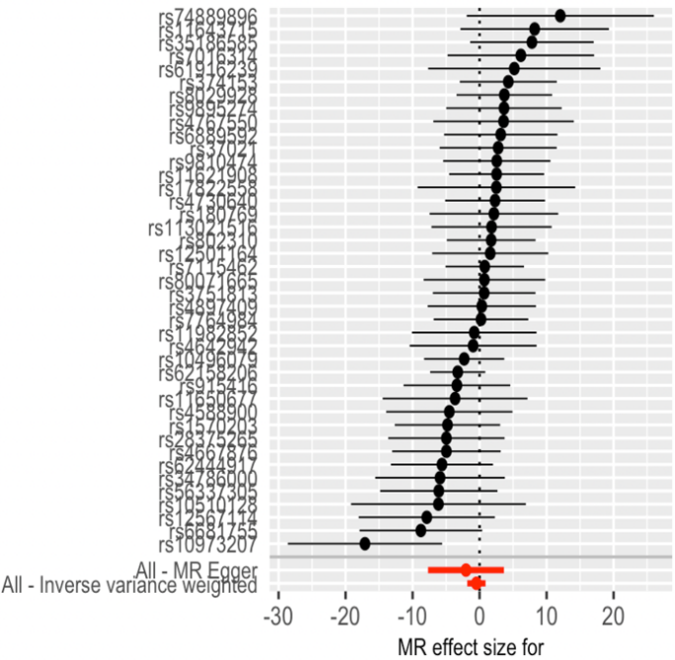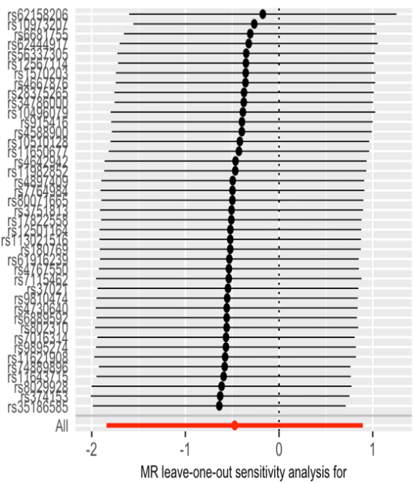
A B
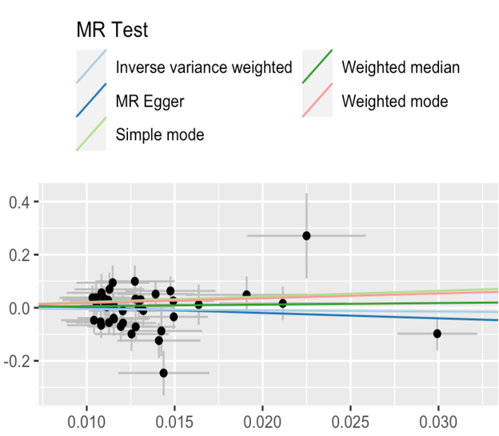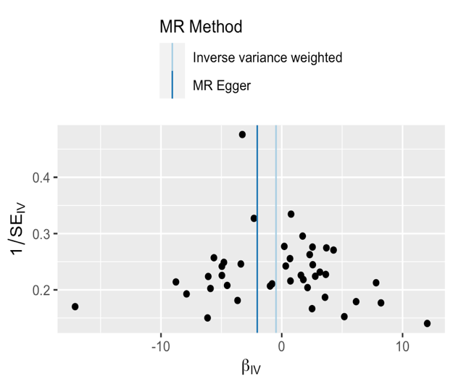
C D

Supplementary Figure 2. Forest plot (1), sensitivity analysis (2), scatter plot (3) and funnel plot (4) of the causal effect of chronotype on ESRD risk.
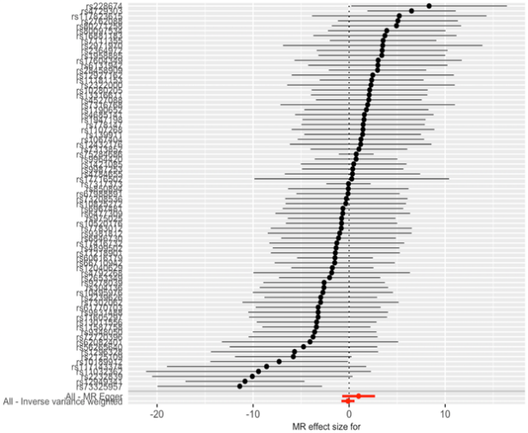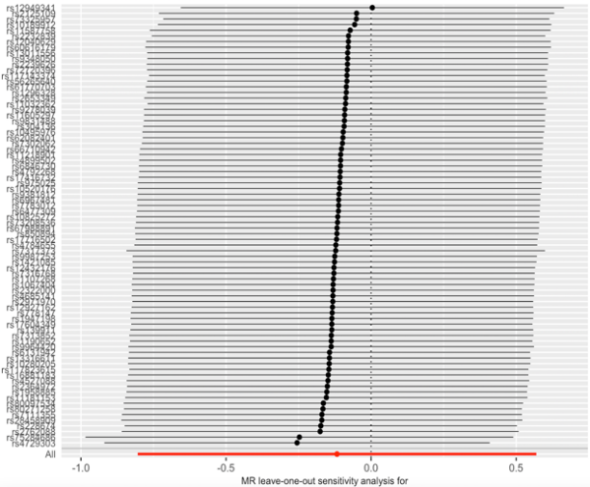
A B
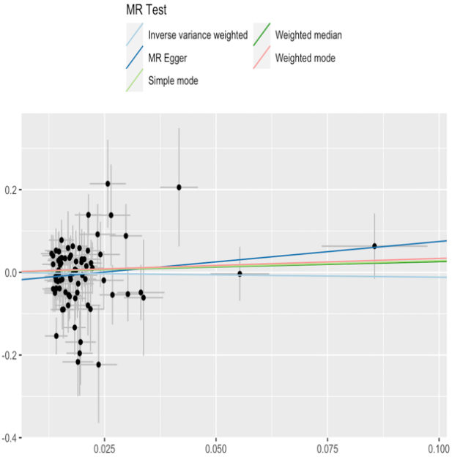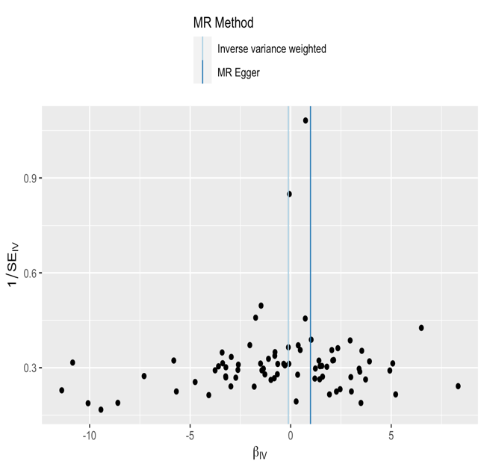
C D

Supplementary Figure 3. Forest plot (1), sensitivity analysis (2), scatter plot (3) and funnel plot (4) of the causal effect of Napping during the day on ESRD risk.
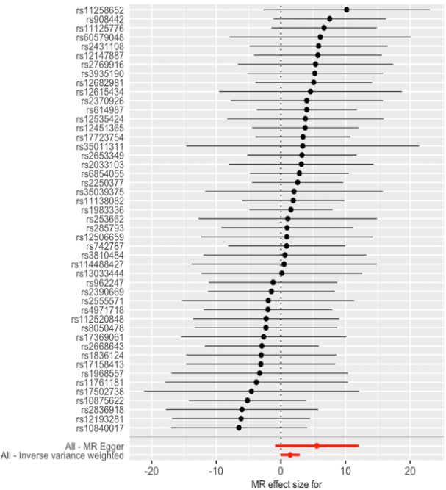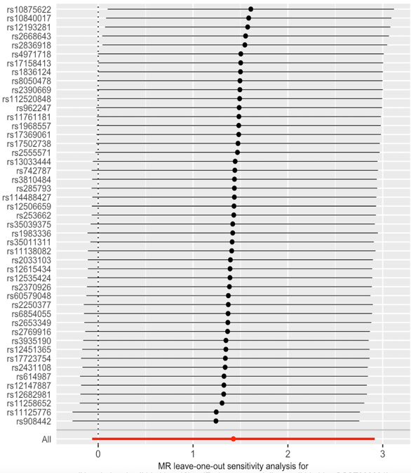
A B
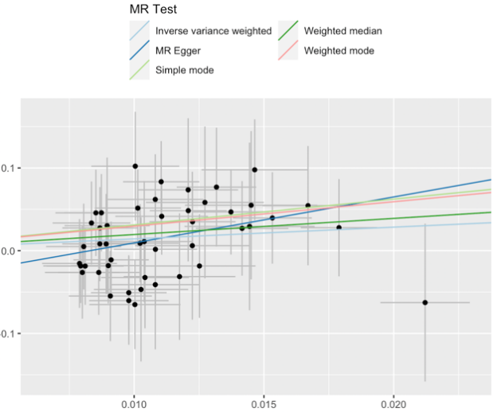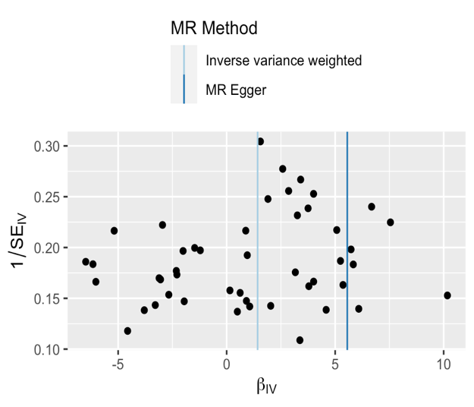
C D

Supplementary Figure 4. Forest plot (1), sensitivity analysis (2), scatter plot (3) and funnel plot (4) of the causal effect of Insomnia on ESRD risk.
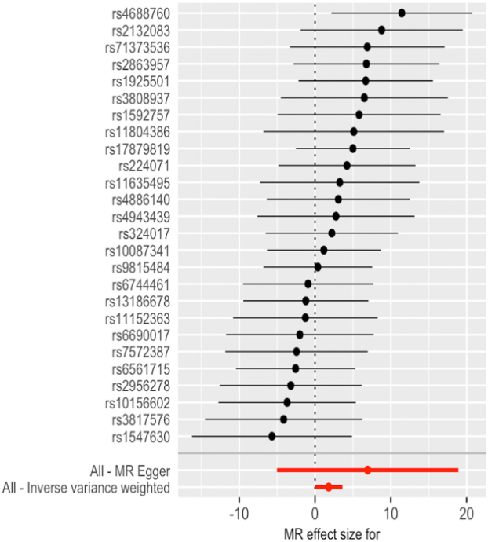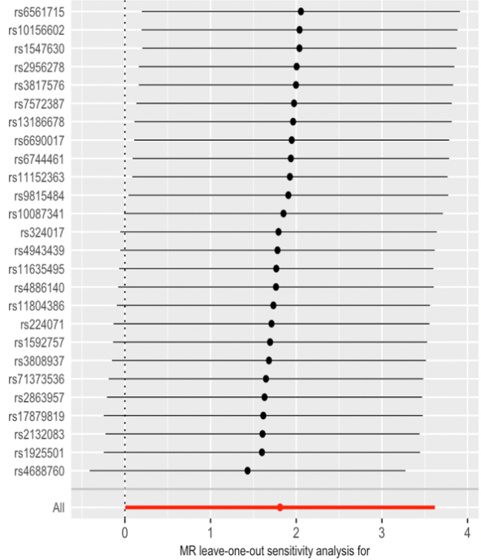
A B
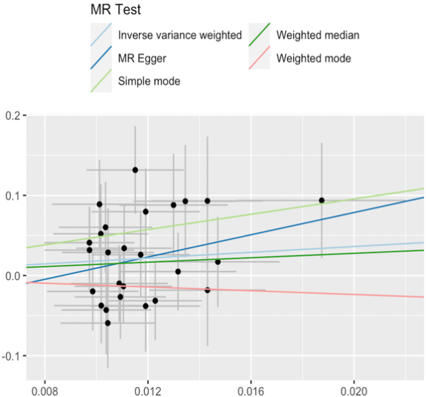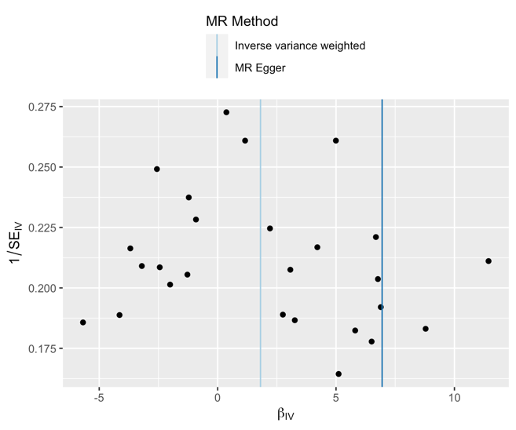
C D

Supplementary Figure 5. Forest plot (1), sensitivity analysis (2), scatter plot (3) and funnel plot (4) of the causal effect of Non-snoring on ESRD risk.
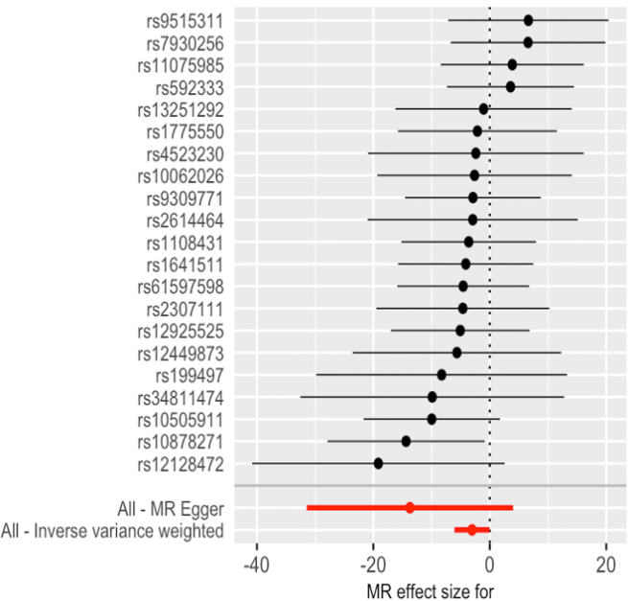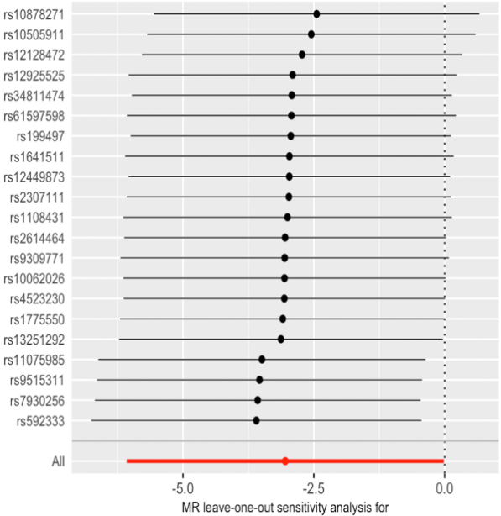
A B
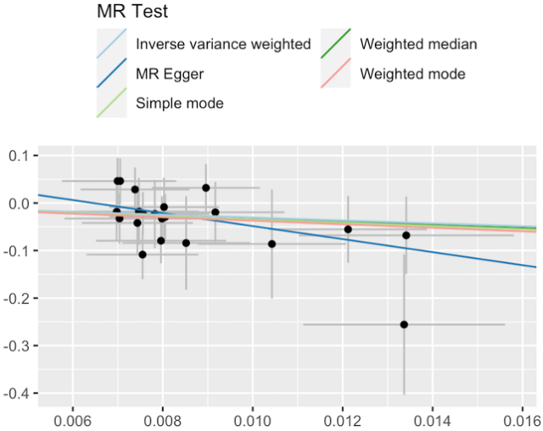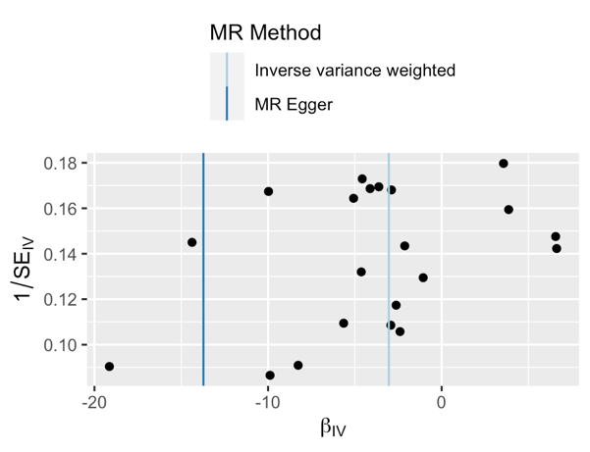
C D

Supplementary Figure 6. Forest plot (1), sensitivity analysis (2), scatter plot (3) and funnel plot (4) of the causal effect of daytime dozing on ESRD risk.
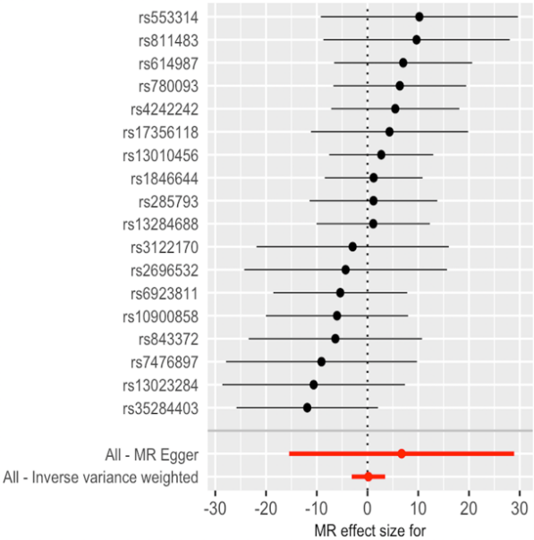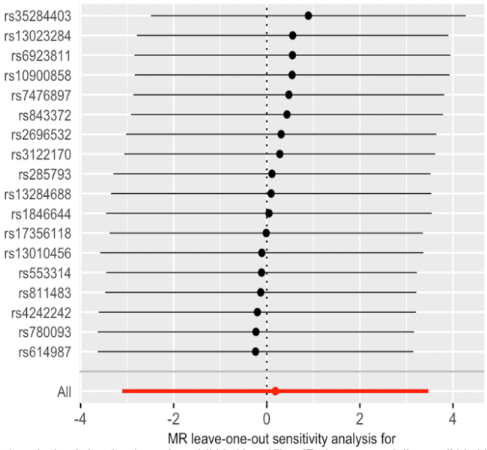
A B
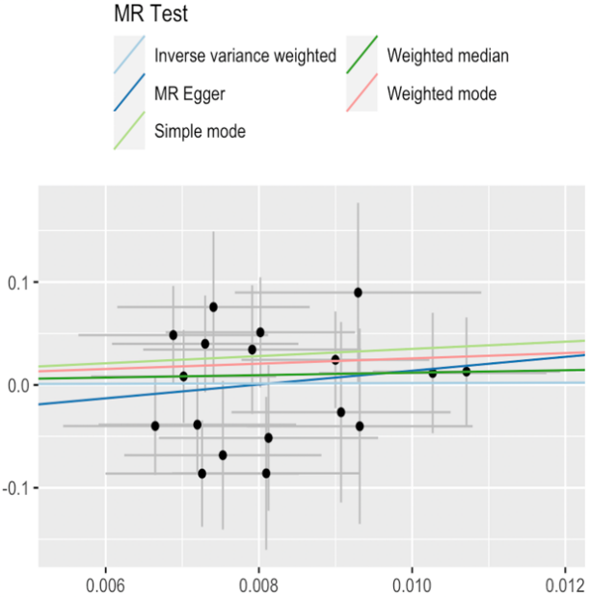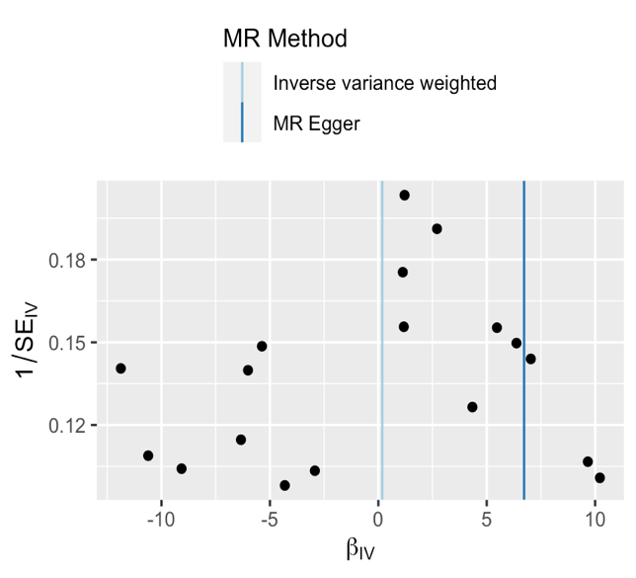
C D

Supplementary Figure 7. Forest plot (1), sensitivity analysis (2), scatter plot (3) and funnel plot (4) of the causal effect of getting up in the morning (adjusting for depression) on ESRD risk.
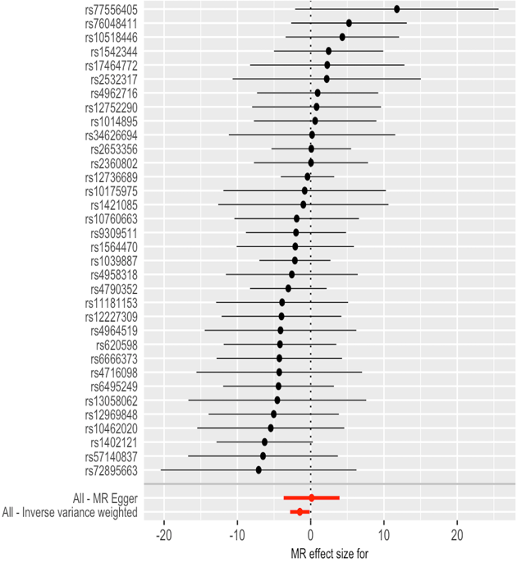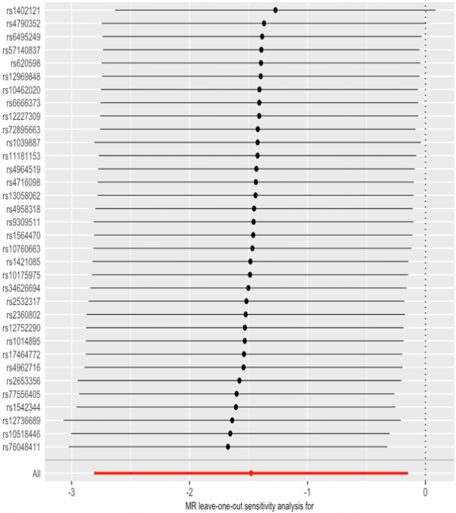
A B
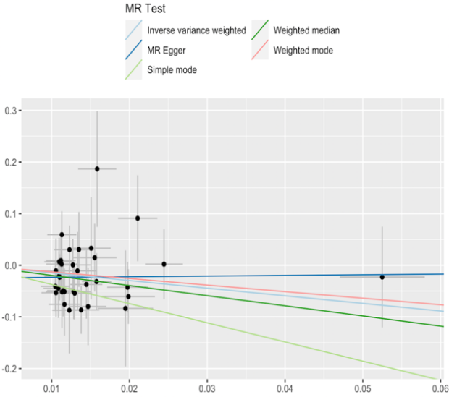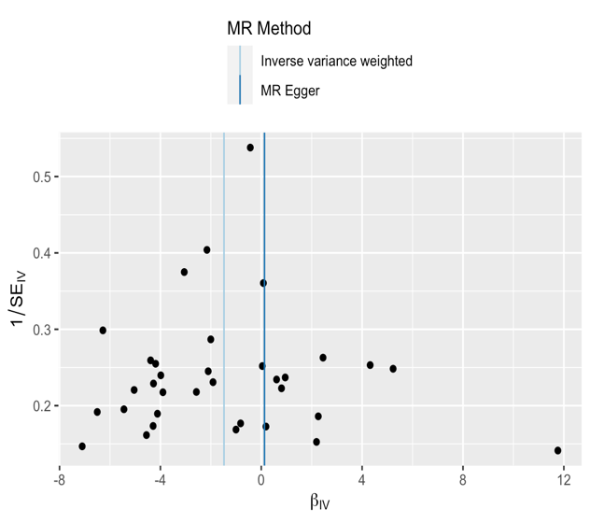
C D

Supplementary Figure 8. Forest plot (1), sensitivity analysis (2), scatter plot (3) and funnel plot (4) of the causal effect of insomnia (adjusting for depression) on ESRD risk.
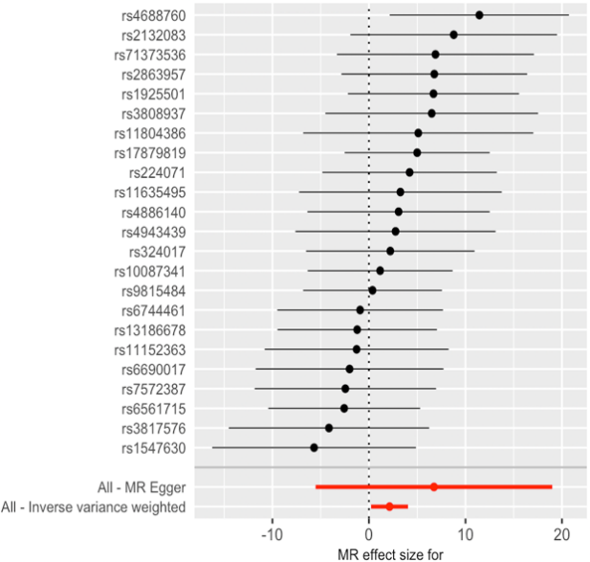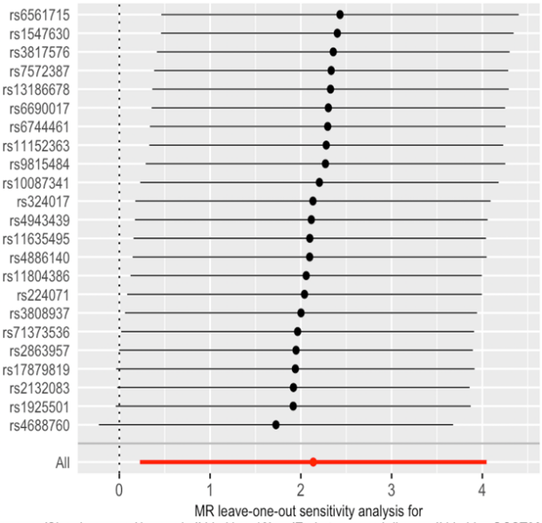
A B
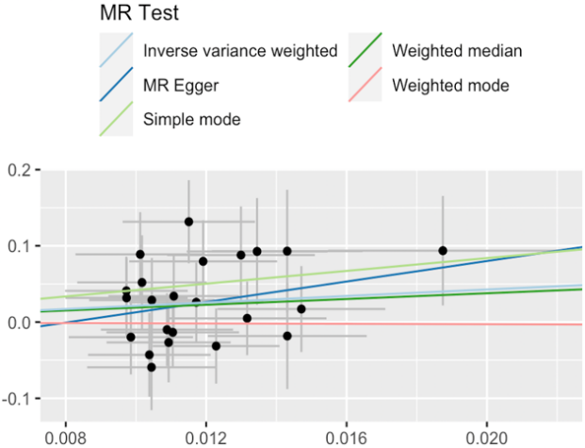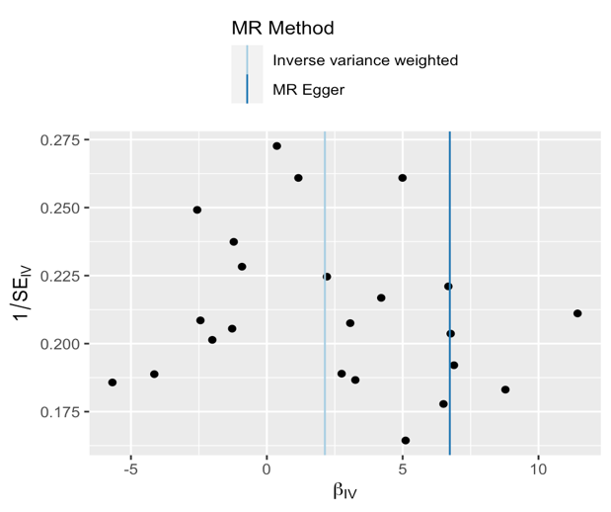
C D

Supplementary Figure 9. Forest plot (1), sensitivity analysis (2), scatter plot (3) and funnel plot (4) of the causal effect of non-snoring (adjusting for BMI/ diabetes) on ESRD risk.
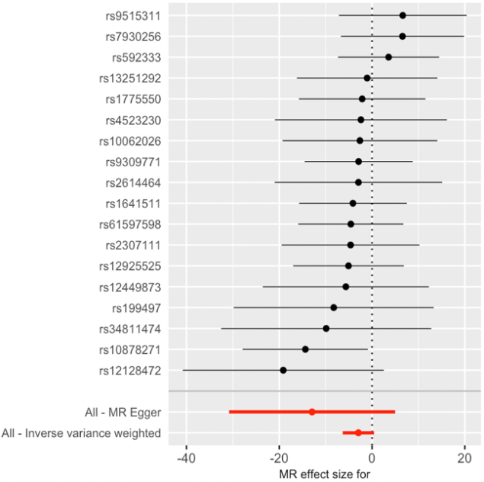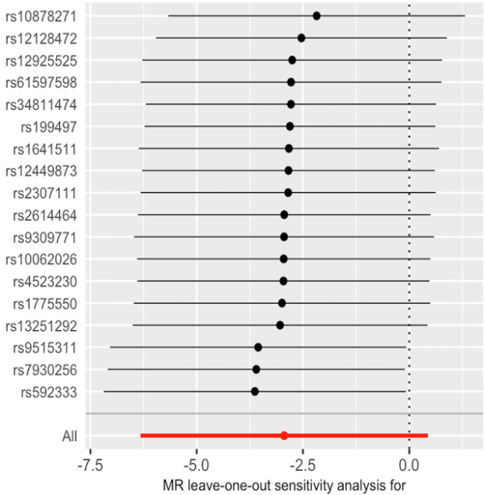
A B
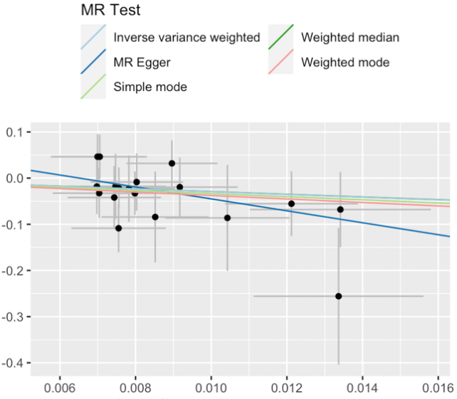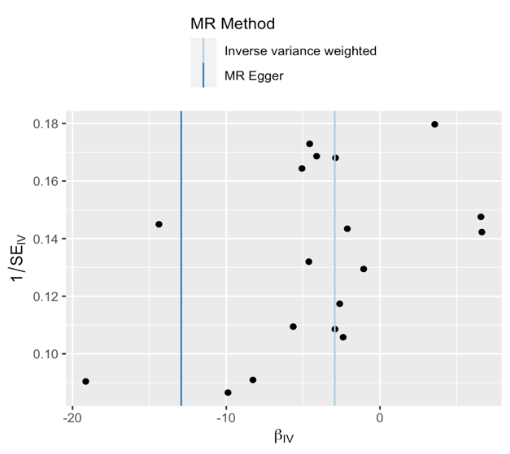
C D

