Supplementary Materials for
Efficient Targeted Delivery of Bifunctional Circular Aptamer-ASO Chimera to Suppress the SARS-CoV-2 Proliferation and Inflammation
Gang Yang^{1,4}, Shengnan Zhang^{2,4}, William Song^{3,4}, Xia Bai^{1,4}, Ling Li^{1,4}, Fatao Luo¹, Yiran Cheng¹, Diyue Wang¹, Jincun Zhao²✉, Yongyun Zhao¹✉
¹Center for Functional Genomics and Bioinformatics, College of Life Science, Sichuan University, Chengdu, Sichuan 610064, P.R. China.
²State Key Laboratory of Respiratory Disease, Guangzhou Institute of Respiratory Disease, The First Affiliated Hospital of Guangzhou Medical University, Guangzhou, Guangdong, 510182, China.
³lncTAC Bio., Chengdu, Sichuan 610200, China.
⁴These authors contributed equally.
✉e-mail: yongyunfly@163.com.; zhaojincun@gird.cn.
This PDF file includes:
Materials and Methods
Figures. S1 to S7
Tables S1
Reference
Materials and Methods
Materials
His-tagged Spike trimer recombinant protein of SARS-CoV-2 was purchased from novoprotein Inc. (DRA49, Shanghai, China). SARS-CoV-2 Spike (WT) Fluc-GFP Pseudovirus was purchased from ACRO Biosystems Inc. (PSSW-HLGB001, USA). SARS-CoV-2 Nucleocapsid Phosphoprotein Rabbit Polyclonal antibody was purchased from Proteintech Inc. (28769-1-AP, USA). SARS-CoV/SARS-CoV-2 Nucleocapsid Mouse Polyclonal antibody was purchased from Sino Biological Inc. (40143-MM05, Beijing, China). HRP-conjugated Beta Actin Monoclonal antibody was purchased from Proteintech Inc. (HRP-60008, USA). TLR4 protein was purchased from Sino Biological Inc. (10146-H08B, Beijing, China). TLR4 polyclonal antibody was purchased from Proteintech Inc. (19811-1-AP, USA). His-tag protein pure Ni-Beads (Ni-Beads) were purchased from BioMag Beads (BMNI-5, Wuxi, China). Exonuclease Ⅰ was purchased from Sangon Biotech (C610019, Shanghai, China). Polyinosinic-polycytidylic acid (Poly(I:C)) and Resatorvid were obtained from MedChemExpress (HY-107202/HY-11109, Shanghai, China). Mouse Tumor Necrosis Factor α ELISA kit and Mouse Interleukin-6 ELISA kit were obtained from Meimian (MM-0122M1/MM-0163M1, Jiangsu, China). Dip and ReadTM Biosensors streptavidin (SA) were purchased from ForteBio (California, USA). All media for cell culture were purchased from Gibco (USA). Fetal bovine serum (FBS) was purchased from Excell Bio (Shanghai, China) and penicillin-streptomycin was purchased from Hyclone (USA). All types of DNA sequences with HPLC purification were synthesized by Sangon Biotech (Shanghai, China).
Cell culture
HEK293T-ACE2 cells were gifts from Prof. Zhao Jincun at the Guangzhou Institute of Respiratory Disease. Calu-3 cells (CL-0054) were obtained from Procell Life Science＆Technology Co., Ltd (ATCC, HTB-55 BCRJ, 0264). THP-1 cells (FH0112, Shanghai, China) were purchased from FuHeng BioLogy (ATCC, TIB-202 DSMZ, 88081201). HEK293T-ACE2 cells were cultured in DMEM medium (Gibco) supplemented with 100 U/mL Penicillin-Streptomycin, 2 μg/mL Puromycin and 10 % (v/v) fetal bovine serum (ExCell Bio), in a humidified atmosphere containing 5% CO₂ incubator at 37 °C. Calu-3 cells were cultured in MEM medium (Gibco) supplemented with 100 U/mL Penicillin-Streptomycin and 10 % (v/v) fetal bovine serum (ExCell Bio), in a humidified atmosphere containing 5% CO₂ incubator at 37 °C. THP-1 cells were cultured in RPMI 1640 medium (Gibco) supplemented with 100 U/mL Penicillin-Streptomycin and 10 % (v/v) fetal bovine serum (ExCell Bio), in a humidified atmosphere containing 5% CO₂ incubator at 37 °C. Cells were negative for mycoplasma.
Fluorescence microscope imaging
HEK293T-ACE2 cells were cultured 48 hours after transfection using N-GFP with or without aptamer ASO chimera. Then, the fluorescence was monitored by the fluorescence microscope (Leica DMi 8, USA). The fluorescence intensity was quantified by Image J software (2022, USA).
Western blot analysis
HEK293T-ACE2 cells and Calu-3 cells were washed twice with PBS and dissolved in lysis buffer (50 mM Tris-HCl pH 7.4, 300 mM NaCl, 1% Triton X-100, 5 mM EDTA, 100 mM phenylmethylsulfonyl fluoride (PMSF) and 10% glycerol) after transfection using N-GFP with or without aptamer ASO chimera. Protein concentration was measured by Bicinchoninic Acid assay (BCA). Proteins were separated by SDS polyacrylamide gel electrophoresis (SDS-PAGE), transferred onto PVDF membranes (Bio-Rad) and incubated overnight at 4 ℃ with corresponding antibodies: anti-N (1:20000), anti-ACTB-HRP (1:10000). A HRP conjugated Rabbit anti-mouse IgG secondary antibody (1:10000) was used for the detection of N. The protein signals were detected using ECL chemiluminescent substrate (FOREGENE, China).
Flow cytometry analysis
To evaluate the binding performance of S proteins (40 nM) coated in Ni-beads were incubated with 200 nM cy3-labeled aptamer-ASO chimera in 100 μL binding buffer at RT for 30 min. Meanwhile, Ni-beads incubated with cy3-labeled random sequences were used as the negative control. The beads were washed twice using washing buffer and suspended in 1 mL binding buffer. The fluorescence intensity of beads with counting about 5000 events was measured by flow cytometry (FACSVerse, BD). Meanwhile, the data was analyzed using FlowJo (V10, BD).
Cells were harvested 48 h after transfection and resuspended in 1 × PBS with 4% FBS and kept on ice before flow cytometry analysis. Flow cytometry data was collected using BD FACScalibur (BD, USA) and analyzed in two channels: green (excitation with 488 nm, emission with 525 ± 25 nm) or red (excitation with 561 nm, excitation with 610 ± 10 nm). The data is processed and analyzed in the FlowJo software.
Construction of circular chimera and its verification
To prepare the circular chimera, SApt1-NASO2 was added to TTT bases at 3’-end, and the modification phosphate group at 5’- terminus to combine with 3’-OH. Subsequently, SApt1-NASO2 were dissolved in T4 DNA Ligase buffer and heated at 95°C for 5 min, followed by rapid chilling to 4 °C. Then, T4 DNA ligase (NEB, America) was quickly added to the solution and reacted at 16 °C for 12 h. Afterward, the T4 DNA ligase was denatured at 65°C for 10 min, according to the manufacturer's instructions. The concentration of circular chimera was determined by UV-vis spectrometry. If necessary, circular chimera was concentrated by 3K MWCO ultrafiltration centrifugation (Thermo Scientific). The construction of circLinker-13 and circLinker-18 (Table 1) was the same approach as above. To verify whether the cyclization was successful, linear and circular chimera (1 μM) were mixed with 0.25 U/μL Exo I, respectively, and incubated for the appointed time at 37°C. After reaching the designed time, samples were heated at 95 °C for 5 min to denature the enzyme and subsequently stored at -20 °C until all samples were collected. Samples were then thawed on ice for electrophoresis.
Agarose gel electrophoresis analysis of aptamer stability
Three μM random sequence, chimera and its circular form were added to the binding buffer containing 10 % FBS and incubated at 37 °C for different times (0, 12, 24, 48, 72 and 96 h). Then, the DNA samples were loaded onto 2 % agarose gel in 1×TAE buffer and run at 120 V for 30 min. Gels were incubated in Ethidium bromide (1 μg/ml) for 5 min and bands were imaged using Gel Doc XR + Gel imaging system (Bio-rad, Hercules, California, USA) with ultraviolet excitation (302 nm).
Binding assays of circular chimera to protein
SARS-CoV-2 S proteins (100 ng per well) were coated in the 96-well ELISA Microplates with 100 μL coating buffer at 4 °C overnight. The S-protein-coated plates were washed twice with washing buffer before blocking with 200 μL of the solution (2% BSA in PBST) at RT for 1 h. Then, 200 nM final concentration biotin-labeled aptamer-ASO chimera at the 5′-end were added into the wells and incubated in binding buffer at RT for 30 min with gentle shaking. After washing two times, streptavidin-horseradish peroxidase (HRP) and its substrates were sequentially added to the reactions. Color development was carried out using 3,3′,5,5′- Tetramethylbenzidine (TMB) substrate and measured using a microplate reader at 450 nm absorbance.
Competition blocking assay of S-TLR4 interaction
This experiment was carried out according to our previous research¹. Briefly, 96-well ELISA Microplates were pre-coated with S proteins in 100 μL coating buffer (pH=9.6, 100 mM NaHCO₃) at 4 ℃ overnight. 200 μL blocking solution was added at room temperature (RT) for 1 h with mild shaking. Serial dilutions of circular chimera were added into microplates and incubated for 30 min. Then, TLR4 was added into microplates and incubated at RT for 30 min with gentle shaking. TLR4 polyclonal antibody was added to the microplates and incubated at RT for 1 h. HRP-conjugated goat anti-rabbit IgG antibody and TMB substrate were used to measure the absorbance.
Bio-layer interferometry (BLI)
BLI was carried out according to our previous research¹. Briefly, the sensors were immersed into 96-well added 200 μL PBST/Mg²⁺ (0.55 mM) and shaking (1000 rpm) for 90 s (baseline phase). For loading purposes, streptavidin biosensors were used to capture biotinylated DNA (the thickness signal was 0.6 nm) in PBST/Mg with shaking for 10 min (loading phase). After washing in the PBST/Mg²⁺ for 60 s (second baseline phase), the loaded sensors were immersed into a serial dilution of S proteins with shaking for 3 min (association phase). Then, the sensors were immersed into PBST/Mg²⁺ for an additional 3 min (disassociation phase). Binding affinity kinetic features using ForteBio Octet K2 (Pall, USA).
Confocal microscope of HEK-293T-ACE2 cells treated with SARS-CoV-2 pseudovirus
Cy3-labeled DNA (200 nM) was incubated with SARS-CoV-2 pseudovirus (low: 1×10⁴ TCID₅₀/mL, high: 1×10⁵ TCID₅₀/mL, 1 TCID₅₀≈0.7 PFU) in binding buffer at RT for 10 min. Then, 1×10⁵ HEK293T-ACE2 cells were incubated with mixtures of SARS-CoV-2 pseudovirus and DNA at 37 °C for 48 h. After incubating with Hoechst 33342 for 15 min, HEK293T-ACE2 cells were harvested to image with a Zeiss CELL Observer SD confocal microscope with a 60 × oil objective. The excitation wavelengths were 488 nm (Green Channel) and 561 nm (Red Channel). Exposure times: 200–400 ms. Acquired images were analyzed by the ZEN (blue edition).
Circular chimera inhibits inflammatory responses in cells
Initially, S protein (10 nM) was mixed with circular chimera in binding buffer at RT for 10 min. Subsequently, the mixtures of S and circular chimera were added to THP-1 cells and incubated at 37 °C for 2 h. Calu-3 cells were cotransfected with N-GFP plasmids and circular chimera with Lipofectamine 2000 following the manufacturer’s protocol. After 48 h, the cell was harvested. Subsequently, Trizol was used to extract RNA. qRT-PCR was used to detect the inflammatory cytokines.
The SARS-CoV-2 strains used in this research were isolated from COVID-19 patients in Guangdong, China, including wild type (SARS-CoV-2/human/CHN/IQTC01/2020, NCBI, accession number: MT123290)，Omicron (B.1.1.529). Authentic SARS-CoV-2 virus (2×10⁶ PFU/mL, MOI= 0.65) were mixed with circular chimera in binding buffer at RT for 10 min. Then, 5×10⁵ THP-1 cells were incubated with mixtures of SARS-CoV-2 and circular chimera at 37 °C for 2 h. Meanwhile, 5×10⁵ of Calu-3 cells were incubated for 2 h. After incubating, cells were harvested to detect the inflammatory cytokines. All authentic SARS-CoV-2 infection experiments were performed in Guangzhou Gustoms District Technology Center Biosafety Level 3 (BSL-3) Laboratory.
Immunofluorescence assay (IFA)
A series of circular chimera and control sequences were incubated with authentic SARS-CoV-2 virus (2×10⁶ PFU/mL, MOI= 0.65) at 37 °C for 1 h. Then, 1×10⁵ Vero E6 cells were incubated with mixtures of SARS-CoV-2 virus and DNA at 37 °C for 48 h or 72 h. For immunofluorescence assay, Vero E6 cells were incubated in Paraformaldehyde at 4°C overnight for permeabilization. The expression of nucleocapsid protein from the SARS-CoV-2 virus was detected by using N protein primary antibody for 1 h at 37°C. After washing with PBST, wells were incubated with secondary antibody for 1 hour at room temperature. Meanwhile, the cell nucleus was stained with DAPI. Images were acquired with the fluorescence microscope and analyzed with Image J software.
Quantitative RT-PCR (qRT-PCR) analysis
Total RNA was isolated from the stimulated cells by RNAiso Plus (108-95-2, TaKaRa, Japan). Then, cDNA was prepared using DNase I (01056834, Thermo Scientific, USA) and RevertAid Reverse Transcriptase (00991337, Thermo Scientific, USA). qRT-PCR was performed using the Applied Biosystems 7500 Real-Time PCR Systems (Thermo Fisher Scientific, USA) with 2×Real PCR EasyTM Mix-SYBR (210520, Foregene, China). The data of qRT-PCR were analyzed by the Livak method (2-ΔΔCt). ACTB was used as a reference gene for the human cell lines.
Cell viability analysis
THP-1 and Calu-3 cells were seeded at a density of 1×10⁴ in 96-well plates. After 8-12 h cell culture, 0-2000 nM chimera and Resatorvid were added to the monolayer cells. At 48 h after cell culture, cell viability was assessed using a CCK-8 kit (Beyotime, China). The absorbance at 450 nm was measured on a microplate reader. The mean value of the wells with media alone was used as background and was subtracted from the absorbances of the wells containing cells.
Aptamers induce cytokine responses in mice
Female C57BL/6 and BALB/c mice (6-8-weeks old) were provided by the Laboratory Animal Center of Sichuan University. All mice were kept in sterile, autoclaved cages and provided with enough food and water. All animal experiments were undertaken at Sichuan University and approved by the local regulatory agency. For in vivo stimulation, 200 μL physiological saline solution containing aptamers was incubated for 20 mins. Subsequently, mice (BALB/c) were randomly separated into 3 groups and injected through intranasal administration. The administration amount of the circular chimera is 20 mg/kg. Control mice received either physiological saline solution (blank) alone or LPS (3 mg/kg) (positive control), respectively. Whole blood samples were obtained by tail clippings at the indicated time. Then, serum was prepared from whole blood by coagulation at 37 °C for 30 min and centrifugation. Mouse cytokine (IL-6, TNF-α) was measured using a mouse cytokine (IL-6, TNF-α) ELISA kit (Meimian, the minimum detectable dose in pg/ml) according to the product information and manual. The lung tissue of mice was lysed using Trizol, and detect the inflammatory cytokines (IL-6, TNF-α) by qRT-PCR.
Statistical analysis
All analyses were repeated at least three times, and a representative experimental result was presented. Data were analyzed using GraphPad Prism version 8.0 (GraphPad Software, San Diego, CA). Continuous variables with normal distribution are expressed as the mean ± standard deviation (SD). Comparisons between groups were all verified for normal distribution by D’Agostino-Pearson omnibus test. Student’s t-test (for pairwise comparisons) and one-way ANOVA (for comparisons among three or more groups) were used. The post hoc test with Bonferroni correction was performed for multiple comparisons following ANOVA.
Figures S1
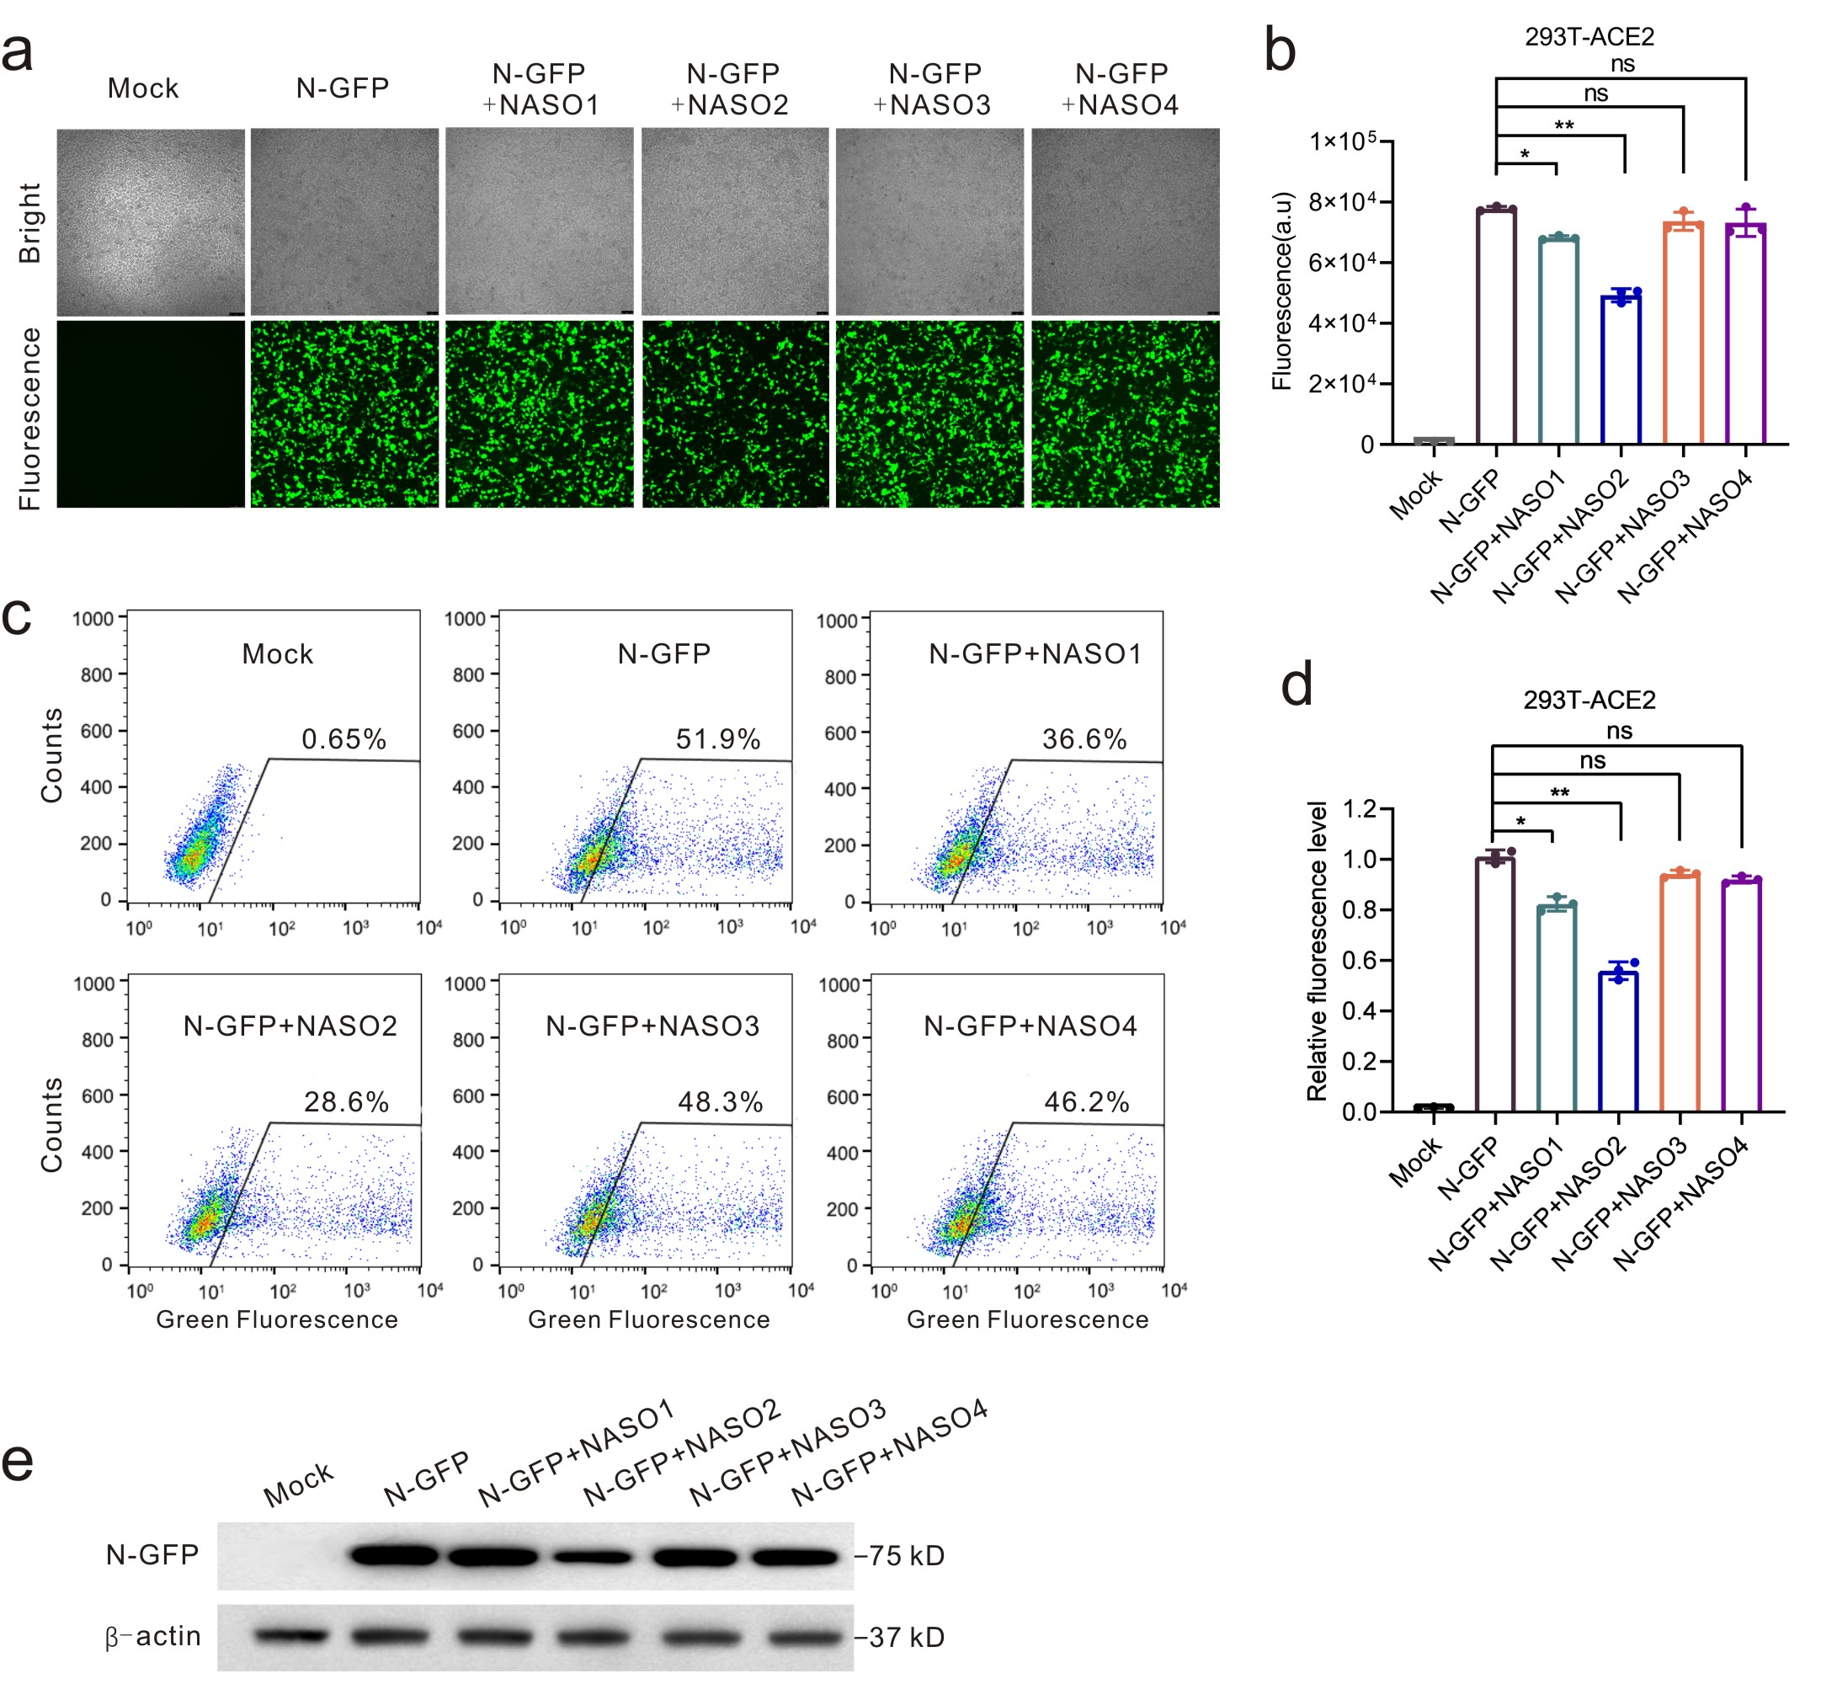
Supplementary Fig. S1. The knockdown efficiency of ASOs targeting the SARS-CoV-2 N gene. a. Representative fluorescence microscopy images of HEK293T cells with different treatments. The cells were co-transfected with a plasmid (500 ng) encoding the N-GFP protein and ASO (100 nM) for 48 h. respectively. b. Quantification of fluorescence of HEK293T cells from Fig. 5a. c. Flow cytometry analysis of fluorescence of HEK293T cells with the same treatment as Fig. S1a. d. Flow cytometry quantification of fluorescence of HEK293T cells from Fig. 5c. e. Representative western blot analysis of the efficiency of ASO in knocking down N protein in HEK293T cells with the same treatment as Fig. S1a. All the error bars indicate standard deviations (n= 3). All the P values were determined using paired t-test. *P＜0.05; **P＜0.005.
Figures S2
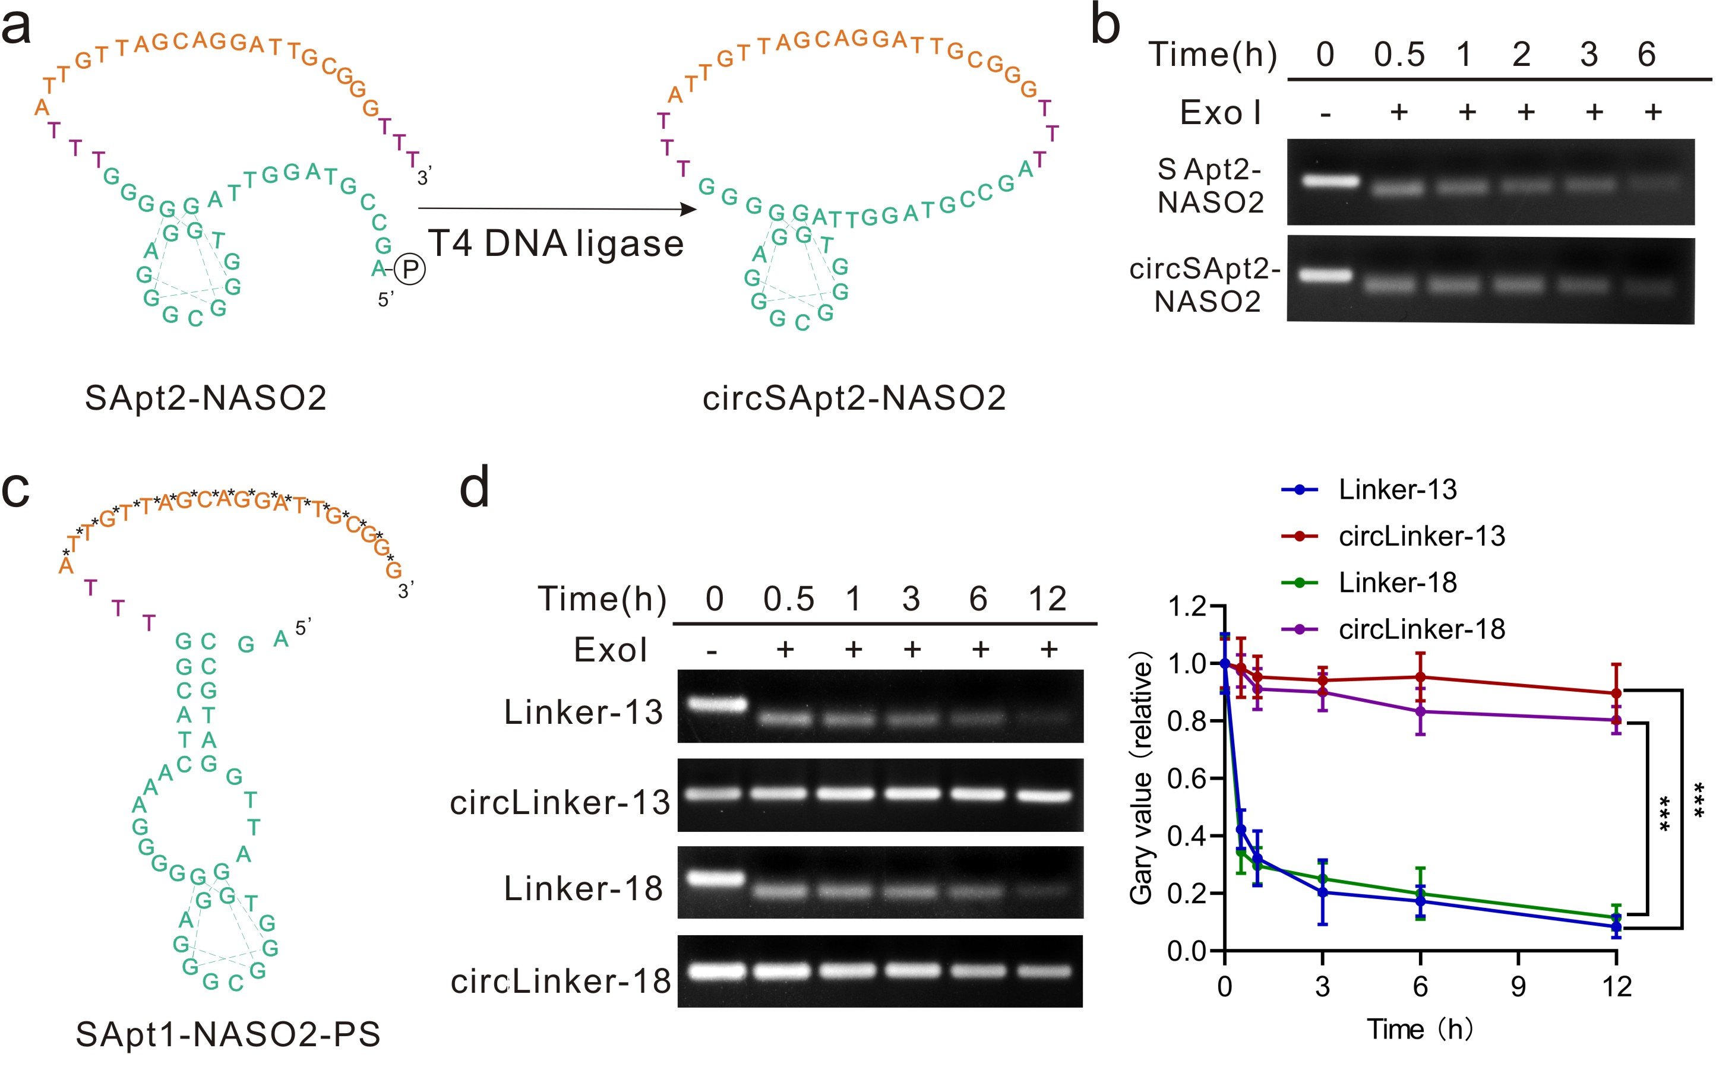
Supplementary Fig. S2. The cyclization of SApt-NASO chimera. a. The sequence of SApt2-NASO2 chimera and the corresponding cyclization. Circled P denotes phosphorylation modification. b. Detection of cyclization in 0.25 U/μL Exo I at 37 °C for different times and the quantitative analysis. c. The sequence of SApt1-NASO2-PS chimera. Ps: phosphorothioate modification. d. Detection of the cyclization of SApt1-NASO2 chimera with different lengths of the linker in 0.25 U/μL Exo I at 37 °C for different times and the quantitative analysis. All the error bars indicate standard deviations (n= 3). All the P values were determined using paired t-test. ***P＜0.001.
Figures S3
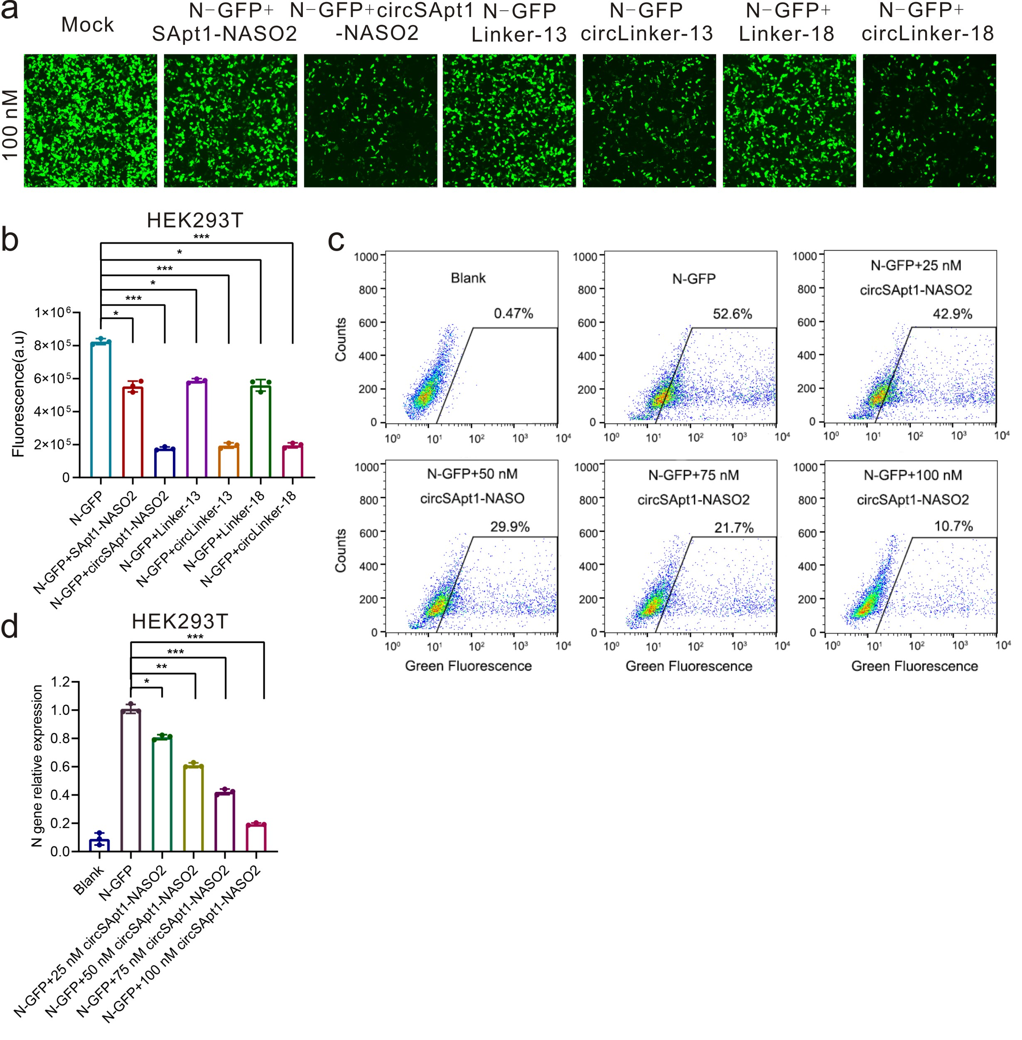
Supplementary Fig. S3. The knockdown efficiency of circular chimeras with different linkers targeting the SARS-CoV-2 N gene. a. Representative fluorescence microscopy images of HEK293T cells with different treatments. The cells were co-transfected with a plasmid (500 ng) encoding N-GFP protein and linear or circular chimeras (100 nM) for 48 h using transfection reagent Lipo2000, respectively. b. Quantification of fluorescence of HEK293T cells from Fig. 5a. c. Flow cytometry analysis of fluorescence of HEK293T cells that were co-transfected with a plasmid (500 ng) encoding the N-GFP protein and circSApt1-NASO2 (100 nM) for 48 h using transfection reagent Lipo2000. d. Flow cytometry quantification of HEK293T cells from Fig. 5c. All the error bars indicate standard deviations (n= 3). All the P values were determined using paired t-test. *P＜0.05; **P＜0.005; ***P＜0.001.
Figures S4
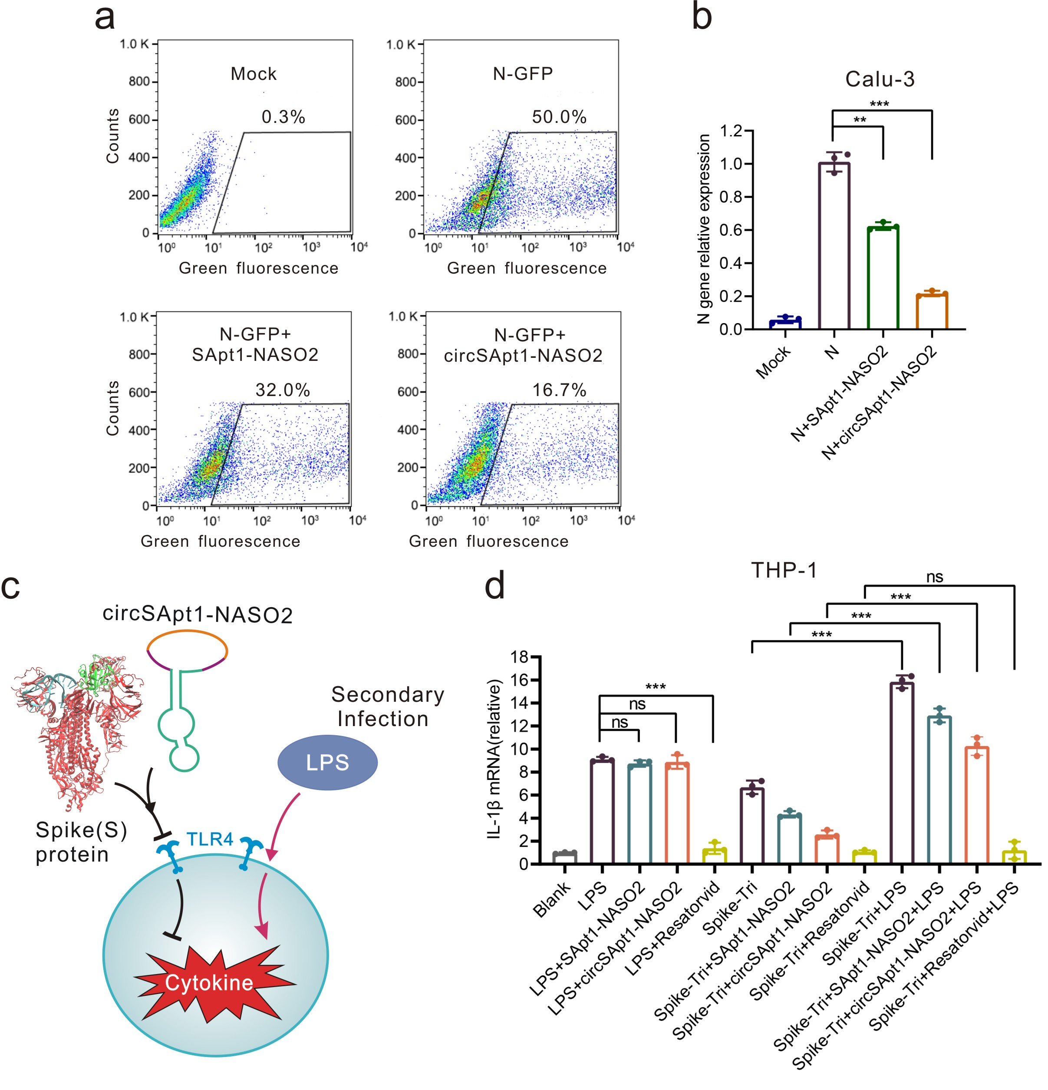
Supplementary Fig. S4. a-b. Flow cytometry analysis and quantification of the knockdown efficiency of circSApt1-NASO2 in Calu-3 cells. The cells were co-transfected with a plasmid (500 ng) encoding the N-GFP protein and circSApt1-NASO2 (100 nM) for 48 h using the transfection reagent Lipo2000. All the cells were analyzed in the green fluorescence channels. c. The diagram depicts that the circSApt1-NASO2 do not interfere with immune cell defense against secondary infection. LPS was used to simulate secondary infection. d. qRT-PCR analysis of immune response to LPS in cells pretreated with spike-Tri (10 nM) and circSApt1-NASO2 (200 nM). THP-1 cells treated with 50 ng/mL LPS for 2 h to induce cytokine again. Resatorvid (100 μM) that a selective TLR4 inhibitor that inhibits cytokines production was used as the control. All the error bars indicate standard deviations (n= 3). All the P values were determined using paired t-test. **P＜0.005; ***P＜0.001.
Figures S5
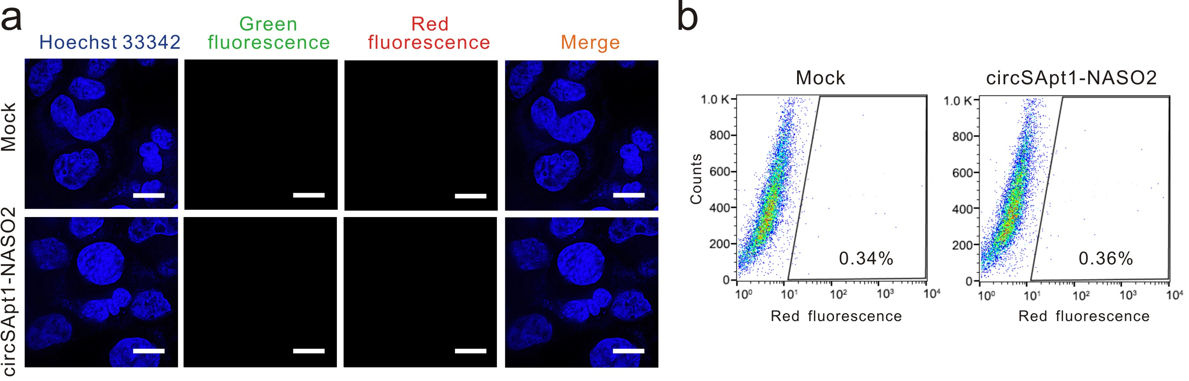
Supplementary Fig. S5. SARS-CoV-2 -mediated delivery of circSApt1-NASO2 is cell type-specific. a. Representative fluorescence confocal imaging of HEK293T cells infected with SARS-CoV-2 pseudovirus (1×10⁵ TCID50/mL) pre-incubated with cy3-labeled circSApt1-NASO2 (200 nM). Scale bars represent 10 μm. Mock: without SARS-CoV-2 pseudovirus. Microphotographs of cells by Laser confocal microscope. Scale bars represent 5 μm. b. Flow cytometry analysis of the cell specificity delivery of cy3-labeled circSApt1-NASO2 by SARS-CoV-2 pseudovirus. Samples were the same as in Fig. S5a and all the cells were analyzed in the red fluorescence channels.
Figures S6
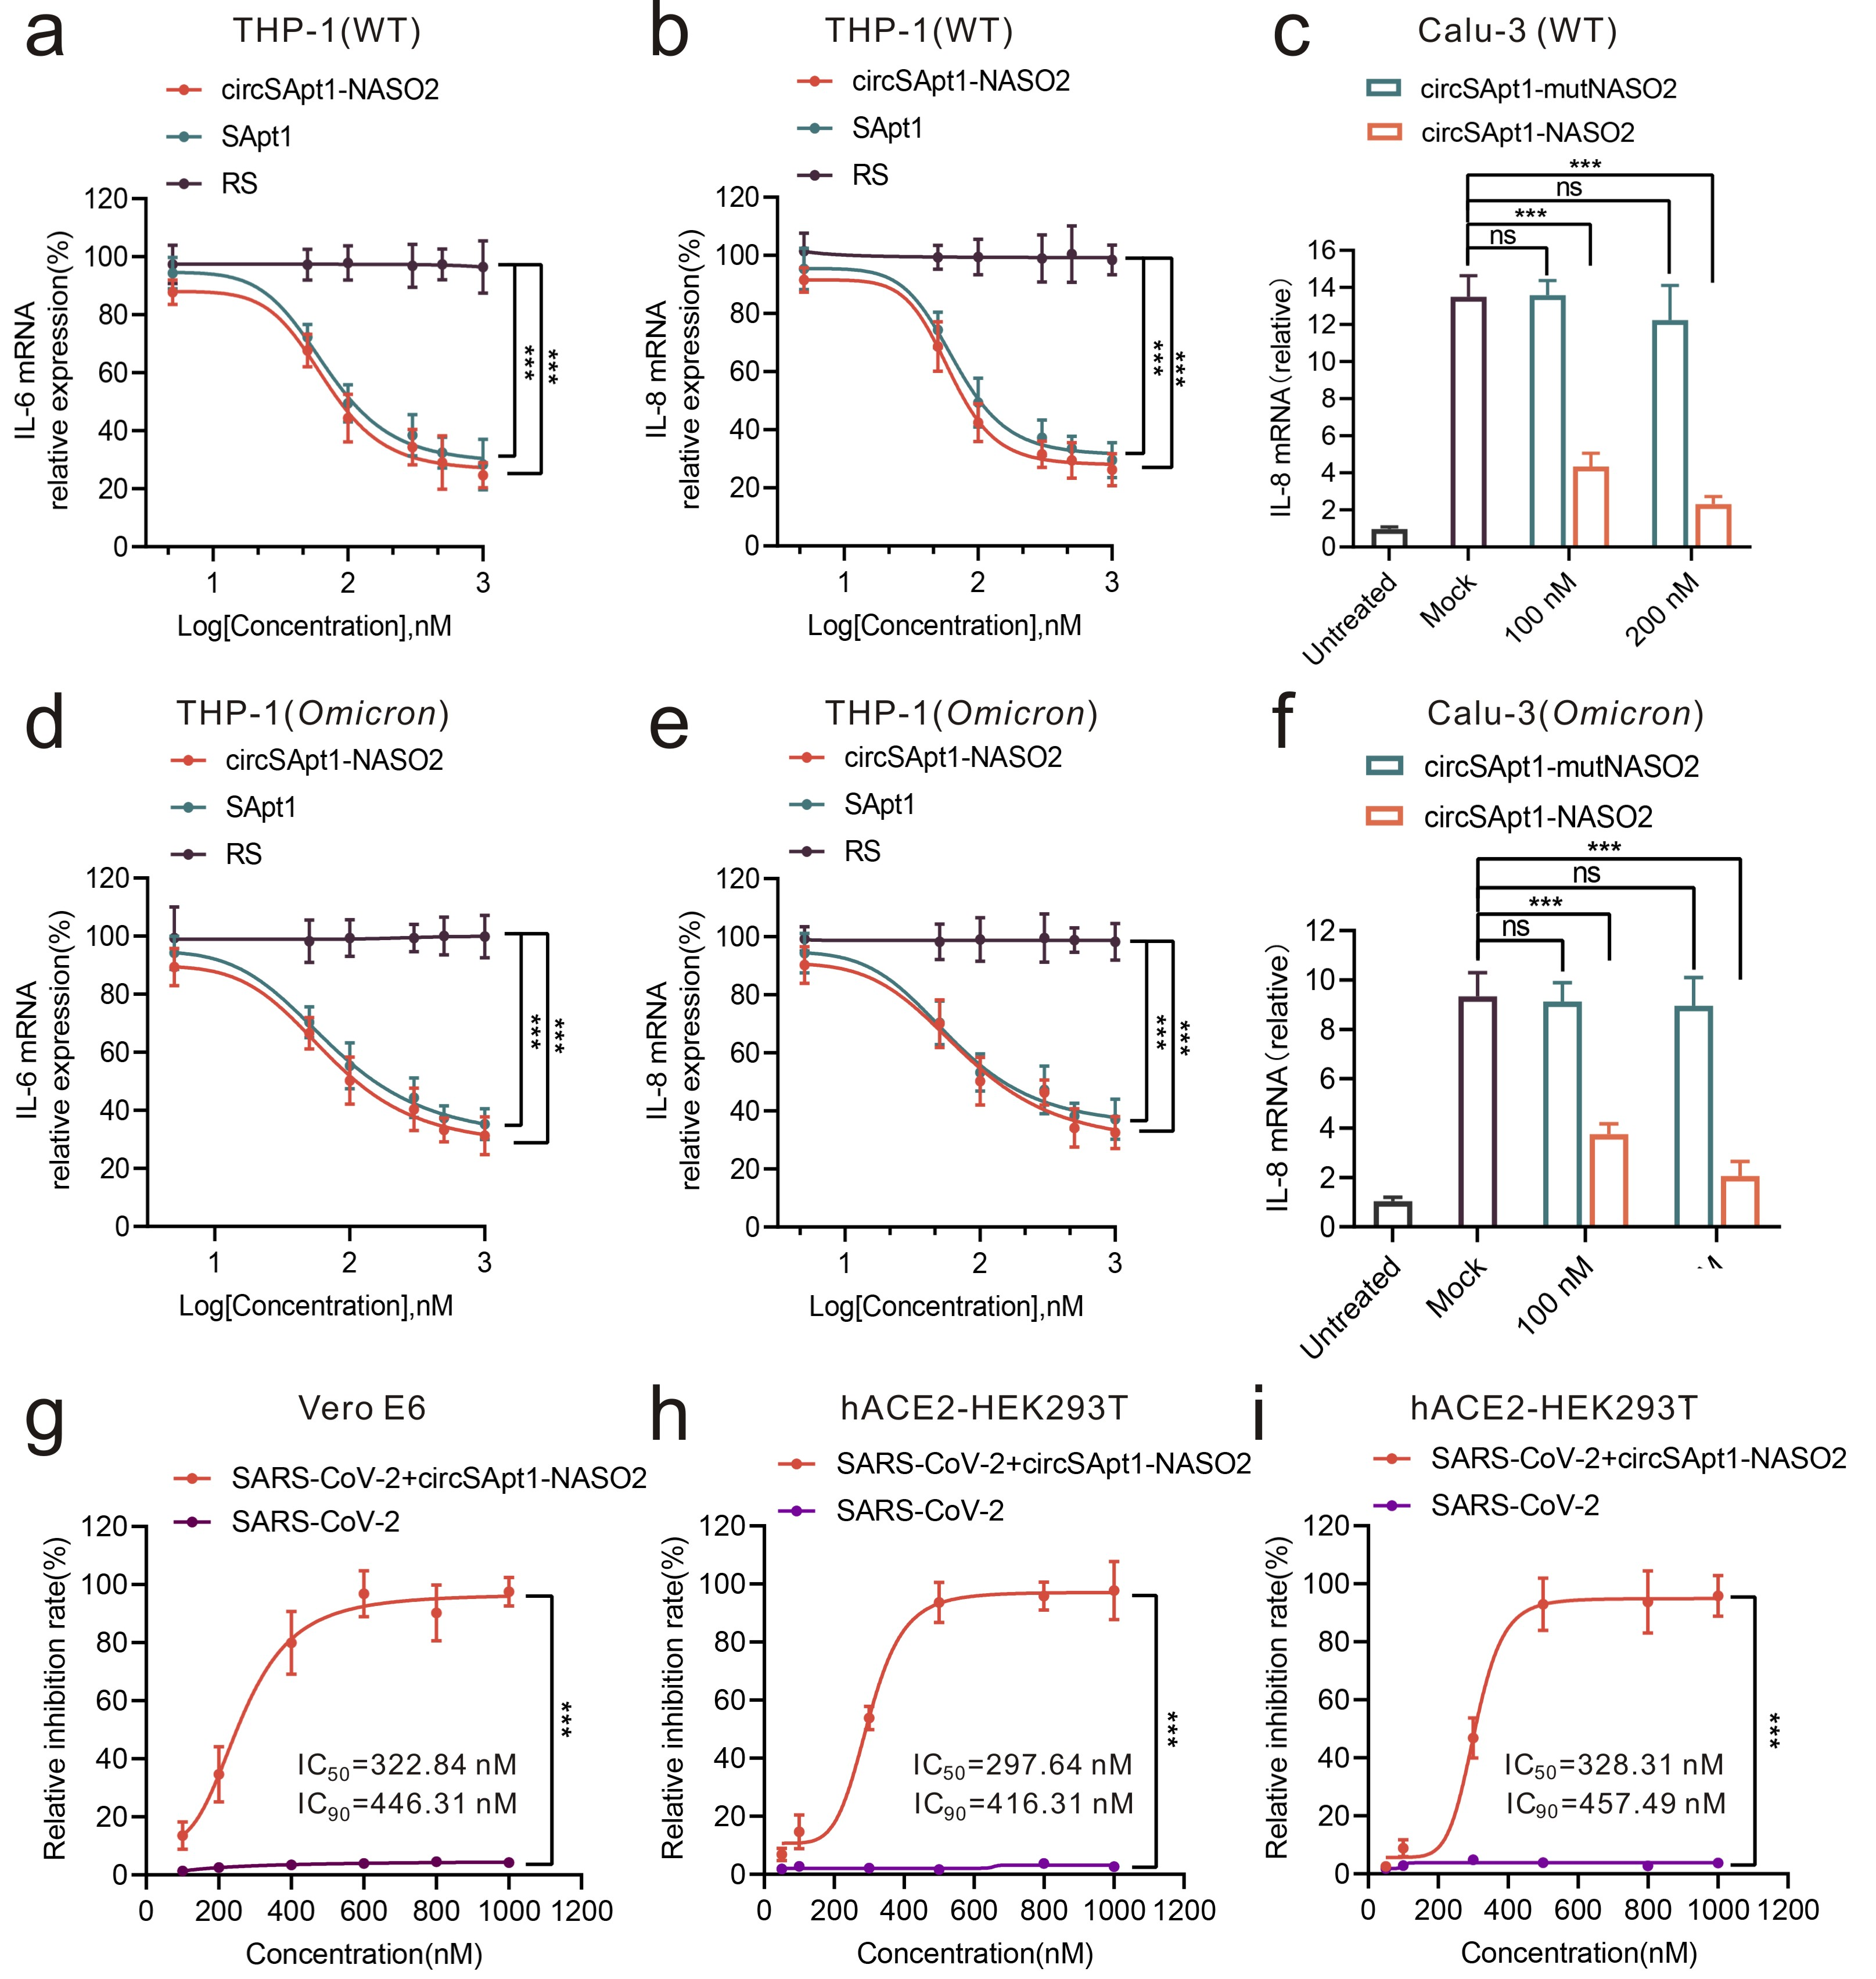
Supplementary Fig. S6. The anti-inflammatory potential of circSApt1-NASO2. a-b. qRT-PCR analysis for the cytokines (IL-6, IL-8) inhibition in THP-1 cells infected with authentic SARS-CoV-2 (MOI= 0.65) and different concentrations of circSApt1-NASO2 chimera for 2 h. c. qRT-PCR analysis for the cytokines (IL-6) inhibition in Calu-3 cells infected with authentic SARS-CoV-2 (MOI= 0.65) with different concentrations of circSApt1-NASO2 chimera for 48 h. d-e. qRT-PCR analysis for the cytokines (IL-6, IL-8) inhibition in THP-1 cells infected with authentic Omicron variant (MOI= 0.65) and different concentrations of circSApt1-NASO2 chimera for 2 h. f. qRT-PCR analysis for the cytokines (IL-6, IL-8) inhibition in Calu-3 cells infected with authentic Omicron variant (MOI= 0.65) and different concentrations of circSApt1-NASO2 chimera for 48 h. g. Quantitative analysis of SARS-CoV-2 replication in Vero E6 cells incubated with authentic SARS-CoV-2 (MOI= 0.65) and different concentrations of circSApt1-NASO2 for 72 h. h-i: Quantitative analysis of SARS-CoV-2 replication in hACE2-HEK293T cells incubated with authentic SARS-CoV-2 (MOI= 0.65) and different concentrations of circSApt1-NASO2 for 48 h and 72 h, respectively. All the error bars indicate standard deviations (n= 3). All the P values were determined using paired t-test. ***P＜0.001.
Figures S7
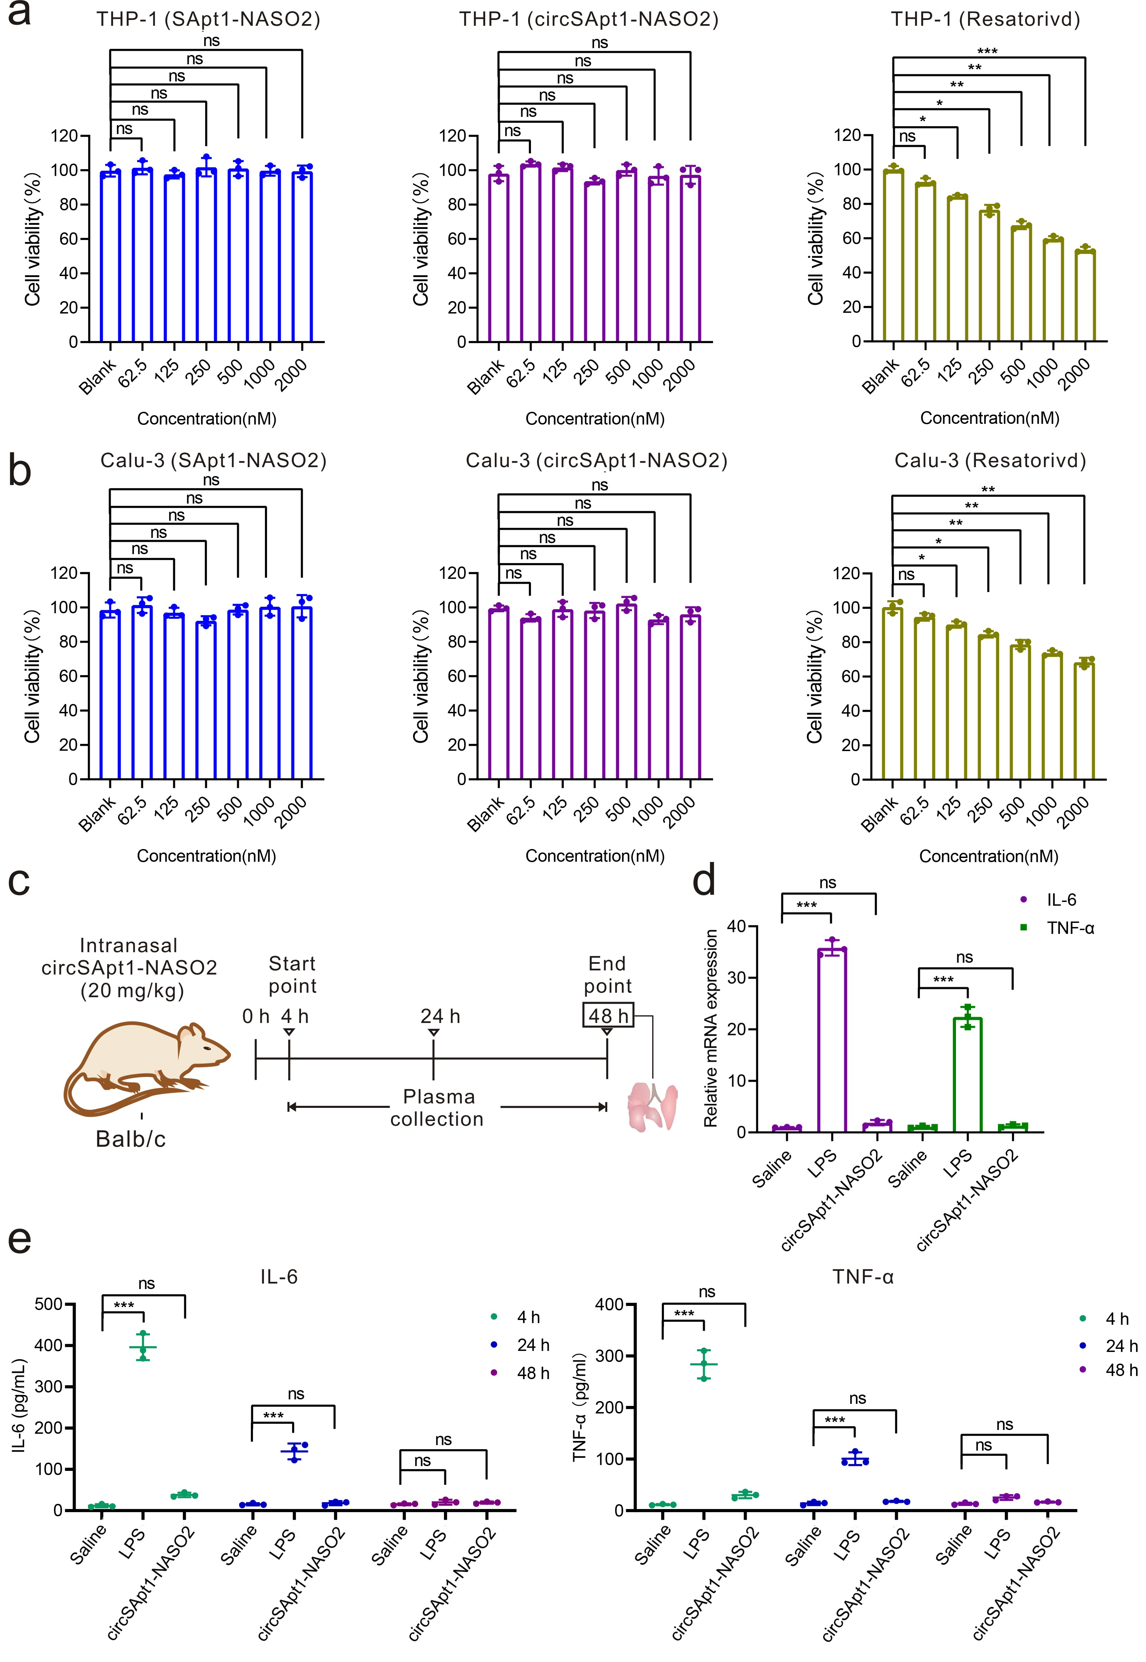
Supplementary Fig. S7. The immunogenicity and cytotoxicity of circSApt1-NASO2. a-b. CCK8 assay for the cytotoxicity analysis of this circSApt1-NASO2 in THP-1 and Calu-3 cells. Resatorvid which can inhibit cell viability was taken as control. c. Schematic illustration for investigation of circSApt1-NASO2 induces cytokine responses in mice (n= 3). The lung and blood collection at the indicated time. d. The mRNA level of cytokine (IL-6, TNF-α) production was measured using qRT-PCR in the lungs. Lungs were collected for analysis at 48 h. e. The level of cytokine (IL-6, TNF-α) production was measured in mouse supernatants using ELISA at the indicated time. The mice were treated intranasally with 20 mg/kg circSApt1-NASO2 or 5 mg/kg LPS. All the error bars indicate standard deviations (n= 3). All the error bars indicate standard deviations (n= 3). All the P values were determined using paired t-test. *P＜0.05; **P＜0.005; ***P＜0.001.

Supplementary Tables S1
Table S1. The information of the DNA sequence used in the experiment. *Represents the phosphorothioate (PS) modification.
Name | Sequences (5'-3')
SApt1 (ST-6-1, 38 nt) | GGCATCAAAGGGGGGAGGGCGGGTGGATTGGATGCCGA
SApt2 (ST-6-2, 27 nt) | GGGGAGGGCGGGTGGATTGGATGCCGA
NASO1 | CCAATGTGATCTTTTGGTGT
NASO2 | ATTGTTAGCAGGATTGCGGG
NASO3 | ATTTCCTTGGGTTTGTTCTG
NASO4 | GGCCAATGTTTGTAATCAGT
SApt2-NASO2 | GGGGAGGGCGGGTGGATTGGATGCCGATTTATTGTTAGCAGGATTGCGGG
SApt1-NASO2 | GGCATCAAAGGGGGGAGGGCGGGTGGATTGGATGCCGATTTATTGTTAGCAGGATTGCGGG
SApt1-NASO2-PS | GGCATCAAAGGGGGGAGGGCGGGTGGATTGGATGCCGATTTA*T*T*G*T*T*A*G*C*A*G*G*A*T*T*G*C*G*G*G*
circSApt1-NASO2 | GGCATCAAAGGGGGGAGGGCGGGTGGATTGGATGCCGATTTATTGTTAGCAGGATTGCGGGTTT
circLinker-13 | AGATGAGGGCATCAAAGGGGGGAGGGCGGGTGGATTGGATGCCGATTTATTGTTAGCAGGATTGCGGGTTT
circLinker-18 | ATCGAAGGGCATCAAAGGGGGGAGGGCGGGTGGATTGGATGCCGAGGTATTTTATTGTTAGCAGGATTGCGGGTTT

Reference:
1. Yang, G. et al. Aptamer blocking S-TLR4 interaction selectively inhibits SARS-CoV-2 induced inflammation. Signal Transduct. Target Ther. 7 (2022).120.

