Supplementary Information
Targeting EphA2 and DDR signaling can overcome the BRAF and MEK inhibitors acquired resistance in melanoma cell lines
Valentina Belli, Stefania Napolitano, Vincenzo De Falco, Gabriella Suarato, Alessandra Perrone, Luigi Pio Guerrera, Giulia Martini, Carminia Maria Della Corte, Erika Martinelli, Floriana Morgillo, Mimmo Turano, Maria Furia, Giuseppe Argenziano, Davide Ciardiello, Fortunato Ciardiello and Teresa Troiani.

Figure S1. Evaluation of cell proliferation of parental SAN and A375 BRAF mutated human melanoma cell lines following treatment with BRAF (vemurafenib) and/or MEK (cobimetinib) inhibitors. Cell viability of SAN and A375 cell lines was evaluated by MTT staining after treatment with increasing concentration of BRAF and MEK inhibitors (range 0,001-25 µM) for 72 hrs. The half-maximal inhibitory concentration (IC50) was reported in the tables.

Figure S2. (A) Wound healing assay performed to detect migration ability of SAN, SAN-VR, SAN-CR and SAN-VRCR cell lines after 48 hrs of culture. (B) Wound healing assay was performed to detect migration ability of A375, A375-VR, A375-CR and A375-VRCR cell lines after 48 hrs of culture.

Figure S3. Western blots showing all the bands and molecular weight of sections reported in Figure 1B.

.
Figure S4. Western blots showing all the bands and molecular weight of sections reported in Figure 1D.

Figure S5. Western blots showing all the bands and molecular weight of sections reported in Figure 3B.

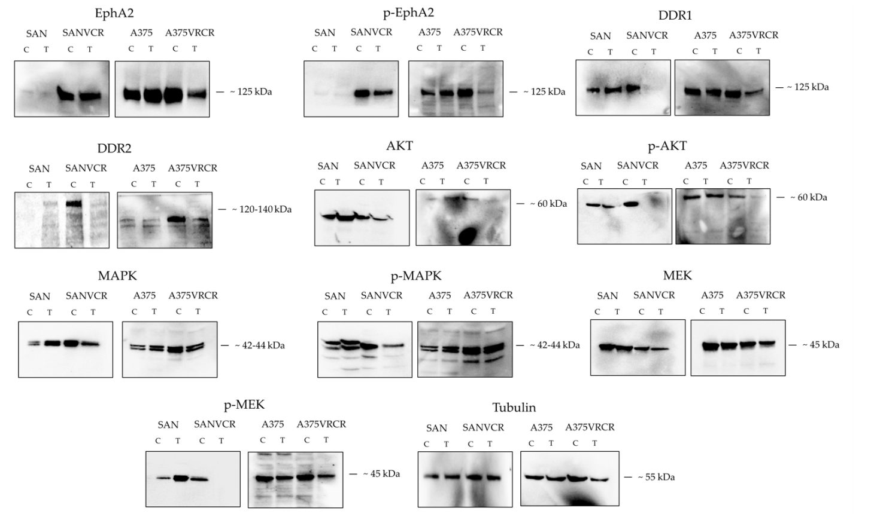
Figure S6. Western blots showing all the bands and molecular weight of sections reported in Figure 3D.

