Supplementary Information

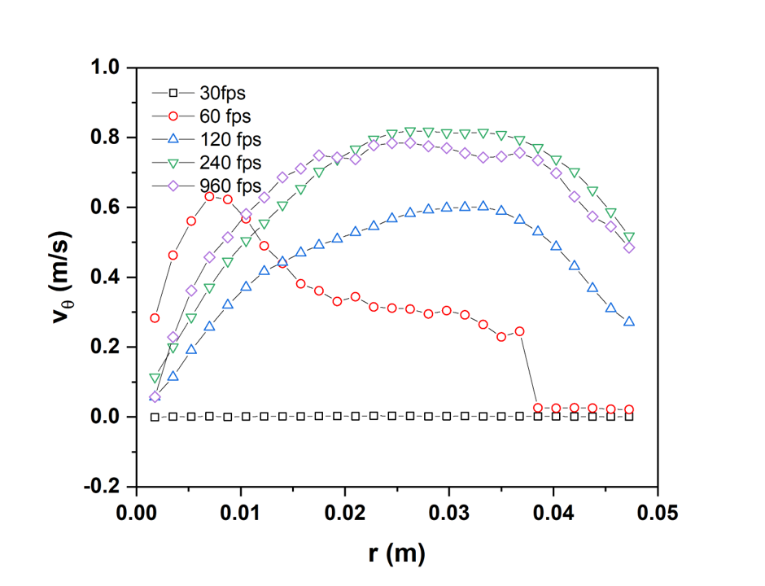
Figure S1: Variation of tangential velocity ($v_{θ})$ as a function of radial distance (r) for various recording speed i.e., 30, 60, 120, 240, and 960 fps for ω = 3.33 s⁻¹

