Additional files: figures

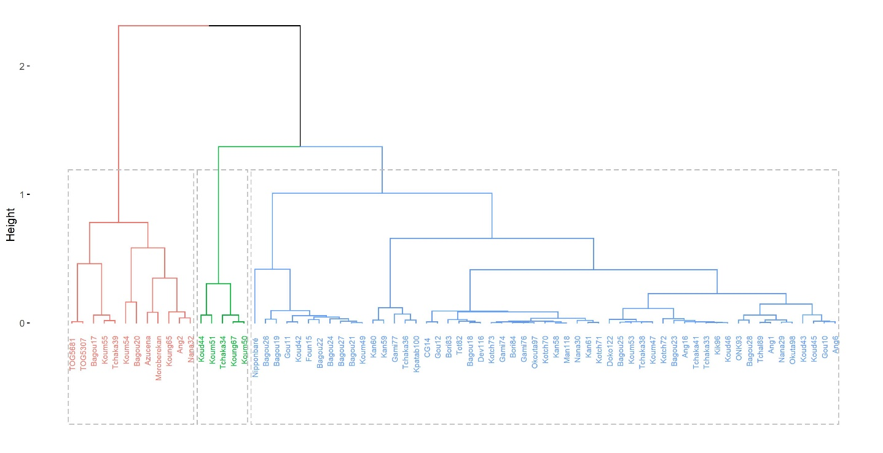
Additional file 4 Figure A1: Hierarchical Classification Ascending (HAC) of the 72 accessions based all quantitative characters 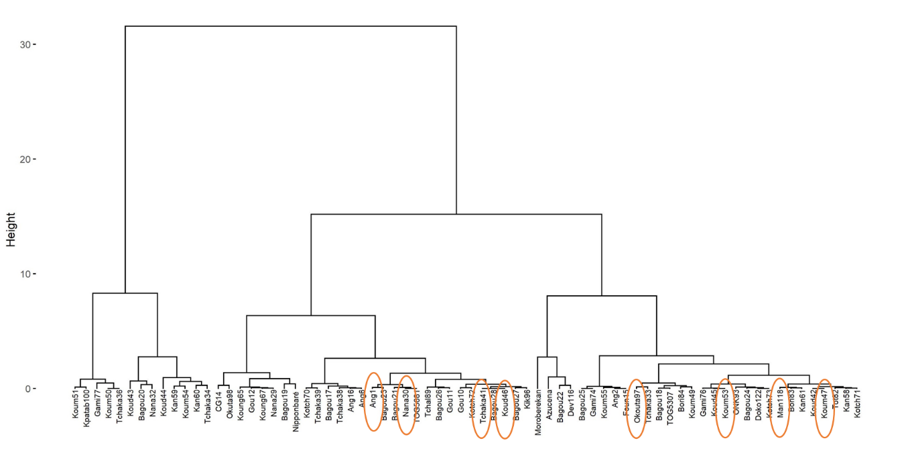 Additional file 5 Figure A2: Hierarchical Classification Ascending (HAC) of the 72 accessions based Number of panicles per plant characters

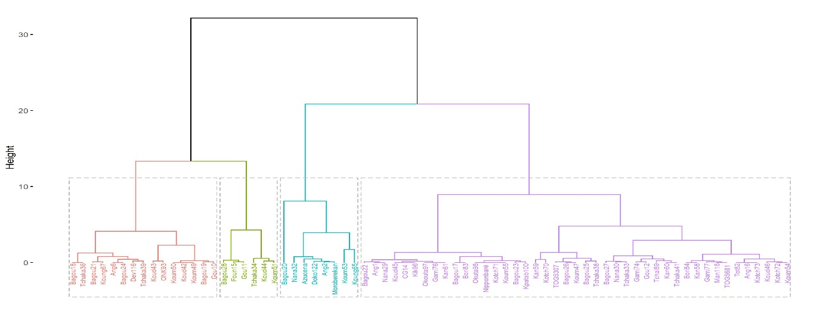

Additional file 6 Figure A3: Hierarchical Classification Ascending (HAC) of the 72 accessions based 1000 grain weight character

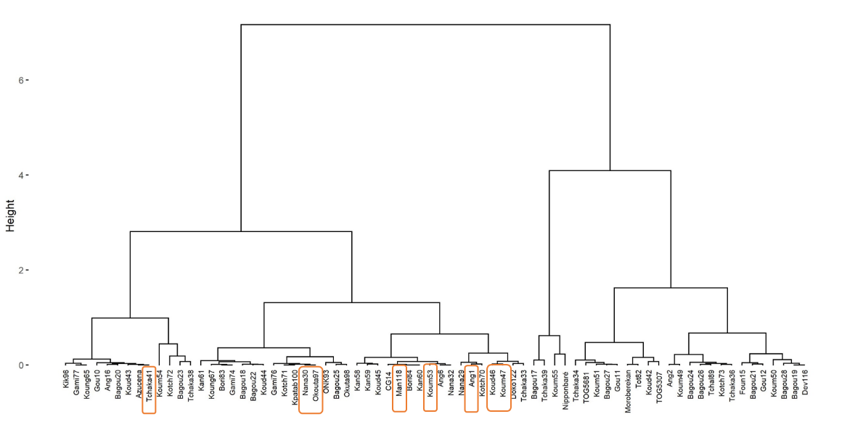
Additional file 7 Figure A4: Hierarchical Classification Ascending (HAC) of the 72 accessions based grain length character

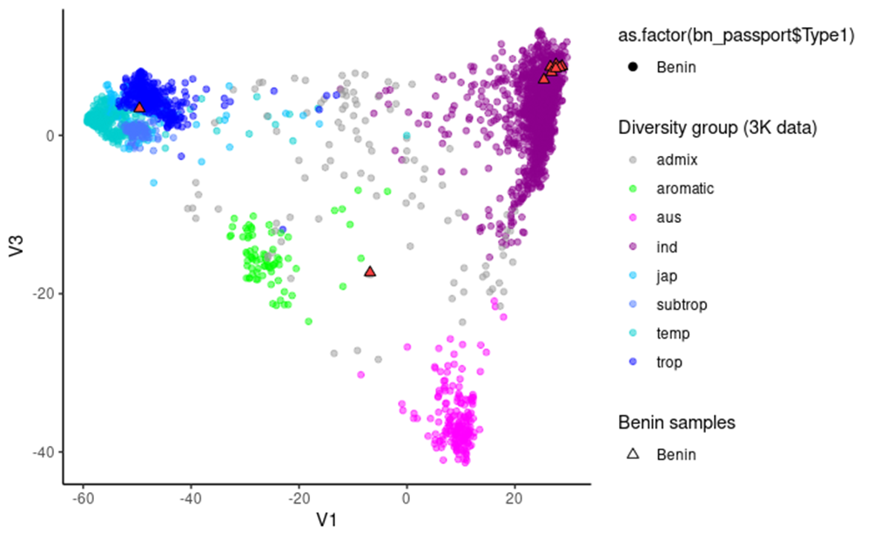

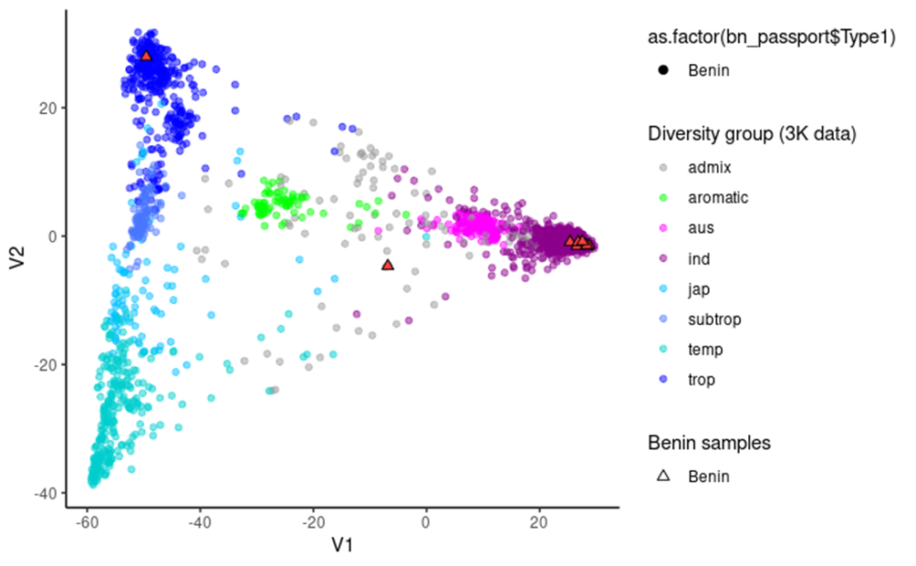Additional file 8 Figure A5: Principal Components Analyses (PCA) based on SNP data for the rice reference data for worldwide diversity (3K genomes) and this study’s 09 samples from Benin and 02 from gene bank of the Institute of Research and Development/IRD-Montpellier/France

