S.Fig.1.Age comparison of patients with high and normal IOP.
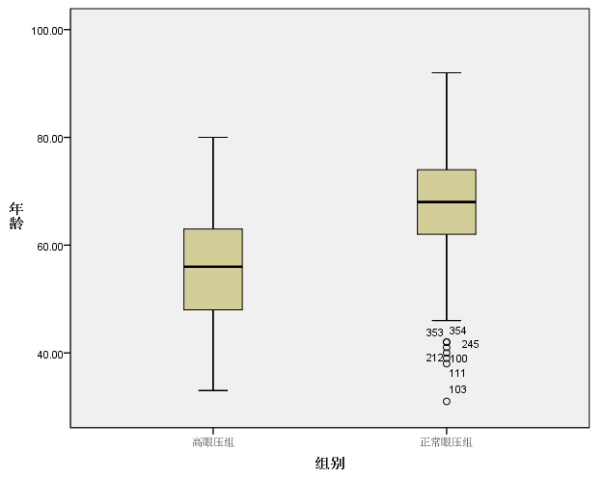
Group

Normal IOP group
High IOP group
Age
S.Fig.2.AXL comparison of patients with high and normal IOP.
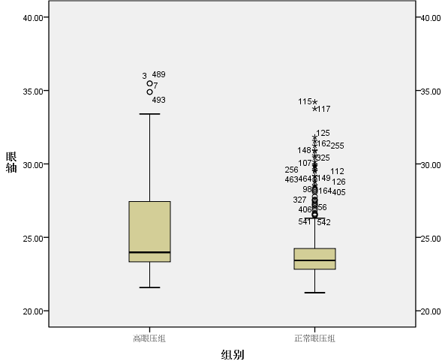
Normal IOP group
Group

High IOP group
AL

S.Fig.3.ACD comparison of patients with high and normal IOP.
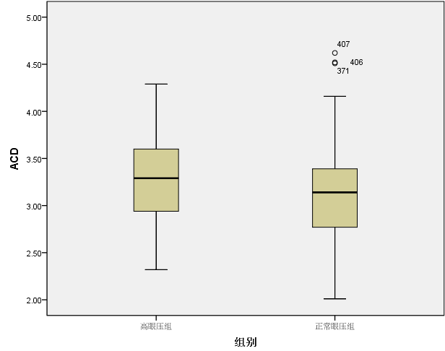
High IOP group
Normal IOP group
Group

S.Fig.4.CDE comparison of patients with high and normal IOP.
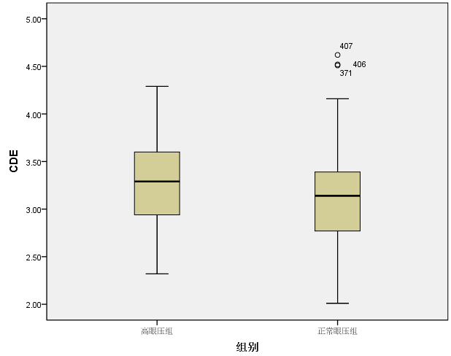
Normal IOP group
High IOP group
Group

