Figure 1

Figure 2

Figure 3

Figure 4

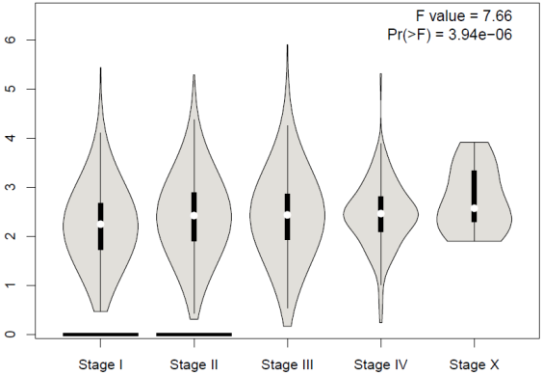
A
B
C
D
E

Figure 5

Figure 6

