Supplementary Material

Three novel marine species of the genus Fulvivirga, rich sources of carbohydrate-active enzymes degrading polysaccharides.

Tra T. H. Nguyen^{1, 2}, Tien Q. Vuong³, Ho Le Han^{1, 4}, Zhun Li¹, Yong-Jae Lee¹, Jaeho Ko¹, Olga I. Nedashkovskaya⁵, Song-Gun Kim^{1, 2, *}

¹Biological Resource Center, Korean Collection for Type Cultures, Korea Research Institute of Bioscience and Biotechnology, Republic of Korea.
²University of Science and Technology (UST), Daejeon 34113, Republic of Korea.
³Hanoi University of Science, Vietnam National University, 334 Nguyen Trai Street, Thanh Xuan, Hanoi, Vietnam.
⁴Scientific Management Department, Dong A University, Danang city, Vietnam.
⁵G.B. Elyakov Pacific Institute of Bioorganic Chemistry of the Far-Eastern Branch of the Russian Academy of Sciences, Prospekt 100 Let Vladivostoku 159, 690022 Vladivostok, Russia.
*Corresponding author: sgkim@kribb.re.kr.

Table S1. 16S rRNA gene sequence similarity among novel strains: 1, SS9-22^{T} (OM403091); 2, W9P-11^{T} (OM403093); 3, SW1-E11^{T} (OM403092), with the closest reference strains: 4, F. sediminis 2943^{T} (MW658189); 5, F. imtechensis JCM 17390^{T} (FR687203); 6, F. aurantia KCTC 82638^{T} (KX896698); 7, F. kasyanovii KCTC 12832^{T} (DQ836305); 8, F. marina 29W222^{T} (MW658171); 9, F. lutimaris KCTC 42720^{T} (KU563147); 10, F. lutea S481^{T} (MT605802).
Strain | 1 | 2 | 3 | 4 | 5 | 6 | 7 | 8 | 9 | 10
SS9-22^{T} | 100 | 94.4 | 95.1 | 94.9 | 96.4 | 94.3 | 98.1 | 97.7 | 96.2 | 95.8
W9P-11^{T} | 94.4 | 94.4 | 97.2 | 97.0 | 94.9 | 94.6 | 94.3 | 94.0 | 93.8 | 93.6
SW1-E11^{T} | 97.2 | 95.1 | 100 | 99.8 | 95.6 | 94.9 | 94.5 | 93.8 | 93.8 | 93.7

Table S2. Comparison of biosynthetic gene clusters (BGCs) among three novel strains with existing members in genus Fulvivirga based on antiSMASH analysis. Taxa: 1, SS9-22^{T}; 2, W9P-11^{T}; 3, SW1-E11^{T}; 4, F. sediminis 2943^{T}; 5, F. imtechensis JCM 17390^{T}; 6, F. aurantia KCTC 82638^{T}; 7, F. kasyanovii KCTC 12832^{T}; 8, F. marina 29W222^{T}; 9, F. lutimaris KCTC 42720^{T}; 10, F. lutea S481^{T}.
Type | 1 | 2 | 3 | 4 | 5 | 6 | 7 | 8 | 9 | 10
Arylpolyene | 1 | 2 | 2 | 1 | 1 | - | 1 | 1 | - | -
HgIE-KS | - | - | 1 | 1 | - | - | - | - | - | -
Lanthipeptide class I | 1 | 1 | 1 | 1 | 2 | - | 1 | 1 | - | -
Lanthipeptide class IV | - | - | - | 1 | - | - | - | - | - | -
NRPS | 3 | 1 | 2 | 5 | 12 | - | 8 | 10 | - | -
NRPS-like | 1 | 2 | 2 | 1 | 2 | 1 | 3 | 2 | - | -
Resorcinol | 1 | 1 | 1 | - | - | - | 1 | 1 | - | -
RiPP-like | - | 1 | - | - | - | - | - | 1 | - | -
Siderophore | 1 | 2 | 1 | 1 | - | - | 1 | 1 | - | -
T1PKS | 4 | 2 | 3 | 5 | 3 | 1 | 2 | 5 | - | -
T3PKS | 1 | 1 | 1 | 1 | 1 | 1 | 1 | 1 | 1 | 1
Terpene | 1 | 1 | 1 | 2 | 1 | 1 | 1 | 1 | 1 | 1
LAP | - | 1 | - | - | - | - | - | - | - | -
PKS-like | 1 | - | - | - | 1 | - | 1 | 1 | - | -
TransAT-PKS | 1 | - | - | - | 1 | - | 4 | 1 | - | -
Phosphonate | - | - | - | - | - | - | - | - | - | 1
Total | 16 | 15 | 15 | 19 | 24 | 4 | 24 | 26 | 2 | 2

Table S3. Distribution of CAZyme in the genome of species in genus Fulvivirga through dbCAN server. GH: Glycoside hydrolase; PUL: polysaccharide utilization loci (through CAZy database).
Strain name | Genome size (Mbp) | dbCAN |  |  |  | CAZy database
Strain name | Genome size (Mbp) | CAZy modules | GHs | GH/Mbp | CGCs | PUL
F. ulvae SS9-22^{T} | 6.98 | 164 | 76 | 10.89 | 58 | 24
F. ligni W9P-11^{T} | 6.52 | 214 | 160 | 24.54 | 66 | 32
F. maritima SW1-E11^{T} | 6.39 | 264 | 111 | 17.37 | 70 | 41
F. sediminis 2943^{T} | 5.69 | 197 | 124 | 21.79 | 69 | -
F. imtechensis JCM 17390^{T} | 6.74 | 135 | 54 | 8.01 | 50 | -
F. aurantia KCTC 82638^{T} | 4.44 | 55 | 16 | 3.60 | 24 | -
F. kasyanovii KCTC 12832^{T} | 7.17 | 171 | 82 | 11.44 | 51 | -
F. marina 29W222^{T} | 6.79 | 171 | 63 | 9.28 | 60 | -
F. lutimaris KCTC 42720^{T} | 4.86 | 113 | 58 | 11.93 | 38 | -
F. lutea S481^{T} | 4.14 | 78 | 25 | 6.04 | 27 | 4

Table S4. CAZyme components encoded in genomes of three novel strains SW1-E11^{T}, W9P-11^{T}, and SS9-22^{T} through dbCAN server, number of appearances in parentheses. AA, Auxiliary Activities; CE, Carbohydrate esterase; CBM, Carbohydrate-Binding Module; GH, Glycoside Hydrolase; GT, GlycosylTransferase; PL, Polysaccharide lyase.
 | SS9-22^{T} | W9P-11^{T} | SW1-E11^{T}
1 | CBM13 | AA2 | AA10
2 | CBM32 | CBM13 (3) | AA2
3 | CBM35 | CBM32 | CBM13 (3)
4 | CBM48 + GH13_9 | CBM35 (2) | CBM6
5 | CBM5 | CBM6 (6) | CBM88
6 | CBM6 | CBM9 | CBM9
7 | CBM9 | CE11 | CE1 (2)
8 | CE11 | CE12 (2) | CE11
9 | CE12 (2) | CE15 | CE12 (2)
10 | CE2 | CE4 (2) | CE4 (2)
11 | CE4 | CE8 (2) | CE8 (2)
12 | CE8 (4) | GH10 (4) | CE8 + CBM6 + PL1_2 + CBM88 + CBM35
13 | GH105 | GH105 | GH10
14 | GH109 | GH11 + CBM60 | GH10 + CBM64
15 | GH13 | GH115 | GH104
16 | GH13_10 + CBM48 (2) | GH125 | GH105
17 | GH13_16 | GH13 (3) | GH125
18 | GH13_26 | GH13_10 + CBM48 | GH127
19 | GH13_3 | GH13_31 | GH128
20 | GH13_31 | GH13_36 | GH13
21 | GH13_36 | GH13_7 | GH13_10
22 | GH13_7 | GH13_8 + CBM48 | GH13_36
23 | GH130 (2) | GH130 (4) | GH13_7
24 | GH133 | GH142 | GH13_8
25 | GH144 (2) | GH143 | GH130 (2)
26 | GH15 | GH144 (2) | GH143
27 | GH16_3 (2) | GH146 (2) | GH144
28 | GH171 | GH147 | GH146 (2)
29 | GH18 (2) | GH15 (2) | GH147
30 | GH18 + CBM6 | GH16 + CBM32 | GH15 (2)
31 | GH18 + CBM73 | GH16 + CBM6 + CBM56 | GH16_3
32 | GH2 (3) | GH16_3 | GH171
33 | GH20 (2) | GH16_3 + CBM6 | GH18 + CBM5
34 | GH23 (3) | GH16_3 + GH128 + CBM6 + CBM32 | GH2 (9)
35 | GH26 (2) | GH171 | GH20
36 | GH27 | GH18 | GH23 (2)
37 | GH28 (2) | GH18 + CBM5 | GH23 + CBM50 (2)
38 | GH29 | GH18 + CBM6 | GH25
39 | GH3 (7) | GH2 (14) | GH26
40 | GH31 (3) | GH2 + CBM32 (2) | GH26 + CBM35
41 | GH37 | GH2 + CBM57 | GH26 + GT2
42 | GH39 | GH20 (2) | GH27
43 | GH43_10 | GH23 | GH28
44 | GH43_9 | GH23 + CBM50 (3) | GH29
45 | GH48 | GH26 (4) | GH29 + CBM32
46 | GH5_26 | GH26 + CBM35 | GH3 (11)
47 | GH5_4 (2) | GH27 | GH30_3
48 | GH5_7 | GH28 | GH30_4
49 | GH51 | GH29 | GH30_8
50 | GH57 (2) | GH29 + CBM32 | GH31 (7)
51 | GH63 | GH3 (10) | GH35
52 | GH64 + CBM6 | GH3 + CBM32 | GH37
53 | GH65 | GH30_1 | GH39
54 | GH77 | GH30_3 (2) | GH43_10
55 | GH8 + CBM32 | GH31 (4) | GH43_24
56 | GH81 + CBM6 | GH32 (2) | GH43_28 (2)
57 | GH9 + CBM64 +CBM3 | GH35 | GH43_29
58 | GH92 (5) | GH37 | GH43_34
59 | GH95 (2) | GH38 | GH43_34 + CBM32
60 | GH97 (2) | GH43 | GH43_37 + CBM61
61 | GT1 (2) | GH43_10 (2) | GH43_5
62 | GT19 | GH43_11 | GH43_5 + CBM13
63 | GT2 (24) | GH43_12 | GH43_9
64 | GT20 | GH43_26 (2) | GH44 + CBM3
65 | GT28 | GH43_28 + CBM32 (2) | GH48
66 | GT30 | GH43_29 | GH5 + CBM6 + CBM13
67 | GT4 (11) | GH43_32 + CBM6 | GH5_1
68 | GT5 | GH43_34 (3) | GH5_2 + CBM6
69 | GT51 (3) | GH43_4 | GH5_26
70 | GT83 (2) | GH43_5 | GH5_4 (3)
71 | GT9 (2) | GH43_5 + CBM13 | GH5_46
72 | PL1 (3) | GH43_8 | GH5_7
73 | PL1_2 (2) | GH48 | GH51 (3)
74 | PL6_1 | GH5 + CBM6 + CBM13 | GH53
75 | PL7_5 (2) | GH5_1 | GH64 + CBM6
76 |  | GH5_13 | GH67
77 |  | GH5_2 + CBM6 | GH73
78 |  | GH5_26 | GH74
79 |  | GH5_4 (2) | GH84
80 |  | GH5_46 + CBM6 | GH88
81 |  | GH5_7 (2) | GH9
82 |  | GH51 (3) | GH9 + CBM64
83 |  | GH53 | GH92 (4)
84 |  | GH62 | GH95
85 |  | GH64 + CBM6 | GH97 (3)
86 |  | GH65 | GT1 (3)
87 |  | GH67 | GT19
88 |  | GH76 (4) | GT2 (22)
89 |  | GH78 | GT20
90 |  | GH81 + CBM32 + CBM38 | GT28
91 |  | GH81 + CBM6 | GT3
92 |  | GH87 | GT30
93 |  | GH87 + CBM9 | GT4 (13)
94 |  | GH88 (2) | GT5
95 |  | GH9 + CBM64 +CBM3 | GT51 (3)
96 |  | GH92 (10) | GT9
97 |  | GH95 (2) | PL1_2 (2)
98 |  | GH97 (5) | PL11_1
99 |  | GT1 | PL11_1 + CBM35
100 |  | GT19 (2) | PL42
101 |  | GT2 (18) | PL9 (2)
102 |  | GT20 | PL9_1
103 |  | GT28 | PL9_1 + CBM35 (2)
104 |  | GT3
105 |  | GT4 (14)
106 |  | GT5
107 |  | GT51 (3)
108 |  | GT83 (2)
109 |  | GT9
110 |  | PL1_2
111 |  | PL29
112 |  | PL42
113 |  | PL9
114 |  | PL9_1

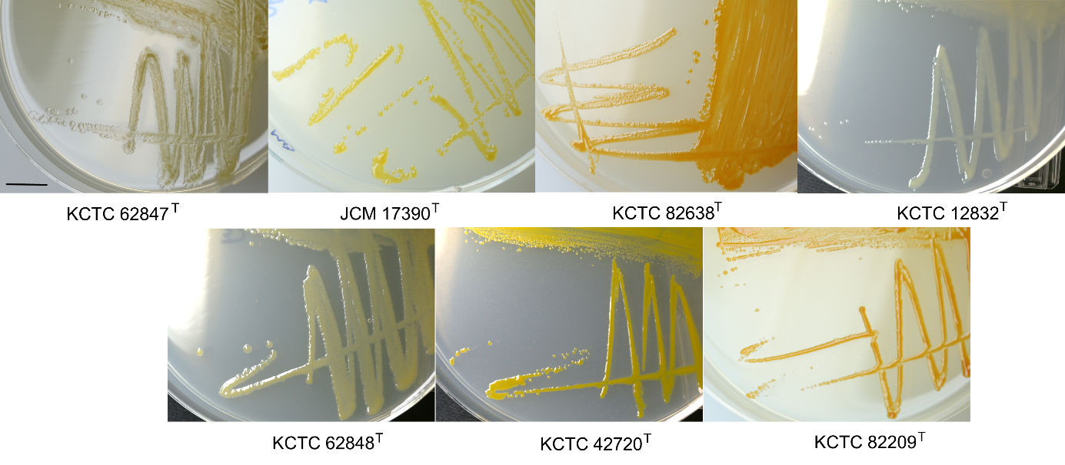
Figure S1. Colony morphology of existing members of genus Fulvivirga.
Taxa: F. sediminis 2943^{T} (KCTC 62847^{T}); F. imtechensis JCM 17390^{T}; F. aurantia KCTC 82638^{T}; F. kasyanovii KCTC 12832^{T}; F. marina 29W222^{T} (KCTC 62848^{T}); F. lutimaris KCTC 42720^{T}; F. lutea S481^{T} (KCTC 82209^{T}). 4-day old plate. Scale bar: 1 cm.

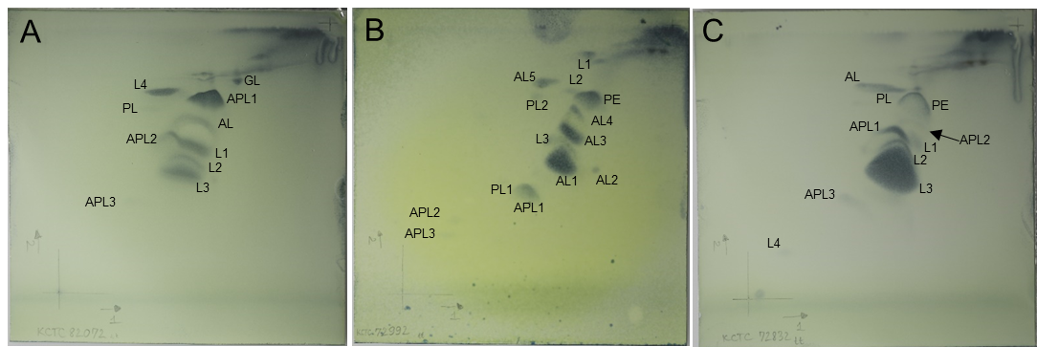
Figure S2. Polar lipid profiles of SS9-22^{T} (A), W9P-11^{T} (B), SW1-E11^{T} (C). AL: unidentified aminolipid, APL: unidentified aminophospholipid, PE: phosphatidylethanolamine, PL: unidentified phospholipid, GL: unidentified glycolipid, L: unidentified lipid.

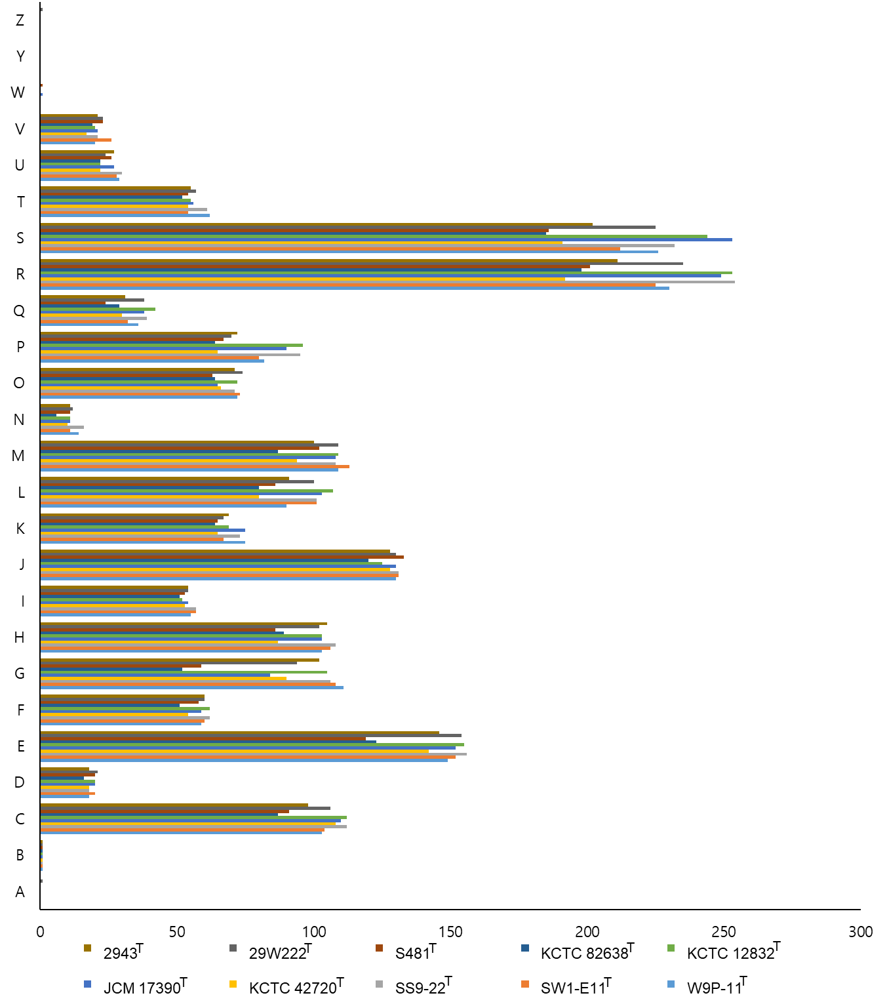
Figure S3. Comparison of clusters of orthologous groups (COGs) of SS9-22^{T}, W9P-11^{T}, and SW1-E11^{T} with the existing species in the genus Fulvivirga: F. sediminis 2943^{T}; F. imtechensis JCM 17390^{T}; F. aurantia KCTC 82638^{T}; F. kasyanovii KCTC 12832^{T}; F. marina 29W222^{T}; F. lutimaris KCTC 42720^{T}; F. lutea S481^{T}. A: RNA processing and modification; B: Chromatin structure and dynamics; C: Energy production and conversion; D: Cell cycle control, cell division, chromosome partitioning; E: Amino acid transport and metabolism; F: Nucleotide transport and metabolism; G: Carbohydrate transport and metabolism; H: Co-enzyme transport and metabolism; I: Lipid transport and metabolism; J: Translation, ribosomal structure and biogenesis; K: Transcription; L: Replication, recombination and repair; M: Cell wall/membrane/envelope biogenesis; N: Cell motility; O: Posttranslational modification, protein turnover, chaperones; P: Inorganic ion transport and metabolism; Q: Secondary metabolite biosynthesis, transport and catabolism; R: General function prediction only; S: Function unknown; T: Signal transduction mechanisms; U: Intracellular trafficking, secretion, and vesicular transport; V: Defense mechanisms; W: Extracellular structures; Y: Nuclear structure; Z: Cytoskeleton.

