Supplementary figure 1: Morphogenesis of the venom apparatus in C. magus.

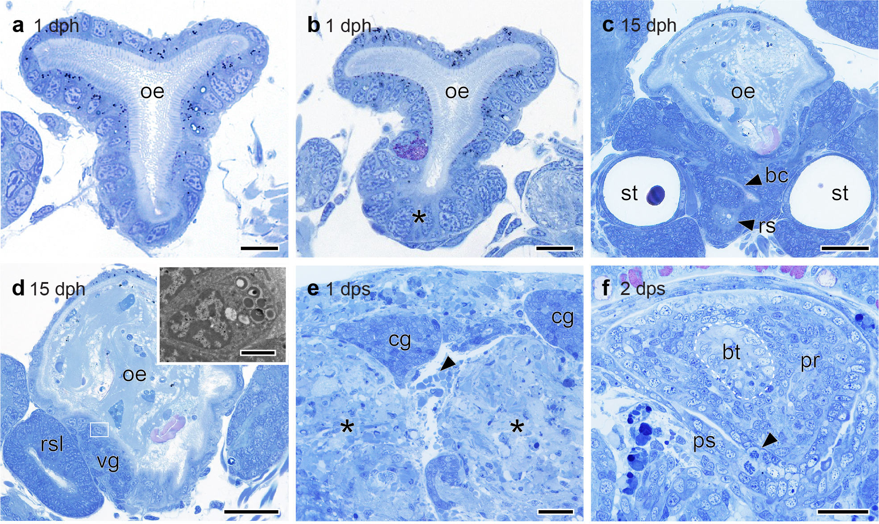

Elements of the venom apparatus were initiated from the larval foregut. (a,b) In hatching larva, the oesophagus (oe) consisted of a simple tube of ciliated epithelium connecting the mouth to the stomach (a). ~ 50 μm in from the mouth, cross-sections revealed a patch of enlarged non-ciliated cells (asterisk) embedded in the ventral wall of the oesophagus (b) that differentiated into the buccal cavity and radular sac. Scale bar = 10 μm. (c,d) In late-larva, the radular sac (rs) had formed as an out-pocketing of the buccal cavity and both structures could be seen as interconnected chambers beneath the oesophagus, at the level of the statocysts (st). The short-arm of the radular sac (rss), visible at the level of the buccal commissure (co), remained incompletely differentiated in late-larva, while buccal ganglia (bg) had started to develop on each side of the oesophagus (c). Immediately posterior to the buccal commissure, the prospective venom gland (vg) was evident as an accumulation of secretory cells embedded in the ventral wall of the oesophagus, adjacent to the long-arm of the radular sac (rsl) (d). The cytoplasm of the vg cells was filled with spherical secretory granules (~ 700 nm in diameter) (inset, transmission electron microscopy). Scale bars: (c,d) = 30 μm, inset = 2 μm. (e) At one dps, the two masses of involuted velar cells arising from the resorption of the velum (asterisks) could be seen on each side of the head, beneath the cerebral ganglia (cg). Black arrowhead indicates the position of the future buccal tube. Scale bar = 30 μm. (f) At two dps, the proboscis (pr) and its sheath (ps) were differentiating around the buccal tube (bt). Black arrowhead indicates mitotic profile of dividing cell. Scale bar = 30 μm.

Supplementary figure 2: Anatomy of the juvenile radular tooth and venom gland.

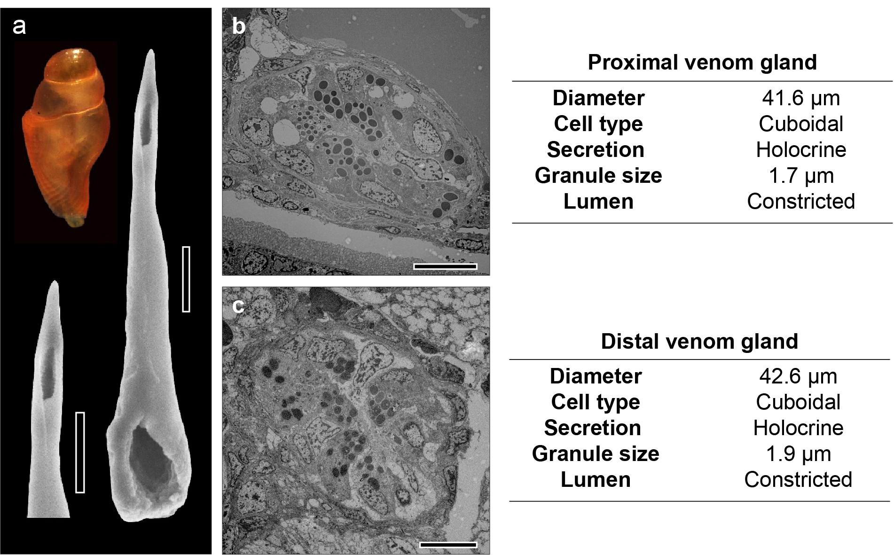

Vermivory in juvenile C. magus was facilitated by short, unbarbed radular teeth and a non-compartmentalised venom gland. (a) Scanning electron micrograph of the juvenile radular tooth. The juvenile radular tooth (6 dps) was short in absolute and relative length, with a wide base and a large opening. It lacked apical barbs and blades. Shell length = 1.6 mm. Scale bars = 10 μm. (b,c) Transmission electron microscopy revealed that, while the adult VG was heterogenous between proximal and distal regions, the juvenile VG showed similar ultrastructure and secretory products along its length. (b) Proximal venom gland. Epithelial cells lining this part of the VG were filled with secretory granules, and the lumen was highly constricted. Scale bar = 10 μm. (d) Distal venom gland. Similarly to the proximal VG, epithelial cells were filled with secretory granules and the central lumen was highly constricted. Scale bars = 10 μm. The dissociation of the secretory cells from the basal lamina and rupture of their membrane in proximal and distal VG indicate that granules are released through a holocrine process.

Supplementary figure 3: Radular tooth morphometry in Conidae.

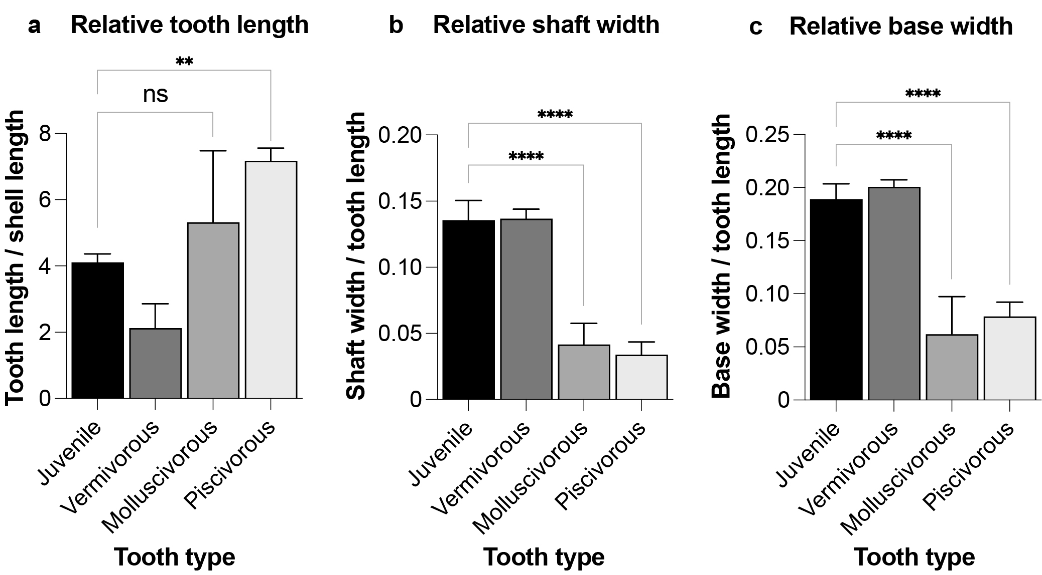

Morphometric analysis of conidean radular teeth reveals ancestral-type tooth of juvenile C. magus. (a) The relative length of the tooth (TL) can be expressed as the percentage of the shell length (SL) with the ratio TL/SLx100. A short tooth is the ancestral state and is found in primitive Conoidae, vermivorous and juveniles Conidae. A longer tooth is a derived condition and is characteristic of piscivorous and molluscivorous species. (b–c) The stoutness of the tooth can be measured by the relative width of the shaft and base. A thicker tooth with a wide base is the ancestral type. The tooth of recently evolved piscivorous and molluscivorous is thin and the base poorly defined. (b) The relative width of the shaft is measured by the ratio SW:TL, where SW is the maximum shaft width. (c) The relative width of the base is measured by the ratio BW:TL, where BW is the maximum base width. N = 5 for juvenile tooth. Vermivorous type: C. naranjus, C. flavusalbus, C. ventricosus, C. miliaris, C. borgesi, C. abbreviatus. Molluscivorous type: C. amadis, C. episcopatus, C. pennaceus, C. ammiralis, C. marmoreus, C. textile. Piscivorous type: C. timorensis, C. achatinus, C. ermineus, C. striatus, C. leebmani, C. catus. Data for vermivorous, molluscivorous and piscivorous species are from Rolán and Raybaudi Massilia, 2002. Data are presented as means ± SEM; *P < 0.05.

Supplementary figure 4: Anatomy of the adult radular tooth and venom gland.

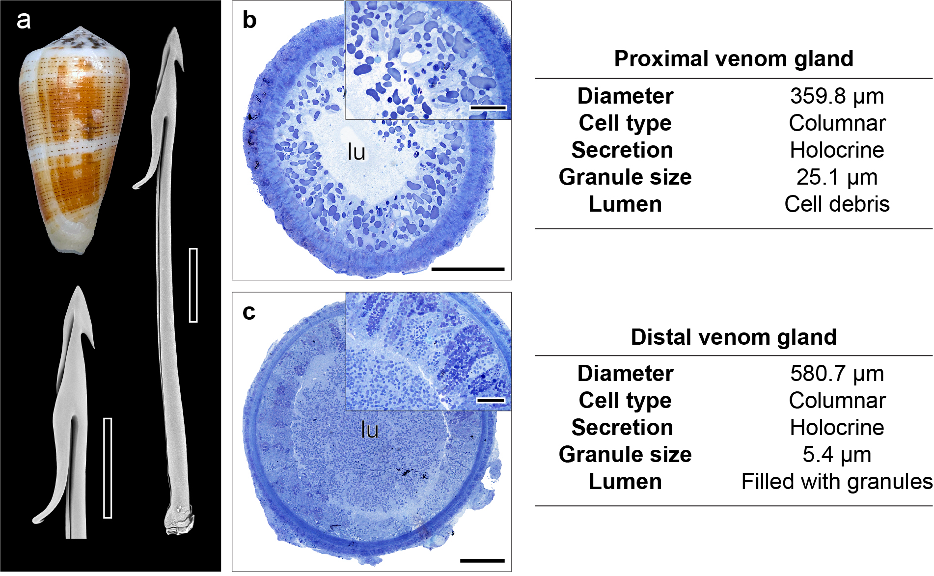

Piscivory in adult C. magus was facilitated by long, hooked radular teeth and a compartmentalised venom gland. (a) Scanning electron micrograph of the adult radular tooth. The adult radular tooth was long and narrow, and the base poorly defined. It had a barb and blade at the apex and the long, hooked accessory process used to tether fish prey. Shell length = 53 mm. Scale bars = 500 μm. (b,c) Histology combined with light microscopy revealed that the proximal and distal regions of the adult VG differed in their ultrastructure and secretory products. (b) Proximal venom gland. Cellular debris and a few granules were found in the lumen of the proximal VG. The secretory cells in this region of the VG were filled with large granules, secreted in the lumen through holocrine process. Scale bars: (b) = 100, inset = 30 μm. (c) Distal venom gland. The lumen of the distal VG was filled with small granules. Granules at different stages of maturity were found in the secretory cells lining this part of the venom gland. Scale bars: (c) = 100, inset = 30 μm.

Supplementary figure 5: Sequence alignments of juvenile dominant transcripts.

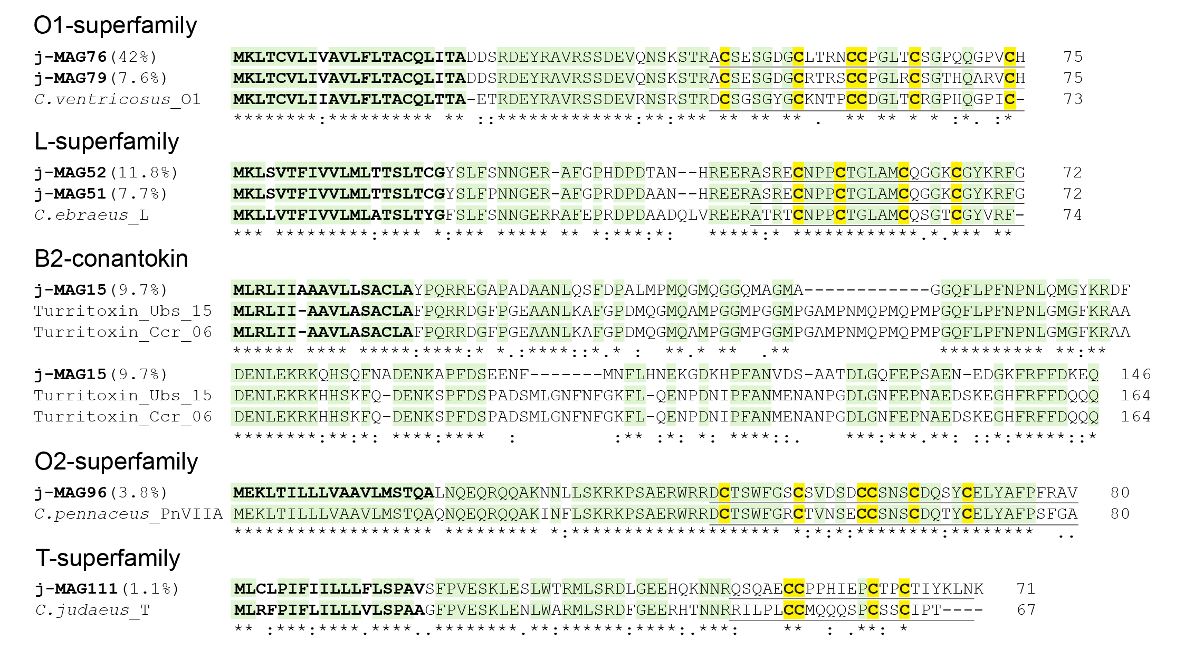

The new O1-superfamily juvenile transcripts j-MAG76 and j-MAG79 contributed 42.0% and 7.6% of total expression. A blastp search revealed these were most closely related to vermivorous conotoxins from C. ventricosus, C. distans or C. flavidus. The new L-superfamily juvenile transcripts j-MAG51 and j-MAG52 also contributed significantly to overall expression (11.8% and 7.7%, respectively) and again shared high sequence similarity with precursors from a vermivorous species (C. ebraeus). The new B2-conantokin-superfamily juvenile transcript j-MAG15, the third most highly expressed transcript (9.7%), was closely related to peptides isolated from the venom glands of Turridae species Unedogemmula bisaya and Crassispira cerithina²⁴. The conserved signal sequence and pro-peptide domain showed high levels of similarity, indicative of a common ancestry. The new juvenile O2-superfamily transcript j-MAG96 (3.8%) shared homology with γ-conotoxins from mollusc-hunters, while the new T-superfamily transcript j-MAG111) shared similarity with a precursor from the vermivorous C. judaeus. Ncbi accession numbers: C. ventricosus_O1, Q9BP94.1; C. ebraeus_L, UMA82769.1; C. pennaceus_PnVIIA, AAG60457; C. judaeus_T, DAZ86876.1. Conotoxin gene superfamilies are indicated. Juvenile sequence names are in bold type and relative transcriptomic expression indicated in brackets. Signal sequence are in bold type, cysteine residues in the mature sequence in highlighted in yellow and mature peptide regions underlined.

Supplementary figure 6: Somatostatin-like conotoxins from C. magus.

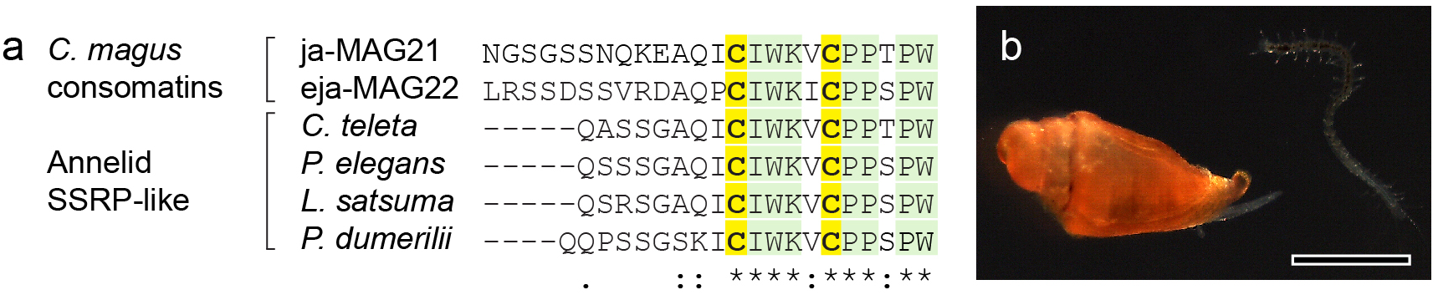

Somatostatin-like conotoxins (consomatins) from C. magus share strong homology with annelid somatostatin-related peptides-like (SSRP-like). (a) Multiple sequence alignment of somatostatin-like conotoxins (consomatins) from C. magus with signalling SSRP-like peptides from diverse annelid species. Both C. magus consomatins were shared between juvenile and adult VG, although upregulated in the juvenile. Sequences annelids are from Koch et al, 2022. (b) The upregulation of consomatins showing homology with annelid SSRP-like peptides in the juveniles was consistent with their vermivorous diet. Juvenile C. magus (14 dps) preying on a syllid worm. Scale bar = 1 mm.

Supplementary figure 7: MALDI-TOF MS supports the heterogenous distribution of conotoxins along the adult C. magus VG.

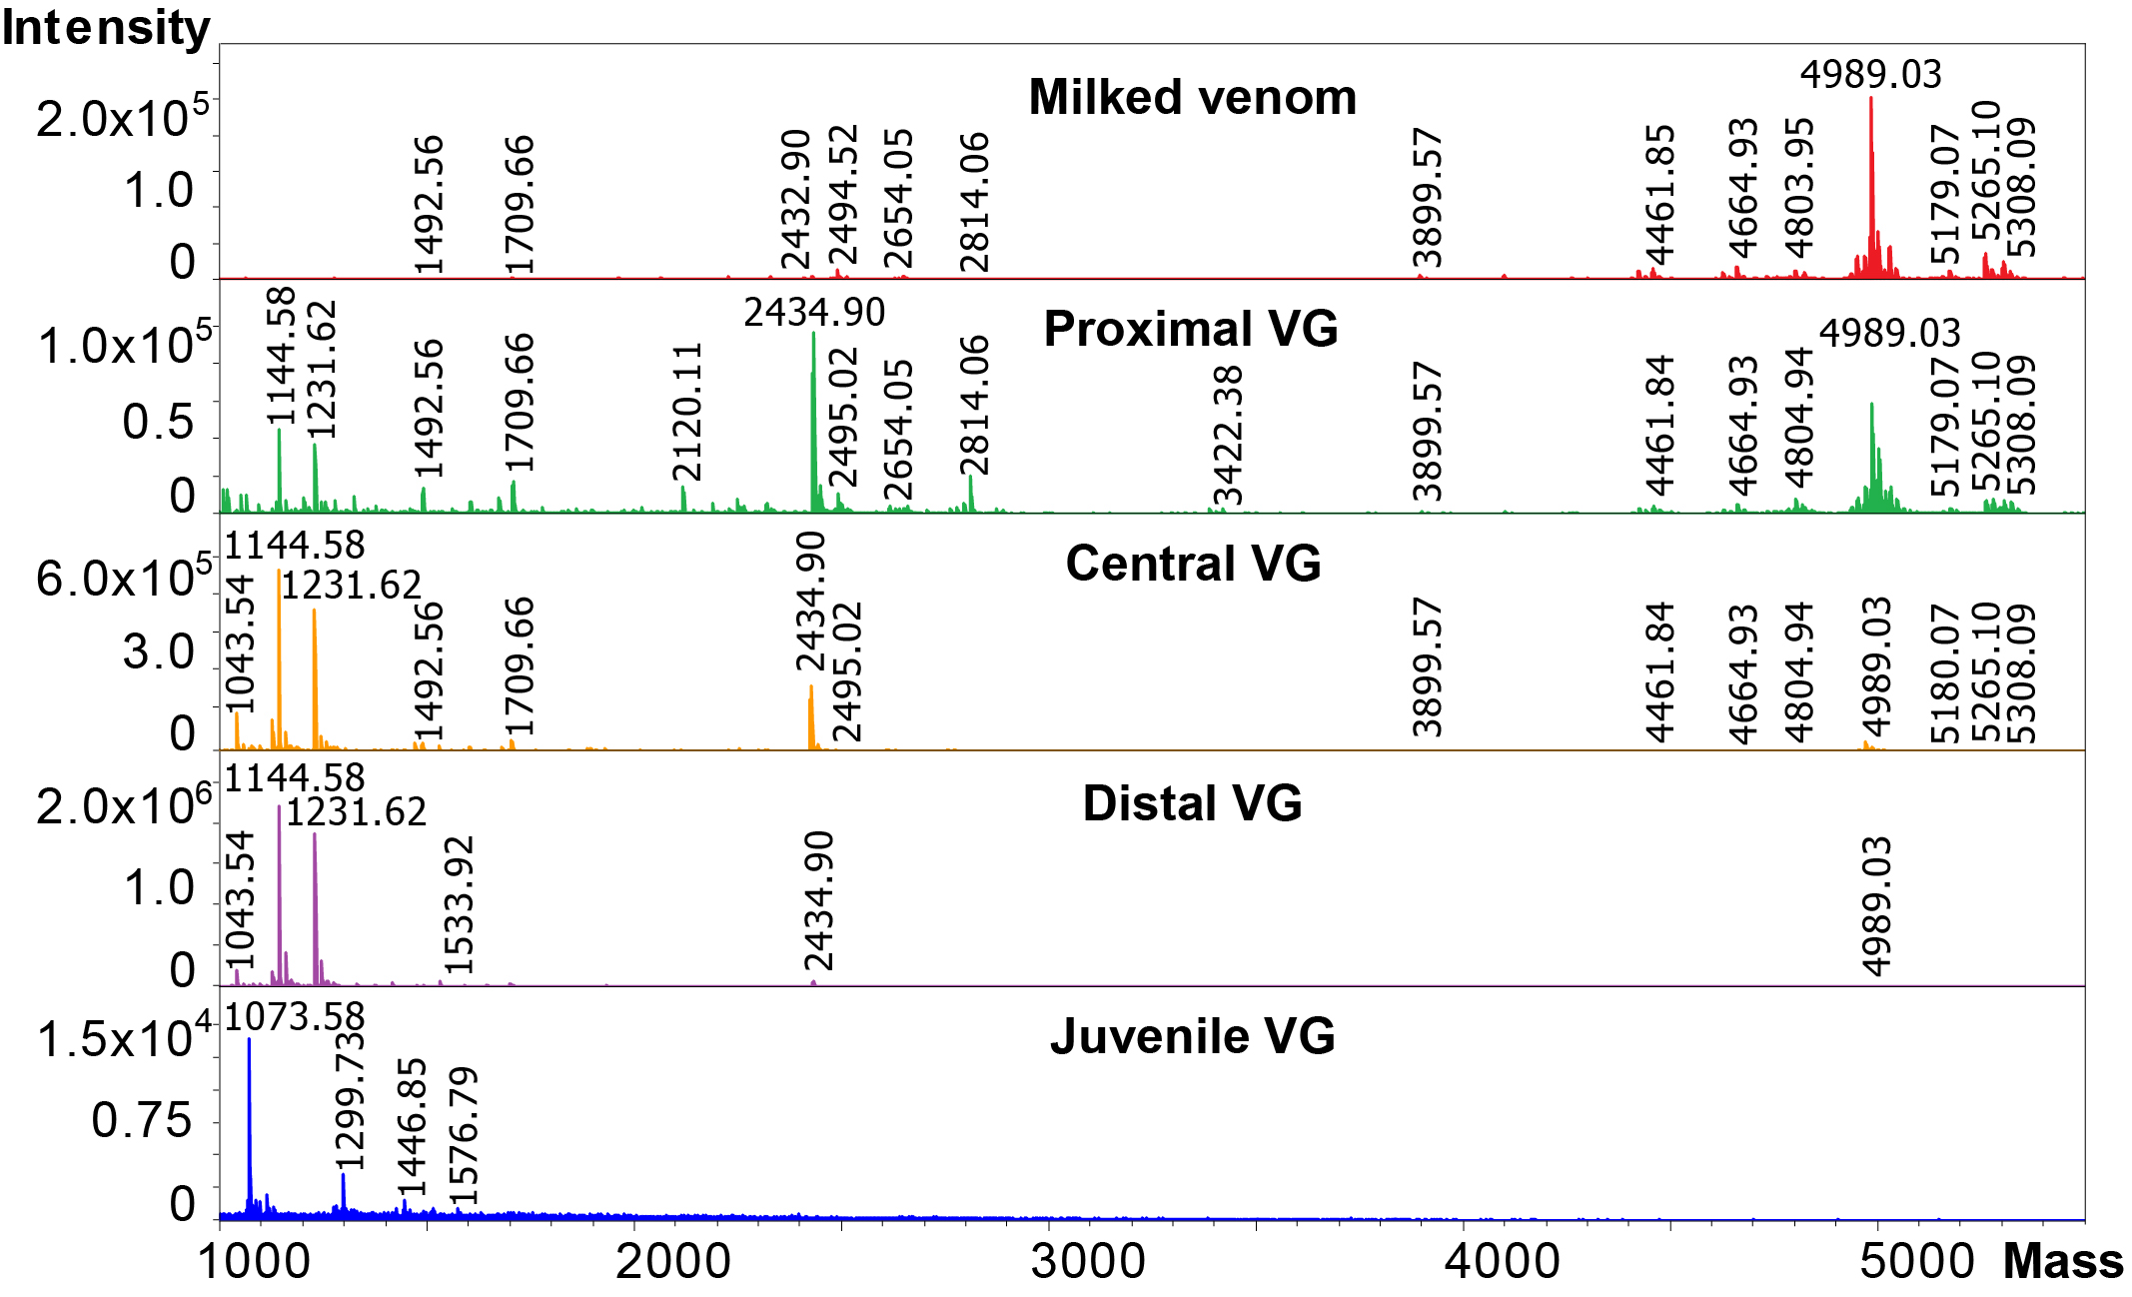

High-resolution matrix-assisted laser desorption ionization (MALDI) mass spectrometry supports the heterogenous distribution of conotoxins along the adult C. magus VG. The milked predatory venom was mostly composed of peptides in the 4.5–5.5 kDa range, which is typical of κA-conotoxins. Tissue-based proteomics revealed that the predatory peptides primarily originated from the proximal VG. Smaller molecular weight peptides expressed in this part of the VG were missing in the milked predatory venom. In contrast, predatory peptides were lowly expressed or missing from the distal VG. On the other hand, the juvenile VG was dominated by smaller masses in the 1–2 kDa range.

Supplementary figure 8: Evidence of glycosylated peptides in the milked predatory venom of adult C. magus.

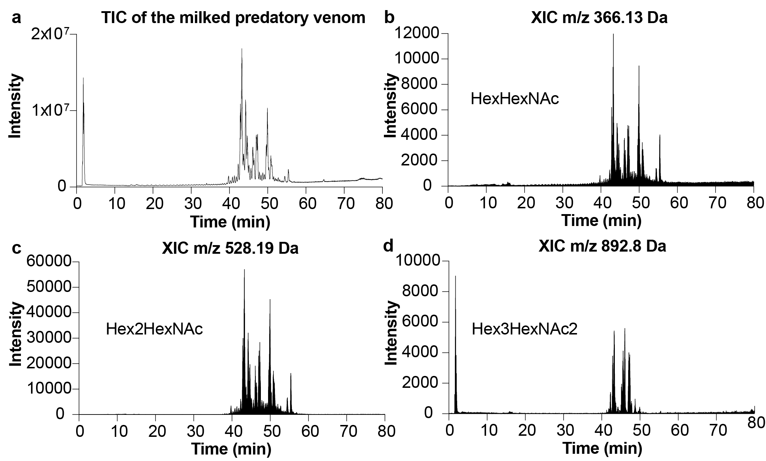

Evidence of the presence of carbohydrate marker ions in the total ion current (TIC) of the adult C. magus milked predatory venom. (a) TIC of the milked predatory venom of adult C. magus, obtained from 10 individual injections. (b–d) Extracted ion chromatograms (XIC) corresponding to the masses of carbohydrate markers (b) HexHexNAc (m/z 366.13 Da), (c) Hex2HexNAc (m/z 528.19 Da) and (d) Hex3HexNAc (m/z 892.8 Da).

