Supplementary Information

Efficient Synthesis of Chlorin e6 and its Potential Photodynamic Immunotherapy in Mouse Melanoma by the Abscopal Effect
Shyam Kumar Mallik, Rajeev Shrestha, Junmo Lim, Pallavi Gurung, Til Bahadur Thapa Magar, and Yong-Wan Kim^{a,}*
Dongsung Cancer Center, Dongsung Biopharmaceutical, Daegu, Korea
*Correspondence: kyw17@ds-pharm.co.kr

Table of Contents
S1. HPLC analysis of chlorophyll a by method 1
S2. HPLC analysis of pheophytin a by method 1
S3. ¹H₁ NMR spectra of Ce6 by method 1
S4. HPLC analysis of chlorophyll a by method 2
S5. HPLC analysis of pheophytin a by method 2
S6. ¹H₁ NMR spectra of Ce6 by method 2

S1. HPLC analysis of chlorophyll a by method 1
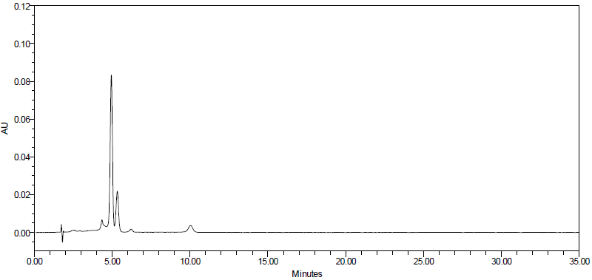
Crude chlorophyll a

S2. HPLC analysis of pheophytin a by method 1
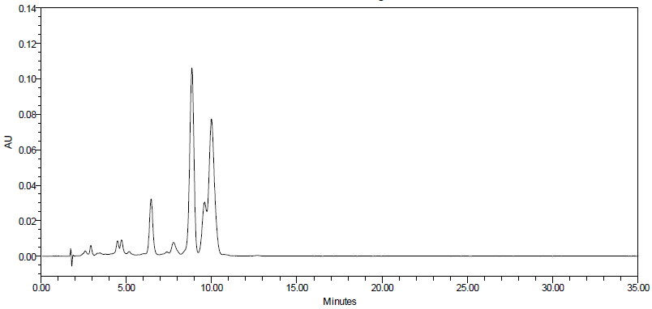
Crude pheophytin a

S3. ¹H₁ NMR spectra of Ce6 by method 1

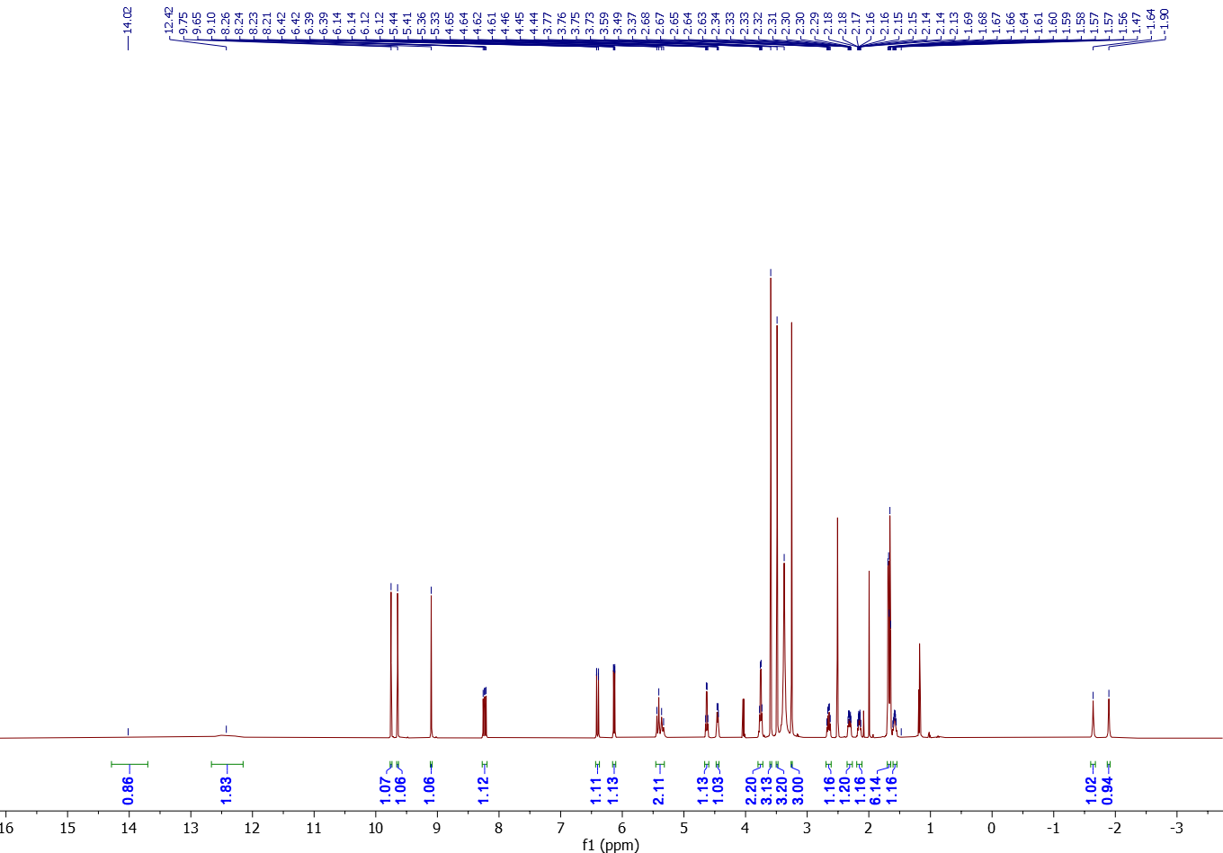
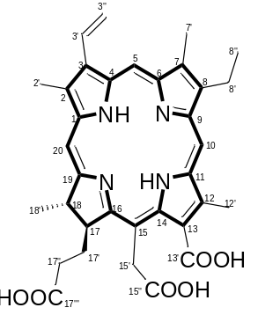

S4. HPLC analysis of chlorophyll a by method 2
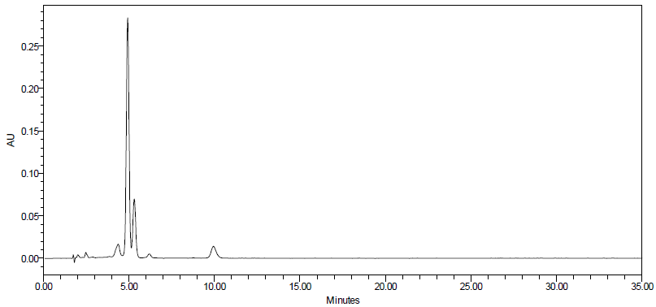
Chlorophyll a

S5. HPLC analysis of pheophytin a by method 2
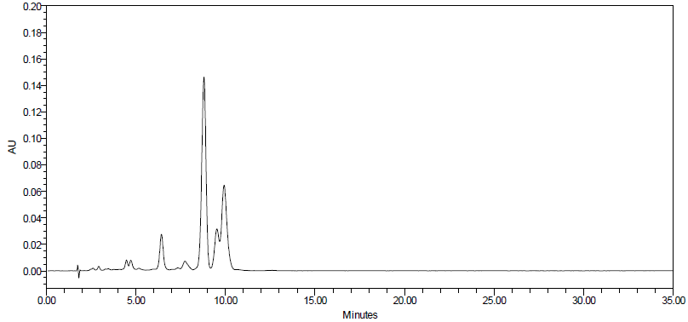
Pheophytin a

S6. ¹H₁ NMR spectra of Ce6 by method 2
