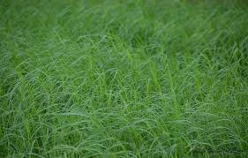

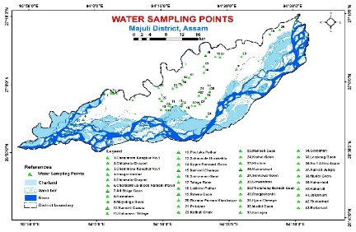
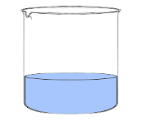
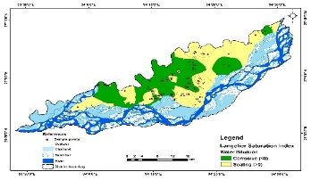
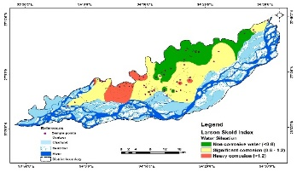
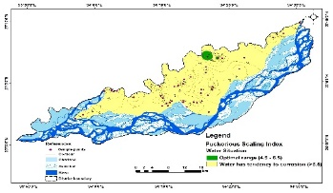
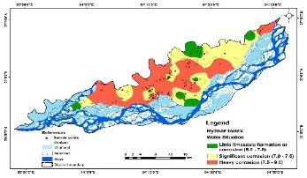
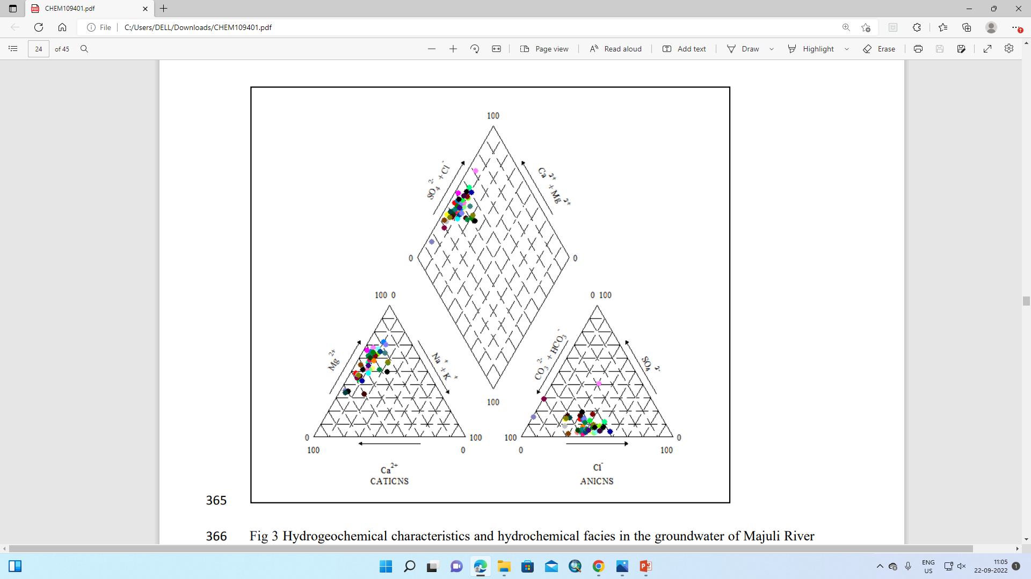
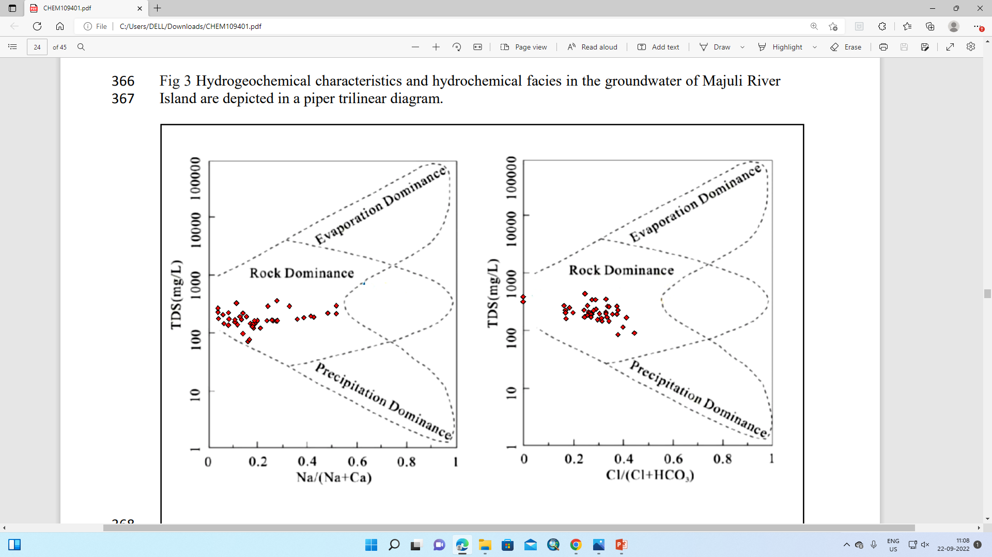
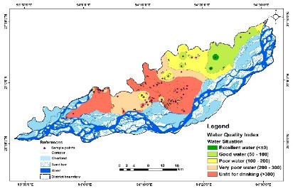
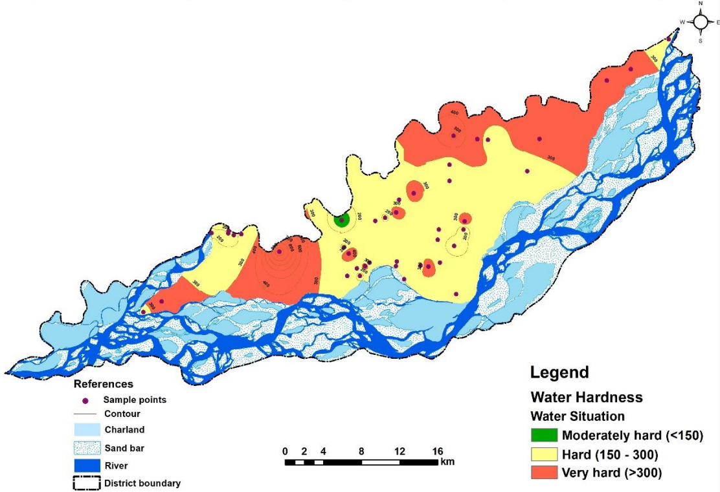
LSI
PSI
LAI
RSI
(Spatial distribution map for corrosion indices of the groundwater)
WQI
TH
(Spatial distribution map for total hardness and water quality index)

Hydrochemical facies and Gibbs diagram
- 27.0 and 79.06, 88.37 and 74.41% of groundwater samples had higher nitrate, total hardness, iron and manganese content respectively, than the acceptable limits of the Bureau of Indian Standards (BIS) for drinking water.
- The water quality index revealed that 72% samples were not at all suitable for human drinking purpose.
- The Ryznar index value of 70% collected groundwater samples was found to be more than 7.0 depicting significant corrosion towards the groundwater. Similarly, 90.69% samples had PSI value >6.5, representing tendency for corrosion.
- The CSMR value of 95.34% samples were >0.5 in the study area.
Study area
Contaminated groundwater
Collection of groundwater for laboratory analysis
Recommendations…………
- WQI and CI indices revealed that that majority of groundwater samples of the Majuli River Island were corrosive in nature and not suitable for drinking purpose, respectively.
- The insight reported in the study of corrosive indices, scaling and water quality should be addressed by policy makers which is significant for inhabitants and industrial purposes

15 groundwater parameters were analysed as pH, EC, TDS, HCO₃⁻, Na⁺, K⁺, Ca²⁺, Mg²⁺, SO₄²⁻, Cl⁻, NO₃⁻, Zn²⁺, Cu²⁺ Mn², and Fe²⁺

