Figure S1. Correlation Coefficient of RNA-Seq Data. SC: single cell RNA-seq data; SC_RootWT1, SC_RootWT2 and SC_Rootshr (Denyer et al., 2019); SC_Root (Zhang et al., 2019); SC_Cotyledon (Liu et al., 2020); RU and RP: bulk RNA-seq data for root (Denyer et al., 2019); D2L and Dark: bulk RNA-Seq data for hypocotyl and cotyledon during de-etiolation (Burko et al., 202). Color: correlation coefficient with whole genome expression levels.
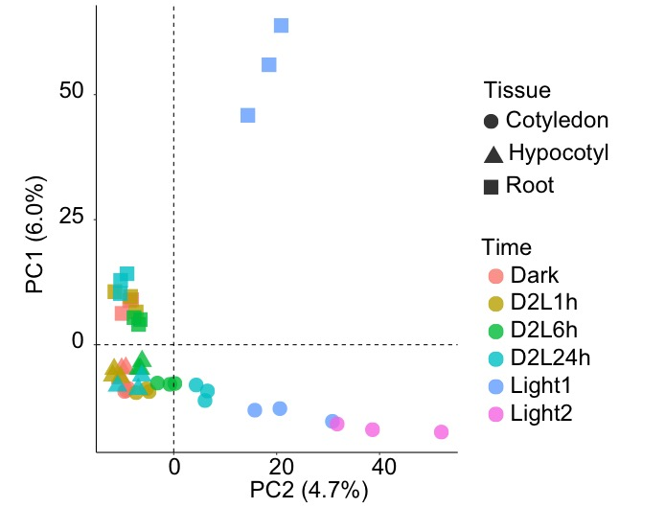
Figure S2. The Principal Component Analysis of Bulk RNA-Seq for Three Organs during De-Etiolation. Shape: different organs; Color: different sampling time points.

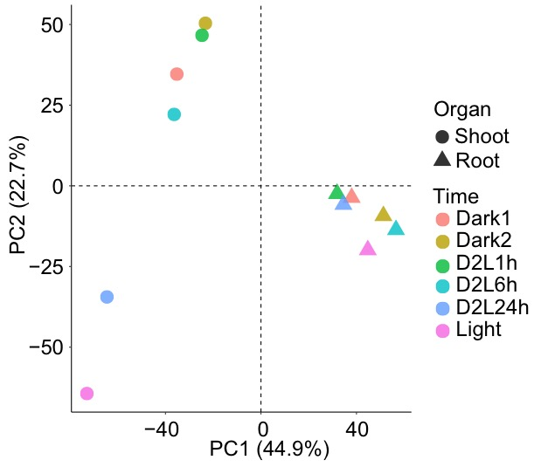
Figure S3. The Principal Component Analysis of Single Cell RNA-Seq during De-Etiolation. Shape: different parts; Color: different sampling time points.

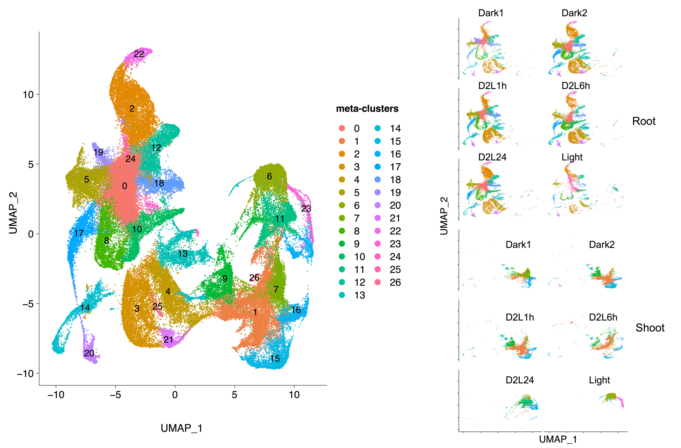
Figure S4. Visualization of Seedling Cells Using UMAP. Dot indicated individual cells while color represented respective cell types. Cells have been split by different samples in the right part.

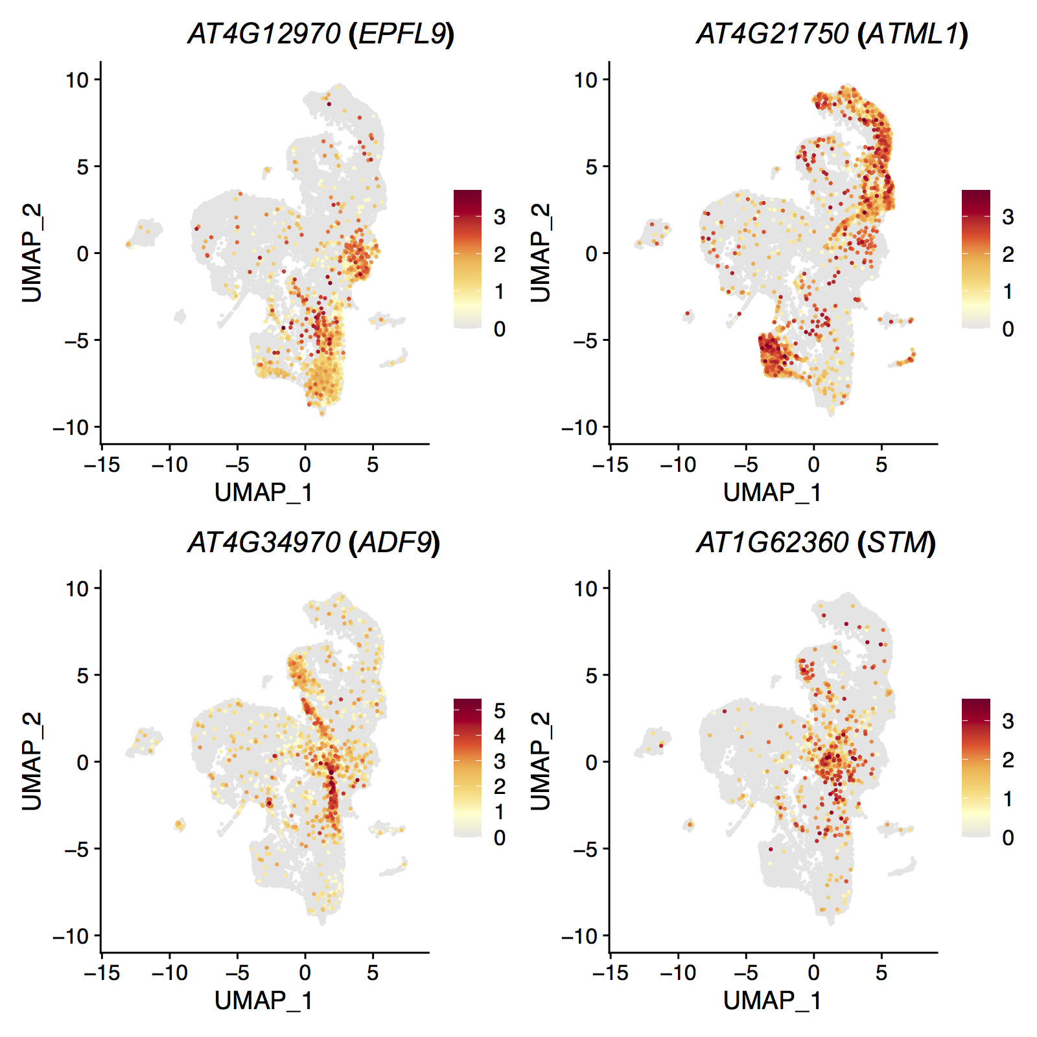
Figure S5. Expression Patterns of Shoot Cell Markers for Mesophyll, Epidermis, Endodermis and SAM cells. Color: Normalized UMI counts.
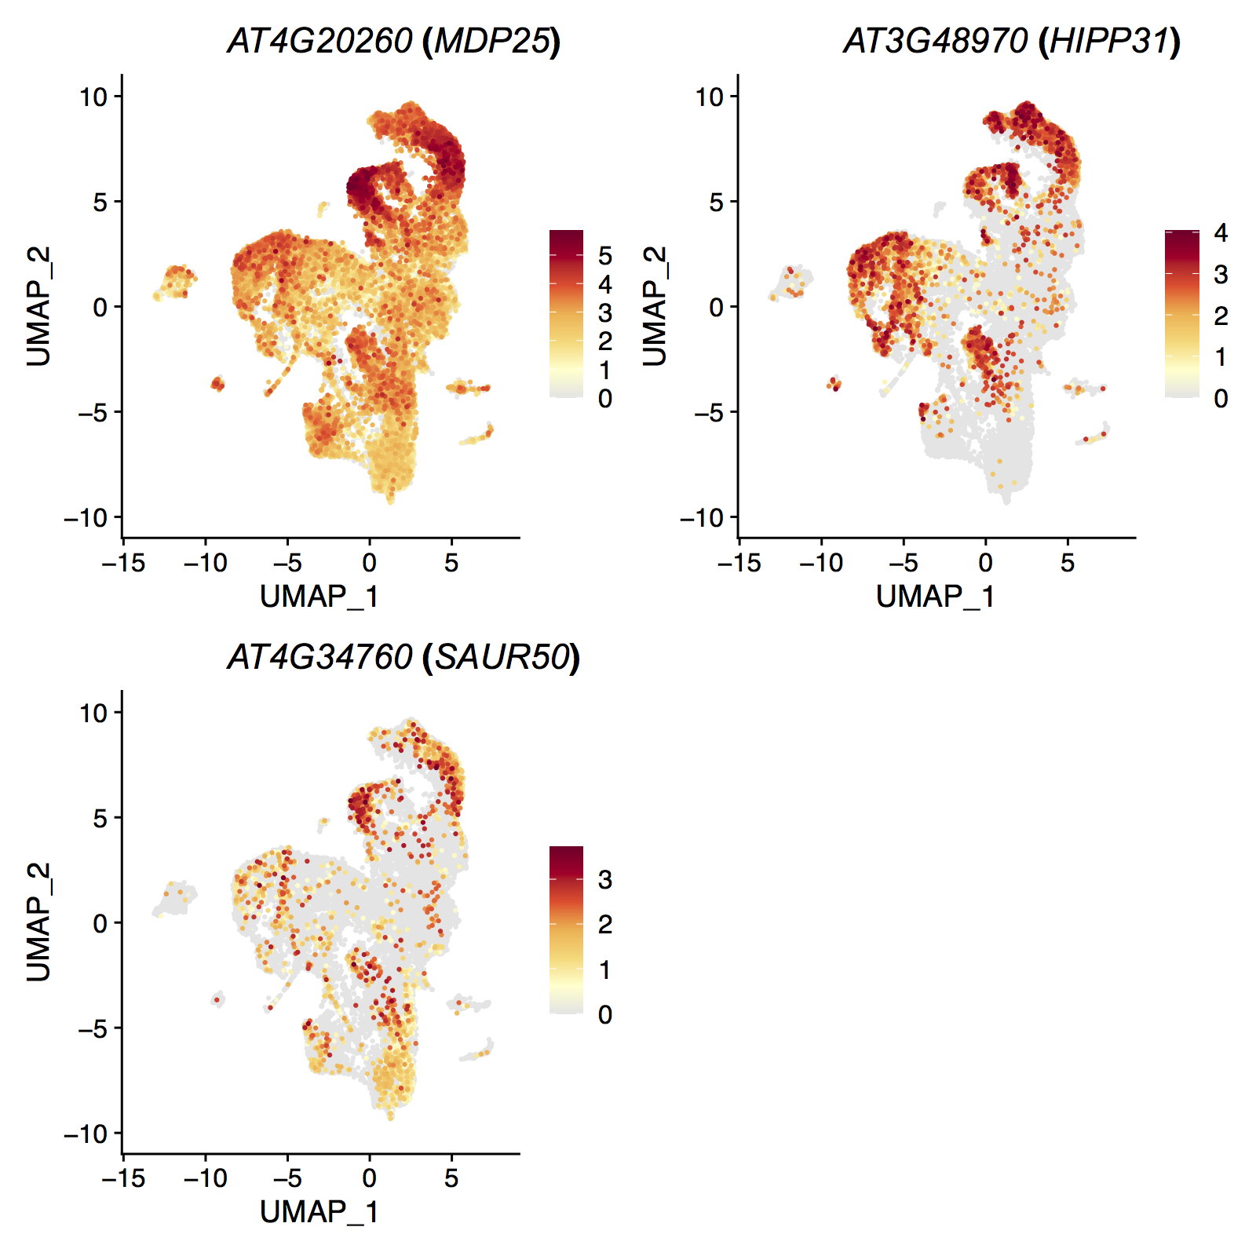
Figure S6. Expression Patterns of Hypocotyl Markers in Shoot Atlas. Color: Normalized UMI counts.
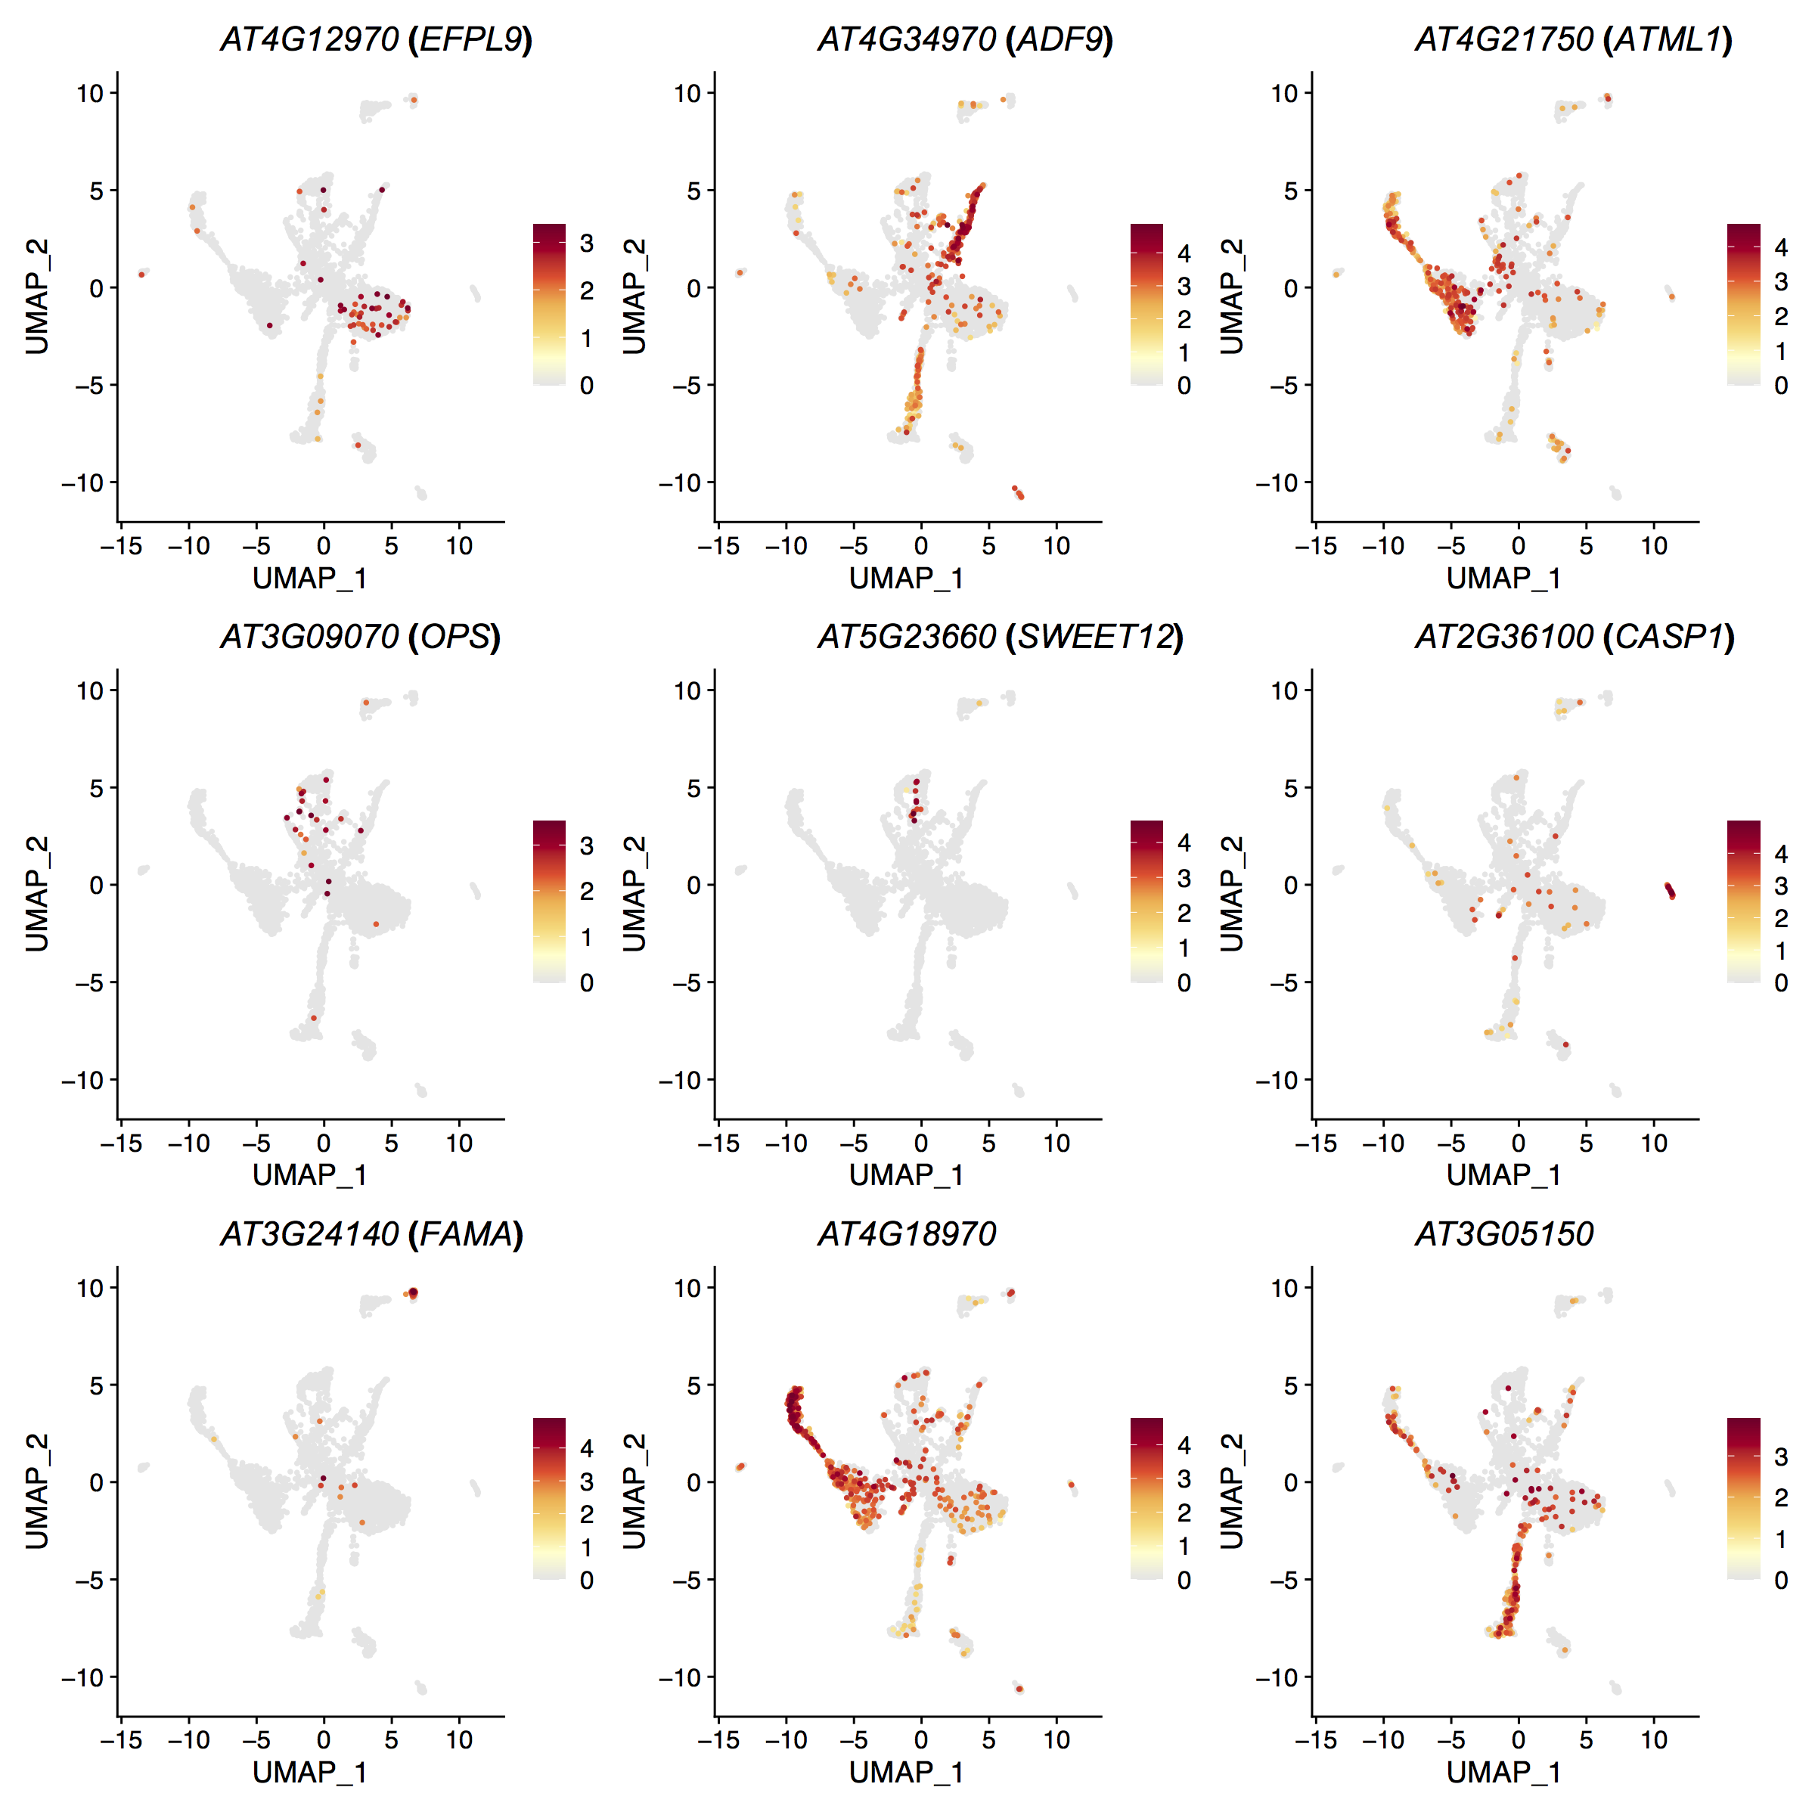
Figure S7. Expression Patterns of Shoot Cell Markers in Single Nucleus Atlas. Color: Normalized UMI counts.
Figure S8. Cell Identity Corresponding Relations before and after Batch Effect Correction. Color: scaled ( cell content).
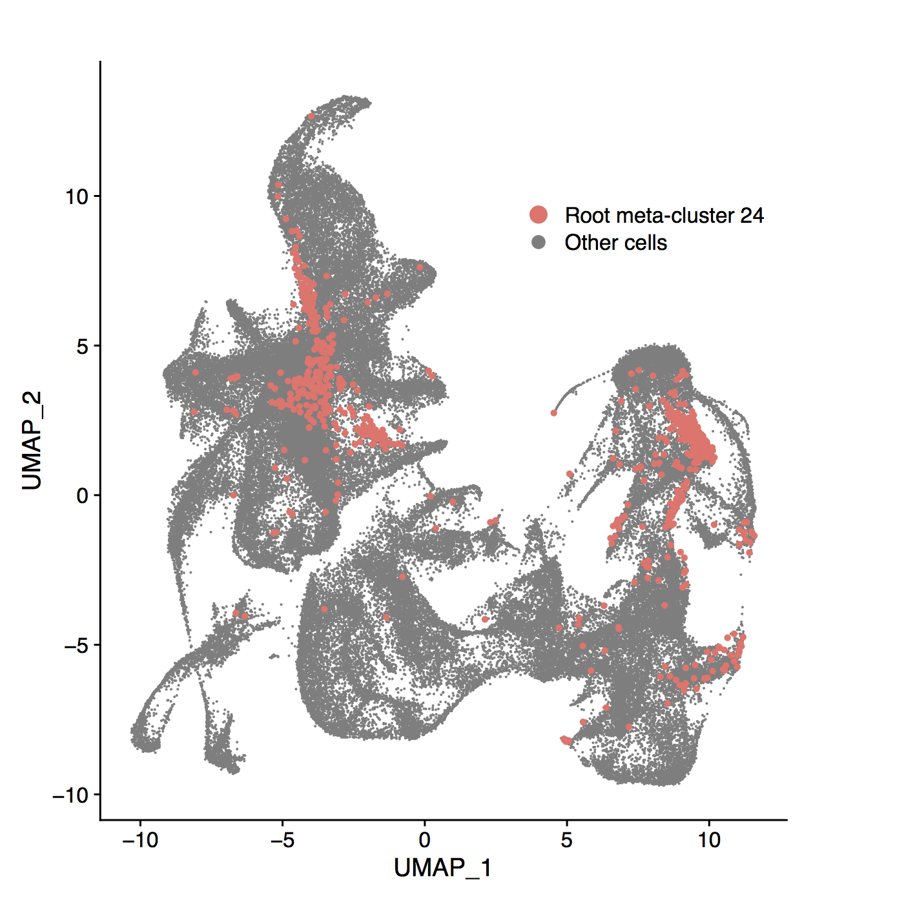
Figure S9. Distribution of Root Cluster 24 in the Seedling Atlas. Cells of root cluster 24 have been highlighted in pink.

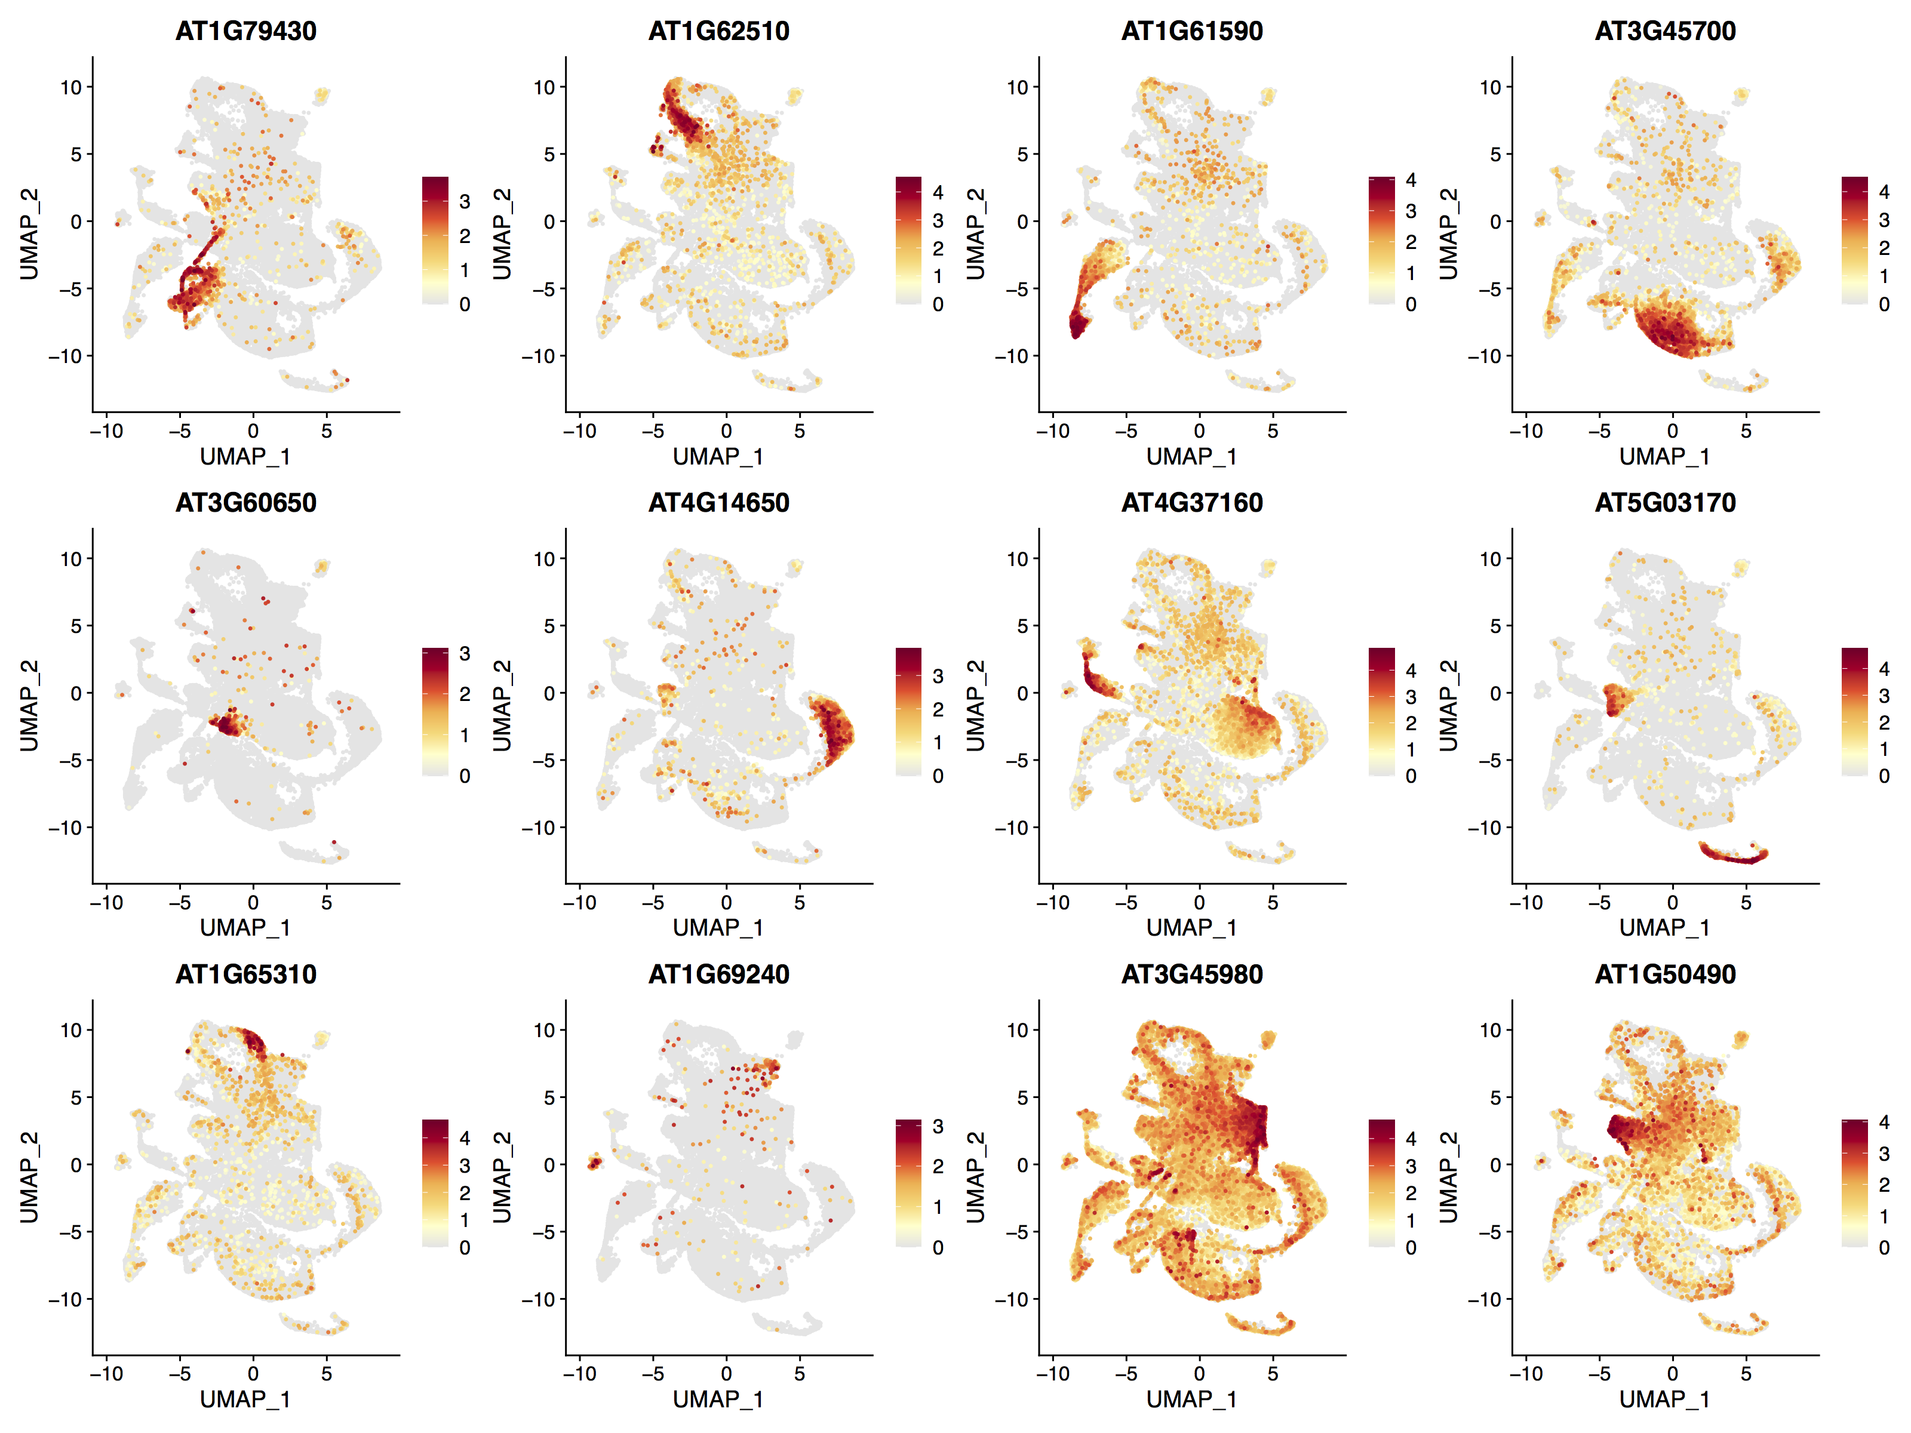
Figure S10. Expression Patterns of Root Cell Markers. Color: Normalized UMI counts.

Figure S11. Spatiotemporal Expression Patterns of Gravitropism Genes during De-Etiolation.

Figure S12. Distribution of Spatiotemporally Specific Genes Involved in Hormone Biosynthesis (Upper) and Signaling (Lower) in Root. Left: Absolute value; Right: Relative value.

Figure S13. Spatiotemporal Expression Patterns of SAUR genes during De-Etiolation.

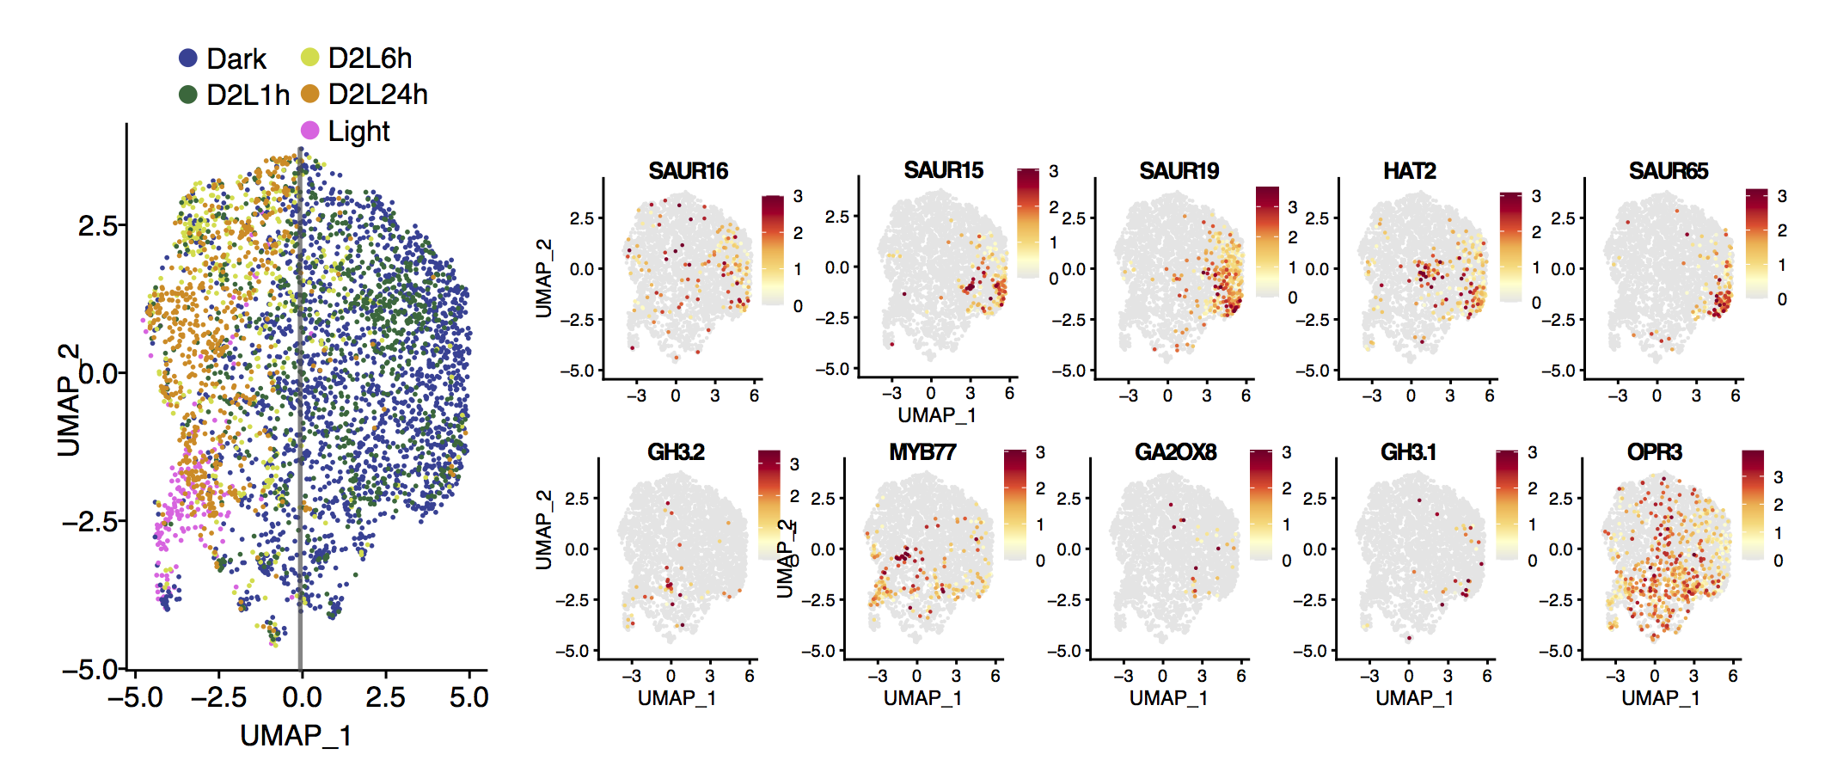
Figure S14. Asymmetric Distribution of Auxin Responsive Genes in Hypocotyl Epidermis Cells. Left: Visualization of hypocotyl epidermal cells using UMAP. Colors indicates different de-etiolation times. Right: Expression pattern of population specific genes in identified in cortex cells.

Figure S15 Enriched GO Terms of Dynamic Genes in Cortex during De-Etiolation. Color: significant level; Size: fold enrichment

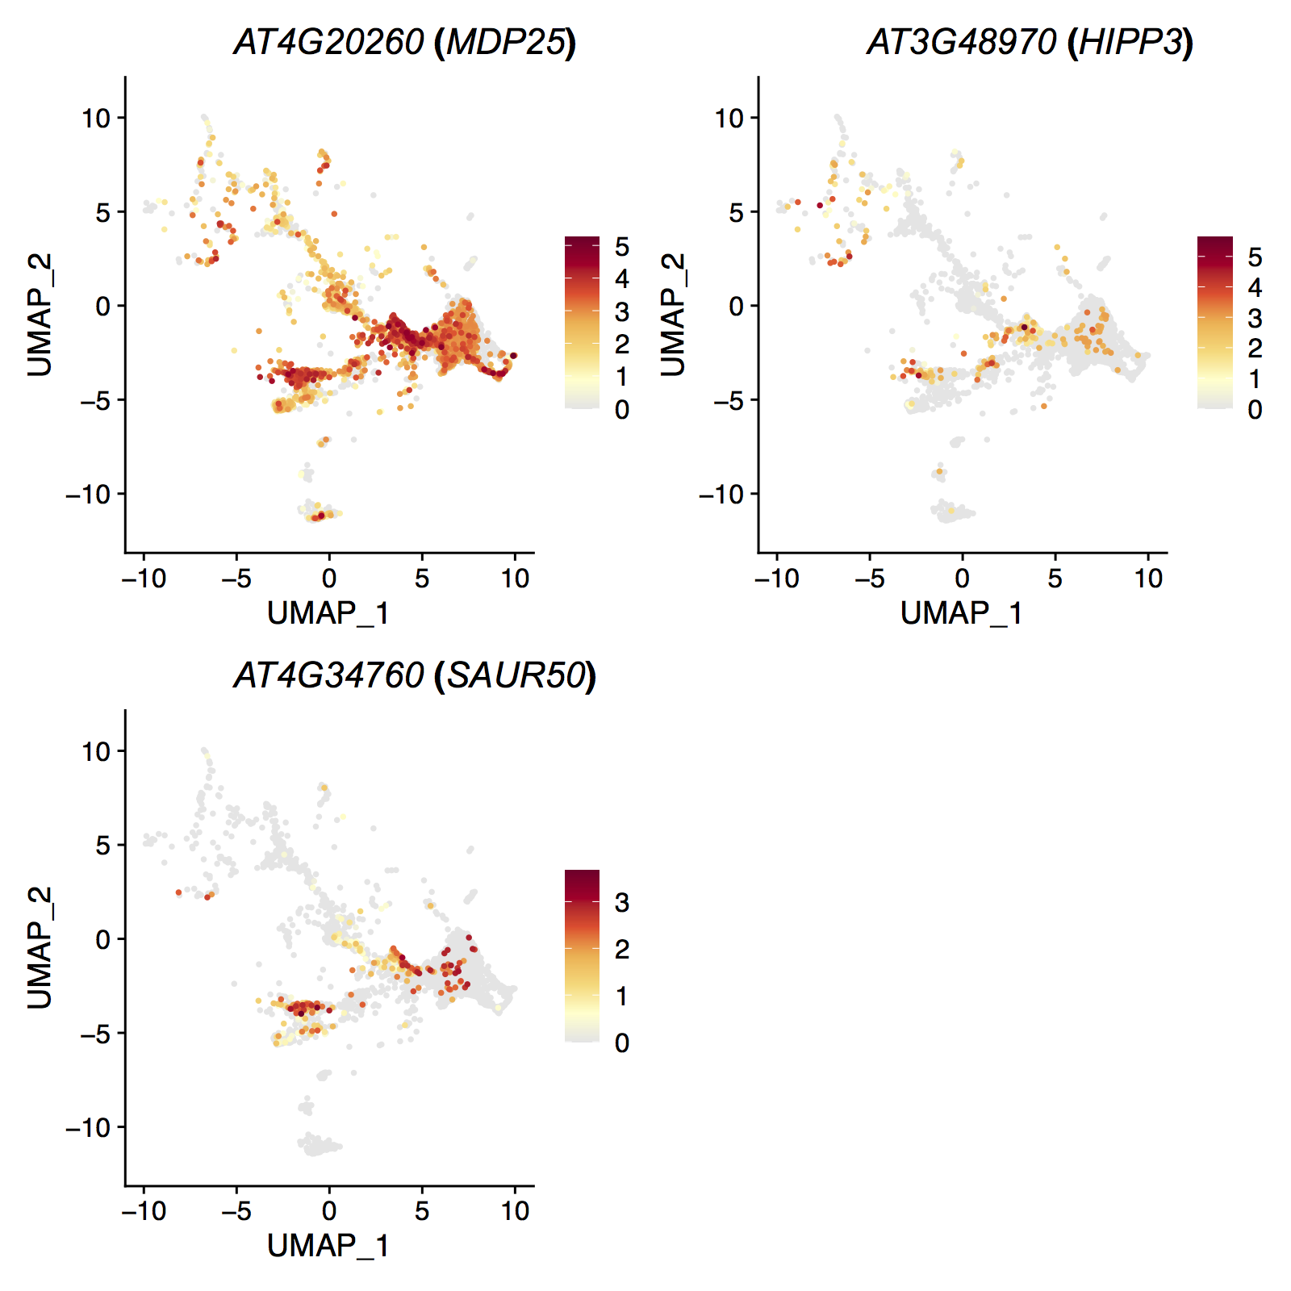
Figure S16. Expression Patterns of Hypocotyl Markers in pifq Shoot Atlas. Color: Normalized UMI counts.

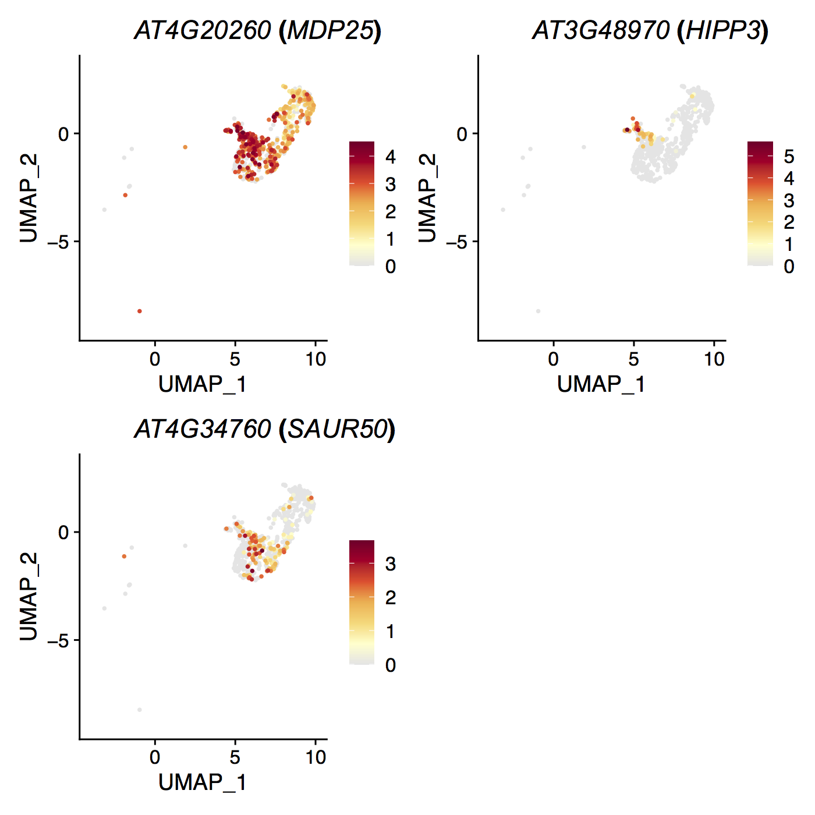
Figure S17. Expression Patterns of Hypocotyl Markers in pifq Epidermis Atlas. Color: Normalized UMI counts.

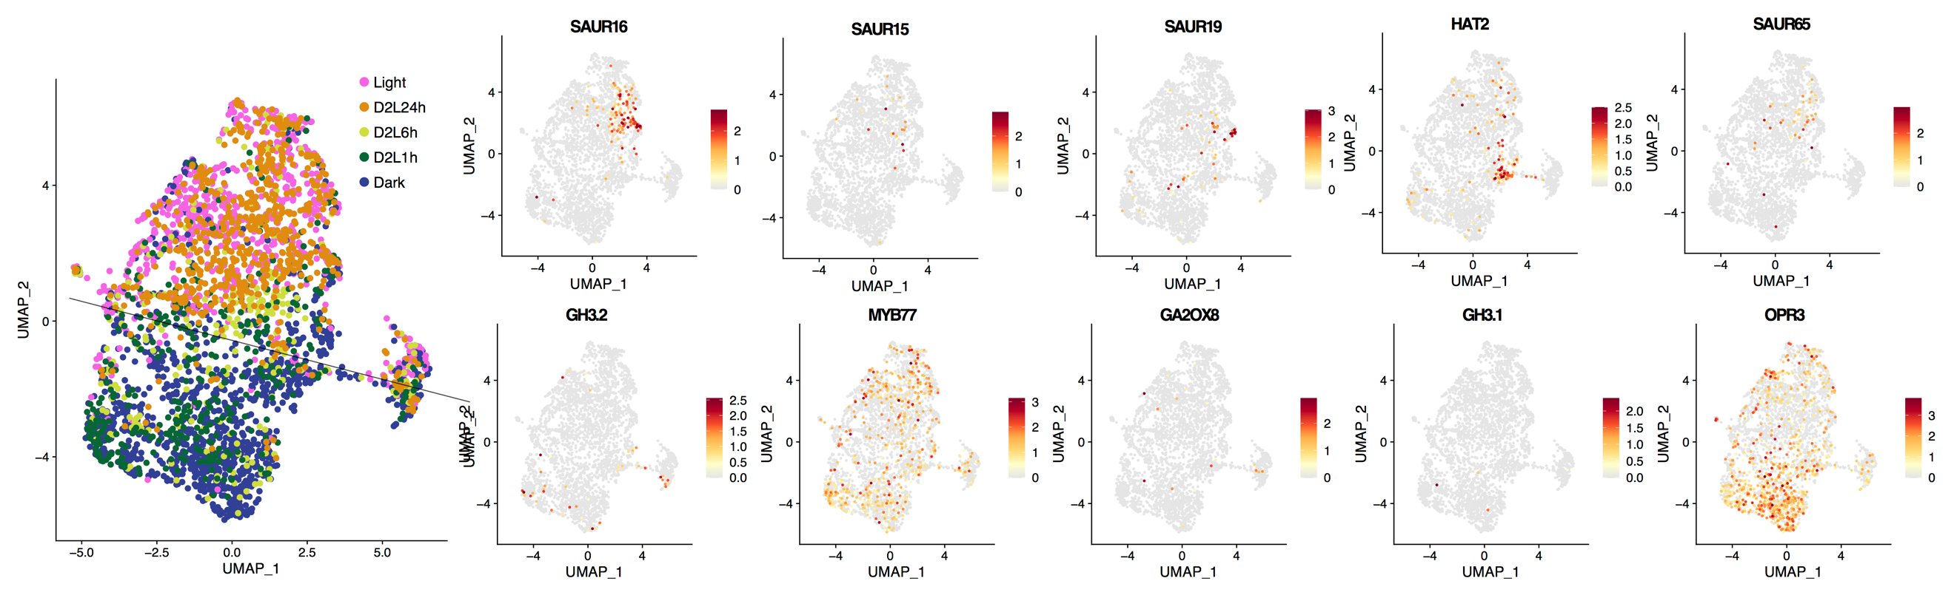
Figure S18. Distribution of Auxin Responsive Genes in Cotyledon Epidermis Cells. Left: Visualization of cotyledon epidermal cells using UMAP. Colors indicates different de-etiolation times. Right: Expression pattern of population specific genes in identified in cortex cells.

Figure S19. Expression of bHLH167 in Epidermis for Seedlings Grown in Constant Dark and Constant Light for 5 Days. The gene expression pattern of bHLH167 and FAMA was revealed by promoter Histone2B-YFP (H2B-YFP, yellow) and CFP-FAMA (blue) reporter. Scale bar: 20 μm.

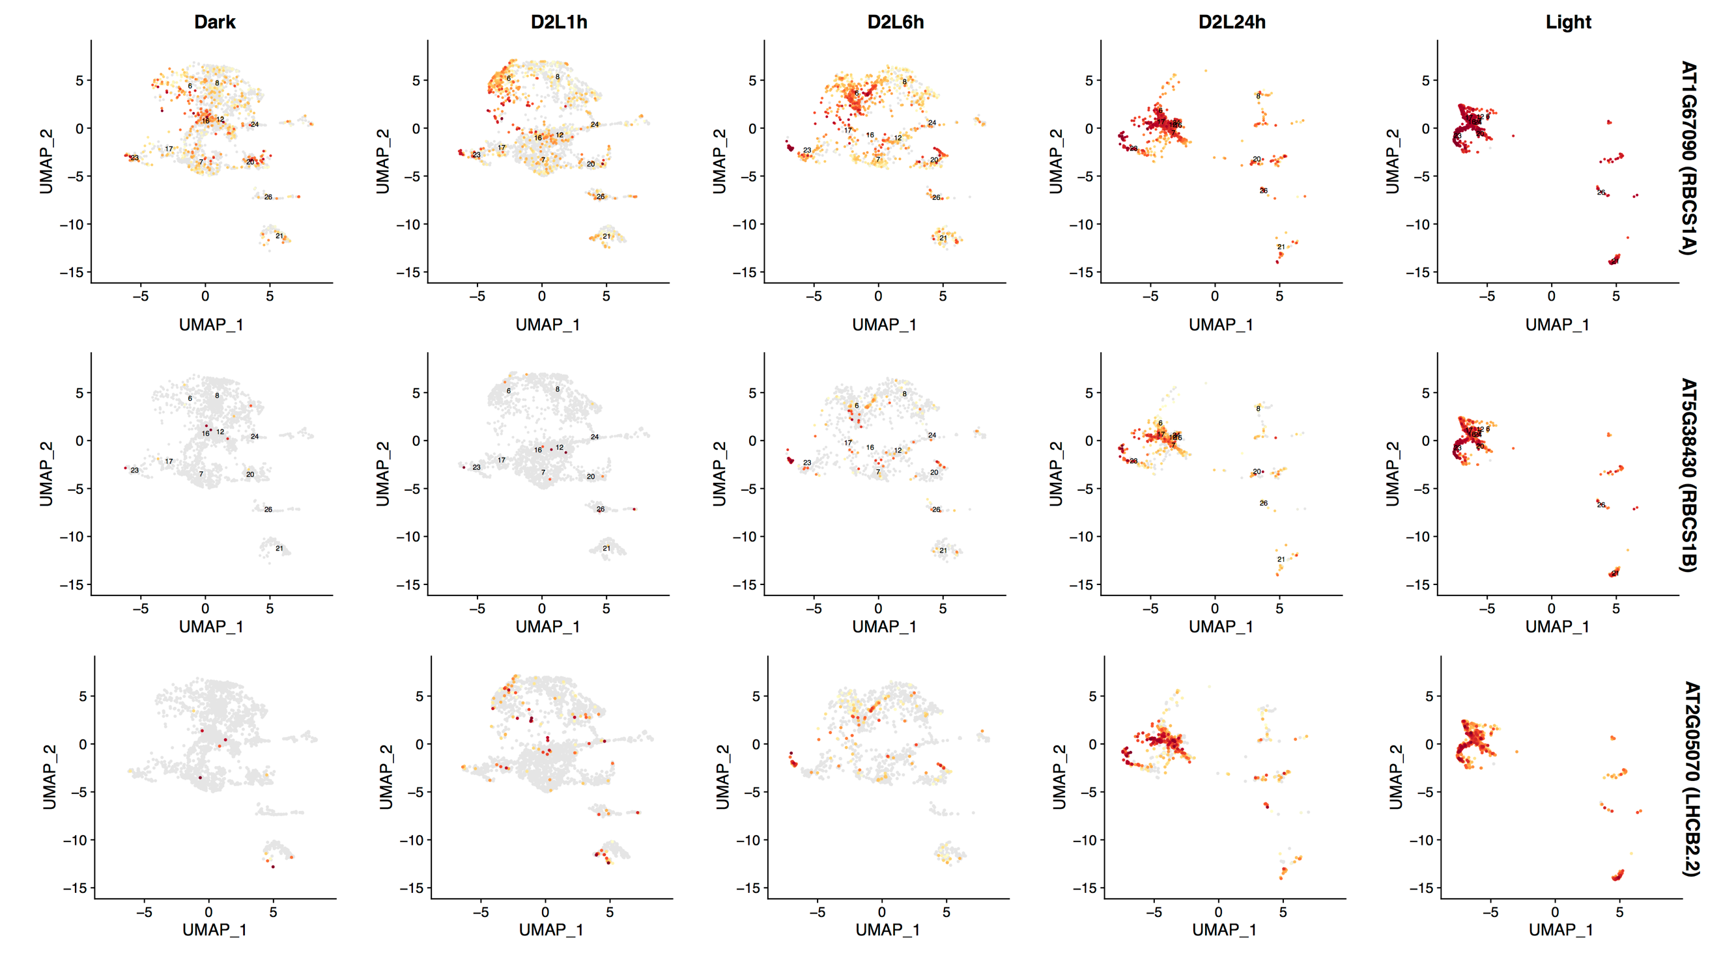
Figure S20. Time-Series Expression Distribution of RBCS and LHCB Genes during De-Etiolation in Vascular Cells. Color: Normalized UMI counts.

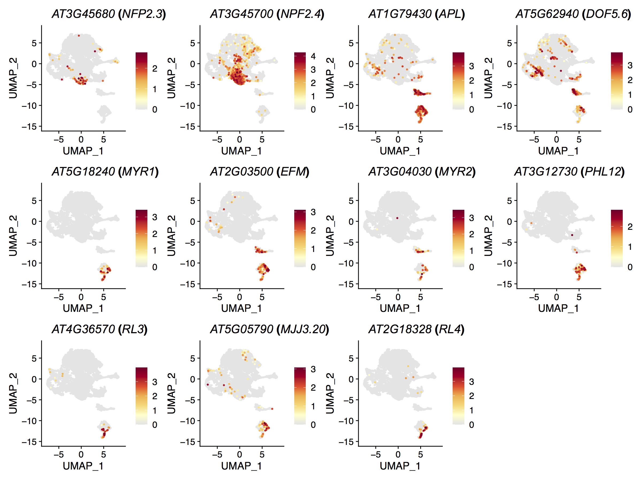
Figure S21. Distribution of Candidate Vasculature Development Regulators in Vascular Cells. Color: Normalized UMI counts.

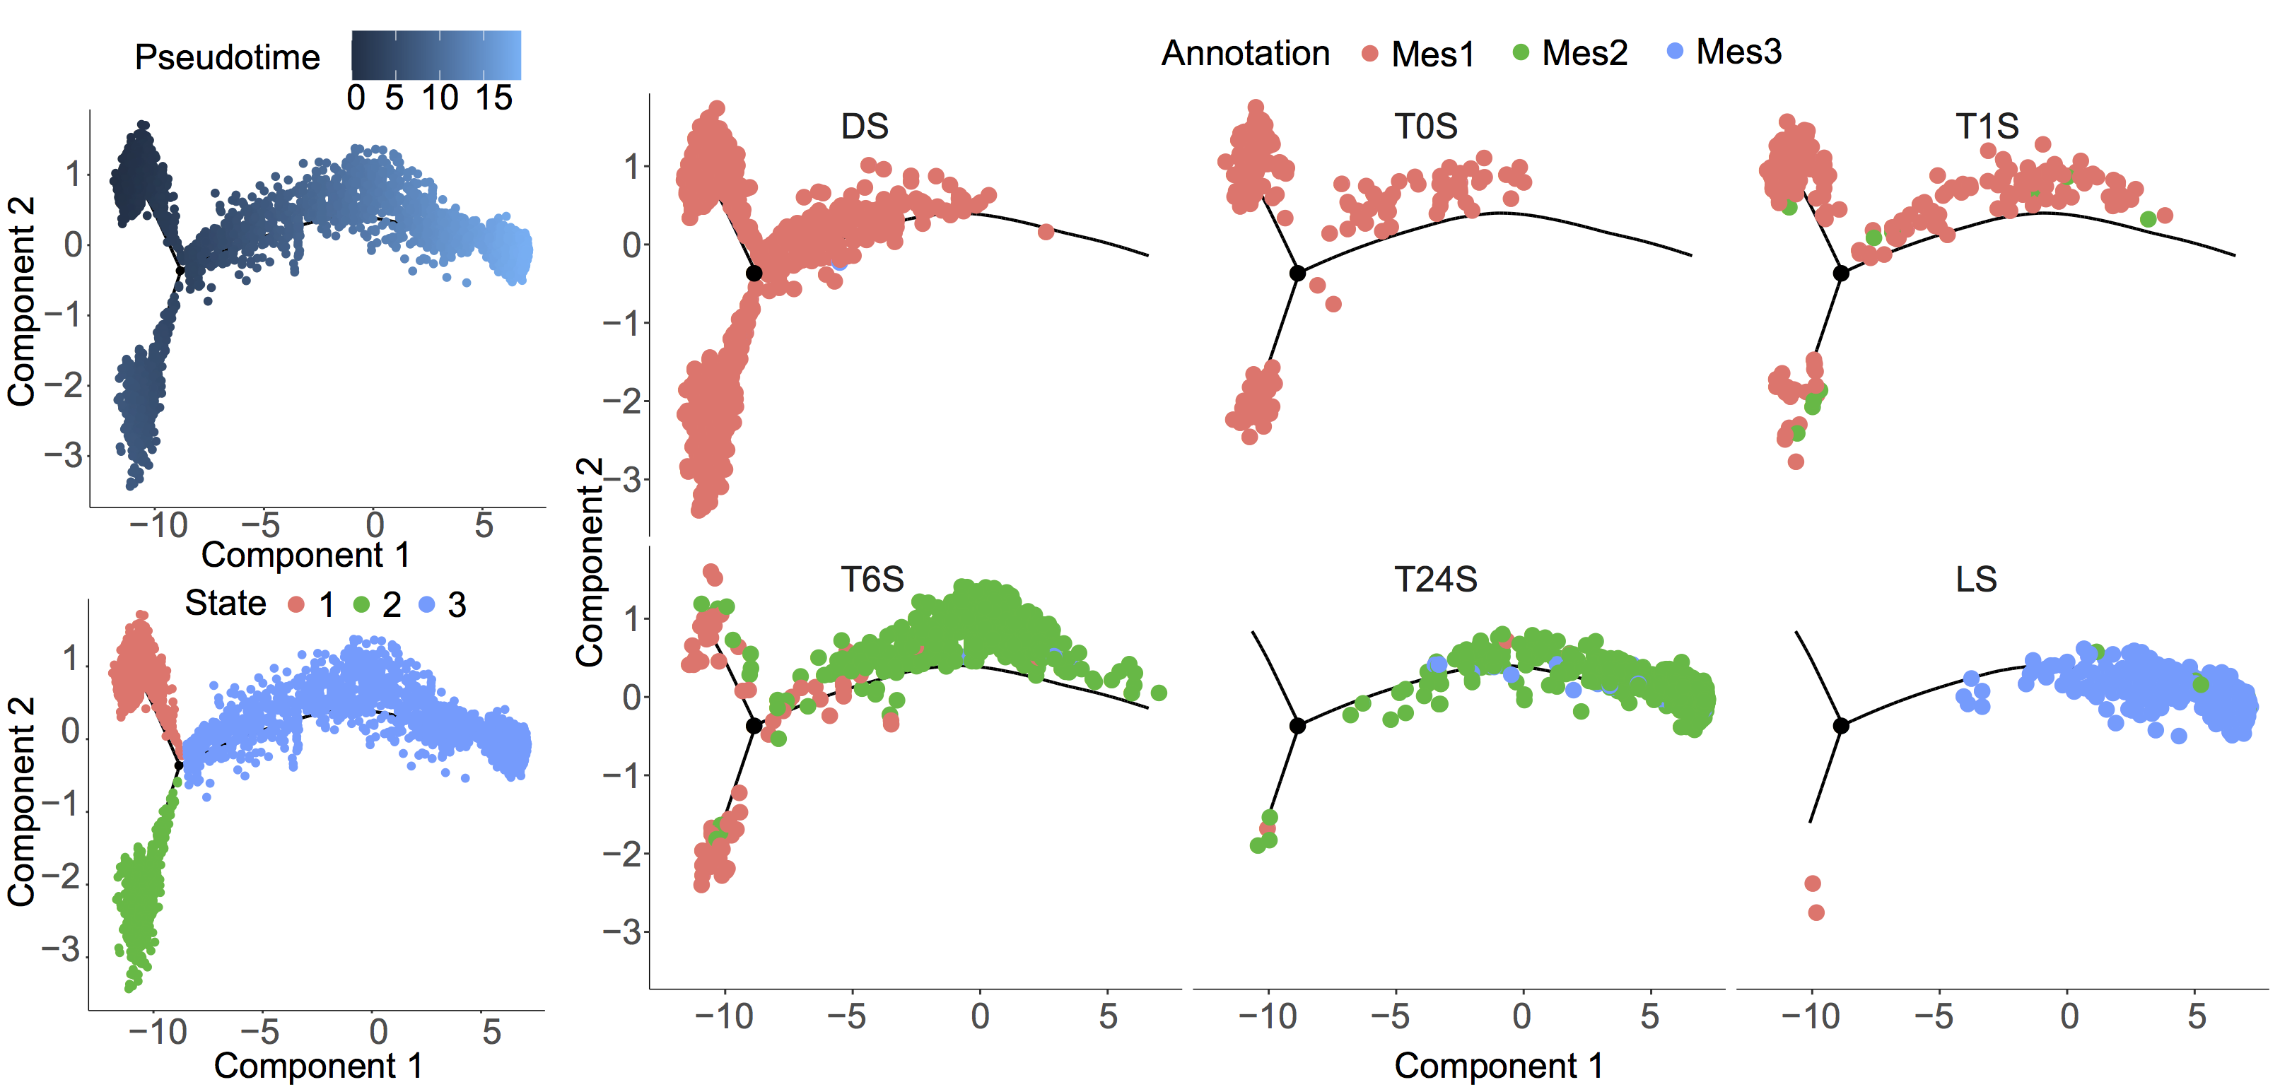
Figure S22. The development trajectories of Mesophyll Cells during De-Etiolation.

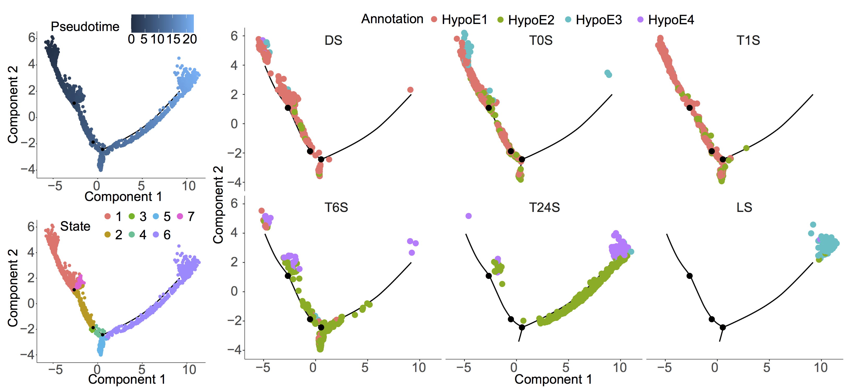
Figure S23. The development trajectories of Hypocotyl Epidermal Cells during De-Etiolation.

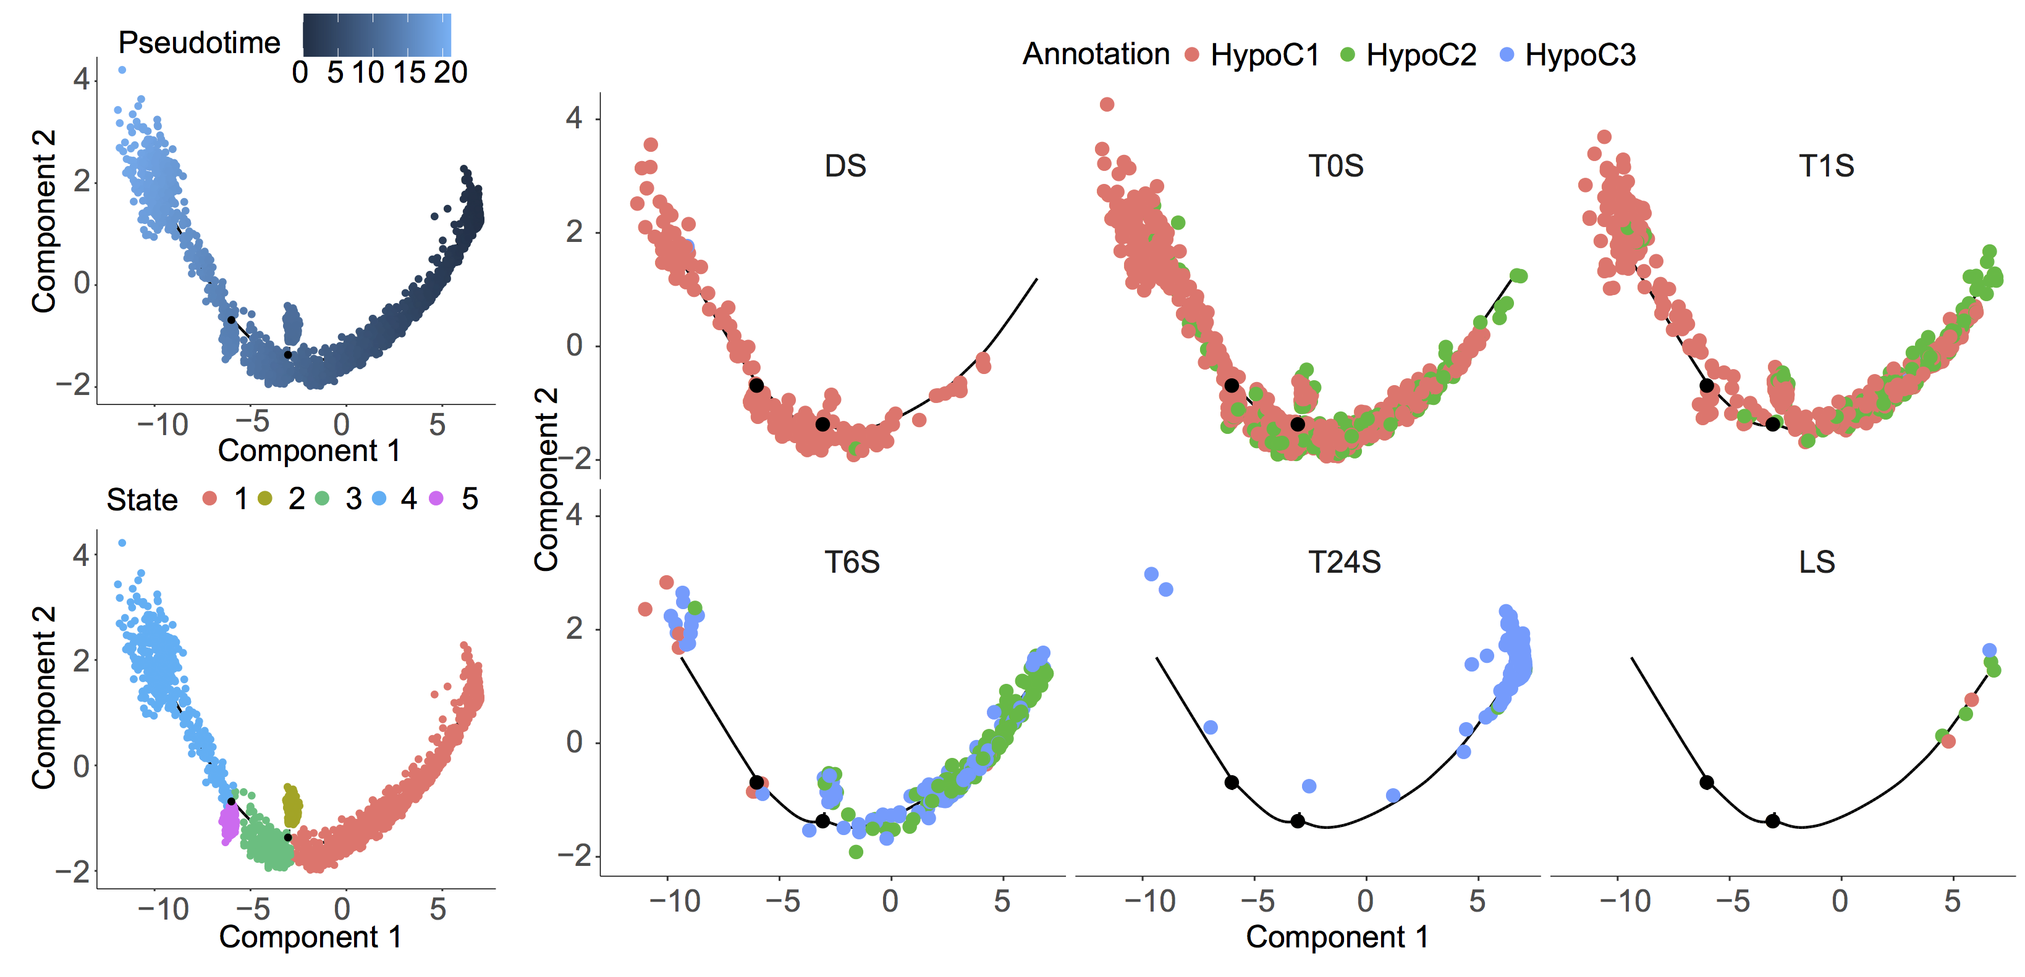
Figure S24. The development trajectories of Cortex Cells during De-Etiolation.

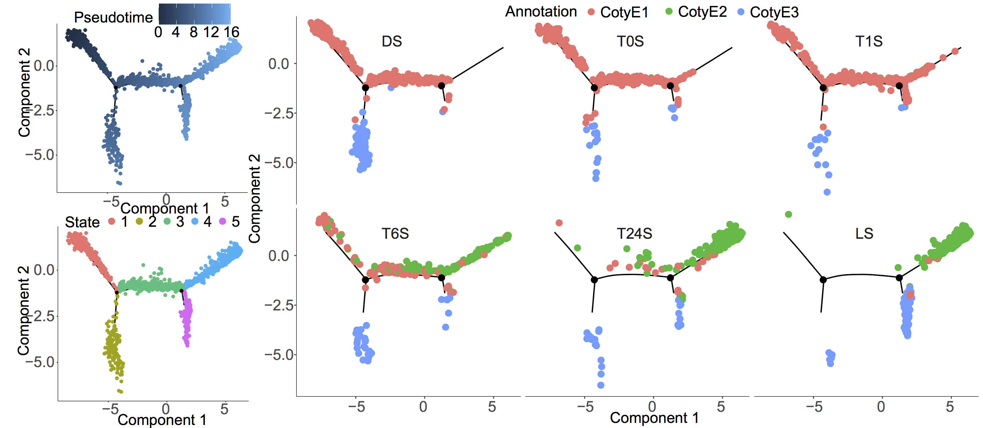
Figure S25. The development trajectories of Cotyledon Epidermal Cells during De-Etiolation.

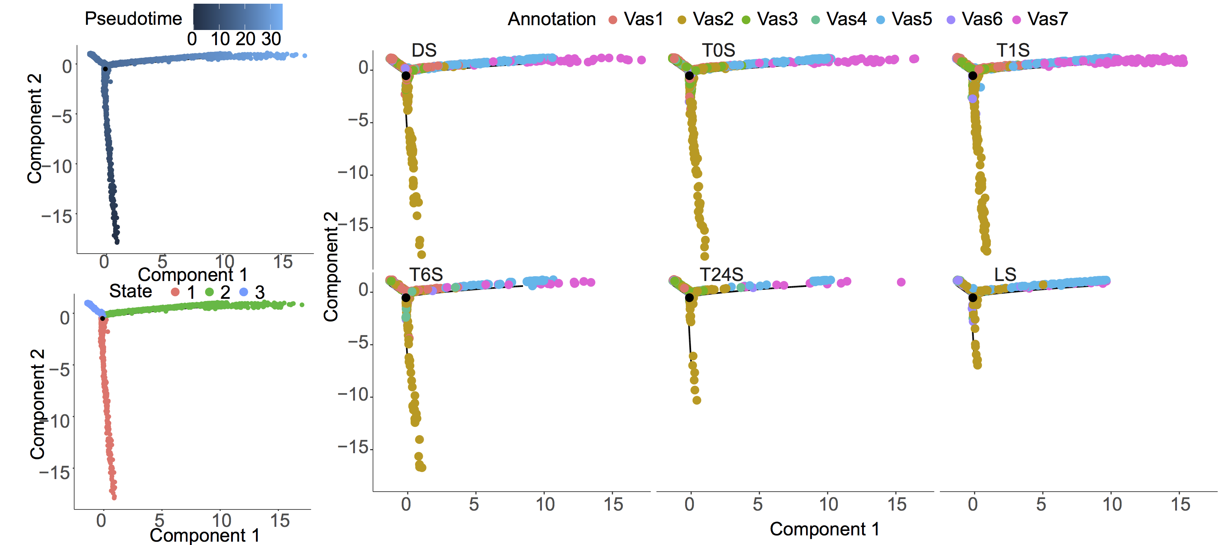
Figure S26. The development trajectories of Vascular Cells during De-Etiolation.
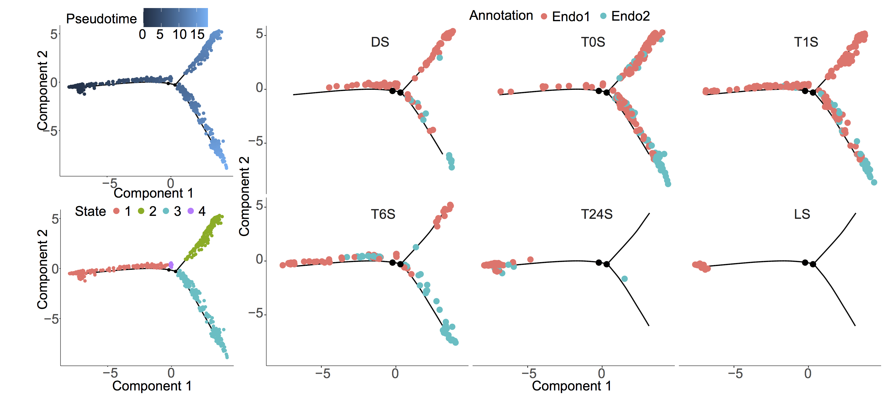
Figure S27. The development trajectories of Endodermis Cells during De-Etiolation.

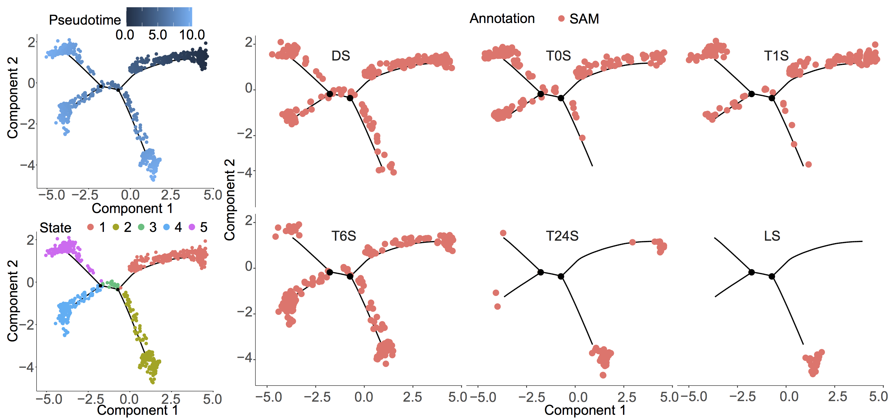
Figure S28. The development trajectories of SAM Cells during De-Etiolation.
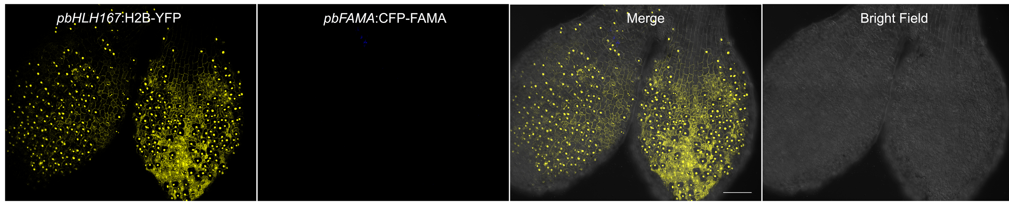
Figure S29. Expression of bHLH167 in Epidermis for Seedlings Grown in Constant Dark 3-4 Days. The gene expression pattern of bHLH167 and FAMA was revealed by promoter Histone2B-YFP (H2B-YFP, yellow) and CFP-FAMA (blue) reporter. Scale bar: 100 μm.

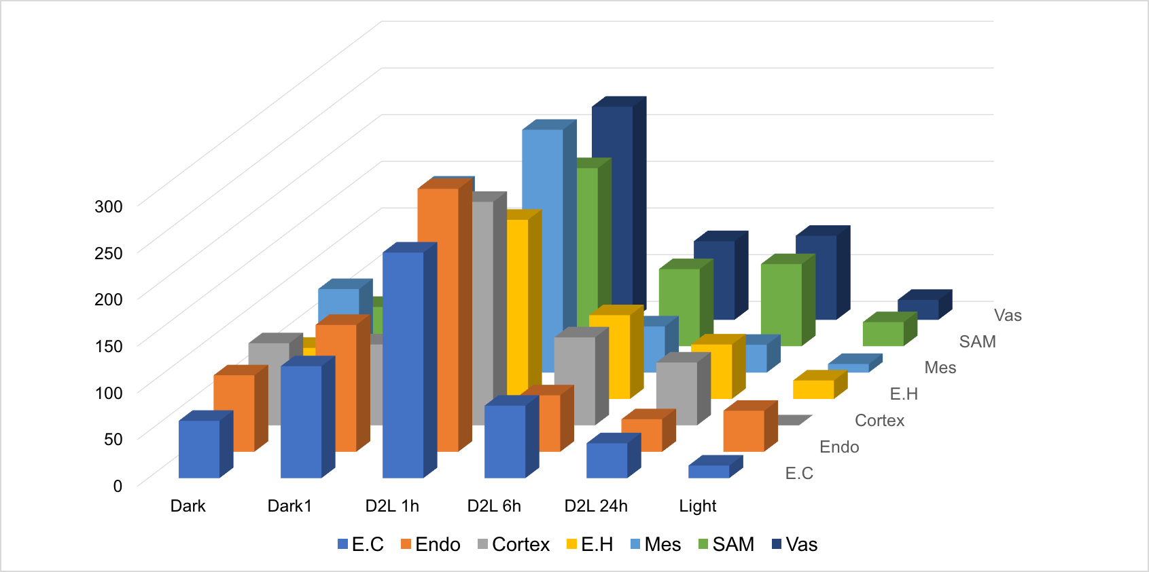
Figure S30. Relative Expression (Mean of Normalized UMI Counts for Each Cell) of HY5 during deetiolation in each cell type.

