Supporting Information
An integrated chromatographic strategy to discover free radical inhibitors from trace fraction of Ribes himalense Royle ex Decne.

Chuang Liuª, Yuqing Leiª, Yue Lv^{d}, Youyi Liu^{c}, Jingrou Guo^{c}, Minchen Wu^{c, *} Jun Dang^{b, *}

ªSchool of Biotechnology, Jiangnan University, Wuxi 214000, People’s Republic of China
^{b}Key Laboratory of Tibetan Medicine Research, Northwest Institute of Plateau Biology, Chinese Academy of Sciences, Xining 810000, People’s Republic of China
^{c}Wuxi School of Medicine, Jiangnan University, Wuxi 214000, People’s Republic of China
^{d}Center for Mitochondria and Healthy Aging, College of Life Sciences, Yantai University, Yantai 264010, People’s Republic of China

Table of Contents

Figure S1. ESI-MS data of Fr4-1-1 3
Figure S2. ¹H NMR (600 MHz) data of Fr4-1-1 (in DMSO-d₆) 4
Figure S3. ¹³C NMR (151 MHz) data of Fr4-1-1 (in DMSO-d₆) 5
Figure S4. HR-ESI-MS data of Fr4-1-2 6
Figure S5. ¹H NMR (600 MHz) data of Fr4-1-2 (in MeOH-d₄) 7
Figure S6. ¹³C NMR (151 MHz) data of Fr4-1-2 (in MeOH-d₄) 8
Figure S7. HMBC data of Fr4-1-2 (in MeOH-d₄) 9
Figure S8. ESI-MS data of Fr4-2 10
Figure S9. ¹H NMR (600 MHz) data of Fr4-2 (in DMSO-d₆) 11
Figure S10. ¹³C NMR (151 MHz) data of Fr4-2 (in DMSO-d₆) 12

Figure S1. ESI-MS data of Fr4-1-1
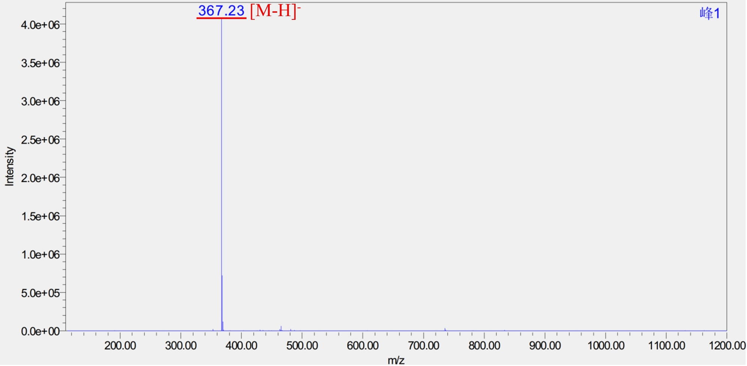

Figure S2. ¹H NMR (600 MHz) data of Fr4-1-1 (in DMSO-d₆)
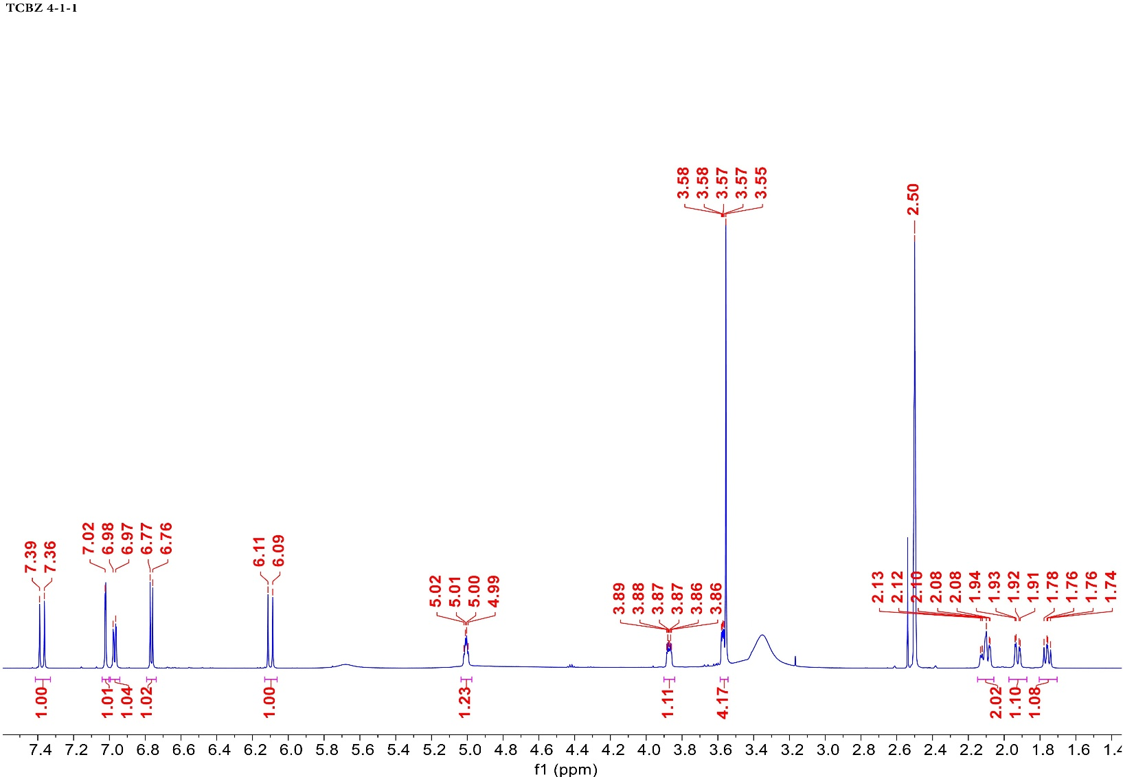

Figure S3. ¹³C NMR (151 MHz) data of Fr4-1-1 (in DMSO-d₆)
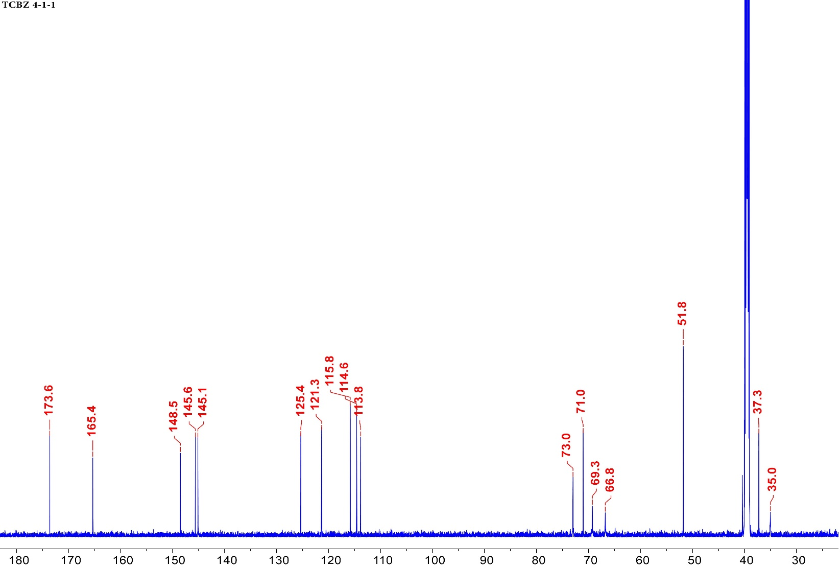

Figure S4. HR-ESI-MS data of Fr4-1-2
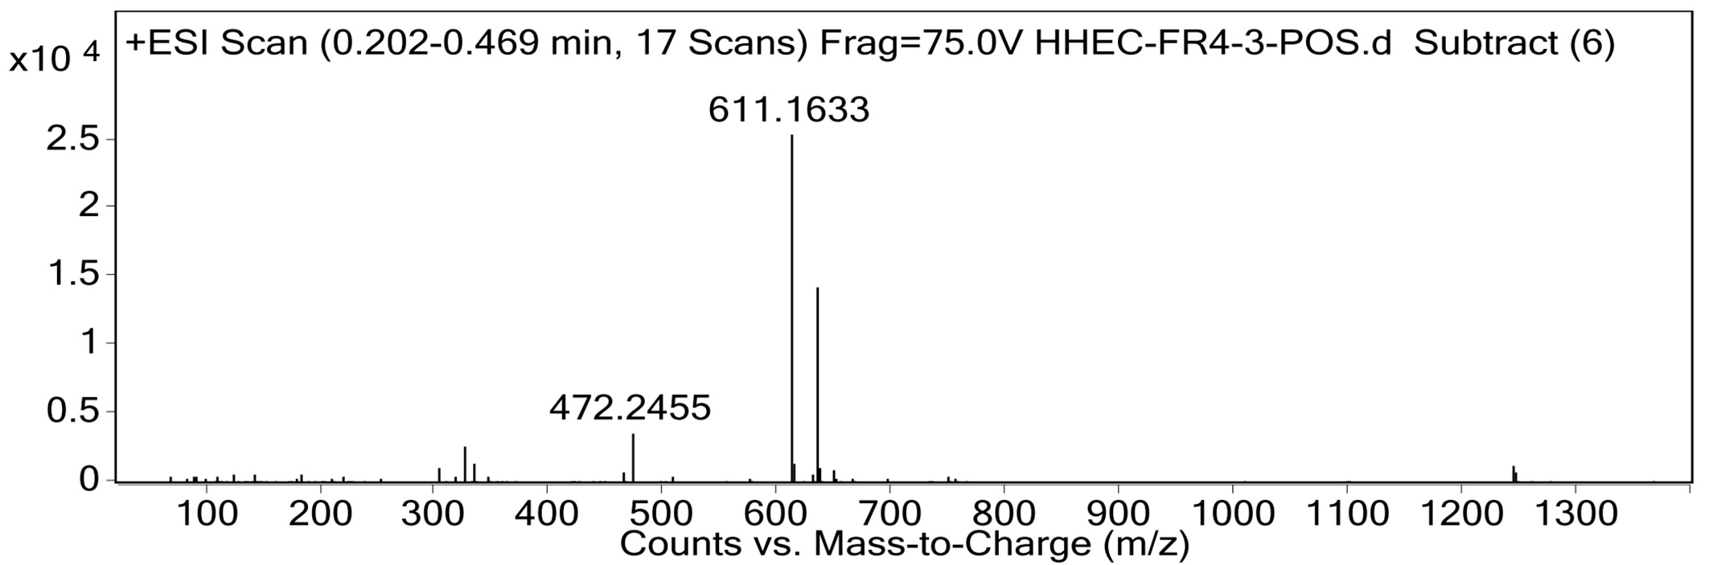

Figure S5. ¹H NMR (600 MHz) data of Fr4-1-2 (in MeOH-d₄)
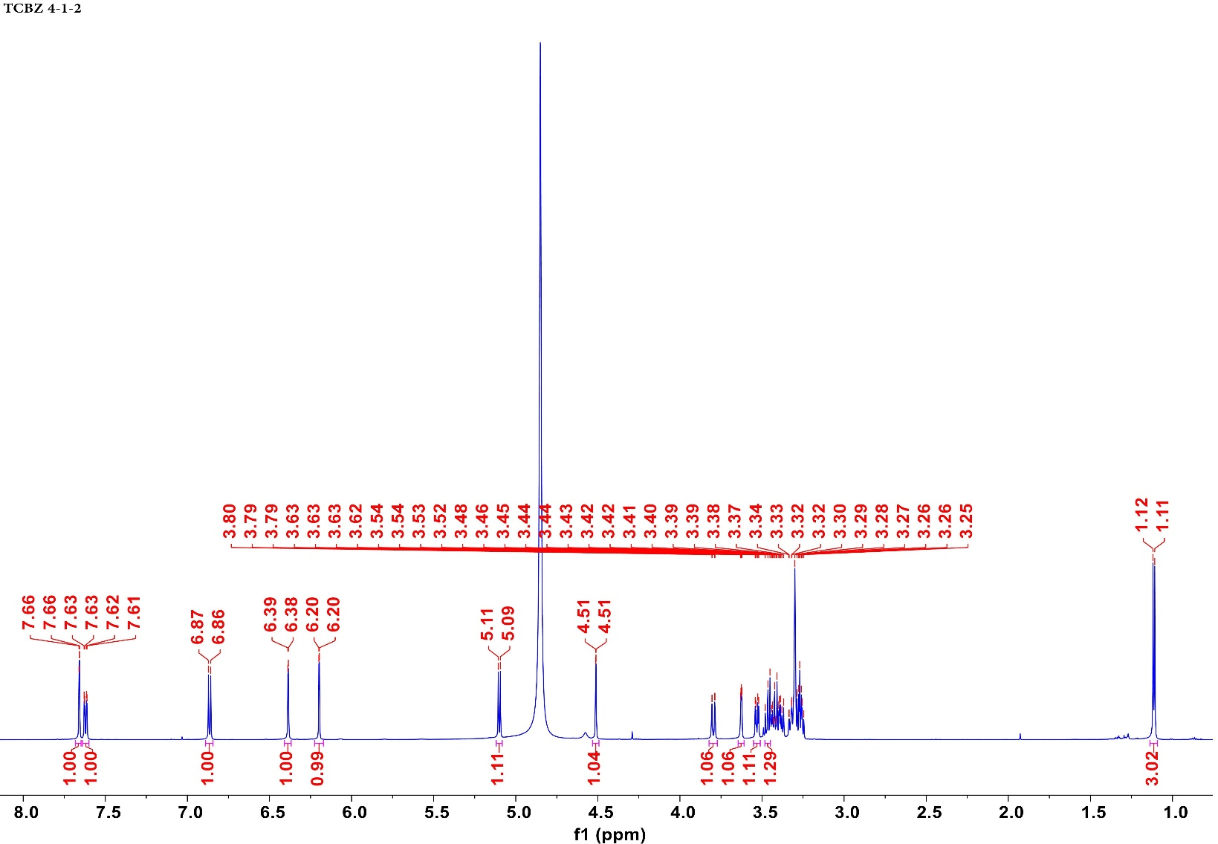

Figure S6. ¹³C NMR (151 MHz) data of Fr4-1-2 (in MeOH-d₄)
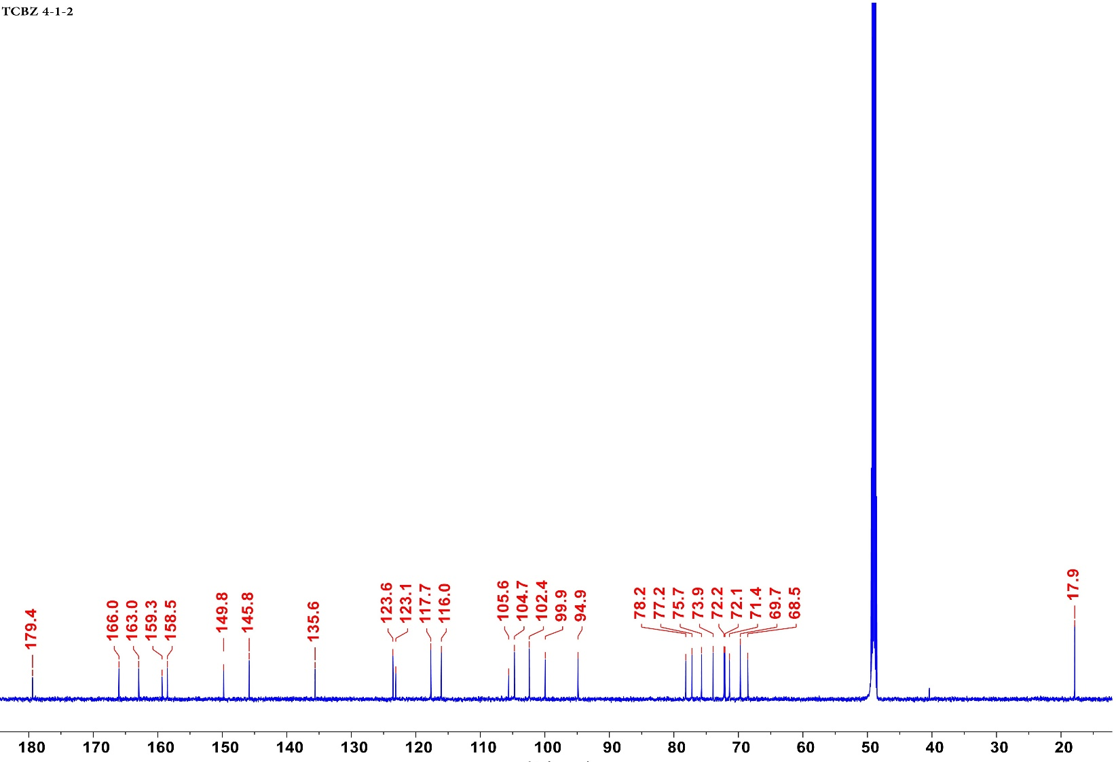

Figure S7. HMBC data of Fr4-1-2 (in MeOH-d₄)
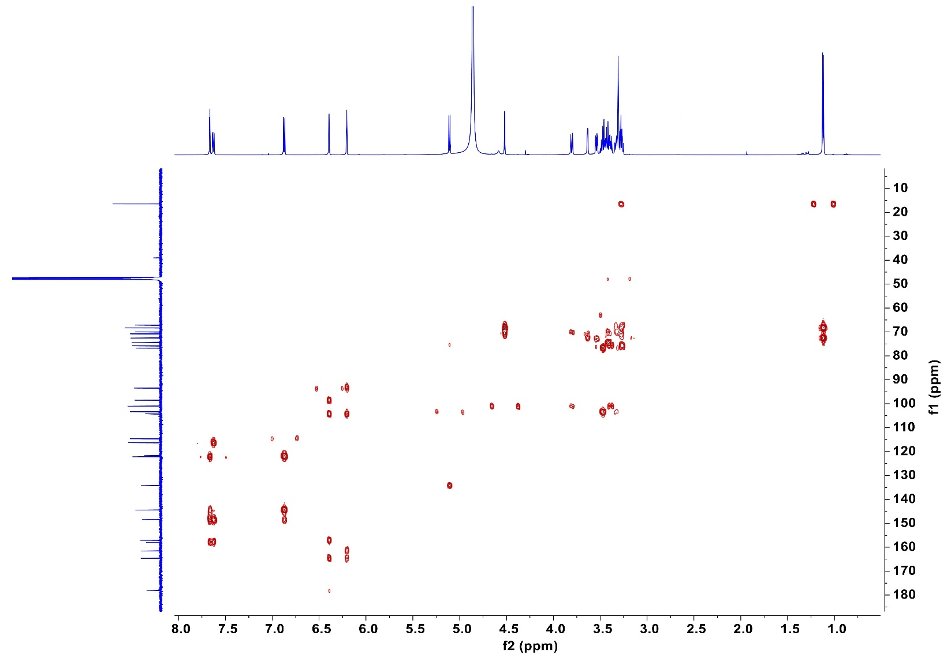

Figure S8. ESI-MS data of Fr4-2
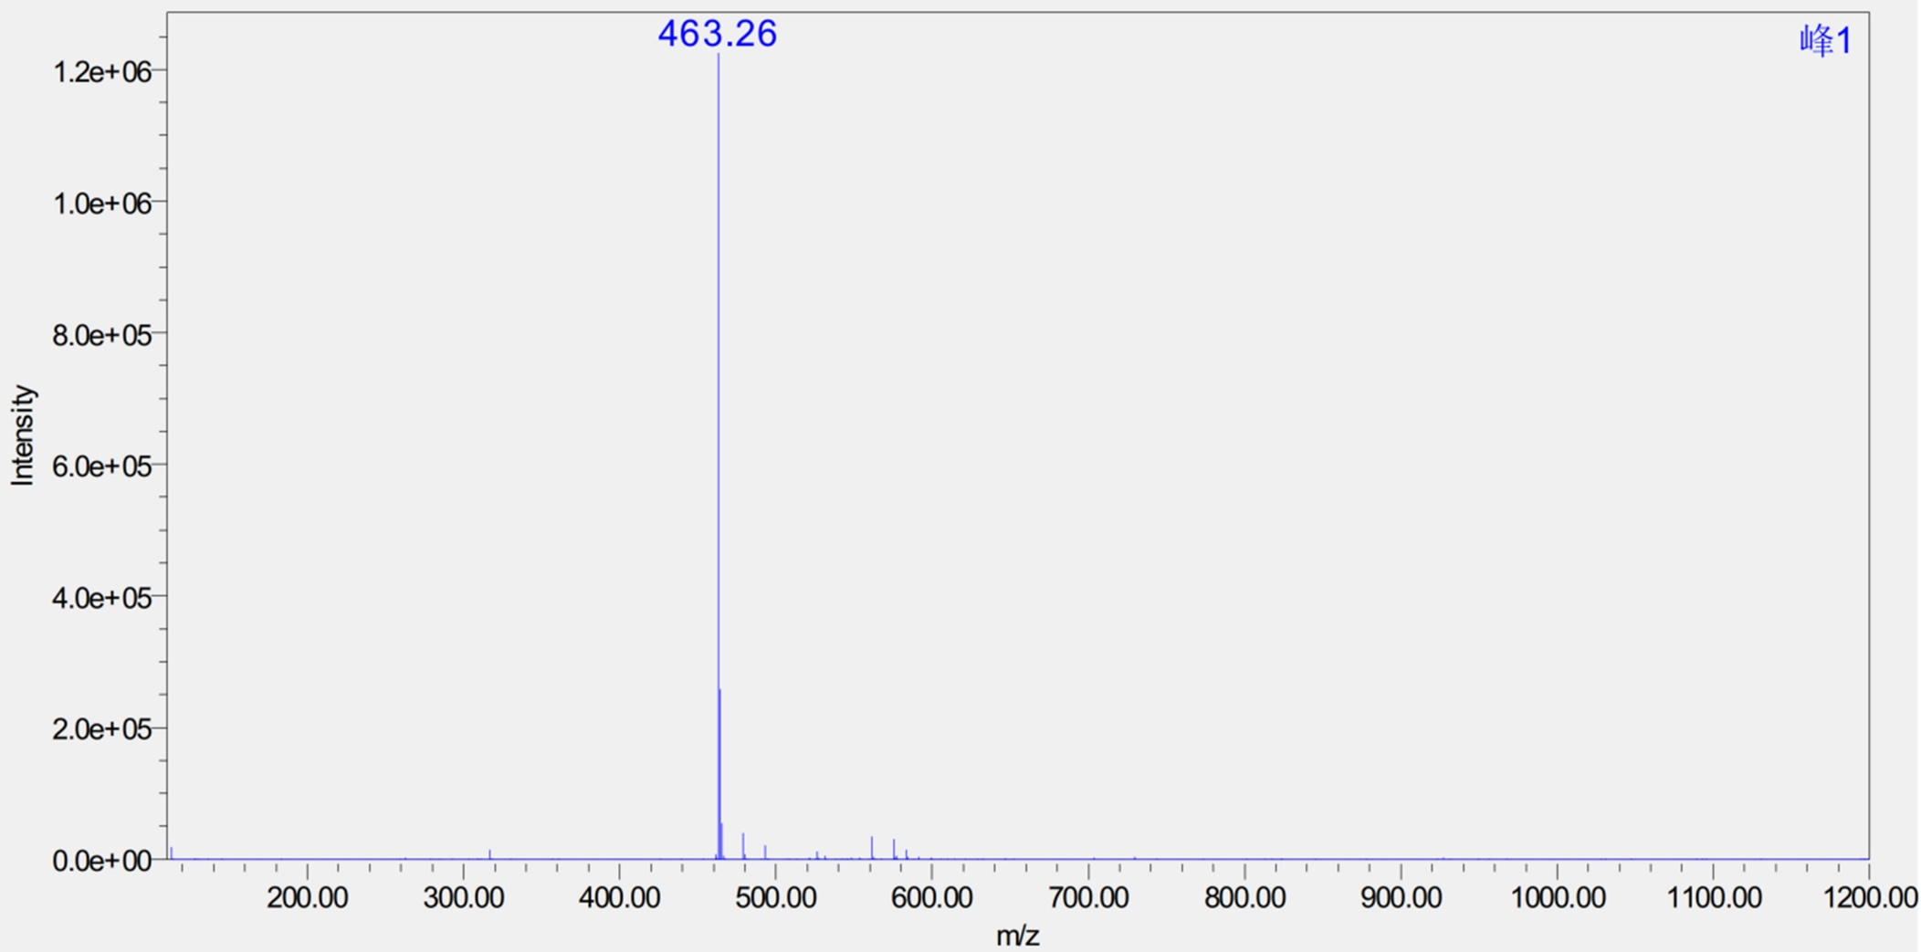

Figure S9. ¹H NMR (600 MHz) data of Fr4-2 (in DMSO-d₆)
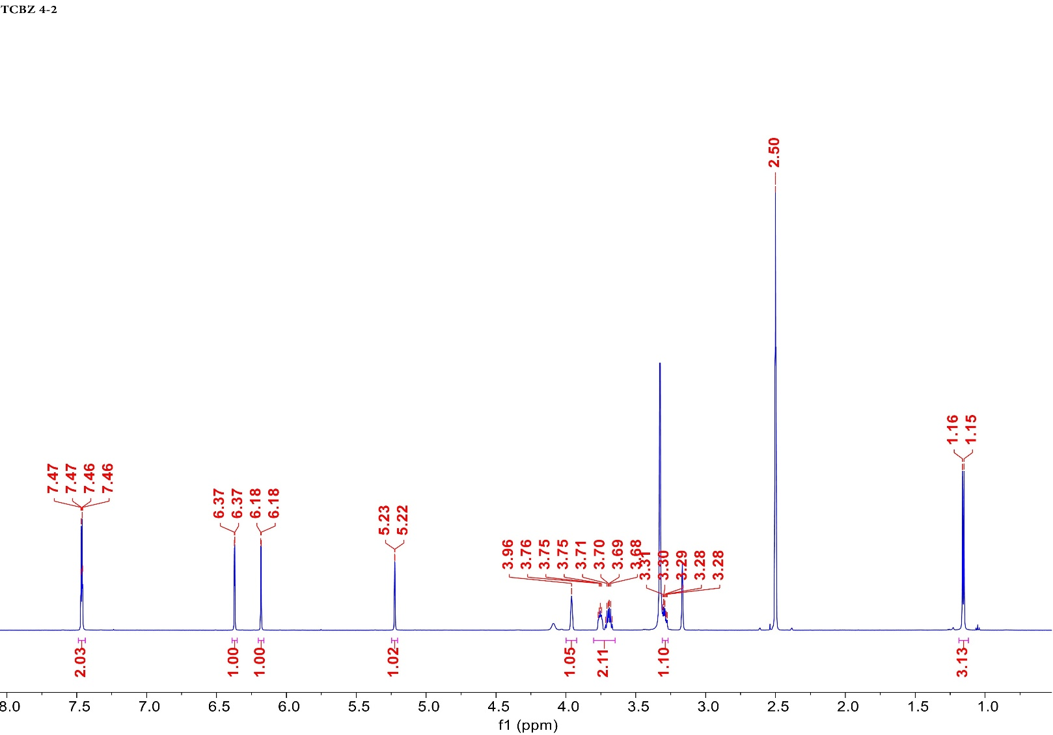

Figure S10. ¹³C NMR (151 MHz) data of Fr4-2 (in DMSO-d₆)
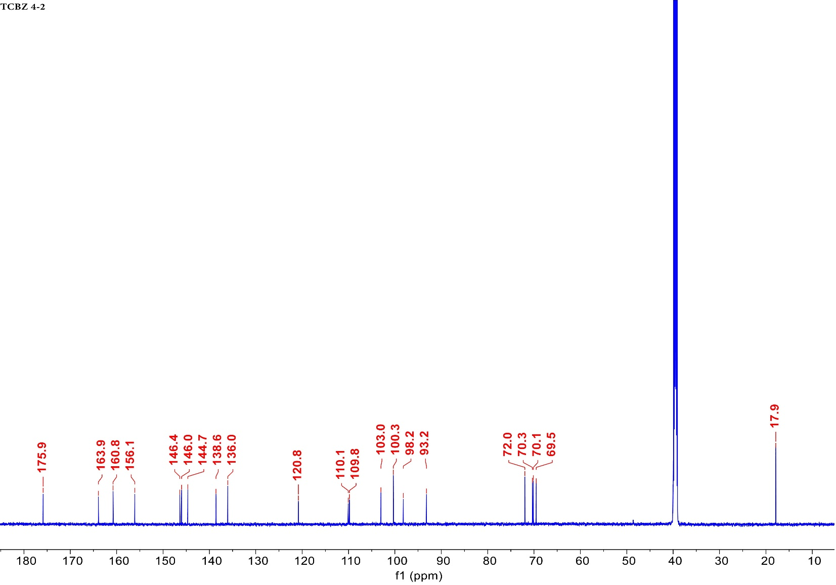

*Corresponding authors: Wuxi School of Medicine, Jiangnan University, no. 1800 Lihu Road, Wuxi, China. Key Laboratory of Tibetan Medicine Research, Northwest Institute of Plateau Biology, Chinese Academy of Sciences, no. 23 Xinning Road, Xining, China. E-mail: biowmc@126.com (Minchen Wu), dangjun@nwipb.cas.cn (Jun Dang).

