Supplementary Information for
Impact of shipping emission reductions on the chemical composition of aerosols in coastal urban air revealed by receptor modelling and numerical simulations

Eunhwa Jang1*, Seongwoo Choi¹, Eunchul Yoo¹, Sangmin Hyun² and Joongeon An³

¹ Busan Metropolitan City Institute of Health and Environment, 120, Hambakbong-ro, 140beon-gil, Buk-gu, Busan, 46616, Republic of Korea
² Marine Environmental Research Center, Korea Institute of Ocean Science and Technology, 385, Haeyang-ro, Yeongdo-gu, Busan, 49111, Republic of Korea
³ Risk Assessment Research Center, Korea Institute of Ocean Science and Technology, Geoje, 53201, Republic of Korea

∗Corresponding authors: jjena77@korea.kr (Eunhwa Jang)

This PDF file includes:
Supplementary Tables 1 to 3
Supplementary Figures 1 to 7

Supplementary Tables

Supplementary Table 1. Information on study sites and observed data.
Site Information |  |  |  |  | Data information
Site name | Longitude | Latitude | Environment type |  | Measurements |  | Temporal resolution
Buk-Hang | 129.055280 | 35.122570 | Port |  | AQM | 6 species | hourly
Site A | 129.055080 | 35.125586 |  |  | SIFT-MS | 70 trace gases | every 40 sec.
Site B | 129.048766 | 35.114855 |  |  | SIFT-MS | 70 trace gases | every 40 sec.
Sin-Hang | 128.834390 | 35.074690 |  |  | AQM  PM_{2.5} speciation | 6 species  8 ionic and 2 carbonaceous species  23 metallic species | hourly  hourly  daily
Yeon-San | 129.074590 | 35.181150 | Urban background |  | AQM  PM_{2.5} speciation | 6 species  8 ionic and 2 carbonaceous species  23 metallic species | hourly  hourly  daily

Supplementary Table 2. Hourly mean concentrations (ug/m³) of trace gases measured by a mobile laboratory equipped with selected ion flow tube mass spectrometery (SIFT-MS) at near port site (Site A) (n = 997).
Group | Species | Concentrations  (Mean $±$ S.D.) |  | Group | Species | Concentrations  (Mean $±$ S.D.)
alkane | Methane | 2874.10 $±$ 714.64 |  | halogenated | Vinyl chloride; 1,2-dichloroethane | 1.34 $±$ 0.79
 | Ethane; Ethene | 25.06 $±$ 15.56 |  |  | 1,1,1-trichloroethane | 3.96 $±$ 2.31
 | Propane | 1036.62 $±$ 633.37 |  |  | 1,1,2-trichloroethane | 12.03 $±$ 7.36
 | Butane | 39.77 $±$ 15.54 |  |  | Ethyl chloride; 1,1-dichloroethane | 8.87 $±$ 7.37
 | Pentane (iso+n) | 87.03 $±$ 62.65 |  |  | Dichloropropene | 1.07 $±$ 0.95
 | Hexane | 23.53 $±$ 17.68 |  |  | 1,2-dichloropropane | 10.51 $±$ 4.86
 | Heptane | 2.69 $±$ 1.82 |  |  | 1,2,4-trichlorobenzene | 1.41 $±$ 1.85
 | Octane (iso+n) | 9.79 $±$ 7.68 |  |  | 1,4-dichlorobenzene | 0.55 $±$ 0.46
 | Nonane | 1.58 $±$ 1.40 |  |  | Chlorobenzene | 2.32 $±$ 1.61
 | Decane | 2.72 $±$ 2.15 |  |  | 1-chlorotoluene | 2.06 $±$ 1.26
 | Undecane | 3.34 $±$ 3.05 |  |  | Freon11; Freon113; Freon114 | 5.65 $±$ 4.12
 | Dodecane | 1.73 $±$ 3.20 |  |  | Freon12; Freon114 | 17.39 $±$ 12.02
 | Cyclopentane | 6.27 $±$ 4.39 |  |  | Carbon tetrachloride | 4.69 $±$ 3.85
 | Cyclohexane | 11.02 $±$ 9.36 |  |  | Tetrachloroethylene | 3.51 $±$ 2.87
 | 2-methylpentane | 3.45 $±$ 3.28 |  | others | Hexachlorobutadiene | 0.70 $±$ 2.82
alkene | Propene | 1.69 $±$ 1.49 |  |  | Carbonyl sulfide | 3.44 $±$ 1.87
 | 2-butene | 1.66 $±$ 1.15 |  |  | Dimethyl sulfide | 0.80 $±$ 0.46
 | 1-pentene | 4.59 $±$ 3.21 |  |  | Carbon disulfide | 8.18 $±$ 6.03
 | 1-hexene | 3.48 $±$ 2.26 |  |  | Sulfuric acid | 29.34 $±$ 16.43
 | 1,3-butadiene | 0.26 $±$ 0.47 |  |  | Methyl mercaptan | 0.60 $±$ 0.60
alkyne | Acetylene | 0.25 $±$ 0.52 |  |  | Acetonitrile | 0.79 $±$ 0.72
biogenic | Isoprene | 0.26 $±$ 0.18 |  |  | Ammonia | 8.93 $±$ 8.72
 | Myrcene | 1.52 $±$ 1.54 |  | oxygenated | Methanol | 9.93 $±$ 6.29
aromatic | Benzene; Dimethyl sulfoxide | 2.55 $±$ 4.19 |  |  | Ethanol; Formic acid | 16.96 $±$ 15.68
 | Toluene | 8.08 $±$ 8.29 |  |  | Formaldehyde | 9.23 $±$ 3.94
 | Xylenes + Ethylbenzene | 7.80 $±$ 13.33 |  |  | Acetaldehyde | 7.67 $±$ 5.88
 | Styrene | 0.76 $±$ 0.57 |  |  | Propanal; Propylene oxide | 5.24 $±$ 2.84
 | C3-alkylbenzene | 4.10 $±$ 3.97 |  |  | Acetone | 8.62 $±$ 3.85
 | Naphthalene | 1.37 $±$ 1.05 |  |  | Butanone | 3.49 $±$ 3.38
halogenated | Bromoform | 0.89 $±$ 1.16 |  |  | Methyl isobutyl ketone | 1.56 $±$ 1.09
 | Chloroform; Dichloromethane;  Tetrachloroethane | 20.61 $±$ 13.94 |  |  | Tetrahydrofuran | 6.32 $±$ 5.30
 | Methyl bromide | 11.12 $±$ 7.49 |  |  | Methyl tert-butyl ether | 8.54 $±$ 6.09
 | 1,2-dibromoethane | 4.54 $±$ 3.61 |  |  | Vinyl acetate | 2.94 $±$ 2.39
 | Trichloroethylene | 1.24 $±$ 1.14 |  |  | Acetic acid | 6.45 $±$ 3.89
 | Dichloroethene (1,1 and 1,2) | 10.32 $±$ 6.33 |  |  | Butanoic acid | 1.49 $±$ 1.12

Supplementary Table 3. CMAQ scenarios for emission control in the shipping sector.
Scenarios | Emission controlling design
Case 0 | Original baseline scenario
Case 1 | SO₂ emissions reduction by 85.7% from switch to low-sulphur fuels (3.5% to 0.5%)
Case 2 | SO₂ emissions reduction by 97.1% from switch to low-sulphur fuels (3.5% to 0.1%)
Case 3 | SO₂ emissions reduction by 97.1% and shipping emission reduction of 6 species (SOx, NOx, VOC, NH₃, CO and primary PM_{2.5}) by 30%
Case 4 | Exception of NOx emission reduction from scenario Case 3
Case 5 | Exception of VOC emission reduction from scenario Case 3

Supplementary Figures

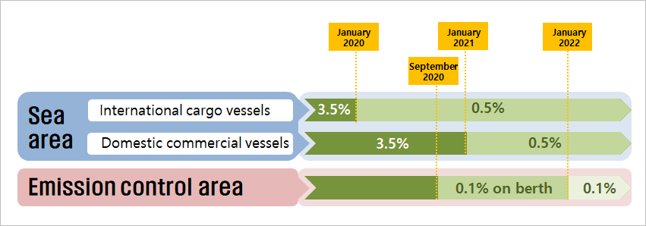
Supplementary Fig. 1. History of sulphur (S) content regulations on shipping fuel oils in Busan.

Phases | Sin-Hang (Port) | Yeon-San (Urban background)
Gaseous  [ppm] | 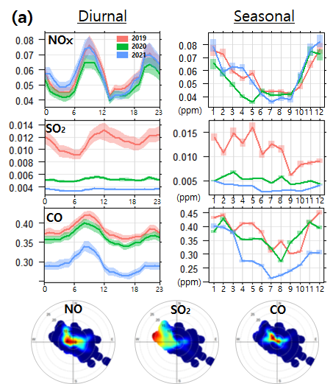 | 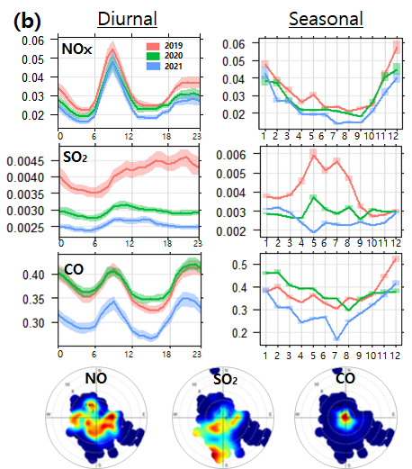
Particulate  [ug/m³] | 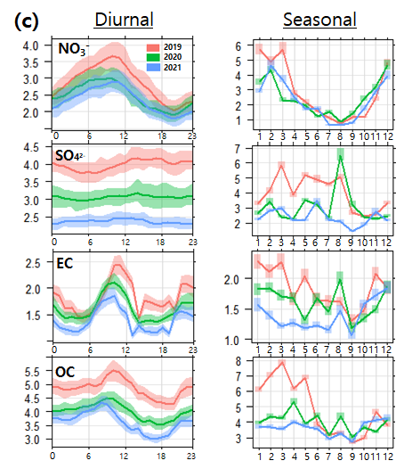 | 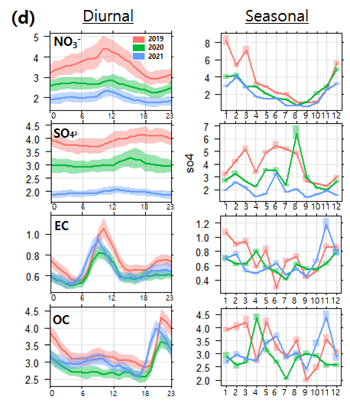

Supplementary Fig. 2. Temporal/seasonal and spatial distributions of ambient pollution level. Concentrations of gaseous species derived from air quality monitoring stations (a) at port site (Sin-Hang) and (b) at urban background site (Yeon-San). Levels of PM_{2.5} elements derived from PM_{2.5} speciation network (c) at Sin-Hang and (d) at Yeon-San.

- Sin-Hang (Port) | - Yeon-San (Urban background)
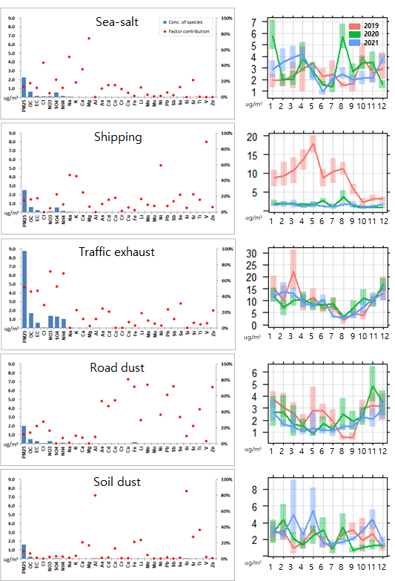 | 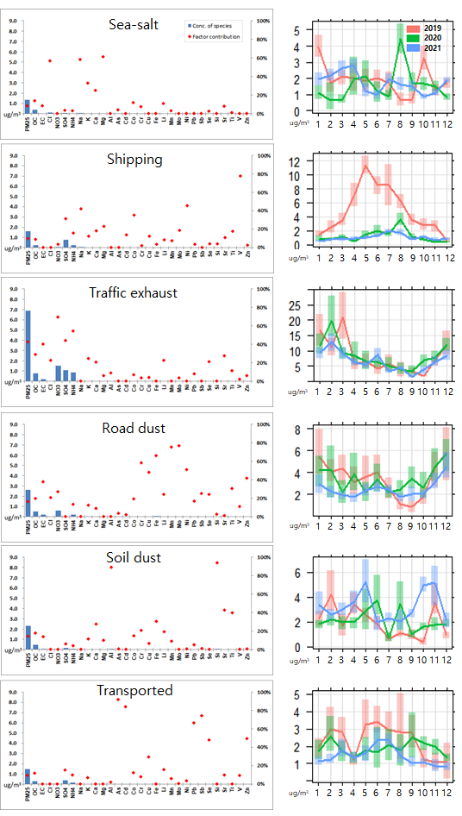

Supplementary Fig. 3. PMF factor profiles for PM_{2.5} and source-specific monthly variations. (a) PM_{2.5} levels of the port dataset are determined by five major factors, and (b) the urban background dataset is explained by a six factor solution.

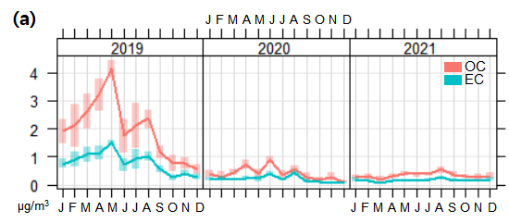
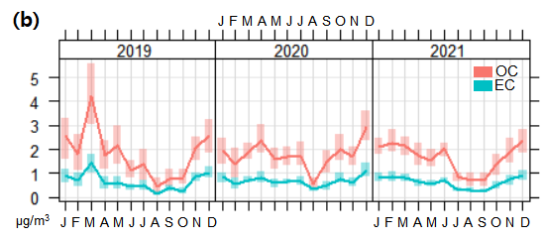

Supplementary Fig. 4. Monthly variations of PMF source-specific concentrations of carbonaceous components in PM_{2.5} at a port site (Sin-Hang) between 2019 and 2021. The concentration of organic carbon (OC) and elemental carbon (EC) associated with (a) shipping-source and (b) traffic-source.

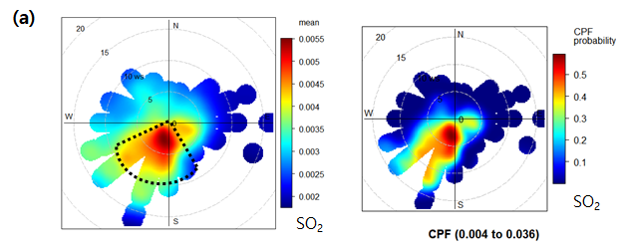
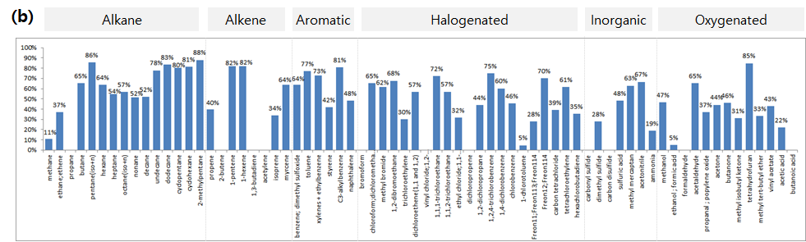

Supplementary Fig. 5. Influence of air pollutions associated with shipping emissions at Site A. (a) Concentrations of SO₂ as a function of meteorological conditions, and a conditional probability function (CPF) plot of SO₂ being greater than the 70th percentile. (b) Contribution profile of net shipping emissions obtained from the cross sectional spatial analysis.

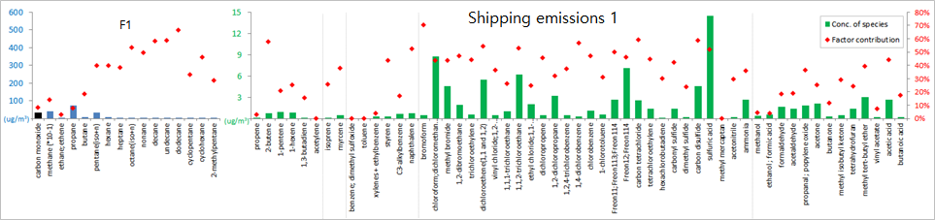
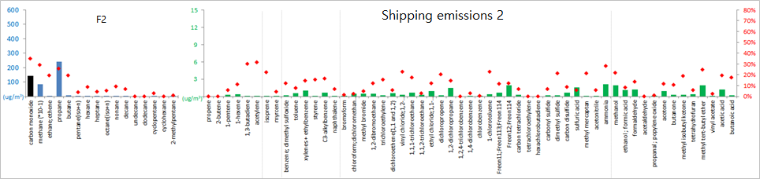
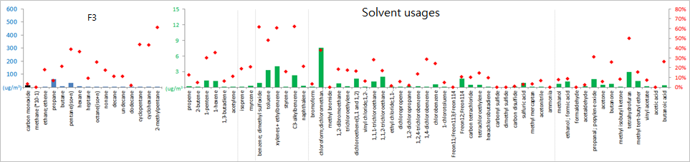
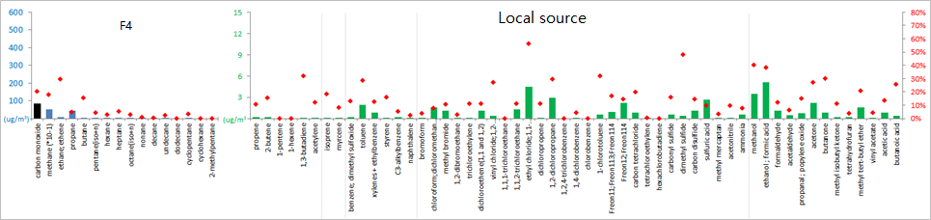
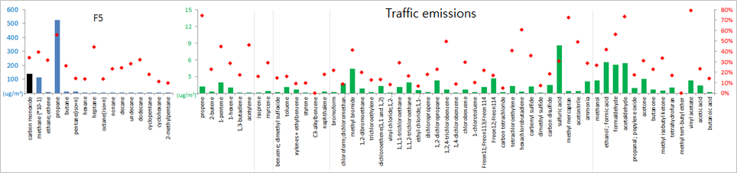

Supplementary Fig. 6. PMF factor profiles for trace gases measured by a mobile laboratory equipped with a selected ion flow tube mass spectrometery (SIFT-MS) at a port site (Site A).
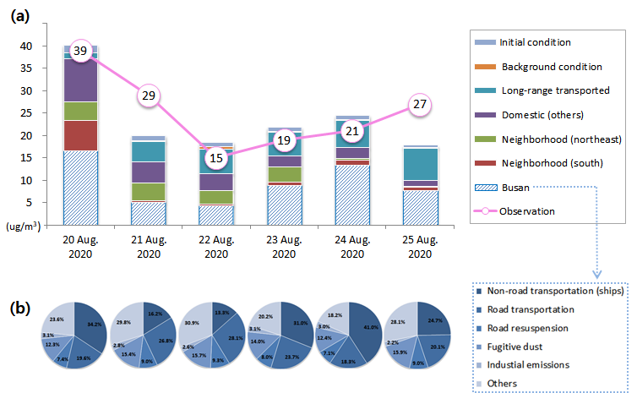

Supplementary Fig. 7. Estimated source-specific contributions to surface PM_{2.5} mass concentrations at the urban background site (Yeon-San) based on CAMx/PSAT modelling results. (a) The bar chart represents major source regions that contribute to the daily PM_{2.5} levels at Yeon-San while the line chart shows the observed PM_{2.5} values at the same location. (b) Source-specific contributions to PM_{2.5} at Yeon-San attributable to local emissions in Busan.

