This file is supplementary to “COVID-19 Mortality Risk Prediction using Clinical and Laboratory Examination: Machine Learning Approach for Implementation” by Siavash Shirzadeh Barough, Seyed Amir Ahmad Safavi-Naini, Fatemeh Siavoshi, Atena Tamimi, Saba Ilkhani, Ali Sajedian, Jalel Ben Hmida, Setareh Akbari, Sadaf Ezzati, Hamidreza Hatamabadi, Mohamad Amin Pourhoseingholi.
Corresponding to: Dr Mohamad Amin Pourhoseingholi, PhD, Basic and Molecular Epidemiology of Gastrointestinal Disorders Research Center, Research Institute for Gastroenterology and Liver Diseases, Shahid Beheshti University of Medical Sciences, Tehran, Iran, Pourhoseingholi@sbmu.ac.ir
Supplementary Table S1. Mean difference and characteristics of mortality and survived cohort.
Feature | Mortality Cohort (N=917) | Survived Cohort (N=4403) | P-Value
Headache | 58.0(6.32%) | 379.0(2.98%) | 0.0001
vomiting | 180.0(19.63%) | 767.0(6.04%) | 0.0001
HLP | 44.0(4.80%) | 155.0(1.22%) | 0.158
Myalgia | 181.0(19.74%) | 895.0(7.05%) | 0.0001
Cough | 373.0(40.68%) | 1402.0(11.04%) | 0.0001
Fever | 343.0(37.40%) | 1312.0(10.33%) | 0.0001
Opium | 43.0(4.69%) | 135.0(1.06%) | 0.39
PH | 7.36(7.29,7.41) | 7.38(7.34,7.42) | 0.0001
Anosmia | 5.0(0.55%) | 54.0(0.43%) | 0.001
Ear pain | 0.0(0.00%) | 5.0(0.04%) | 0.231
CA | 8.50(8.00,9.10) | 8.70(8.20,9.23) | 0.0001
HB | 11.80(10.00,13.30) | 12.40(11.00,13.60) | 0.0001
o2sat | 85.00(78.00,90.00) | 90.00(85.72,93.00) | 0.0001
HCO3 | 23.70(20.20,27.40) | 26.00(23.20,28.70) | 0.0001
Gender | nan(0.00%) | nan(0.00%) | 0.0001
Dyspnea | 557.0(60.74%) | 1698.0(13.37%) | 0.126
rigors | 218.0(23.77%) | 870.0(6.85%) | 0.0001
Weakness | 379.0(41.33%) | 1027.0(8.09%) | 0.118
Sore throat | 14.0(1.53%) | 73.0(0.57%) | 0,046
Anorexiua | 143.0(15.59%) | 522.0(4.11%) | 0.012
Diarrhea | 76.0(8.29%) | 334.0(2.63%) | 0.0001
Chest pain | 63.0(6.87%) | 319.0(2.51%) | 0.0001
Seizure | 12.0(1.31%) | 21.0(0.17%) | 0.107
Lymph adenopathy | 0.0(0.00%) | 3.0(0.02%) | 0.416
Dermatic lesions | 8.0(0.87%) | 5.0(0.04%) | 0.006
Abdominal pain | 61.0(6.65%) | 195.0(1.54%) | 0.307
Hemorragia | 9.0(0.98%) | 11.0(0.09%) | 0.044
Hemi paresia | 9.0(0.98%) | 20.0(0.16%) | 0.303
Pregnancy | 2.0(0.22%) | 17.0(0.13%) | 0.104
Smoker | 60.0(6.54%) | 160.0(1.26%) | 0.275
Hookah | 4.0(0.44%) | 20.0(0.16%) | 0.233
HTN | 419.0(45.69%) | 997.0(7.85%) | 0.0001
CABG | 65.0(7.09%) | 120.0(0.95%) | 0.002
Ashtma | 23.0(2.51%) | 87.0(0.69%) | 0.164
Pneumonia | 7.0(0.76%) | 7.0(0.06%) | 0.041
CKD | 64.0(6.98%) | 111.0(0.87%) | 0.0001
Thyroid problems | 51.0(5.56%) | 156.0(1.23%) | 0.439
immunodefficacy | 1.0(0.11%) | 6.0(0.05%) | 0.436
Tuberclosis | 3.0(0.33%) | 10.0(0.08%) | 0.572
Anemia | 13.0(1.42%) | 40.0(0.32%) | 0.517
Liver steatosis | 4.0(0.44%) | 22.0(0.17%) | 0.172
LYMPHH | 10.00(7.00,16.40) | 16.00(10.00,24.30) | 0.0001
PLT | 185.00(135.00,259.00) | 192.00(149.00,255.00) | 0.0001
AST | 45.00(29.00,73.90) | 36.00(25.50,53.00) | 0.0001
ALT | 30.00(18.00,50.38) | 29.65(18.42,47.57) | 0.0001
CRP | 41.20(14.30,77.80) | 28.50(10.80,61.10) | 0.0001
pco2 | 42.80(36.50,50.10) | 45.00(39.40,50.30) | 0.0001
troponin | 0.02(0.00,0.12) | 0.01(0.00,0.03) | 0.0001
cpk | 161.00(80.00,379.00) | 118.00(63.00,264.00) | 0.0001
pt | 13.00(12.40,14.60) | 13.00(12.00,13.50) | 0.0001
ptt | 32.00(27.00,38.00) | 31.00(26.70,35.00) | 0.0001
esr | 36.00(21.00,58.00) | 33.24(20.00,53.00) | 0.0001
NA | 138.00(135.00,141.00) | 138.00(135.00,140.00) | 0.0001
pr | 88.00(80.00,100.00) | 86.00(80.00,94.00) | 0.0001
DBP | 75.00(70.00,80.00) | 80.00(70.00,80.00) | 0.0001
SBP | 116.00(100.00,130.00) | 120.00(110.00,130.00) | 0.0001
T | 85.00(78.00,90.00) | 80.00(70.00,85.00) | 0..520
NEUT | 85.00(78.00,90.00) | 80.00(70.00,85.00) | 0.0001
RR | 19.09(18.00,22.00) | 18.00(18.00,20.00) | 0.0001
Age | 74.00(61.00,83.00) | 60.00(47.00,71.00) | 0.0001
WBC | 9.20(6.30,13.30) | 6.80(4.90,9.70) | 0.0001
DM | 346.0(37.73%) | 784.0(6.17%) | 0.0001
k | 4.20(3.80,4.60) | 4.00(3.80,4.40) | 0.0001
Cancer | 78.0(8.51%) | 128.0(1.01%) | 0.0001
inr | 1.14(1.00,1.30) | 1.07(1.00,1.20) | 0.0001
IHD | 214.0(23.34%) | 394.0(3.10%) | 0.0001
CR | 1.40(1.10,2.20) | 1.10(0.90,1.40) | 0.0001
CHF | 31.0(3.38%) | 52.0(0.41%) | 0.01
COPD | 22.0(2.40%) | 47.0(0.37%) | 0.133
CVA | 101.0(11.01%) | 134.0(1.06%) | 0.0001
GI problems | 15.0(1.64%) | 35.0(0.28%) | 0.271
Hepatitis C | 1.0(0.11%) | 4.0(0.03%) | 0.625
Alzheimer | 63.0(6.87%) | 48.0(0.38%) | 0.0001
Arthralgia | 14.0(1.53%) | 40.0(0.32%) | 0.515
Psychological problems | 24.0(2.62%) | 39.0(0.31%) | 0.017
Rheumatoid Arthritis | 13.0(1.42%) | 27.0(0.21%) | 0.193
mg | 2.00(1.80,2.20) | 1.90(1.80,2.10) | 0.0001
rhinorrhea | 9.0(0.98%) | 20.0(0.16%) | 0.303
Parkinson | 25.0(2.73%) | 24.0(0.19%) | 0.0001
Loss of consciousness | 233.0(25.41%) | 179.0(1.41%) | 0.0001
Alcohol consumption | 10.0(1.09%) | 11.0(0.09%) | 0.022

Supplementary Table S2. Cox regression of variables for mortality incidence.
Feature | HR | Lower 95% CI | Upper 95% CI | P-Value
Headache | 0.881 | 0.668 | 1.164 | 0.374
vomiting | 0.830 | 0.696 | 0.990 | 0.038
HLP | 0.957 | 0.697 | 1.315 | 0.788
Myalgia | 0.825 | 0.688 | 0.988 | 0.037
Cough | 0.946 | 0.811 | 1.104 | 0.481
Fever | 0.936 | 0.774 | 1.133 | 0.500
Opium | 0.827 | 0.581 | 1.178 | 0.293
PH | 0.651 | 0.413 | 1.024 | 0.063
Anosmia | 0.925 | 0.380 | 2.253 | 0.864
Ear pain | 0.000 | 0.000 | ######## | 0.904
CA | 0.979 | 0.919 | 1.042 | 0.501
HB | 0.962 | 0.931 | 0.995 | 0.025
o2sat | 0.970 | 0.965 | 0.976 | 0.000
HCO3 | 0.971 | 0.957 | 0.986 | 0.000
Gender | 0.991 | 0.853 | 1.151 | 0.906
Dyspnea | 0.925 | 0.792 | 1.081 | 0.326
rigors | 0.978 | 0.789 | 1.213 | 0.842
Weakness | 1.025 | 0.889 | 1.183 | 0.731
Sore throat | 0.828 | 0.481 | 1.426 | 0.496
Anorexia | 0.846 | 0.698 | 1.026 | 0.090
Diarrhea | 1.180 | 0.922 | 1.509 | 0.189
Chest pain | 0.877 | 0.668 | 1.152 | 0.346
Seizure | 0.973 | 0.501 | 1.888 | 0.935
Lymph adenopathy | 0.001 | 0.000 | ######## | 0.926
Dermatic lesions | 3.221 | 1.537 | 6.750 | 0.002
Abdominal pain | 1.063 | 0.803 | 1.408 | 0.669
Hemorragia | 0.761 | 0.380 | 1.521 | 0.439
Hemi paresia | 1.161 | 0.586 | 2.299 | 0.669
Pregnancy | 0.960 | 0.122 | 7.552 | 0.969
Smoker | 0.860 | 0.631 | 1.171 | 0.338
Hookah | 0.578 | 0.162 | 2.055 | 0.397
HTN | 0.890 | 0.766 | 1.035 | 0.132
CABG | 1.184 | 0.899 | 1.560 | 0.229
Asthma | 0.800 | 0.518 | 1.233 | 0.312
Pneumonia | 1.243 | 0.556 | 2.776 | 0.597
CKD | 0.775 | 0.576 | 1.044 | 0.094
Thyroid problems | 1.195 | 0.887 | 1.610 | 0.241
Immune defficacy | 1.619 | 0.221 | 11.854 | 0.635
Tuberculosis | 0.913 | 0.276 | 3.020 | 0.881
Anemia | 1.222 | 0.685 | 2.182 | 0.497
Liver steatosis | 1.249 | 0.460 | 3.390 | 0.663
LYMPHH | 1.005 | 0.987 | 1.024 | 0.576
PLT | 0.999 | 0.998 | 1.000 | 0.002
AST | 1.000 | 1.000 | 1.001 | 0.804
ALT | 1.000 | 0.999 | 1.001 | 0.811
CRP | 1.002 | 1.000 | 1.003 | 0.039
pco2 | 1.004 | 0.999 | 1.008 | 0.084
troponin | 1.011 | 0.987 | 1.035 | 0.368
CPK | 1.000 | 1.000 | 1.000 | 0.006
pt | 1.000 | 0.997 | 1.004 | 0.848
ptt | 1.002 | 0.995 | 1.008 | 0.619
esr | 0.999 | 0.996 | 1.003 | 0.715
NA | 1.003 | 0.991 | 1.015 | 0.611
pr | 1.005 | 1.002 | 1.009 | 0.004
DBP | 1.000 | 0.999 | 1.001 | 0.740
SBP | 0.999 | 0.996 | 1.002 | 0.537
T | 1.000 | 0.995 | 1.005 | 0.972
NEUT | 1.019 | 1.003 | 1.036 | 0.019
RR | 1.009 | 1.002 | 1.016 | 0.016
Age | 1.028 | 1.023 | 1.034 | 0.000
WBC | 1.008 | 1.002 | 1.015 | 0.015
DM | 1.090 | 0.936 | 1.270 | 0.266
k | 1.040 | 0.991 | 1.091 | 0.111
Cancer | 1.253 | 0.966 | 1.626 | 0.089
INR | 1.100 | 0.954 | 1.267 | 0.188
IHD | 1.101 | 0.927 | 1.309 | 0.272
CR | 1.041 | 1.000 | 1.085 | 0.051
CHF | 1.129 | 0.761 | 1.675 | 0.546
COPD | 1.181 | 0.755 | 1.849 | 0.466
CVA | 1.207 | 0.957 | 1.522 | 0.112
GI problems | 1.797 | 1.037 | 3.113 | 0.037
Hepatitis C | 1.348 | 0.185 | 9.805 | 0.768
Alzheimer | 1.038 | 0.776 | 1.387 | 0.802
Arthralgia | 0.992 | 0.555 | 1.775 | 0.979
Psychological problems | 1.636 | 1.073 | 2.495 | 0.022
Rheumatoid Arthritis | 1.908 | 1.062 | 3.427 | 0.031
mg | 1.020 | 0.836 | 1.243 | 0.848
rhinorrhea | 1.892 | 0.926 | 3.868 | 0.080
Parkinson | 1.106 | 0.720 | 1.700 | 0.645
Loss of consciousness | 1.499 | 1.253 | 1.794 | 0.000
Alcohol consumption | 2.599 | 1.235 | 5.469 | 0.012

Supplementary Figure S1. Feature selection by Boruta method.
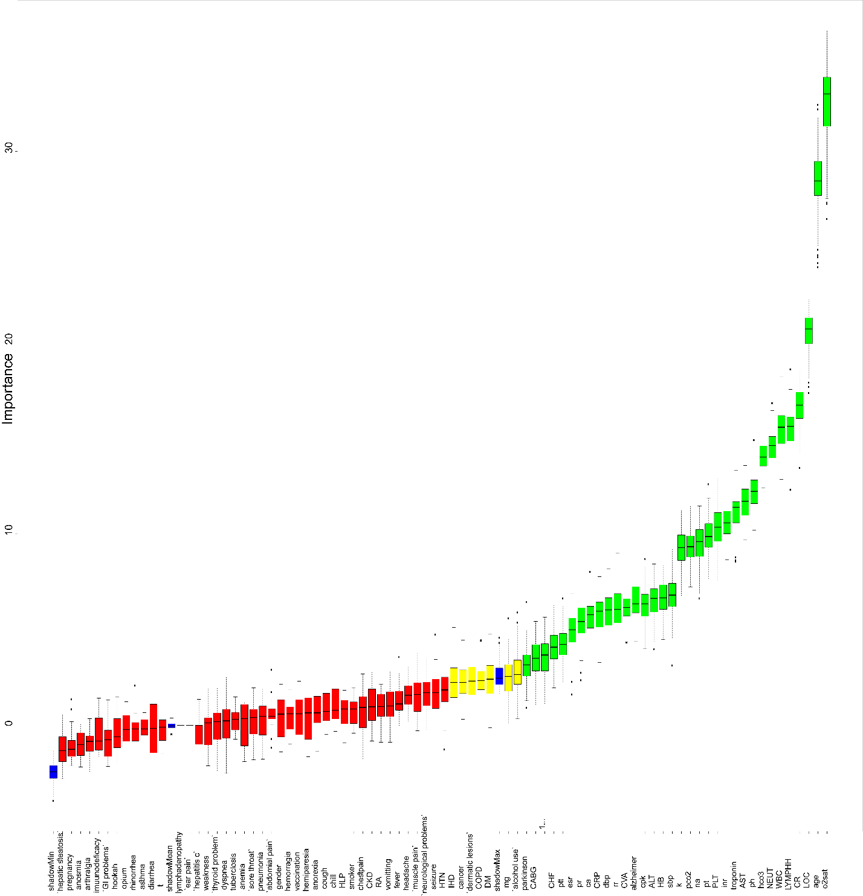

Supplementary Figure S2. Feature Selection by LASSO method.

Supplementary Figure S3. Correlation gram of nominal variables. 