The tragedy of the cows: exploring the short and long-term warming effect of methane emissions in agricultural mitigation

Supplementary Information

Scenario description
For practical reasons and transparency, a similar set of scenarios as in Frank et al. 2019 is used and extended with new scenarios. The scenarios are counterfactual to a long-term ‘business as usual’ projection of agricultural commodity markets and are presented to provide a more comprehensive perspective of how global mitigation policies and dietary policies could contribute to the temperature target set by the Paris Agreement under GWP₁₀₀ and GWP* metrics. Focus is on the reduction of agricultural methane emissions over time and their effective contribution to climate change, differentiating between sources (e.g. ruminant, dairy and rice production) and world producing regions.
In order to analyse the economic impact of global climate mitigation policies we use on the supply side a global carbon price path as a proxy for a global mitigation effort (see Frank et al. 2019). The impacts of this global carbon price on methane emissions depends on the emission metric applied, and will differ from the standard GWP₁₀₀, if GWP* metric is applied due to the introduction of time dynamics in its calculation. This is achieved through the following equation, presented as in the simplified rearrangement from Lynch et al (2020):
$$E_{{CO}_{2}-{w.e.}_{({CH}_{4})}}={GWP}_{100}×(4×E_{{CH}_{4}\left(t\right)}-3.75×E_{{CH}_{4}\left(t-20\right)})$$
Where ‘CO₂-warming-equivalent’ (CO₂^{we}) emissions have a large initial effect at the time of release $(4 ×$ the conventional GWP₁₀₀ valuation), but much of this (3.75 $×$the conventional GWP₁₀₀ valuation) is considered reversed 20 years later. Consequently, the reported CO₂-equivalence valuation of methane emissions can be higher for those sources where emissions have increased over time and can be negative for those cases where emissions have decreased.
‘Carbon pricing’ is widely acknowledged as an efficient means to achieve the ambitions set out in the Paris-agreement (Bowen 2011, Baranzini et al. 2017, Stiglitz et al. 2017, Akerlof et al. 2019), however it requires a transparent, predictable, and practicable monitoring system that reports emissions at their source. Emissions from agriculture differ from emissions from standardized industrial processes due to their biological nature, diverse land-use techniques and different farm management practices leading to large variations in emission intensities for identical products (Bonesmo et al. 2013, Alemu et al. 2017, Samsonstuen et al. 2020). In addition, the spatial dispersion of farming renders the accurate monitoring of agricultural emissions at their source almost impossible. Carbon prices have therefore been applied in agricultural economic models as an approximation of other policies that incentivize farmers to implement mitigation options (or penalizes them for not adopting them), while the transaction costs caused by those policies have been neglected (Ripple et al. 2014, Frank et al. 2019).
Notwithstanding the fact that monitoring emissions in agriculture involves high transaction costs, the change in the GHG accounting metric to GWP* makes the implementation of a carbon price in agriculture more complicated as the warming impact of methane emissions needs to be based on two points in time and differ with a time span of 20 years. In effect, the full impact of emissions is delayed by 20 years raising concerns about who can be made responsible to paying the carbon price. GWP₁₀₀ accounts emissions only in the year they originate. On the contrary, GWP* accounting requires the year emissions occur, and 20 years before, to reflect that short-lived methane is rapidly destroyed in the atmosphere via natural processes. A carbon price that requires a time span of 20 years to be calculated, is difficult to administer. Neither the farmer nor the firm responsible for the emissions will necessarily be the same after 20 years.
For this exploratory study, we consider two options for the computation of the carbon price: a “short term” (MEF-ST) and a “long term” (MEF-LT) one, separating out the two components of the GWP* equation.
The MEF-ST option focuses on the strong impact of changing methane emission rates, computing the carbon price based on the initial valuation at the point an emissions occurs, and neglecting the subsequent reversal of most of the emission’s impact in the years ahead. Consequently, the resulting carbon price will be four times higher compared to a GWP₁₀₀-based carbon price, leading to strong incentives to mitigate methane emissions. The MEF-ST option could reflect motives of decision makers that prioritise reducing overall GHG emissions fast, i.e., almost independent from any metric.
The MEF-LT option aims at implementing a GWP*-based carbon price assuming that the methane dynamics are that is perfectly understood by economic actors and credibly enforced by regulators. Since we apply static models to a dynamic planning problem, we simplify the planning problem by assuming Hotelling’s rule (1931). This rule states that the optimal price path of a non-renewable, durable resource follows the discount rate. We assume that every CO₂ emission causes the same damage, and, consequently, no tipping points are considered. In our case, that resource would be the CO₂-absorbing capacity of the atmosphere. With constant carbon prices in real terms, the carbon price will be understood as a regime that charges emissions four times the GWP₁₀₀-based carbon price the year they accrue, but rewards a rebate of 3.75 times that price 20 years later. The net effect is a price of (4 – 3.75 =) 25 percent of the GWP₁₀₀-based carbon price. The MEF-LT option thus reflects the fact that “after 20 years much of the warming caused by an individual methane emitter is automatically reserved” (Lynch et al. 2020). In our models, the MEF-LT carbon price is implemented with its net effect in the year emissions occur.
The two options above only regard the pricing of methane. The computation of the carbon price for carbon dioxide and nitrous oxide is not affected by GWP* and follows GWP₁₀₀ in both options. Although nitrous oxide is less durable than carbon dioxide, it is not considered a short-lived climate gas as methane. These globally uniform carbon prices (see Figure X) are used to estimate the cost-efficient mitigation potential and its distribution across sectors and regions rather than a real world policy [14]. We apply two global carbon price trajectories, 100 and 500 $/t CO₂e. at 2070, consistent with earlier publications, as higher carbon prices cannot stimulate more technical options, but decrease consumption [14]. In addition to CH₄ emissions, N₂O emissions from agricultural production are priced according to the GWP₁₀₀ N₂O price. In line with the focus of this study on non-CO₂ emissions from agriculture, CO₂ emissions from deforestation or other land-use change are not priced.
Figure S1: carbon price trajectories for agricultural emissions from 2030 to 2070: 150$ (left) and 500$ (right)
Note: see Table S1 below for scenario acronyms.
Our second mitigation option is a shift towards a less animal protein based diet. The adoption of such a diet has been identified in the literature as a promising strategy to curb greenhouse gas emissions from the agriculture and global food systems [24] [25]. This is in line with recommendations by the EAT-Lancet Commission, which proposes a healthier diet where whole grains, fruits, vegetables, nuts and legumes comprise a greater proportion of foods consumed. This diet includes calorie intake targets by food group and a total calorie intake target of 2100 kcal [26] [30] [31].
Frank et al., 2019 assess in their analysis the implications for GHG mitigation and food availability of a shift in preferences towards less animal product based diets in developed and emerging countries. To allow for comparison of methane emission reductions based on different GWP metrics, we follow the same simplified dietary assumptions and assume a threshold on animal product calories of 430 kcal per capita per day. This target excludes waste and is assumed to be achieved by 2070, such that calorie consumption decreases linearly from current levels. No increase in consumption of vegetable calories is assumed, but might occur as a ‘rebound’ effect.
Preference shifts towards plant-based diets (i.e. lower consumption of livestock products) can have a positive impact on a smaller and less intensive livestock sector, with a reduction of methane emissions from enteric fermentation and manure management processes. In our analysis, we reduce the calorie consumption from ruminant meat, non-ruminant meat and dairy products by and non-ruminants in equal portions (see Figure S2). Under the BASE_D scenario, per capita calorie consumption is reduced by about 12 - 60% in 2030, 50 - 80% in 2050 and 70-120% in 2070, depending on the model. This calorie reduction takes place only in emerging economies (e.g. China, Former Soviet Union) and developed countries (European Union, US and Canada).
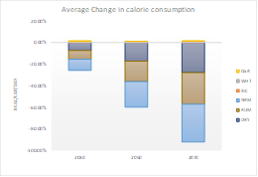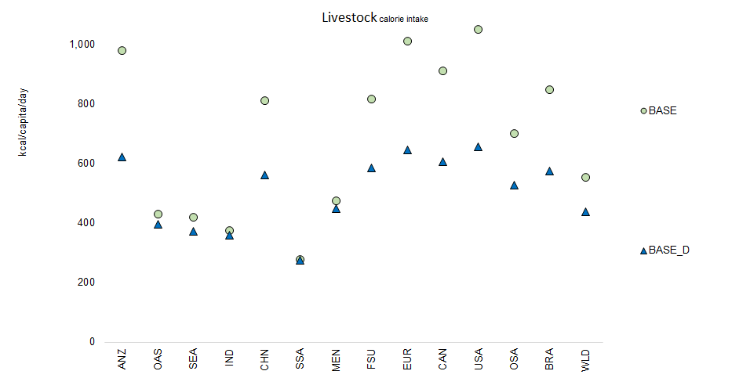
Figure S2: change in calorie consumption, world totals for scenarios BASE and BASE_D by baseline year and agricultural commodity groups (a) and by region for year 2050 (b). DRY, milk; RUM, ruminant meats; NRM, non-ruminant meats; RIC, paddy rice; CER, cereals; OCR, other crops. ANZ, Australia and New Zealand; OAS, other Asia; SEA, Southeast Asia; IND, India; CHN, China; SSA, sub-Saharan Africa; MEN, Middle East, North Africa and Turkey; FSU, former Soviet Union; EUR, Europe; CAN, Canada; USA, United States of America; OSA, other South, Central America and Caribbean (including Mexico); BRA, Brazil.
In Table S1 the mitigation and dietary shift scenarios analysed by the three models are included.
Table S1: scenario matrix. MEF-short term: 4x25 = 100, MEF-long term: 0.25x25 = 6.25
Carbon price regime for methane | No carbon price |  | Carbon price 150$ |  | Carbon price 500$
Carbon price regime for methane | No dietary change | Low animal protein diet | No dietary change | Low animal protein diet | No dietary change | Low animal protein diet
No carbon pricing | BASE | BASE_D
GWP₁₀₀ (=25) |  |  | CP150 | CP150_D | CP500 | CP500_D
MEF-ST (=100) |  |  | CP150_ST | CP150_ST_D | CP500_ST | CP500_ST_D
MEF-LT (=6.25) |  |  | CP150_LT | CP150_LT_D | CP500_LT | CP500_LT_D

Method for calculating methane prices
The models are run for two options for the computation of the carbon price: MEF-ST (“short-term”) and MEF-LT (“long-term”). Both options use the same carbon price. We distinguish two price paths: 150 $ per t CO₂ and 500 $ per t CO₂ in 2005. Following Hotelling’s rule, the optimal carbon price path follows a discount rate which is set to 5 per cent. This results in the carbon price rates shown in table S2.
Table S2. Carbon price rates by carbon price level for 2030, 2050 and 2070 (€ per t CO₂e)
Carbon price level | 2030 | 2050 | 2070
150 $ per t CO₂ | 18.73 | 49.69 | 131.84
500 $ per t CO₂ | 62.43 | 165.63 | 439.47
We base our computation of the carbon price for methane on the GWP* equation in Lynch et al. (2020), p. 3:
$${{GWP}^{*}}_{t}=\left(4 ×E_{SLCP\left(t\right)}-3.75 ×E_{SLCP\left(t-20\right)}\right)×{GWP}_{100}$$
where GWP*_{t} measures the global warming potential of methane depending on emitted methane in t and emitted methane 20 years before (t-20). Emitted methane in t appears a second time in the calculation of GWP* in t+20:
$${{GWP}^{*}}_{t+20}=\left(4 ×E_{SLCP\left(t+20\right)}-3.75 ×E_{SLCP\left(t\right)}\right)×{GWP}_{100}$$
Assuming a carbon price rate CPR_{t}, a given methane emission E_{SLCP(t)} in t is taxed twice and the total amount CP_{t} of that emission is given by:
$$CP_{t}=\left(4 ×E_{SLCP\left(t\right)}×{CPR}_{t}-3.75 ×E_{SLCP\left(t\right)}×{CPR}_{t+20}\right)×{GWP}_{100}$$
Since the path of the carbon price follows the discount rate, the carbon price rate in real prices remains the same in all years, CP_{t+20} = CP_{t}.
The MEF-ST option of the carbon price disregards the flow term, i.e., the price reward 20 years after the emission occurred. Therefore, the carbon price of a methane emission in t defined as € per t CH₄ becomes:
$$CP_{t}\left("short-term"\right)=\left(4 ×E_{SLCP\left(t\right)}×{CPR}_{t}\right)×{GWP}_{100}$$
The long-term option of the carbon price regards both terms, and the carbon price of a methane emission in t defined as € per t CH₄ is computed as:
$$CP_{t}\left("long-term"\right)=\left(.25 ×E_{SLCP\left(t\right)}×{CPR}_{t}\right)×{GWP}_{100}$$
Assuming GWP₁₀₀ = 25 (AR4), the carbon price for the two options are shown in table S3. For comparison, the price rates based on GWP₁₀₀ are also shown.
Table S3. Carbon price rates for methane by carbon price level and pricing option for 2030, 2050 and 2070 (€ per t CH₄)
Carbon price level | Pricing option | 2030 | 2050 | 2070
150 $ per t CO₂ | GWP₁₀₀ | 468.19 | 1 242.24 | 3 296.04
150 $ per t CO₂ | MEF-ST | 1 872.75 | 4 968.97 | 13 184.15
150 $ per t CO₂ | MEF-LT | 117.05 | 310.56 | 824.01
500 $ per t CO₂ | GWP₁₀₀ | 1 560.63 | 4 140.81 | 10 986.79
500 $ per t CO₂ | MEF-ST | 6 242.51 | 16 563.23 | 43 947.17
500 $ per t CO₂ | MEF-LT | 390.16 | 1035.20 | 2 746.70

Additional supporting Tables and Figures
Figure S3: Methane and nitrous oxide emissions for the baseline and 150 $/t carbon price scenarios; world totals by year and model; (a) annual Mt CH₄; (b) annual Mt N₂O; (c) added warming for CH₄ emissions (°C); and (d) added warming for total non-CO₂ emissions °C).
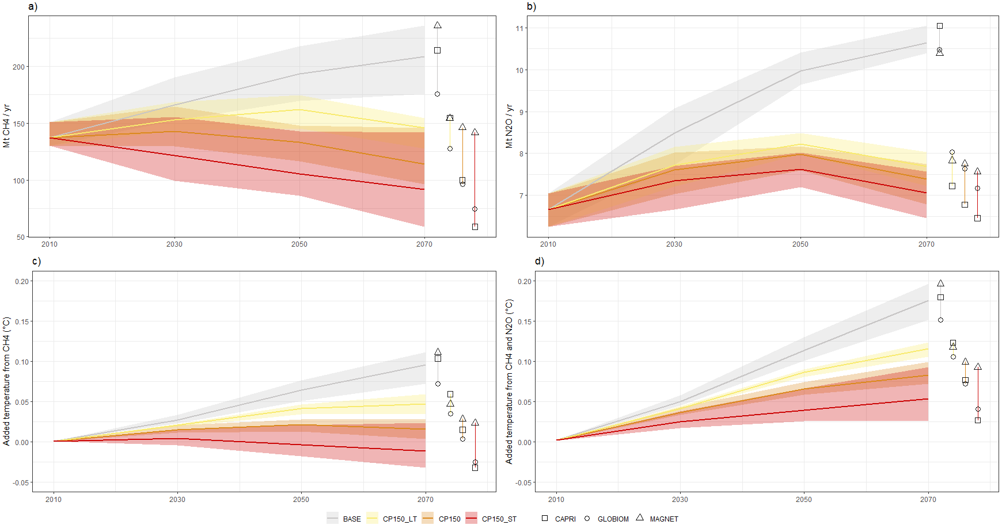

Figure S4: Methane and nitrous oxide emissions for the baseline and short-term carbon price scenarios including diet shifts; world totals by year and model; (a) Annual Mt CH₄; (b) Annual Mt N₂O; (c) added warming for CH₄ emissions (°C); and (d) added warming for total non-CO₂ emissions (°C).
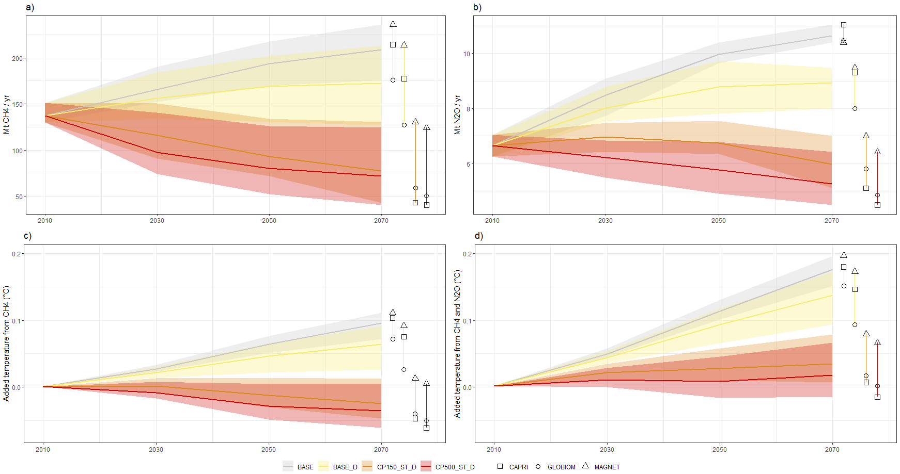

Figure S5: methane and nitrous oxide emissions for the baseline and long-term carbon price scenarios including diet shifts; world totals by year and model; (a) Annual Mt CH₄; (b) Annual Mt N₂O; (c) added warming for CH₄ emissions (°C); and (d) added warming for total non-CO₂ emissions (°C).
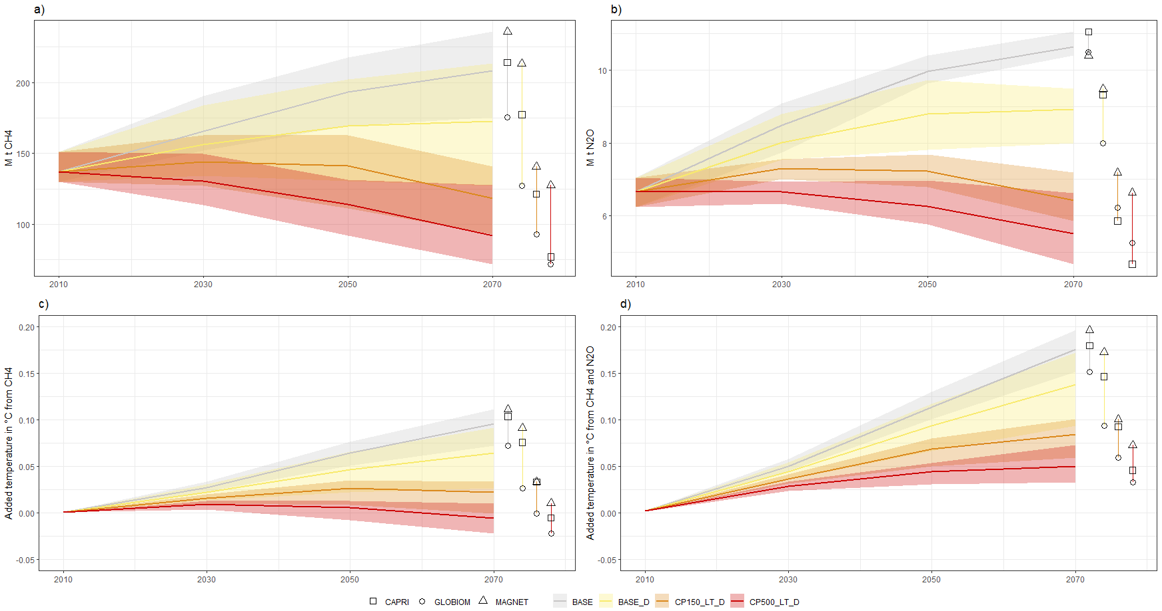

Models

CAPRI
CAPRI (Common Agricultural Policy Regionalised Impact) modelling system is an economic large-scale, comparative-static, partial equilibrium model focusing on agriculture and the primary processing sectors (www.capri-model.org). CAPRI comprises two interacting modules, linking a set of mathematical programming models of EU regional agricultural supply to a spatial multi-commodity model for global agri-food markets. The regional supply models depict a profit maximizing behavior of representative farms in the EU and candidate countries, taking constraints related to land availability, nutrient balances for cropping and animal activities and policy restrictions into account (Britz and Witzke, 2014). The market module consists of a spatial, non-stochastic global multi-commodity model for about 60 primary and processed agricultural products, covering 77 countries in 40 trading blocks. Bilateral trade flows and attached prices are modelled based on the Armington assumption of quality differentiation (Armington 1969). The behavioral functions in the market model represent supply and demand for primary agricultural and processed commodities (including human and feed consumption, biofuel use, import demand from multilateral trade relations), balancing constraints and agricultural market policy instruments (i.e. import tariffs, tariff rate quotas, producer and consumer support estimates, etc.). Depending on scenarios behavioural functions are shifted (e.g to reflect productivity shocks or preference shifts) and the model solves for the new market equilibrium.
With regard to GHG accounting, CAPRI calculates EU agricultural GHG emissions for the most important nitrous oxide and methane emission sources based on the inputs and outputs of agricultural production activities, following to a large extent the 2006 IPCC guidelines. It also includes specific technical and management-based GHG mitigation options for EU agriculture into account, specified quite detailed for agricultural activities. GHG emissions for the rest of the world are estimated on a commodity basis in the market model (Pérez Domínguez, 2016; Fellmann et al, 2018). GHG mitigation in non-European countries is represented by a change in emission factors and a matching change in output prices to reflect the increase in cost, derived from mitigation cost functions from the literature (Lucas et al. 2007). In terms of the database the European data are mostly sourced from Eurostat while the international data are mostly from FAO, for both model parts supplemented by topic related sources.
The modelling of the diet cuts was done by reducing the consumption of animal products in all countries that consume more animal product calories than 430 kcal per capita per day based on recommendations by the United States Department of Agriculture (www.cnpp. usda.gov/USDAFoodPatterns). The calories target (excluding waste) is achieved gradually by 2070, such that calorie consumption will decrease linearly from the 2020 level to 430 kcal per capita per day in 2070.
References:
Armington, P. S., 1969. A Theory of Demand for Products Distinguished by Place of Production. IMF Staff Papers 16, 159-178.EN.REFLISTWolf, W., 1995. ‘SPEL system, Methodological documentation (Rev. 1), Vol. 1: Basics, BS, SFSS’, Eurostat Luxembourg.
Britz W., Witzke H.P. (2014). CAPRI Model Documentation 2014. University of Bonn. Available online: http://www.capri-model.org/docs/capri_documentation.pdf
Fellmann, T., Witzke, P., Weiss, F., Van Doorslaer, B., Drabik, D., Huck, I., Salputra, G.,Jansson, T., Leip, A., (2018). Major challenges of integrating agriculture into climatechange mitigation policy frameworks. Mitig. Adapt. Strat. Glob. Change 23, 451–468 doi: http://dx.doi.org/10.1007/s11027-017-9743-2.
Pérez Domínguez, I., T. Fellmann, F. Weiss, P. Witzke, J. Barreiro-Hurlé, M. Himics, T. Jansson, G. Salputra, A. Leip (2016): An economic assessment of GHG mitigation policy options for EU agriculture (EcAMPA 2). JRC Science for Policy Report, EUR 27973 EN, 10.2791/843461.
Lucas, P. L., van Vuuren, D. P., Olivier, J. G. J. & den Elzen, M. G. J. Long-term reduction potential of non-CO2 greenhouse gases. Environ. Sci. Policy 10, 85–103 (2007).

GLOBIOM
The Global Biosphere Management Model (GLOBIOM) (Havlík et al. 2014) is a partial equilibrium model that covers the global agricultural and forestry sectors, including the bioenergy sector. Commodity markets and international trade are represented at the level of 35 economic regions in this study. Prices are endogenously determined at the regional level to establish market equilibrium to reconcile demand, domestic supply and international trade. The spatial resolution of the supply side relies on the concept of Simulation Units, which are aggregates of 5 to 30 arcmin pixels belonging to the same altitude, slope, and soil class, and also the same country (Skalský et al. 2008). For crops, livestock, and forest products, spatially explicit Leontief production functions covering alternative production systems are parameterized using biophysical models like EPIC (Environmental Policy Integrated Model) (Williams 1995), G4M (Global Forest Model) (Kindermann et al. 2008, Gusti 2010), or the RUMINANT model (Herrero et al. 2013). For the present study, the supply side spatial resolution was aggregated to 2 degrees (about 200 x 200 km at the equator). Land and other resources are allocated to the different production and processing activities to maximize a social welfare function which consists of the sum of producer and consumer surplus. The model includes six land cover types: cropland, grassland, short rotation plantations, managed forests, unmanaged forests, and other natural vegetation land. Depending on the relative profitability of primary, by-, and final products production activities, the model can switch from one land cover type to another. Spatially explicit land conversion over the simulation period is endogenously determined within the available land resources and conversion costs that is taken into account in the producer optimization behavior. Land conversion possibilities are further restricted through biophysical land suitability and production potentials, and through a matrix of potential land cover transitions. GLOBIOM covers major GHG emissions from agricultural production, forestry, and other land use including CO₂ emissions from above- and belowground biomass changes, N₂O from the application of synthetic fertilizer and manure to soils, N₂O from manure dropped on pastures, CH₄ from rice cultivation, N₂O and CH₄ from manure management, and CH₄ from enteric fermentation. For this study, only results for non-CO₂ emissions were reported. The model explicitly covers different mitigation options for the agricultural sector: technical mitigation options such as anaerobic digesters, livestock feed supplements, nitrogen inhibitors etc. are based on Beach et al. (2015), structural adjustments are represented through a comprehensive set of crop- and livestock management systems parameterized using bio-physical models i.e. transition in management systems, reallocation of production within and across regions (Havlík et al. 2014), and consumers’ response to market signals (Valin et al. 2014). Detailed information on the parameterization of the different mitigation options for the agricultural sector are presented in Frank et al. (2018). For more information on the general model structure we refer to Havlík et al. (2011) and Havlík et al. (2014).
References:
Beach, R. H., Creason, J., Ohrel, S. B., Ragnauth, S., Ogle, S., Li, C., Salas, W. (2015). Global mitigation potential and costs of reducing agricultural non-CO2 greenhouse gas emissions through 2030. Journal of Integrative Environmental Sciences, 12(sup1), 87-105. doi:10.1080/1943815X.2015.1110183
Frank, S., Beach, R., Havlík, P., Valin, H., Herrero, M., Mosnier, A., Obersteiner, M. (2018). Structural change as a key component for agricultural non-CO2 mitigation efforts. Nature Communications, 9(1), 1060. doi:10.1038/s41467-018-03489-1
Gusti, M. (2010). An algorithm for simulation of forest management decisions in the global forest model. Artificial Intelligence, N4, 45-49.
Havlík, P., Schneider, U. A., Schmid, E., Böttcher, H., Fritz, S., Skalský, R., Obersteiner, M. (2011). Global land-use implications of first and second generation biofuel targets. Energy Policy, 39(10), 5690-5702. doi:10.1016/j.enpol.2010.03.030
Havlík, P., Valin, H., Herrero, M., Obersteiner, M., Schmid, E., Rufino, M. C., Notenbaert, A. (2014). Climate change mitigation through livestock system transitions. Proceedings of the National Academy of Sciences, 111(10), 3709-3714. doi:10.1073/pnas.1308044111
Herrero, M., Havlík, P., Valin, H., Notenbaert, A., Rufino, M. C., Thornton, P. K., Obersteiner, M. (2013). Biomass use, production, feed efficiencies, and greenhouse gas emissions from global livestock systems. Proceedings of the National Academy of Sciences, 110(52), 20888-20893. doi:10.1073/pnas.1308149110
Kindermann, G. E., McCallum, I., Fritz, S., & Obersteiner, M. (2008). A global forest growing stock, biomass and carbon map based on FAO statistics. Silva Fennica, 42(3), 387-396.
Skalský, R., Tarasovičová, Z., Balkovič, J., Schmid, E., Fuchs, M., Moltchanova, E., Scholtz, P. (2008). GEO-BENE global database for bio-physical modeling v. 1.0 - concepts, methodologies and data. The GEO-BENE database report. Retrieved from
Valin, H., Sands, R. D., van der Mensbrugghe, D., Nelson, G. C., Ahammad, H., Blanc, E., Willenbockel, D. (2014). The future of food demand: understanding differences in global economic models. Agricultural Economics, 45(1), 51-67. doi:10.1111/agec.12089
Williams, J. R. (1995). The EPIC Model. In V. P. Singh (Ed.), Computer Models of Watershed Hydrology (pp. 909-1000): Water Resources Publications, Highlands Ranch, Colorado.

MAGNET
The Modular Applied GeNeral Equilibrium Tool (MAGNET) model is a multi-regional, multi-sectoral, applied general equilibrium model based on neo-classical microeconomic theory (Woltjer et al. 2014, Van Meijl et al. 2006 & 2018). It is an extended version of the standard GTAP model (Hertel et al. 1997). The core of MAGNET is an input–output model, which links industries in value added chains from primary goods, over continuously higher stages of intermediate processing, to the final assembly of goods and services for consumption. Primary production factors are employed within each economic region, and hence returns to land and capital are endogenously determined at equilibrium, i.e., the aggregate supply of each factor equals its demand. On the consumption side, the regional household is assumed to distribute income across savings and (government and private) consumption expenditures according to fixed budget shares. Private consumption expenditures are allocated across commodities according to a non-homothetic constant difference of elasticity (CDE) expenditure function and the government consumption according to Cobb-Douglas expenditure function.
The MAGNET model, in comparison to GTAP, uses a more general multilevel sector specific nested CES (constant elasticity of substitution) production function, allowing for substitution between primary production factors and (land, labour, capital and natural resources) and intermediate production factors and for substitution between different intermediate input components (e.g. energy sources, and animal feed components). MAGNET includes an improved treatment of agricultural sectors (like various imperfectly substitutable types of land, the land use allocation structure, a land supply function, substitution between various animal feed components (Van Meijl et al. 2006, Eickhout et al. 2007), agricultural policy (like production quotas and different land related payments) and biofuel policy (capital-energy substitution, fossil fuels-biofuels substitution, (Banse et al. 2008 & 2011, Van Meijl et al. 2018). On the consumption side, a dynamic CDE expenditure function is implemented which allows for changes in income elasticities when purchasing power parity (PPP)-corrected real GDP per capita changes. Segmentation and imperfect mobility between agriculture and non-agriculture labour and capital are introduced in the modelling of factors markets.
MAGNET calculates absolute non-CO₂ greenhouse gas emissions resulting from agricultural production. In all models absolute production depends on demand (GDP, population, diet and bioenergy use) as well as productivity. Emission intensities (i.e. emissions per unit of production) are determined through model-specific emission factors. In addition, emission intensities change in the SSP2 baseline scenario due to assumptions on technological improvements: (1) N fertilizer substitution with labour, capital and land, (2) Yield increases due to exogenous technological improvements (adopted from IMAGE) and endogenous improvements due to substitution of land with fertilizer and land-fertilizer bundle with labour and capital, (3) Exogenous feed use efficiency by livestock (adopted from IMAGE) and endogenous substitution between different feed components.
In MAGNET most of the CH₄ emissions scale with the output of the agricultural sector and so taxing the emissions is equivalent to a tax on output. This is also the case with N₂0 emissions from the livestock sectors. For the crop sectors however N₂0 emissions come mostly from the application of synthetic fertilizer which can be substituted for land. If the land price rises (declines) the crop sectors will have an increased incentive to apply more (less) fertilizer and use relatively less (more) land.
In MAGNET Marginal Abatement Cost curves were exogenously implemented based on calculations per sector and region from the IMAGE model. For every period the CO₂ price would correspond to a particular level of emission abatement by technical means (i.e. farmers would have an incentive to invest in abatement technology) which would be reflected in a reduction of the emission coefficient for a particular agricultural sector. The additional cost of this abatement would be added to the effective carbon price applied to the sector.
To implement the change in diet in MAGNET, the calories target from animal products (excluding waste) is achieved gradually by 2070, such that calorie consumption from meat will decrease linearly from the 2020 level to 430 kcal per capita per day in 2070. In MAGNET less meat consumption means more expenditure on other goods which could include other food products.
References:
Woltjer G, Kuiper M, A. Kavallari, H. van Meijl, J. Powell, M. Rutten, L. Shutes and A. Tabeau. The MAGNET model - Module description. LEI Report 14-057. The Hague: LEI - part of Wageningen UR (University & Research centre). 2014.
Van Meijl, H., van Rheenen, T., Tabeau, A. & Eickhout, B. The impact of different policy environments on agricultural land use in Europe. Agriculture, Ecosystems & Environment 114, 21-38, doi:http://dx.doi.org/10.1016/j.agee.2005.11.006. 2006.
Van Meijl, H., Y. Tsiropoulos, H. Barteling, R. Hoefnagels, E. Smeets, A. Tabeau, A Faaij. On the macro-economic impact of bioenergy and biochemicals – Introducing advanced bioeconomy sectors into an economic modelling framework with a case study for the Netherlands, Biomass and Bioenergy, 108 . - p. 381 - 397 (Impact factor 3.1). https://doi.org/10.1016/j.biombioe.2017.10.040. 2018.
Hertel, T. Global Trade Analysis: Modeling and Applications. (Cambridge University Press, 1997).
Eickhout, B., H. van Meijl, T. van Rheenen and A. Tabeau. Economic and ecological consequences of four European land-use scenarios, Land Use Policy, 24, 562–575. https://doi.org/10.1016/j.landusepol.2006.01.004. 2007.
Banse, M., H. van Meijl, A. Tabeau and G. Woltjer, 2008. Will EU Biofuel Policies affect Global Agricultural Markets? European Review of Agricultural Economics, 35: 117-141.
Banse, M. et al. Impact of EU biofuel policies on world agricultural production and land use. Biomass and Bioenergy 35, 2385-2390, doi:10.1016/j.biombioe.2010.09.001. 2011.

A time span of 20 years is suggested in [12], which has the effect of reducing the volatility in CO₂^{we} emissions and improving the correspondence with temperature response."

