Supplementary information

Cyclic phosphatidic acid is produced by GDE7 in the ER lumen as a lysophospholipid mediator

Keisuke Kitakaze ^{1, #}, Hanif Ali ², Raiki Kimoto ^{1, 3}, Yasuhiro Takenouchi ¹, Hironobu Ishimaru ¹, Atsushi Yamashita ⁴, Natsuo Ueda ⁵, Tamotsu Tanaka ², Yasuo Okamoto ¹, Kazuhito Tsuboi ^{1, #}

1 Department of Pharmacology, Kawasaki Medical School, Kurashiki, Okayama, Japan
2 Graduate School of Technology, Industrial and Social Sciences, Tokushima University, Tokushima, Japan
3 Nara Medical University, Kashihara, Nara, Japan
4 Laboratory of Biological Chemistry, Faculty of Pharma-Science, Teikyo University, Tokyo, Japan
5 Department of Biochemistry, Kagawa University School of Medicine, Miki, Kagawa, Japan

# These authors jointly supervised this work

Keisuke Kitakaze, Ph.D.
Department of Pharmacology, Kawasaki Medical School
577 Matsushima, Kurashiki, Okayama 701-0192, Japan
Phone: +81-86-462-1111
E-mail: kitakaze@med.kawasaki-m.ac.jp
ORCID: 0000-0002-4852-1257

Kazuhito Tsuboi, Ph.D.
Department of Pharmacology, Kawasaki Medical School
577 Matsushima, Kurashiki, Okayama 701-0192, Japan
Phone: +81-86-462-1111
E-mail: ktsuboi@med.kawasaki-m.ac.jp
ORCID: 0000-0002-4943-944X

Supplementary Figure 1. Models of hGDE7 proteins.
a The predicted conformation of wild-type (WT) as well as N- and C-terminally FLAG-tagged hGDE7.
b The predicted conformation of hGDE7 mutants, F227E and Y238K.

Supplementary Figure 2.
The membrane fractions (10 μg) used in Fig. 5b were subjected to immunoblotting with anti-FLAG and anti-GDE7 antibodies. Anti-GAPDH antibody was used as a loading control.

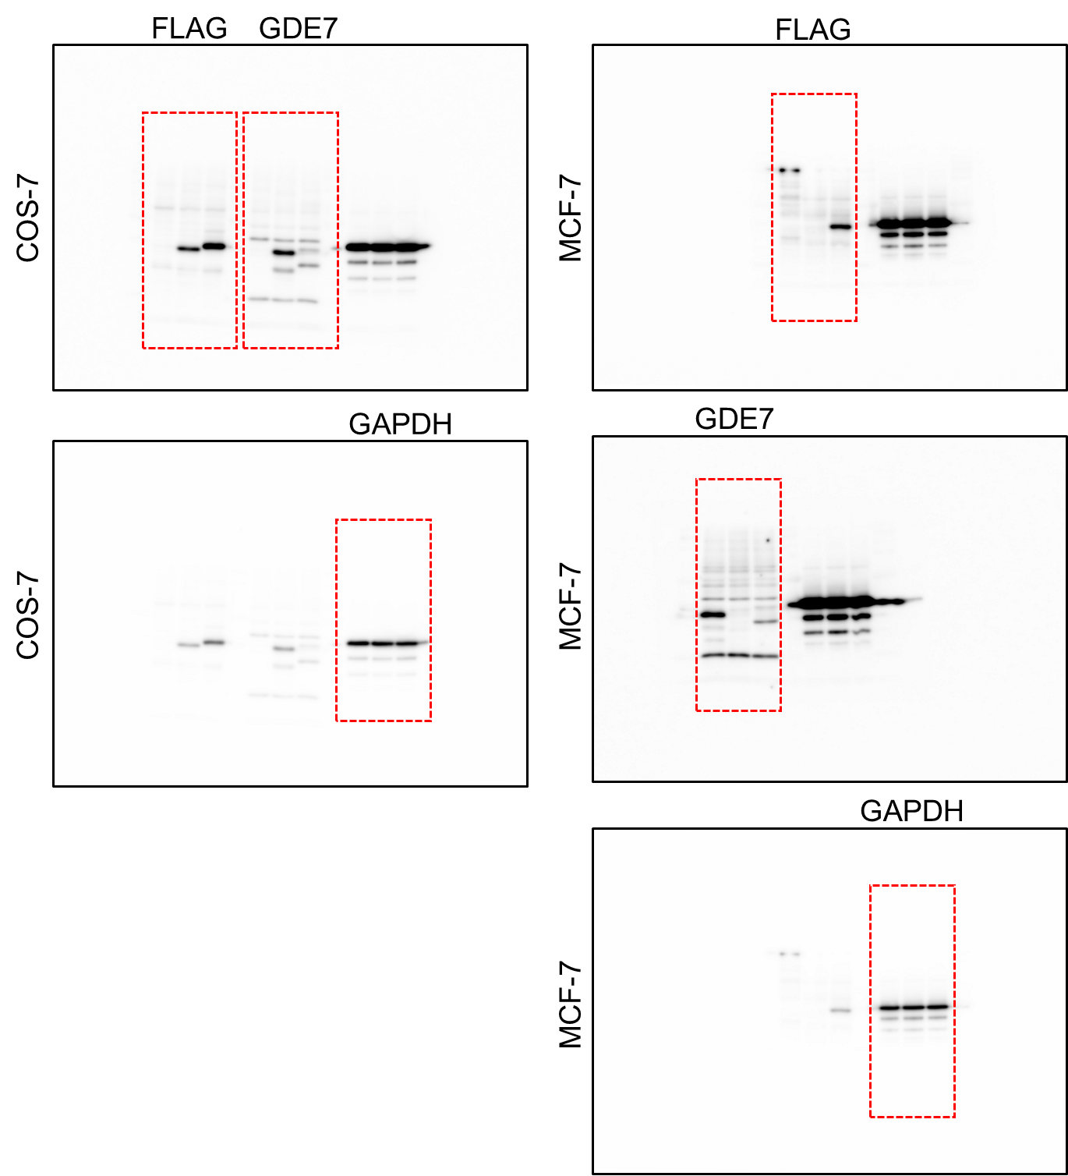

Supplementary Figure 3. Uncropped immunoblots for Fig. 1b and f

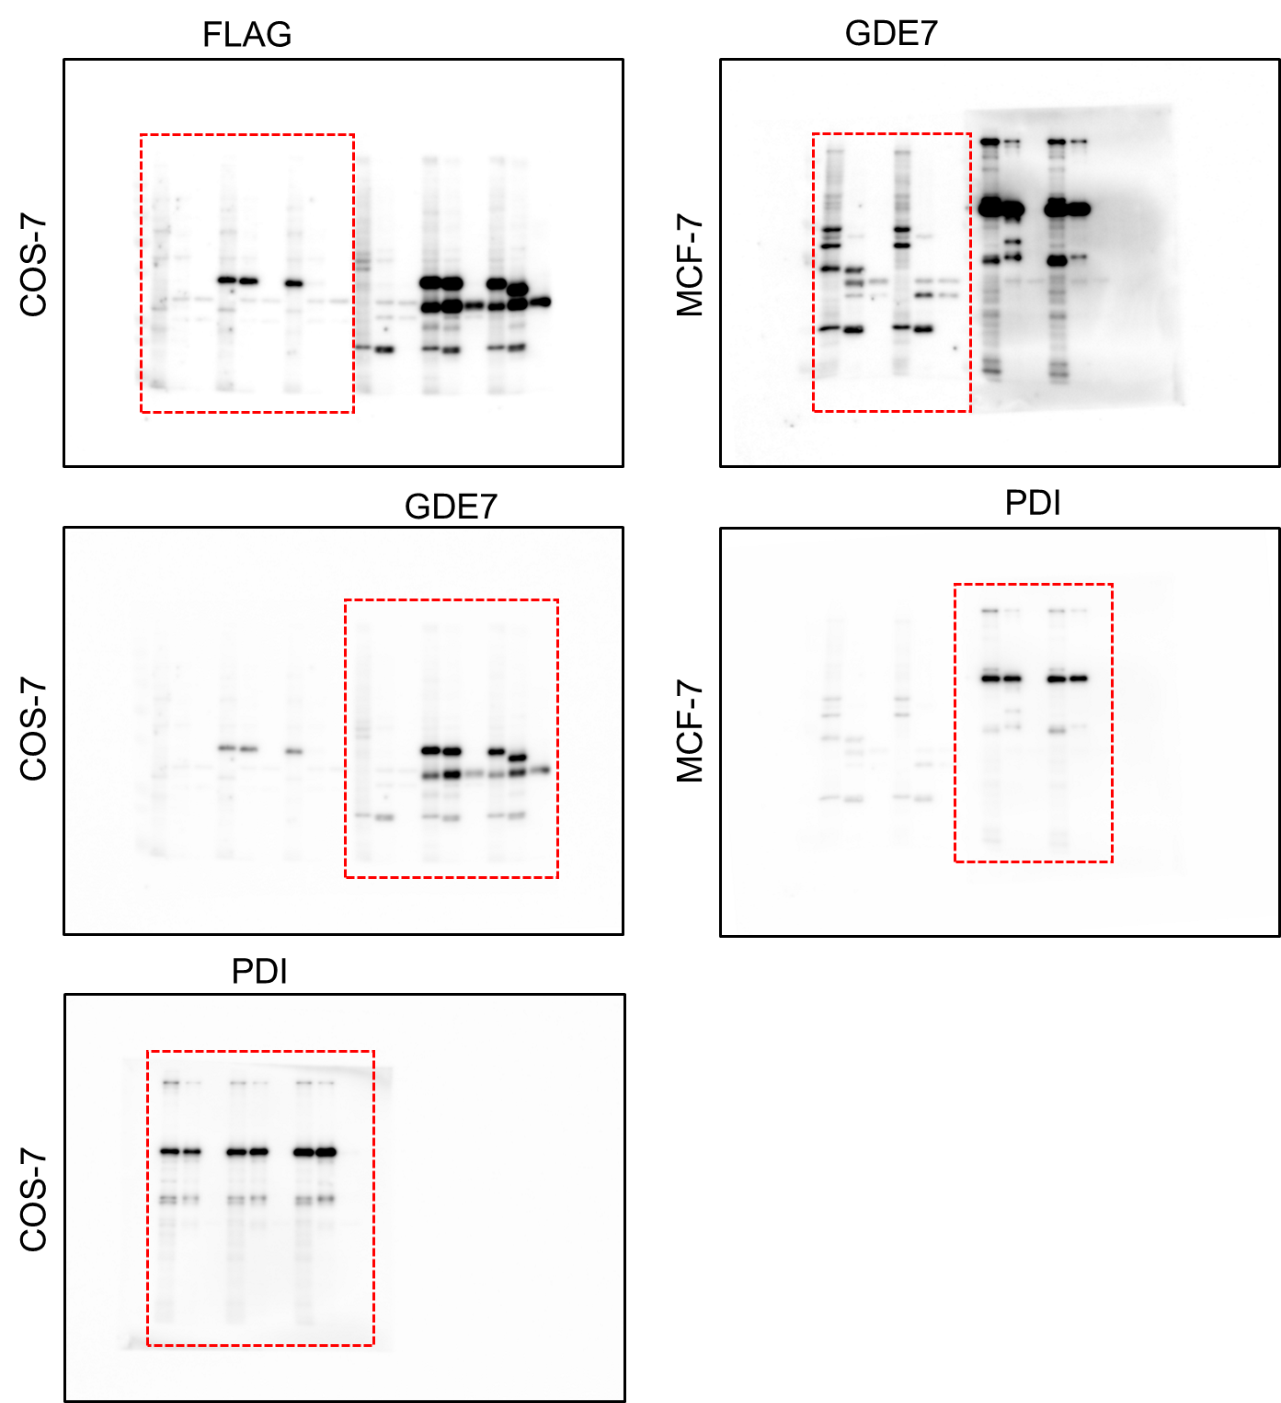

Supplementary Figure 4. Uncropped immunoblots for Fig. 4a and b

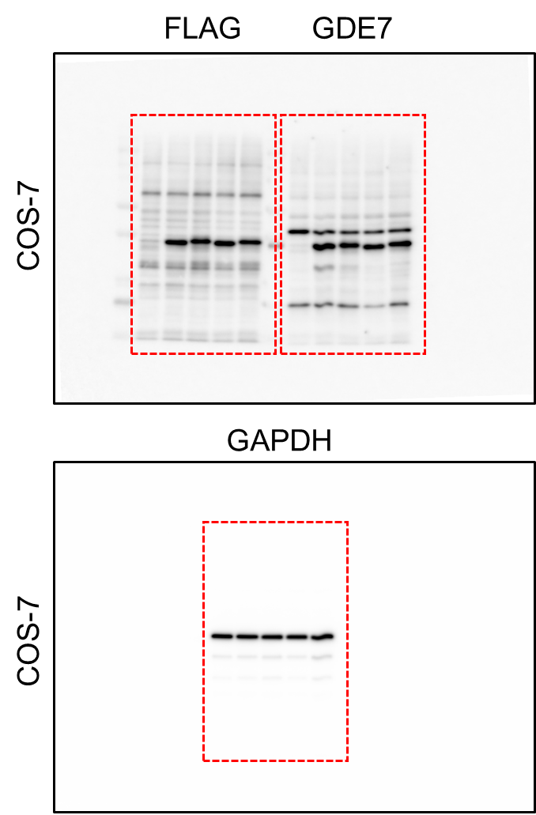

Supplementary Figure 5. Uncropped immunoblots for Fig. 5b

Supplementary Table 1. Sequences of primers
Name | Application | Sequence (5′–3′)
Name | Application | Forward | Reverse
N-terminally FLAG-tagged GDE7 | Cloning | GGTCTAGAGCCACCATGGACTACAAAGACGATGACGATAAAGGTGGAGGTGGAGGTAGCCTTTTGCTGTACTATG | AAGGATCCTTAGGAGGTCCGGGCAGCTGGTCCA
F227E (flagment1) | Cloning | GGGACAGCAGAGATCCAGTT | GAAGCATTCGAAGAACTTCTCAGGGATTG
F227E (flagment2) | Cloning | TTCTTCGAATGCTTCCTGCCCAACATCAT | CCCGTTAACTTACTACTTGTCATCGTCAT
Y238K (flagment1) | Cloning | GGGACAGCAGAGATCCAGTT | TGGGAATTTGGTCCTGTTGATGATGTTGG
Y238K (flagment2) | Cloning | AGGACCAAATTCCCATTTTCCTGCTCTTG | CCCGTTAACTTACTACTTGTCATCGTCAT
hCD36 | qPCR | TGTCCTGGCTGTGTTTGGAG | CCTTCTTCGAGGACAACTTGC
hCYP27A1 | qPCR | GAGGGCAAGTACCCAGTACG | GGTACCAGTGGTGTCCTTCC
hCSF1 | qPCR | AGCTTTCCAGAAGCCACTCC | AACGGAGTTAAAACGGGGCA
hPPARG | qPCR | TGCGAAAGCCTTTTGGTGAC | GGGCTTGTAGCAGGTTGTCT

