Neurobehavioral and neurochemical basis of compulsive behavior:
A 7T magnetic resonance spectroscopy study in humans

Marjan Biria, Paula Banca, Máiréad P. Healy, Engin Keser, Stephen J. Sawiak, Ana Maria Frota Lisbôa Pereira de Souza, Aleya A.Marzuki, Akeem Sule, Karen D. Ersche, Trevor W. Robbins

Supplementary Information

Figure S1 depicting the clinical and demographic information for Healthy Volunteers (HV) in green and OCD patients in blue. Acronyms: MADRS = Montgomery- Asberg Depression Rating Scale, STAI-T = State Trait Anxiety Inventory- Trait, STAI-S = State Trait Anxiety Inventory- State, YBOCS = Yale Brown Obsessive Compulsive Scale, OCI = Obsessive-Compulsive Inventory, IUS = Intolerance of Uncertainty Scale, HTQ = Habitual Tendencies Questionnaire, HV = healthy volunteers, OCD = obsessive compulsive disorder, * = p < 0.05, *** = p < 0.001.
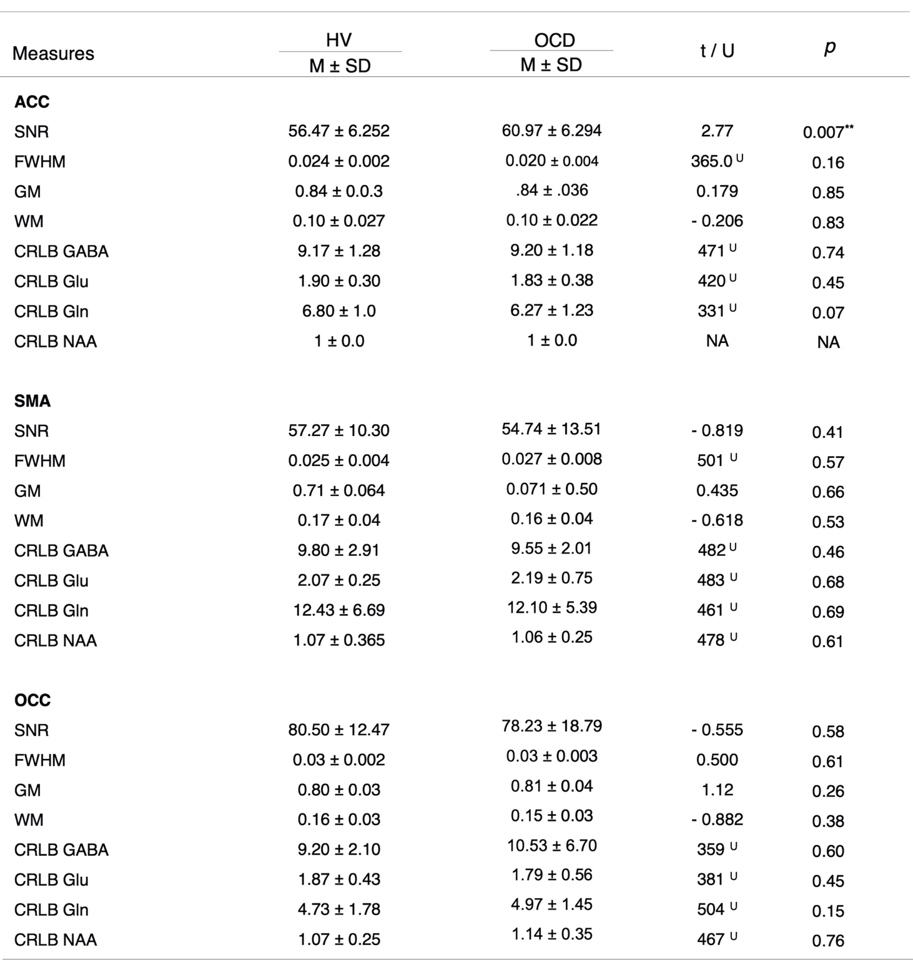
Table S1 Measures of magnetic resonance spectroscopy quality and tissue composition
Acronyms: ACC = anterior cingulate cortex, SMA = supplementary motor area, OCC = occipital cortex, SNR: signal-to-noise ratio, FWHM = full width at half maximum, GM = gray matter, WM = white matter, CRLB: Cramer-Rao Lower Bounds, GABA = γ-amino-butyric acid, Glu = glutamate, Gln = Glutamine, NAA = N-acetylaspartate, t = independent sample t-test, U = Mann-Whitney U test, M = mean, SD = standard deviation, NA = not applicable, test could not be performed as values for all subject for both groups were exactly the same, HV = healthy volunteers, OCD = obsessive-compulsive disorder, ** = p < 0.01.

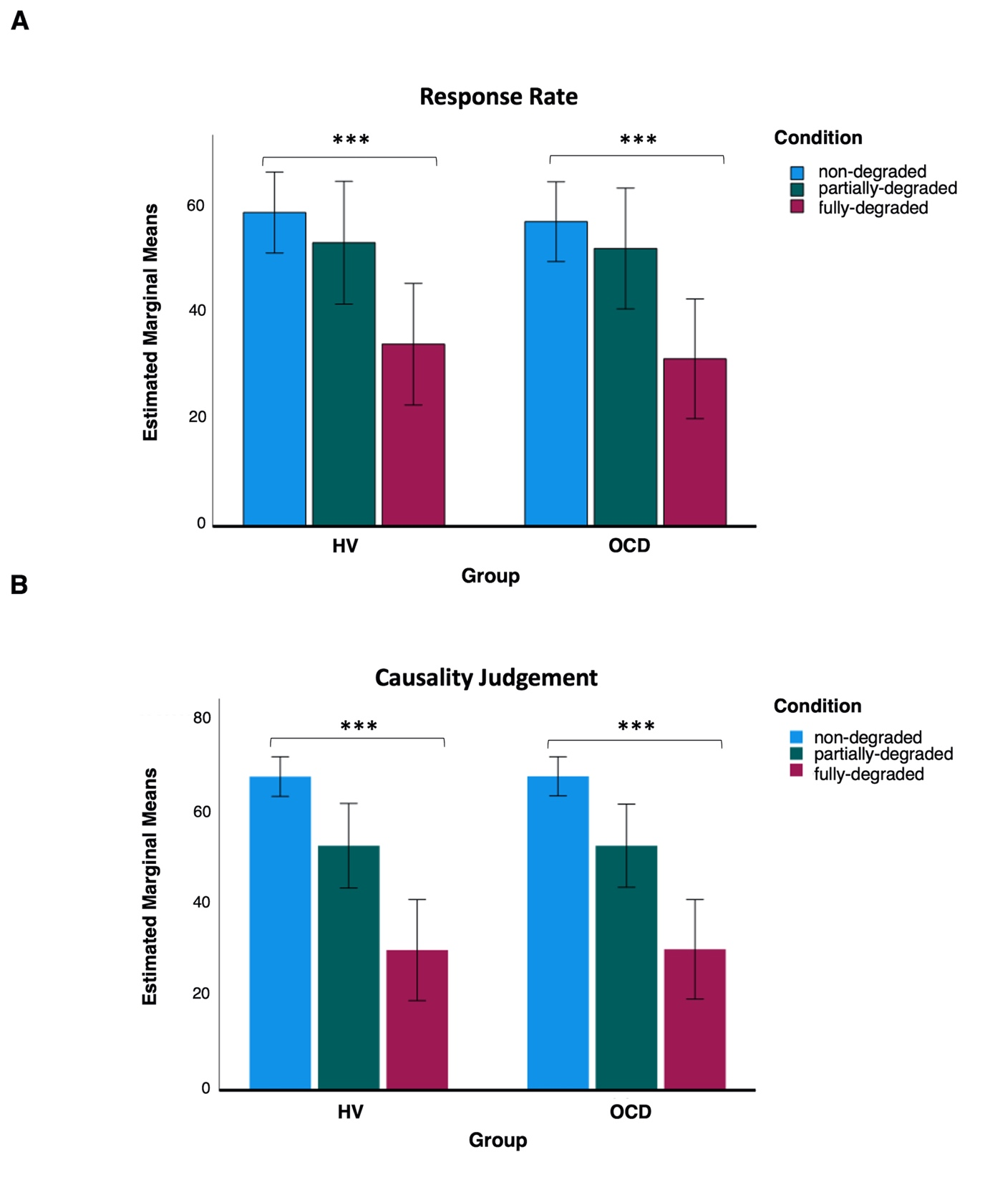

Figure S2 shows the results of a mixed repeated measure ANOVA for the habitual responding and the corresponding subjective causality judgements in OCD and healthy subjects between conditions of fully minus none, and partially minus none degradation. (A) displays the response rates and (B) shows the subjective causality judgements in OCD and health volunteers, in none-degraded (blue), partially-degraded (green), and fully degraded (red) conditions. Error bars represent ± 2 standard errors. Acronyms: HV = healthy volunteers, OCD = obsessive-compulsive disorder, *** = p < 0.001.

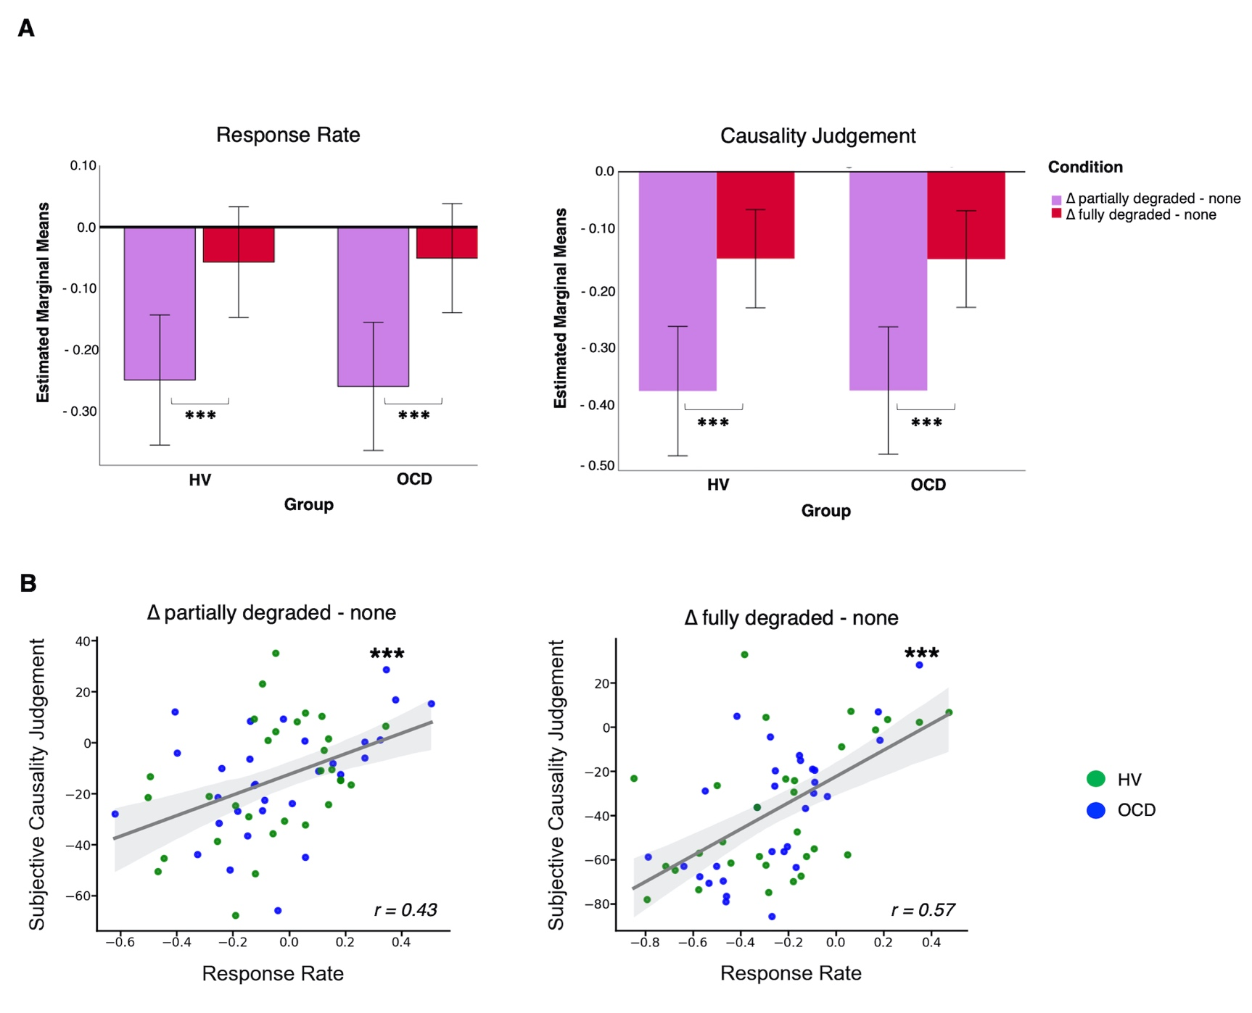
Figure S3 (A) shows the results of a mixed repeated measure ANOVA for the habitual responding and the corresponding subjective causality judgements in OCD and healthy subjects between conditions of fully minus none, and partially minus none degradation. The habitual responding index used for the main analysis is represented in red in the response rate plot. Although both groups showed significant differences between conditions, no interaction with group was found. (B) displays the significant relationships between the habitual responding and the corresponding subjective causality judgements for both groups with the fitted line for the entire sample in gray, between the conditions of none minus partial, and none minus full degradation, respectively. Error bars represent ± 2 standard errors. Acronyms: HV = healthy volunteers, OCD = obsessive-compulsive disorder, r = Pearson’s r correlation coefficient, *** = p < 0.001.

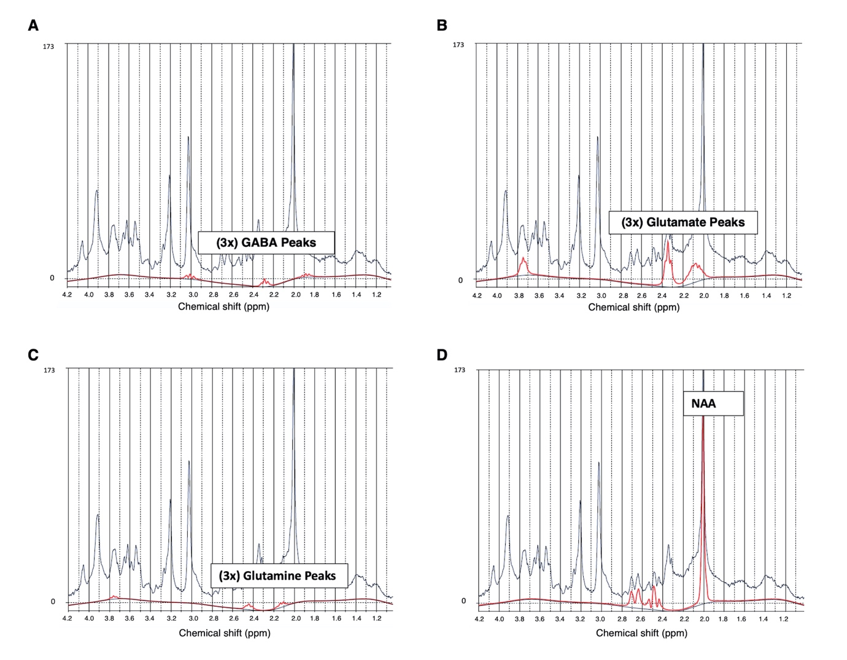
Figure S4 shows examples of the LCModel analysis of in vivo ¹H MR spectra acquired from a healthy participant at 7T (semi-LASER, echo time/repetition time = 1.99/4300 ms, from a 20 x 20 x 20mm voxel placed bilaterally at supplementary motor area). The x-axis depicts the chemical shift, the acquired spectrum is plotted in black and the fit is presented in red for (A) GABA, (B) Glutamate, (C) Glutamine, and (D) NAA. Acronyms: GABA = γ-amino-butyric acid, NAA = N-acetylaspartate, ppm = parts per million.

