Supplementary Materials

Partitioning Diluted Anyons Reveals Their Braiding Statistics

June-Young M. Lee^{1*}, Changki Hong^{2*}, Tomer Alkalay^{2*}, Noam Schiller², Moty Heiblum², Yuval Oreg², H.-S. Sim¹
¹Department of Physics, Korea Advanced Institute of Science and Technology, Daejeon 34141, South Korea
²Department of Condensed Matter, Weizmann Institute of Science, Rehovot, Israel
*Equal Contribution
SI. EXPERIMENTAL SETUP DETAILS
The basis of our device is a high mobility GaAs-AlGaAs heterostructure that supports a two-dimensional electron gas (2DEG) 125 nm below the surface. The 2DEG has an electron density of 9.2 × 10¹⁰ cm⁻², and low temperature (4 kelvin) dark mobility of 3.9 × 10⁶ cm²V⁻¹s⁻¹. Our experimental setup is shown in Fig. S1. Three Quantum Point Contacts (QPC) were patterned in close proximity and served as beam splitters in the measurement, ohmic contacts were used to source and collect the current. In the two-QPC setup, QPC1 dilutes the DC current $I_{S}$ that is injected from source contact S1. The dilute reflected part of the current is then partitioned by QPC2. In the three-QPC setup, another source contact S2 is biased and injects DC current to the sample. Current from S2 is diluted by QPC3, and then fed into the second input of the QPC2. In both setups, the auto-correlation noise of each output beam, as well as the cross-correlation between the two outputs, are measured at a frequency of 730kHz set by the LC circuits. The signal was amplified by a home-made preamplifier cooled to $4.2K$ followed by a room temperature amplifier. The output of the amplification chain is then fed into a home-made analog cross-correlator circuit, which multiplies each signal with itself, as well as with the second signal. The output voltage from the analog cross-correlator was measured by digital multimeters. In order to calibrate the auto-correlation and cross-correlation measurements, we measured the shot noise of a full beam at an integer filling factor ($ν=3$). This was performed by fully pinching QPC1 while source contact is biased, such that only the QPC2 partitioned the beam. Comparing the auto-correlations and cross-correlations to Eq. (1) allowed us to calibrate our system. In addition, we repeated this measurement at $ν=1/3$, and made sure that both auto-correlations and the cross correlations leads to the correct fractional charge based on Eq. (1).
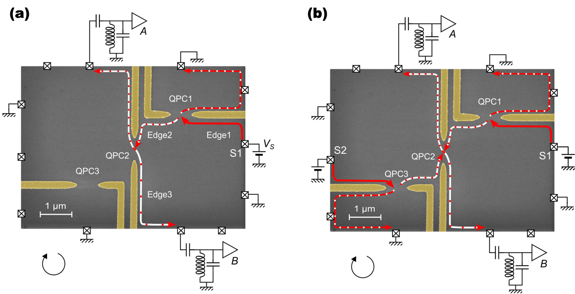
FIG. S1: ‘Two-QPC’ and ‘three-QPC’ geometries. (a) A full beam is injected from source contact S1 and propagates along Edge1. The current is diluted by QPC1, the reflected part continues along Edge 2 and is partitioned by QPC2. (b) A second source (S2) is used to inject a full beam to QPC3, which is tuned such that it has the same tunneling probability as QPC1. The reflected current from QPC3 reaches the second input of QPC2. In both cases, the auto-correlation noise in each output beam is measured together with the cross-correlation between them.

SII. SUPPLEMENTARY DATA
- Noise of a full beam impinging on QPC2
Here we compare the situation in which a dilute beam is injected to QPC2 (Fig. (3) in the main text) to that of a full beam injection. For the purpose, we utilized a second source contact [S2 contact in Fig. (S1)] to inject a full beam to QPC2, while QPC3 was fully pinched. QPC1 and QPC2 were held fixed at the same reflection used in the measurement of the dilute beam noise. As shown in Fig. S2, the noise follows Eq.(1) of the main text with charge $e^{*} e/3$. This measurement emphasizes the remarkable difference between a full beam injection to a QPC and the dilute injection. In the former as Fig. S2, the Fano factor is sensitive only to the partitioned charge dominated by the trivial partitioning. In the latter as Fig. 3 in the main paper, the time-domain braiding takes over and the Fano factor becomes dependent on the braiding phase of anyons.
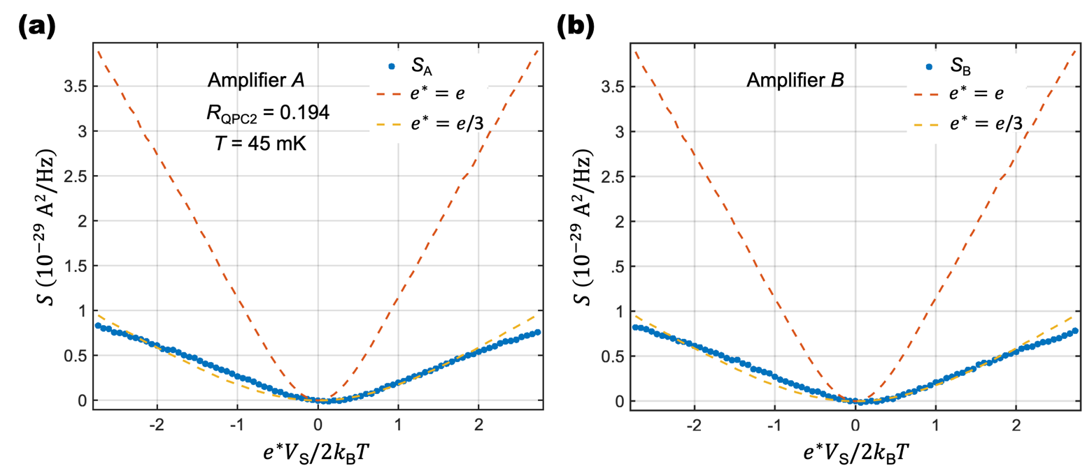
FIG. S2: Noise of a full beam partitioned at QPC2. A full beam is injected to QPC2 by biasing S2 and fully pinching QPC3. QPC1 and QPC2 were held at the same condition used to measure the noise of a dilute beam (R_{QPC2}=0.194). The AC noise at the two amplifiers (blue dots) is plotted together with the prediction of Eq. (1). The yellow dashed line is the expected noise with charge $e^{*}=e/3$ , while the red dashed line shows the expected noise for $e^{*}=e$ for comparison. The data is in very good agreement with Eq. (1), demonstrating that the noise of a full beam is only sensitive to the charge of the partitioned particles. This should be contrasted with the noise of a dilute beam, shown in the main paper, where the Fano factor becomes a probe of the statistical phase due to contributions from the time-domain braiding process.

- Two-QPC experiment in the IQH of filling factor 3
We performed the two-QPC experiment in the integer quantum Hall (IQH) regime, using the outer edge mode of filling factor 3. The condition is simpler (more ideal) to calculate because the DC bias dependency of the reflection probability is flat compared to other edges. In this regime, due to the trivial braiding phase of fermions, only the trivial partition process is expected to contribute to the noise, leading to $F_{dilute}=1$. In Fig. S3, we compare the measured auto-correlation noise at amplifier A and B with Eq.(1) (dashed lines in Fig. S3), with the electronic charge $e^{*}=e$ and $R_{QPC1}$ replaced by the total probability to reach the amplifier such that for amplifier A, $R_{QPC1}$ is replaced by $R_{QPC1}\left(1-R_{QPC2}\right)$, while for amplifier B, $R_{QPC1}$ is replaced by $R_{QPC1}R_{QPC2}$. The theoretically expected values and the measurement results are in very good agreement, supporting that only the trivial partition process happens in the IQH.

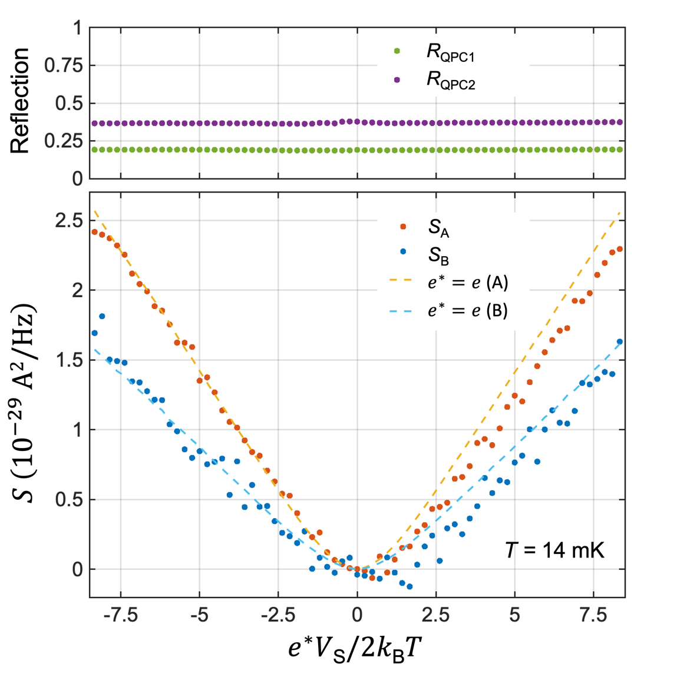
FIG. S3: Excess auto-correlation noise in the two-QPC geometry at an integer filling factor ($ν=3$). The upper panel shows the reflection probability of QPC1 and QPC2. In the lower panel, the red and blue dots are the measured AC noises at the two amplifiers. The red dashed line is the noise expected by Eq. (1), with the electronic charge $e^{*}=e$ and $R_{QPC1}$ replaced by the combined probability to reach amplifier A, which is $R_{QPC1}\left(1-R_{QPC2}\right)$. Similarly, the blue dashed line is the expected noise at amplifier B with $e^{*}=e$ and $R_{QPC1}→R_{QPC1}R_{QPC2}$. The agreement with the expected noise indicates that there is no additional contribution to the noise apart from the contribution of the trivial partitioning.

- Bias dependence of the reflection
In the main text, each noise measurement is shown along with the average value of the reflection probability of each of the relevant QPC’s. Here we show the full bias dependence of the reflection probabilities. Each panel of Fig. S4 shows the measured reflection probability for QPC1 ($R_{QPC1}$) and QPC2 ($R_{QPC2})$ and corresponds to one of the noise measurement presented in the main text. The corresponding noise measurement in the main text is written in the inset of each of the sub-figures. Figures S4 (a) to (e) measured at 45 mK, and Figure S4 (f) measured at 12 mK.

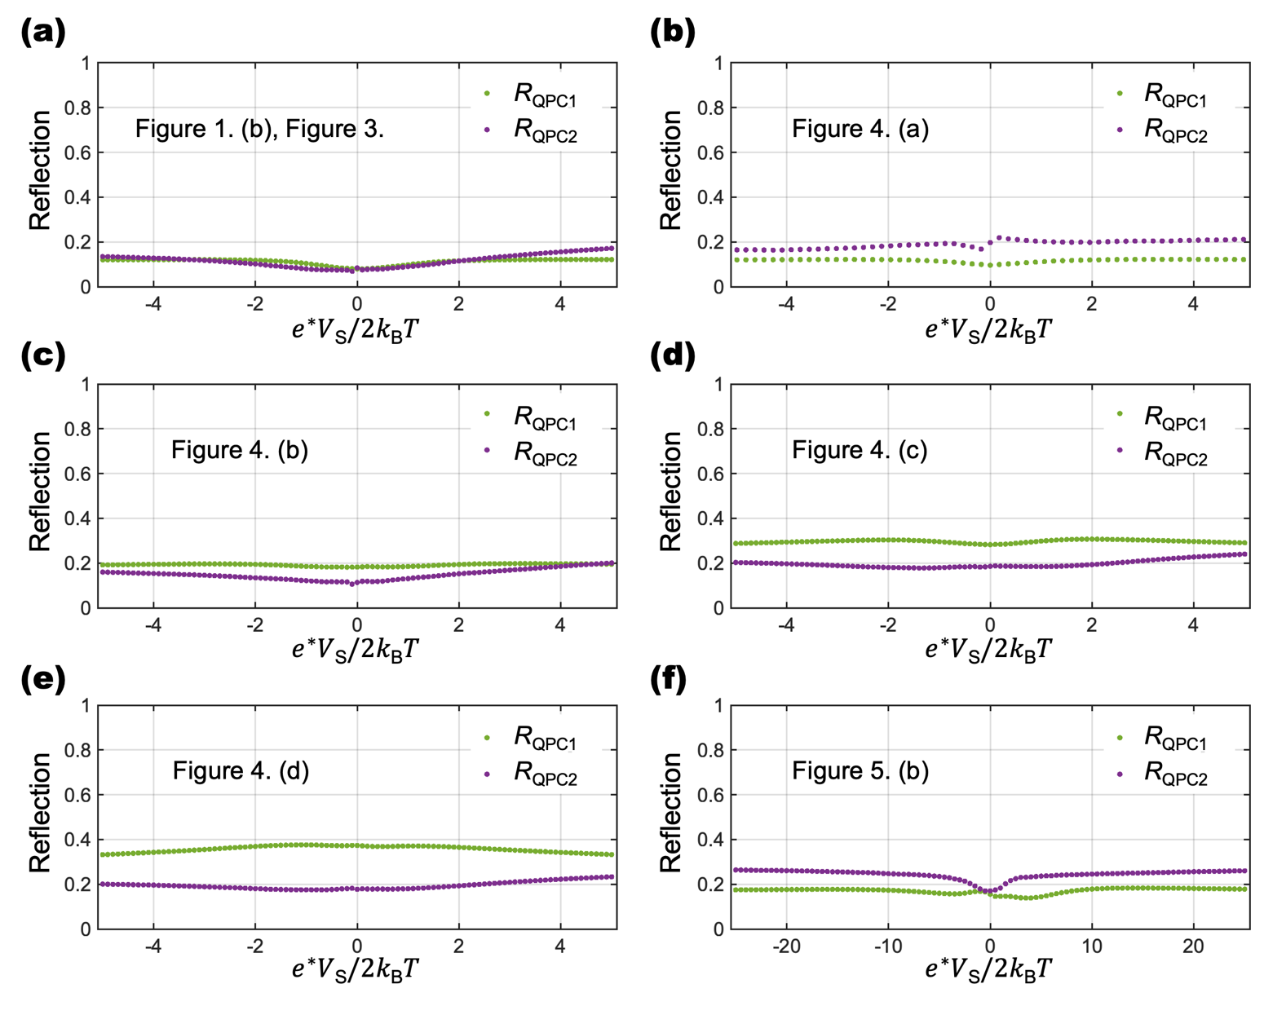
FIG. S4: Bias dependence of the reflection probability. Each of the panels (a)-(f) shows the full bias dependence of reflection probability measurement results for $R_{QPC1}$ (green dots) and $R_{QPC2}$(purple dots). Each panel corresponds to noise measurement results in the main text: (a) corresponds to Fig. 1(b) and Fig. 3, (b) to Fig. 4(a), (c) to Fig. 4(b), (d) to Fig. 4(c), (e) to Fig. 4(d), and (f) to Fig. 5(b).

SIII. THEORY OF THE ANOMALOUS PARTITION NOISE
A. Fano factor $F_{dilute}$
We provide the theory of the Fano factor $F_{dilute}$ at sufficiently small $R_{QPC2}$ and $e^{*}V_{S}≫k_{B}T$. In Ref. [S1], the non-equilibrium correlator of anyon tunneling at QPC2 was derived for the dilute limit of $R_{QPC1}≪1$.
We first restate the result for Abelian anyons [S1]. The tunneling operator at QPC2 is expressed as $T\left(t\right)=γ_{2}ψ_{3}^{†}\left(0,t\right)ψ_{2}(0,t)$, where $ψ_{i}(x,t)$ is the anyon annihilation operator on Edgei at position $x$ and time $t$, and $γ_{2}$ is the tunneling strength at QPC2. For simplicity, the position of QPC2 is chosen as $x=0$ on both Edge2 and Edge3. The non-equilibrium correlator of the tunneling operator $C_{neq}\left(t_{1},t_{2}\right)≡{〈T\left(t_{1}\right)T^{†}\left(t_{2}\right)〉}_{neq}$ in the presence of the dilute anyon beam is related to the equilibrium correlator $C_{eq}\left(t_{1},t_{2}\right)≡{〈T\left(t_{1}\right)T^{†}\left(t_{2}\right)〉}_{eq}$ in the absence of the beam,

$$C_{neq}\left(t_{1},t_{2}\right)=e^{-\frac{I_{QPC1}}{e^{*}}\left(e^{i2θ\operatorname{sign}\left(t_{2}-t_{1}\right)}-1\right)\left|t_{2}-t_{1}\right|}C_{eq}\left(t_{1},t_{2}\right)+\text{subleading terms}.$$ | (S1)

This was derived with the firm theoretical ground based on the conformal field theory or the bosonization (the chiral Luttinger liquid (CLL) theory) for FQH edge channels, combined with the Keldysh perturbation theory for arbitrary orders of anyon tunneling at QPC1.
The multiplicative factor, the non-equilibrium part of the expression of $C_{neq}\left(t_{1},t_{2}\right)$, is a consequence of time-domain anyon braiding. We found that the factor equals the average of the braiding phase $e^{2ikθ}$ accumulated when the time-domain loop of a thermally excited anyon braids with k anyons of the dilute beam arriving at QPC2 in the time interval $t_{2}-t_{1} (≫h/e^{*}V_{S})$,
$${〈e^{2ikθ}〉}_{Poissonian}=\sum_{k=0}^{∞}{Q_{k}e^{2ikθ}}=e^{-\frac{I_{QPC1}}{e^{*}}\left(e^{2iθ}-1\right)\left(t_{2}-t_{1}\right)}.$$ | (S2)
The probability $Q_{k}$ of the event of k anyons arriving at QPC2 in the interval $t_{2}-t_{1}$ follows the Poissonian distribution $Q_{k}=\frac{m^{k}}{k!}e^{-m}$, and $m=I_{QPC1}(t_{2}-t_{1})/e^{*}$ is the average number of anyons arriving at QPC2 in the interval $t_{2}-t_{1}$. The Poisson distribution is natural, since anyons of the dilute beam is generated by tunneling from Edge1 to Edge2 at QPC1 in the regime of $R_{QPC1}≪1$.
For a less dilute beam with relatively large $R_{QPC1}$, yet small enough for the anyon tunneling, it is natural to expect that the time distribution of anyons of the beam follows a binomial distribution, instead of the Poissonian distribution. Hence, in our phenomenological theory, we replace the multiplicative factor ${〈e^{2ikθ}〉}_{Poissonian}$ by the average braiding phase ${〈e^{2ikθ}〉}_{binomial}$over the binomial distribution $P_{k}$ of the number k,
$${〈e^{2ikθ}〉}_{binomial}=\sum_{k=0}^{n}{P_{k}e^{2ikθ}}={\left(1-R_{QPC1}+R_{QPC1}e^{2iθ}\right)}^{{I_{S}\left(t_{2}-t_{1}\right)}/{e^{*}}}$$ | (S3)
where $P_{k}=\frac{n!}{k!\left(n-k\right)!}R_{QPC1}^{k}{\left(1-R_{QPC1}\right)}^{n-k}$, and $n=I_{S}\left(t_{2}-t_{1}\right)/e^{*}$ is the number of anyons impinging at QPC1 on Edge1 in the time interval $t_{2}-t_{1} (≫h/e^{*}V_{S})$. Using the factor, we write the non-equilibrium correlator
$$C_{neq}\left(t_{1},t_{2}\right)={\left(1-R_{QPC1}+R_{QPC1}e^{2iθ\operatorname{sign}\left(t_{2}-t_{1}\right)}\right)}^{{I_{S}\left|t_{2}-t_{1}\right|}/{e^{*}}}C_{eq}\left(t_{1},t_{2}\right)+\text{subleading terms}.$$ | (S4)
This expression is also applicable to the case of $t_{2}<t_{1}$, in which the braiding direction of the time-domain loop is opposite to the $t_{2}>t_{1}$ case. Eq. (S4) reduces to the previous results of Eq. (S1) for $R_{QPC1}≪1$. This equation is valid for the long time regime $\left|t_{2}-t_{1}\right|≫h/e^{*}V_{S}$, where the spatial width of the wave packet of anyons in the dilute beam is sufficiently narrow so that the time-domain braiding is well-defined. The subleading terms describe the trivial partition process and become important in the short time regime of $\left|t_{2}-t_{1}\right|≃h/e^{*}V_{S}$.
Once the non-equilibrium correlator is obtained, it is straightforward to calculate the tunneling rates $W_{2→3}$ and $W_{3→2}$,
$$W_{2→3}=\int_{-∞}^{∞}{dt{〈T^{†}\left(0\right)T\left(t\right)〉}_{neq}} , W_{3→2}=\int_{-∞}^{∞}{dt{〈{T\left(t\right)T}^{†}\left(0\right)〉}_{neq}} .$$ | (S5)
We first compute the contribution from the long time $\left|t_{2}-t_{1}\right|≫h/e^{*}V_{S}$ described by the time-domain braiding process,
$$W_{2→3}^{braid}=2\frac{{\left|γ_{2}\right|}^{2}}{ℏ^{2}}Γ\left(1-2δ\right)Re\left[e^{iπδ}{\left(-\frac{I_{S}}{e^{*}}\log\left(1+R_{QPC1}\left(e^{-2iθ}-1\right)\right)\right)}^{2δ-1}\right] , \\ W_{3→2}^{braid}=2\frac{{\left|γ_{2}\right|}^{2}}{ℏ^{2}}Γ\left(1-2δ\right)Re\left[e^{iπδ}{\left(-\frac{I_{S}}{e^{*}}\log\left(1+R_{QPC1}\left(e^{2iθ}-1\right)\right)\right)}^{2δ-1}\right] .$$ | (S6)
Note that the only difference between the two rates is the braiding phase factor, $e^{-2iθ}↔e^{2iθ}$. This is explained by the fact that the the braiding direction of the time-domain loop is opposite between the processes of the two rates, particle tunneling from Edge2 to Edge3 for $W_{2→3}^{braid}$and hole tunneling from Edge2 to Edge3 for $W_{3→2}^{braid}$ . The time-domain braiding process contributes to the tunneling current and noise across QPC2 as $I_{QPC2}^{braid}=e^{*}\left(W_{2→3}^{braid}-W_{3→2}^{braid}\right)$ and $S_{QPC2}^{braid}={2\left(e^{*}\right)}^{2}\left(W_{2→3}^{braid}+W_{3→2}^{braid}\right)$,
$$I_{QPC2}^{braid}=-4\frac{e^{*}}{ℏ^{2}}{\left|γ_{2}\right|}^{2}Γ\left(1-2δ\right)\sin{πδ}Im\left[{\left(-\frac{I_{S}}{e^{*}}\log\left(1+R_{QPC1}\left(e^{-2iθ}-1\right)\right)\right)}^{2δ-1}\right] , \\ S_{QPC2}^{braid}=8\frac{{e^{*}}^{2}}{ℏ^{2}}{\left|γ_{2}\right|}^{2}Γ\left(1-2δ\right)\cos{πδ}Re\left[{\left(-\frac{I_{S}}{e^{*}}\log\left(1+R_{QPC1}\left(e^{-2iθ}-1\right)\right)\right)}^{2δ-1}\right] .$$ | (S7)
If only the time-domain braiding determines the current and noise, the Fano factor $F_{dilute}$ is written as
$$F_{dilute}\text{≃}\frac{S_{QPC2}^{braid}}{{2e}^{*}I_{QPC2}^{braid}}=-\cot{πδ}\frac{Re\left[{\left(-\log\left(1+R_{QPC1}\left(e^{-2iθ}-1\right)\right)\right)}^{2δ-1}\right]}{Im\left[{\left(-\log\left(1+R_{QPC1}\left(e^{-2iθ}-1\right)\right)\right)}^{2δ-1}\right]} .$$ | (S8)
The dependence of $F_{dilute}$ on the diluteness $R_{QPC1}$ is plotted as the blue curve in Fig. S5. The Fano factor approaches to $F_{dilute}≃3.27$ in the Poissonian limit $R_{QPC1}≪1$, and decreases as the beam becomes less dilute.

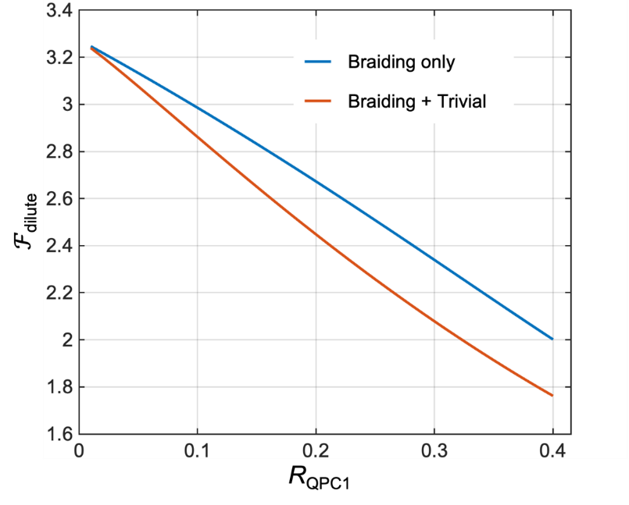
FIG. S5: Dependence of Fano factor $F_{dilute}$ on the diluteness $R_{QPC1}$. The blue curve shows the Fano factor computed only with the time-domain braiding process, while the red curve shows the Fano factor contributed from both the time-domain braiding process and the trivial partition process.
There is also the trivial partition process, in which an anyon of the dilute beam directly tunnels at QPC2. This process occurs with the short time of $\left|t_{2}-t_{1}\right|≃h/e^{*}V_{S}$. It is sub-dominant in contributing to the current and noise at QPC2, and described by the subleading terms in Eq. (S1) and Eq. (S4),
$$\text{the sub-leading terms of Eq. }\left(\text{S1}\right)\text{ and Eq. }\left(\text{S4}\right)\text{ ≃}\frac{e}{e^{*}}\frac{Γ\left(2δ\right)}{{Γ\left(δ\right)}^{2}}R_{QPC1}e^{-ie^{*}V_{S}\left(t_{1}-t_{2}\right)/ℏ}C_{eq}\left(t_{1},t_{2}\right) .$$ | (S9)
Using this, the contribution of the trivial partition process to the current and noise at QPC2 is obtained,
$$I_{QPC2}^{trivial}=e^{*}W_{2→3}^{trivial}=R_{QPC1}×\frac{2πe{\left|γ_{2}\right|}^{2}}{ℏ^{2}Γ{\left(δ\right)}^{2}}{\left(\frac{2πI_{S}}{e}\right)}^{2δ-1} , S_{QPC2}^{trivial}=2e^{*}I_{QPC2}^{trivial} .$$ | (S10)
For the dilute limit $R_{QPC1}≪1$, the contribution of the trivial process is sub-dominant compared to that of the braiding process,
$$\frac{\text{contribution of the trivial partition}}{\text{contribution of the time-domain braiding}}∝R_{QPC1}^{2-2δ}.$$ | (S11)
We note that if there were only the trivial partition process, the Fano factor has the value of $F_{dilute} = S_{QPC2}^{trivial} /(2e^{*}$
$I_{QPC2}^{trivial} ) = 1$ [see Eq. (S10)], as discussed in the main text.
The total current and noise at QPC2 are $I_{QPC2} = I_{QPC2}^{braid}+I_{QPC2}^{trivial}$ and $S_{QPC2} = S_{QPC2}^{braid}+S_{QPC2}^{trivial}$, where both the time-domain braiding process and the trivial partition process are taken into account. The full Fano factor is
$$F_{dilute}=\frac{S_{QPC2}}{2e^{*}I_{QPC2}}=\frac{S_{QPC2}^{braid}+S_{QPC2}^{trivial}}{2e^{*}\left(I_{QPC2}^{braid}+I_{QPC2}^{trivial}\right)}.$$ | (S12)
The dependence of the full Fano factor on $R_{QPC1}$ is shown as the red curve in Fig. S5. As the contribution of the trivial partition process becomes larger (yet smaller than that of the braiding process) for larger $R_{QPC1}$, the Fano factor further decreases.

B. Phenomenological extension in Eq. (2)
In the last subsection, we have derived $S_{QPC2}=F_{dilute}×2e^{*}I_{QPC2}$ for high voltage $e^{*}V_{S}≫k_{B}T$ and small QPC2 reflection $R_{QPC2}≪1$. We now phenomenologically extend it to the form in Eq. (2) of the main text, to compare the result with our experimental data in a wider range of the parameters. We restate the equation,
$$S_{QPC2}=F_{dilute}×2e^{*}I_{QPC1}R_{QPC2}\left(1-R_{QPC2}\right)\left[\coth\left(\frac{e^{*}V_{S}}{2k_{B}T}\right)-\frac{2k_{B}T}{e^{*}V_{S}}\right].$$ | (S13)
We here provide the rationale behind the extension.
Firstly, $[coth(e^{*}V_{S}/2k_{B}T) - 2k_{B}T/e^{*}V_{S}]$ is introduced to describe a parameter range of relatively small values of voltage $V_{S}$. The factor $coth(e^{*}V_{S}/2k_{B}T)$ comes from the hole-like anyon injection process at the QPC1 [S2]. It can be considered that the hole-like anyons are incoming from the source to QPC1 with a rate $I_{S}exp(-e^{*}V_{S}/k_{B}T)/e^{*},$ which is exponentially suppressed in comparison with the particle-like anyon injection. The hole-like anyon injection affects both the time-domain braiding process and the trivial partition process. In the time-domain braiding process, when a hole-like anyon is injected at QPC1 to the dilute beam flowing along Edge2, the time-domain loop of a thermally excited anyon at QPC2 can braid the hole-like anyon, giving rise to the braiding phase factors of $e^{±2iθ}$, instead of the factors $e^{∓2iθ}$ of the case of the particle-like anyon injection in Eq. (S4). As a result, the first term of the non-equilibrium correlator in Eq. (S4) has an additional multiplicative factor of ${\left(1-R_{QPC1}+R_{QPC1}e^{-2iθsign⁡\left(t_{2}-t_{1}\right)}\right)}^{\frac{I_{S}}{e^{*}}exp⁡\left(-\frac{e^{*}V_{S}}{k_{B}T}\right)\left|t_{2}-t_{1}\right|}$ coming from the hole-like anyon injection. Then the current and noise at QPC2 are modified accordingly. On the other hand, in the trivial partition process, the hole-like anyon injection modifies the current and noise at QPC2 as $I_{QPC2}^{trivial}→ I_{QPC2}^{trivial}\left(1-exp⁡\left(-\frac{e^{*}V_{S}}{k_{B}T}\right)\right)$ and $S_{QPC2}^{trivial}→ S_{QPC2}^{trivial}\left(1+exp⁡\left(-\frac{e^{*}V_{S}}{k_{B}T}\right)\right)$. The Fano factor $F_{dilute}$ is then calculated by $F_{dilute}=\frac{S_{QPC2}}{2e^{*}I_{QPC2}coth\left(e^{*}V_{S}/2k_{B}T\right)}$. The last term of Eq. (S13) proportional to $-2k_{B}T/e^{*}V_{S}$ is introduced to make the excess noise to vanish at the zero bias of $V_{S}=0$. Note that all the temperature dependence is introduced from the detailed balance principle, while we used the zero-temperature correlator of the CLL theory in the calculation of $F_{dilute}$. This phenomenological treatment is in analogy to the full beam case [S2], which remedies the power-law temperature dependence of the CLL theory that disagrees with experiments.
Secondly, we did the substitution of $R_{QPC2}$ to $R_{QPC2}(1-R_{QPC2})$ to obtain Eq. (S13). With this substitution, a parameter range of relatively large values of $R_{QPC2}$ is described by Eq. (S13). This is done in the same spirit with the phenomenological expression of Eq.(1) for the partition of a full beam, where the substitution of $R_{QPC1}$ to $R_{QPC1}(1-R_{QPC1})$ has been performed [S3] to have comparison between experimental data and the phenomenological expression in determination of fractional charges by shot noise, going beyond the parameter regime of the chiral Luttinger liquid theory. Excellent agreement between the phenomenological expression in Eq. (S13) (namely Eq. (2) of the main text) with our experimental data is found as shown in Fig. 3 & 4 of the main text.
C. Dependence of Fano factor $F_{dilute}$ on the scaling dimension δ
While the chiral Luttinger liquid theory predicts the power law behavior $R_{QPC}∝V^{2δ-2}$ of the reflection probability $R_{QPC}$ at a QPC with respect to a bias voltage $V$, this expected behavior has not been confirmed by experiments [S4]. As the Fano factor $F_{dilute}$ of our theory also depends on the scaling dimension $δ$, it is in fact surprising that the excellent agreement between the theory and our experiment is found over a wide range of the parameters. To understand why, we investigate how $F_{dilute}$varies as a function of the scaling dimension $δ$. For simplicity, we concentrate on the high voltage regime of $e^{*}V_{S}≫k_{B}T$.
For the Poissonian limit of $R_{QPC1}≪1$, the time-domain braiding process dominates the trivial partition process, and the Fano factor is written concisely,
$$F_{dilute}=-\cot{πδ}\cot\left(\left(\frac{π}{2}-θ\right)\left(2δ-1\right)\right).$$ | (S14)
As non-ideal effects at QPCs usually affect the scaling dimension δ to become larger than its ideal value 1/3 at ν = 1/3 [S5, S6], we explore how the Fano factor varies as δ increases from the ideal value. The result is shown as the blue curve in Fig. S2. As δ increases, the Fano factor decreases from the ideal value ($≃3.27)$at δ = 1/3 to 3 at δ = 1/2, and increases back to the original value at δ = 2/3. It shows that the Fano factor varies less than 10 % over the range of 1/3 < δ < 2/3. This may in part explain the excellent agreement between the theory and the experiment.
Next we take the realistic value of $R_{QPC1}=0.1$, as in Fig. 3 of the main text. If we consider the time-domain braiding process only, $F_{dilute}$ starts from 3.13 at δ = 1/3, reduces to 2.87 at δ = 1/2, and increases back to the original value 3.13 at δ = 2/3 (see the red curve in Fig. S6). Again, the variation of $F_{dilute}$ is less than 10% over the range of δ. The variation becomes bigger if we also include the trivial partition process. It starts from 3.08 at δ = 1/3 and decreases monotonically to 2.36 at δ = 2/3 (see the yellow curve in Fig. S6). In this case, the difference becomes about 20%. The relatively big variation is because the trivial process is less suppressed for larger δ, as expected from the ratio $R_{QPC1}^{2-2δ}$ of the contribution of the trivial process to that of the braiding process shown in Eq. (S11). Still, however, the variation is not that strong compared to the variation range of δ.
Nevertheless, our transmission data are nearly flat, corresponding to δ = 1 (Supplementary Section SII C). With δ = 1, the Fano factor in Eq. (S14) diverges and cannot explain our experimental results. This suggests to revisit the long-time issue of whether and how the scaling dimension can be obtained from experimental data of the voltage dependence of QPC transmission. For example, the QPC model Hamiltonian used in the chiral Luttinger liquid theory for the prediction of the voltage dependence (the power-law behavior $R_{QPC}∝V^{2δ-2}$ of the QPC reflection probability $R_{QPC}$ on a voltage $V$ ) might be too simplified; while the bare anyon-tunneling strength at a QPC has been assumed to be energy independent in the theory, it could be energy dependent in realistic situations, which distorts the predicted power-law behavior even when the scaling dimension remains around the ideal value. Or, measurements of other quantities might be useful for experimental identification of the scaling dimension (see, e.g., Ref. [S8]).

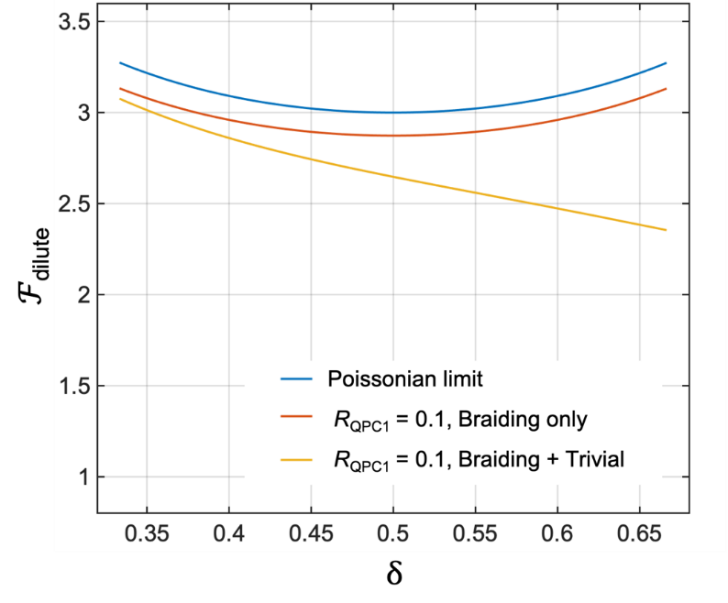
FIG. S6: Dependence of Fano factor $F_{dilute}$ on the scaling dimension δ. The blue curve is for the Poissonian limit, while the red and yellow curves are for $R_{QPC1}=0.1$. In the red curve, only the time-domain braiding process is taken into account, while the yellow curve accounts both the braiding process and the trivial partition process.

SIV. COMPARISON BETWEEN $S_{B}$ AND $S_{QPC2}$
Below we show that the measured excess AC noise $S_{B}$ at amplifier B provides the direct probe of the theoretical prediction of the excess AC $S_{QPC2}$ at QPC2.
The excess AC S_{B} at amplifier B and the excess AC $S_{QPC2}$ at QPC2 are related [S9] as
$$S_{B}=S_{QPC2}+4k_{B}TG\left[{\left.\frac{∂I_{QPC2}}{∂V_{3}}\right|}_{V_{3}=0}-{\left.\frac{∂I_{QPC2}}{∂V_{3}}\right|}_{V_{3}=V_{S}=0}\right] ,$$ | (S15)
where $G=νe^{2}/h$. The second term of Eq. (S15) is obtained by lock-in measurement with a small variation of a voltage $V_{3}$ applied to S2 while pinching QPC3 completely off, in the presence of the voltage $V_{S}$ on Edge1. The third term is the same quantity with the second, but it is obtained in the absence of $V_{S}$. These terms correspond to the correlation between the tunneling current across QPC2 and the current flowing along Edge3.
The difference between $S_{B}$ and $S_{QPC2}$ is small at high voltage${ e}^{*}V_{S}≫k_{B}T$. Moreover, as excess noises are the quantities of interest, the difference is even more negligible; the third term partly cancels the second term in Eq. (S15). This is explicitly shown in Fig. S7. This shows that the measured excess noise $S_{B}$ provides the direct probe of the theoretical prediction of $S_{QPC2}$.

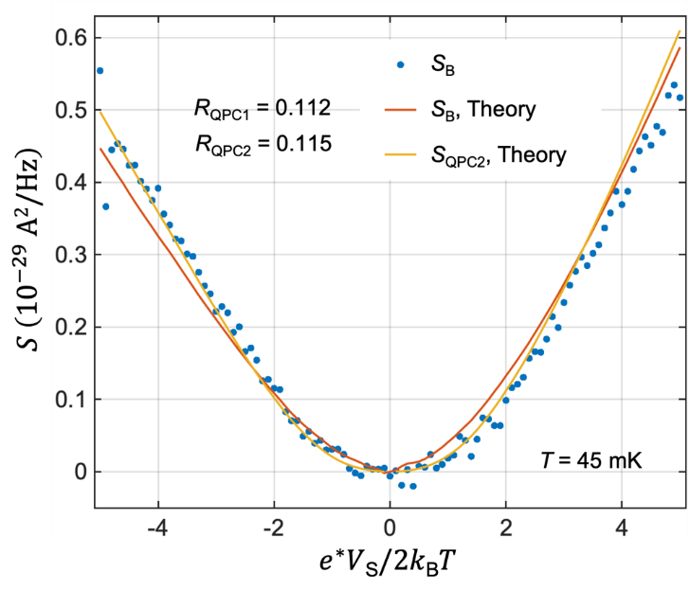
FIG. S7: $S_{B}$ and $S_{QPC2}$. The difference between $S_{B}$ and $S_{QPC2}$ is sufficiently small. The same data set with Fig. 3 of the main text is used.

SV. TWO-QPC EXPERIMENT AT FILLING FACTOR $ν=2/5$
In this supplementary section, we extend our study to the FQH regime at ν = 2/5. Its edge structure is composed of two (inner and outer) edge channels. The inter-QPC distance is 2 µm.
First, we performed a two-QPC experiment on the outer edge channel, making the inner edge channels fully reflected at the QPCs. In the same way with Fig. 1(b), we confirmed that the tunneling charge at QPC1 is $e^{*}=e/3$ [Fig. S8(a)], as expected. We observed that partitioning of diluted anyons of the fractional charge at QPC2 results in the Fano factor close to $F_{dilute}$ = 3.27 as in ν = 1/3 [Fig. S8(b)]. The Fano factor agrees well with our theory based on the braiding angle $2θ=2π/3$ and the scaling dimension $δ=1/3$, supporting the time-domain braiding process also in the outer edge channel at ν = 2/5.
Next, we performed another two-QPC experiment on the inner edge channel, making the outer edge channels fully transmitted through the QPCs. The tunneling charge at QPC2 was found as $e^{*}=e/5$ from the shot noise measurement where a full beam impinges at QPC2 while QPC1 is pinched off [Fig. S9(a)]. Then, partitioning a dilute beam at QPC2, we obtained $F_{dilute}$ ∼ 1 in our measurement uncertainty (which suffers from the very weak spectral density, weaker than the ν = 1/3 case). The result implies that the trivial partition process is more substantial along the inner channel.
We compare the experimental result of partitioning the inner channel with existing theoretical models. There are several models for edges at ν = 2/5. In the model by Wen [S11] where large spatial separation between the inner and outer channels is considered, anyons with fractional charge $e^{*}=e/5$ have the braiding phase $2θ=6π/5$and scaling dimension δ = 3/5. This model supports $F_{dilute}$ ≃ −5.16 when only the time-domain braiding process is considered and $F_{dilute}$ ≃ 30 when both the time-domain braiding and the trivial partition processes are considered with the measured value of $R_{QPC1} = 0.088$. Hence it is incompatible with our experiment. Another model proposed by Lopez and Fradkin [S12] predicts a downstream charge mode and non-propagating neutral modes. In this case, the braiding phase is solely from the propagating downstream charge mode, and it has the value of $2θ=π/5$. And, the two $δ$s appearing in Eq. (S14) become to have different values; the first one is $8/5$ and the second is $1/10$. This is because the non-propagating neutral mode contributes to the anyonic exchange phase at a QPC, but not to its tunneling exponent. The resulting Fano factor is $F_{dilute}≃-0.2$, which cannot explain our experiment. On the other hand, Ferraro et al. [S13] modified the Lopez-Fradkin model. In their model, there is a downstream charge mode and upstream neutral modes. Then, while the most relevant tunneling charge at a QPC at low temperature is $e^{*}=2e/5$ (which is described by $2θ=4π/5$and $δ=2/5$), there is another quasiparticle tunneling of charge $e^{*}=e/5$ (described by $2θ=π/5$ and $δ=8/5$). Since our experimental data support $e^{*}=e/5$ and it is expected that the quasiparticle of $e^{*}=e/5$ has larger bare QPC tunneling strength than that of $e^{*}=2e/5$, we assumed that the anyon with $e^{*}=e/5$ dominates the QPC tunneling in our experiment. Our theory shows that this anyon results in the Fano factor $F_{dilute}≃1$, since the large scaling dimension $δ=8/5 (>1)$ makes the trivial partition process to dominate over the braiding process [See Eq. (S11)]. This may explain our experiment on partitioning the inner edge channel. There might be also a possibility that interactions between the channels give rise to decoherence effects in favor of the trivial partition process.

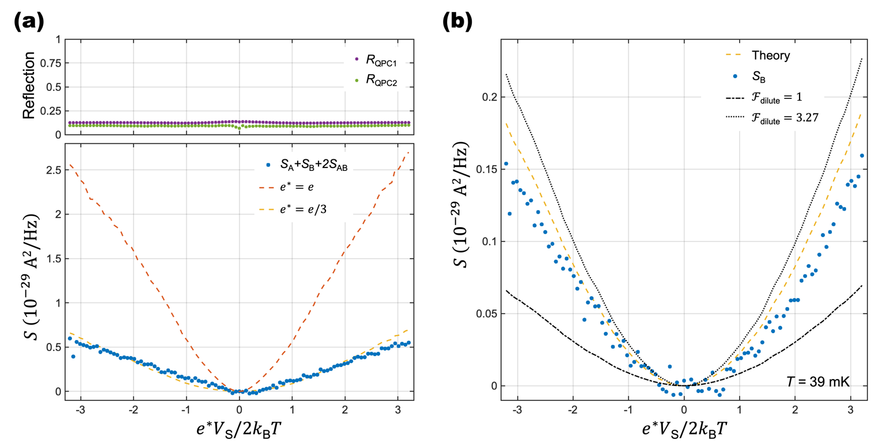
FIG. S8: Noise measurement for ν = 2/5 outer edge. (a) Upper panel: Reflection probabilities $R_{QPC1}$ (purple dots) and $R_{QPC2}$ (green dots). Lower panel: Measurement of tunneling charge at QPC1. Blue dots are $S\text{A}+S\text{B}+2S\text{AB}$ noise calculation from measurement. Red dashed line and yellow dashed line are obtained from Eq. (1) in the main text, with $e^{*}=e$ and ${ e}^{*}=e/3$ respectively. (b) Dilute beam impinges on QPC2, creating the excess AC. The reflection probabilities of the QPCs are the same as (a).

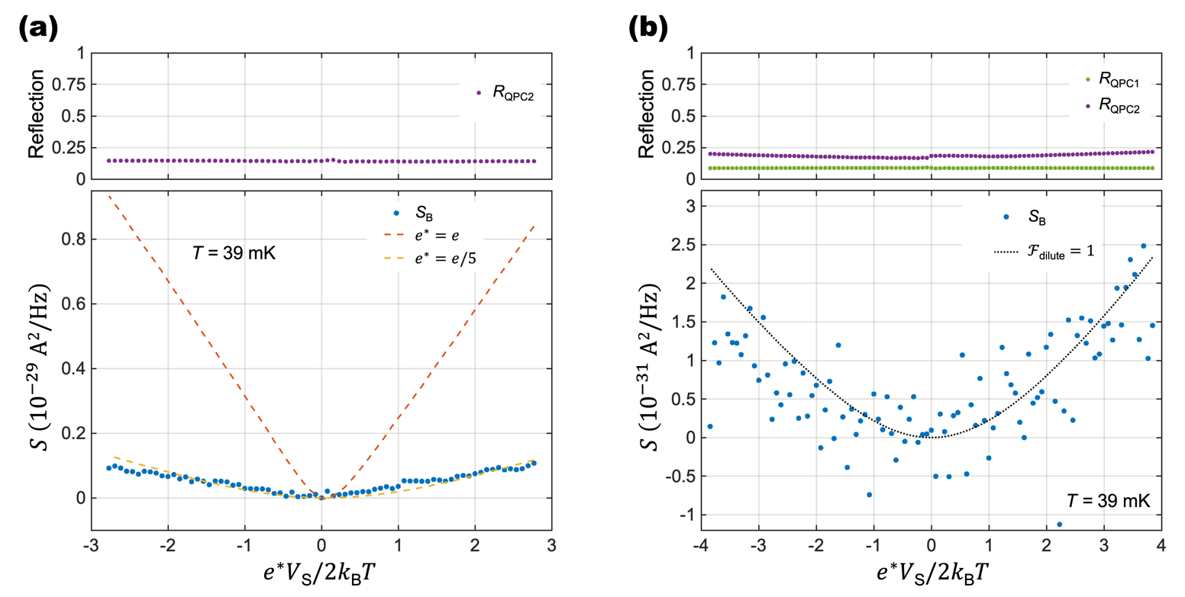
FIG. S9: Noise measurement for ν = 2/5 inner edge. (a) QPC1 is pinched off for injecting a full beam to QPC2. Upper panel: Reflection probability R_{QPC2} for the inner edge. Lower panel: Auto-correlation shot noise measurement results (blue dots) at 39 mK. Red dashed line and yellow dashed line are obtained from Eq. (1) in the main text, with $e^{*}=e$ and ${ e}^{*}=e/5$ respectively. (b) Two-QPC experiment result. Upper panel: Reflection probability $R_{QPC1}$ (green dots) and $R_{QPC2}$ (purple dots). Lower panel: The measured excess noise $S_{B}$ (blue dots). The black dotted line corresponds to Eq. (2) with $F_{dilute}$= 1.

SVI. CROSS CORRELATION
Here, we show that our experimental data of the cross correlation (CC) $S_{AB}$ of the two-QPC setup and an additional three-QPC setup are also in excellent agreement with our theory mainly based on the time-domain braiding process. For the two-QPC setup, the CC $S_{AB}$ between amplifiers A and B is related to the AC noise of QPC2 by
$$S_{AB}={-S}_{QPC2}+\frac{∂I_{QPC2}}{∂I_{QPC1}}S_{QPC1} ,$$ | (S16)
where the second term corresponds to the correlation between the tunneling current $I_{QPC1}$ at QPC1 and the tunneling current $I_{QPC2}$ at QPC2 [S1, S7]. For comparison between our experimental data and the theory, we replace the differential reflection $∂I_{QPC2}/∂I_{QPC1}$by its averaged value R_{QPC2}. Then $S_{AB}$ is obtained by using $S_{QPC2}$ in Eq. (S13) and $S_{QPC1}$ in Eq.(1) of the main text. This theoretical result is in good agreement with our experimental data [Fig. S10(a)]. For comparison, we also cite the free fermion results from the Landauer-Büttiker formalism, which corresponds to the trivial partition,
$$S_{AB}=-2e^{*}I_{S}R_{QPC1}^{2}R_{QPC2}\left(1-R_{QPC2}\right)\left[\coth\left(\frac{e^{*}V_{S}}{2k_{B}T}\right)-\frac{2k_{B}T}{e^{*}V_{S}}\right] ,$$ | (S17)
and plot it in Fig. S10(a) as the red dashed line with $e^{*} = e/3$.
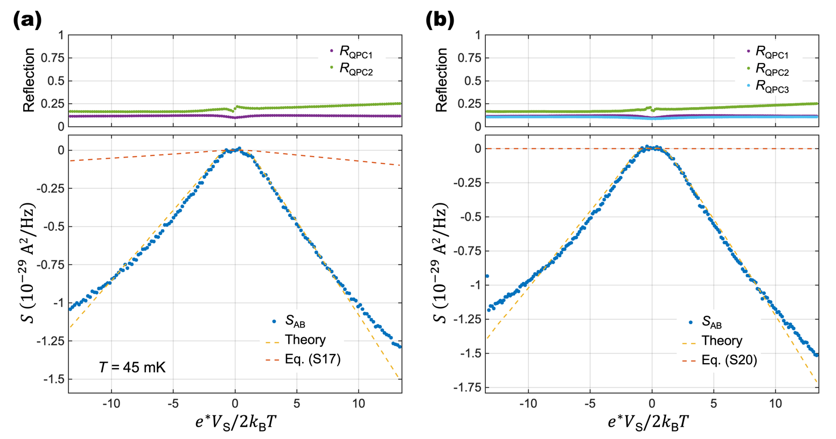
FIG. S10: Cross correlations (a) Cross correlation S_{AB} of the two-QPC geometry. (b) S_{AB} of the three-QPC geometry with symmetric injection of two dilute beams to QPC2. The experimental data of (a) were obtained with the same measurement (e.g., R_{QPC1}, R_{QPC2}) with Fig. 4(a) of the main text. The data of (b) were obtained with the average value of R_{QPC1} = 0.116, R_{QPC2} = 0.192, and R_{QPC3} = 0.102. The results are in good agreement with our theoretical result (yellow dashed lines). The results of Eq. (S17) and Eq. (S20) for the trivial partition process (red dashed lines) are shown for comparison.
We also analyze our experimental data of the CC $S_{AB}$ of a three-QPC geometry [Fig. S1(b)], which is essentially the same configuration with Ref. [S10]. To have the three-QPC geometry, we operated an additional QPC, QPC3, located downside of QPC2. This QPC connects Edge3 with an additional edge channel, Edge4, via anyon tunneling. By applying a voltage of the same amplitude $V_{S}$ to the source contact S2 with that applied to the source contact S1 of Edge1, a current $I_{S}$ flows along Edge4 (the same amount with the current along Edge1). It is reflected at QPC3, then a dilute beam of current $I_{QPC3}=R_{QPC3}I_{S}$ is generated to flow along Edge3 towards QPC2, where $R_{QPC3}$ is the reflection probability at QPC3. So the two dilute beams, one along Edge2 and the other along Edge3, are injected to QPC2. Then the CC $S_{AB}$ between amplifiers A and B was measured.
Theoretically, the CC is written as
$$S_{AB}={-S}_{QPC2}+\frac{∂I_{QPC2}}{∂I_{QPC1}}S_{QPC1}-\frac{∂I_{QPC2}}{∂I_{QPC3}}S_{QPC3} ,$$ | (S18)
where $S_{QPC3}=2e^{*}I_{S}R_{QPC3}\left(1-R_{QPC3}\right)\left[\coth\left(\frac{e^{*}V_{S}}{2k_{B}T}\right)-\frac{2k_{B}T}{e^{*}V_{S}}\right]$ is the excess tunneling noise at QPC3 following Eq. (1). The third term is the correlation between the tunneling currents $I_{QPC2}$ and $I_{QPC3}$. As in our phenomenological theory for the two-QPC setup, we calculated the noise $S_{QPC2}$ as
$$S_{QPC2}=F_{dilute}×2e^{*}\left|I_{QPC1}-I_{QPC3}\right|R_{QPC2}\left(1-R_{QPC2}\right)\left[\coth\left(\frac{e^{*}V_{S}}{2k_{B}T}\right)-\frac{2k_{B}T}{e^{*}V_{S}}\right].$$ | (S19)
The Fano factor $F_{dilute}=S_{QPC2}/2e^{*}I_{QPC2}$ is calculated by the CLL theory for $R_{QPC2}≪1$and $e^{*}V_{S}≫k_{B}T$ as before. The non-equilibrium correlator in Eq. (S4) has the multiplicative factor in the first term, which describes the effect of the dilute beam injected across QPC1. In the case of the two dilute beams, the non-equilibrium correlator is modified such that the first term has an additional multiplicative factor of ${\left(1-R_{QPC3}+R_{QPC3}e^{-2iθsign⁡\left(t_{2}-t_{1}\right)}\right)}^{\frac{I_{S}}{e^{*}}\left|t_{2}-t_{1}\right|}$ which describes the effect of the dilute beam injected across QPC3. We note that the braiding phase factor $e^{-2iθsign⁡\left(t_{2}-t_{1}\right)}$of this multiplicative factor for the dilute beam injected across QPC3 differs from the factor $e^{2iθsign⁡\left(t_{2}-t_{1}\right)}$ of the multiplicative factor for the dilute beam injected across QPC1, because the time-domain loop at QPC2 braids the two beams in the opposite direction to each other. Using the modified non-equilibrium correlator, it is straightforward to compute the tunneling current and noise at QPC2, hence, the Fano factor $F_{dilute}$.
Note that in the case of the perfectly symmetric injection of $I_{QPC1}=I_{QPC3}$, $F_{dilute}$ diverges, and Eq. (S19) is invalid. However, Eq. (S18) is applicable to our experimental situation where there was about 10% difference between $R_{QPC1}$ and $R_{QPC3}$ [Fig. S10(b)] so that both $I_{QPC1}-I_{QPC3}$ and $F_{dilute}$ are finite.
For comparison between our experimental data and the theory, we replace the differential reflections $∂I_{QPC2}/∂I_{QPC1}$ and $-∂I_{QPC2}/∂I_{QPC3}$ in Eq. (S17) by their averaged value $R_{QPC2}$. Then $S_{AB}$ is obtained by using $S_{QPC2}$ in Eq. (S19), $S_{QPC1}$ in Eq. (1) of the main text and an equation for $S_{QPC3}$ corresponding to Eq. (1). This theoretical result is in good agreement with our experimental data [Fig. S10(b)]. The excellent agreement between our phenomenological theory and our measurement of the CC $S_{AB}$ strongly supports that the time-domain braiding process is the underlying mechanism in both the two- and three-QPC geometries. Note that we also plot the non-interacting results from the Landauer-Büttiker formalism with the trivial partition process (with $e^{*} = e/3$),
$$S_{AB}=-2e^{*}I_{S}{(R}_{QPC1}^{ }-R_{QPC3})^{2}R_{QPC2}\left(1-R_{QPC2}\right)\left[\coth\left(\frac{e^{*}V_{S}}{2k_{B}T}\right)-\frac{2k_{B}T}{e^{*}V_{S}}\right] ,$$ | (S20)
as the red dashed line in Fig. S10(b) for comparison.
Last but not least, we point out that measurement of AC $S_{B}$ at the port B in the two-QPC geometry is more useful for detecting the time-domain anyon braiding at QPC2 than the CC $S_{AB}$, especially for the case of non-Abelian anyons. It is firstly because $S_{B}$ is more directly related to the noise $S_{QPC2}$ at QPC2 where the time-domain braiding process happens. As shown in Eq. (S15), $S_{B}$ becomes the same with $S_{QPC2}$ as the temperature becomes lower. By contrast, the difference between the CC $S_{AB}$ and $S_{QPC2}$ is not negligible, as the second term of Eq. (S16) is of the same order with $S_{QPC2}$. Secondly, in the most promising non-Abelian FQH states, upstream and downstream flows coexist along FQH edges. Then, there can occur some side-effects by the coexistence [S1]. The ratio of the side-effects compared to the main signal of our interest is of the order of $R_{QPC1}R_{QPC2}$ for the case of $S_{B}$, but it is of the order of $R_{QPC1}$ for the case of $S_{AB}$. The AC S_{B} is more robust against the side-effects than CC $S_{AB}$.

[S1] J.-Y. M. Lee and H.-S. Sim, Non-Abelian Anyon Collider, arXiv:2202.03649 (2022).
[S2] D. E. Feldman and M. Heiblum, Why a noninteracting model works for shot noise in fractional charge experiments, Phys. Rev. B 95, 115308 (2017).
[S3] For a review, see M. Heiblum, in Perspectives of Mesoscopic Physics: Dedicated to Yoseph Imry’s 70th Birthday, edited by A. Ahrony and O. Entin-Wohlman (World Scientific, Singapore, 2010).
[S4] D. C. Glattli, Tunneling Experiments in the Fractional Quantum Hall Regimes. In: Douçot, B., Pasquier, V., Duplantier, B., Rivasseau, V. (eds) The Quantum Hall Effect. Progress in Mathematical Physics, vol 45. Birkhäuser Basel (2005).
[S5] B. Rosenow and B. I. Halperin, Nonuniversal Behavior of Scattering between Fractional Quantum Hall Edges, Phys. Rev. Lett. 88, 096404 (2002).
[S6] A. Braggio, D. Ferraro, M. Carrega, N. Magnoli, and M. Sassetti, Environmental induced renormalization effects in quantum Hall edge states, New J. Phys. 14, 093032 (2012).
[S7] B. Rosenow, I. P. Levkivskyi, and B. I. Halperin, Current Correlations from a Mesoscopic Anyon Collider. Phys. Rev. Lett. 116, 156802 (2016).
[S8] N. Schiller, Y. Oreg, and K. Snizhko, Extracting the scaling dimension of quantum Hall quasiparticles from current correlations, Phys. Rev. B 105, 165150 (2022).
[S9] B. Lee, C. Han, and H.-S. Sim, Negative Excess Shot Noise by Anyon Braiding. Phys. Rev. Lett. 123, 016803 (2019).
[S10] H. Bartolomei et al., Fractional statistics in anyon collisions, Science 368, 6487 (2020).
[S11] X.-G. Wen, Topological orders and edge excitations in fractional quantum Hall states, Adv. Phys. 44, 405 (1995).
[S12] A. Lopez and E. Fradkin, Universal structure of the edge states of the fractional quantum Hall states, Phys. Rev. B 59, 15323 (1999).
[S13] D. Ferraro, A. Braggio, M. Merlo, N. Magnoli, and M. Sassetti, Relevance of Multiple Quasiparticle Tunneling between Edge States at ν = p/(2np + 1), Phys. Rev. Lett. 101, 166805 (2008).

