Supplemental materials

Molecular patterns identify distinct subclasses of myeloid neoplasia

Content:
A) Supplementary tables
- Supplementary Table-1. Summary of all the sources of cases included in our study, page 3.
- Supplementary Table-2. Summary of clinical and molecular features of all cohorts, page 4.
- Supplementary Table-3. List of 40 genes used in our molecular clustering scheme, page 5.
- Supplementary Table-4. Molecular signatures of all novel clusters, page 5.
- Supplementary Table-5. Clinical, cytogenetic, and molecular features of experimental and validation cohorts, page 6.
- Supplementary Table-6. Clinical, cytogenetic, and molecular features of original and validation cohorts based on clusters, pages 7-8.
- Supplementary Table-7. Median overall survival of the validation cohort based on the assigned clusters, page 9.
- Supplementary Table-8. Clinical, cytogenetic, and molecular features of all risk groups, page 9.
- Supplementary Table-9. Hazard risk (HR) coefficients of the identified risk groups across the training and the validation datasets, page 10.

B) Supplementary figures
- Supplementary Figure 1. The frequency of total mutations numbers, page 11.
- Supplementary Figure 2. The frequency of genetic mutations and cytogenetic abnormalities based on genomic clusters, page 12.
- Supplementary Figure 3. The most important genetic features used in our scheme, page 13.
- Supplementary Figure 4. The most important genetic features used in our scheme at the level of each cluster, page 14.
- Supplementary Figure 5. K-fold cross validation method, page 15.
- Supplementary Figure 6. The distribution of genomic clusters among patients with different clinical diagnosis, page 16.
- Supplementary Figure 7. The median bone marrow blast percent per genomic clusters, page 17.
- Supplementary Figure 8. Genomic clusters percentage in all the molecular mutations and cytogenetic abnormalities, page 18.
- Supplementary Figure 9. Kaplan-Meier analysis showing the overall survival (in months) of cases assigned to different clusters, page 19.
- Supplementary Figure 10. Cox proportional hazard model for overall survival, page 20.
- Supplementary Figure 11. Kaplan-Meier analysis showing the overall survival (in months) of MDS cases based on IPSS-R subgroups, page 21.
- Supplementary Figure 12. Kaplan-Meier analysis showing the overall survival (in months) for training set and the validation cohort based on the assigned molecular clusters, page 22.
- Supplementary Figure 13. Hyperparameter tuning of the random forest multi-class classification model via cross-validation, page 23.

C) Supplementary figure legends, page 24-25.
D) Supplementary methods, pages 25-26
Genetic studies
- Conventional cytogenetics
- Statistical Methods
- Autoencoder
- Gaussian Mixture Model
- Unsupervised Clustering
- Classification of New Data
- Validation
E) Supplementary results, page 27
F) References, page 28-29.

Supplementary Table-1. Summary of the sources of myelodysplastic syndrome and secondary acute myeloid leukemia cases included in our study

Cohorts | Total number of patients
Our cohorts | 2902
Cleveland Clinic Foundation (CCF) | 1627
Munich Leukemia Laboratory (MLL) | 1275
Public cohorts# | 686
Beat AML master trial¹ | 45
Euro-MDS cohort² | 641
External Validation Cohorts | 419
Wayne State University Karmanos Comprehensive cancer center | 207
University of Texas Southwestern Simmons Comprehensive Cancer Center | 212
# Only cases with available cytogenetics and molecular features were included.
¹ Tyner JW, Tognon CE, Bottomly D, et al. Functional genomic landscape of acute myeloid leukaemia. Nature 2018;562:526-31.
² Bersanelli M, Travaglino E, Meggendorfer M, et al. Classification and Personalized Prognostic Assessment on the Basis of Clinical and Genomic Features in Myelodysplastic Syndromes. J Clin Oncol 2021;39:1223-33.

Variables | Cleveland Clinic Foundation (CCF)  N=1627 | Munich Leukemia Laboratory (MLL)  N= 1275 | Beat AML master trial  N=45 | Euro-MDS cohort  N=641
Age, median (IQR) | 69 (61-76) | 73 (67-78) | 69 (62-74) | 74 (68-79)
Gender
Male, n (%) | 59 | 60 | 69 | 61
Female, n (%) | 41 | 40 | 31 | 39
BM blast %, median (IQR) | 3 (1-13) | 6 (2-20) | 37 (21-62) | 4 (2-7)
Diagnosis
LR-MDS | 1041 (64) | 611 (48) | 0 | 427 (67)
HR-MDS | 277 (17) | 283 (22) | 0 | 214 (33)
s-AML | 309 (19) | 381 (30) | 45 | 0
Cytogenetics
Normal | 774 (48) | 757 (59) | 17 (38) | 475 (74)
Abnormal | 837 (52) | 517 (41) | 28 (62) | 166 (26)
Complex | 287 (18) | 66 (5) | 11 (24) | 26 (4)
Molecular Clusters
1 | 79 (5) | 98 (8) | 3 (7) | 21 (3)
2 | 436 (27) | 325 (26) | 17 (38) | 142 (22)
3 | 35 (2) | 29 (2) | 0 (0) | 12 (2)
4 | 74 (5) | 125 (10) | 0 (0) | 114 (18)
5 | 71 (4) | 25 (2) | 0 (0) | 11 (2)
6 | 98 (6) | 114 (9) | 0 (0) | 89 (14)
7 | 166 (10) | 24 (2) | 0 (0) | 35 (5)
8 | 69 (4) | 131 (10) | 1 (2) | 35 (5)
9 | 88 (5) | 89 (7) | 0 (0) | 42 (7)
10 | 31 (2) | 49 (4) | 0 (0) | 63 (10)
11 | 70 (4) | 43 (3) | 2 (5) | 6 (1)
12 | 49 (3) | 56 (4) | 0 | 25 (4)
13 | 287 (18) | 67 (5) | 11 (24) | 26 (4)
14 | 74 (5) | 100 (8) | 11 (24) | 20 (3)
Status Death, n (%) | 752 (46) | 521 (41) | 31 (76) | 255 (40)
Supplementary Table-2. Clinical, cytogenetic, and molecular characteristics of original cohorts

Supplementary Table-3. List of 40 genes in our targeted panel used for the molecular machine learning model
ASXL1 | BCOR | BCORL1 | CALR | CUX1 | CEBPA | CBL | CSF3R
DNMT3A | DDX41 | EZH2 | ETV6 | FLT3 | GATA2 | GNAS | IDH1
IDH2 | JAK2 | KRAS | KIT | MPL | NRAS | NPM1 | NF1
NOTCH1 | PTPN11 | PHF6 | RAD21 | RUNX1 | SF3B1 | SRSF2 | SMC1A
SMC3 | STAG2 | SETBP1 | TET2 | TP53 | U2AF1 | WT1 | ZRSR2

Supplementary Table-4. Molecular clusters signatures.

Risk Group |  | Clusters | Signature
Group-1 |  | MC-4 | Normal KT (100%), SF3B1 (100%), DNMT3A (20%)
 |  | MC-10 | Normal KT (100%), SF3B1 (100%), DNMT3A (24%), TET2 (100%)
Group-2 |  | MC-2 | Normal KT (100%), DNMT3A (11%), RAS MT (10%)
 |  | MC-6 | Normal KT (100%), SRSF2 (49%), RAS MT (23%)
 |  | MC-8 | Del 5q (100%), DNMT3A (17%), TP53 (17%)
Group-3 |  | MC-3 | Del Y (54%), TET2 (100%), ZRSR2 (23%), ASXL1 (21%)
 |  | MC-5 | Del 20q (76%), U2AF1 (28%), ASXL1 (16%)
 |  | MC-7 | Other KT (100%), Other MTs
 |  | MC-9 | Normal KT (100%), ASXL1 (100%), SRSF2 (34%), RUNX1 (31%)
 |  | MC-12 | Normal KT (100%), TET2 (100%), ASXL1 (100%), SRSF2 (48%), RUNX1 (40%)
 |  | MC-14 | Del Y (42%), SF3B1 (24%)
Group-4 |  | MC-1 | Trisomy 8 (100%), ASXL1 (35%), TET2 (31%), RUNX1 (24%)
 |  | MC-11 | Del 7q (100%), RAS MT (28%), TET2 (20%)
Group-5 |  | MC-13 | Complex (100%), TP53 (44%)

Supplementary Table-5. Clinical, cytogenetic, and molecular characteristics of original and validation cohorts
Variables | Experimental Cohort  N=3588 | External Cohort  N= 412 | P-value
Age, median (IQR) | 72 (64-77) | 69 (62-75) | 0.000
Gender |  |  | 0.815
Male, n (%) | 2143 (60) | 248 (60)
Female, n (%) | 1444 (40) | 163 (40)
BM blast %, median (IQR) | 4 (2-13) | 7 (2-19) | 0.000
Diagnosis |  |  | 0.000
LR-MDS | 2079 (58) | 156 (38)
HR-MDS | 774 (22) | 134 (33)
s-AML | 735 (20) | 122 (30)
Cytogenetics |  |  | 0.000
Normal | 2023 (57) | 252 (62)
Abnormal | 1548 (43) | 156 (38)
Number of MT |  |  | 0.000
0 | 825 (23) | 33 (8)
1-2 | 1666 (46) | 204 (49)
3-4 | 813 (23) | 114 (28)
>4 | 581 (16) | 61 (15)
Molecular clusters
1 | 201 (6) | 25 (6)
2 | 920 (26) | 74 (18)
3 | 76 (2) | 2 (1)
4 | 313 (9) | 17 (4)
5 | 107 (3) | 10 (2)
6 | 301 (8) | 19 (5)
7 | 225 (6) | 54 (13)
8 | 236 (7) | 13 (4)
9 | 219 (6) | 26 (6)
10 | 143 (4) | 9 (2)
11 | 121 (3) | 16 (4)
12 | 130 (4) | 19 (5)
13 | 391 (11) | 118 (29)
14 | 205 (6) | 10 (2)
Status Death, n (%) | 1559 (44) | 190 (46) | 0.315

IQR: interquartile range, MDS: myelodysplastic syndrome, sAML: secondary acute myeloid leukemia, LR: low-risk, HR: high-risk, MT: mutation, BM: bone marrow

Supplementary Table-6. Clinical, cytogenetic, and molecular characteristics of original and validation cohorts in all clusters
IQR: interquartile range, WBC: white blood cell, MDS: myelodysplastic syndrome, sAML: secondary acute myeloid leukemia, SLD: single lineage dysplasia, MLD: multi-lineage dysplasia, CMML: chronic myelomonocytic leukemia, EB: excess blast. Only mutations with frequency >2% are shown.
 | C1 |  |  | C2 |  |  | C3 |  |  | C4 |  |  | C5 |  |  | C6 |  |  | C7
Variables | O | V | P | O | V | P | O | V | P | O | V | P | O | V | P | O | V | P | O | V | P
 | 201 | 25 |  | 920 | 74 |  | 76 | 2 |  | 313 | 17 |  | 107 | 10 |  | 301 | 19 |  | 225 | 54
Age, M (IQR)
Gender |  |  | 0.779 |  |  | 0.866 |  |  | 0.467 |  |  | 0.368 |  |  | 0.031 |  |  | 0.391 |  |  | 0.921
Male | 131 (65) | 17 (68) |  | 519 (56) | 41 (55) |  | 60 (79) | 2 (100) |  | 182 (58) | 8  (47) |  | 72 (67) | 10 (100) |  | 203 (67) | 11 (58) |  | 135 (60) | 32 (59)
Female | 70 (44) | 8  (32) |  | 401 (44) | 33 (45) |  | 16 (21) | 0  (0) |  | 131 (42) | 9  (53) |  | 35 (33) | 0  (0) |  | 35 (33) | 8  (42) |  | 90 (40) | 22 (41)
BM blast %
Diagnosis |  |  | 0.004 |  |  | 0.035 |  |  | 0.358 |  |  | 0.009 |  |  | 0.787 |  |  | 0.117 |  |  | 0.000
LR-MDS | 73 (36) | 4  (16) |  | 566 (62) | 35 (47) |  | 37 (49) | 2 (100) |  | 268 (86) | 10 (59) |  | 77 (72) | 7  (70) |  | 152 (51) | 9  (47) |  | 147 (65) | 23 (43)
HR-MDS | 50 (25) | 14 (56) |  | 148 (16) | 19 (26) |  | 28 (37) | 0  (0) |  | 27  (9) | 5  (29) |  | 14 (13) | 2  (20) |  | 116 (39) | 5  (26) |  | 49 (22) | 10 (19)
sAML | 78 (39) | 7  (28) |  | 206 (22) | 20 (27) |  | 11 (15) | 0  (0) |  | 18  (6) | 2  (12) |  | 16 (15) | 1  (10) |  | 33 (11) | 5  (26) |  | 29 (13) | 21 (39)
Cytogenetics |  |  |  |  |  | 0.000 |  |  | - |  |  | - |  |  | - |  |  | 0.008
Normal | 1  (1) | 0  (0) |  | 920 (100) | 71 (96) |  | 0  (0) | 0  (0) |  | 313 (100) | 17 (100) |  | 0  (0) | 0  (0) |  | 300 (99.7) | 18 (95) |  | 0  (0) | 0  (0)
Abnormal | 200 (100) | 25 (100) |  | 0  (0) | 3  (4) |  | 76 (100) | 2 (100) |  | 0  (0) | 0  (0) |  | 106 (100) | 10 (100) |  | 1  (0.3) | 1  (5) |  | 221 (100) | 54 (100)
MT # |  |  | 0.015 |  |  | 0.000 |  |  | 0.952 |  |  | 0.000 |  |  | 0.775 |  |  | 0.000 |  |  | 0.066
0 | 40 (20) | 0  (0) |  | 446 (49) | 16 (22) |  | 0  (0) | 0  (0) |  | 0  (0) | 0  (0) |  | 22 (21) | 2  (20) |  | 0  (0) | 0  (0) |  | 39 (17) | 1  (2)
1-2 | 70 (35) | 11 (44) |  | 366 (40) | 26 (49) |  | 45 (59) | 1  (50) |  | 235 (75) | 9  (53) |  | 55 (51) | 5  (50) |  | 162 (54) | 7  (37) |  | 109 (48) | 27 (50)
3-4 | 57 (28) | 8  (32) |  | 77  (8) | 25 (34) |  | 26 (34) | 1  (50) |  | 68 (22) | 6  (36) |  | 21 (20) | 2  (20) |  | 117 (39) | 7  (37) |  | 50 (22) | 18 (34)
>4 | 34 (17) | 6  (24) |  | 31  (3) | 7  (9) |  | 5  (7) | 0  (0) |  | 10 (13) | 2  (12) |  | 9  (8) | 1  (10) |  | 22  (7) | 5  (26) |  | 27 (12) | 8  (19)

IQR: interquartile range, MDS: myelodysplastic syndrome, sAML: secondary acute myeloid leukemia, LR: low-risk, HR: high-risk, MT: mutation, #:number, BM: bone marrow, C: cluster, O: original cohort, V: validation cohort, P:p-value,
 | C8 |  |  | C9 |  |  | C10 |  |  | C11 |  |  | C12 |  |  | C13 |  |  | C14
Variables | O | V | P | O | V | P | O | V | P | O | V | P | O | V | P | O | V | P | O | V | P
 | 236 | 13 |  | 219 | 26 |  | 143 | 9 |  | 121 | 16 |  | 130 | 19 |  | 391 | 117 |  | 205 | 10
Age, M (IQR)
Gender |  |  | 0.523 |  |  | 0.480 |  |  | 0.888 |  |  | 0.903 |  |  | 0.289 |  |  | 0.506 |  |  | 0.722
Male | 71 (30) | 5  (38) |  | 163 (74) | 21 (81) |  | 76 (53) | 5  (56) |  | 70 (58) | 9  (56) |  | 91 (70) | 11  (58) |  | 217 (56) | 69 (59) |  | 153 (75) | 7  (70)
Female | 165 (70) | 8  (62) |  | 56 (26) | 5  (19) |  | 67 (47) | 4  (44) |  | 51 (42) | 7  (44) |  | 39 (30) | 8  (42) |  | 174 (45) | 48 (41) |  | 51 (25) | 3  (30)
BM blast %
Diagnosis |  |  | 0.002 |  |  | 0.424 |  |  | 0.223 |  |  | 0.057 |  |  | 0.476 |  |  | 0.012 |  |  | 0.161
LR-MDS | 184 (78) | 6  (46) |  | 96 (44) | 8  (31) |  | 112 (78) | 8  (89) |  | 46 (38) | 3  (19) |  | 68 (52) | 8  (42) |  | 150 (38) | 28  (24) |  | 103 (50) | 5  (50)
HR-MDS | 21  (9) | 5  (38) |  | 86 (39) | 12 (46) |  | 26 (18) | 0  (0) |  | 33 (27) | 9  (56) |  | 42 (32) | 6  (32) |  | 111 (28) | 44  (37) |  | 23 (11) | 3  (30)
sAML | 31 (13) | 2  (15) |  | 37 (17) | 6  (23) |  | 5 (4) | 1  (11) |  | 42 (35) | 4  (25) |  | 20 (15) | 5  (26) |  | 130 (33) | 46  (39) |  | 79 (39) | 2  (20)
Cytogenetics |  |  | - |  |  | 0.000 |  |  | 0.801 |  |  | - |  |  | 0.009 |  |  | - |  |  | -
Normal | 0  (0) | 0  (0) |  | 217 (99) | 23 (89) |  | 142 (99) | 9 (100) |  | 0  (0) | 0  (0) |  | 130 (100) | 18 (95) |  | 0  (0) | 0  (0) |  | 0  (0) | 0  (0)
Abnormal | 236 (100) | 13 (100) |  | 2  (1) | 3  (12) |  | 1  (1) | 0  (0) |  | 121 (100) | 16  (100) |  | 0  (0) | 1  (6) |  | 391 (100) | 117  (100) |  | 205 (100) | 10  (100)
MT # |  |  | 0.699 |  |  | 0.004 |  |  | 0.266 |  |  | 0.089 |  |  | 0.551 |  |  | 0.000 |  |  | 0.558
0 | 75 (32) | 2  (15) |  | 0  (0) | 0  (0) |  | 0  (0) | 0  (0) |  | 34 (28) | 1  (6) |  | 0  (0) | 0  (0) |  | 92 (24) | 8  (7) |  | 77 (38) | 3  (30)
1-2 | 130 (55) | 11 (85) |  | 57 (26) | 3  (12) |  | 63 (44) | 1  (11) |  | 54 (36) | 7  (44) |  | 7  (5) | 0  (0) |  | 219 (56) | 80  (68) |  | 104 (51) | 6  (60)
3-4 | 26 (11) | 0  (0) |  | 114 (52) | 14 (54) |  | 70 (49) | 6  (67) |  | 32 (26) | 5  (31) |  | 71 (55) | 7  (37) |  | 64 (16) | 23  (20) |  | 20 (10) | 1  (10)
>4 | 5  (2) | 0  (0) |  | 48 (22) | 9  (35) |  | 10  (7) | 2  (22) |  | 1  (1) | 3  (19) |  | 52 (40) | 12  (63) |  | 16  (4) | 6  (5) |  | 4  (2) | 0  (0)

Supplementary Table-7. Median overall survival with 95% Confidence Intervals
Cluster | Median Survival
Cluster-1 | 16 (12-NA)
Cluster-2 | NA (38-NA)
Cluster-3 | 5.5 (0-NA)
Cluster-4 | NA (19-NA)
Cluster-5 | NA (30-NA)
Cluster-6 | 30 (20-NA)
Cluster-7 | 47 (21-NA)
Cluster-8 | 36 (32-NA)
Cluster-9 | 26 (12-NA)
Cluster-10 | NA (NA-NA)
Cluster-11 | 25 (13-NA)
Cluster-12 | 51 (11-NA)
Cluster-13 | 13 (8-28)
Cluster-14 | NA (12-NA)

Supplementary Table-8. Clinical, cytogenetic, and molecular characteristics of all risk groups
Variables | All | Low Risk | Low-Int Risk | High-Int Risk | High Risk | Very High Risk
Total population | 3588 | 456 | 1457 | 962 | 322 | 391
Test cohort | 718 (20) | 89 (19) | 291 (20) | 192 (20) | 59 (18) | 87 (22)
Training cohort | 2870 (80) | 367 (81) | 1166 (80) | 770 (80) | 263 (82) | 304 (78)
Age, median (IQR) | 72 (64-77) | 73 (68-78) | 71 (63-77) | 72 (64-78) | 73 (65-78) | 71 (63-77)
Gender
Male | 2143 (60) | 258 (57) | 793 (54) | 674 (70) | 201 (62) | 217 (56)
Female | 1444 (40) | 198 (43) | 664 (46) | 287 (30) | 121 (38) | 174 (45)
Labs
WBC (10⁹/L) | 4 (3-11) | 6 (4-8) | 5 (3-10) | 6 (3-15) | 5 (3-15) | 3 (2-8)
Hb(g/dL) | 10 (9-11) | 10 (9-11) | 10 (9-12) | 10 (9-11) | 9 (8-11) | 10 (9-11)
Platelets (10⁹/L) | 112 (50-240) | 290 (169-395) | 112 (60-227) | 102 (44-202) | 67 (27-158) | 58 (30-102)
BM blast % | 4 (2-13) | 2 (1-4) | 4 (2-11) | 5 (2-14) | 11 (4-32) | 12 (3-22)
Diagnosis
LR-MDS | 2079 (58) | 380 (83) | 902 (62) | 528 (55) | 119 (37) | 150 (38)
HR-MDS | 774 (22) | 53 (12) | 285 (20) | 242 (25) | 83 (26) | 111 (28)
sAML | 735 (21) | 23 (5) | 270 (19) | 192 (20) | 120 (37) | 130 (33)
Cytogenetics
Normal | 2023 (57) | 455 (100) | 1220 (84) | 347 (37) | 1 (0) | 0 (0)
Abnormal | 1548 (43) | 1 (0) | 237 (16) | 600 (63) | 319 (100) | 391 (100)
Number of MT
0 | 825 (23) | 0 (0) | 521 (36) | 138 (14) | 74 (23) | 92 (24)
1-2 | 1666 (46) | 298 (66) | 658 (45) | 377 (39) | 114 (35) | 219 (56)
3-4 | 813 (23) | 138 (31) | 220 (16) | 302 (31) | 89 (28) | 64 (17)
>4 | 284 (8) | 20 (4) | 58 (4) | 145 (15) | 45 (14) | 16 (4)
IQR: interquartile range, WBC: white blood cell count, Hb: hemoglobin, MDS: myelodysplastic syndrome, sAML: secondary acute myeloid leukemia, LR: low-risk, HR: high-risk, MT: mutation, BM: bone marrow.

Supplementary Table-9. Hazard-Risk (HR) Coefficients and associated CI and P-values comparing the aggregated risk groups to reference (Group-1) group across the training dataset and external validation dataset.
Risk Group | Training Set (HR, CI, P-Value) | Validation Set (HR, CI, P-Value)
Group-2 | 0.41 (0.10-3.90, <0.0001) | 0.62 (0.43-1.43, 0.15)
Group-3 | 0.86 (0.1-8.01, <0.0001) | 0.75 (0.42-1.75, 0.08)
Group-4 | 1.24 (0.12-9.82, <0.0001) | 0.92 (0.46-1.98, 0.04)
Group-5 | 1.77 (0.11-15.10, <0.0001) | 1.32 (0.42-3.11, 0.001)

Supplementary Figure-1
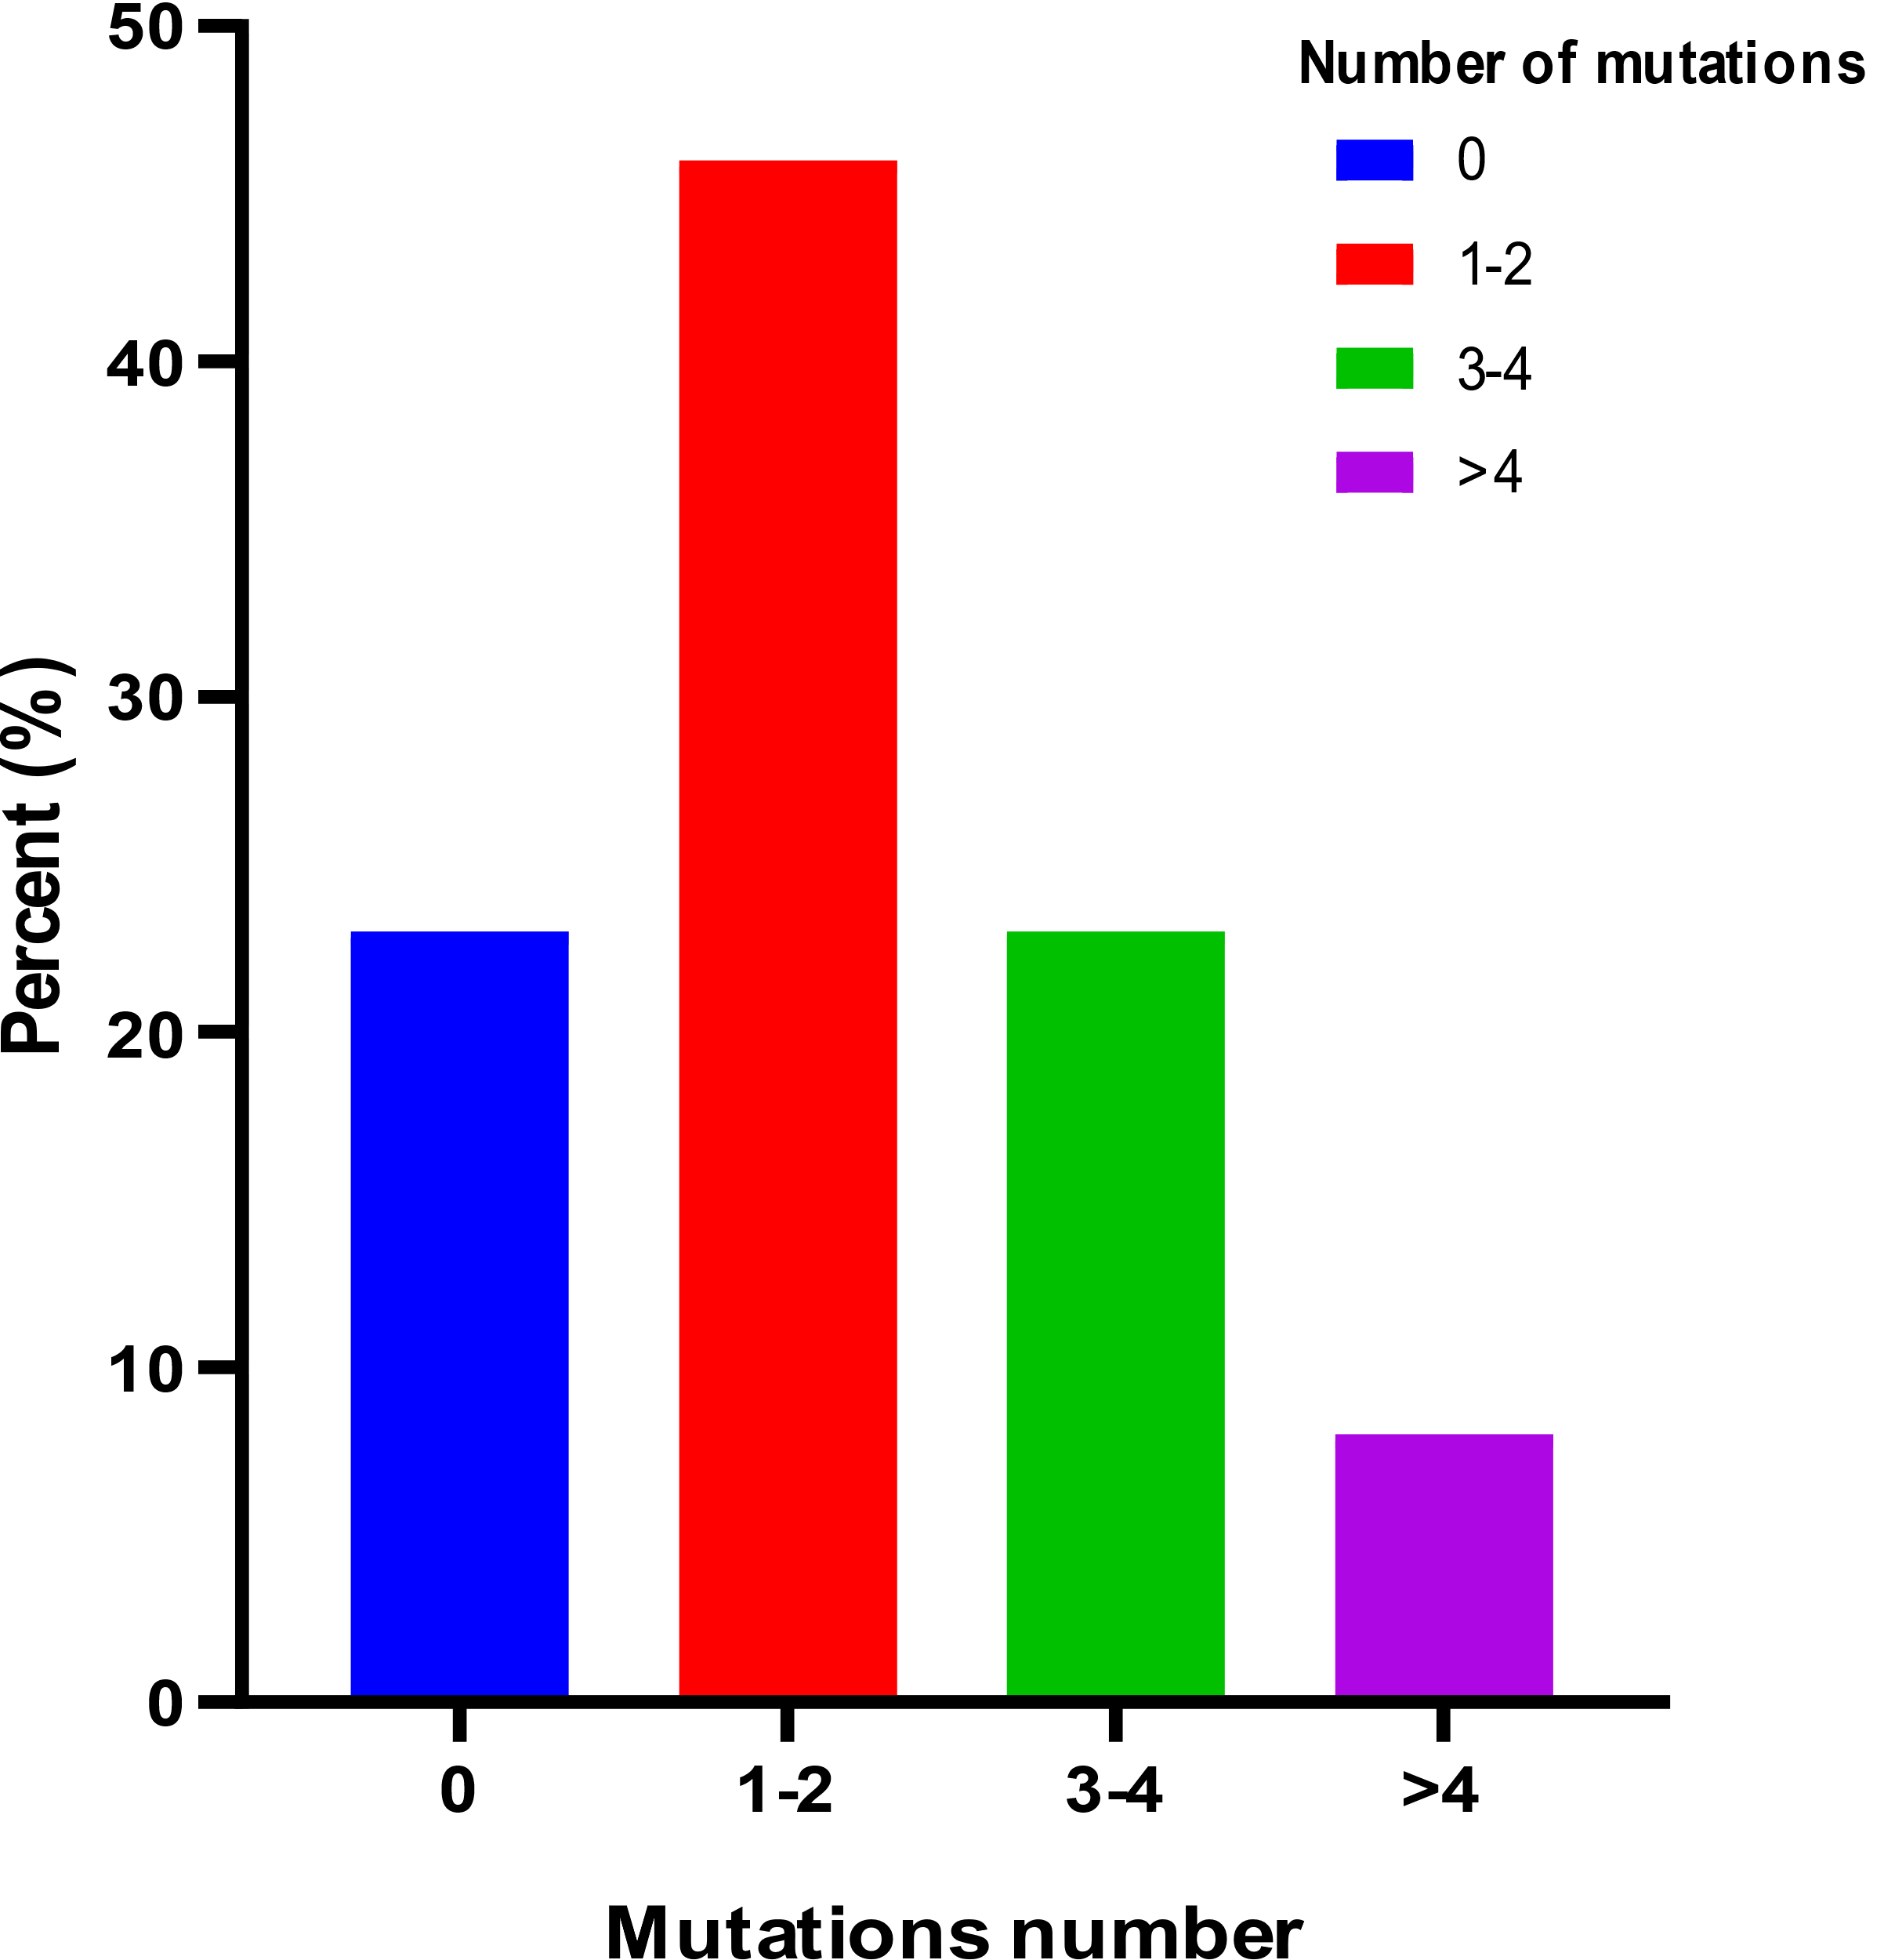

Supplementary Figure-2
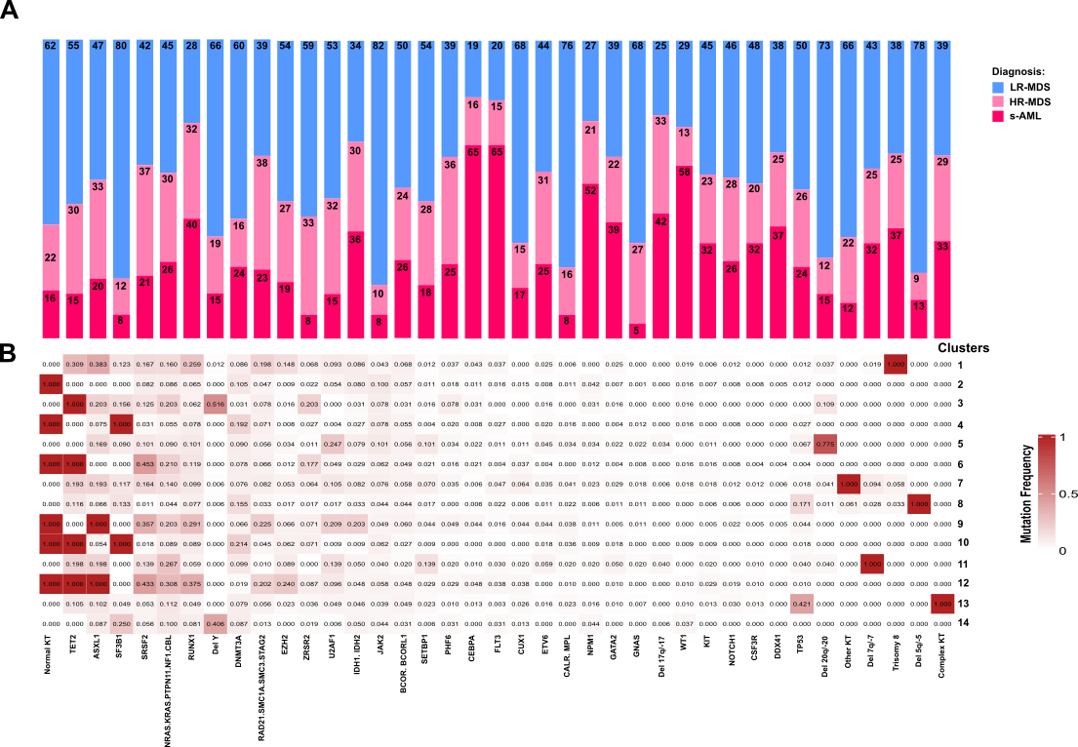
Supplementary Figure-3
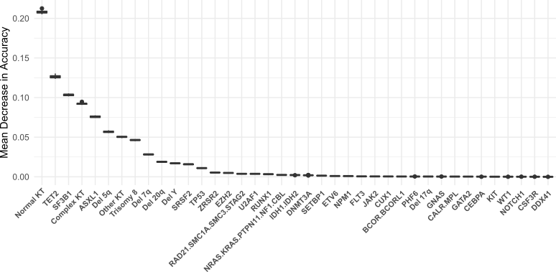

Supplementary Figure-4
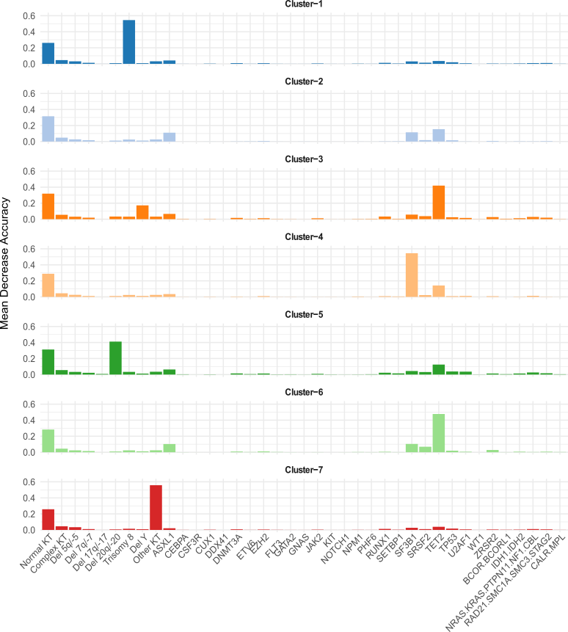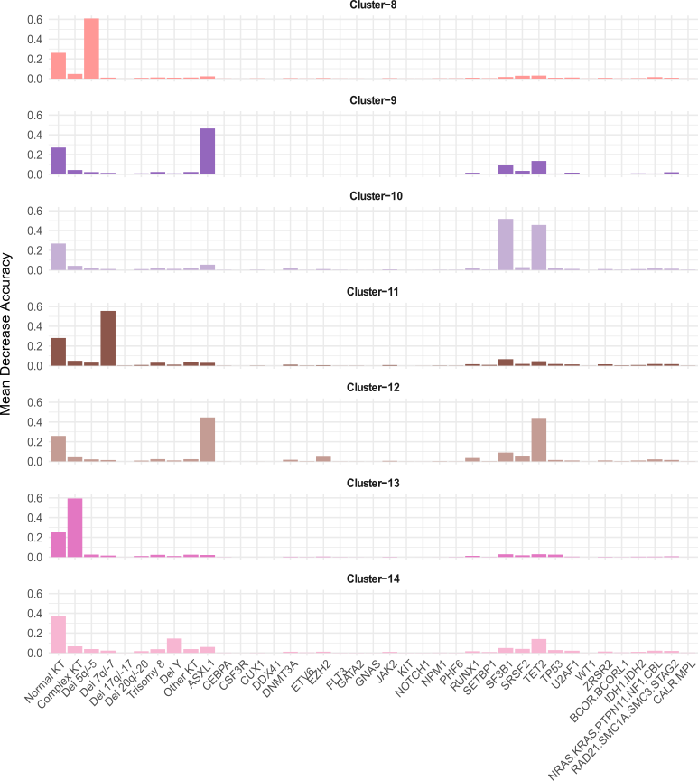

Supplementary Figure-5
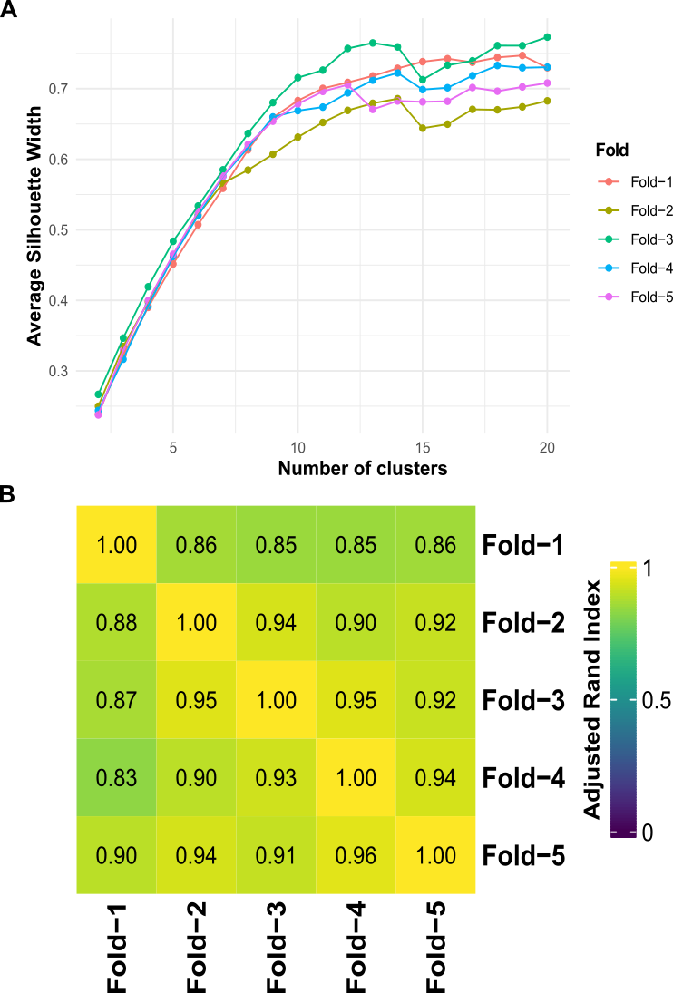

Supplementary Figure-6
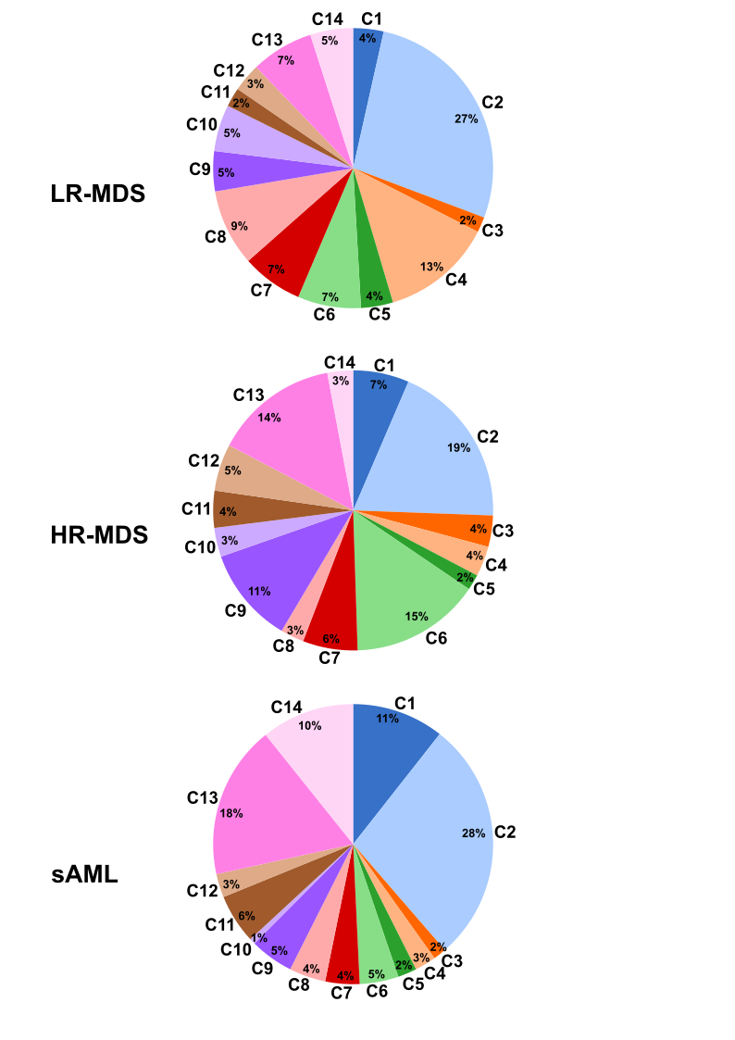

Supplementary Figure-7
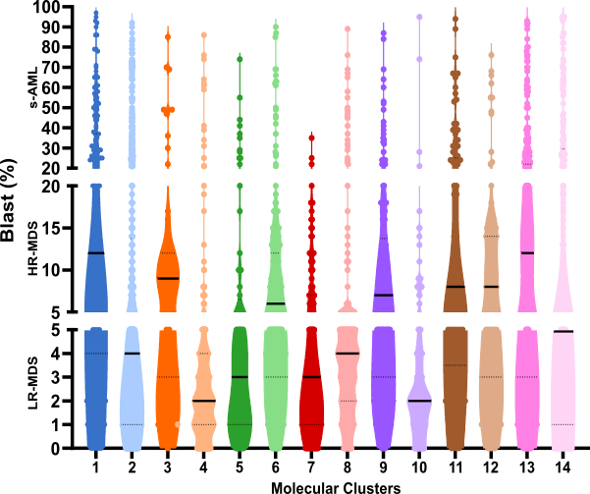

Supplementary Figure-8
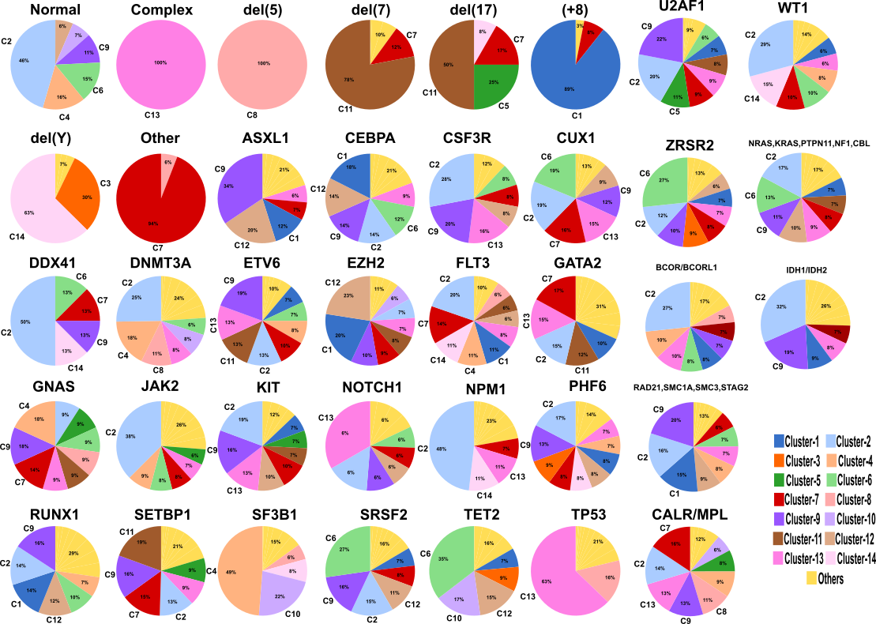
Supplementary Figure-9
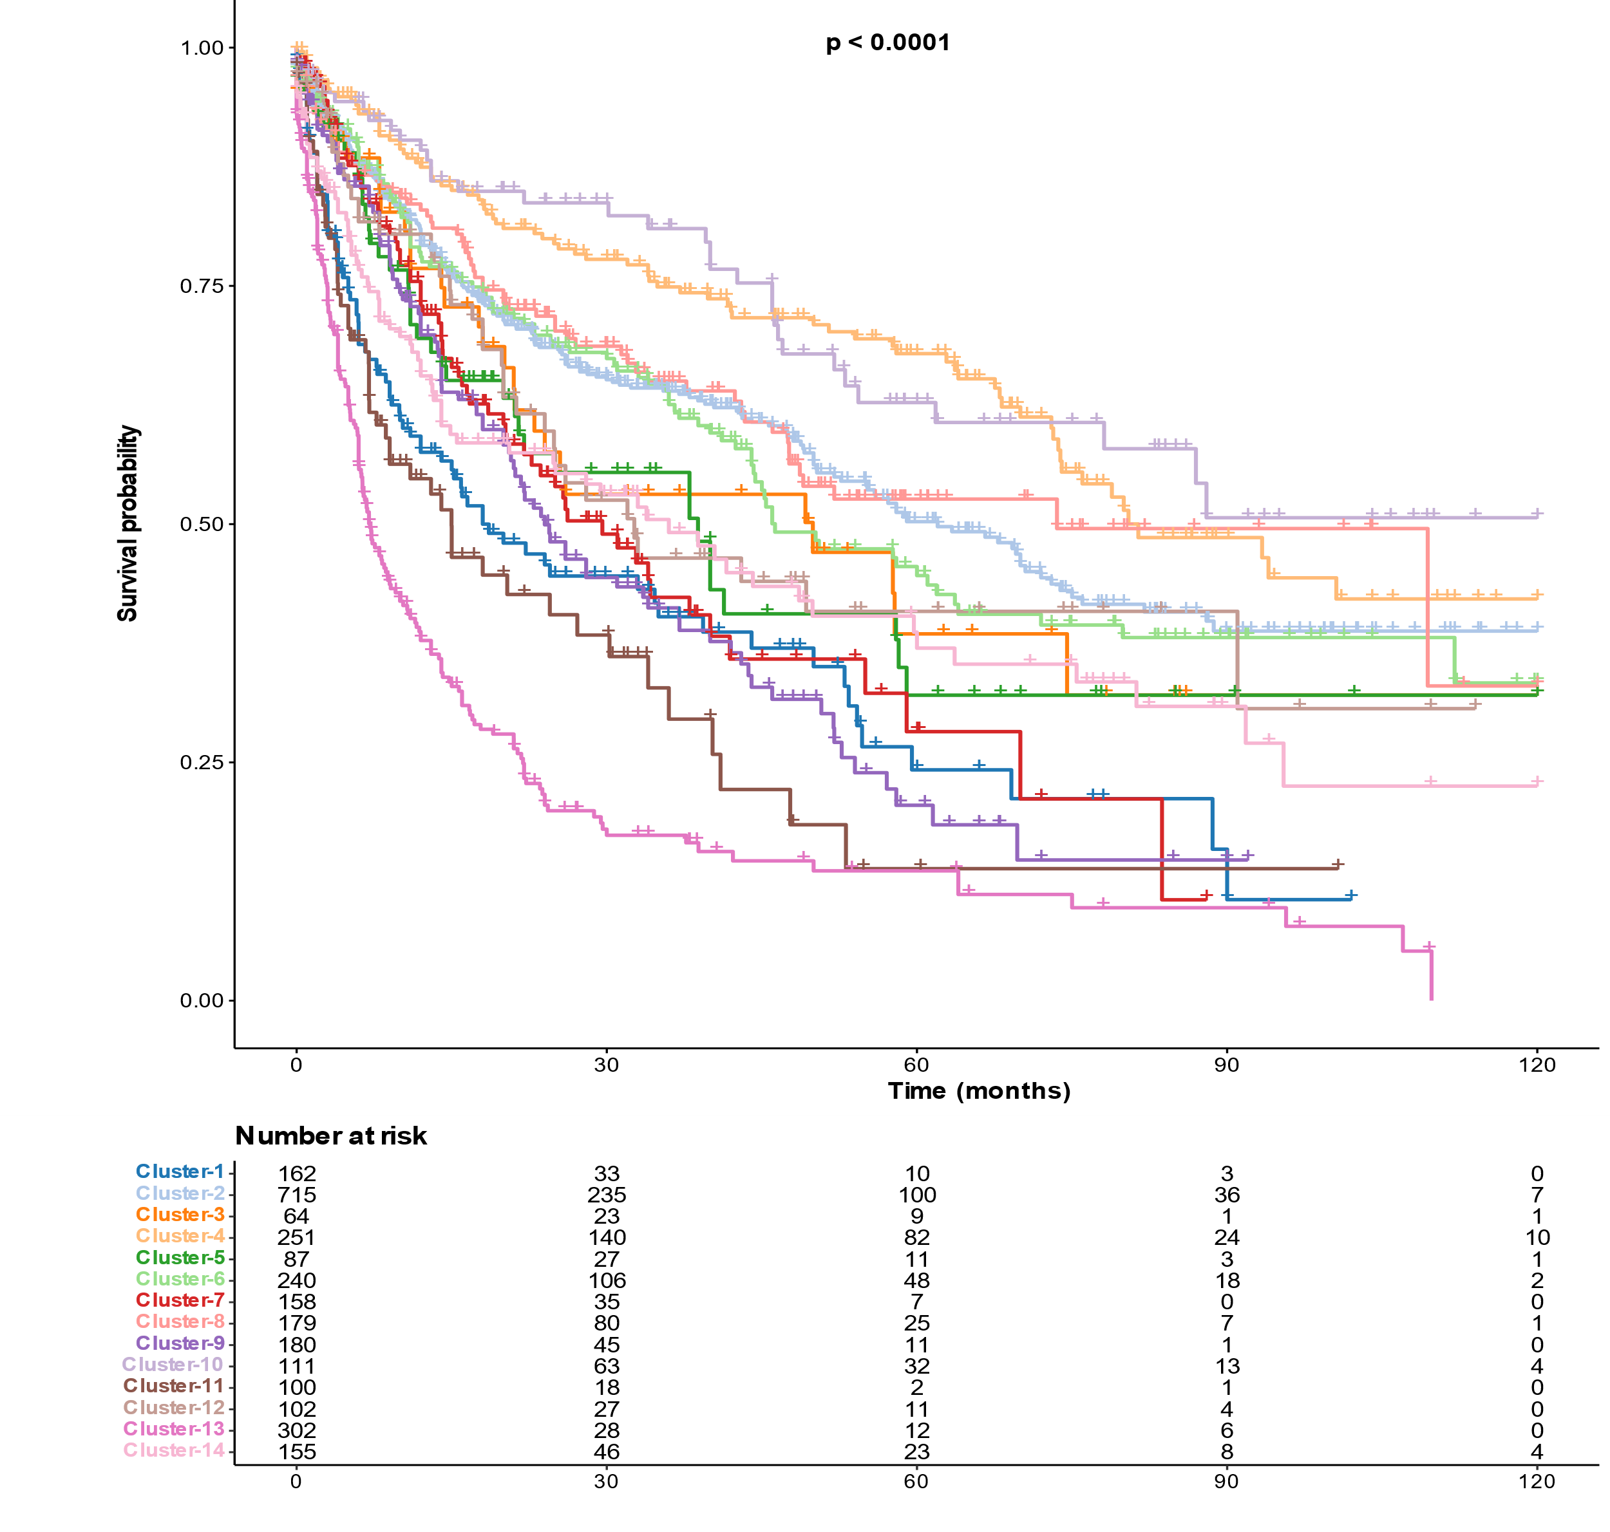

Supplementary Figure-10
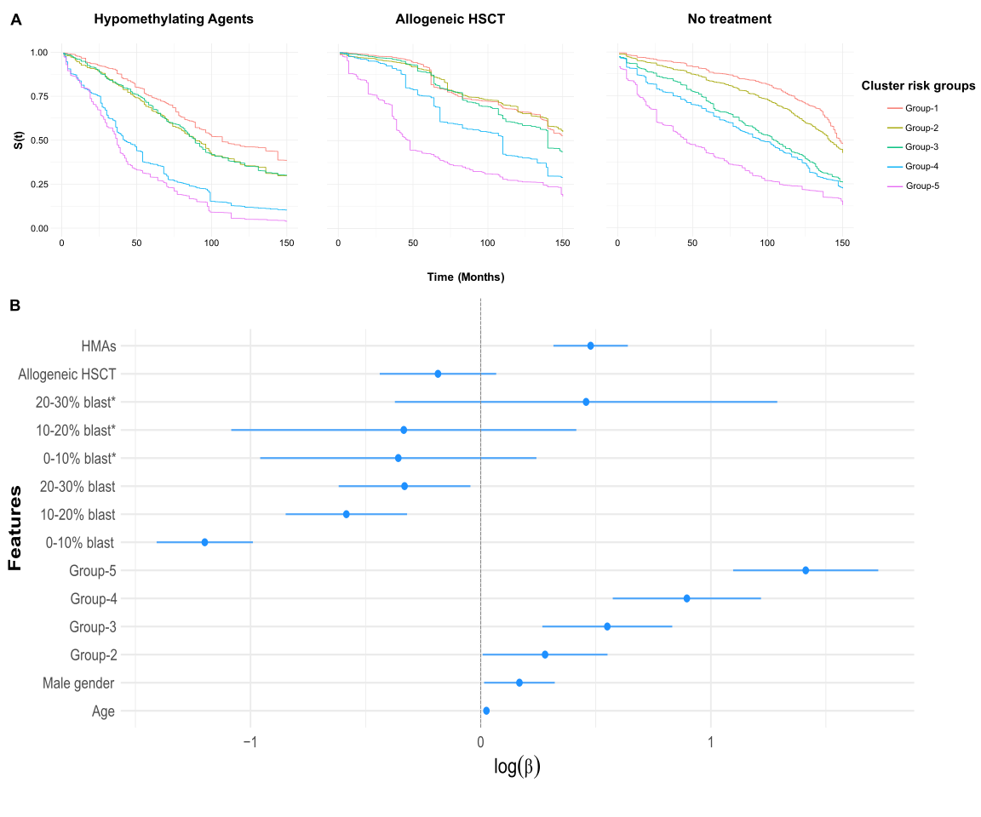

Supplementary Figure-11

Supplementary Figure-12

Supplementary Figure-13
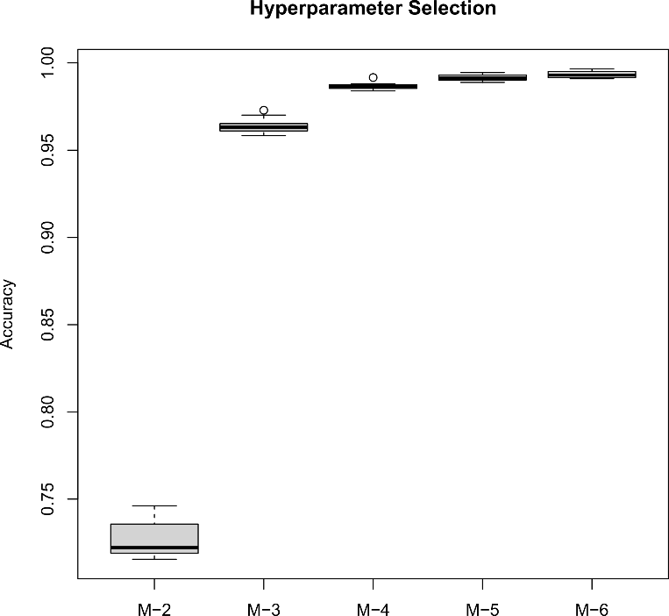

Supplementary figure legends
Supplementary Figure 1. Frequency of total mutations number as distributed among our myelodysplastic syndrome (MDS) and secondary acute myeloid leukemia (sAML) cases.
Supplementary Figure 2.A: Histogram bars represent the distribution of molecular hits and cytogenetics abnormalities among LR-MDS, HR-MDS, and sAML patients illustrated by a specific figure color legend. B: Heatmap representation of the frequency of molecular mutations and cytogenetic abnormalities per each genomic cluster.
Supplementary Figure 3. Genetic features ordered by ‘global importance’ measured by mean decrease in accuracy for the random forest classification model. A mean decrease in accuracy≥0.01 was considered significant.
Supplementary Figure 4. Cluster-specific importance of genetic features measured by mean decrease in accuracy for the random forest classification model. A mean decrease in accuracy≥0.01 was considered significant.
Supplementary Figure 5. K-fold cross-validation method for the proposed unsupervised clustering approach. A: The figure represents the silhouette values based on the number of the clusters. Total cluster number of 14 was associated with highest silhouette values in all folds. B: Overlap between the sub-groups (folds) based on the predicted assignments of random-forest classification models generated from each fold separately. More specifically, row j comparing column k shows the overlap of cases in fold j and fold k quantified byAdjusted Rand Index (ARI) classified by the model trained on fold j only.
Supplementary Figure 6. Molecular clusters (C) percentage in low-risk myelodysplastic syndrome (LR-MDS), high-risk myelodysplastic syndrome (HR-MDS), and secondary acute myeloid leukemia (sAML) patients. The pie charts demonstrate the percentage of each molecular cluster (C) in different clinical diseases. Each molecular cluster is presented by a specific figure legend color.
Supplementary Figure 7. Bone marrow blast percent (%) per molecular clusters. The plot represents the distribution of bone marrow blast percent in each molecular cluster. Solid lines represent median and dashed lines represent the 95% confidence intervals.
Supplementary Figure 8. Distribution of all the molecular mutations and cytogenetic abnormalities used to build our scheme across molecular Clusters (C). The pie charts illustrate the abundance of each molecular cluster (C) with regards to gene mutations and cytogenetic abnormalities. Each molecular cluster is presented by a specific figure legend color.
Supplementary Figure 9. Kaplan-Meier analysis showing the overall survival (in months) of cases assigned to different molecular clusters (cluster-1 to cluster-14). Statistically significant difference of log-Rank test is indicated by the p-value.
Supplementary Figure 10. A: Non-parametric survival estimation using Random Survival-Forest for different genomic risk groups adjusted for hypomethylating agents (HMAs) treatment, allogeneic hematopoietic stem cell transplant (HSCT), no treatment, age and sex. Survival curves are estimated for a pseudo-patient (male, aged 75 years) showing the effect of molecular clusters adjusting for treatment and other clinical variables. Each risk group is presented by a specific figure legend color. B: Subgroup analysis of overall survival according to age, gender, cluster risk groups, bone marrow blast percent before 25 months and after 25 months (asterisk [*]), HMAs treatment, and allogeneic HSCT.
Supplementary Figure 11. Kaplan-Meier analysis showing the overall survival (in months) of cases assigned to different molecular risk groups (Low, Int-low, Int-high, High, and Very-high) among different Revised
International Prognostic Scoring System (IPSS-R) risk groups. Statistically significant difference of log-Rank test is indicated by the p-value.
Supplementary Figure 12. Kaplan-Meier analysis showing the overall survival (in months) of cases assigned to different molecular clusters (MC) in the training set (yellow) and the validation cohort (blue). The KM curves for the external validation and training sets showed no difference except for MC 13 where comparison of MC-3,5,8,10,14 was hampered by low number of classified cases.
Supplementary Figure 13. Hyperparameter tuning of the random forest multi-class classification model via cross-validation.
Supplementary Methods
Genetic studies
For the data collected at CC, whole-exome sequencing (WES) was performed and paired disease and germline DNA of purified CD3+ lymphocytes were used. Whole-exome capture was accomplished by hybridizing sonicated genomic DNAs to a bait cDNA library synthesized on magnetic beads (SureSelect Human All Exon 50Mb or V4 kit, Agilent Technologies). Captured targets were sequenced using a HiSeq 2000 (Illumina) and standard protocols for 100-bp paired-end reads. Reads were aligned to the human genome (hg19) by a Burrows-Wheeler aligner (http://bio-bwa.sourceforge.net/) using a GATK pipeline that also extracted candidate variants/polymorphisms to reduce sequencing errors. Data were validated using targeted sequencing. Targeted sequencing was performed using a TruSeq Custom Amplicon kit (Illumina); a panel of 40 genes was interrogated (Supplementary Table-2). Sequencing libraries were generated according to an Illumina paired-end library protocol. The enriched targets were sequenced using a HiSeq 2000 or MiSeq (Illumina), at 862x coverage. Variants were annotated using Annovar14 and filtered by removing: i) synonymous single nucleotide variants; ii) variants only present in 140 unidirectional reads; and iii) variants in repetitive genomic regions. Variants with minimum depth less than 20 or number of high-quality reads less than 5 were filtered out. A bio-analytic pipeline developed in-house¹⁻³ deidentified somatic mutations using sequences derived from controls and mutational databases such as dbSNP138, 1000 Genomes or ESP 6500 database, and Exome Aggregation Consortium (ExAC). Variant allelic frequencies (VAFs) were adjusted according to zygosity and copy number based on conventional metaphase karyotyping and/or single nucleotide polymorphism array results. Patients from the MLL cohort were investigated by NGS using different methods and gene panels as previously described^{1,2,4}. The gene sequencing methods of publicly-shared patients were previously described⁵⁻⁸.
Conventional cytogenetics
Metaphase cytogenetics was performed on bone marrow (BM) aspirates. The median number of metaphases analyzed was 20. Chromosomal preparation was performed on G-banded metaphase cells using standard techniques, and karyotypes were described all the patients according to the International System for Human Cytogenetic Nomenclature^{9,10}.
Statistical Methods
Fisher’s exact test and Chi-square test were used to compare categorical variables. Mann–Whitney U test/ Wilcoxon rank-sum test were used for continuous variables. All p- values were two-sided; those less than 0.05 were considered statistically significant. All statistical computations were performed using R 3.6.2 (www.r-project.org) and Prism (GraphPad). To assess prognostic differences among the identified clusters, pairwise survival analysis using Kaplan Meier estimator and log-rank test was performed.
Autoencoder
Autoencoders are neural-network architectures, which can be designed to generate efficient compressed/low dimensional representations of given data. Here, we used a single layer autoencoder with shared layer between encoder and decoder to generate low-dimensional representations of binary mutation profiles of MDS samples. With a single shared layer, autoencoders can learn to capture the principal component space without orthogonality constraint, hence a proxy for binary-PCA analysis. We used TensorFlow framework to optimize via Adam optimizer and learning rate and batch size set to 1e-4 and 32 respectively. l1 and l2 regularization parameters are set to 0.1 as well to prevent possible overfitting^{11,12}.
Gaussian Mixture Model
Gaussian-mixture models (GMM) are model-based clustering methods where observations are separated into components/clusters representing gaussian distributions parameterized by different µ and σ. We used scikit-learn package to fit GMM with expectation-maximization over increasing number of components and used Bayesian Information Criterion (BIC) to select the number of clusters.
Over 100 iterations with random sub-sampling of binary observation vectors of mutation profiles, we first generated a low dimensional embedding of the sub-sampled data and used GMM to cluster the observations, where the number of GMM components was selected using Bayesian Information Criterion (BIC). Keeping track of co-clustering of observations at each iteration, we generated a consensus-matrix representing the frequency of clustering observations in the same cluster. The generated consensus-matrix was further clustered using hierarchical-clustering with Ward’s criteria to create the final cluster assignments using Silhouette value to select the number of clusters.¹³.
Unsupervised Clustering
Coupling Autoencoders and Gaussian-Mixture Models, we generated unsupervised clusters of MDS cases via Consensus approach. Over 100 iterations with random sub-sampling of data, we embedded the observations using the single layer autoencoder and clustered using the gaussian-mixture model. Keeping track of co-clustering of observations we generated a consensus-matrix. Finally, the consensus-matrix is clustered using hierarchical clustering with Ward’s criteria and Silhouette value to select the number of clusters to generate the final cluster assignments for all cases as described in more detail above.
Classification of New Data
Since our unsupervised clustering approach is a ‘distance’ based approach quantified by the frequency of co-occurance, new datasets cannot be readily assigned to individual clusters. For this purpose, we utilized Random Forests via R package randomForest in order to generate a multi-class classification model using binary mutation profiles as input and molecular clusters as classes. Hyperparameter tuning is done via cross-validation. This model is both used to classify internal and external validation cohorts and also available as a web based open-source tool (Supplementary Figure 13).
Validation
The model was internally and externally validated. Internal validation was performed by dividing the whole cohort into training (80%) and test (20%) sets. The model was developed based on the training set only. Survival analysis by random forest (RF) was then performed on the remaining 20% test set separately for internal validation. External validation was conducted on an independent cohort of MDS and sAML patients from the University of Texas Southwestern and the Wayne State University (Supplementary Table 1).

Supplementary results

Examples of molecular associations in our MCs:
Example 1
SF3B1 mutations were enriched in MC4, MC10, and MC14 and associated with TET2 (100%) mutations in MC10, indicating functional relationships. Notably, this group was distinct from MC14 in which SF3B1 mutations were grouped with delY and SRSF2 mutations. The diverse pathobiological derivation of these groups was also illustrated by their significant survival differences. Other splicing factor mutations were instead functionally distinctive and were assigned to different genomic groups. Indeed, SRSF2 mutations were enriched in MC9 and MC12 and associated with ASXL1 mutations and normal karyotype, but MC12 cases had additional TET2 mutations. A similar principle seemed to apply to U2AF1 mutations, abundant in MC5. These results argue that the genomic sub-classification of splicing factor mutations is strongly dependent on the presence/absence of other unique correlating cofounders affecting the functionality and biology of the distinct cluster.
Example 2
Traditionally, epigenetic modulator mutations have been grouped together for classification purposes, often ignoring their distinct or even often opposite function^{5,14,15}. In contrast, our ML-derived model highlights these functional differences, underscoring intertwining relationships across different molecular pathways of leukemogenesis. For instance, we found that IDH1/IDH2 mutations were mainly abundant in two MCs (MC2 and MC9), which had discrete survival differences and a significantly higher percentage of STAG2 and IDH1/IDH2 mutations in MC9 vs. MC2, in which they coincided with more frequent RAS and DNMT3A hits. Similarly, the functional effect of DNMT3A/SF3B1 co-mutations was reflected by a better OS of MC4 and MC10 (Low-Risk group). This phenomenon can be functionally explained by the relative mitigation effects of SF3B1 mutation on DNMT3A clones^{16,17}. Because DNMT3A and TET2 have different biological and possibly opposite functions, mutations in these epigenetic regulators belong to distinct functional pathways and separate MCs. Both EZH2 and UTX possess opposite H3K27 methylation effects and thus their mutations clustered separately and associated/substituted with/for distinct cluster-defining hits. Finally, RUNX1 mutations were abundant in MC9, MC12 and MC1 and were significantly associated with either ASXL1 and SRSF2 mutations as previously reported¹⁸.
Example 3
While our results reaffirm previous studies regarding the poor survival outcome associated with complex cytogenetics and TP53 mutations^{5,19-21}, the impact of TP53 allelic configuration on pathology and prognosis was also reflected in our molecular clustering, e.g., TP53 mutations in MC8 were mostly monoallelic (70%), explaining the better outcomes as compared to other MCs with TP53 in biallelic configuration. In addition, mutually exclusive PPM1D mutations coincided with TP53 clusters (MC13 and MC8), pointing towards to the known similar pathogenic pathway²²⁻²⁴.

References
1. Meggendorfer M, Haferlach C, Kern W, et al: Molecular analysis of myelodysplastic syndrome with isolated deletion of the long arm of chromosome 5 reveals a specific spectrum of molecular mutations with prognostic impact: a study on 123 patients and 27 genes. Haematologica 102:1502-1510, 2017
2. Delic S, Rose D, Kern W, et al: Application of an NGS-based 28-gene panel in myeloproliferative neoplasms reveals distinct mutation patterns in essential thrombocythaemia, primary myelofibrosis and polycythaemia vera. Br J Haematol 175:419-426, 2016
3. Haferlach T, Nagata Y, Grossmann V, et al: Landscape of genetic lesions in 944 patients with myelodysplastic syndromes. Leukemia 28:241-7, 2014
4. Palomo L, Meggendorfer M, Hutter S, et al: Molecular landscape and clonal architecture of adult myelodysplastic/myeloproliferative neoplasms. Blood 136:1851-1862, 2020
5. Bersanelli M, Travaglino E, Meggendorfer M, et al: Classification and Personalized Prognostic Assessment on the Basis of Clinical and Genomic Features in Myelodysplastic Syndromes. J Clin Oncol 39:1223-1233, 2021
6. Nagata Y, Zhao R, Awada H, et al: Machine learning demonstrates that somatic mutations imprint invariant morphologic features in myelodysplastic syndromes. Blood 136:2249-2262, 2020
7. Radakovich N, Nagy M, Nazha A: Machine learning in haematological malignancies. Lancet Haematol 7:e541-e550, 2020
8. Tyner JW, Tognon CE, Bottomly D, et al: Functional genomic landscape of acute myeloid leukaemia. Nature 562:526-531, 2018
9. Gonzalez Garcia JR, Meza-Espinoza JP: Use of the International System for Human Cytogenetic Nomenclature (ISCN). Blood 108:3952-3; author reply 3953, 2006
10. Liehr T: International System for Human Cytogenetic or Cytogenomic Nomenclature (ISCN): Some Thoughts. Cytogenet Genome Res 161:223-224, 2021
11. Baldi AP: Autoencoders, Unsupervised Learning, and Deep Architectures. Presented at the Proceedings of ICML Workshop on Unsupervised and Transfer Learning, 2012
12. Hinton GE, Salakhutdinov RR: Reducing the dimensionality of data with neural networks. Science 313:504-7, 2006
13. Fabian Pedregosa GV, Alexandre Gramfort, Vincent Michel, Bertrand Thirion, Olivier Grisel, Mathieu Blondel, Peter Prettenhofer, Ron Weiss, Vincent Dubourg, Jake Vanderplas, Alexandre Passos, David Cournapeau, Matthieu Brucher, Matthieu Perrot, Édouard Duchesnay: Scikit-learn: Machine Learning in Python. Journal of Machine Learning Research 12(85)::2825−2830, 2011
14. Reilly B, Tanaka TN, Diep D, et al: DNA methylation identifies genetically and prognostically distinct subtypes of myelodysplastic syndromes. Blood Adv 3:2845-2858, 2019
15. Venney D, Mohd-Sarip A, Mills KI: The Impact of Epigenetic Modifications in Myeloid Malignancies. Int J Mol Sci 22, 2021
16. Lin ME, Hou HA, Tsai CH, et al: Dynamics of DNMT3A mutation and prognostic relevance in patients with primary myelodysplastic syndrome. Clin Epigenetics 10:42, 2018
17. Song J, Hussaini M, Qin D, et al: Comparison of SF3B1/DNMT3A Comutations With DNMT3A or SF3B1 Mutation Alone in Myelodysplastic Syndrome and Clonal Cytopenia of Undetermined Significance. Am J Clin Pathol 154:48-56, 2020
18. Gaidzik VI, Teleanu V, Papaemmanuil E, et al: RUNX1 mutations in acute myeloid leukemia are associated with distinct clinico-pathologic and genetic features. Leukemia 30:2282, 2016
19. Bahaj W, Gurnari C, Kewan T, et al: The Drive to Acquire Biallelic Hits Inversely Correlates with the Functional Impact of the Primary TP53 Lesion: The Complexity of TP53 Role Assessment. Blood 138:3322, 2021
20. Bernard E, Nannya Y, Hasserjian RP, et al: Implications of TP53 allelic state for genome stability, clinical presentation and outcomes in myelodysplastic syndromes. Nat Med 26:1549-1556, 2020
21. Grob T, Al Hinai AS, Sanders MA, et al: Molecular Characterization of Mutant Tp53 Acute Myeloid Leukemia and High-Risk Myelodysplastic Syndrome. Blood, 2022
22. Kim B, Won D, Lee ST, et al: Somatic mosaic truncating mutations of PPM1D in blood can result from expansion of a mutant clone under selective pressure of chemotherapy. PLoS One 14:e0217521, 2019
23. Kindler T: CHIPing out PPM1D-mutant hematopoiesis. Blood 132:1087-1088, 2018
24. Singh A, Mencia-Trinchant N, Griffiths EA, et al: Mutant PPM1D- and TP53-Driven Hematopoiesis Populates the Hematopoietic Compartment in Response to Peptide Receptor Radionuclide Therapy. JCO Precis Oncol 6:e2100309, 2022

