Electronic Supporting Information
Label-Free Fluorometric Characterization of Fibre Cement: Unraveling Lignin Degradation via Multidimensional Fluorometry
Mahfuzul Hoque¹, Saeid Kamal², Sreenath Raghunath¹, and E. Johan Foster^{1,3*}
¹Department of Chemical and Biological Engineering, The University of British Columbia. 2385 East Mall, Pulp and Paper Centre, V6T 1Z4.
²Laboratory for Advanced Spectroscopy and Imaging Research (LASIR), Department of Chemistry, The University of British Columbia. 2036 Main Mall, Vancouver, BC Canada V6T 1Z1
³Bioproducts Institute, 2385 East Mall Vancouver, BC Canada V6T 1Z4
Correspondence and requests for materials should be addressed to E. J. F (email: johan.foster@ubc.ca)
Email Address: johan.foster@ubc.ca
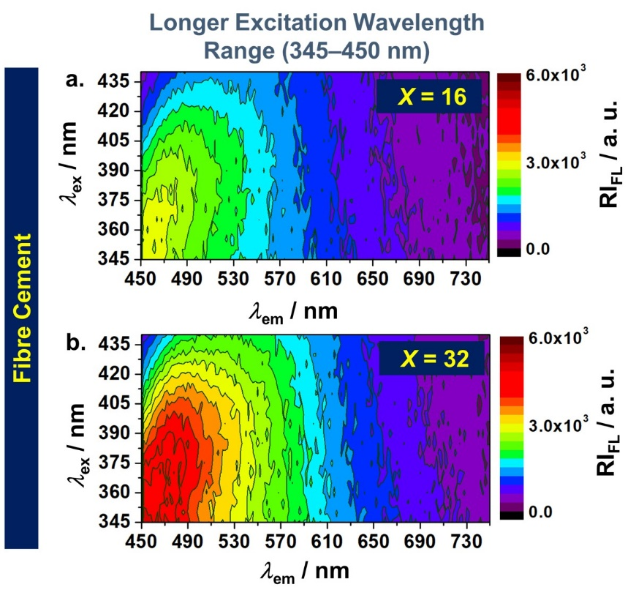
Figure S1. EEM of fibre cement at different pulp fibre content under longer excitation wavelength range (345–440 nm). 2D contour plot of fibre cement with (a) 16 wt.%, and (b) 32 wt.% pulp fibre content.
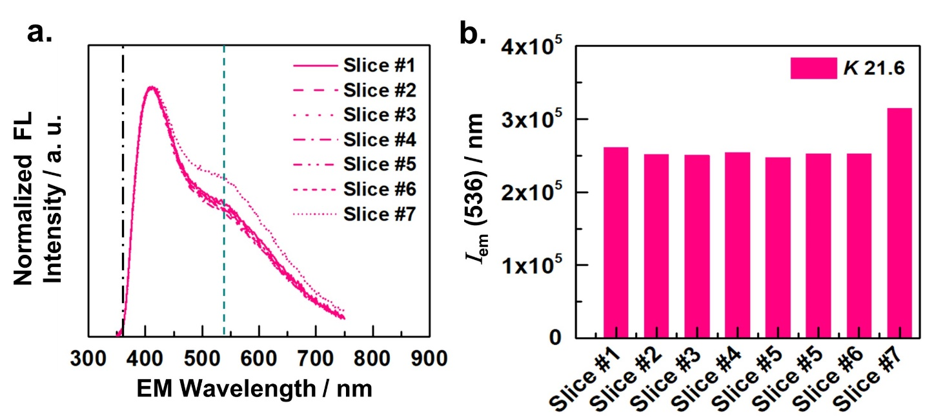
Figure S2. Steady-state emission spectrum of pristine pulp (X = 100) (a) Emission spectrums and (b) Variation of emission intensity at 536 nm for seven different slices (1.5x1.5 cm) of pristine pulp with Kappa number (K) of 21.6, which were cut from the 5x5 cm pulp sheet. In Fig. S2a, the dotted (vertical) lines are drawn at 536 nm emission (EM) wavelength. In Fig. S2b, value of the EM intensity (at 536 nm) was obtained from Fig. S2a. All the fluorescence experiment was carried at 330 nm excitation wavelength (see, experimental section for detailed breakdown of the experimental parameters).
To account the any change in emission intensity, which could simply be ascribed to the natural variation of lignin content within the pulp fibre, we recorded emission spectrums at several locations of the pulp with Kappa number (K) of 21.6 (by cutting them into slices, labeled as slice #number in Fig. S2a-b) and there was about 1.5% variation in fluorescence intensity (Fig. S2b).
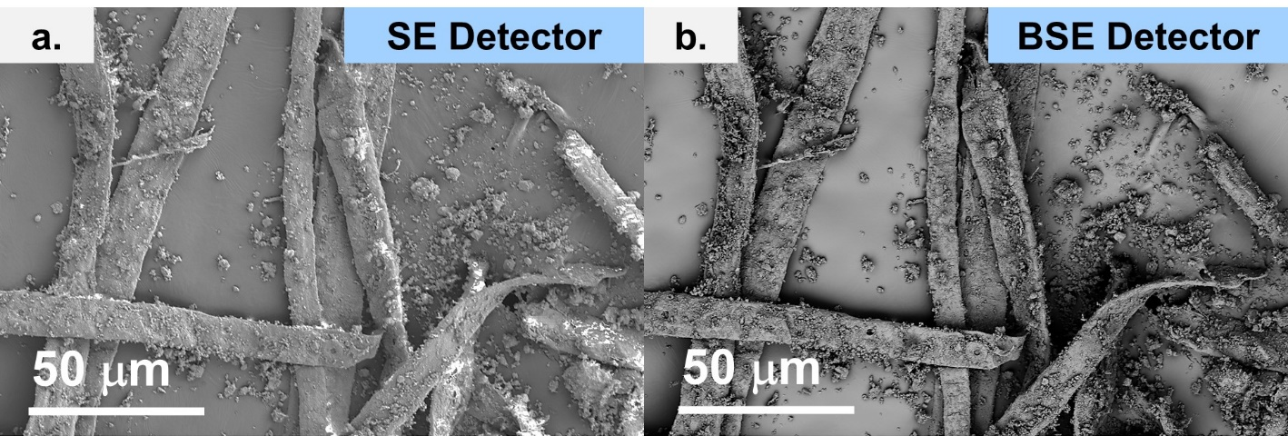
Figure S3. Microscopic characterization of fibre cement using different electron detectors. Scanning electron micrographs of fibre cement (X = 8) acquired using (a) secondary electron (SE) detector and (b) backscattered electron (BSE) detector respectively.

 | Unbleached Pulp (K23.3) | Unbleached Pulp (K21.6)
Conductivity (µS/cm) | 35.36 | 47.26
pH | 5.28 | 5.46
Fiber Length (mm) | 2.473 | 2.525
Width (mm) | 28.9 | 29
Aspect ratio | 85.571 | 87.069
Curl | 13 | 13.4
Fines (%) | 6.3 | 6.3

Table S1. Physical properties of unbleached Kraft pulp.
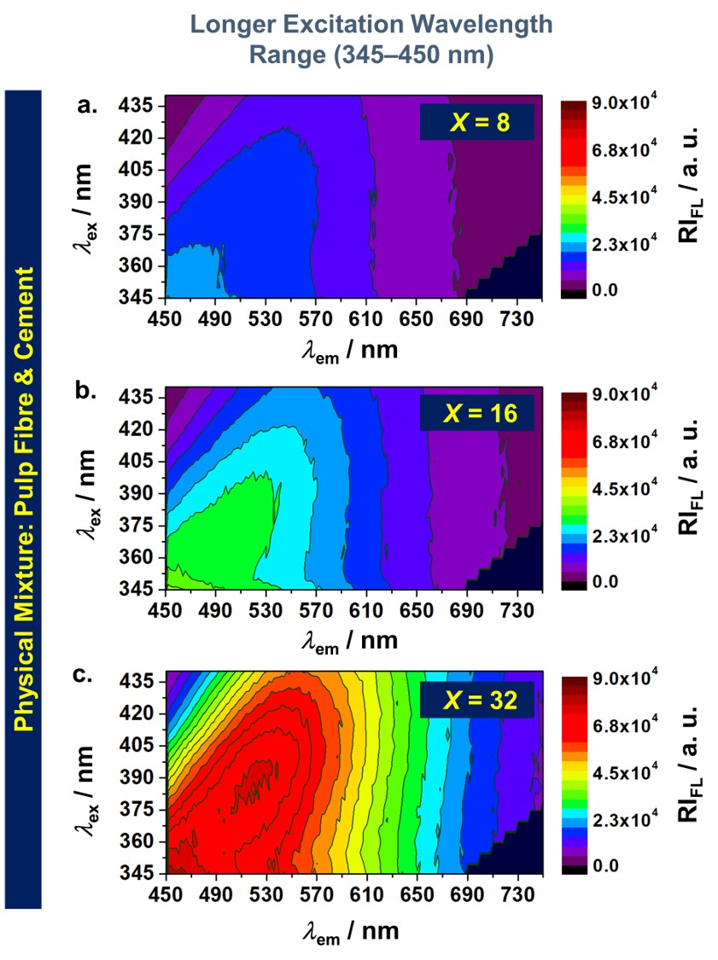
Figure S4. EEM of the physical mixture of pulp fibre and cement content under longer excitation wavelength range (345–440 nm). 2D contour plot of the (dry) mixture with (a) 8 wt.% (b) 16 wt.%, and (c) 32 wt.% pulp fibre.
Prior to the acquisition of EEM, pulp sheet was micronized using a blender (model: IKA A11 basic) — for the controlled physical mixture, water must be avoided. Then, the micronized pulp and cement particles were weighted proportionately (pulp fibre content was varied from 8 wt.% to 32 wt.%) and then hand mixed with a stirring rod. After that, the physical mixture of pulp fibre and cement (dry-mix) was sieved with the same sieve used for fibre cement samples (see, main article, methods section).

