Appendix A.1.
Table A.1: A high-level description of the used terminologies.
Parameters | Description
Hybrid recommendation generation | A hybrid recommendation system integrates multiple recommendation algorithms as a single unit. Solely data-driven or rule-based recommendation systems have several disadvantages in healthcare. In this study, we have adopted a hybrid recommendation architecture where data-driven prediction results are combined with a rule base.
Semantic Modeling with ontology and ontology tree in decision making | Ontology supports flexibility in solving real-world modeling and knowledge representation problems. An ontology has a tree-like hierarchical structure (О_{h}) with the following properties. An ontology О is defined as a tuple Ω = {Ć, R}, where Ć is the set of concepts and R is a set of relations:  L = Levels (О_{h}) = Total number of levels in the ontology hierarchy, 0 ≤ n ≤ L, where n⋲ Z⁺ and n=0 represents the root node  Cn,j = a model classifying О at a level n; where, j ⋲ {0, 1, ….., |Cn|}  |C| = Number of instances classified as class C  E = Edge (Cn,j, Cn-1, k) = edge between node Cn,j and its parent node Cn-1, k  Ontologies have specific benefits in modeling concepts, data, and recommendation generation [12][58]. It helps interpret which recommendation message to generate using a binary tree-like structure (if-then or if-then-else conditional statement).
Probabilistic interval prediction | Prediction intervals provide a way to quantify the uncertainty of a single future observation, assuming that the underlying distribution is normal. In PIP, we express uncertainty in predictions through probability distributions. The point forecast is the mean of this distribution. It describes the probability of observing possible future values ​​with the fitted model.
Observation with activity sensor or tracker | Activity trackers record individual movements throughout the day. These sensors measure many parameters such as acceleration (e.g., steps taken during the day, distance traveled, duration of the activity, whether you are reaching your daily goals), frequency, duration, intensity, and patterns of individual movements. Then they are passed through Algorithms to do some guesswork to make sense of all the readings the data provides. Popular activity trackers are MOX2-5, Fitbit, Actigraph, Xiaomi Mi Band, Huawei Watch, Apple Watch, Samsung watch, and AS Series (97, 98, 99). Wearable activity trackers are connected to the mobile app via Bluetooth short-range data transfer medium.
Preference settings | Preferences can be system-defined or user-defined (or generic). Preferences can be three types: goal setting, response type for intuitive coaching, and interaction type. Preferences settings are adequate for customizing tailored recommendation generation. Preference settings define the nature of goals, kind of response (e.g., direct vs. motivational, generic vs. personalized), mode (e.g., style, graph), frequency (e.g., hourly, quarterly, twice a day, once a day), and medium (e.g., audio, video, voice, text) of the interaction with an eCoach.
Logical recommendation generation | Interpretability makes identifying the cause-and-effect relationships between data input and data output easier. A rule base may help interpret which recommendations to follow and under which binary condition, and in this regard, ontology can be promising. In ontology, the analytical and structural presentation of knowledge, hierarchical model structuring (e.g., class, sub-class, object and data properties, axioms), and inferred knowledge generation with reasoners can solve interpretability problems in decision-making.

Appendix A.2.
Table A.2: Propositional variable and corresponding recommendation messages.
Type | Propositional variable | Description
A-1 | Sedentary | Please continue a light activity (e.g., sports 1-3 days/week, a walking goal of 5,000 to 7,499 steps/ day)
A-2 | Low_physically_active | Please continue more activity (e.g., sports 3-5 days/week, a walking goal of 7,500 to 9,999 steps/ day) OR do at least 150-300 minutes (2.5 – 5 hours) of moderate-intensity aerobic exercise; or at least 75-150 minutes of high-intensity aerobic exercise or perform an equivalent combination of moderate and high-intensity activities within a week to stay active
A-3 | Physically_active | Please continue the same or more activity based on your goal (e.g., sports 3-5 days/week, a walking goal of 7,500 to 9,000 steps/ day)
A-4 | Moderate_physically_active | Please continue the same or more activity based on your goal (e.g., sports 3-5 days/week, a walking goal of 10,000 to 12,499 steps/ day)
A-5 | Vigorous_physically_active | Please continue the same or more activity based on your goal (e.g., sports 5+ days/week, a walking goal of 12,500+ steps/ day)
A-6 | Sedentary_hour_negative | Please be active for z hr. more as today you were z hr. more sedentary beyond your goal.
A-7 | Sedentary_hour_positive | You were very active today and z hr. less sedentary; therefore, you can take that hr. of rest tomorrow.
A-8 | Steps_negative | Please continue x steps more tomorrow to achieve your weekly goal of x1 steps.
A-9 | Steps_positive | You have performed extra x steps today beyond your goal; therefore, you can do x steps less tomorrow or you can carry out the same pace. You are x1 step behind to achieve your weekly goal (OR) congratulations! You have achieved your weekly target.
A-10 | Activity_minute_negative | Please continue more activity of n minutes tomorrow to achieve n1 mins. of weekly goals.
A-11 | Activity_minute_positive | You have performed extra m minutes of activity today beyond your goal; therefore, you can be m mins. of less highly active tomorrow or you can carry out the same pace. You are n1 mins. behind to achieve your weekly goal (OR) congratulations! You have achieved your weekly target.
A-12 | Step_forecast_trend_postive | Based on your weekly step forecast trend in this Week-N you can achieve the step goal.
A-13 | Step_forecast_trend_negative | Based on your weekly step forecast trend in this Week-N you cannot achieve the step goal. On Week-XX and Week-XY weeks, you were very active. Please try to follow similar activity patterns.
A-14 | Daily_Goal_achieved | Good work. Please keep it up tomorrow. You are active and completed the goal for today.  Overview:  You have performed x steps today.  You slept y hrs.  You were sedentary for z hrs.  You were m minutes of medium active.  You were n minutes of highly active.
A-15 | Daily_Goal_not_achieved | You must improve to meet the daily goal. Please stay active tomorrow.  Overview:  You have performed x steps today.  You slept y hrs.  You were sedentary for z hrs.  You were m minutes of medium active.  You were n minutes of highly active.
A-16 | Weekly_Goal_achieved | Good work. Please keep it up next week. You are active and completed the goal for this week.
A-17 | Weekly_Goal_not_achieved | You must improve to meet the weekly goal. Please stay active next week and try to overcome the shortcomings of this week. On Week-XX and Week-XY weeks, you were very active. Please try to follow similar activity patterns.

Appendix A.3.
Table A.3: In-context recommendation conditions, and corresponding rules (rule-based) for test set-up.
No. | Semantic Rule(s) [If] and Condition [Implies]
1 | (hasActivityLevel == 0) IMPLIES (Sedentary AND hasActivityLevel)  (hasActivityLevel == 1) IMPLIES (Low_physically_active AND hasActivityLevel)  (hasActivityLevel == 2) IMPLIES (Physically_active AND hasActivityLevel)  (hasActivityLevel == 3) IMPLIES (Moderate_physically_active AND hasActivityLevel)  (hasActivityLevel == 4) IMPLIES (Vigorous_physically_active AND hasActivityLevel)
2 | ((hasSedentaryBouts – daily_sedentary_goal_time as set in goal) > 0) IMLPIES (Sedentary_hour_negative)  ((hasSedentaryBouts – daily_sedentary_goal_time as set in goal) <= 0) IMLPIES (Sedentary_hour_positive)
3 | ((hasSteps – daily_step_goal as set in goal) => 0) IMLPIES (Steps_positive)  ((hasSteps – daily_step_goal as set in goal) < 0) IMLPIES (Steps_negative)
4 | ((hasMPAMinutes – daily_MPA_goal as set in goal) OR (hasVPAMinutes*2 – daily_VPA_goal as set in goal) => 0) IMLPIES (Activity_minute_positive)  ((hasMPAMinutes – daily_MPA_goal as set in goal) OR (hasVPAMinutes*2 – daily_VPA_goal as set in goal) < 0) IMLPIES (Activity_minute_negative)
5 | ((hasWeeklyStepPrediction – weekly_step_goal as set in goal) => 0) IMLPIES (Step_forecast_trend_postive)  (hasWeeklyStepPrediction – weekly_step_goal as set in goal < 0) IMLPIES (Step_forecast_trend_negative)
6 | ((hasSteps – daily_step_goal as set in goal) => 0) AND ((hasMPAMinutes – daily_MPA_goal as set in goal) OR (hasVPAMinutes*2 – daily_VPA_goal as set in goal) => 0) AND (hasTotalSleepTime => (daily_sleep_goal as set in goal *60)) AND ((hasSedentaryBouts – daily_sedentary_goal_time as set in goal) <= 0) IMLPIES (Daily_Goal_achieved)
7 | ((hasSteps – weekly_step_goal as set in goal) => 0) AND ((hasMPAMinutes – weekly_MPA_goal as set in goal) OR (hasVPAMinutes*2 – weekly_VPA_goal as set in goal) => 0) AND (hasTotalSleepTime => (weekly_sleep_goal as set in goal *60)) AND ((hasSedentaryBouts – weekly_sedentary_goal_time as set in goal) <= 0) IMLPIES (Weekly_Goal_achieved)
8 | (Sedentary + Low_physically_active + Moderate_physically_active + Vigorous_physically_active + Sedentary_hour_negative + Sedentary_hour_positive + Steps_negative + Steps_positive + Activity_minute_negative + Activity_minute_positive + Step_forecast_trend_postive + Step_forecast_trend_negative + Daily_Goal_achieved + Daily_Goal_not_achieved + Weekly_Goal_achieved + Weekly_Goal_not_achieved + Good_weather + Bad_weather = 1)

Appendix A.4.
Table A.4: The attributes of MOX2-5 datasets.
No | Attributes | Type | Description
1 | Date | String | Recorded activity date
2 | Time | String | Recorded activity time
3 | UploadStatus | Character | Indicates the following two types of uploading status: ‘H’ and ‘L’.
4 | IMA | Integer | Total activity intensity
5 | WeightBearing | Integer | Total weight-bearing seconds
6 | Sedentary | Integer | Total sedentary seconds
7 | Standing | Integer | Total standing seconds
8 | LPA | Integer | Total low physical activities seconds
9 | MPA | Integer | Total moderate physical activities seconds
10 | VPA | Integer | Total vigorous physical activities seconds
11 | Steps | Integer | Total daily step count

Appendix A.5.
Table A.5: Participant characteristics (N=16).
Factors | Mean (µ) | SD (σ) | Min | Max
Age | 35.375 | 7.03 | 21 | 51
Height (cm) | 173.5 | 8.02 | 158.5 | 184.0
Weight (Kg.) | 77.0 | 16.36 | 55.0 | 107.0
BMI | 25.38 | 3.93 | 19.41 | 31.604
Duration (days) | 33.6875 | 5.41 | 30 | 48
Total sedentary seconds | 2449171 | 1051610.5 | 590028 | 4261190
Total VPA seconds | 41887.81 | 60688.5 | 112 | 256896
Total MPA seconds | 53231.75 | 17965 | 23402 | 95730
Total LPA seconds | 154647.1 | 66540.6 | 32272 | 254332
Total steps | 366703.3 | 87202.25 | 252551 | 588132

Appendix A.6.
Figure A.7. The training vs. testing curve for GB Classifier for original (a) PMData and (b) MOX2-5 datasets.
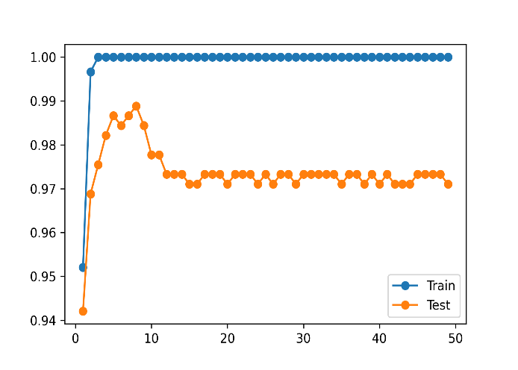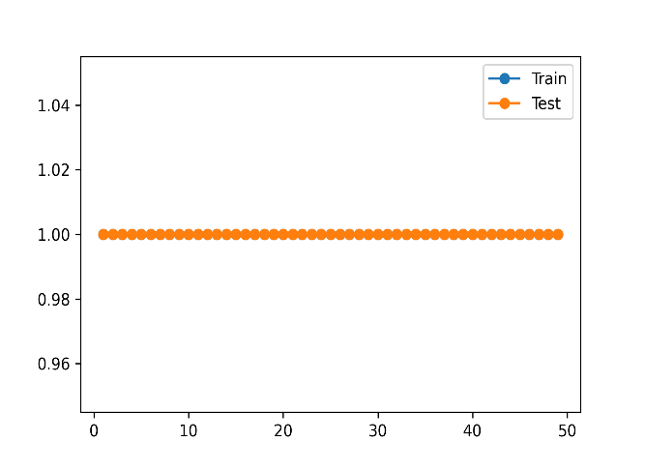
- (b)

Appendix A.7.
Figure A.7. The learning curve for GB Classifier for original (a) PMData and (b) MOX2-5 datasets.
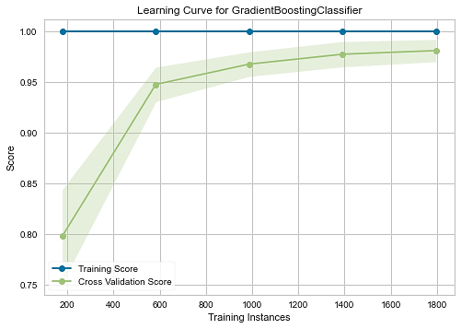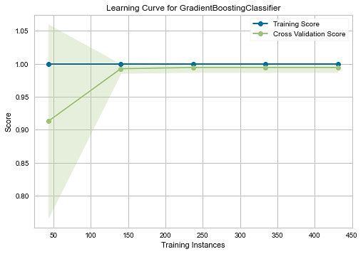
- (b)
Appendix A.8.
Figure A.8. The validation curve for GB Classifier for original (a) PMData and (b) MOX2-5 datasets.
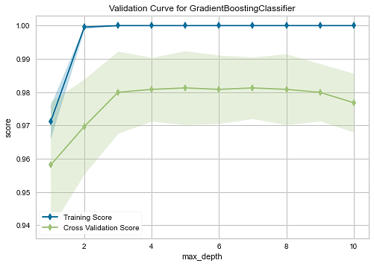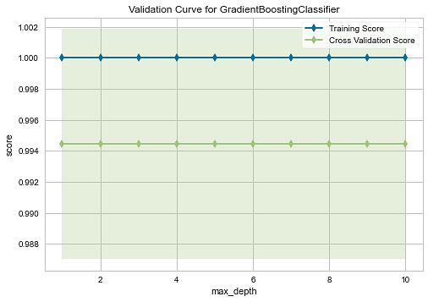
- (b)
Appendix A.9.
Figure A.9. (a) Autocorrelation and (b) Partial autocorrelation plot for the P-1 from the original PMData dataset.

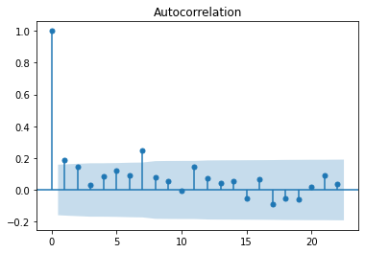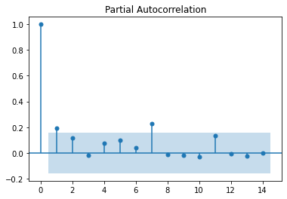
(a) (b)

Appendix A.10.
Figure A.10. The prediction comparison between the autoregression model with residual error minimization (predicted) and the autoregression model without residual error minimization for the P-1 from the original PMData dataset.
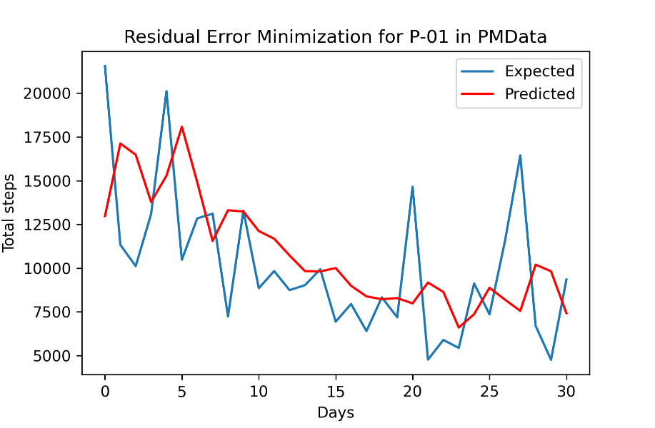

Appendix A.11.
Figure A.11. Visualization of daily step count, target step count, and predicted interval.

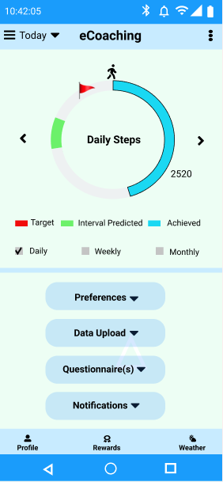

Appendix A.12.
Textbox A.12. Selected list of SPARQL queries.
Prefixes:

PREFIX rdf: <http://www.w3.org/1999/02/22-rdf-syntax-ns#>
PREFIX owl: <http://www.w3.org/2002/07/owl#>
PREFIX rdfs: <http://www.w3.org/2000/01/rdf-schema#>
PREFIX xsd: <http://www.w3.org/2001/XMLSchema#>
PREFIX ssn: <http://purl.oclc.org/NET/ssnx/ssn#>
PREFIX: <http://www.co-ode.org/ontologies/uia/ont.owl#>
PREFIX status: http://www.w3.org/2003/06/sw-vocab-status/ns#

a. Rule for viewing personal preference data:

SELECT ?participant ?datetime ?goalTimeFrame ?goalType ?goalSteps ?goalMPA ?goalVPA ?sleepTime ?sedentaryMinutes ?physicalActivityType ?interactionFrequency ?interactionMedium ?interactionMode ?response
WHERE {
?participant :hasPreferences ?preferences .
?goal :hasGoalTimeFrame ?goalTimeFrame .
?goal :hasGoalType ?goalType .
?goal :hasGoalSteps ?goalSteps .
?goal :hasGoalMPAMinutes ?goalMPA .
?goal :hasGoalVPAMinutes ?goalVPA .
?goal :totalSleepTime ?sleepTime .
?goal :hasSedentaryMinutes ?sedentaryMinutes .
?goal :hasPhysicalActivityType ?physicalActivityType .
?interaction :hasInteractionFrequency ?interactionFrequency .
?interaction :hasInteractionMedium ?interactionMedium .
?interaction :hasInteractionMode ?interactionMode .
?responseType :hasResponseType ?response .
?preferences :hasTimeStamp ?temporalentity .
?temporalentity :hasDateTime ?datetime .
}
ORDER BY DESC (?datetime)

b. Rule for finding activity related results from an individual participant:

SELECT ?participant ?datetime ?status ?level ?day1 ?day2 ?day3 ?day4 ?day5 ?day6 ?day7
WHERE {
?participant :hasStatus ?participantStatus .
?participantStatus :hasParticipantStatus ?status .
?participant :hasHealthRecord ?participanthealthrecord .
?activityLevel :hasActivityLevel ?level .
?stepPrediction : hasIntervalDay1 ?day1 .
?stepPrediction : hasIntervalDay2 ?day2 .
?stepPrediction : hasIntervalDay3 ?day3 .
?stepPrediction : hasIntervalDay4 ?day4 .
?stepPrediction : hasIntervalDay5 ?day5 .
?stepPrediction : hasIntervalDay6 ?day6 .
?stepPrediction : hasIntervalDay7 ?day7 .
?participanthealthrecord :hasTimeStamp ?temporalentity .
?temporalentity :hasDateTime ?datetime .
}
ORDER BY DESC (?datetime)

c. Rule for finding recommendation results from an individual participant:

SELECT ?participant ?datetime ?action ?element ?subject ?time ?formalMessages ?informalMessages
WHERE {
?participant :hasReceivedRecommendation ?recommendation .
?messageComponent :hasAction ?action .
?messageComponent :hasElement ?element .
?messageComponent :hasSubject ?subject .
?messageComponent :hasTime ?time .
?formal :hasRecommendationMessages ?formalMessages .
?informal :hasRecommendationMessages ?informalMessages .
?recommendation :hasTimeStamp ?temporalentity .
?temporalentity :hasDateTime ?datetime .
}
ORDER BY DESC (?datetime)

Appendix A.13.
Figure A.13: Weekly recommendation generation as a text (e.g., push notification) for P-1.
