Supplementary Information
Spatial patterns of bamboo’s invasion across scales: how does bamboo interact with competing trees?
Author List: Aiyu Zheng^{a*}, Jianhua Lv^{b}
ª Department of Ecology and Evolutionary Biology, Princeton University, Princeton, NJ 08544, USA
^{b} State Key Laboratory of Subtropical Silviculture, Zhejiang A&F University, Hangzhou, 311300, China
*Corresponding Author: aiyuz@princeton.edu, +1 719-323-9965
ORCID: ª 0000-0002-1162-6944; ^{b} 0000-0002-2548-0412

S1. Remote sensing methods
S1.1. Supervised classification: workflow
Satellite imagery
Three images (LC08_L1TP_119039_20140316_20170425_01_T1; LC08_L1TP_119039_20180311_20180320_01_T1; LC08_L1TP_120039_20210326_20210402_02_T1) from Landsat 8 Operational Land Imager (OLI) level-1 data products were downloaded from USGS Earth Explorer (U.S. Geological Survey). We chose Landsat 8 OLI because it provided the most consistent low cloud cover (<15%) time series in our study area with reasonably fine resolution (30 m).
Preprocessing
These images were calibrated for their radiance using the radiometric calibration tool in ENVI 5.3 (Exelis Visual Information Solutions 2012). Corrected images were then applied with FLAASH (Fast Line-of-sight Atmospheric Analysis of Spectral Hypercubes) in ENVI 5.3 (Exelis Visual Information Solutions 2012), which is a first-principles atmospheric correction modeling tool for retrieving spectral reflectance from hyperspectral radiance images.
Band selection
Based on classified results in previous studies in Tianmu Mountain Nature Reserve (TMNR) (Ying et al. 2016), we divided land use into five major classes: evergreen forests including coniferous stands and evergreen broadleaf forests, deciduous forests, bamboo-dominant forests, construction (including bare grounds and abandoned fields), and water. We hand-drew polygons for each class in Google Earth Pro (version 7.3.4.8642, Google Earth 2022) based on high-resolution imagery in 2014, 2018, and 2021 in TMNR. Steps described below were done in R version 4.2.1 (R Core Team 2022). Polygons were exported from Google Earth and then used to extract strata of each class from preprocessed satellite imagery. For each year’s image, 300 random spatial points were sampled from each class’s strata (except for water, as it only contained 40 points in total) to obtain surface reflectance of all Landsat OLI-8’s bands at each point’s location. We examined the spectral signatures of each land class by plotting the distribution of reflectance collected from sampled points in each land class (see figure S1). Bamboo was the most distinct in NIR. We did not incorporate other vegetation indexes such as normalized difference vegetation index (NDVI) nor canopy vegetation index (CVI), because their values were highly correlated with other band values and adding them did not significantly improve classification accuracy. R packages used to sample spatial points and analyze spectral profiles include sp (version 1.5-0, Bivand, Pebesma and Gomez-Rubio 2013), rgdal (version 1.5-32, Bivand et al. 2022), raster (version 2.0-12, Hijmans and Etten 2012), RStoolbox (version 0.3.0, Leutner et al. 2022).
Classification methods
The entire classification process was done in R version 4.2.1 (R Core Team 2022). Image classification consisted of two steps: training and predicting using R package caret—Classification and Regression Training (version 6.0-93, Kuhn 2008). First, we experimented with five different classification algorithms to train them using our data set created from randomly sampled points of each class. 75% of the data were used to train classifiers, and 25% of the data were independently used to validify classification accuracy. The algorithms included five of the most common ones (Kamusoko 2019): 1) k nearest neighbor, using R package kknn (version 1.3.1, Schliep, Hechenbichler and Lizee 2016) 2) artificial neural network, using R package nnet (version 7.3-18, Venables and Ripley 2002) 3) support vector machines, using R package e1071 (version 1.7-11, Meyer et al. 2022) 4) kernel-based machines, using R package kernlab (version 0.9-31, Karatzoglou et al. 2022) 5) simple classification tree, using R package rpart (version 4.1.16, Therneau et al. 2022). Each satellite image pixel was assigned a land class based on the statistical characteristics of each land class’s surface reflectance learned by each algorithm. Figure S2 showed the classification accuracy of each algorithm, and k nearest neighbor was selected to perform the classification of land class for the time series in TMNR. Maps of land types in TMNR created using the trained KNN classifier in 2014, 2018, and 2021 were shown in figure S3a. Figure 3b presented close-ups of transects 1, 2, and 3 changing over time.
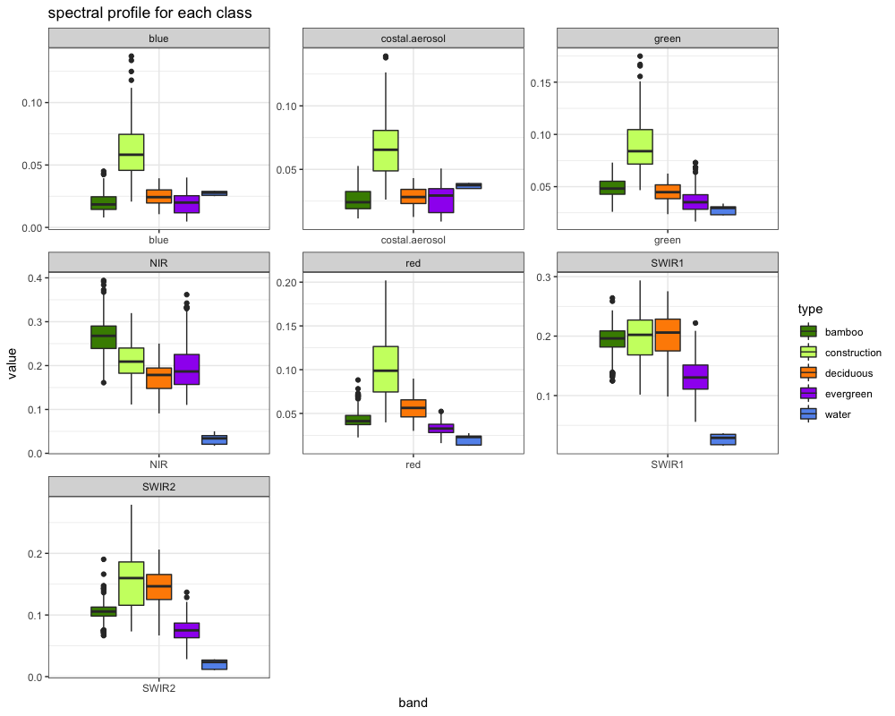
Figure S1. Spectral profile for training data points of each class. Each panel contains extracted value of surface reflectance from each band in Landsat OLI-8 imagery.
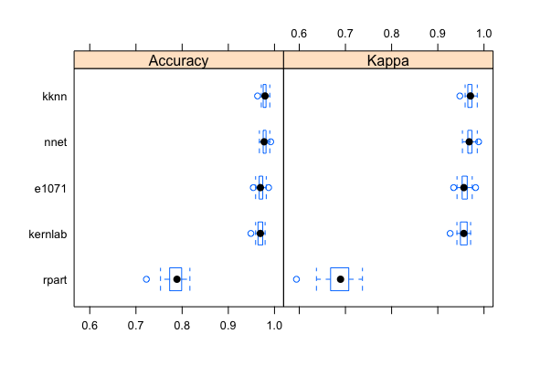
Figure S2. Performance of five different classification algorithms. Algorithm acronyms: 1) kknn: k nearest neighbor 2) nnet: artificial neural network 3) e1071: support vector machines 4) kernlab: kernel-based machines 5) rpart: classification tree. Accuracy is the percentage of correctly classified instances out of all instances. A higher value of Cohen’s Kappa indicates higher agreement among classified instances.

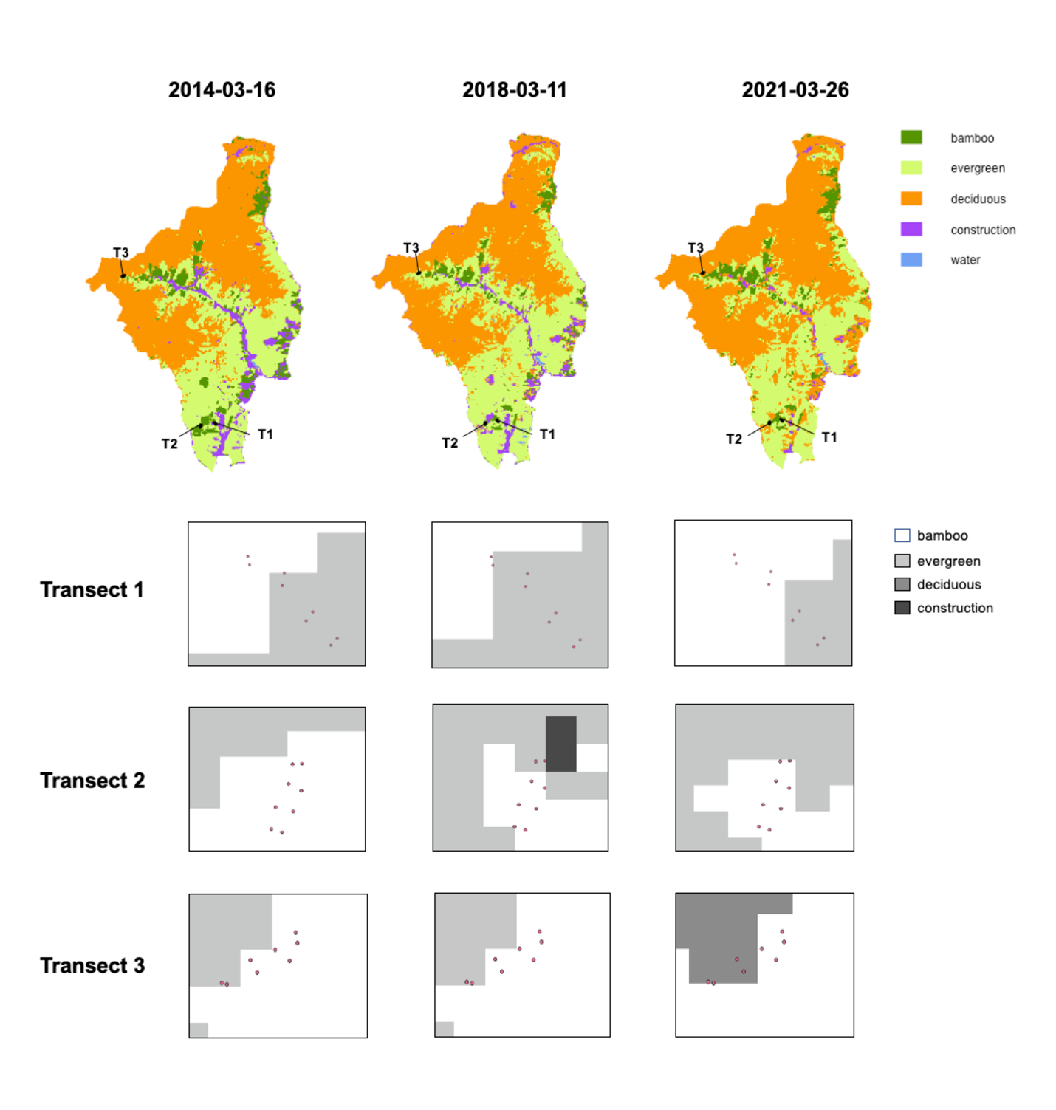
Figure S3. a) Maps of TMNR created from supervised classification for the year 2014, 2018, and 2021. T1, T2, and T3 marked out the location of three transects where vegetation survey, plant censuses, and sample collection were done. b) Shifts of bamboo invasion fronts in all transects extracted from classified results over the observational period. Dots were located at the corners of zone B, M, and F along all transects.
S1.2. Misclassification rates
Each land class in each year’s classified map was randomly sampled for 100 spatial points for estimating misclassification errors. The coordinates of sampled points were imported into Google Earth Pro (version 7.3.4.8642, Google Earth 2022) to examine whether its classified class was correctly identified. If the actual class of a point was bamboo while it was misidentified as any other class, the case was considered a false negative. If the actual class of a point was not bamboo while it was identified as bamboo, the case was considered a false positive. The false positive and false negative rates of each class in 2014, 2018, and 2021 were summarized in figure S4. The misclassification information can be stored in a confusion matrix for calculating the probability of a pixel’s true class in a way similar to Bayesian updating.
We define a few terms here:
1) The true probability of a pixel being in class$k$ is $Q_{k}$.
2) Every pixel in the study region has probability $p_{k}$ to be identified by the classifier as class $k$. 3) As we obtain information from the classifier initially, $p_{k}$ is the ratio of pixels identified as $k$to total number of pixels, where$m$ is the total number of classes.
$p_{k}=\frac{N_{k}}{N_{total}}$ and $\sum_{k=1}^{m}{p_{k}}=1$
4) Now the validation information in the confusion matrix can update our initial plausibility, $p_{k}$.
For a five-class classifier, ${\left(C_{i,j} \right)}_{i,j∈\{1,...,5\}}$ is its confusion matrix where the rows indicate results from the classifiers and the columns indicate true categories. $C_{i,j}$ represents the number of cases for actual class $j$being identified as class $i$.
5) The misclassification likelihood of a pixel identified as class $i$ and validated to be in class $j$ is denoted as $L_{i,j}$. When $i=j$, the classifier acurately predicted the class. The sample size of validation data for each class$i$ is the sum of entries in row $i$of the confusion matrix. Therefore:
$$L_{i,j} =\frac{C_{i,j}}{\sum_{j=1}^{m}{C_{i,j}}}$$
The confusion matrix tells us that the probability of a pixel being a true class $j$ is the probability of such pixel identified as class $j$ given a correct identification, plus the sum of probabilities of the pixel being misidentified for class $i$ times the probability of a false negative report on class $i$pixels. The joint probability of class $k$ is $P_{k}$:
$$P_{k}(classifer,validated)=\sum_{j=1}^{m}{p_{i}}×L_{i,j=k}$$
$$P_{k}(validated)=\sum_{k=1}^{m}{\sum_{i=1}^{m}{p_{i}}×L_{i,j=k}}$$
And thus, we can update the initial probability from classification, and let’s denote this updated
probability as $Q_{k}$:
$$Q_{k}(classifer | validated)=\frac{prior × probability of observations}{Average probability of observations}=\frac{\sum_{j=1}^{m}{p_{i}}×L_{i,j=k}}{\sum_{k=1}^{m}{\sum_{i=1}^{m}{p_{i}}×L_{i,j=k}}}$$
Using steps 1-5 described above, we updated the probability of each class type to calculate the total bamboo-dominated area in TMNR (see figure 2b in main text). Confusion matrices acquired from validation were included in table S1. The overall accuracy was determined by the fraction of correctly identified cases (sum of the diagonal elements in a confusion matrix) to total cases identified (sum of all elements in a confusion matrix). The user’s accuracy for class $k$is the fraction of correctly identified $k$-class cases to total identified cases for class $k$. The producer’s accuracy is the fraction of correctly identified cases in class $k$to all cases that are validated as class$k$.

Year 2014
 | Validated class $(j)$
Classified class $(i)$ | Bamboo | Evergreen | Deciduous | Construction | Water
Bamboo | 93 | 1 | 2 | 4 | 0
Evergreen | 11 | 81 | 5 | 3 | 0
Deciduous | 0 | 10 | 90 | 0 | 0
Construction/other | 9 | 0 | 9 | 82 | 0
Water | 0 | 1 | 0 | 0 | 29

Year 2018
 | Validated class $(j)$
Classified class $(i)$ | Bamboo | Evergreen | Deciduous | Construction | Water
Bamboo | 90 | 6 | 1 | 3 | 0
Evergreen | 8 | 84 | 5 | 3 | 0
Deciduous | 2 | 6 | 92 | 0 | 0
Construction/other | 16 | 2 | 8 | 74 | 0
Water | 0 | 64 | 0 | 0 | 34

Year 2021
 | Validated class $(j)$
Classified class $(i)$ | Bamboo | Evergreen | Deciduous | Construction | Water
Bamboo | 86 | 10 | 0 | 4 | 0
Evergreen | 1 | 95 | 1 | 3 | 0
Deciduous | 0 | 15 | 80 | 5 | 0
Construction/other | 4 | 0 | 2 | 93 | 1
Water | 0 | 0 | 0 | 0 | 40

Table S1. Confusion matrices were acquired by validating each year’s classification results.
Overall accuracy for each year’s classification was 87.2%, 74.8%, and 89.5%. For the bamboo class, the user accuracy for each year was 93%, 90%, and 86%. The producer accuracy for bamboo was 82%, 77.5%, and 94.5% at 2014, 2018, and 2021.

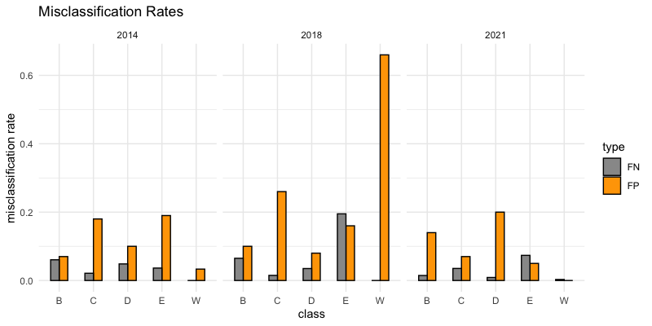
Figure S4. Misclassification rates of each class grouped by false negatives and positives. For each class (B= bamboo, C= Construction, D= Deciduous, E= Evergreen, W= Water), its false negative rate is the proportion of total cases being falsely identified as other classes. Its false positive rate is the proportion of total cases that are being falsely identified as the class of interest.

S2. Vegetation surveys
S2.1 Vegetation survey protocol
Each transect consists of B, M, and F zones, which were 30 m × 10 m plots split into three 10 m × 10 m subplots for convenience. In each zone, one 10 m × 10 m quadrat for trees, one 5 m × 5 m quadrat for shrubs, and three 1 m × 1 m quadrats (one per subplot) for the grasses were established. The abundance, coverage, and average height of each occurring species were documented for tree, shrub, and grass layers in all transects.

S2.2 Vegetative survey results
The importance value (IV) of a tree species was calculated as the sum of its relative density (RD), relative height (RH), and relative dominance (RD). The IV of a shrub species or a grass species was calculated as the sum of RD, RH, and relative cover (RC). Density is the number of stem occurrences over an area, and a species’ relative density is its density divided by total density in that area. Relative height of a species is the fraction of its average height to the sum of average heights of all species. Relative dominance is the fraction of a species’ total cross-sectional area at breast height to the sum of all individuals’ cross-sectional area at breast height in the censused area. Relative cover is the fraction of a species’ cover to total plant cover in the area of interest. The IV for tree, shrub, and grass layers in each transect were reported in Table S2-S4 below.

Tree species | T1 | T2 | T3
Acer yangjuechi | 6.79 | 0 | 0
Ailanthus altissima | 5.55 | 0 | 0
Albizia kalkora | 0 | 0 | 8.66
Amygdalus persica | 0 | 5.85 | 5.69
Aphananthe aspera | 0 | 9.61 | 0
Betula austrosinensis | 0 | 0 | 6.81
Carpinus viminea | 11.44 | 0 | 6.8
Cedrus deodara | 15.36 | 0 | 0
Cerasus yedoensis | 0 | 0 | 19.66
Cercidiphyllum japonicum. | 0 | 0 | 6.26
Chamaecyparis obtuse | 4.9 | 0 | 0
Cinnamomum chekiangense | 2.95 | 0 | 0
Cryptomeria fortunei | 4.45 | 0 | 0
Cunninghamia lanceolata | 7.48 | 0 | 6.78
Cyclocarya paliurus | 0 | 6.48 | 0
Dalbergia hupeana | 5.72 | 0 | 9.16
Dendrobenthamia japonica | 0 | 0 | 7.28
Diospyros cathayensis | 0 | 0 | 6.01
Eucommia ulmoides | 8.05 | 0 | 0
Evodia fargesii | 0 | 6.95 | 0
Firmiana simplex | 0 | 8.42 | 0
Liquidambar formosana | 36.45 | 6.93 | 0
Lithocarpus brevicaudatus | 0 | 0 | 6.78
Lithocarpus glaber | 0 | 0 | 8.46
Litsea auriculata | 0 | 0 | 7.11
Magnolia liliflora | 9 | 0 | 0
Mallotus apelta | 0 | 8.31 | 0
Microdesmis casearifolia | 0 | 5.85 | 0
Phyllostachys edulis | 96.33 | 191.33 | 142.95
Picea asperata | 23.44 | 0 | 0
Pinus massoniana | 23.92 | 0 | 0
Poncirus trifoliata | 5.7 | 0 | 0
Populus alba | 8.62 | 0 | 0
Pyrus xerophila | 6.35 | 0 | 0
Quercus acutissima | 8.81 | 0 | 6.78
Quercus fabri | 0 | 0 | 33.87
Rhus chinensis | 0 | 7.61 | 0
Torreya grandis | 0 | 7.44 | 0
Toxicodendron succedaneum | 0 | 0 | 6.18
Trachycarpus sortunei | 8.73 | 0 | 0
Ulmus pumila | 0 | 4.58 | 4.78
Vernicia fordii | 0 | 8.06 | 0
Yulania amoena | 0 | 7.4 | 0
Yulania denudate | 0 | 7.78 | 0
Zanthoxylum multijugum | 0 | 7.38 | 0

Table S2. Importance values for all tree species in three transects. Phyllostachys edulis was included as a tree rather than a grass species because it formed canopies structurally similar to tree canopies.

Shrub species | T1 | T2 | T3
Aphananthe aspera | 0 | 19.61 | 0
Camellia oleifera | 53.21 | 131.1 | 0
Camellia sinensis | 15.54 | 24.01 | 27.98
Carpinus viminea | 0 | 11.19 | 0
Cercidiphyllum japonicum | 0 | 0 | 6.27
Cinnamomum chekiangense | 15.73 | 16.01 | 0
Cornus controversa | 11.85 | 0 | 0
Cunninghamia lanceolata | 17.32 | 0 | 0
Elaeagnus pungens | 9.34 | 0 | 6.49
Eurya hebeclados | 0 | 0 | 32.98
Fortunearia sinensis | 37.34 | 0 | 0
Garcinia multiflora | 16.64 | 0 | 0
Hyptis suaveolens | 0 | 0 | 34.34
Ligustrum sinense | 0 | 10.25 | 49.45
Lindera aggregata | 12.08 | 0 | 0
Liquidambar formosana | 21.39 | 19.61 | 0
Litsea coreana var. sinensis | 7.08 | 0 | 0
Lycium chinense | 0 | 0 | 7.08
Morus mongolica | 0 | 0 | 23.14
Phoebe chekiangensis | 0 | 7.99 | 0
Phyllostachys veitchiana | 0 | 0 | 9.21
Poncirus trifoliata | 23.24 | 0 | 0
Premna microphylla | 0 | 0 | 31.32
Rhododendron fortunei | 0 | 0 | 16.25
Schima superba | 15.63 | 0 | 0
Smilax china | 0 | 0 | 22.24
Symplocos sumuntia | 34.78 | 35.88 | 0
Ulmus pumila | 0 | 15.23 | 16.55
Viburnum dilatatum | 0 | 0 | 16.7
Wisteria sinensis | 8.82 | 9.16 | 0

Table S3. Importance values for all shrub species surveyed in three transects.

Grass species | T1 | T2 | T3
Unknown species | 0 | 35.77 | 0
Alangium chinense | 0 | 0 | 23.73
Boehmeria nivea | 0 | 4.57 | 0
Carex siderosticta | 0 | 51.99 | 0
Chlorophytum comosum | 0 | 4.31 | 0
Codonopsis lanceolata | 10.55 | 0 | 0
Cyclosorus acuminatus | 7.49 | 0 | 0
Cyclosorus interruptus | 13.56 | 0 | 0
Diplazium donianum | 15.68 | 0 | 0
Dryopteris chinensis | 0 | 10.01 | 0
Dryopteris crassirhizoma | 11.11 | 7.94 | 0
Eurya hebeclados | 0 | 0 | 15.3
Goodyera daibuzanensis | 3.42 | 0 | 0
Hosta plantaginea | 12.59 | 0 | 0
Hoya carnosa | 27.9 | 0 | 0
Indocalamus decorus | 0 | 0 | 49.32
Kalopanax septemlobus | 0 | 0 | 7.38
Lindsaea orbiculata | 4.18 | 17.82 | 4.93
Lophatherum gracile | 12.78 | 51.37 | 0
Lygodium japonicum | 16.81 | 0 | 0
Melanthera prostrata | 0 | 11.72 | 0
Morus cathayana | 0 | 0 | 38.24
Morus mongolica | 0 | 0 | 3.55
Ophiopogon japonicus | 76.01 | 55.05 | 8.81
Oplismenus undulatifolius | 14.43 | 0 | 0
Osmunda japonica | 0 | 0 | 9.17
Parathelypteris glanduligera | 35.8 | 0 | 0
Plantago major | 0 | 14.5 | 0
Polygonatum odoratum | 0 | 8.34 | 0
Rubia sylvatica | 0 | 0 | 52.61
Rubus buergeri | 11.1 | 0 | 0
Rubus pacificus | 0 | 4.99 | 12.48
Saussurea japonica | 0 | 0 | 28.92
Smilax china | 0 | 0 | 15.64
Trachycarpus sortunei | 18.95 | 0 | 0
unknown Pteridophyta species B | 0 | 0 | 7.18
Viburnum dilatatum | 0 | 0 | 3.98
Vitis flexuosa | 7.61 | 21.6 | 0
Yulania denudata | 0 | 0 | 18.77

Table S4. Importance values for all grass species surveyed in three transects.
S3. Spatial point pattern analysis
R package spatstat (version 2.3-4, Baddeley and Turner 2005) was used in analyzing spatial point patterns. Figure S4-6 below were generated in the same way as figure 4a in main text, but each figure only contained data from one transect.
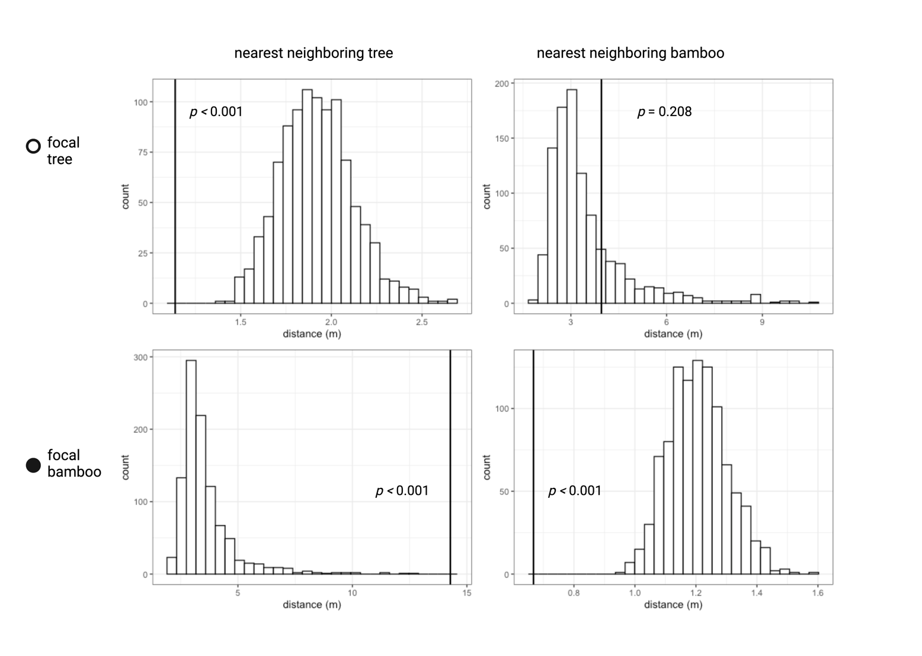
Figure S4. The distributions of average distance between neighbors were extracted from 1000 simulated maps to be compared with the observed mean in transect 1. $p$ values were shown for one-tailed tests.
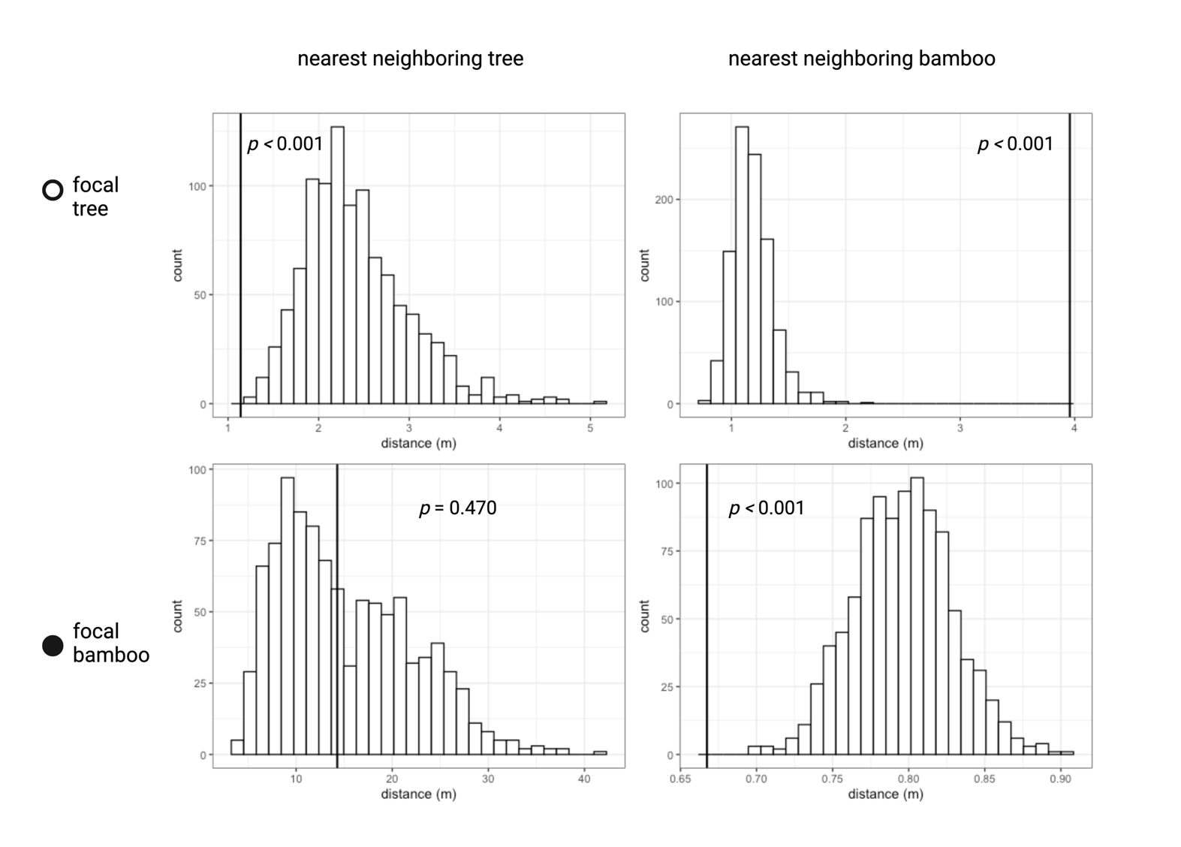
Figure S5. The distributions of average distance between neighbors were extracted from 1000 simulated maps to be compared with the observed mean in transect 2. $p$ values were shown for one-tailed tests.

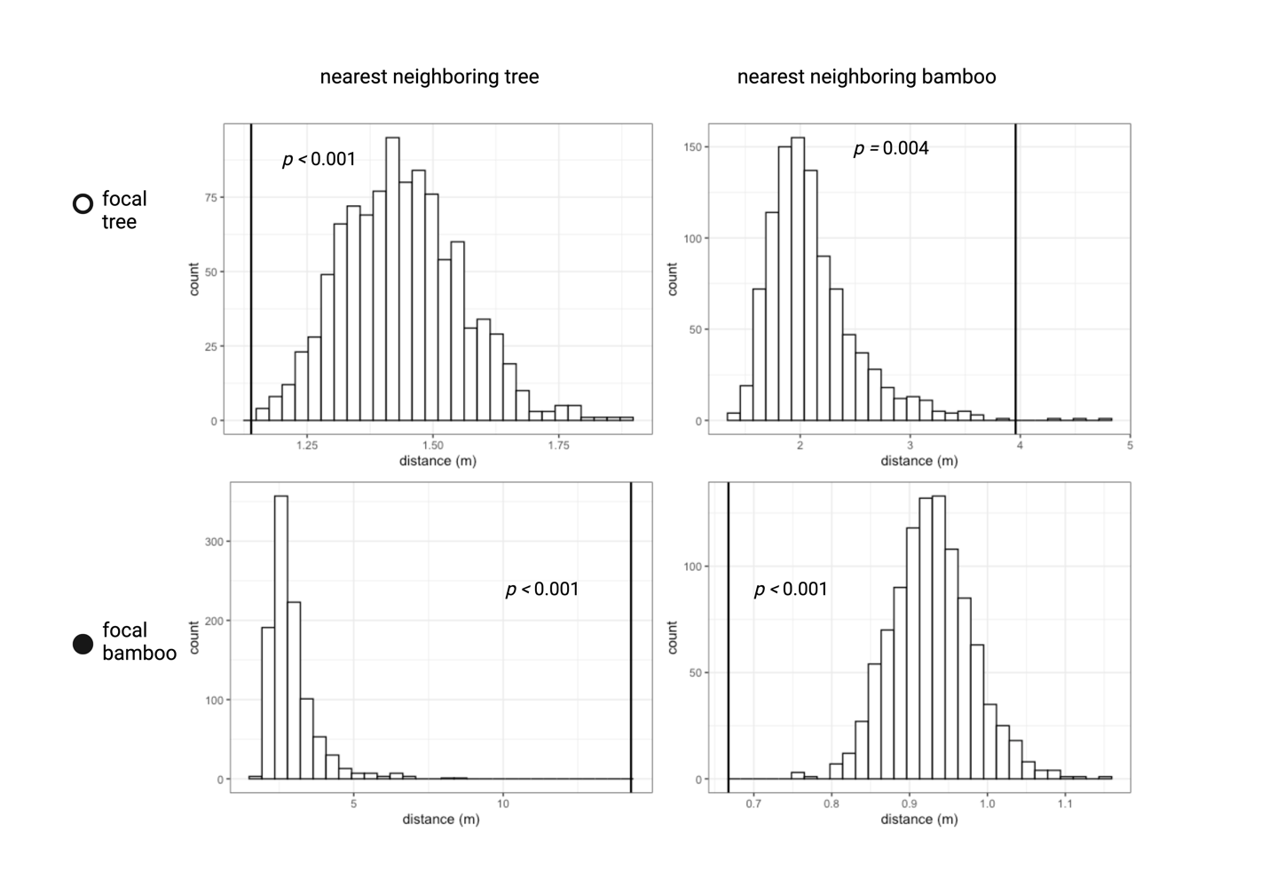Figure S6. The distributions of average distance between neighbors were extracted from 1000 simulated maps to be compared with the observed mean in transect 3. $p$ values were shown for one-tailed tests.

References
Bivand R., Keitt T., Rowlingson B., Pebesma E., Sumner. M, Hijmans R., Baston D., Rouault E., Warmerdam F., Ooms J., & Rundel C. Rgdal: bindings for the “geospatial” data abstraction library. R package version 1.5-32. https://cran.rproject.org/web/packages/rgdal/index.html
Bivand, RS., Pebesma, E., & Gomez-Rubio V. (2013). Applied spatial data analysis with R, Second edition. Springer, NY. https://asdar-book.org/.
Baddeley A, Turner R (2005). “spatstat: An R Package for Analyzing Spatial Point Patterns.” Journal of Statistical Software, 12(6), 1–42. doi: 10.18637/jss.
Exelis Visual Information Solutions. (2012). Atmospheric correction module: Quac and flaash user’s guide. Version, 4, 44.
Google Earth (2022). Google Earth Pro. https://earth.google.com/web/
Kamusoko, C. (2019). Remote sensing image classification in R. Springer.
Karatzoglou A., Smola A., Hornik K (2022). kernlab: Kernel-Based Machine Learning Lab. R package version 0.9-31. https://CRAN.R-project.org/package=kernlab.
Kuhn, M. (2008). Building Predictive Models in R Using the caret Package. Journal of Statistical Software, Articles, 28(5), 1–26. https://doi.org/10.18637/jss.v028.i05
Leutner B., Horning N., Schwalb-Willmann J., Hijmans R. J. RStoolbox: tools for remote sensing data analysis. R package version 0.3.0. https://CRAN.R-project.org/package=RStoolbox
Meyer D., Dimitriadou E., Hornik K., Weingessel A., Leisch F., Chung Lin C. C. (2022). e1071: Misc Functions of the Department of Statistics, Probability Theory Group (Formerly: E1071), TU Wien. R package version 1.7-11. https://CRAN.R-project.org/package=e1071
QGIS Development Team. (2022). QGIS Geographic Information System. Open Source Geospatial Foundation. http://qgis.org
R Core Team (2022). R: A language and environment for statistical computing. R Foundation for Statistical Computing, Vienna, Austria. https://www.R-project.org/
Robert J. Hijmans & Jacob van Etten (2012). raster: Geographic analysis and modeling with raster data. R package version 2.0-12. http://CRAN.R-project.org/package=raster
Schliep K., Hechenbichler. K, and Lizee A. (2016). Weighted k-nearest neighbors for classification, regression and clustering. R package version 1.3.1. https://CRAN.R-project.org/package=kknn
Therneau T., Atkinson B., & Ripley. B. rpart: Recursive Partitioning and Regression Trees. R package version 4.1.16. https://CRAN.R-project.org/package=rpart
U.S. Geological Survey, 2022, Earth Explorer at https://earthexplorer.usgs.gov/ (Accessed August 20, 2022)
Venables WN., Ripley BD (2002). Modern Applied Statistics with S, Fourth edition. Springer, New York. ISBN 0-387-95457-0, https://www.stats.ox.ac.uk/pub/MASS4/.
Ying, W., Jin, J., Jiang, H., Zhang, X., Lu, X., Chen, X., & Zhang, J. (2016). Satellite-based detection of bamboo expansion over the past 30 years in Mount Tianmushan, China. International Journal of Remote Sensing, 37(13), 2908–2922. https://doi.org/10.1080/01431161.2016.1186851

