Exposure to a sublethal concentration of CdO nanoparticles impairs the vision of the fruit fly (Drosophila melanogaster) by disrupting histamine synthesis and recycling mechanisms
Samar El Kholy and Yahya Al Naggar*

Zoology Department, Faculty of Science, Tanta University, 31527 Tanta, Egypt

Corresponding:
yehia.elnagar@science.tanta.edu.eg (Y. Al Naggar).

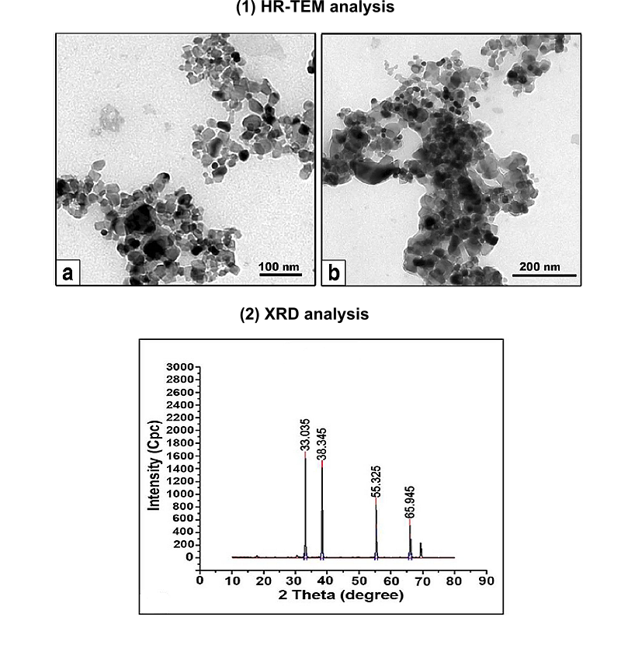

Fig. S1 Showing 1) HRTEM micrograph of synthesized CdO NPs scale bar: a) 100 nm and b) 200 nm and 2) XRD patterns of a CdO nanoparticles prepared at 0.5 M of cadmium acetate at room temperature (see (AL Naggar et al., 2020)).

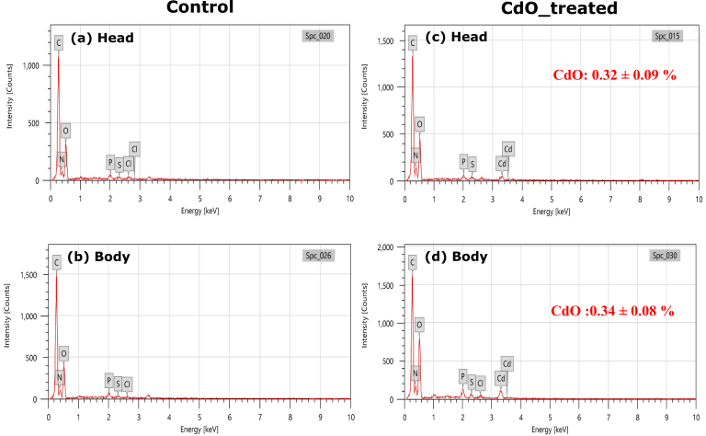
Figure S2. SEM-EDX spectra of air-dried head and body tissues of adult Drosophila flies exposed for 7 days to control (a, b), or food media spiked with a sublethal concentration (0.03 mg/ml) of CdO NPs) (c, d). Semi-quantitative detection (% of height peak) of Cd oxides NPs were expressed (mean ± SD) (n=3).

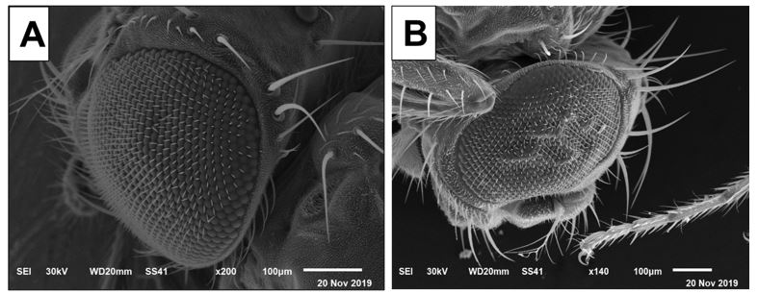

Fig. S3. Scanning electron microscopy micrographs of compound eye 3-days old adults (A) F1 of control Drosophila melanogaster flies compared to F1 of treated flies (B) (n = 9 male and female flies). Parents (P1) of these flies have been exposed for 7 days to a control or food media spiked with a sublethal concentration (0.03 mg mL⁻¹) of CdO NPs.

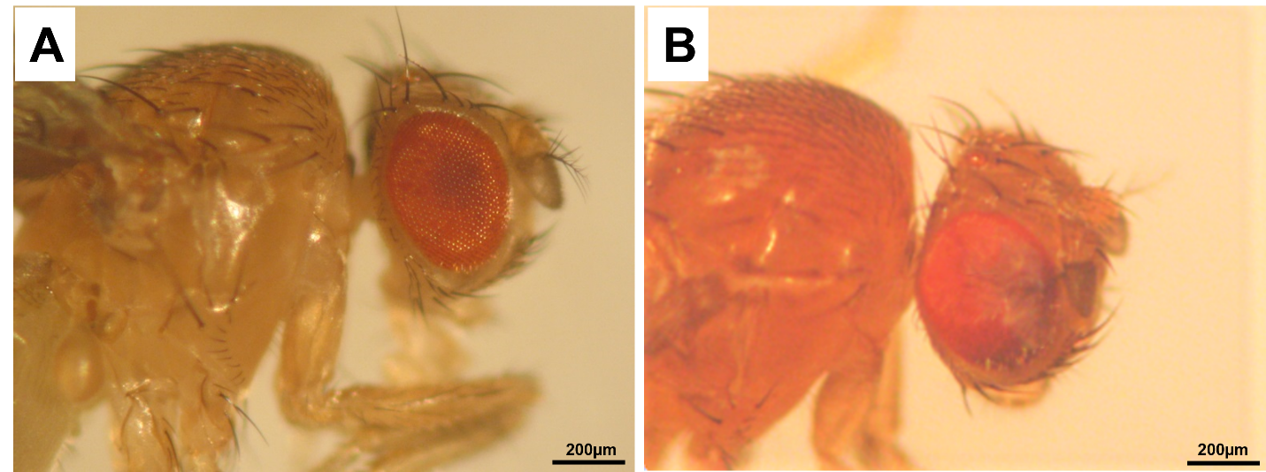

Fig. S4. Light microscopy micrographs of compound eye 3-days old adults (A) F1 of control Drosophila melanogaster flies compared to F1 of treated flies (B). Parents (P1) of these flies have been exposed for 7 days to a control or food media spiked with a sublethal concentration (0.03 mg mL⁻¹) of CdO NPs.
Table S1. XRD data of CdO nanoparticles prepared at 0.5 M (AL Naggar et al., 2020).
Metal | d-spacing  (Å) Observed | Intensity  (cps) | FWHM  β (deg) | (2Theta) | Grain size  (nm)
CdO | 2.71 | 100.00 | 0.17 | 33.03 | 50.93
CdO | 2.34 | 91.25 | 0.17 | 38.34 | 51.70
CdO | 1.66 | 55.26 | 0.10 | 55.32 | 95.64
CdO | 1.41 | 34.97 | 0.12 | 65.94 | 81.11

AL Naggar, Y., Dabour, K., Masry, S., Sadek, A., Naiem, E., Giesy, J.P., 2020. Sublethal effects of chronic exposure to CdO or PbO nanoparticles or their binary mixture on the honey bee (Apis millefera L.). Environ. Sci. Pollut. Res. 27, 19004–19015. https://doi.org/10.1007/s11356-018-3314-2

