Supplementary Materials for

Ultrapotent SARS-CoV-2 neutralizing antibodies effectively block new-emerging mutational variants

Tingting Li, Yingming Wang, Xiaojian Han, Chenjian Gu, Hangtian Guo, Kai Wang, Fengjiang Liu, Feiyang Luo, Jie Hu, Chao Hu, Shenglong Li, Yanan Hao, Jingjing Huang, Yingyi Long, Shuyi Song, Wang Wang, Meiying Shen, Ruixin Wu, Song Mu^{1,2}, Qian Chen, Fengxia Gao, Jianwei Wang, Shunhua Long, Luo Li, Yang Wu, Yan Gao, Wei Xu, Xia Cai, Di Qu, Qingzhu Gao, Guiji Zhang, Changlong He, Wei Wang, Xiaoyun Ji, Ni Tang, Zhenghong Yuan, Youhua Xie†, Haitao Yang†, Ailong Huang†, and Aishun Jin†

†Correspondence: yhxie@fudan.edu.cn (Y.H.X); yanght@shanghaitech.edu.cn (H.T.Y); ahuang@cqmu.edu.cn (A.L.H); aishunjin@cqmu.edu.cn (A.S.J)
Includes:
Extended Data Figs. 1-7
Extended Data Tables 1-3

Extended Data Fig. 1 The efficacy of other 10 neutralizing Abs. Neutralizing potencies of the other 10 of the selected 20 mAbs, measured by the authentic SARS-CoV-2 neutralization assay. Dashed lines indicated 0% and 50% reduction in viral infectivity. Data for each mAb were obtained from a representative neutralization experiment, with three replicates, presented as mean ± SEM.

Extended Data Fig. 2 The blocking effect of the neutralizing Abs on the ACE2-S-RBD interaction. Competitive ELISA for the neutralizing Abs to inhibit the ACE2-S-RBD interaction. The SARS-CoV specific mAb CR3022 was used as the negative control. Data are representative of at least 2 independent experiments performed in technical duplicate, presented as mean ± SEM.

Extended Data Fig. 3 The neutralizing Abs competing with ACE2 for the binding of S-RBD. In the SPR assay, the purified soluble SARS-CoV-2 S-RBD was coated onto a CM5 sensor chip followed by injection of individual neutralizing Abs at concentration of 20 μg/mL. The competition capacity of each antibody was indicated by the level of reduction in response unit of ACE2 comparing with or without prior antibody incubation. The SARS-CoV S-RBD mAb CR3022 was used as the negative control.

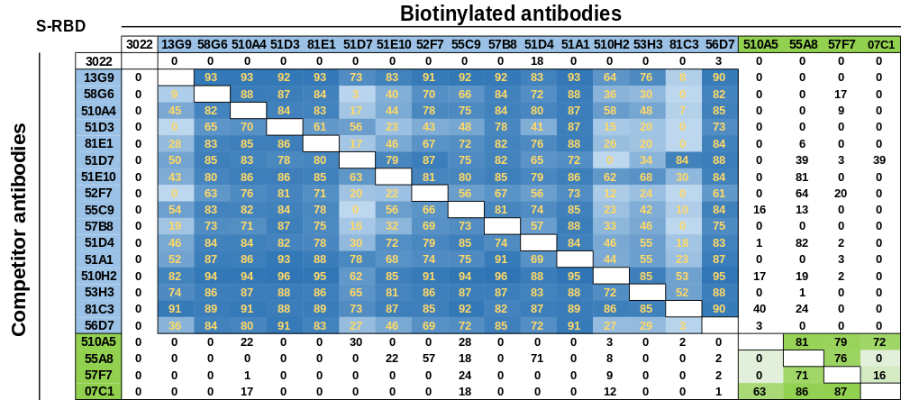

Extended Data Fig. 4 The competitive analysis of potential epitopes recognized by these 20 neutralizing Abs. Each of our 20 mAb was biotinylated and competed with other unmodified mAbs for the identification of the precise epitopes. The numbers in each box show the inhibition rate between two mAbs tested by competitive ELISA. Results are representatives of two independent experiments.

Extended Data Fig. 5 Workflow for 13G9 and 58G6 cryo-EM 3D Reconstructions. (a) Gel filtration profile of the affinity-purified SARS-CoV-2 S trimer. (b) SDS-PAGE analysis of the SARS-CoV-2 S protein. (c) The viewing direction distribution plot for SARS-CoV-2 S in complex with 13G9 Fab. (d) Global FSC and Histogram. (e) Cryo-EM density of the SARS-CoV-2 S in complex with 13G9 Fab, colored according to local resolution. (f) The viewing direction distribution plot for SARS-CoV-2 S in complex with 58G6 Fab. (g) Global FSC and Histogram. (h) Cryo-EM density of the SARS-CoV-2 S in complex with 58G6 Fab, colored according to local resolution. (i and j) Cryo-EM data processing workflow of 13G9 (i) and 58G6 (j).

Extended Data Fig. 6 The binding activity of purified mAbs to the denatured S-RBD. Western blot results of the 1-10 (a) and 11-20 (b) neutralizing Abs binding to the denatured S-RBD. Data are representative of at least 2 independent experiments performed.

Extended Data Fig 7. The binding activity of purified mAbs to the S-RBD related peptides. (a) The amino acid sequences for the S-RBDs of SARS-CoV-2 and SARS-CoV were aligned for comparison. Linear peptides designed for SARS-CoV-2 were shown in ash blue and the name of the peptides were indicated in the boxes above. The non-conserved residues between two viruses were displayed in yellow. The binding sites for CR3022, 58G6 and ACE2 were distinguished by underlines of different colors indicated below. (b) The interactions of 5 out of 9 mAbs from Extended Data Fig. 6 to the linear peptides were analyzed by peptide ELISA. The other 4 mAbs were uncapable to react with synthesized peptides. (c) The interactions of 58G6 to the linear peptides were analyzed by peptide ELISA. Data are representative of at least 2 independent experiments performed in technical duplicate. The mean ± SEM of duplicates are shown.

Extended Data Table 1. The summary of the IC₅₀ of the top 10 neutralizing Abs.
Antibody |  | Authentic virus  (µg/mL) | SARS-CoV-2  pseudovirus (µg/mL) |  | 501Y.V1 pseudovirus  (µg/mL) | 501Y.V2 pseudovirus  (µg/mL) | Inhibition of ACE2-S-RBD interaction  (µg/mL)
13G9 | 0.007 |  | 0.006 | 0.003 |  | 0.033 | 0.058
58G6 | 0.010 |  | 0.004 | 0.008 |  | 0.006 | 0.046
510A5 | 0.011 |  | 0.003 | 0.003 |  | 0.006 | 0.279
51D7 | 0.039 |  | 0.004 | 0.005 |  | 0.125 | 0.055
510A4 | 0.043 |  | 0.005 | 0.005 |  | 0.011 | 0.039
51D3 | 0.047 |  | 0.034 | 0.019 |  | 0.023 | 0.023
81E1 | 0.051 |  | 0.022 | 0.027 |  | 0.597 | 0.034
51E10 | 0.054 |  | 0.003 | 0.003 |  | >10 | 0.047
55A8 | 0.060 |  | 0.021 | 0.025 |  | 0.036 | 0.075
52F7 | 0.072 |  | 0.008 | 0.018 |  | >10 | 0.060
The ultrapotent neutralizing Abd was marked with blue shade. Effective Abs against 501Y.V2 pseudovirus were shown in bold.

Extended Data Table 2. Cryo-EM data collection and models refinement statistics
EM Data collection and reconstruction statistics
Protein Spike-58G6 Fab Spike-13G9 Fab
Voltage (kV) 300 300
Detector K3 K3
Pixel size (Å) 0.82 0.82
Electron dose (e⁻/ Å²) 60 60
Defocus range 1.0-2.8 1.0-2.8
Micrographs collected 2605 1167
Particles initial/final 820,872/106,020 266,357/52,880
Final resolution (Å) 3.56 3.92

Models refinement and validation statistics
Protein Spike-58G6 Fab Spike-13G9 Fab
RMSD
Bond lengths (Å) 0.008 0.008
Bond angles (°) 1.328 1.211
Ramachandran statistics
Favored (%) 90.93 91.76
Allowed (%) 8.60 8.02
Outliers (%) 0.48 0.21
Rotamer outliers (%) 0.14 0.15
Clash score 14.54 16.24
C-beta outliers (%) 0.23 0.18
CaBLAM outliers (%) 4.28 3.69

Extended Data Table S3. The Sequences of 2 of the ultrapotent neutralizing Abs to SARS-CoV-2 S-RBD.
NAbs | VDJ information |  |  |  | CDR information
NAbs | VH | JH | VL | JL | CDRH3 | CDRL3
13G9 | IGHV1-58 | IGHJ3-2 | IGKV3-20 | IGKJ1-1 | AAPYCSSTSCRDGFDI | QQYGRSPWT
58G6 | IGHV1-58 | IGHJ3-2 | IGKV3-20 | IGKJ1-1 | AAPNCNSTTCHDGFDI | QQYDNSPWT

VDJ alignment is determined by IgBLAST. The CDRH3 and CDRL3 sequences of 13G9 and 58G6 are aligned.

