Appendix 1

Table S1. PRISMA checklist

Section and Topic | Item # | Checklist item | Location where item is reported
TITLE
Title | 1 | Identify the report as a systematic review. | 1
ABSTRACT
Abstract | 2 | See the PRISMA 2020 for Abstracts checklist. | 2
INTRODUCTION
Rationale | 3 | Describe the rationale for the review in the context of existing knowledge. | 2-3
Objectives | 4 | Provide an explicit statement of the objective(s) or question(s) the review addresses. | 2-6
METHODS
Eligibility criteria | 5 | Specify the inclusion and exclusion criteria for the review and how studies were grouped for the syntheses. | 4
Information sources | 6 | Specify all databases, registers, websites, organisations, reference lists and other sources searched or consulted to identify studies. Specify the date when each source was last searched or consulted. | 4
Search strategy | 7 | Present the full search strategies for all databases, registers and websites, including any filters and limits used. | Appendix 1
Selection process | 8 | Specify the methods used to decide whether a study met the inclusion criteria of the review, including how many reviewers screened each record and each report retrieved, whether they worked independently, and if applicable, details of automation tools used in the process. | 4
Data collection process | 9 | Specify the methods used to collect data from reports, including how many reviewers collected data from each report, whether they worked independently, any processes for obtaining or confirming data from study investigators, and if applicable, details of automation tools used in the process. | 4
Data items | 10a | List and define all outcomes for which data were sought. Specify whether all results that were compatible with each outcome domain in each study were sought (e.g. for all measures, time points, analyses), and if not, the methods used to decide which results to collect. | 5
Data items | 10b | List and define all other variables for which data were sought (e.g. participant and intervention characteristics, funding sources). Describe any assumptions made about any missing or unclear information. | 5-6
Study risk of bias assessment | 11 | Specify the methods used to assess risk of bias in the included studies, including details of the tool(s) used, how many reviewers assessed each study and whether they worked independently, and if applicable, details of automation tools used in the process. | 5
Effect measures | 12 | Specify for each outcome the effect measure(s) (e.g. risk ratio, mean difference) used in the synthesis or presentation of results. | 5-6
Synthesis methods | 13a | Describe the processes used to decide which studies were eligible for each synthesis (e.g. tabulating the study intervention characteristics and comparing against the planned groups for each synthesis (item #5)). | 5-6
Synthesis methods | 13b | Describe any methods required to prepare the data for presentation or synthesis, such as handling of missing summary statistics, or data conversions. | 5-6
Synthesis methods | 13c | Describe any methods used to tabulate or visually display results of individual studies and syntheses. | 5-6
Synthesis methods | 13d | Describe any methods used to synthesize results and provide a rationale for the choice(s). If meta-analysis was performed, describe the model(s), method(s) to identify the presence and extent of statistical heterogeneity, and software package(s) used. | 5-6
Synthesis methods | 13e | Describe any methods used to explore possible causes of heterogeneity among study results (e.g. subgroup analysis, meta-regression). | 5-6
Synthesis methods | 13f | Describe any sensitivity analyses conducted to assess robustness of the synthesized results. | 5-6
Reporting bias assessment | 14 | Describe any methods used to assess risk of bias due to missing results in a synthesis (arising from reporting biases). | 6
Certainty assessment | 15 | Describe any methods used to assess certainty (or confidence) in the body of evidence for an outcome. | 6
RESULTS
Study selection | 16a | Describe the results of the search and selection process, from the number of records identified in the search to the number of studies included in the review, ideally using a flow diagram. | 6, Figure 1
Study selection | 16b | Cite studies that might appear to meet the inclusion criteria, but which were excluded, and explain why they were excluded. | 6, Figure1
Study characteristics | 17 | Cite each included study and present its characteristics. | 6, Appendix 2
Risk of bias in studies | 18 | Present assessments of risk of bias for each included study. | 7, Table 1, Appendix 3
Results of individual studies | 19 | For all outcomes, present, for each study: (a) summary statistics for each group (where appropriate) and (b) an effect estimate and its precision (e.g. confidence/credible interval), ideally using structured tables or plots. | 7-10, Figure 2-6, Appendix 4
Results of syntheses | 20a | For each synthesis, briefly summarise the characteristics and risk of bias among contributing studies. | 7-10, Figure 2-6, Appendix 4
Results of syntheses | 20b | Present results of all statistical syntheses conducted. If meta-analysis was done, present for each the summary estimate and its precision (e.g. confidence/credible interval) and measures of statistical heterogeneity. If comparing groups, describe the direction of the effect. | 7-10, Figure 2-6, Appendix 4
Results of syntheses | 20c | Present results of all investigations of possible causes of heterogeneity among study results. | 10-14, Appendix 5, Table 2, Figure 7
Results of syntheses | 20d | Present results of all sensitivity analyses conducted to assess the robustness of the synthesized results. | 10-13, Appendix 5
Reporting biases | 21 | Present assessments of risk of bias due to missing results (arising from reporting biases) for each synthesis assessed. | 14, Appendix 6
Certainty of evidence | 22 | Present assessments of certainty (or confidence) in the body of evidence for each outcome assessed. | 14, Appendix 7
DISCUSSION
Discussion | 23a | Provide a general interpretation of the results in the context of other evidence. | 15-17
Discussion | 23b | Discuss any limitations of the evidence included in the review. | 15-17
Discussion | 23c | Discuss any limitations of the review processes used. | 15-17
Discussion | 23d | Discuss implications of the results for practice, policy, and future research. | 15-17
OTHER INFORMATION
Registration and protocol | 24a | Provide registration information for the review, including register name and registration number, or state that the review was not registered. | 4
Registration and protocol | 24b | Indicate where the review protocol can be accessed, or state that a protocol was not prepared. | 4
Registration and protocol | 24c | Describe and explain any amendments to information provided at registration or in the protocol. | 4
Support | 25 | Describe sources of financial or non-financial support for the review, and the role of the funders or sponsors in the review. | 18
Competing interests | 26 | Declare any competing interests of review authors. | 18
Availability of data, code and other materials | 27 | Report which of the following are publicly available and where they can be found: template data collection forms; data extracted from included studies; data used for all analyses; analytic code; any other materials used in the review. | 18

From: Page MJ, McKenzie JE, Bossuyt PM, Boutron I, Hoffmann TC, Mulrow CD, et al. The PRISMA 2020 statement: an updated guideline for reporting systematic reviews. BMJ 2021;372:n71. doi: 10.1136/bmj.n71
For more information, visit: http://www.prisma-statement.org/

Reporting of background should include | Page/Location
Problem definition | 2-3
Hypothesis statement | 2-3
Description of study outcome(s) | 5
Type of exposure or intervention used | 4
Type of study designs used | 4
Study population | 4
Reporting of search strategy should include
Qualifications of searchers (eg, librarians and investigators) | 4
Search strategy, including time period included in the synthesis and keywords | 4, Appendix 1
Effort to include all available studies, including contact with authors | 4, Appendix 1
Databases and registries searched | 4, Appendix 1
Search software used, name and version, including special features used (eg, explosion) | 4, Appendix 1
Use of hand searching (eg, reference lists of obtained articles) | 4, Appendix 1
List of citations located and those excluded, including justification | 4-6, Appendix 1, Figure 1
Method of addressing articles published in languages other than English | 4
Method of handling abstracts and unpublished studies | 4
Description of any contact with authors | 4
Reporting of methods should include
Description of relevance or appropriateness of studies assembled for assessing the hypothesis to be tested | 4-6
Rationale for the selection and coding of data (eg, sound clinical principles or convenience) | 5-6
Documentation of how data were classified and coded (eg, multiple raters, blinding, and interrater reliability) | 4-6
Assessment of confounding (eg, comparability of cases and controls in studies where appropriate) | 5
Assessment of study quality, including blinding of quality assessors; stratification or regression on possible predictors of study results | 5-6
Assessment of heterogeneity | 5-6
Description of statistical methods (eg, complete description of fixed or random effects models, justification of whether the chosen models account forpredictors of study results, dose-response models, or cumulative meta-analysis) in sufficient detail to be replicated | 5-6
Provision of appropriate tables and graphics | Figure 1-7, Table 1-2, Appendix 1-7
Reporting of results should include
Graphic summarizing individual study estimates and overall estimate | Figure 2-6, Appendix 4
Table giving descriptive information for each study included | Appendix 2
Results of sensitivity testing (eg, subgroup analysis) | Appendix 5
Indication of statistical uncertainty of findings | 7-10, Appendix 4
Reporting of discussion should include
Quantitative assessment of bias (eg, publication bias) | 14, Appendix 6
Justification for exclusion (eg, exclusion of non-English-language citations)
Assessment of quality of included studies | 7, Table 1, Appendix 3
Reporting of conclusions should include
Consideration of alternative explanations for observed results | 15-17
Generalization of the conclusions (ie, appropriate for the data presented and within the domain of the literature review) | 15-17
Guidelines for future research | 15-17
Disclosure of funding source | 17-18
Table S2. MOOSE checklist

Table S3. Search strategies
Dadabases | Indexed and keyword terms
PubMed | ("covid 19"[All Fields] OR "covid 19"[MeSH Terms] OR "covid 19 vaccines"[All Fields] OR "covid 19 vaccines"[MeSH Terms] OR "covid 19 serotherapy"[All Fields] OR "covid 19 serotherapy"[Supplementary Concept] OR "covid 19 nucleic acid testing"[All Fields] OR "covid 19 nucleic acid testing"[MeSH Terms] OR "covid 19 serological testing"[All Fields] OR "covid 19 serological testing"[MeSH Terms] OR "covid 19 testing"[All Fields] OR "covid 19 testing"[MeSH Terms] OR "sars cov 2"[All Fields] OR "sars cov 2"[MeSH Terms] OR "severe acute respiratory syndrome coronavirus 2"[All Fields] OR "ncov"[All Fields] OR "2019 ncov"[All Fields] OR (("coronavirus"[MeSH Terms] OR "coronavirus"[All Fields] OR "cov"[All Fields]) AND 2019/11/01:3000/12/31[Date - Publication]) OR ("sars cov 2"[MeSH Terms] OR "sars cov 2"[All Fields] OR "2019 ncov"[All Fields]) OR ("sars cov 2"[MeSH Terms] OR "sars cov 2"[All Fields] OR "sars cov 2"[All Fields])) AND ("remdesivir"[Supplementary Concept] OR "remdesivir"[All Fields]) Filters: Publication date from 1000/01/01 to 2022/04/01
Web of Science (SCIE) | (TS=(COVID-19 OR SARS-CoV-2 OR 2019-nCoV)) AND TS=(remdesivir) (1980-2022)
Embase | (“COVID-19”/exp OR COVID-19) OR (“SARS-CoV-2”/exp OR “SARS-CoV-2”) OR (“2019-nCoV”/exp “2019-nCoV”)) AND (“remdesivir”/exp OR “remdesivir”) (<1966-2022)
Cochrane Library (Trials) | (Remdesivir) AND ("SARS-CoV-2" OR "2019-nCoV" OR "COVID-19") (Word variations have been searched) in Trials (All years)
American Clinical trial Center (ClinicalTrials.gov) | Condition or disease: COVID-19 OR SARS-CoV-2 OR 2019-nCoV  Study type: All studies  Study Results: All studies  Sex: All  Intervention/treatment: Remdesivir

Figure S1. Flow diagram

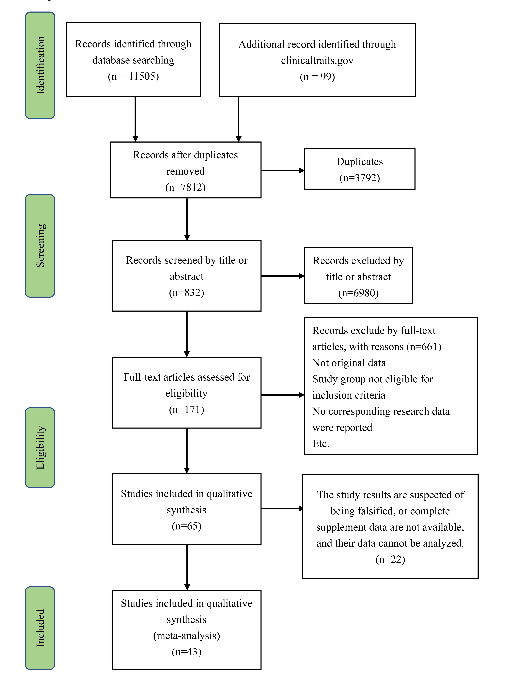
Appendix 2

Table S4. Characteristics of study

Study | Published years | Study type ^{b} | Intervention group(n) | Control group(n) | Age  Intervention/Control (Standard Deviation or IQR) | Female Intervention/Control (%) | Race  Intervention/Control (%) | Outcomes ^{d}
Alessandro Russo et al. [27] | 2021 | Prospective cohort study | Remdesivir (294) | standard of care (113) | 63.2(15.3) / 62.5(20) | 44(20) / 43(38) | -
Andreas Barratt-Due et al. [28] | 2021 | RCT | Remdesivir (42) | standard of care (57) | 59.7(16.5) / 58.1(15.7) | 13(31) / 14(24.6) | -
Arkadiy Finn et al. [29] | 2022 | Retrospective cohort study | Remdesivir (748) | standard of care (1531) | 64.2(16.7) / 63.0(18.4) | 317(42.4) / 741(48.4) | Asian: 9(1.2)/26(1.7)  Black: 98(13.1)/259(16.9)  NHOPI: 3(0.4)/8(0.5)  Other: 219(29.3)/450(29.4)  White: 408(54.5)/776(50.7)
Brian T. Garibaldi et al. [30] | 2021 | Retrospective cohort study | Remdesivir (285) | standard of care (285) | 60(48,70) / 62(51,75) | 125(43.9) / 127(44.6) | Black: 95(33.3)/100(35.1)  Latinx: 98(34.4)/86(30.2)  White: 59(20.7)/66(23.2)  Other: 33(11.6)/33(11.6)
Carlos K. H. Wong et al. [31] | 2022 | Retrospective cohort study | Remdesivir (352) | standard of care (1347) | 65.2(13.7) / 66.7(13.7) | 154(43.8) / 609(45.2) | -
Carolina Garcia-Vidal et al. [32] | 2021 | Retrospective cohort study | Remdesivir (438) | standard of care (2169) | 65(54,77) | 162(37) / 939(43.3) | -
Christoph D. Spinner et al. ª [33] | 2020 | RCT | Remdesivir (193) | standard of care (200) | 56(45,66) | 75(39) / 75(63) | White: 107(57)/112(58)  Black: 37(20)/27(14)  Asian: 31(16)/37(19)  Other: 13(7)/17(9)
Eun-Jeong Joo et al. [34] | 2021 | Retrospective cohort study | Remdesivir (48) | Supportive care (38) | 69.0(14.9) / 68.0(10.4) | 31(64.6) / 21(55.3) | -
Florence Ader et al. [35] | 2022 | RCT | Remdesivir (414) | standard of care (418) | 63(55,73) / 64(54,72) | 123(30) / 130(31) | White: 244(68)/255(70)  North African: 49(14)/61(17)  Sub-Saharan African: 30(8)/17(5)  Other: 37(10)/31(9)
Florin Elec et al. [36] | 2022 | Retrospective cohort study | Remdesivir (38) | standard of care (127) | 53(9) / 49(12) | 17(45) / 38(30) | -
George A. Diaz et al. [37] | 2021 | Retrospective cohort study | Remdesivir (286) | supportive care (452) | 61.4(16.9) / - | 124(43.4) / - | White: 150(52.4)/-  Asian, Pacific Islander: 33(11.5)/-  Black, African American: 13(4.5)/-  Hispanic, Latino: 57(19.9)/-  Other, unknown: 33(11.5)/-
Giuseppe Lapadula et al. [38] | 2020 | Prospective cohort study | Remdesivir (33) | standard of care (80) | 59(56,69) / 61(57,67) | 10(30.3) / 13(16.2) | -
J.H. Beigel et al. [12] | 2020 | RCT | Remdesivir (541) | Placebo (521) | 58.6(14.6) / 59.2(15.4) | 189(34.9) / 189(36.3) | American Indian or Alaska Native: 4(0.7)/3(0.6)  Asian: 79(14.6)/56(10.7)  Black or African American: 109(20.1)/117(22.5)  White: 134(24.8)/116(22.3)
JM Jeetendra Kumar et al. [39] | 2021 | Retrospective cohort Study | Remdesivir (100) | standard of care (100) | 55(14.3) / 55(14.3) | 34(34)/ 33(33) | -
Kan Kikuchi et al. [40] | 2021 | Retrospective cohort study | Remdesivir (98) | standard of care (293) | - | 31(31.6) / 83(28.3) | -
Karim Ali et al. [41] | 2022 | RCT | Remdesivir (634) | standard of care (647) | 65(53,77) / 66(54,77) | 260(41.0) / 255(39.4) | White: 269(42.4)/255(39.4)  South Asian: 90(14.2)/110(17.0)  East Asian: 40(6.3)/42(6.5)  Indigenous or First Nations: 40(6.3)/28(4.3)  Black: 20(3.2)/25(3.9)  Arab: 22(3.5)/24(3.7)  Latin American: 23(3.6)/21(3.2)  West Asian: 8(1.3)/12(1.9)  Other: 9(1.4)/14(2.2)  Not available: 119(18.8)/126(19.5)
Lakshmi Mahajan et al. [42] | 2021 | RCT | Remdesivir (34) | standard of care (36) | 58.1(12.1) / 57.4(14.1) | 13(38.3) / 9(25.0) | -
Mahmoud Hammad et al. [43] | 2021 | Prospective cohort study | Remdesivir (45) | standard of care (31) | 9(2,18) / 10(1,18) | 20(44.4) / 14(45.1) | -
Markos Kalligeros et al. [44] | 2020 | Retrospective cohort study | Remdesivir (99) | Supportive care (125) | 58(50,68) / 60(50,68) | 30(30.3) / 44(35.2) | Asian: 1(1.0)/1(0.8)  Black or African American: 10(10.1)/20(16.0)  Hispanic or Latino: 48(48.5)/50(40.0)  Other/unknown: 5(5.1)/7(5.6)  White or Caucasian: 35(35.4)/47(37.6)
Michael E. Ohl et al. [45] | 2021 | Retrospective cohort study | Remdesivir (1172) | standard of care (1172) | 66.6(14.2) / 67.5(14.1) | 71 (6.1) / 71 (6.1) | White: 693(59.1)/674(57.5)  Black: 388(33.1)/406(34.6)  Other: 27(2.3)/38(3.2)  Missing: 65(5.5)/55(4.7)
Quratulain Shaikh et al. [46] | 2021 | Prospective cohort study | Remdesivir (102) | standard of care (166) | 55.0(12.8) / 56.2(13.3) | 27(26.5) / 36(21.7) | -
R.L. Gottlieb et al. [47] | 2022 | RCT | Remdesivir (279) | Placebo (283) | 50(15) / 51(15) | 131(47.0) / 138(48.8) | White: 228(81.7)/224(79.2)  Black: 20(7.2)/22(7.8)  American Indian or Alaska Native: 15(5.4)/21(7.4)  Asian, Native Hawaiian, or Pacific Islander: 7(2.5)/7(2.5)  Hispanic or Latinx: 123(44.1)/112(39.6)  Other: 3(1.1)/2(0.7)
Sherief Abd-Elsalam et al. [48] | 2022 | RCT | Remdesivir (100) | standard of care (100) | 55.0(14.2) / 52.0(16.3) | 34(34.0) / 47(47.0) | -
Shinobu Tamura et al. [49] | 2022 | Retrospective cohort study | Remdesivir (63) | standard of care (122) | 59.6(14.7) / 44.1(20.1) | 27(42.9) / 64(52.5) | -
Sohini Sengupta et al. [50] | 2021 | Retrospective cohort study | Remdesivir (34)  Tocilizumab + Remdesivir (25) | standard of care (69)  Remdesivir (34) | <=30: 13  31-50: 32  51-70: 66  >70：17 | 48(37.5) | -
Susan A. Olender et al. [51] | 2021 | Retrospective cohort study | Remdesivir (368) | standard of care (1399) | 59.7(14.7) / 60.5(14.8) | 137(37.2) / 522(37.3) | White: 251(68.2)/949(67.9)  Asian: 42(11.4)/164(11.7)  Black or African American: 43(11.7)/171(12.2)  Other: 32(8.7)/115(8.3)
WHO Solidarity Trial Consortium ^{c} [52] | 2021 | RCT | Remdesivir (2743) | standard of care (2708) | <50: 961 / 952  50–69: 1282 / 1287  ≥70: 500 / 469 | 1037(37.8) / 983(36.3) | Europe and Canada: 715(26.1)/698(25.8)  Latin America: 470(17.1)/514(19.0)  Asia and Africa:  1558(56.8)/1496(55.2)
Yeming Wang et al. [13] | 2020 | RCT | Remdesivir (158) | Placebo (78) | 66(57,73) / 64(53,70) | 69(44) / 27(35) | -
Zeno Pasquini et al. [53] | 2020 | Retrospective cohort study | Remdesivir (25) | standard of care (26) | 64(57,75) / 70(63,76) | 2(8.0) / 2(7.7) | -
Aldo Marrone et al. [54] | 2022 | Prospective cohort study | Remdesivir + Dexamethasone (76) | Dexamethasone (75) | 64(55,74) / 66(55,75) | 28(36.8) / 27(36) | -
Derek T. Larson et al. [55] | 2022 | Retrospective cohort study | Remdesivir + Dexamethasone (42) | supportive care (14) | 58(51,67) / 62(50,70) | 12(28.6) / 7(50) | Caucasian: 18(42.8)/6(24.0)  Black: 14(33.3)/6 (30.0)  Other/Unreported: 10(23.8)/2(14.3)
Simon B. Gressens et al. [56] | 2022 | Retrospective cohort study | Remdesivir + Dexamethasone (90) | Dexamethasone (90) | 68.6(58.8,77.9) / 67.0(58.8,77.9) | 37(41) / 35(39) | White: 58(64)/62(69)  Black: 8(9)/7(8)  Asian: 4(4)/2(2)  Other: 20(22)/19(21)
Subhadra Mandadi et al. [57] | 2022 | Retrospective cohort study | Corticosteroid + Remdesivir (74) | Corticosteroid (74) | 61.9(15.2) / 61.3(14.9) | 32(43) / 41(55) | White: 43(58)/47(64)  Black or African American: 26(35)/23(31)  Hispanic or Latino: 10(14)/10(14)  Asian: 10(14)/0(0)
Thomas Benfield et al. [58] | 2021 | Retrospective cohort study | Remdesivir + Dexamethasone (1694) | standard of care (1053) | 69(57,79) / 71(57,80) | 621(36.7) / 474(45.0) | -
Toshiki Kuno et al. [59] | 2021 | Retrospective cohort study | Corticosteroid+ Remdesivir (999) | Corticosteroid (999) | 65.9(15.8) / 65.9(15.8) | 430(43) / 431(42.9) | White: 334(33.4)/335(33.5)  African American：151(15.1)/150(15.0)  Hispanic: 215(21.5)/213(21.3)  Asian: 81(8.1)/84(8.4)  Other: 218(21.8)/217(21.7)
Ivan O. Rosas et al. [60] | 2021 | RCT | Tocilizumab + Remdesivir (430) | Placebo + Remdesivir (210) | 60.1(13.3) / 58.2(13.3) | 164(38.1) / 71(33.8) | White: 279(64.9)/150(71.4)  Black or African American: 51(11.9)/19(9)  Asian: 17(4)/5(2.4)  Native Hawaiian or Other Pacifc Islander: 7(1.6)/3(1.4)  American Indian or Alaska Native: 4(0.9)/4(1.9)  Multiple: 9(2.1)/2(1)  Unknown: 63(14.7)/27(12.9)
Nouf K. Almaghlouth et al. [61] | 2021 | Retrospective cohort study | Tocilizumab + Remdesivir (33) | Tocilizumab (80) | <30: 1(3.0)/3(3.8)  30-49: 10(30.3) / 16(20.3)  50-69: 14(42.4) / 37(46.9)  >=70: 8 (24.2) / 23(29.1) | 18(54.6) / 34(43.0) | -
Vishal Gupta et al. [62] | 2021 | Retrospective cohort study | Tocilizumab + Remdesivir (76) | Remdesivir (414) | 58.5(21) / 57(18) | 29(38.1) / 155(37.4) | -
Anna Moniuszko-Malinowska et al. [63] | 2020 | Retrospective cohort study | Convalescent Plasma + Remdesivir (25) | Remdesivir (53) | 59.5(18.8) | 32(41.0) | -
Janak Koirala et al. [64] | 2021 | Prospective cohort Study | Convalescent Plasma + Remdesivir (114) | Remdesivir (910) | 55.8(15.7) | 346(26.3) | -
Jered Arquiette et al. [65] | 2021 | Prospective cohort study | Convalescent Plasma + Remdesivir (42) | Remdesivir (11) | 50.5(40.8,65.3) / 56(54,68) | 15(35.7) / 3(27.3) | Hispanic: 28(66.7)/7(63.6)  Asian: 9(21.4)/1(9.1)  White: 1(2.4)/1(9.1)  Black: 3(7.1)/0(0)  Other: 1(2.4)/2(18.2)
M. Nasir et al. [66] | 2020 | Retrospective cohort study | Convalescent Plasma + Remdesivir (21)  Favipiravir + Remdesivir (14) | Remdesivir (22)  Favipiravir (5) | - | 13(22.5) | -
Kübra DEMİR ÖNDER et al. [67] | 2021 | Retrospective cohort study | Favipiravir + Remdesivir (17) | Favipiravir (73) | 51.6(13) / 58.4(13.7) | 6(35.3) / 25(34.2) | -
Mortality, Duration of hospital stay, Recovery, Any adverse events, Serious adverse events, New use of mechanical ventilation or ECMO (extracorporeal membrane oxygenation) at baseline, Days of mechanical ventilation or ECMO during study, New use of noninvasive ventilation or high-flow oxygen at baseline, Days to negative PCR, New use of oxygen or low-flow oxygen at baseline, Days of receiving oxygen or low-flow oxygen during study, New admission of ICU at baseline, Clinical improvement, Time to clinical improvement, Time to recovery, Discharge, Kidney injury ^{e}, Liver injury ^{f}, Cardiac disorders.
RCT: Randomized Controlled Trials
a: Data were analyzed at 10 days of remdesivir administration.
b: The original data were used for prospective studies, and the data after matching analysis were used for retrospective studies with matching analysis.
c: The WHO Solidarity Trial Consortium contains data from studies by Andreas Barratt-Due et al., and Karim Ali et al. Therefore, for the data duplicately published in the three studies, the data of WHO shall be taken. If no relevant data has been published by WHO, the data of the other two studies shall be taken.
d: Outcomes were taken at the end of follow-up.
e: Data were collected to report various types of kidney injury and creatinine clearance decreased.
f: Data were collected to report various types of liver injury and transaminase abnormality.

Appendix 3

Table S5. NOS of observational study

Study | Selection |  |  |  | Comparability | Outcome |  |  | Newcastle-Ottawa scale
Study | 1 | 2 | 3 | 4 | Comparability | 1 | 2 | 3 | Newcastle-Ottawa scale
Aldo Marrone et al. 2022 | * | * | * | * | ** | * | * | * | 9
Alessandro Russo et al. 2021 | * | * | * | * | * | * | * | * | 8
Anna Moniuszko-Malinowska et al. 2020 | * | * | * | * | - | * | * | * | 7
Arkadiy Finn et al. 2022 | * | * | * | * | * | * | * | * | 8
Brian T. Garibaldi et al. 2021 | * | * | * | * | ** | * | * | * | 9
Carlos K. H. Wong et al. 2022 | * | * | * | * | ** | * | * | * | 9
Carolina Garcia-Vidal et al. 2021 | * | * | * | * | * | * | * | * | 8
Derek T. Larson et al. 2022 | - | * | * | * | ** | * | * | * | 8
Eun-Jeong Joo et al, 2021 | * | * | * | * | ** | * | * | * | 9
Florin Elec et al. 2022 | - | * | * | * | * | * | * | * | 7
George A. Diaz et al. 2021 | * | * | * | * | * | * | * | * | 8
Giuseppe Lapadula et al. 2020 | - | * | * | * | * | * | * | * | 7
Janak Koirala et al. 2021 | - | * | * | * | * | * | * | - | 6
Jered Arquiette et al. 2021 | * | * | * | * | ** | * | * | * | 9
JM Jeetendra Kumar et al. 2021 | * | * | * | * | ** | * | * | * | 9
Kan Kikuchi et al. 2021 | - | * | * | * | ** | * | * | * | 8
Kübra DEMİR ÖNDER et al. 2021 | * | * | * | * | ** | * | * | * | 9
M. Nasir et al. 2020 | * | * | * | * | - | * | * | * | 7
Mahmoud Hammad et al. 2021 | - | * | * | * | * | * | * | * | 7
Markos Kalligeros et al. 2020 | * | * | * | * | ** | * | * | * | 9
Michael E. Ohl et al. 2021 | - | * | * | * | ** | * | * | * | 8
Nouf K. Almaghlouth et al.2021 | * | * | * | * | ** | * | * | * | 9
Quratulain Shaikh et al. 2021 | * | * | * | * | * | * | * | * | 8
Shinobu Tamura et al. 2022 | * | * | * | * | ** | * | * | * | 9
Simon B. Gressens et al. 2022 | * | * | * | * | ** | * | * | * | 9
Sohini Sengupta et al. 2021 | * | * | * | * | - | * | * | * | 7
Subhadra Mandadi et al. 2022 | - | * | * | * | ** | * | * | * | 8
Susan A. Olender et al. 2021 | - | * | * | * | ** | * | * | * | 8
Thomas Benfield et al. 2021 | * | * | * | * | * | * | * | * | 8
Toshiki Kuno et al. 2021 | - | * | * | * | ** | * | * | * | 8
Vishal Gupta et al. 2021 | * | * | * | * | * | * | * | * | 8
Zeno Pasquini et al. 2020 | * | * | * | * | ** | * | * | * | 9

Appendix 4 Forest plot
Figure S2. Forest plot of duration of hospital stay
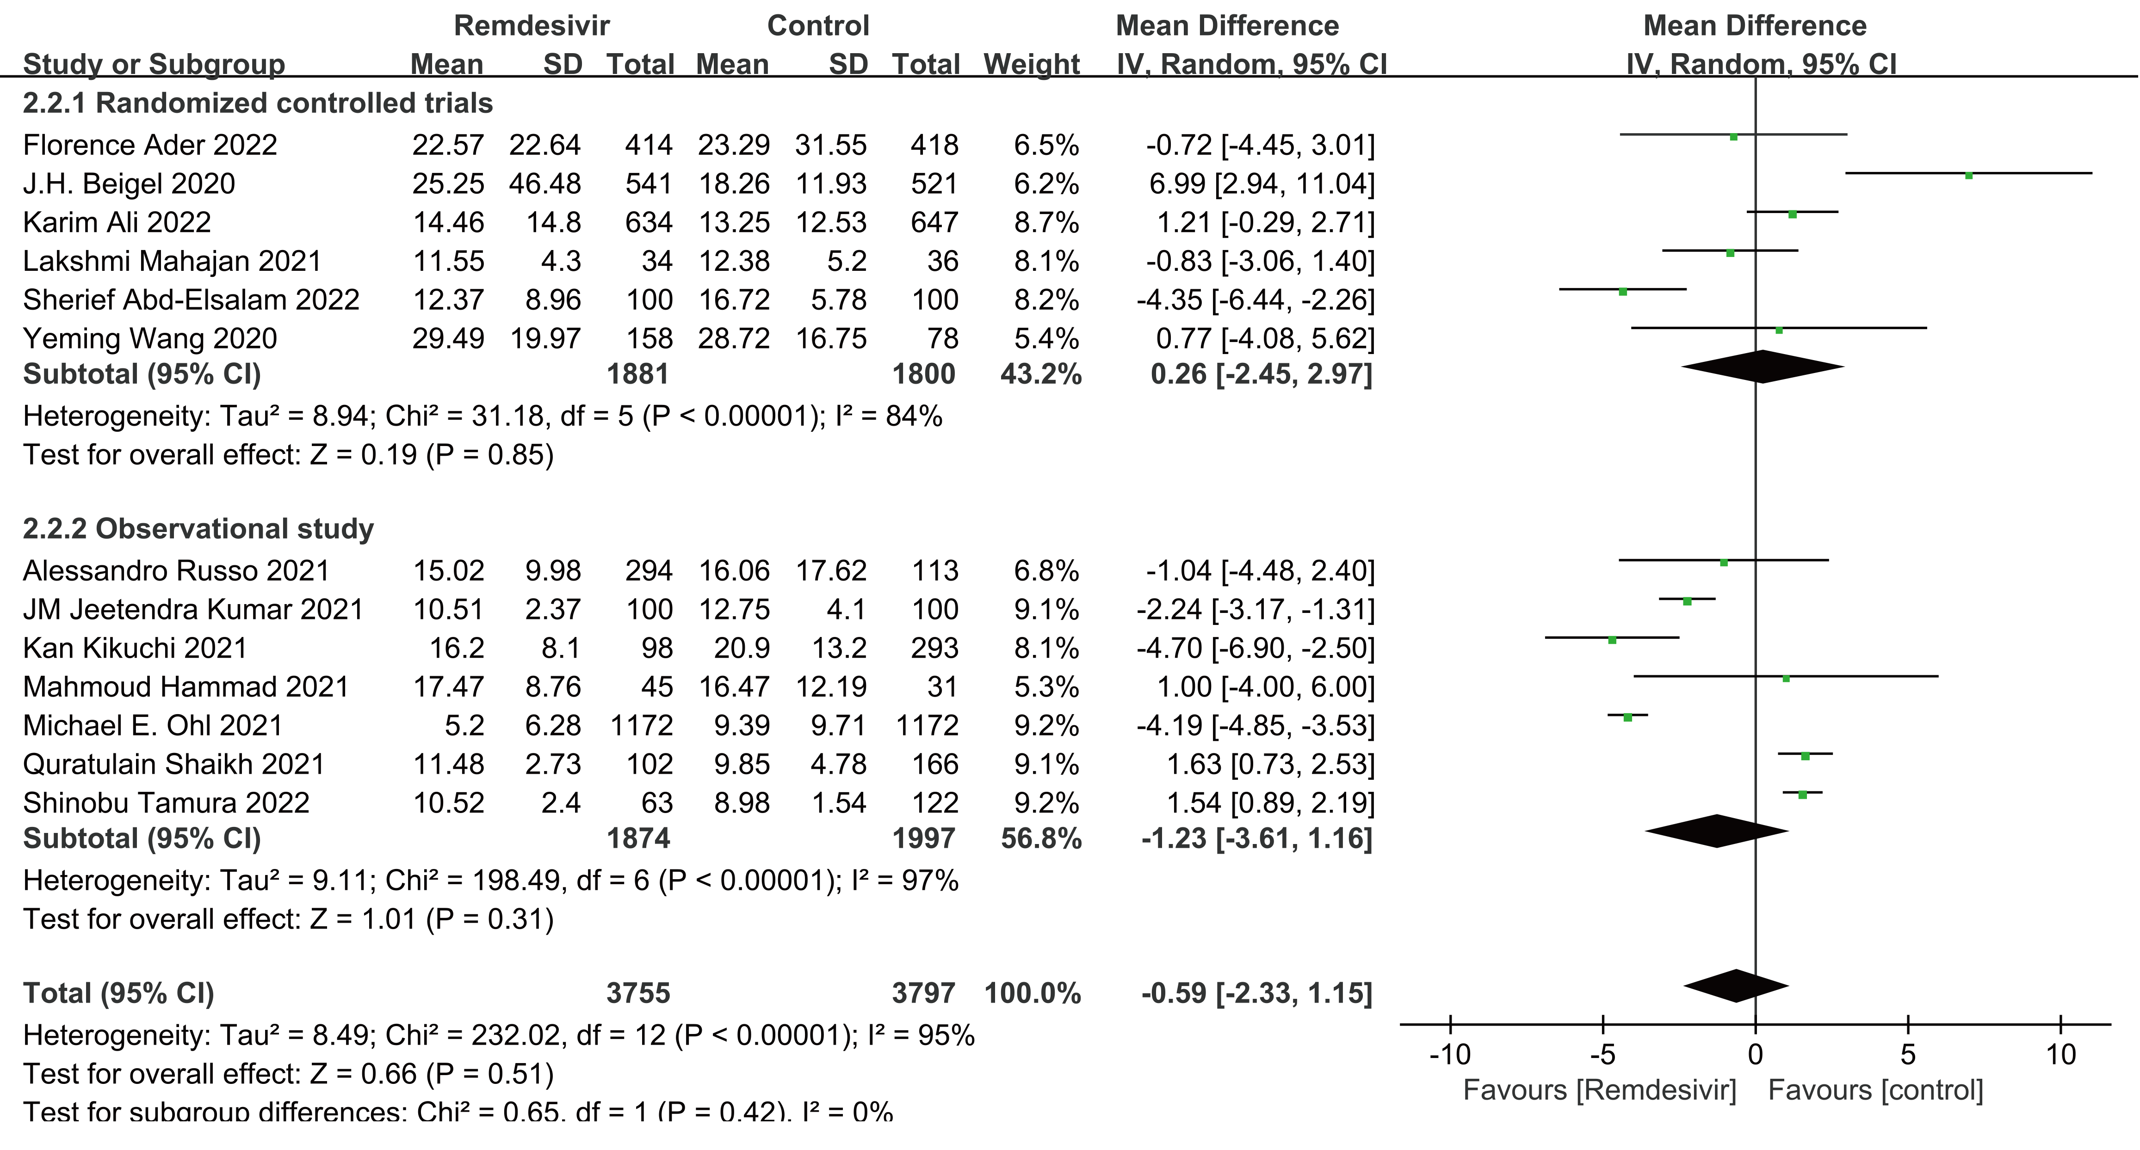
Figure S3. Forest plot of duration of new use of mechanical ventilation or ECMO at baseline
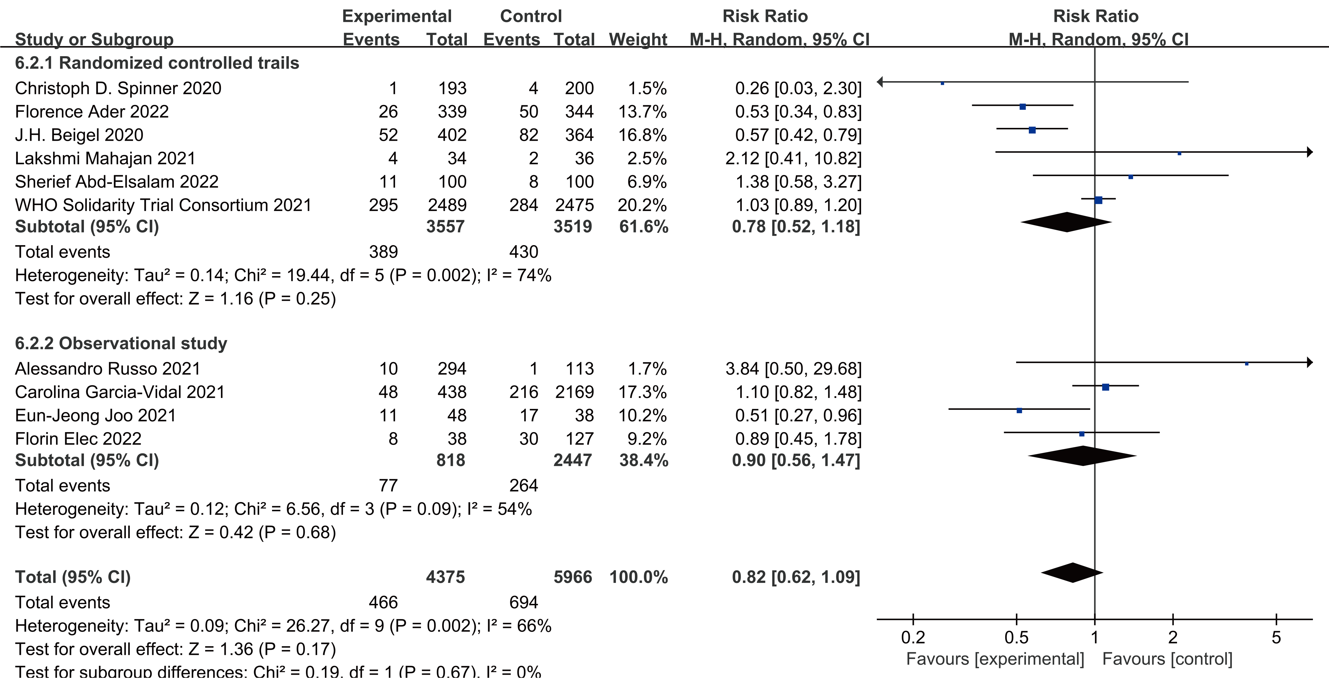

Figure S4. Forest plot of days of mechanical ventilation or ECMO during study
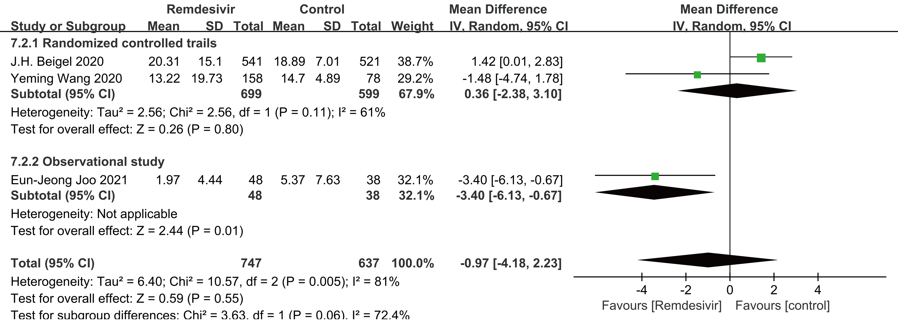
Figure S5. Forest plot of new use of noninvasive ventilation or high-flow oxygen at baseline
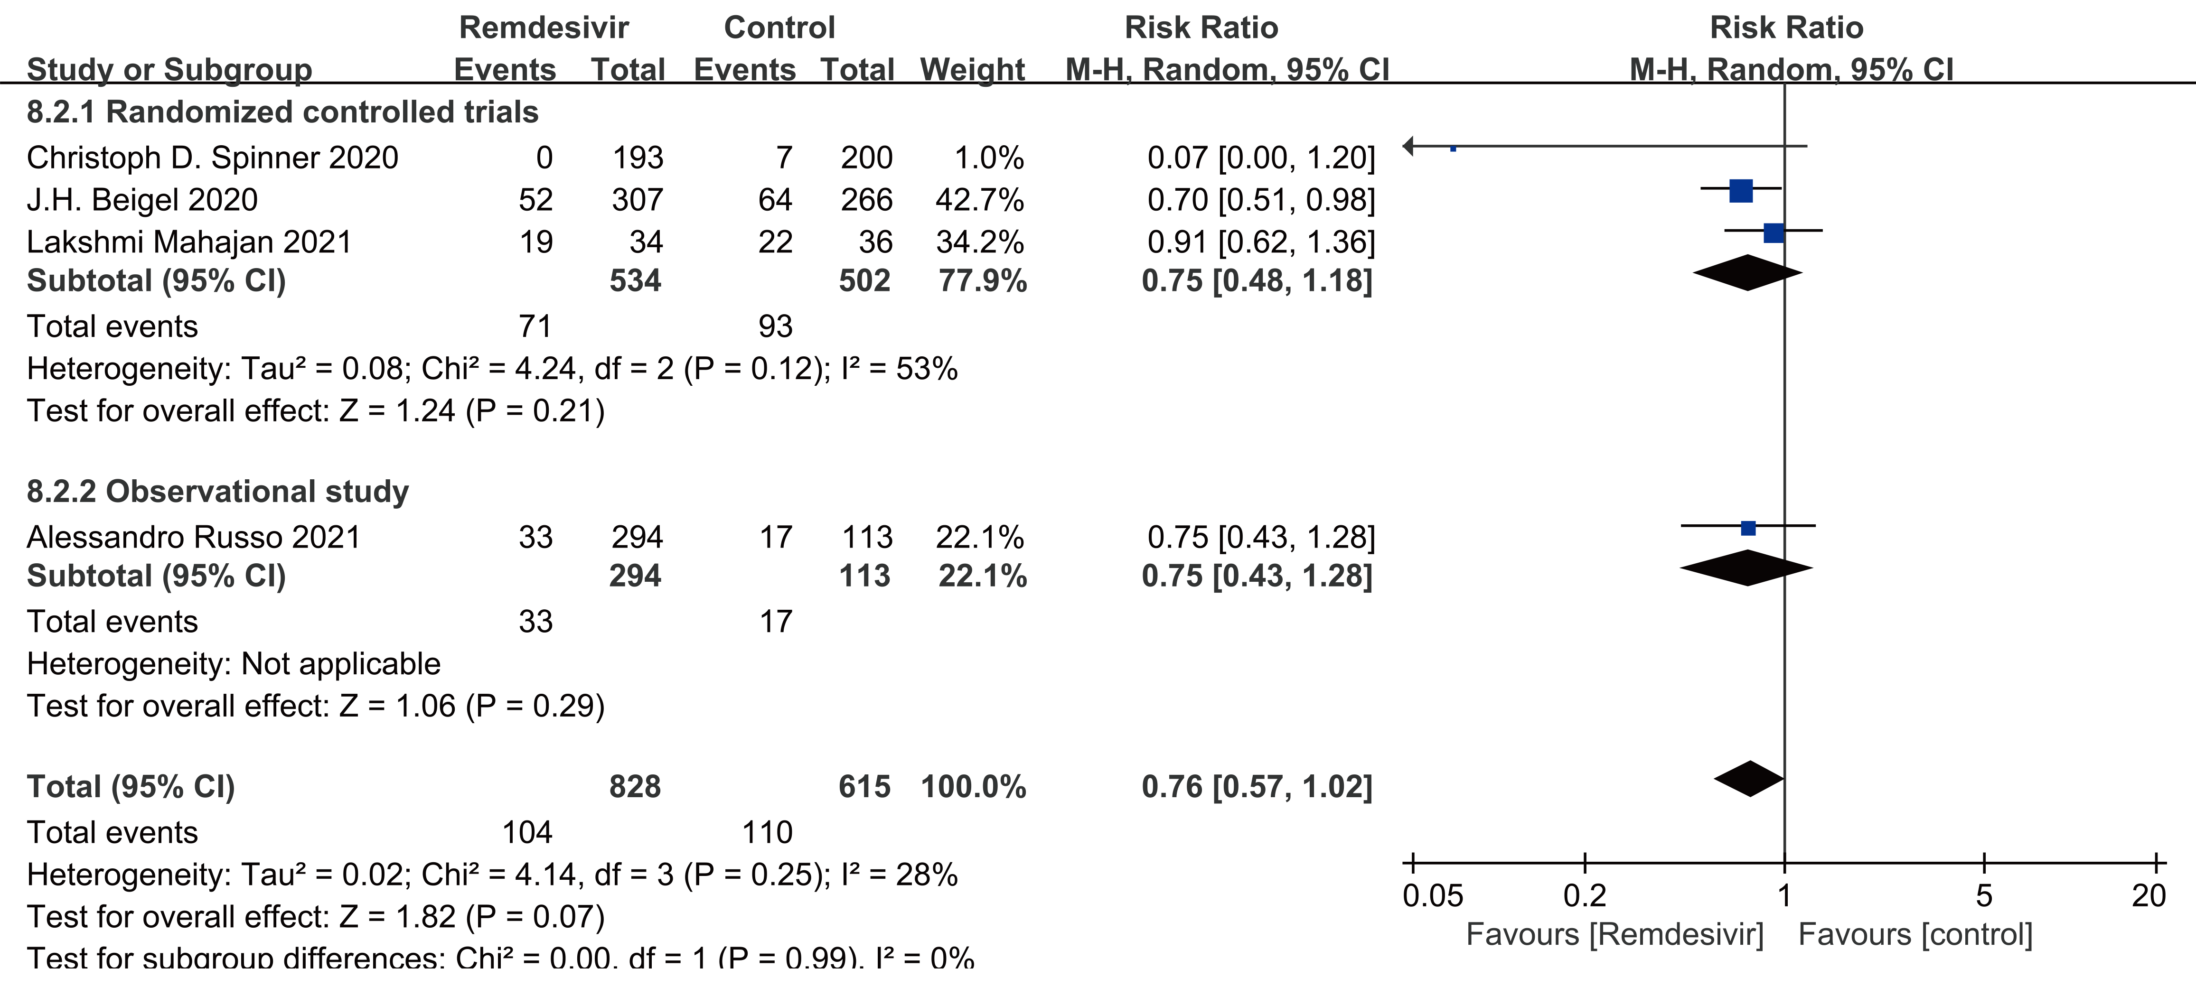
Figure S6. Forest plot of days of receiving oxygen or low-flow oxygen during study
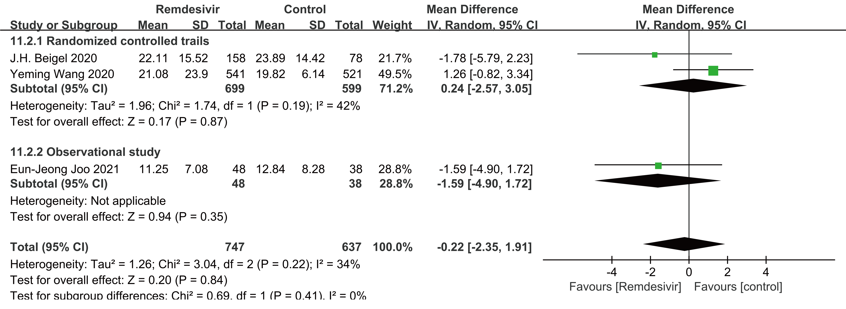
Figure S7. Forest plot of new admission of ICU at baseline
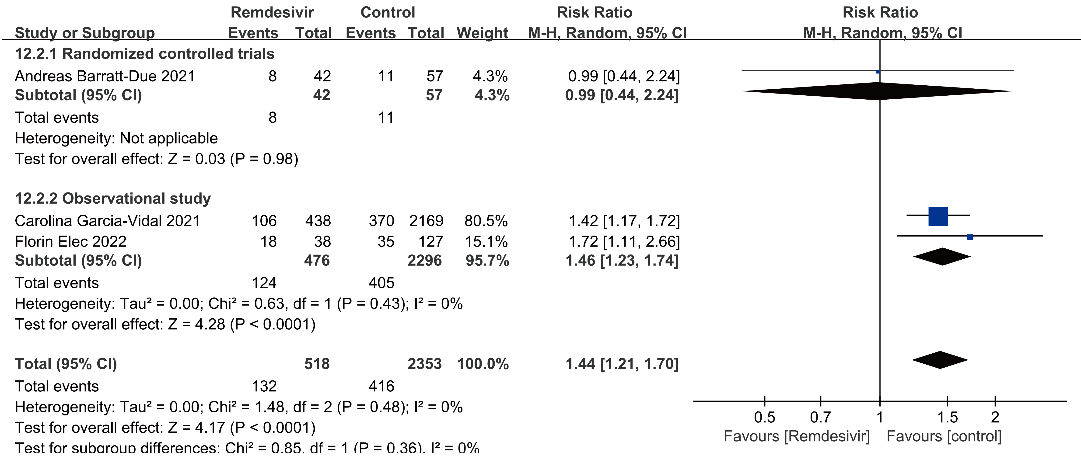
Figure S8. Forest plot of clinical improvement
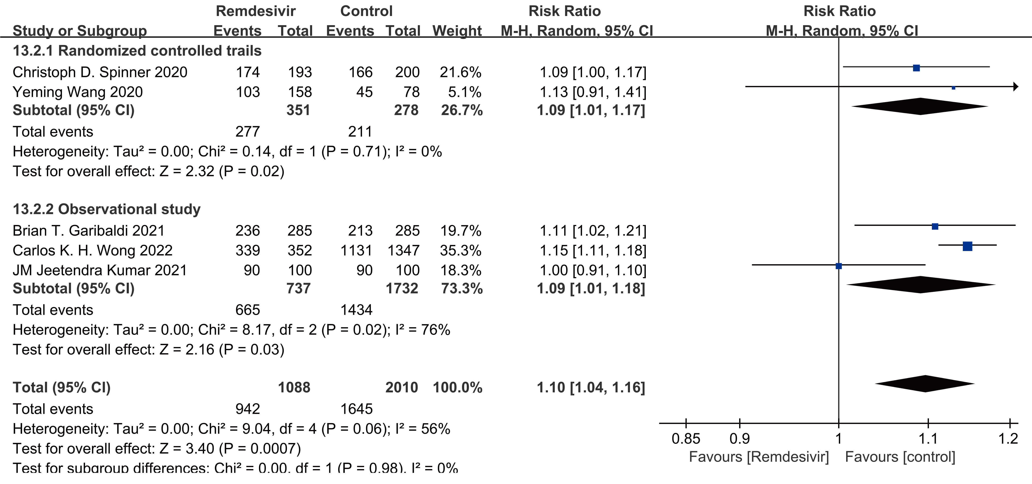

Figure S9. Forest plot of time to clinical improvement
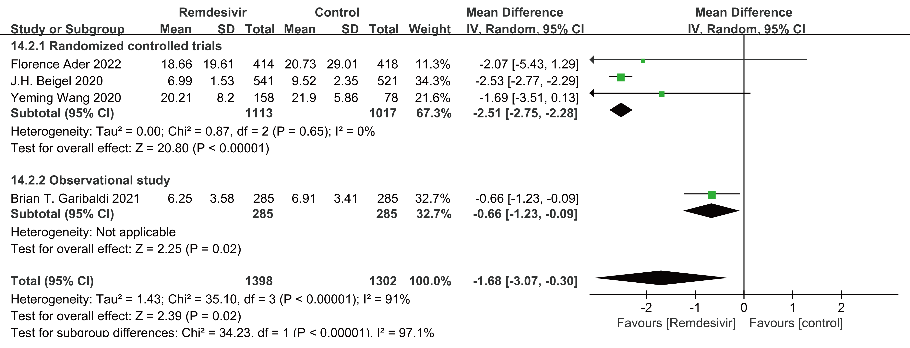
Figure S10. Forest plot of time to recovery
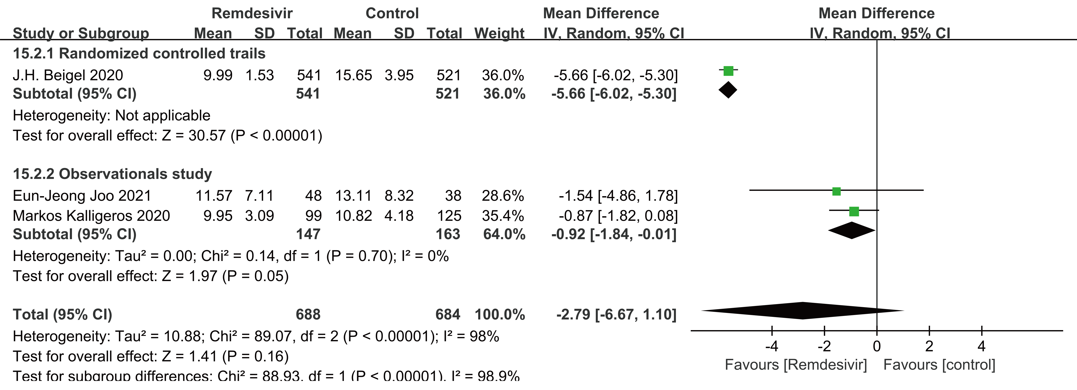
Figure S11. Forest plot of discharge
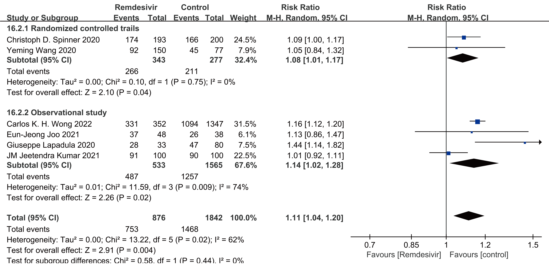
Figure S12. Forest plot of days to negative PCR
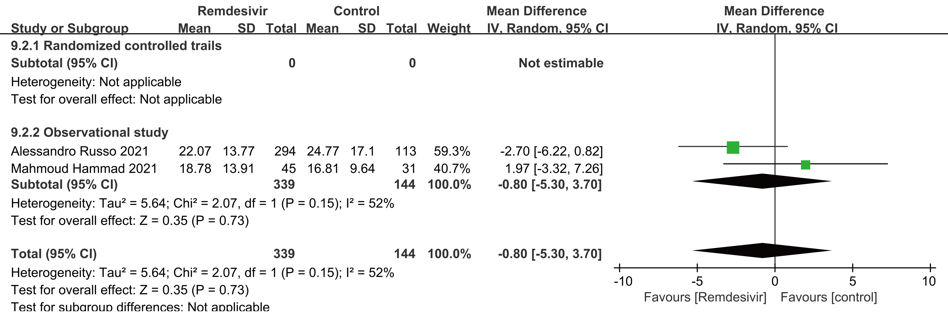
Figure S13. Forest plot of kidney injury
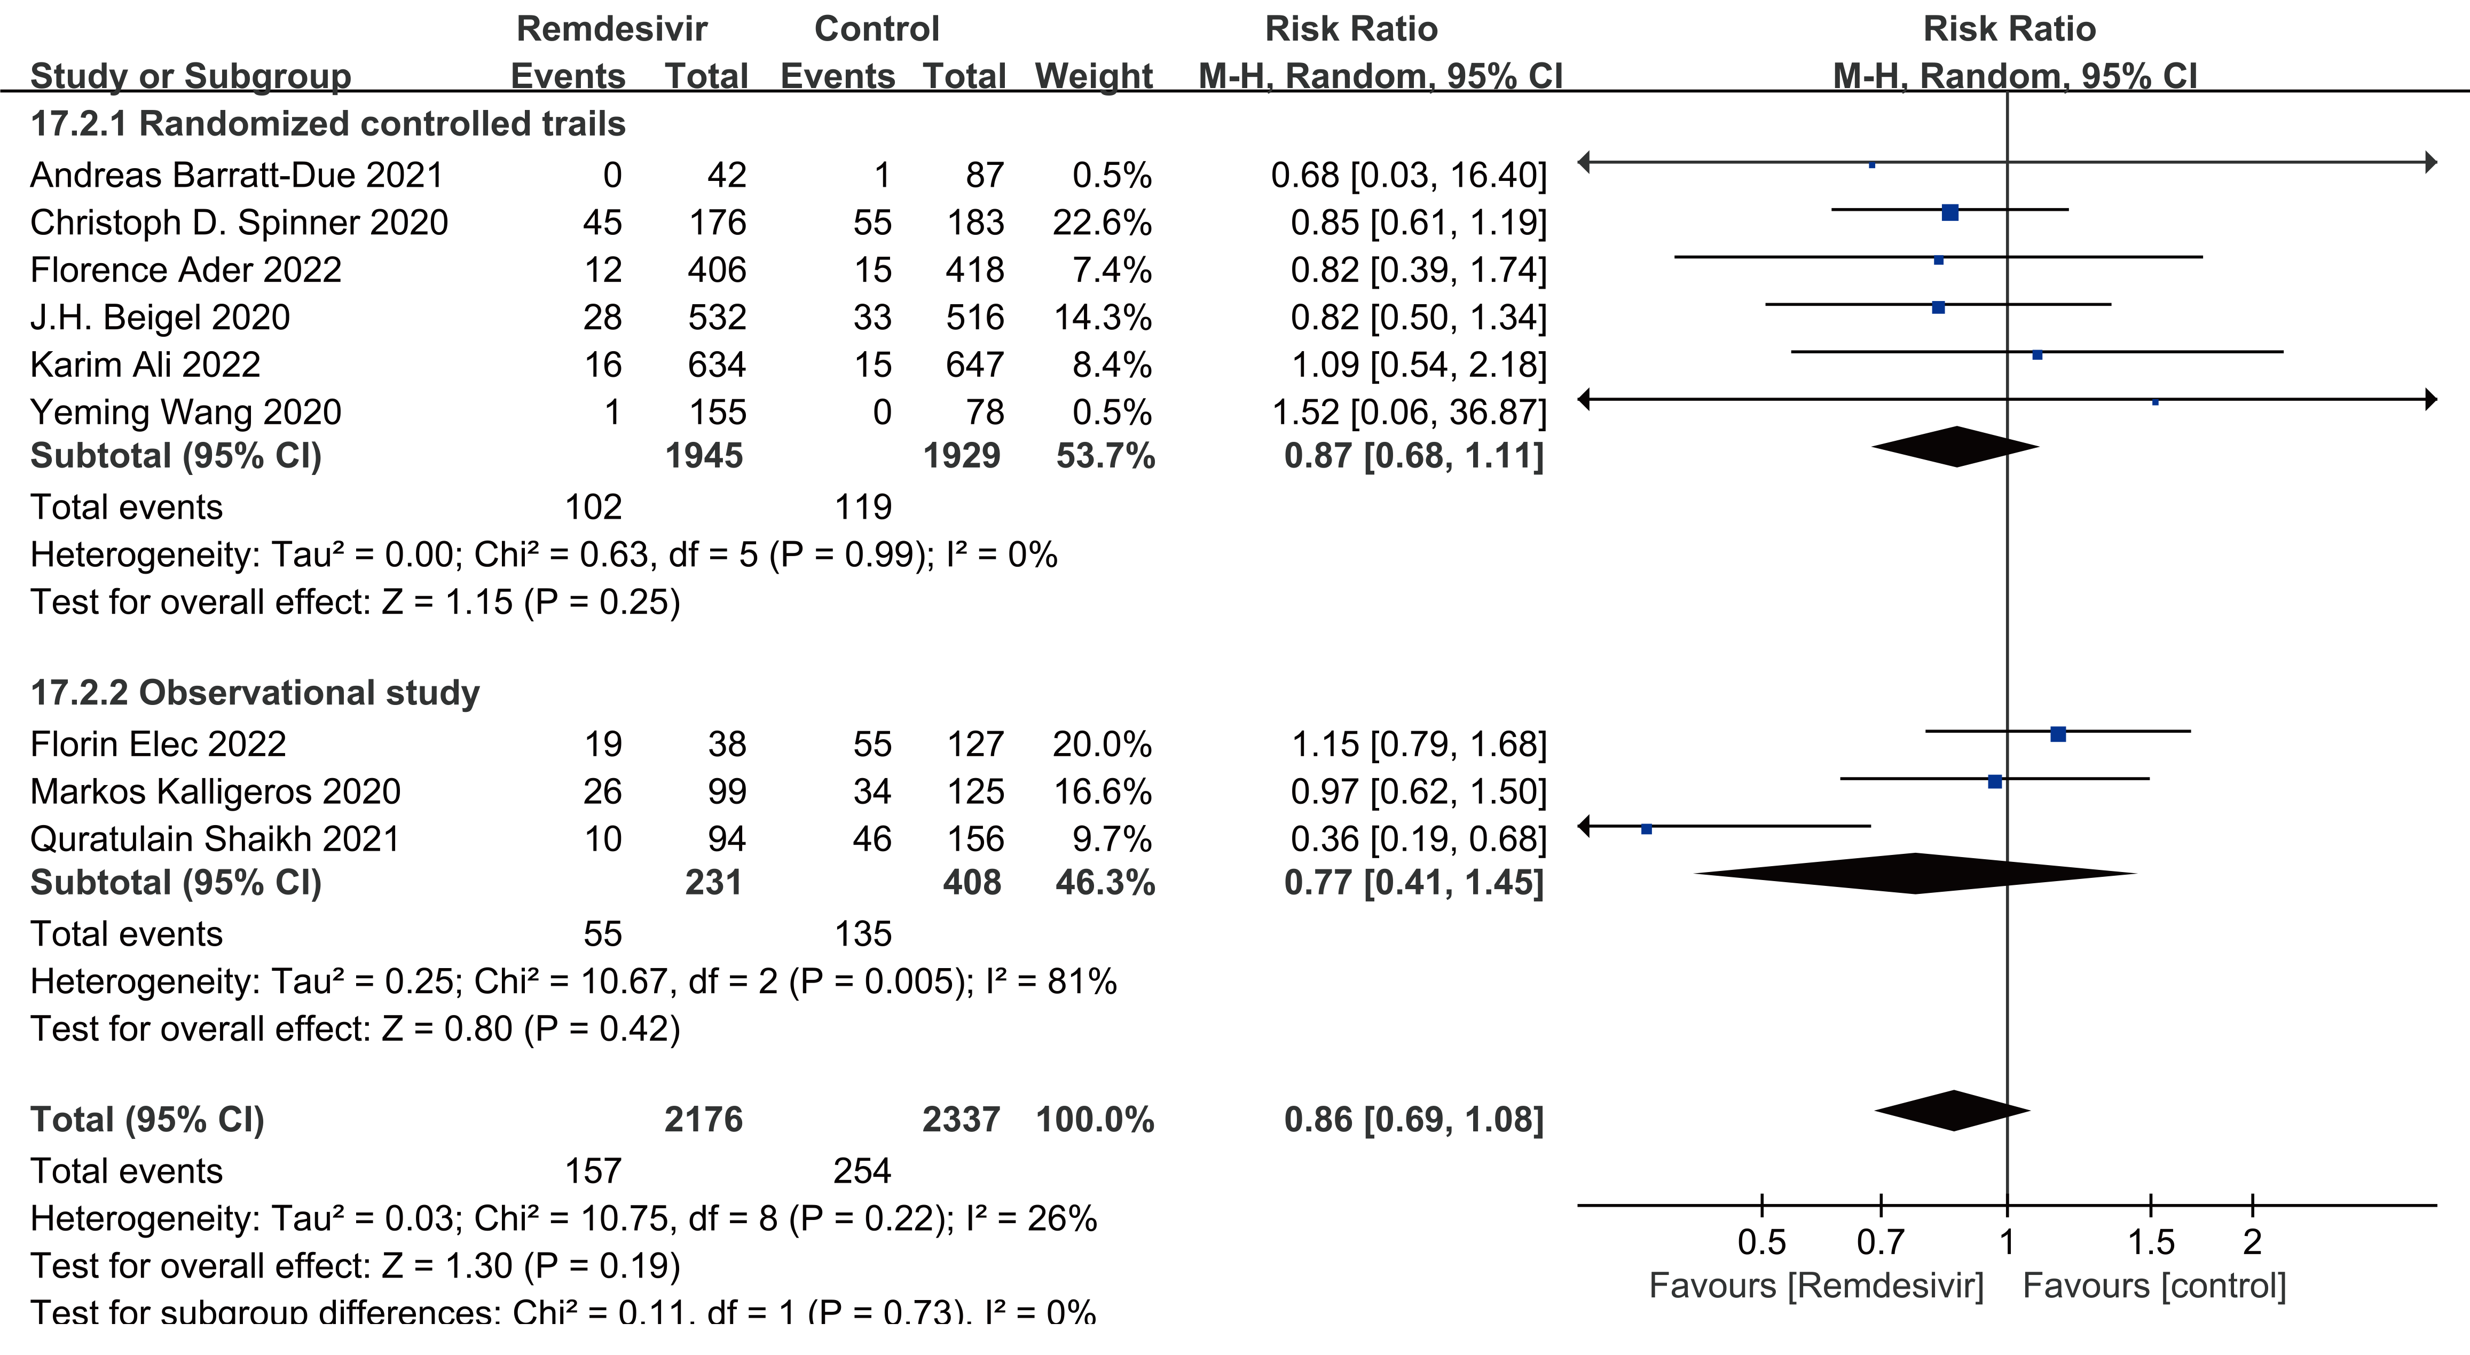

Figure S14. Forest plot of liver injury
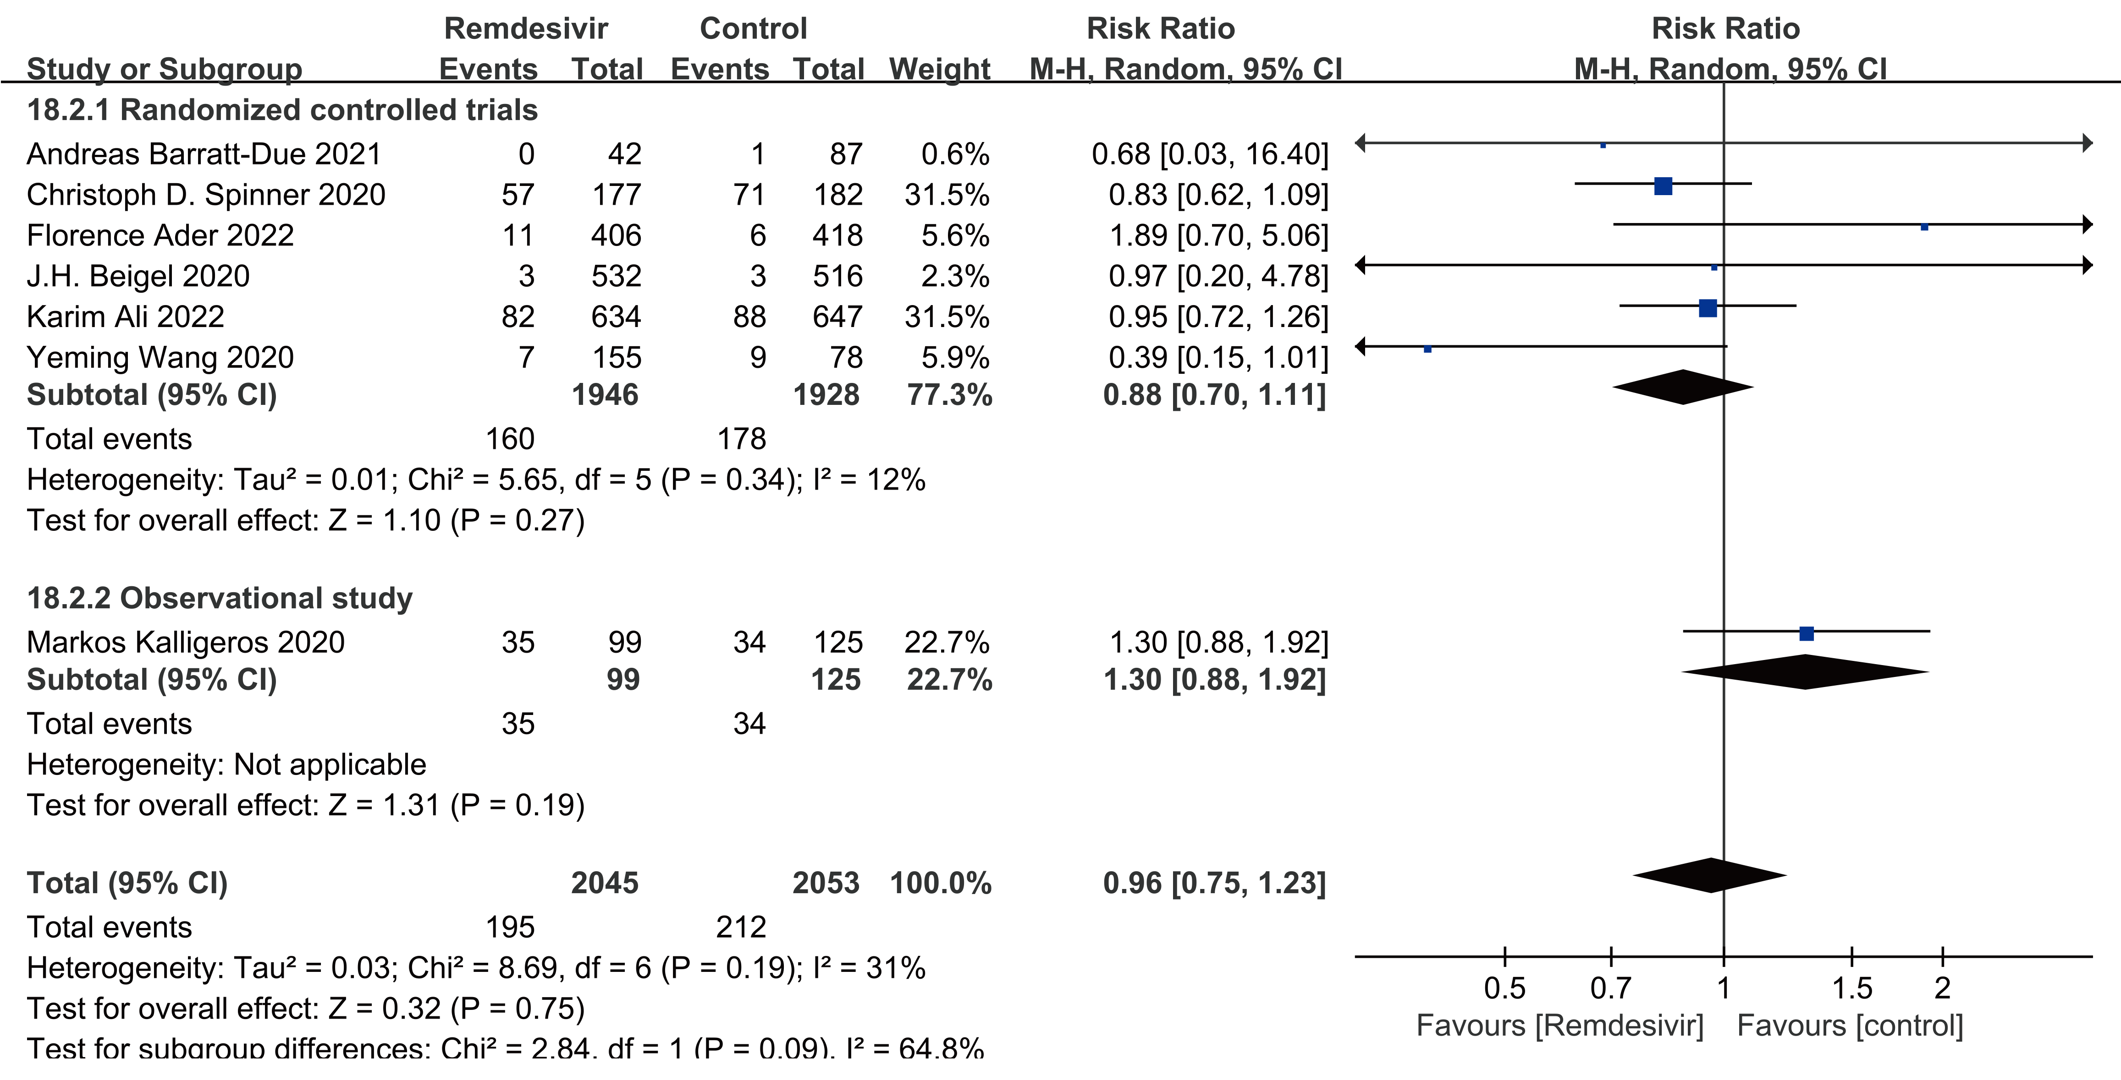
Figure S15. Forest plot of mortality (remdesivir with steroid)
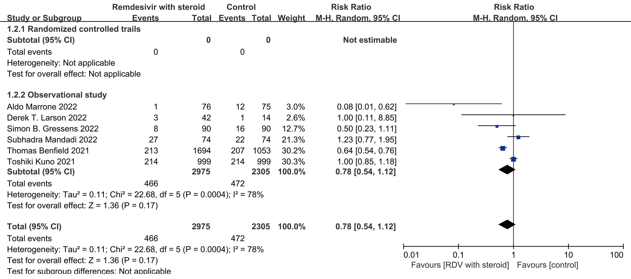
RDV: remdesivir

Figure S16. Forest plot of duration of hospital stay (remdesivir with steroid)
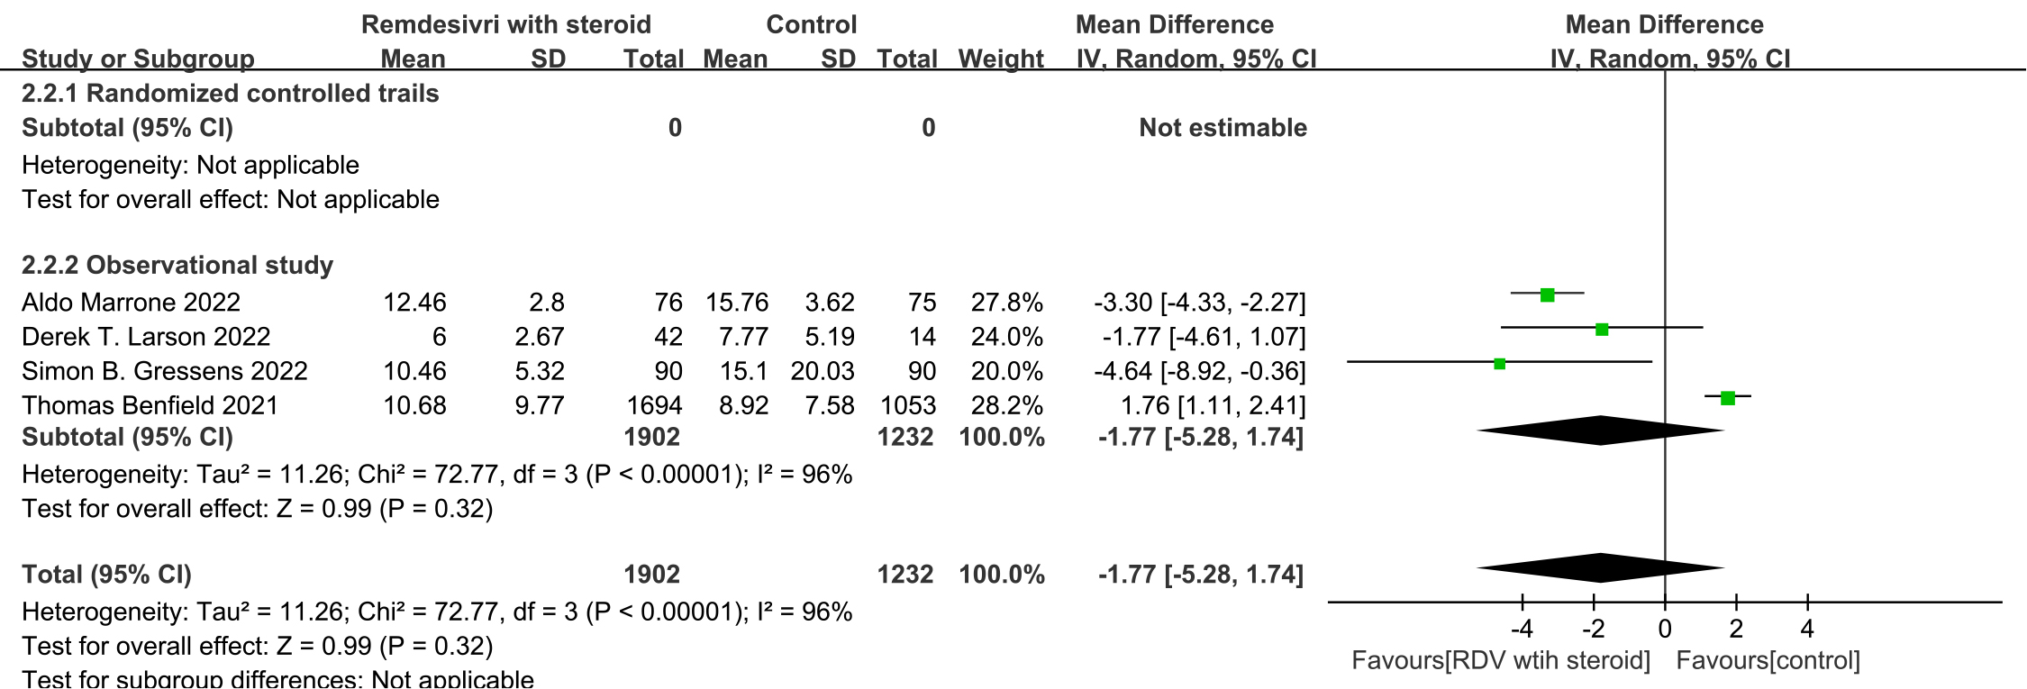
RDV: remdesivir
Figure S17. Forest plot of new admission of ICU at baseline (remdesivir with steroid)
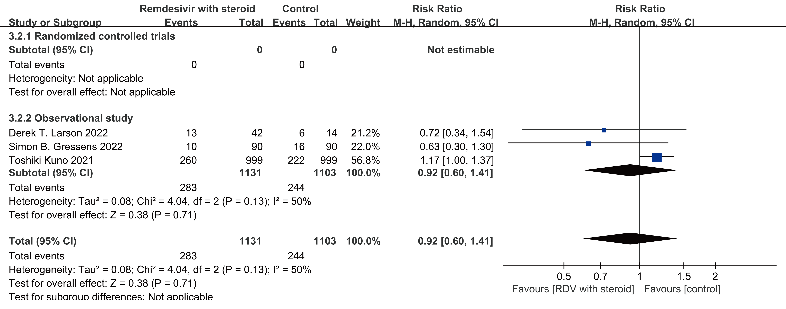
RDV: remdesivir

Figure S18. Forest plot of liver injury (remdesivir with steroid)
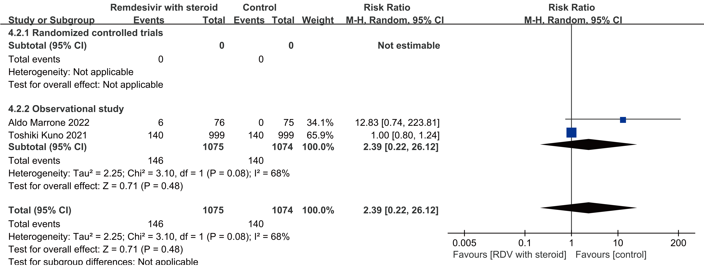
RDV: remdesivir
Figure S19. Forest plot mortality (remdesivir with tocilizumab)
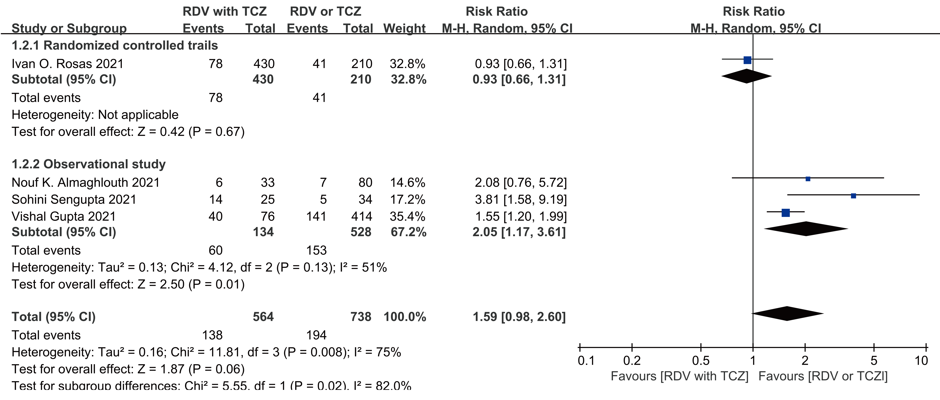
RDV: remdesivir, TCZ: tocilizumab

Figure S20. Forest plot mortality (remdesivir with convalescent plasma)
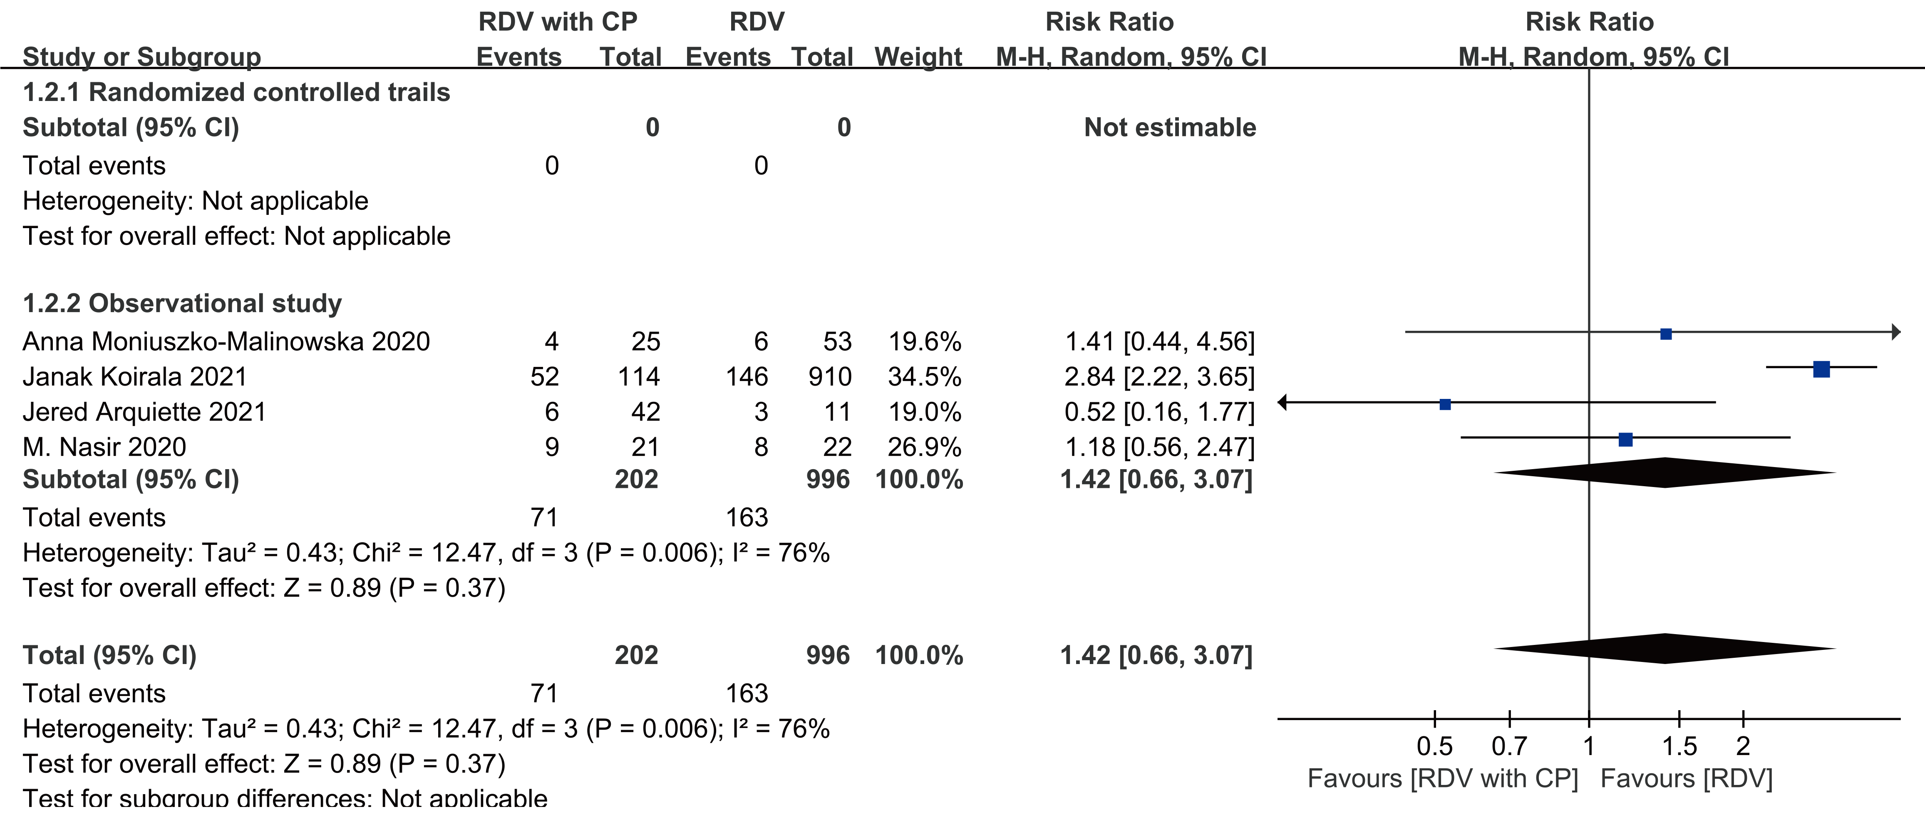
RDV: remdesivir, CP: convalescent plasma
Figure S21. Forest plot mortality (remdesivir with favipiravir)
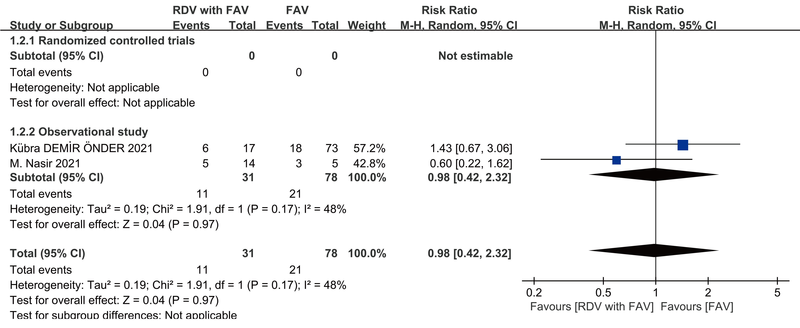
RDV: remdesivir, FAV: favipiravir

Appendix 5. Sensitivity analysis
Figure S22. Sensitivity analysis of mortality (observational study)
Figure S23. Sensitivity analysis of duration of hospital stay (RCT)
Figure S24. Sensitivity analysis of duration of hospital stay (observational study)
Figure S25. Sensitivity analysis of recovery (observational study)
Figure S26. Sensitivity analysis of any adverse events (RCT)
Figure S27. Sensitivity analysis of serious adverse events (RCT)
Figure S28. Sensitivity analysis of new use of mechanical ventilation or ECMO at baseline (RCT)

Figure S29. Sensitivity analysis of new use of mechanical ventilation or ECMO at baseline (observational study)

Figure S30. Sensitivity analysis of new use of mechanical ventilation or ECMO at baseline (RCT)

Figure S31. Sensitivity analysis of clinical improvement (observational study)
Figure S32. Sensitivity analysis of discharge (observational study)
Figure S33. Sensitivity analysis of kidney injury (observational study)

Figure S34. Sensitivity analysis of mortality (observational study) (remdesivir with steroid)
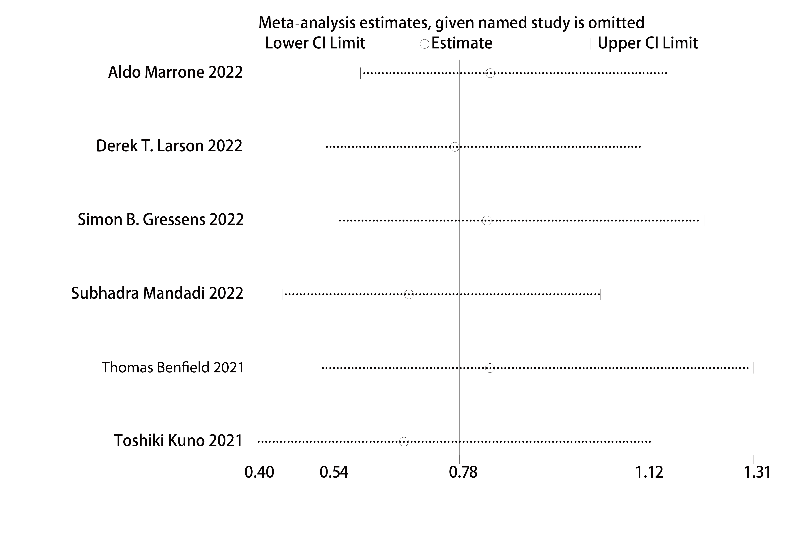

Figure S35. Sensitivity analysis of duration of hospital stay (observational study) (remdesivir with steroid)

Figure S36. Sensitivity analysis of new admission of ICU at baseline (observational study) (remdesivir with steroid)

Figure S37. Sensitivity analysis of mortality (observational study) (remdesivir with tocilizumab)

Figure S38. Sensitivity analysis of mortality (observational study) (remdesivir with convalescent plasma)

Appendix 6
Table S6. Publication bias
Outcomes | Study | Coef. (bias) | Std. Err. (bias) | t (bias) | P>|t| (bias) | [95% Conf. Interval] (bias)
Mortality | RCT | .1957626 | .5207506 | 0.38 | 0.722 | -1.14287 1.534395
Mortality | Observational study | -1.468173 | .8597379 | -1.71 | 0.110 | -3.312127.3757816
Duration of hospital stay | RCT | -3.186774 | 1.964973 | -1.62 | 0.180 | -8.642414 2.268866
Duration of hospital stay | Observational study | 5.111777 | 2.53473 | 2.02 | 0.100 | -1.403955 11.62751
Recovery rate | RCT | - | - | - | - | -
Recovery rate | Observational study | .2282489 | 2.854222 | 0.08 | 0.944 | -12.05248 12.50898
Any adverse events | RCT | 3.042402 | 1.486956 | 2.05 | 0.110 | -1.086049 7.170853
Any adverse events | Observational study | - | - | - | - | -
Serious adverse events | RCT | -1.339603 | 1.184814 | -1.13 | 0.321 | -4.629175 1.949969
Serious adverse events | Observational study | - | - | - | - | -
New use of mechanical ventilation or ECMO at baseline | RCT | -.8290791 | 1.291659 | -0.64 | 0.556 | -4.415299 2.757141
New use of mechanical ventilation or ECMO at baseline | Observational study | -.0539957 | 1.737456 | -0.03 | 0.978 | -7.529664 7.421673
Days of mechanical ventilation or ECMO during study | RCT | - | - | - | - | -
Days of mechanical ventilation or ECMO during study | Observational study | - | - | - | - | -
New use of noninvasive ventilation or high-flow oxygen at baseline | RCT | -1.68528 | 1.404412 | -1.20 | 0.442 | -19.53003 16.15947
 | Observational study | - | - | - | - | -
Days to negative PCR | RCT | - | - | - | - | -
Days to negative PCR | Observational study | - | - | - | - | -
New use of oxygen or low-flow oxygen at baseline | RCT | .2182028 | .852143 | 0.26 | 0.822 | -3.448272 3.884678
New use of oxygen or low-flow oxygen at baseline | Observational study | - | - | - | - | -
Days of receiving oxygen or low-flow oxygen during study | RCT | - | - | - | - | -
Days of receiving oxygen or low-flow oxygen during study | Observational study | - | - | - | - | -
New admission of ICU at baseline | RCT | - | - | - | - | -
New admission of ICU at baseline | Observational study | - | - | - | - | -
Clinical improvement rate | RCT | - | - | - | - | -
Clinical improvement rate | Observational study | -2.894589 | 1.748932 | -1.66 | 0.346 | -25.11688 19.3277
Time to clinical improvement | RCT | 7.825395 | 25.49981 | 0.31 | 0.810 | -316.1804 331.8312
Time to clinical improvement | Observational study | - | - | - | - | -
Time to recovery | RCT | - | - | - | - | -
Time to recovery | Observational study | - | - | - | - | -
Discharge rate | RCT | - | - | - | - | -
Discharge rate | Observational study | .0182198 | 1.894772 | 0.01 | 0.993 | -8.134326 8.170765
Kidney injury | RCT | .1954121 | .2737688 | 0.71 | 0.515 | -.564692 .9555162
Kidney injury | Observational study | -8.826446 | 1.028758 | -8.58 | 0.074 | -21.89806 4.245169
Liver injury | RCT | -.0640856 | .77581 | -0.08 | 0.938 | -2.21808 2.089908
Liver injury | Observational study | - | - | - | - | -
Cardiac disorders | RCT | -.3143835 | .9411386 | -0.33 | 0.770 | -4.363776 3.735009
Cardiac disorders | Observational study | - | - | - | - | -
Mortality (Remdesivir with steroid) | RCT | - | - | - | - | -
Mortality (Remdesivir with steroid) | Observational study | -.7141962 | 1.439823 | -0.50 | 0.646 | -4.711786 3.283393
Duration of hospital stay  (Remdesivir with steroid) | RCT | - | - | - | - | -
Duration of hospital stay  (Remdesivir with steroid) | Observational study | -5.141452 | 2.049696 | -2.51 | 0.129 | -13.96058 3.677678
New admission of ICU at baseline (Remdesivir with steroid) | RCT | - | - | - | - | -
New admission of ICU at baseline (Remdesivir with steroid) | Observational study | -1.853714 | .2854693 | -6.49 | 0.097 | -5.480946 1.773518
Liver injury (Remdesivir with steroid) (Remdesivir with steroid) | RCT | - | - | - | - | -
 | Observational study | - | - | - | - | -
Mortality (Remdesivir with tocilizumab) | RCT | - | - | - | - | -
Mortality (Remdesivir with tocilizumab) | Observational study | 1.721131 | 1.091624 | 1.58 | 0.360 | -12.14927 15.59153
Mortality (Remdesivir with convalescent plasma) | RCT | - | - | - | - | -
Mortality (Remdesivir with convalescent plasma) | Observational study | -2.713311 | .7302243 | -3.72 | 0.065 | -5.855212 .4285912
Mortality (Remdesivir with favipiravir) | RCT | - | - | - | - | -
Mortality (Remdesivir with favipiravir) | Observational study | - | - | - | - | -
“-”: Data is inadequacy, cannot undertake to Egger’s test.

Appendix 7

Table 6. GRADE evidence Profiles

Quality assessment |  |  |  |  |  |  | No of patients |  | Effect |  | Quality | Importance
No of studies | Design | Risk of bias | Inconsistency | Indirectness | Imprecision | Other considerations | Outcome | Control | Relative  (95% CI) | Absolute | Quality | Importance
Mortality - Randomized controlled trials
7 | randomized trials | no serious risk of bias | no serious inconsistency | no serious indirectness | no serious imprecision | none | 433/4175  (10.4%) | 442/4060  (10.9%) | RR 0.94 (0.83 to 1.07) | 7 fewer per 1000 (from 19 fewer to 8 more) | ⊕⊕⊕⊕  HIGH | CRITICAL  (9)
 |  |  |  |  |  |  |  | 9.1% | RR 0.94 (0.83 to 1.07) | 5 fewer per 1000 (from 15 fewer to 6 more) | ⊕⊕⊕⊕  HIGH | CRITICAL  (9)
Mortality - Observational study
16 | observational studies | no serious risk of bias | no serious inconsistency¹ | no serious indirectness | no serious imprecision | none | 475/4367  (10.9%) | 1203/9130  (13.2%) | RR 0.73 (0.59 to 0.9) | 36 fewer per 1000 (from 13 fewer to 54 fewer) | ⊕⊕ΟΟ  LOW | CRITICAL  (9)
 |  |  |  |  |  |  |  | 13.8% | RR 0.73 (0.59 to 0.9) | 37 fewer per 1000 (from 14 fewer to 57 fewer) | ⊕⊕ΟΟ  LOW | CRITICAL  (9)
Duration of hospital stay - Randomized controlled trials (Better indicated by lower values)
6 | randomized trials | serious² | serious³ | no serious indirectness | no serious indirectness | none | 1881 | 1800 |  | MD 0.26 higher (2.45 lower to 2.97 higher) | ⊕⊕ΟΟ  LOW | CRITICAL  (7)
Duration of hospital stay - Observational study (Better indicated by lower values)
7 | observational studies | serious² | serious³ | no serious indirectness | no serious indirectness | none | 1874 | 1997 |  | MD 1.23 lower (3.61 lower to 1.16 higher) | ⊕ΟΟΟ  VERY LOW | CRITICAL  (7)
Recovery - Randomized controlled trials
2 | randomized trials | no serious risk of bias | no serious inconsistency | no serious indirectness | no serious imprecision | none | 577/734  (78.6%) | 522/721  (72.4%) | RR 1.09 (1.03 to 1.15) | 65 more per 1000 (from 22 more to 109 more) | ⊕⊕⊕⊕  HIGH | CRITICAL  (7)
 |  |  |  |  |  |  |  | 76.3% | RR 1.09 (1.03 to 1.15) | 69 more per 1000 (from 23 more to 114 more) | ⊕⊕⊕⊕  HIGH | CRITICAL  (7)
Recovery- Observational study
4 | observational studies | no serious risk of bias | no serious inconsistency⁴ | no serious indirectness | no serious imprecision | none | 372/523  (71.1%) | 1017/1731  (58.8%) | RR 1.18 (1.05 to 1.32) | 106 more per 1000 (from 29 more to 188 more) | ⊕⊕ΟΟ  LOW | CRITICAL  (7)
 |  |  |  |  |  |  |  | 69.3% | RR 1.18 (1.05 to 1.32) | 125 more per 1000 (from 35 more to 222 more) | ⊕⊕ΟΟ  LOW | CRITICAL  (7)
Any adverse events - Randomized controlled trials
6 | randomized trials | no serious risk of bias | serious³ | no serious indirectness | no serious imprecision | none | 899/1607  (55.9%) | 855/1582  (54%) | RR 1.06 (0.93 to 1.2) | 32 more per 1000 (from 38 fewer to 108 more) | ⊕⊕⊕Ο  MODERATE | CRITICAL  (8)
 |  |  |  |  |  |  |  | 51.5% | RR 1.06 (0.93 to 1.2) | 31 more per 1000 (from 36 fewer to 103 more) | ⊕⊕⊕Ο  MODERATE | CRITICAL  (8)
Serious adverse events - Randomized controlled trails
6 | randomized trials | no serious risk of bias | serious³ | no serious indirectness | no serious imprecision | none | 317/1607  (19.7%) | 363/1582  (22.9%) | RR 0.79 (0.60 to 1.0) | 49 fewer per 1000 (from 95 fewer to 9 more) | ⊕⊕⊕Ο  MODERATE | CRITICAL  (8)
 |  |  |  |  |  |  |  | 20.3% | RR 0.79 (0.60 to 1.0) | 44 fewer per 1000 (from 86 fewer to 8 more) | ⊕⊕⊕Ο  MODERATE | CRITICAL  (8)
New use of mechanical ventilation or ECMO at baseline - Randomized controlled trails
6 | randomized trials | no serious risk of bias | serious³ | no serious indirectness | no serious imprecision | none | 389/3557  (10.9%) | 430/3519  (12.2%) | RR 0.78 (0.52 to 1.18) | 27 fewer per 1000 (from 59 fewer to 22 more) | ⊕⊕⊕Ο  MODERATE | IMPORTANT  (6)
 |  |  |  |  |  |  |  | 9.7% | RR 0.78 (0.52 to 1.18) | 21 fewer per 1000 (from 47 fewer to 17 more) | ⊕⊕⊕Ο  MODERATE | IMPORTANT  (6)
New use of mechanical ventilation or ECMO at baseline - Observational study
4 | observational studies | no serious risk of bias | serious³ | no serious indirectness | no serious imprecision | none | 77/818  (9.4%) | 264/2447  (10.8%) | RR 0.9 (0.56 to 1.47) | 11 fewer per 1000 (from 47 fewer to 51 more) | ⊕ΟΟΟ  VERY LOW | IMPORTANT  (6)
 |  |  |  |  |  |  |  | 16.8% | RR 0.9 (0.56 to 1.47) | 17 fewer per 1000 (from 74 fewer to 79 more) | ⊕ΟΟΟ  VERY LOW | IMPORTANT  (6)
Days of mechanical ventilation or ECMO during study - Observational study (Better indicated by lower values)
2 | randomized trials | serious² | serious³ | no serious indirectness | no serious imprecision | none | 699 | 599 | - | MD 0.36 higher (2.38 lower to 3.1 higher) | ⊕⊕ΟΟ  LOW | IMPORTANT  (6)
Days of mechanical ventilation or ECMO during study - Observational study (Better indicated by lower values)
1 | observational studies | serious² | no serious inconsistency | no serious indirectness | serious⁵ | none | 48 | 48 | - | MD 3.4 lower (6.13 to 0.67 lower) | ⊕ΟΟΟ  VERY LOW | IMPORTANT  (6)
New use of noninvasive ventilation or high-flow oxygen at baseline - Randomized controlled trials
3 | randomized trials | no serious risk of bias | no serious inconsistency⁴ | no serious indirectness | no serious imprecision | none | 71/534  (13.3%) | 93/502  (18.5%) | RR 0.75 (0.48 to 1.18) | 46 fewer per 1000 (from 96 fewer to 33 more) | ⊕⊕⊕⊕  HIGH | IMPORTANT  (6)
 |  |  |  |  |  |  |  | 24.1% | RR 0.75 (0.48 to 1.18) | 38 fewer per 1000 (from 86 fewer to 42 more) | ⊕⊕⊕⊕  HIGH | IMPORTANT  (6)
New use of noninvasive ventilation or high-flow oxygen at baseline - Observational study
1 | observational studies | no serious risk of bias | no serious inconsistency | no serious indirectness | serious⁵ | none | 33/294  (11.2%) | 17/113  (15%) | RR 0.75 (0.43 to 1.28) | 38 fewer per 1000 (from 86 fewer to 42 more) | ⊕ΟΟΟ  VERY LOW | IMPORTANT  (6)
 |  |  |  |  |  |  |  | 15% | RR 0.75 (0.43 to 1.28) | 38 fewer per 1000 (from 86 fewer to 42 more) | ⊕ΟΟΟ  VERY LOW | IMPORTANT  (6)
Days to negative PCR - Observational study (Better indicated by lower values)
2 | observational studies | no serious risk of bias | serious³ | no serious indirectness | no serious imprecision | none | 339 | 144 | - | MD 0.8 lower (5.3 lower to 3.7 higher) | ⊕ΟΟΟ  VERY LOW | IMPORTANT  (4)
New use of oxygen or low-flow oxygen at baseline - Randomized controlled trials
4 | randomized trials | no serious risk of bias | no serious inconsistency | no serious indirectness | no serious imprecision | none | 59/373  (15.8%) | 61/353  (17.3%) | RR 0.83 (0.61 to 1.12) | 29 fewer per 1000 (from 67 fewer to 21 more) | ⊕⊕⊕⊕  HIGH | IMPORTANT  (5)
 |  |  |  |  |  |  |  | 23.2% | RR 0.83 (0.61 to 1.12) | 39 fewer per 1000 (from 90 fewer to 28 more) | ⊕⊕⊕⊕  HIGH | IMPORTANT  (5)
New use of oxygen or low-flow oxygen at baseline - Observational study
2 | observational studies | no serious risk of bias | no serious inconsistency | no serious indirectness | no serious imprecision | none | 307/332  (92.5%) | 121/240  (50.4%) | RR 1.72 (1.48 to 2) | 363 more per 1000 (from 242 more to 504 more) | ⊕⊕ΟΟ  LOW | IMPORTANT  (5)
 |  |  |  |  |  |  |  | 50.8% | RR 1.72 (1.48 to 2) | 366 more per 1000 (from 244 more to 508 more) | ⊕⊕ΟΟ  LOW | IMPORTANT  (5)
Days of receiving oxygen or low-flow oxygen during study - Randomzied controlled trails (Better indicated by lower values)
2 | randomized trials | serious² | no serious inconsistency | no serious indirectness | no serious imprecision | none | 699 | 599 | - | MD 0.24 higher (2.57 lower to 3.05 higher) | ⊕⊕⊕Ο  MODERATE | IMPORTANT  (5)
Days of receiving oxygen or low-flow oxygen during study - Observational study (Better indicated by lower values)
1 | observational studies | seriou² | no serious inconsistency | no serious indirectness | serious⁵ | none | 48 | 38 | - | MD 1.59 lower (4.9 lower to 1.72 higher) | ⊕ΟΟΟ  VERY LOW | IMPORTANT  (5)
New admission of ICU at baseline - Randomized controlled trials
1 | randomized trials | no serious risk of bias | no serious inconsistency | no serious indirectness | serious⁵ | none | 8/42  (19%) | 11/57  (19.3%) | RR 0.99 (0.44 to 2.24) | 2 fewer per 1000 (from 108 fewer to 239 more) | ⊕⊕⊕Ο  MODERATE | IMPORTANT  (5)
 |  |  |  |  |  |  |  | 19.3% | RR 0.99 (0.44 to 2.24) | 2 fewer per 1000 (from 108 fewer to 239 more) | ⊕⊕⊕Ο  MODERATE | IMPORTANT  (5)
New admission of ICU at baseline - Observational study
2 | observational studies | no serious risk of bias | no serious inconsistency | no serious indirectness | no serious imprecision | none | 124/476  (26.1%) | 405/2296  (17.6%) | RR 1.46 (1.23 to 1.74) | 81 more per 1000 (from 41 more to 131 more) | ⊕⊕ΟΟ  LOW | IMPORTANT  (5)
 |  |  |  |  |  |  |  | 22.3% | RR 1.46 (1.23 to 1.74) | 103 more per 1000 (from 51 more to 165 more) | ⊕⊕ΟΟ  LOW | IMPORTANT  (5)
Clinical improvement - Randomized controlled trails
2 | randomized trials | no serious risk of bias | no serious inconsistency | no serious indirectness | no serious imprecision | none | 277/351  (78.9%) | 211/278  (75.9%) | RR 1.09 (1.01 to 1.17) | 68 more per 1000 (from 8 more to 129 more) | ⊕⊕⊕⊕  HIGH | IMPORTANT  (5)
 |  |  |  |  |  |  |  | 70.4% | RR 1.09 (1.01 to 1.17) | 63 more per 1000 (from 7 more to 120 more) | ⊕⊕⊕⊕  HIGH | IMPORTANT  (5)
Clinical improvement - Observational study
3 | observational studies | no serious risk of bias | no serious inconsistency⁴ | no serious indirectness | no serious imprecision | none | 665/737  (90.2%) | 1434/1732  (82.8%) | RR 1.09 (1.01 to 1.18) | 75 more per 1000 (from 8 more to 149 more) | ⊕⊕ΟΟ  LOW | IMPORTANT  (5)
 |  |  |  |  |  |  |  | 84% | RR 1.09 (1.01 to 1.18) | 76 more per 1000 (from 8 more to 151 more) | ⊕⊕ΟΟ  LOW | IMPORTANT  (5)
Time to clinical improvement - Randomized controlled trials (Better indicated by lower values)
3 | randomized trials | serious² | no serious inconsistency | no serious indirectness | no serious imprecision | none | 1113 | 1017 | - | MD 2.51 lower (2.75 to 2.28 lower) | ⊕⊕⊕Ο  MODERATE | IMPORTANT  (5)
Time to clinical improvement - Observational study (Better indicated by lower values)
1 | observational studies | serious² | no serious inconsistency | no serious indirectness | no serious imprecision | none | 285 | 285 | - | MD 0.66 lower (1.23 to 0.09 lower) | ⊕ΟΟΟ  VERY LOW | IMPORTANT  (5)
Time to recovery - Randomized controlled trails (Better indicated by lower values)
1 | randomized trials | serious² | no serious inconsistency | no serious indirectness | no serious indirectness | none | 541 | 521 | - | MD 5.66 lower (6.02 to 5.3 lower) | ⊕⊕⊕Ο  MODERATE | IMPORTANT  (5)
Time to recovery - Observational study (Better indicated by lower values)
2 | observational studies | serious² | no serious inconsistency | no serious indirectness | serious³ | none | 147 | 163 | - | MD 0.92 lower (1.84 to 0.01 lower) | ⊕ΟΟΟ  VERY LOW | IMPORTANT  (5)
Discharge - Randomized controlled trails
2 | randomized trials | no serious risk of bias | no serious inconsistency | no serious indirectness | no serious imprecision | none | 266/343  (77.6%) | 211/277  (76.2%) | RR 1.08 (1.01 to 1.17) | 61 more per 1000 (from 8 more to 129 more) | ⊕⊕⊕⊕  HIGH | IMPORTANT  (5)
 |  |  |  |  |  |  |  | 70.7% | RR 1.08 (1.01 to 1.17) | 57 more per 1000 (from 7 more to 120 more) | ⊕⊕⊕⊕  HIGH | IMPORTANT  (5)
Discharge - Observational study
4 | observational studies | no serious risk of bias | serious³ | no serious indirectness | no serious imprecision | none | 487/533  (91.4%) | 1257/1565  (80.3%) | RR 1.14 (1.02 to 1.28) | 112 more per 1000 (from 16 more to 225 more) | ⊕ΟΟΟ  VERY LOW | IMPORTANT  (5)
 |  |  |  |  |  |  |  | 74.8% | RR 1.14 (1.02 to 1.28) | 105 more per 1000 (from 15 more to 209 more) | ⊕ΟΟΟ  VERY LOW | IMPORTANT  (5)
Kidney injury - Randomized controlled trails
6 | randomized trials | no serious risk of bias | no serious inconsistency | no serious indirectness | no serious imprecision | none | 102/1945  (5.2%) | 119/1929  (6.2%) | RR 0.87 (0.68 to 1.11) | 8 fewer per 1000 (from 20 fewer to 7 more) | ⊕⊕⊕⊕  HIGH | CRITICAL  (8)
 |  |  |  |  |  |  |  | 3% | RR 0.87 (0.68 to 1.11) |  | ⊕⊕⊕⊕  HIGH | CRITICAL  (8)
Kidney injury - Observational study
3 | observational studies | no serious risk of bias | serious³ | no serious indirectness | no serious imprecision | none | 55/231  (23.8%) | 135/408  (33.1%) | RR 0.77 (0.41 to 1.45) | 76 fewer per 1000 (from 195 fewer to 149 more) | ⊕ΟΟΟ  VERY LOW | CRITICAL  (8)
 |  |  |  |  |  |  |  | 29.5% | RR 0.77 (0.41 to 1.45) | 68 fewer per 1000 (from 174 fewer to 133 more) | ⊕ΟΟΟ  VERY LOW | CRITICAL  (8)
Liver injury - Randomized controlled trials
6 | randomized trials | no serious risk of bias | no serious inconsistency | no serious indirectness | no serious imprecision | none | 160/1946  (8.2%) | 178/1928  (9.2%) | RR 0.88 (0.7 to 1.11) | 11 fewer per 1000 (from 28 fewer to 10 more) | ⊕⊕⊕⊕  HIGH | CRITICAL  (8)
 |  |  |  |  |  |  |  | 6.5% | RR 0.88 (0.7 to 1.11) | 8 fewer per 1000 (from 20 fewer to 7 more) | ⊕⊕⊕⊕  HIGH | CRITICAL  (8)
Liver injury - Observational study
1 | observational studies | no serious risk of bias | no serious inconsistency | no serious indirectness | serious⁵ | none | 35/99  (35.4%) | 34/125  (27.2%) | RR 1.3 (0.88 to 1.92) | 82 more per 1000 (from 33 fewer to 250 more) | ⊕ΟΟΟ  VERY LOW | CRITICAL  (8)
 |  |  |  |  |  |  |  | 27.2% | RR 1.3 (0.88 to 1.92) | 82 more per 1000 (from 33 fewer to 250 more) | ⊕ΟΟΟ  VERY LOW | CRITICAL  (8)
Cardiac disorders - Randomized controlled trials
4 | randomized trials | no serious risk of bias | no serious inconsistency | no serious indirectness | no serious imprecision | none | 31/1135  (2.7%) | 16/1099  (1.5%) | RR 1.95 (1.07 to 3.56) | 14 more per 1000 (from 1 more to 37 more) | ⊕⊕⊕⊕  HIGH | CRITICAL  (8)
 |  |  |  |  |  |  |  | 1.4% | RR 1.95 (1.07 to 3.56) | 13 more per 1000 (from 1 more to 36 more) | ⊕⊕⊕⊕  HIGH | CRITICAL  (8)
Cardiac disorders - Observational study
1 | observational studies | no serious risk of bias | no serious inconsistency | no serious indirectness | serious⁵ | none | 22/94  (23.4%) | 27/156  (17.3%) | RR 1.35 (0.82 to 2.23) | 61 more per 1000 (from 31 fewer to 213 more) | ⊕ΟΟΟ  VERY LOW | CRITICAL  (8)
 |  |  |  |  |  |  |  | 17.3% | RR 1.35 (0.82 to 2.23) | 61 more per 1000 (from 31 fewer to 213 more) | ⊕ΟΟΟ  VERY LOW | CRITICAL  (8)
Mortality - Observational study (Remdesivir with steroid)
6 | observational studies | no serious risk of bias | serious³ | no serious indirectness | no serious imprecision | none | 466/2975  (15.7%) | 472/2305  (20.5%) | RR 0.78 (0.54 to 1.12) | 45 fewer per 1000 (from 94 fewer to 25 more) | ⊕ΟΟΟ  VERY LOW | CRITICAL  (9)
 |  |  |  |  |  |  |  | 18.7% | RR 0.78 (0.54 to 1.12) | 41 fewer per 1000 (from 86 fewer to 22 more) | ⊕ΟΟΟ  VERY LOW | CRITICAL  (9)
Duration of hospital stay- Observational study (Remdesivir with steroid) (Better indicated by lower values)
4 | observational studies | serious² | serious³ | no serious indirectness | no serious imprecision | none | 1902 | 1232 | - | MD 1.77 lower (5.28 lower to 1.74 higher) | ⊕ΟΟΟ  VERY LOW | CRITICAL  (7)
New admission of ICU at baseline - Observational study (Remdesivir with steroid)
3 | observational studies | no serious risk of bias | serious³ | no serious indirectness | no serious imprecision | none | 283/1131  (25%) | 244/1103  (22.1%) | RR 0.92 (0.6 to 1.41) | 18 fewer per 1000 (from 88 fewer to 91 more) | ⊕ΟΟΟ  VERY LOW | IMPORTANT  (5)
 |  |  |  |  |  |  |  | 22.2% | RR 0.92 (0.6 to 1.41) | 18 fewer per 1000 (from 89 fewer to 91 more) | ⊕ΟΟΟ  VERY LOW | IMPORTANT  (5)
Liver injury - Observational study (Remdesivir with steroid)
2 | observational studies | no serious risk of bias | serious³ | no serious indirectness | no serious imprecision | none | 146/1075  (13.6%) | 140/1074  (13%) | RR 2.39 (0.22 to 26.12) | 181 more per 1000 (from 102 fewer to 1000 more) | ⊕ΟΟΟ  VERY LOW | CRITICAL  (8)
 |  |  |  |  |  |  |  | 7% | RR 2.39 (0.22 to 26.12) | 97 more per 1000 (from 55 fewer to 1000 more) | ⊕ΟΟΟ  VERY LOW | CRITICAL  (8)
Mortality - Randomized study (Remdesivir with tocilizumab)
1 | randomised trials | no serious risk of bias | no serious inconsistency | no serious indirectness | no serious imprecision | none | 78/430  (18.1%) | 41/210  (19.5%) | RR 0.93 (0.66 to 1.31) | 14 fewer per 1000 (from 66 fewer to 61 more) | ⊕⊕⊕⊕  HIGH | CRITICAL  (9)
 |  |  |  |  |  |  |  | 19.5% | RR 0.93 (0.66 to 1.31) | 14 fewer per 1000 (from 66 fewer to 60 more) | ⊕⊕⊕⊕  HIGH | CRITICAL  (9)
Mortality - Observational study (Remdesivir with tocilizumab)
3 | observational studies | no serious risk of bias | no serious inconsistency ⁴ | no serious indirectness | no serious imprecision | strong association⁶ | 60/134  (44.8%) | 153/528  (29%) | RR 2.05 (1.17 to 3.61) | 304 more per 1000 (from 49 more to 756 more) | ⊕⊕⊕Ο  MODERATE | CRITICAL  (9)
 |  |  |  |  |  |  |  | 14.7% | RR 2.05 (1.17 to 3.61) | 154 more per 1000 (from 25 more to 384 more) | ⊕⊕⊕Ο  MODERATE | CRITICAL  (9)
Mortality - Observational study (Remdesivir with convalescent plasma)
4 | observational studies | no serious risk of bias | serious³ | no serious indirectness | no serious imprecision | none | 71/202  (35.1%) | 163/996  (16.4%) | RR 1.42 (0.66 to 3.07) | 69 more per 1000 (from 56 fewer to 339 more) | ⊕ΟΟΟ  VERY LOW | CRITICAL  (9)
 |  |  |  |  |  |  |  | 21.7% | RR 1.42 (0.66 to 3.07) | 91 more per 1000 (from 74 fewer to 449 more) | ⊕ΟΟΟ  VERY LOW | CRITICAL  (9)
Mortality - Observational study (Remdesivir with favipiravir)
2 | observational studies | no serious risk of bias | no serious inconsistency | no serious indirectness | serious⁵ | none | 11/31  (35.5%) | 21/78  (26.9%) | RR 0.98 (0.42 to 2.32) | 5 fewer per 1000 (from 156 fewer to 355 more) | ⊕ΟΟΟ  VERY LOW | CRITICAL  (9)
 |  |  |  |  |  |  |  | 42.3% | RR 0.98 (0.42 to 2.32) | 8 fewer per 1000 (from 245 fewer to 558 more) | ⊕ΟΟΟ  VERY LOW | CRITICAL  (9)
*The basis for the assumed risk (e.g. the median control group risk across studies) is provided in footnotes. The corresponding risk (and its 95% confidence interval) is based on the assumed risk in the comparison group and the relative effect of the intervention (and its 95% CI).
CI: Confidence interval; RR: Risk ratio;
GRADE Working Group grades of evidence
High quality: Further research is very unlikely to change our confidence in the estimate of effect.
Moderate quality: Further research is likely to have an important impact on our confidence in the estimate of effect and may change the estimate.
Low quality: Further research is very likely to have an important impact on our confidence in the estimate of effect and is likely to change the estimate.
Very low quality: We are very uncertain about the estimate.
¹ There is heterogeneity, but meta-regression analysis and subgroup analysis have found the source of heterogeneity.
² Data is transformed by formula
³ Outcome showed heterogeneity and unexplained
⁴ There was heterogeneity, but sensitivity analysis found the source of heterogeneity and heterogeneity is dismissed.
⁵ The sample size of the included studies is too small
⁶ There were two studies with RR > 2

