Supplementary Information

Organic neuromorphic spiking circuit for retina-inspired sensory coding and neurotransmitter-mediated neural pathways.
Giovanni Maria Matrone¹, Eveline R.W. van Doremaele¹, Sophie Griggs², Gang Ye³, Iain McCulloch^{2,4}, Francesca Santoro^{5,6}, Yoeri van de Burgt¹

¹Microsystems, Institute for Complex Molecular Systems, Eindhoven University of Technology, 5612AJ, Eindhoven, The Netherlands.
²Department of Chemistry, Chemistry Research Laboratory, University of Oxford, Oxford, OX1 3TA, UK.
³Center for Biomedical Optics and Photonics (CBOP) & College of Physics and Optoelectronic Engineering, Key Laboratory of Optoelectronic Devices and Systems, Shenzhen University, Shenzhen 518060, P. R. China.
⁴King Abdullah University of Science and Technology (KAUST), KAUST Solar Center (KSC), Thuwal, 23955-6900, Saudi Arabia.
⁵ Tissue Electronics, Istituto Italiano di Tecnologia, Naples, 80125, Italy.
⁶ Faculty of Electrical Engineering and IT, RWTH Aachen, 52074, Germany.
Institute for Biological Information Processing-Bioelectronics, Forschungszentrum Juelich, 52428, Germany.

Supplementary Discussion 1: Spiking circuit

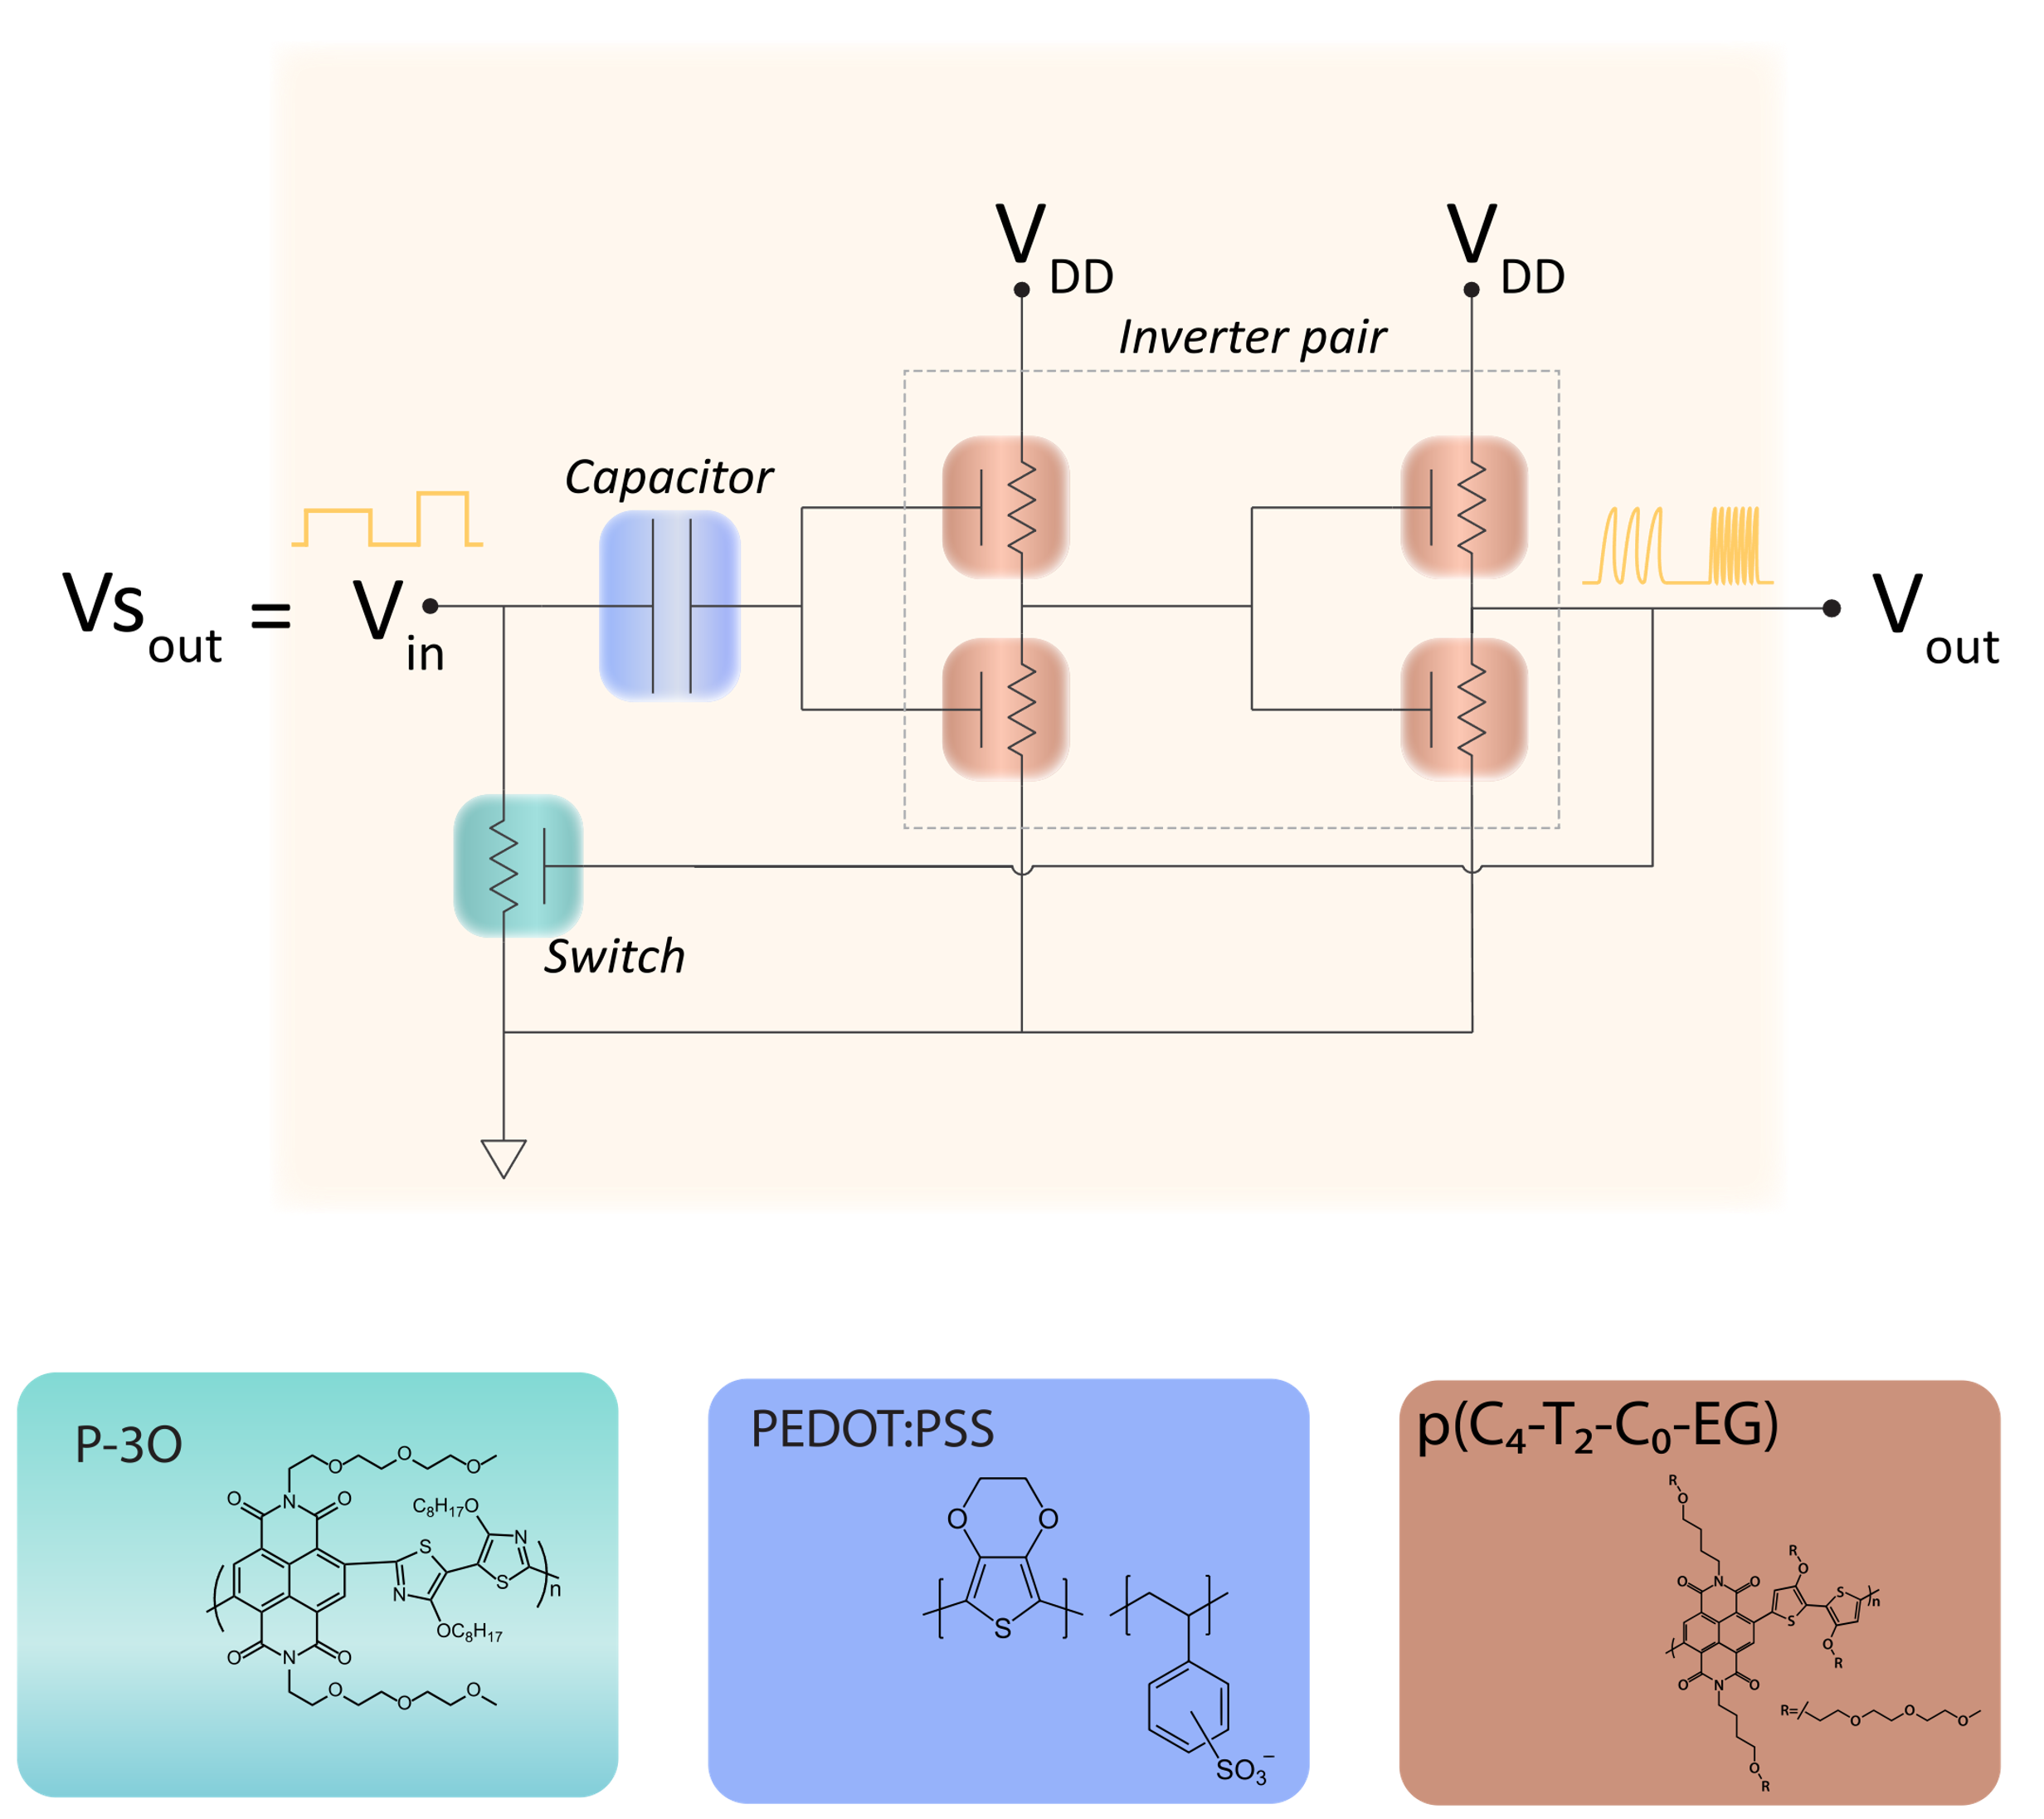
Supplementary Figure 1 Schematic illustrating the neuromorphic spiking circuits connections, highlighting the different materials used to fabricate the different electronic components. In green the P-3O-based OECT used as an electronic switch, in blue the PEDOT:PSS-based capacitor and in orange the p(C4-T2-C0-EG)-based OECTs composing the inverter pairs.

In this section the devices and materials that compose the spiking circuits ( Fig.1 and Supplementary Fig.1) are presented and the single device voltage and transfer characteristics are displayed (Supplementary Fig.2, 3, 4, 5). The spiking circuit features a capacitor (PEDOT: PSS OECT) which receives the external input in forms of voltage potential charging from 0 to 0.26 V (see Supplementary Fig.5). A 330 kOhm resistor is used to connect the capacitor to the Vin. The capacitor is connected to the ground through a switch device (series connection through the channel terminal of this device). The switch (P-3O OECT) opens and close the ground connection of the capacitor depending on its resistance (Supplementary Fig.4). The switch device is in ON/OFF state depending on the voltage applied to its gate terminal and allows the capacitor to charge and discharge ( Supplementary Fig.5). The inverter pair of the neuromorphic circuits are constituted by four identical p(C4-T2-C0-EG) OECTs. p(C4-T2-C0-EG) is an ambipolar material so the inverter of these OECTs can behave both as n-type and p-type transistors (Supplementary Fig.2). To the first inverter a V_{DD1}= 0.5V is applied, while on the second inverter V_{DD2} = 0.8V is applied. The V_{DD} unbalance was introduced to obtain from the double-stage inverter a sharper inversion point (increasing de-facto the gain and the inversion range of the second capacitor) which is key to replicate neural spikes. When the capacitor charge reaches the inverters threshold (0.3 V) the first inverter characteristic voltage, due to the low V_{DD1,} moves from 0.3 to 0 V (Supplementary Fig.3, top panel). The second inverter, receiving as input voltage the output of the first inverter, displays a characteristic curve with an inversion point (0.26 V) with the voltage moving from 0 to 0.7 V (Supplementary Fig.3, bottom panel). The output terminal of the double stage inverter is connected to the gate terminal of the switch device so that the voltage inversion (0 to 0.7 V) of this system modulate the change of the state of the switch from OFF to ON (Supplementary Fig.4).
When the switch is in the ON state the connection to the ground is closed and the capacitor discharges to 0V, allowing a new cycle to start.
In Supplementary Fig.6 it is displayed a frequency modulation experiment with relevant parameters reported in Table 1. In this case the capacitor was directly connected to an external voltage supplier and the voltage input was increased from 0.3 to 0.6V (0.05 V step). In Supplementary Fig.7 the spiking frequency extracted from the previous data are plotted. With a linear regression (red line, y = a + bx) it is proved that the voltage/ frequency relation is sublinear (b = ± 0.62) in the voltage window examined (0.3 -0.6 V).

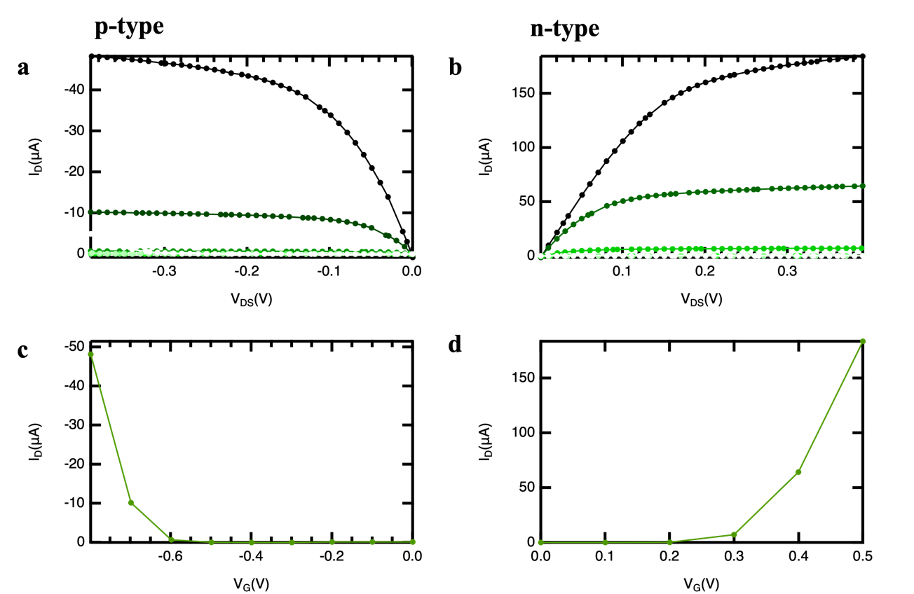
Supplementary Figure 2 : p(C4-T2-C0-EG) transfer and output curves for both n-type and p-type behaviors. a) p-type output curve V_{G} from 0 to -0.8 V (step-size 0.1V). b) n-type output curve V_{G} from 0 to 0.4 V (step-size 0.1V). c) p-type transfer curve at V_{DS} = -0.1 V. d) n-type transfer curve at V_{DS} = 0.1 V.
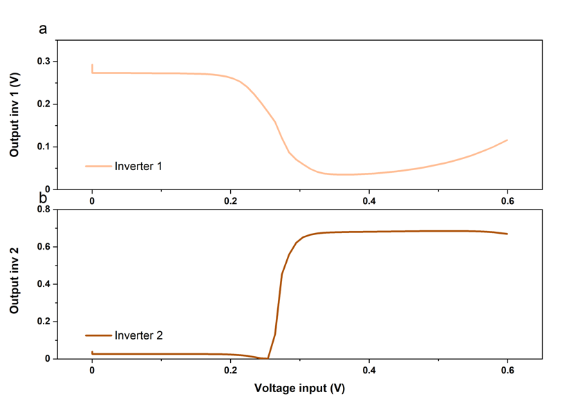
Supplementary Figure 3 Ambipolar inverter characteristics for both single and double stage inverters.

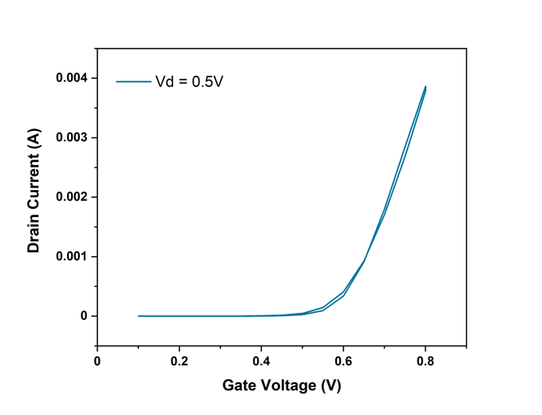
Supplementary Figure 4. P-3O transfer curve
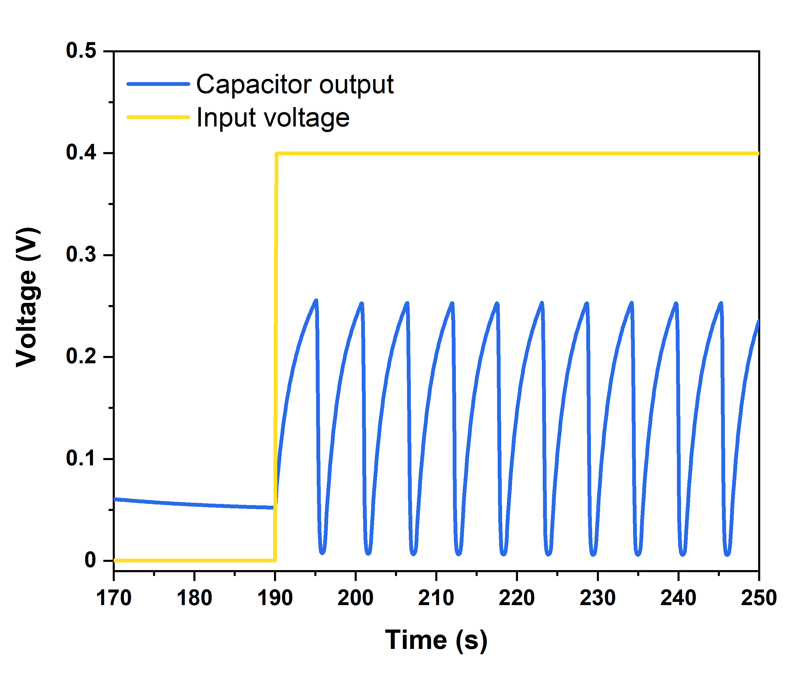
Supplementary Figure 5 Capacitor characteristic

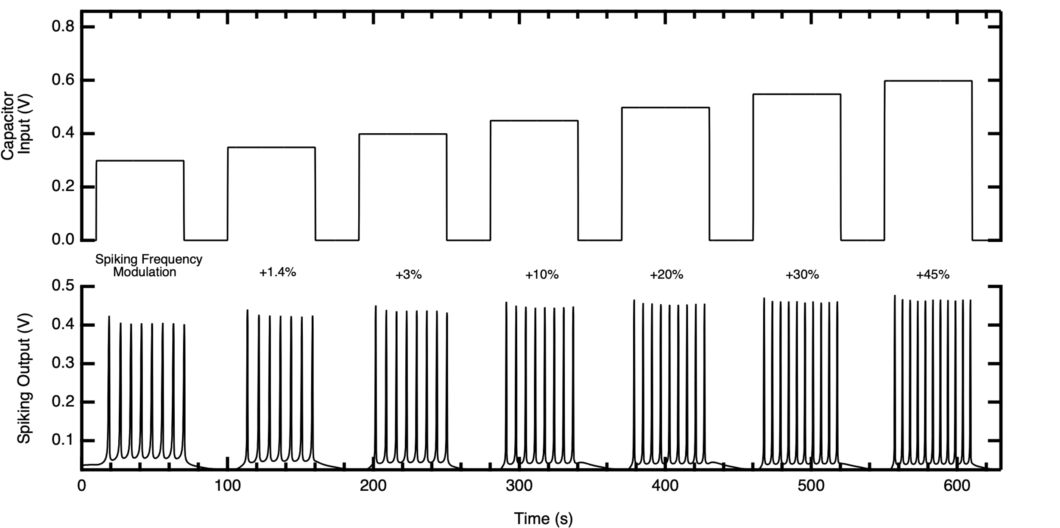
Supplementary Figure 6 The voltage spikes (bottom) generated by the neuromorphic circuit responding to different voltages applied (top), through an external voltage supplier), directly to the capacitor element. In between top and bottom panels, the spiking frequency change (in percentage) corresponding to each spike pattern-voltage pair is reported.

Table 1. Spikes modulation data as extracted from the trace in Supplementary Fig.6, comprising capacitor input, the time between each pair of spikes, the corresponding frequency and the percentage of frequency change.
Capacitor Input (V) | Spikes timing (s) | Frequency (Hz) | Percentage
0.3 | 7 | 0.14 | 0.00
0.35 | 6.9 | 0.145 | 1.45
0.4 | 6.8 | 0.15 | 2.94
0.45 | 6.4 | 0.16 | 9.38
0.5 | 5.9 | 0.17 | 18.64
0.55 | 5.4 | 0.19 | 29.63
0.6 | 4.8 | 0.21 | 45.83

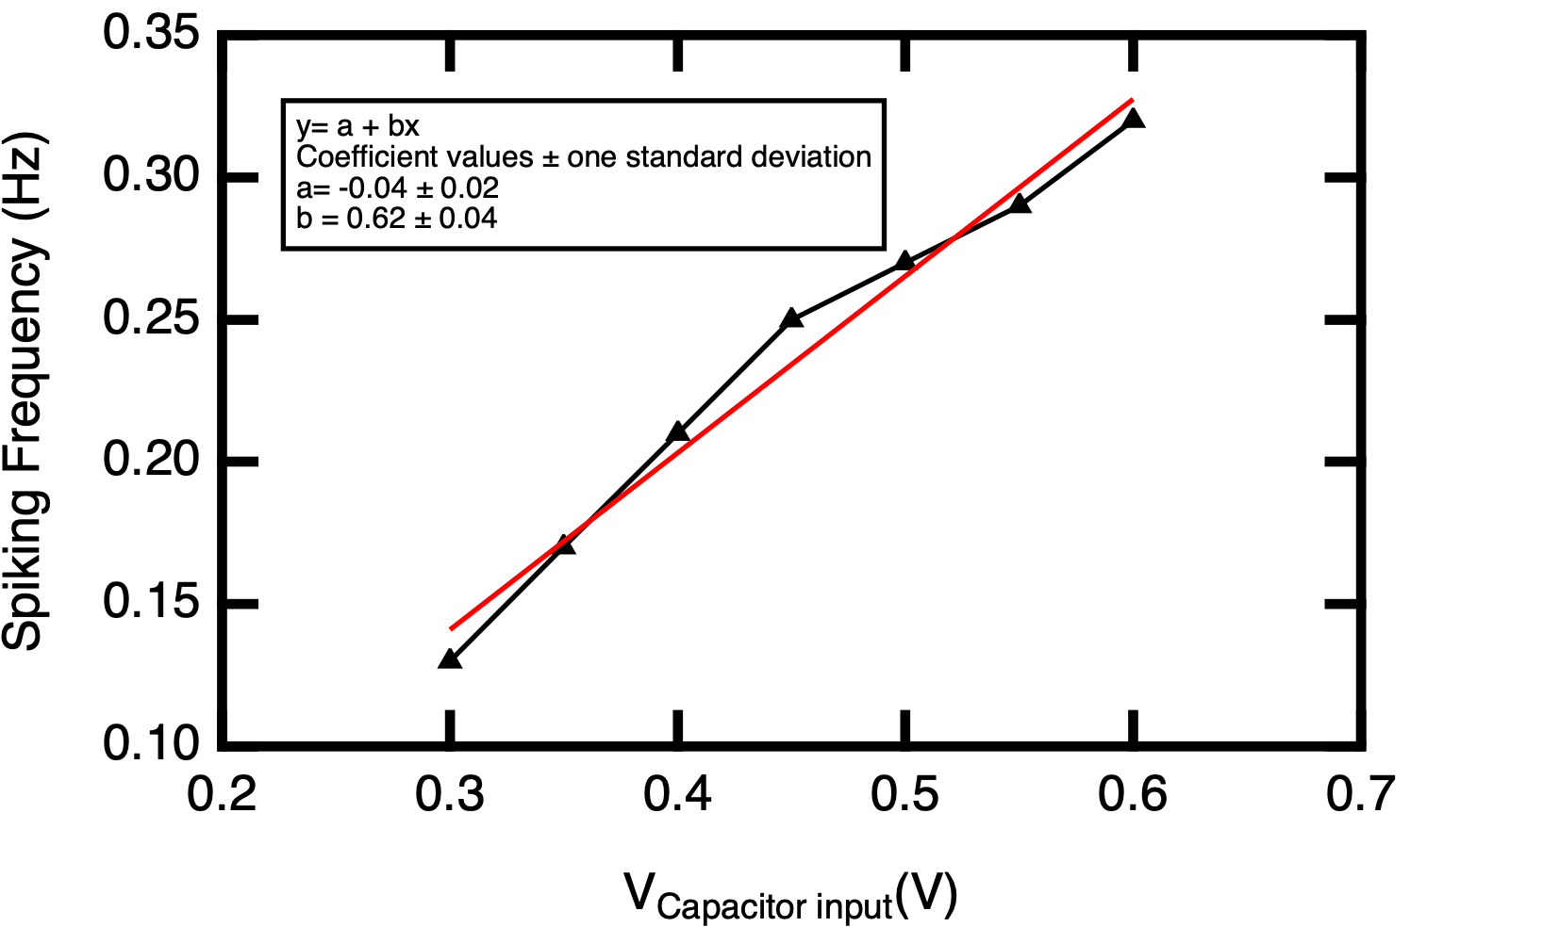
Supplementary Figure 7 The spiking frequency modulation (depending on the V_{capacitor input}) as extracted from Supplementary Fig.6 traces. The plot shows that the relation is sublinear in the voltage region 0.3 – 0.6V.

Supplementary Discussion 2: Sensory coding with pressure sensor

In this section we describe in detail the mechanisms of coupling of the commercially available force sensor (Grove-Round Force Sensor, FSR402) to the neuromorphic spiking circuit. The results of the spiking activity are presented in Supplementary Fig.9. The pressure sensor is a force sensitive module with at the end a round force sensitive resistor ($R_{FSR}$). This resistance depends on the pressure applied to this resistor: the greater the pressure, the smaller the resistance. Output voltage is equal to
$V_{out}= \frac{R_{M}*V_{CC}}{{(R}_{M}+R_{FSR})}$,
where the measuring resistor $R_{M}=30$k and the supply voltage $V_{CC}=1$V.

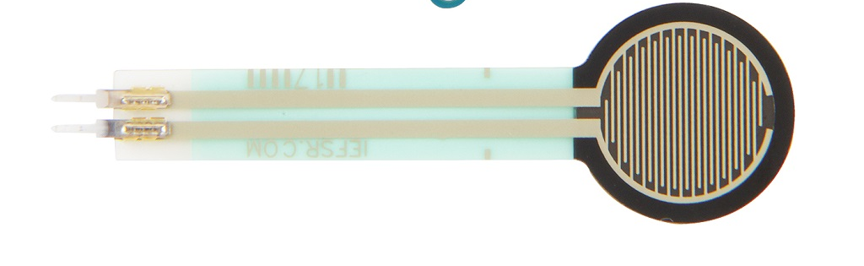
Supplementary Figure 8: Figure of the Grove-Round Force Sensor, FSR402

We connect the force sensor that replicates the behavior of biological skin receptors by transducing a set of pressure stimuli (i.e., the weight of four different objects) into voltage potentials that are used as the input to the neuromorphic circuit (afferent neuron). Each input generates a train of voltage spikes with a characteristic frequency as reported in Table 2. The spiking frequency (ranging from 0.14Hz to 0.35Hz) shows a linear response to the pressure stimuli emulating the biological mechanism of conscious sensation on the skin of the hand where receptors are programmed to respond to different pressures by featuring specific thresholds (Supplementary Fig. 10 and 11).

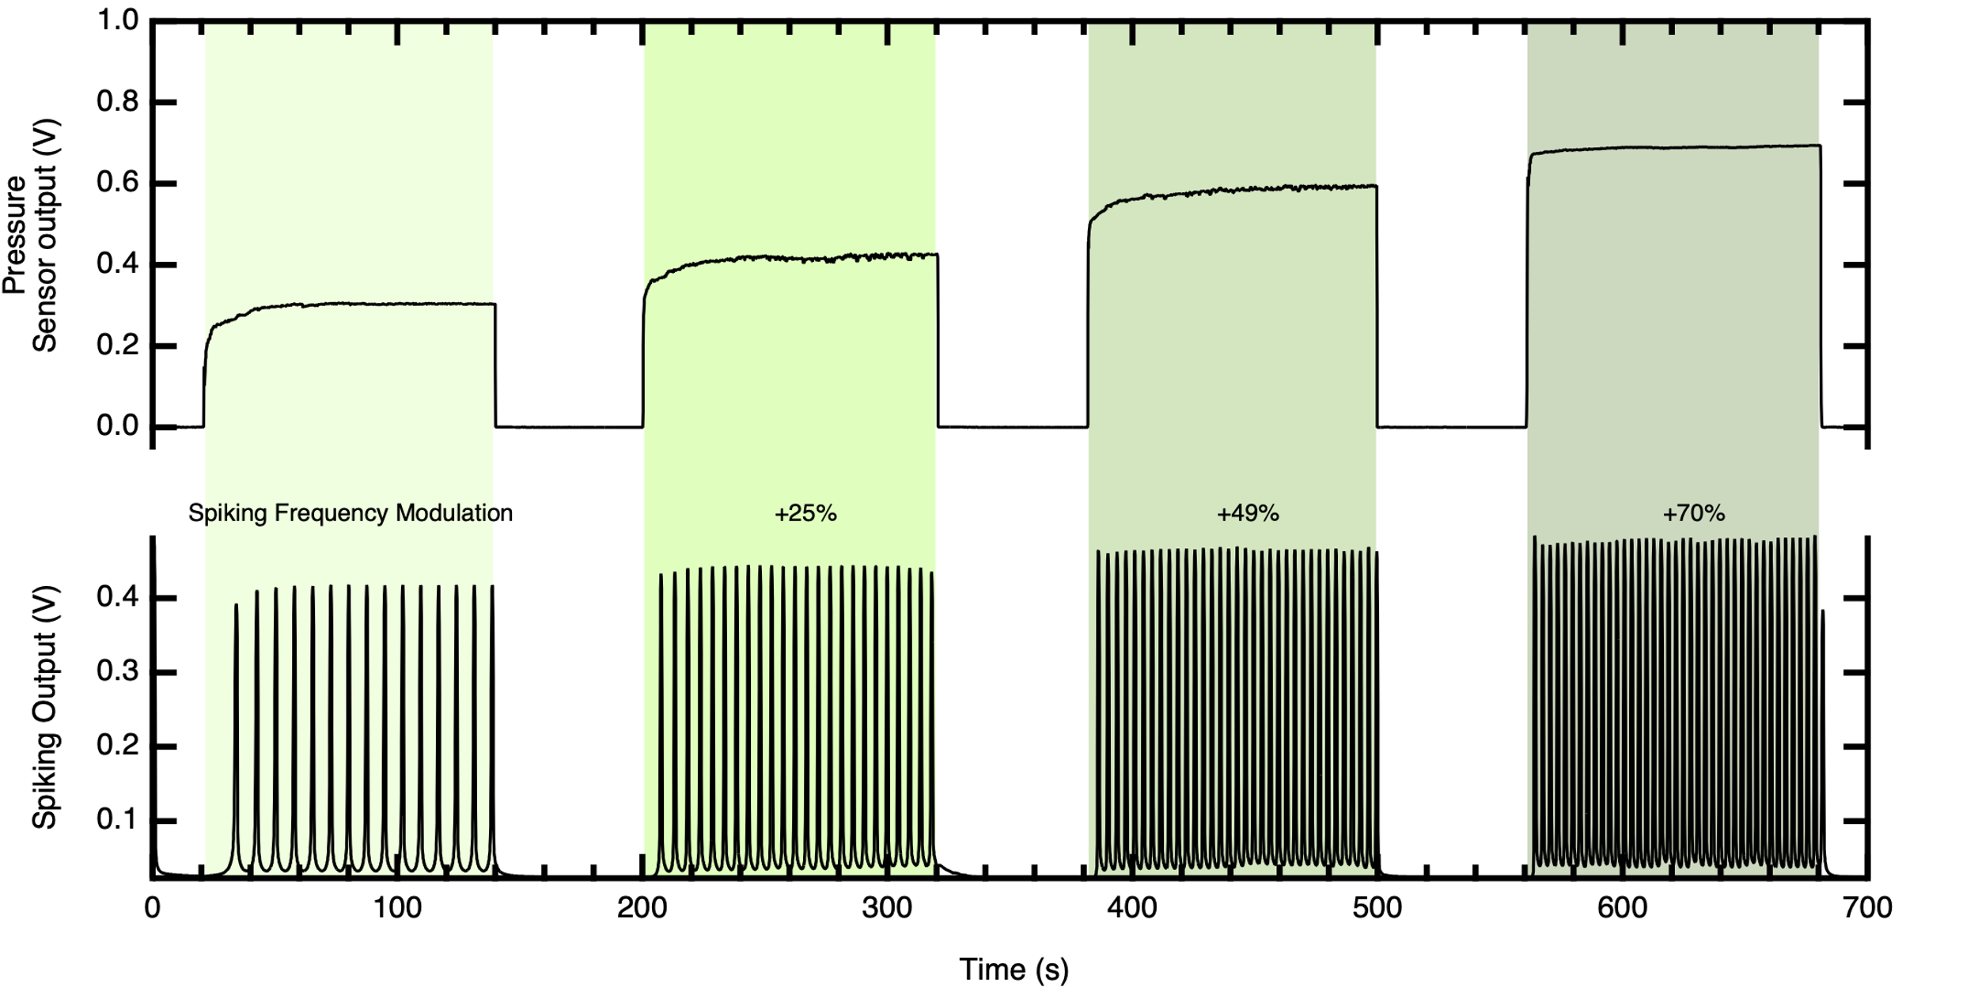
Supplementary Figure 9 Sensory coding of touch using the force sensor as physical receptor showing an increasing spiking frequency output with increasing sensor output voltage.
Table 2 Spikes modulation data as extracted from the trace in Supplementary Fig. 9, comprising the mass of the specimens, the pressure sensor output, the time between each pair of spikes, the corresponding frequency and the percentage of frequency change.
Mass of the specimen (g) | Pressure Sensor Output(V) | Spikes timing (s) | Frequency (Hz) | Percentage
55 | 0.3 | 7 | 0.14 | 0.00
67 | 0.41 | 5.6 | 0.18 | 25.00
87 | 0.59 | 4.7 | 0.21 | 48.94
116 | 0.69 | 4.1 | 0.24 | 70.73

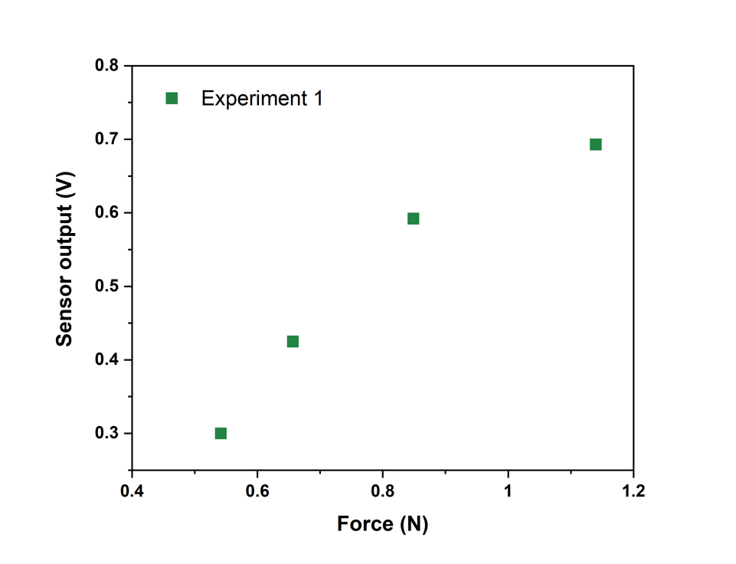
Supplementary Figure 10: Relationship of the sensor output voltage and the applied force after placing 4 objects with a weight varying from 55g to 116 g.
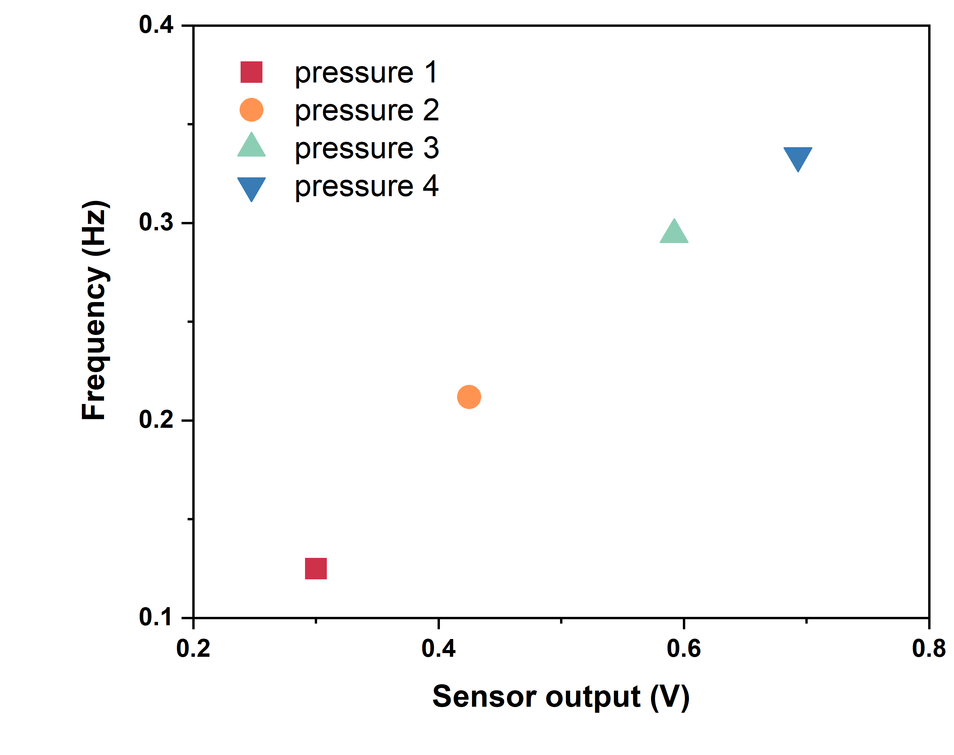
Supplementary Figure 11: Output spiking frequency of the spiking neuron with depending on the pressure sensor output voltage corresponding to the weights ranging from 55g to 116 g.

Supplementary Discussion 3: bio-hybrid synapse and its synaptic modulation

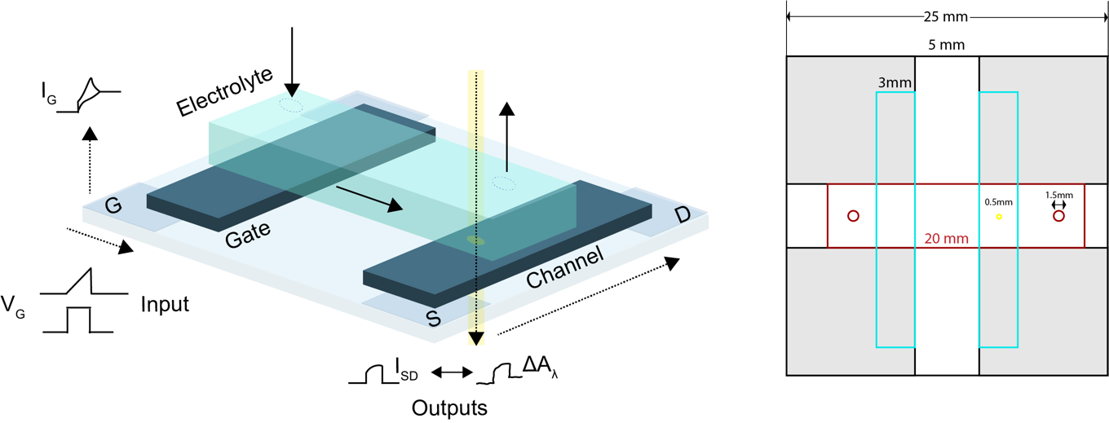
Supplementary Figure 12 Overall bio-hybrid synapse layout (left) and layout of the glass-ITO substrate. Reproduced with permission from.

In Supplementary Fig. 12 the overall bio-hybrid synapse layout is depicted on the left of the figure, showing the G (gate), S(source), D(drain) ITO electrodes, as reported in a previous work. On the right the transparent glass is depicted where the grey areas represent the ITO electrode, the blue rectangle are the PEDOT:PSS films used as gate and channel of the transistor, the blue area corresponds to the microfluidic module.
In Supplementary Fig. 13 the bio-hybrid synapse conductance modulation is reported in case dopamine (left) and serotonin (right) is employed. In this experiment the input voltage applied to the bio-hybrid gate consist of three periodic voltage pulses of 300 mV (dopamine) and 400 mV (serotonin) with time width 3 s and delay of 10 s. The conductance G_{D} depends on the concentration of neurotransmitter and on the number of voltage pulses applied (in these graphs only three). As more pulses are applied the dynamic range of the device saturates (Fig.2) and the conductance modulation per pulse decreases.

Supplementary Figure 13 Bio-hybrid synapse characteristic with and without DA and 5-HT neurotransmitters

Supplementary Discussion 4: Sensory coding with neurotransmitters dopamine and serotonin

In this section the strategy to employ the bio-hybrid synapse to modulate the spiking frequency of the circuit is presented. The bio-hybrid synapse is included in a voltage divider configuration (Supplementary Fig.14) connected in series with a 1kOhm resistor. The V_{OUT} of this voltage divider depends on the ratio of the resistance of the two elements comprising the circuit according to the formula:
$$V_{OUT}= \frac{R_{O.S.}}{(R_{O.S.}+ R_{1kOhm}) }$$

In the above formula we assume the bio-hybrid synapse to be a tuneable resistor. Indeed, the resistance of the PEDOT:PSS-based can be tuned by applying a gate potential > 0 V , i.e. switching off the OECT. During the course of the experiments (Fig.1 d and Supplementary Fig. 13) periodic voltage pulses are applied to the gate of the bio-hybrid synapse, matching the oxidation potential of DA or 5-HT. In case of PBS (no neurotransmitter in solution) the voltage applied to the gate biohybrid synapse enable a reversible modulation of its resistance. So that the V_{OUT} of the voltage divider does not change. When DA or 5-HT are introduced in solution the oxidation of these molecules lead to an increase of the resistance of the bio-hybrid synapse that depends on the numbers of pulses applied and on the concentration of the neurotransmitters. This lead to an increase of the voltage divider output. This is used as input voltage to charge the capacitor of the spiking circuit. Hence, the spiking frequency is modulated (increases) depending on the type of neurotransmitter used and on the pulsing time.
Supplementary Fig.15 and 16 report the spiking output trace at different time (Fig. 1d) that have been used to extract the temporal evolution of the frequency modulation (Tables 3,4).
As for DA in Fig.1 d, the same mechanism has been replicated with the use of two different concentrations of 5-HT (0.01mM and 0.05mM). Indeed, Supplementary Fig.17 is the replica of Fig.1 d in case of 5-HT while Supplementary Fig.18 shows the plots that have been used to extract the frequency modulation (Tables 5,6). In 5-HT case, the evolution of the frequency modulation is faster and only the frequency at time > 500s are reported.

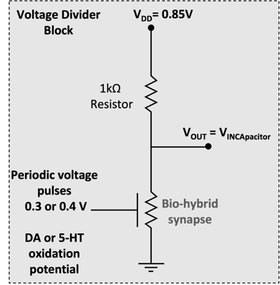
Supplementary Figure 14. Voltage divider configuration for exploiting the bio-hybrid synapse as a chemical receptor

Supplementary Figure 15. Spiking output plot used to calculate the spiking frequency modulation as shown in Fig.1 as a 0.025mM DA solution is set to flow in the microfluidic module of the biohybrid synapse. The flow of DA solution starts at time 200s. The spiking frequency is extracted at time 0 (PBS), time 250 s (yellow), time 450 s (green) and time 650 s( violet).

Supplementary Figure 16. Spiking output plot used to calculate the spiking frequency modulation as shown in Fig.1 as a 0.1mM DA solution is set to flow in the microfluidic module of the biohybrid synapse. The flow of DA solution starts at time 200s. The spiking frequency is extracted at time 0 (PBS), time 250 s (yellow), time 450 s (green) and time 650 s(violet).

Table 3 Spikes modulation data as extracted from the trace in Fig. 1 d for DA 0.025 mM, comprising the time, the voltage divider (synaptic modulator) output, the time between each pair of spikes, the corresponding frequency and the percentage of frequency change.
Time (s) | Voltage Divider Output(V) | Spikes timing (s) | Frequency (Hz) | Percentage
0 | 0.34 | 5.00 | 0.2 | 0
250 | 0.37 | 4.76 | 0.21 | 5.1
450 | 0.38 | 4.35 | 0.23 | 15.3
650 | 0.41 | 3.85 | 0.26 | 30.2

Table 4 Spikes modulation data as extracted from the trace in Fig. 1 d for DA 0.1 mM, comprising the time, the voltage divider (synaptic modulator) output, the time between each pair of spikes, the corresponding frequency and the percentage of frequency change.
Time (s) | Voltage Divider Output(V) | Spikes timing (s) | Frequency (Hz) | Percentage
0 | 0.34 | 5.00 | 0.2 | 0
250 | 0.39 | 4.35 | 0.23 | 5.05
450 | 0.40 | 4.00 | 0.25 | 15.25
650 | 0.41 | 3.83 | 0.26 | 30.3

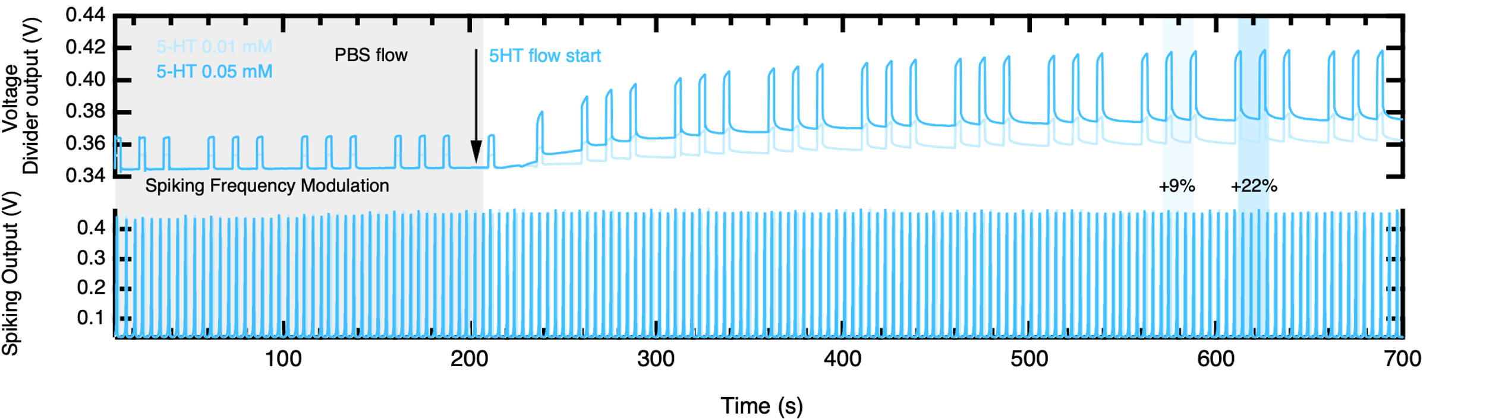
Supplementary Figure 17 The spikes generated by the neuromorphic circuit responding to different concentrations of the neurotransmitter serotonin (0.01mM pale blue, 0.05mM darker blue). On top, the voltage divider output is plotted.
Supplementary Figure 18. Spiking output plot used to calculate the spiking frequency modulation as shown in Supplementary Fig.13 as 0.01mM (pale blue) and 0.05mM (darker blue) 5-HT solution are used to modulate the resistance of the biohybrid synapse. The frequency values are extracted after 500s, when the voltage divider output modulation is finished.
Table 5 Spikes modulation data as extracted from the trace in Supplementary Fig. 17 5-HT 0.01 mM, comprising the time, the voltage divider (synaptic modulator) output, the time between each pair of spikes, the corresponding frequency and the percentage of frequency change.
Time (s) | Voltage Divider Output(V) | Spikes timing (s) | Frequency (Hz) | Percentage
0 | 0.33 | 4.55 | 0.22 | 0.00
>500 | 0.37 | 4.17 | 0.24 | 9.09

Table 6 Spikes modulation data as extracted from the trace in Supplementary Fig. 17 5-HT 0.05 mM, comprising the time, the voltage divider (synaptic modulator) output, the time between each pair of spikes, the corresponding frequency and the percentage of frequency change.
Time (s) | Voltage Divider Output(V) | Spikes timing (s) | Frequency (Hz) | Percentage
0 | 0.33 | 4.55 | 0.22 | 0.00
>500 | 0.39 | 3.70 | 0.27 | 22.73

Supplementary Discussion 5: Voltage divider + switch circuit to connect the two bio-hybrid synapses

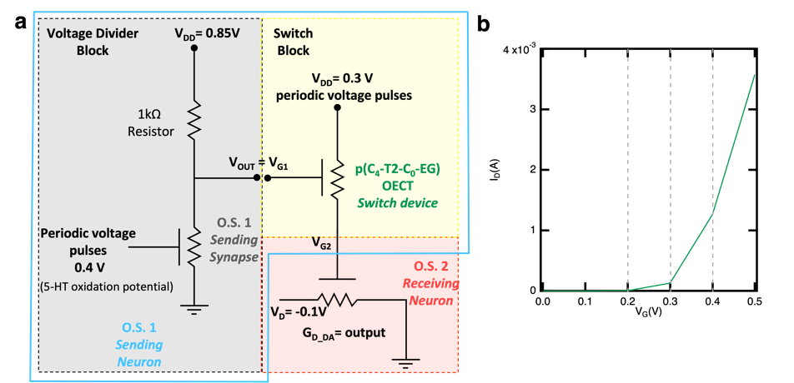
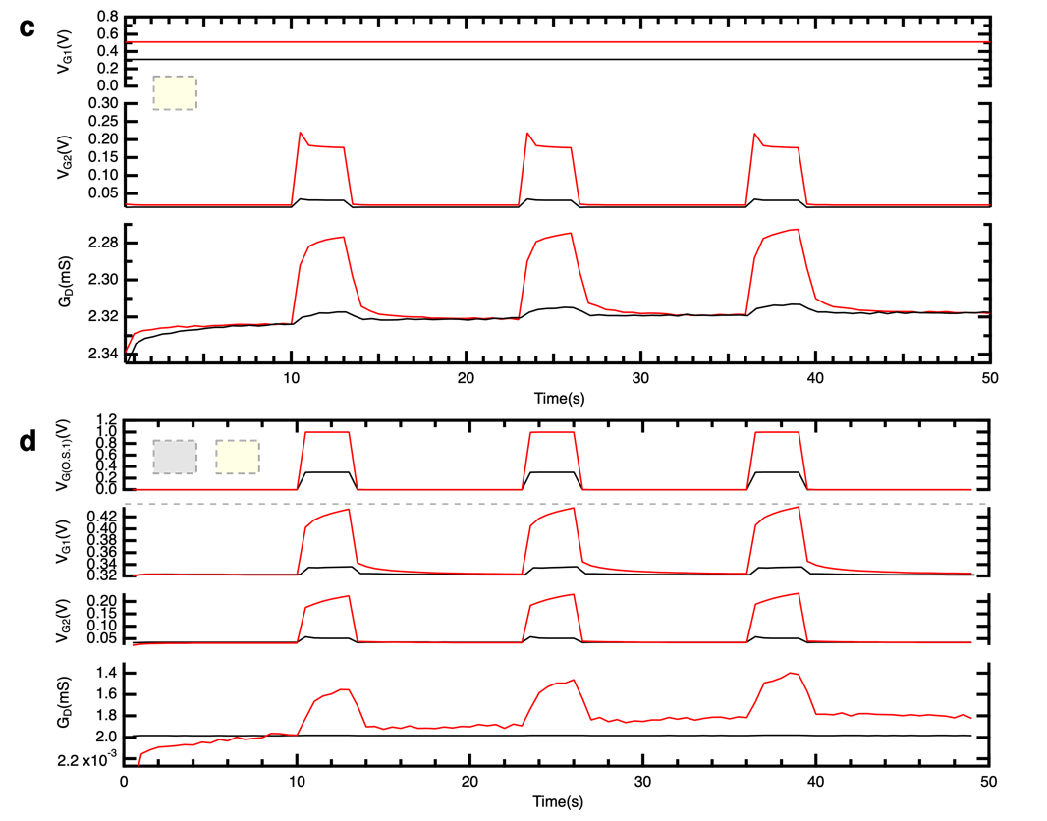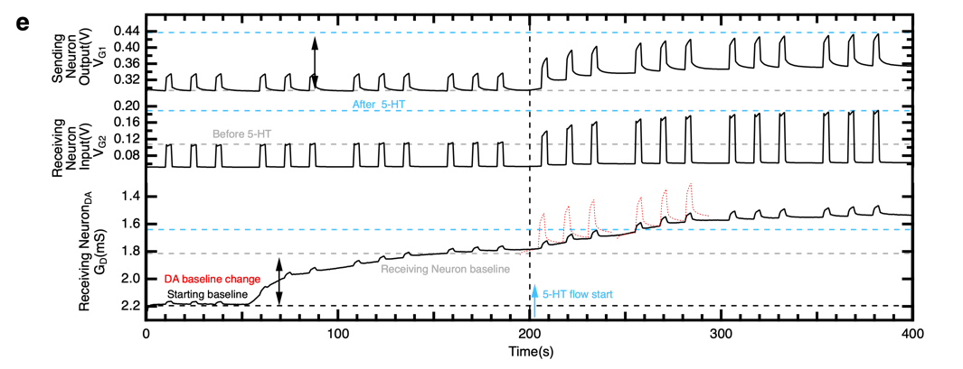
Supplementary Figure 19 a) Schematics of the circuit, comprising a voltage divider and a switch OECT, used to connect organic synapse O.S.1 (working with 5-HT) with O.S.2 (working with DA). The combination of the voltage divider and the switch block constitute the Sending Neuron. b) Transfer characteristic of the p(C₄-T2-C₀-EG) based OECT used as a switch device. c) Voltage and current characteristics of the switch element (in red) when V_{G2} is externally connected to a controlled voltage supplier. d) Voltage and current characteristics of the voltage divider (in blue) connected to the switch element (red) under different input voltages. e) Fig. 4 extended version: complete voltage and conductance monitoring of the key elements of the circuit, showing the initial (time 0-140s) baseline DA-dependent baseline change.
The circuit presented in this section (referring to Fig.2) has been designed to connect two organic synapses, O.S.1 and O.S.2 (Supplementary Fig.19 a), that operate with 5-HT and DA respectively without recurring to a neuromorphic spiking circuit. The combination of the voltage divider and the switch block constitutes the Sending Neuron. The broad scope of the circuit is to provide a technological approach to transmit the signal of an O.S. (conductance modulation) to multiple devices.

The operation of the switch device has been assessed before connecting this element to the voltage divider. To create a voltage-controlled switch device, the channel of a p(C₄-T2-C₀-EG)-based OECT has been connected in series with the gate of the O.S.2. Thus, the voltage V_{G2} applied on the O.S.2 depends on the state of the switch device (ON/OFF). The p(C₄-T2-C₀-EG)-based OECT displays a sharp turn on voltage around 0.3V (Supplementary Fig.19 b). However, the device enters a completely ON-state around 0.4V which is needed to sustain larger currents. Indeed, when V_{G1} is externally controlled by a voltage supplier (Supplementary Fig.19 c), applying 0.3V does not activate the switch device (black curve) and leads to values of V_{G2} below 0.1V (O.S.2 conductance reversible modulation is low). When the voltage supplier sets V_{G1} = 0.5V (red curves), V_{G2} reaches 0.2V which trigger a visible modulation of the O.S.2 conductance.

For the voltage divider (Supplementary Fig.19 a in blue) a commercial resistor of 1kOhm has been connected in series with the O.S.1. The V_{OUT} of this voltage divider depends on the ratio of the resistance of the two elements comprising the circuit according to the formula:
$$V_{OUT}= \frac{R_{O.S.}}{(R_{O.S.}+ R_{1kOhm}) }$$

In the above formula we assume the O.S.1 to be a tuneable resistor. Indeed, the resistance of the PEDOT:PSS-based O.S.1 can be tuned by applying a gate potential > 0 V , i.e. switching off the OECT. In Fig.2 this has been achieved by using a 0.05mM 5-HT solution while pulsing the gate of the O.S.1 at 0.4 V. However, in the preliminary experiments performed to check the characteristic of the voltage divider and presented in this section, a PBS solution has been used (Supplementary Fig.19 d black curves). In the starting condition (O.S. 1 is ON) the V_{OUT=G1} of this voltage divider is around 0.3 V. If a 0.3 V pulsing input is applied to the gate of the O.S. 1 the V_{OUT=G1} oscillates around 0.3 V (Supplementary Figure 19 d first two rows, black curves). To switch OFF (and simulate the condition achieved in the manuscript by using 5-HT) the O.S.1 and tune the V_{OUT}, the amplitude of the pulsing on the gate of O.S. 1 is increased from 0.3 to 1 V. In this condition, the V_{OUT} (connected to the following element of the circuit and corresponds to V_{G1} in the same graph) moves from 0.3V to values above 0.4V. In the experiment presented in the manuscript (Fig.2), the resistance of O.S. 1 is increased to the value that corresponds to a V_{OUT=G1} ≈ 0.4 V by pulsing the gate at 0.4 V while using a 0.05mM 5-HT solution.

At this stage, the overall operation of the circuit (voltage divider + switch = Sending Neuron, Supplementary Fig. 19 d and e) has been assessed before operating the circuit with the neurotransmitters DA and 5-HT. Again, the O.S.1 conductance modulation achievable with the 5-HT, has been simulated by the application of a large gate input (1V) on O.S.1. As from Supplementary Fig.19 d, a train of pulses of 0.3V on the gate of O.S.1 simulate the circuit situation before the 5-HT is infused in the microfluidic module. Indeed, the voltage divider output V_{OUT} is around 0.3V corresponding to a V_{G2} < 0.1V. As such, O.S. 2 conductance is poorly modulated. Increasing the amplitude of the train of pulses on the gate of O.S.1 to 1V moves the voltage divider V_{OUT} to values >0.4V. These values are enough to switch ON the switch device. Hence, the V_{G2}, the Receiving Neuron Input reaches 0.2V which is enough to appreciate a reversible modulation of O.S. 2 conductance. As in Fig.2, in presence of DA in the microfluidic module of O.S.2, the increase of resistance of O.S.1 with 5-HT, by moving the V_{G2} from <0.1V to ≈0.2V trigger a partial oxidation of DA allowing to establish a connection between the conductance modulation of the two O.S. devices.

Finally, Supplementary Fig.19 e represents the extended version of Fig.2 including the time window (0-140s) where (due to the start of the DA flow on the receiving neuron) the biohybrid synapse conductance level experience a baseline change (conductance decrease). This is caused by the occurrence of a new equilibrium condition established between the PEDOT:PSS OECT channel and electrolyte protons when passing from a PBS to a PBS+DA solution. However, before the activation of the 5-HT flow and so the start of the neural cascade, the conductance level of the receiving neuron has reached a stable baseline (140-200 s).

Supplementary Discussion 6: Sensory coding with light

Light sensor
The light sensor we used is the DFRobot's Analog Ambient Light Sensor (DFR0026) with a voltage supply of 5V (Supplementary Fig. 20). The light sensor was shielded from the ambient light except for a small opening on top of the sensor. This opening was fully or partially covered to simulate various light conditions ( low, high light intensity).
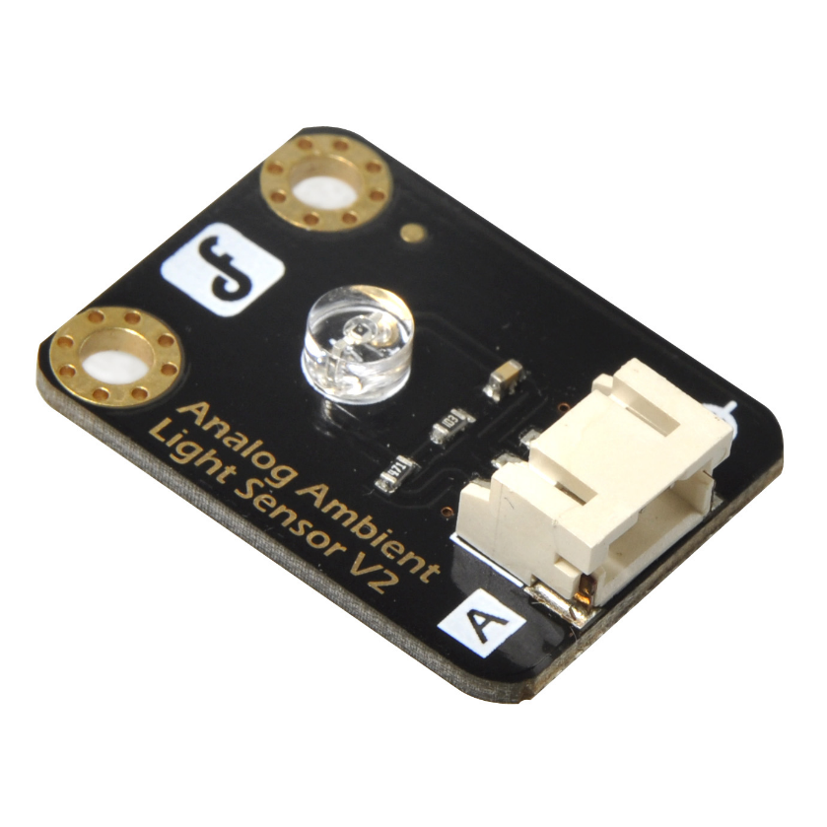
Supplementary Figure 20: Analog ambient light sensor (supply voltage 5V).
Table 7 Spikes modulation data as extracted from the trace in Fig. 1 c, comprising the light sensor output, the time between each pair of spikes, the corresponding frequency and the percentage of frequency change.
Light Sensor Output(V) | Spikes timing (s) | Frequency (Hz) | Percentage
0.38 | 12 | 0.08 | 0.00
0.5 | 10 | 0.10 | 20.00
0.6 | 8.2 | 0.12 | 46.34
0.8 | 6.8 | 0.15 | 76.47
1 | 5.6 | 0.18 | 114.29

As reported in Fig. 1 c, different light conditions have been employed to test the light sensory coding capability of the neuromorphic circuit. Relevant parameters, extracted from the spiking pattern of Fig. 1c, are reported in Table 7.

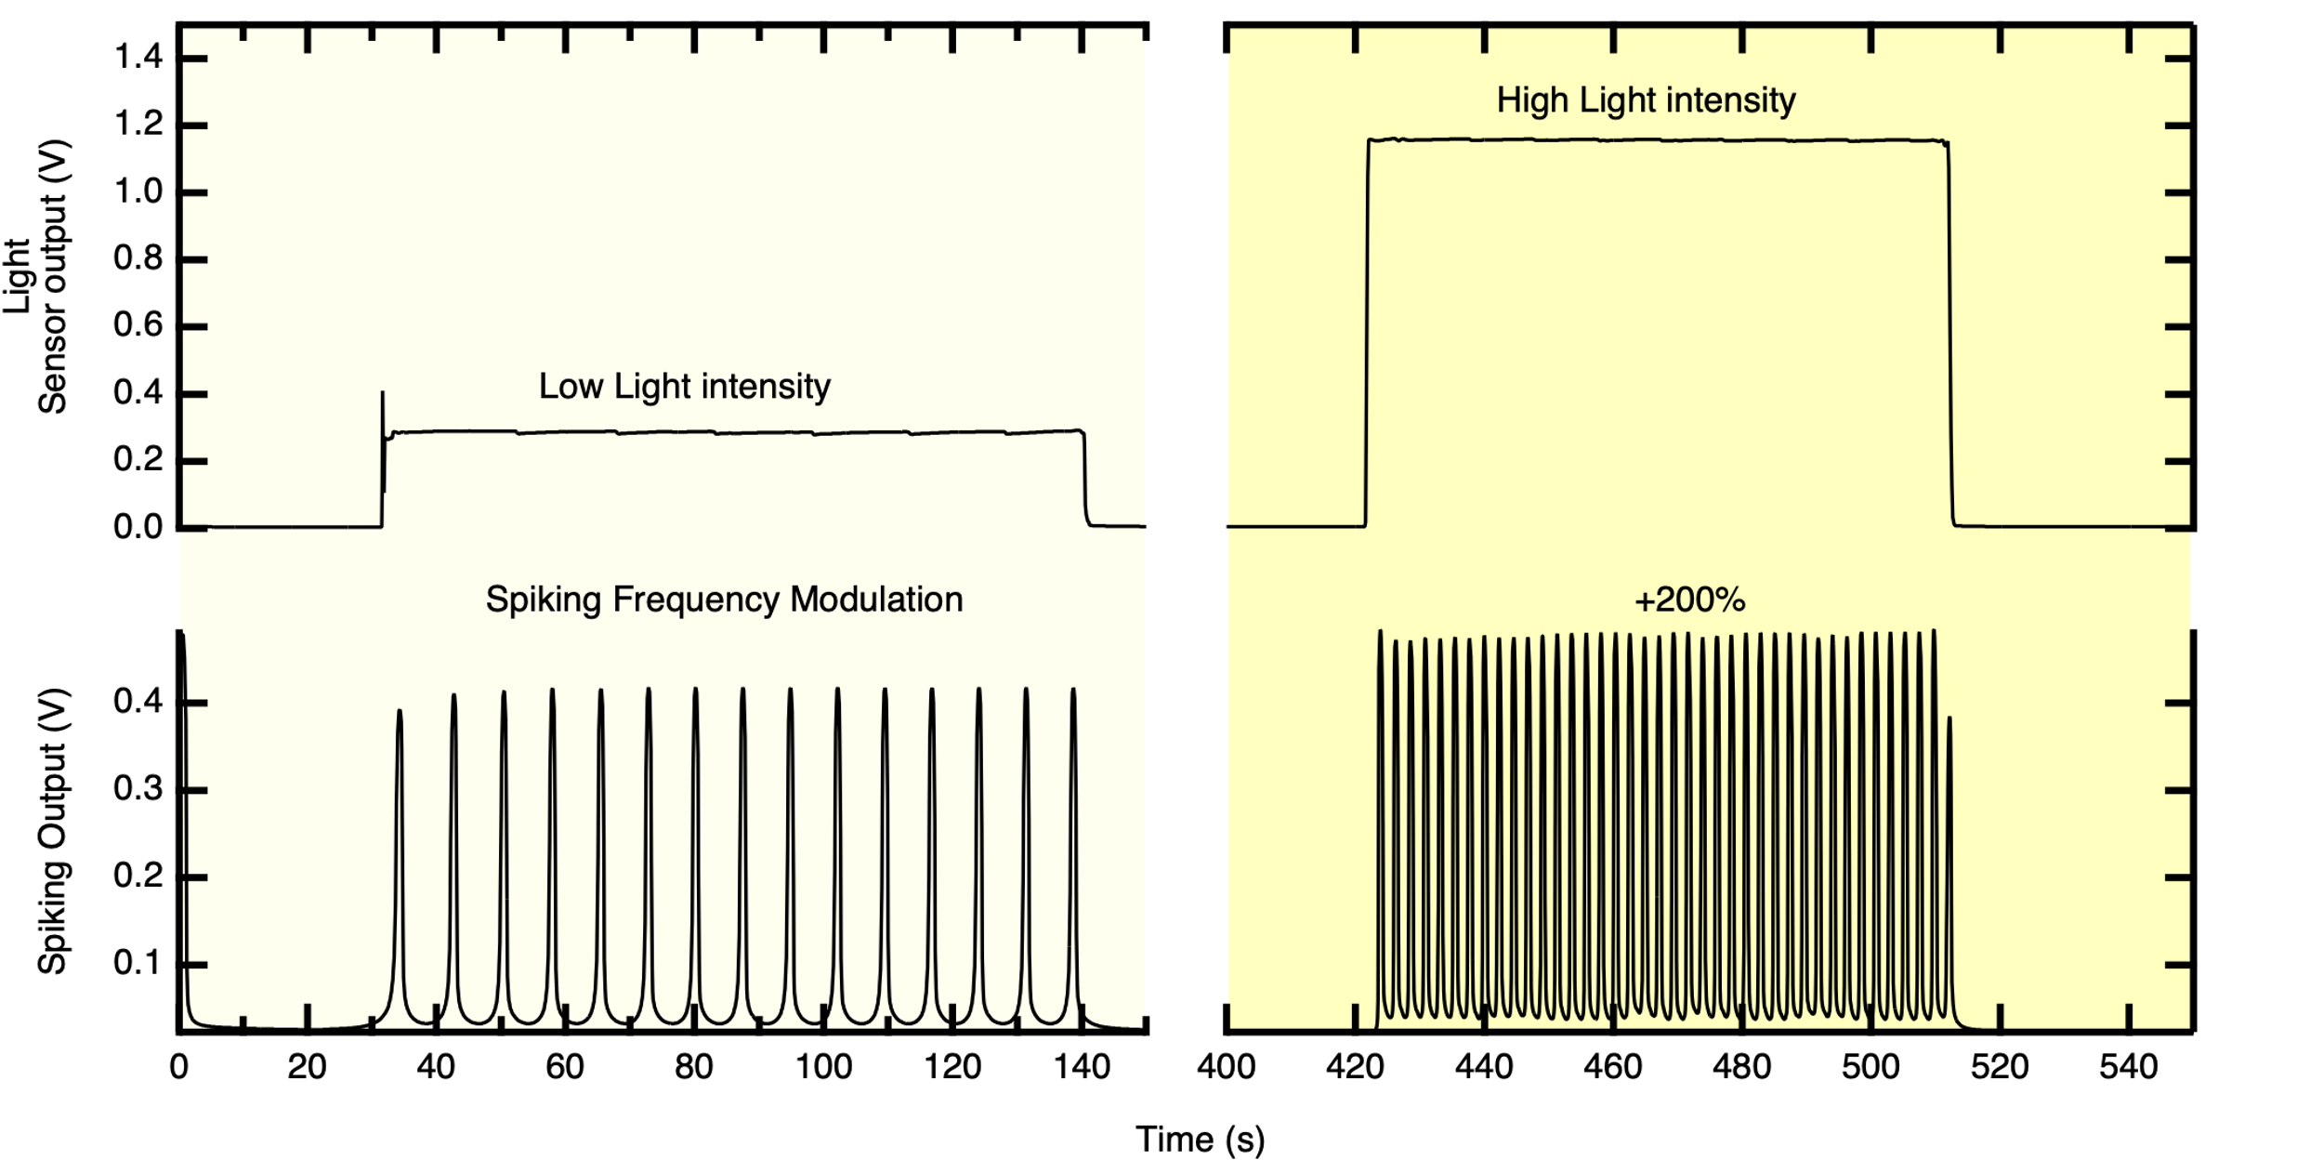
Supplementary Figure 21 The spikes generated by the neuromorphic circuit responding to the light conditions used in Fig.3.
As reported in the manuscript and Fig.3, two different light conditions have been employed to replicate a retinal neural pathway. Calibration experiments are here reported (Supplementary Fig.21) showing a modulation of the spiking frequency from 0.14 Hz to 0.45 Hz, as extracted in Table 8, when moving from low light (0.3V light sensor output) to high light intensity (1.2 V sensor output).

Table 8. Spikes modulation data as extracted from the trace in Fig. 21, comprising the light sensor output, the time between each pair of spikes, the corresponding frequency and the percentage of frequency change.
Light Sensor Output(V) | Spikes timing (s) | Frequency (Hz) | Percentage
0.3 | 7 | 0.14 | 0.00
1.2 | 2.22 | 0.45 | 221.75

