Supplemenatary
Section 1. Growth stagnation
In articles by Mullins et. al. [S1 - S3] the growth stagnation effect caused by thermal grooves is described in detailes. For polycrystalline materials, on grain boundaries with higher and lower surfaces balance of force and grain-boundary energy leads to “grooves” formation. At high substrate temperatures, a noticeable migration of atoms occurs along the line where the boundaries cover the surface, a thermal groove appears. The cause of the groove formation is a consequence of increasing the energy consumption in order to reduce its area and hence the free energy. Transport processes that can form a groove are evaporation, surface diffusion and bulk diffusion. Groove is called thermal because it is formed due to evaporation. Depth of the groove does not affect growth stagnation, it is determined by boundary angle. The critical groove stagnation angle is determined from the condition of the start/stop point of grains movement and corresponds to 0.05 rad or 3 degrees.

Section 2. Specimen thickness effect [S3]
In materials science, the concept of the “specimen thickness” effect of the sample thickness is widely known, grain growth stops when values approaching the thickness of the material are reached. The stagnation condition is determined based on the grain curvature radius. The radius of curvature, in turn, is directly determined from the grain diameter. Based on this, we can conclude that the grain size should be determined only based on the energies of the film and substrate:
D=$\frac{r_{max}}{σ}$=$\frac{a}{2θ_{c}σ}=\frac{3γ_{s}}{σ*γ_{b}}a$
For real films this dependence is not fulfilled. The grain size is mostly affected by the film deposition parameters. For example, in thin films, the “sample thickness” effect is often not observed, and giant grains can grow. This may happen due to the following reasons:
- firstly, this happens if there are some special conditions that cause a large initial mismatch in grain size;
When large grains are found in a matrix of small grains, the grain boundary will be gear-shaped, with the concave sides of its arcs facing outward. The radii of curvature r of the arcs (in the film plane) will be approximately equal to the diameter of the matrix grains. But the grain diameters of the matrix do not exceed the film thickness - and, therefore, r<=a. It follows that 𝜃 for a gear-shaped boundary will be less than or equal to 17° (the angle of the catenoid at r = a),
𝜃 = f(a/r) = (a/2r),
which obviously exceeds the critical angle 3° (see Section 1). We conclude that the growth of a giant grain among a matrix of small ones will not be hindered by thermal grooves, even if its diameter is many times greater than the film thickness (the “sample thickness” effect is overcome). In addition, the curvature of its boundary favors the limited growth of the giant grain.
- secondly, this can occur in alloys (does not correspond to the case considered in the article).
- thirdly, it can be caused by the presence of free surface energy, as well as the free energy of the boundaries [S3]. The dependence of the free energy at the gas-metal interface on the crystallographic orientation means that different grains located on the film surface will generally have different free surface energies. These free energies must be taken into account when one analyzes the growth of surface grains.
Let us consider the effect of surface energy on film growth. For convenience of description, we assume that there is no thermal groove at the grain boundary. This case is similar to the wetting of a solid body by a liquid, where the angle 𝜃 corresponds to the contact angle. A non-zero value of 𝜃 will create a curvature at the grain boundary, which will tend to return to a flat state to minimize energy. This situation is also similar to the capillary penetration of liquid between two wetted parallel plates. Its result is that grains with higher free surface energy are eliminated by grains with lower free surface energy.
And even in the case of adding a thermal groove, unequal free surface energies provide stationary solutions to the equations for describing motion with an arbitrary speed. Therefore, it can be concluded that thermal grooves will not prevent abnormal growth caused by differences in surface free energy, in case if these differences are at least a few percent.

Section 3. The theory of film growth in the works of Thompson
3.1. General description of the growth mechanism
One of the most complete descriptions of the mechanisms of thin film growth can be traced in the series of works of the MIT Department of Materials and Engineering Sciences by Thompson et. Al since 1986, based on the fundamental papers by Mullins [S1-S4].
The first works were dedicated to the development of a general theory of growth and crystallization of thin films [S5, S6]. The main ideas of the theory proposed by the authors are that grain growth can occur during the deposition of thin films and after deposition (including its external initiation). Grain growth can lead not only to a sharp increase in the average size of crystals in the film, but can also lead to a change in the nature of the crystal orientation and even to epitaxial films. The mechanisms and modes of grain growth in thin films are considered below.
Depending on the deposition conditions and the deposited material, the film grain sizes in the as-deposited films may be smaller than the film thickness. For example, when deposited at temperatures below 0.2–0.3 of the melting temperature (Tm), metals will generally have an almost columnar fibrous microstructure in which the average grain size in the film plane dj is significantly smaller than the average grain size in the perpendicular plane to the film plane, dp, as schematically shown in Fig. S6. This type of microstructure after deposition is also common in semiconductors even at relatively high deposition temperatures. For example, Si deposited using chemical vapor decomposition at 0.5 Tm or higher has a structure similar to that shown in Fig. S6a. On the other hand, Si films that are amorphous when deposited, but subsequently after annealing, they crystallize and exhibit an equiaxed grain structure such. This type of microstructure can also be obtained for deposited metal films.
If the film after deposition has an equiaxed initial grain structure (dj ≤ dp), for which the grain size is smaller than the film thickness, then normal three-dimensional grain growth should occur for it, described by the following equation:
${\overline{r}}^{m}-{\overline{r}}_{0}^{m}=αt$,
where r is the average grain radius after time t, r_{o} is the average initial grain radius, m is usually expected to be 2, but it often turns out to be somewhat larger, and α is calculated as
$$α=α_{0}exp⁡(\frac{-Q}{kT})$$
where α₀ is a constant weakly dependent on temperature, Q is the activation energy of grain boundary motion, and k and T have their usual values. It is also generally accepted that the grain size distribution during normal grain growth in bulk systems is well described by the lognormal function (see below) and that this is the case at all stages of the grain growth process, i.e., the grain size distribution remains self-similar.
This situation differs from the growth of the silver film considered in our article. In our case, abnormal grain growth develops, which will be discussed below.

3.2. Anomalous secondary grain growth in thin films
Even if a stagnant columnar grain structure does not develop in thin films, grain growth in a columnar thin film is expected to occur abnormally. With anomalous grain growth, the growth of a subpopulation of grains of larger size is favorable, so that, at least at the first stage, a non-self-similar distribution will develop until all grains that are not included in the subpopulation of smaller size are consumed. Therefore, the shape of grain size distribution depends on the stage of the crystallization process. As discussed above, in thin films with a columnar grain structure, for which di ≤ dp, grain growth stagnates. If subsequent grain growth is observed, it is usually abnormal. In this case, a small part of the grain population continues to grow, while most of the grains either do not grow at all or grow at a much slower rate. Abnormal grain growth, in which a few grains grow at the expense of a static matrix of normal grains, is often referred to as secondary grain growth. This process can lead to an intermediate stage in which grain sizes are distributed bimodally, as shown schematically in Fig. S1.
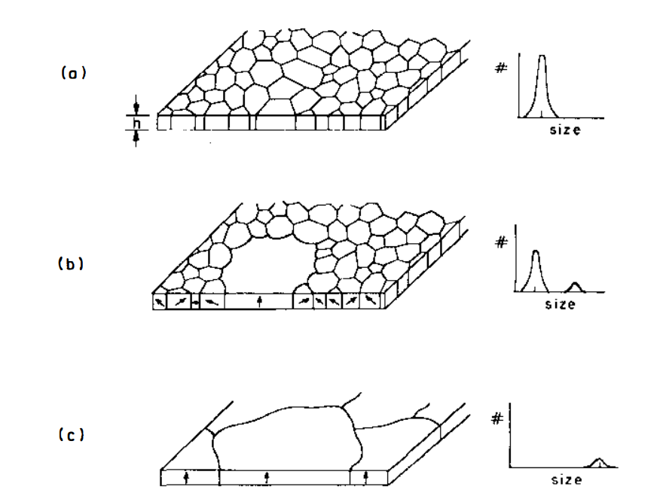
Figure S1. Schematic representation of the microstructure and grain size distribution for films during secondary grain growth [S6].

3.3. Modeling at the stage of secondary grain growth
In the literature, the term “recrystallization” is usually used to describe the process when new grains are nucleated and grow, eliminating the surrounding grains [S5-S8]. However, the term secondary recrystallization is usually applied to a process occurring in cold-deformed materials that have already undergone primary recrystallization. Therefore, in this case, the term “secondary recrystallization” is often used as a synonym for the term “abnormal grain growth”, even if no new grains were nucleated at any stage.
It has been observed that in abnormal or secondary grain growth and secondary recrystallization, abnormal grains often have a non-random crystallographic (fibrous) texture; that is, they tend to have certain planes parallel to the surface of the substrate, which is a confirmation of the theory of evolutionary selection used in the article. The development of texture as a result of anomalous grain growth is a result of the energy anisotropy of the free grain surfaces (surfaces at the top and bottom of the film). When a columnar structure is formed, for which di ≤ dp, the free surface contributes a significant fraction of the total energy. Since the energy of this surface strongly depends on the crystallographic orientation of the grain relative to the film surface, those grains whose orientation leads to low surface energies have an energy advantage during growth. It can be seen from the above results and discussions that grain growth in films is strongly influenced by the properties of the film surface. In the next section, the theory of anomalous grain growth in thin films will be considered along with the corresponding experimental results.
It has long been noted that normal grain growth in thin films stops when the average grain diameter is two to three times the film thickness (200–300 nm for the case considered in our article) [S9]. As mentioned above, this is called the “speciment thickness” effect. If grain growth continues beyond this point, then it is caused by abnormal or secondary growth. There may be several factors that contribute to this behavior. When the grains become larger than the film thickness, the free surface area of the film becomes comparable to the area of the grain boundaries. If there is sufficient free surface energy anisotropy, then minimizing the free surface energy becomes an important driving force for grain boundary migration. During growth, preference is given to grains with an orientation having a low free surface energy. Such grains can overcome the stagnation effect of surface grooves and become secondary or abnormal grains.
Factors affecting film grain growth are presented in Table S1.

Table S1. Factors affecting film grain growth
Grain motion caused by free surface energy anisotropy  $$v=v_{gb}+v_{S}=μ(k+Г)$$ | Grain motion caused by free surface energy anisotropy considering film stress  $$v=v_{gb}+v_{S}+v_{e}=μ(k+Г+F_{ε})$$

Both cases will be discussed in more details below.

3.3.1 Simulation of anomalous grain growth caused by free surface energy anisotropy
Abnormal grain growth (or secondary grain growth) occurs when the boundaries surrounded by a few grains move rapidly in relation to most of the other boundaries. We assume that the boundary rate is determined by the driving force multiplied by the mobility of the boundary. Abnormal growth is the result of either abnormally high mobility boundaries or a higher driving force. Note that usually abnormal grain growth is not expected, its initiation is possible only in the case when the grain has a large initial size advantage [S10]. Although a very large grain may grow faster than its neighbors, it will not grow relatively faster than the average normal grain size. If the initial structure does not contain abnormally large grains, then their development is not expected only from geometrical considerations.
Anomalous grain growth caused by the anisotropy of the free surface energy:
(Explanation 1). Abnormal grain growth happens due to increased mobility of all its boundaries. The result of this anomalous growth is that the size of the anomalous grain increases relative to the average normal grain size until its relative size asymptotically reaches a fixed value. This relative size is determined by the ratio of the anomalous boundary mobility to the normal boundary mobility.
(Explanation 2). Another possible reason for the anomalous grain growth is the difference in the driving force of the anomalous grains. As it was discussed, one of the likely sources of driving forces that are additional to those associated with grain boundary capillarity is the fact that grains with different crystallographic orientations have different energies at the interfaces between the film and environment. It could be explained either by the energies of the free surface or by the energies of the film–substrate interface. (The term "energy" refer to the thermodynamic free energy.)
If the free surface energy of one grain, γ₁, differs from the free surface energy of an neighbor grain, γ₂, then there is a driving force that causes the boundary between the two grains to migrate and increase the more energetically favorable surface area at the expense of the less energetically favorable surface. For a quantitative description of this additional driving force, we will relate it to the driving force due to grain boundary capillarity, which depends on the thickness of the thin film h. An isolated circular grain boundary cylinder with planar curvature k (radius l/k) has a grain boundary area of 2π∙h/k. If its radius decreases by a distance dx, the surface area of the grain boundary decreases by 2π∙h∙dx, which reduces the grain boundary surface energy by 2π∙h∙γ_{gb}∙dx. Assume that the boundary moves a distance dx with a time increment dt for a rate v. Let us assume that the velocity is proportional to the rate of energy decrease per unit area of the boundary, per distance unit, using the proportionality constant M. Contribution to the rate from the decrease in the area of the grain boundary:
$$v_{gb}=M\frac{2πhγ_{gb}dx}{(2πh/k)dx}=Mγ_{gb}k$$

Considering the local velocity proportional to the local curvature with a mobility constant μ such that v = μ∙k, so μ=M∙γ_{gb}. In this case the driving force is caused by the difference in free surface energies inside and outside the cylindrical boundary: migration by a distance dx reduces the free surface energy by 2π∙dx∙dγ/k on each film surface. (Assume for now that the film is bounded on both sides by interfaces of the same type). The contribution v to the grain boundary rate resulting from this reduction in energy is:
$$v_{S}=M\frac{2(\frac{2πdxdγ}{k})}{(2πh/k)dx}=M\frac{2dγ}{h}=μ\frac{2dγ}{hγ_{gb}}$$
The total grain velocity v is the sum of the components due to the capillarity of the grain boundaries and the difference in the energies of the free surface. This can be expressed in terms of the driving force for the free surface energies:
$v=v_{gb}+v_{S}=μ(k+Г)$,
where
$$Г=\frac{2dγ}{hγ_{gb}}$$
Grain growth modeling with additional driving force is easily done by changing the ratio between v and k, as shown in Fig. S2a. The interaction of the grain boundary pinning mechanism with an additional driving force can be modeled as shown in Fig. S2b.
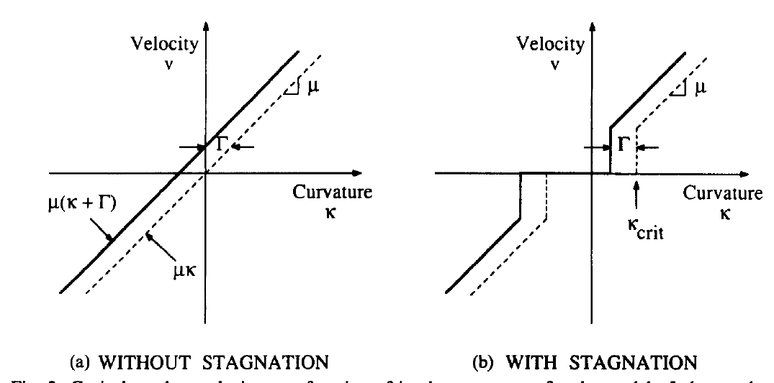
Figure S2. Dependence of the growth rate on the radius of grain curvature.

Stagnation condition:
$$v=μ\left(k+Г\right);\left|k+Г\right|>k_{crit}$$
$$v=0;\left|k+Г\right|<k_{crit}$$
To simulate the granular structure, an initial position is chosen that results from continuous nucleation and growth before a collision, often called the Johnson and Mehl structure [S11]. For the convenience of calculations, grain growth is first simulated without any stagnation conditions up to the normalized time t = 0.1 (the normalized time t_{n} = μt/Ao is used, where t is the time and Ao is the initial average grain area). Then, using the critical curvature condition, the simulation was carried out until the moment when all the remaining grains stopped (Figure S3).

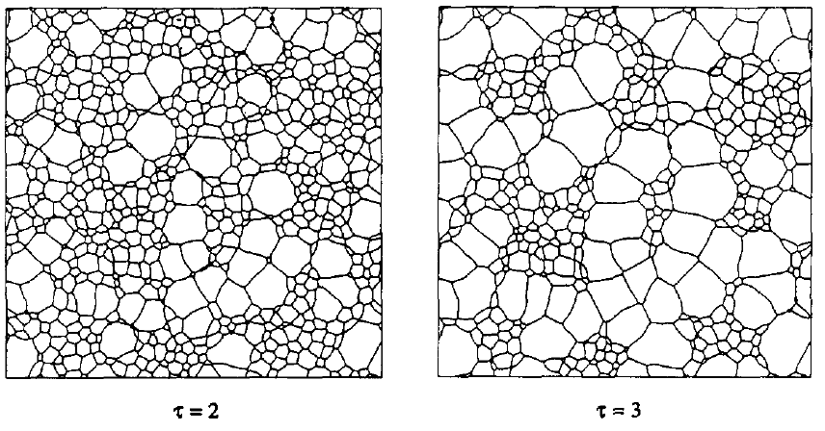
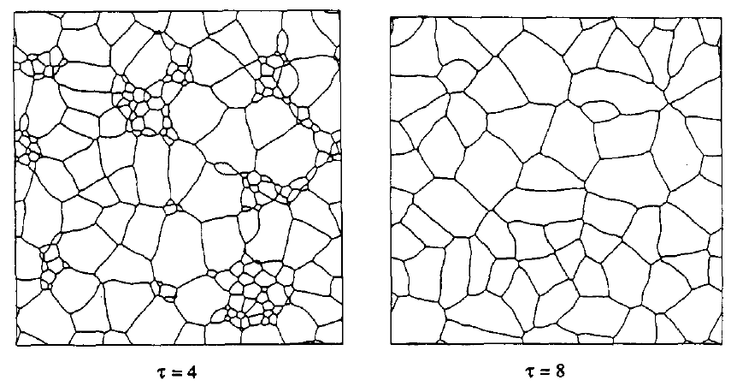
Figure S3. Simulation of changes in film structure with time.

Visually, deposited films are close to the picture corresponding to τ=4. It turns out that this simulation does not describe the real system. To describe a real system, it is necessary to take into account additional factors that affects the growth of thin films – i.e. stress.

3.3.1 Simulation of anomalous grain growth caused by free surface energy anisotropy considering film stress
Thompson et al also published a paper on simulation of film growth under stress [S12]. It is dedicated to thin films deposited on substrates at a temperature different from that at which grain growth occurs. Since the film and the substrate have different coefficients of thermal expansion, films upon annealing at temperatures above the deposition temperature undergo biaxial deformation in the film plane and accumulate stress:
$$ε=\int_{Tdep}^{Tgg}{(a_{s}\left(T\right)-}a_{f}\left(T\right))dT≅\left(T\text{gg}-T\text{dep}\right)\left(a_{s}-a_{f}\right),$$
where α_{f} and α_{s} are the isotropic thermal expansion coefficients of the film and substrate, respectively, and T_{dep} and T_{gg} are the deposition and grain growth temperatures, respectively.
For the case when α_{f} and α_{s} weakly depend on temperature, the integral can be simplified to a multiplication: $\left(T\text{gg}-T\text{dep}\right)\left(a_{s}-a_{f}\right)$.
Grains with different textures have different elastic constants inversely due to elastic anisotropy. In the elastic mode, this leads to texture-dependent stress and, consequently, to an increase in texture-dependent strain energy. The stress state of thin film under the biaxial deformation, can be described as a two dimensional stress, while all components of the elasticity tensor are equal zero. Elastically deformed grain with texture (hkl) under biaxial deformation E and plane stress, has an increase in strain energy:
$Wε=M\text{hkl}ε^{2}$,
where M_{hkl} is an orientation dependent effective biaxial modulus that can be obtained from the material stiffness tensor under plane stress conditions. Then the difference in the strain energy density between two neighboring grains with orientations (h1k1J1) and (h2k2l2) is equal to:
$ΔWε=(M\text{h1k1l1}{-M\text{h2k2l2})ε}^{2}$,

the available driving force for grain growth, which depends only on the orientation of the two grains, regardless of their shape.
Assuming that the grains are deformed uniformly over the entire volume of the grain, the energy density of elastic deformation of a deformed grain with a texture (M_{hkl}) is equal to:
$$Wε=\frac{σ_{y}^{2}}{M\text{hkl}}$$

,where σ_{y} – grain yield strength and depends on both texture and grain geometry.
The driving force of grain growth due to the difference in strain energies is defined as:

$$Fε=\frac{ΔW_{ε}}{γ_{gb}}$$

,where ΔW$ε$ is difference in strain energy densities between two grains meeting at a their boundary.
The total local grain boundary velocity can be calculated as the sum of the available driving forces for grain growth$v=μF$
$$F=k+Г+F_{ε}$$

The limiting speed is determined by the expression:
$$v=μF;\left|F\right|>Fstag$$
$$v=0;\left|F\right|≤Fstag$$

Yield strength model of individual grains in a polycrystalline thin film, when considering the propagation of a dislocation from the grain surface through its thickness is calculated as:
$$σ_{y}=\frac{tanϕ}{cosλ}(\frac{{2K}_{s}}{dsinϕ}+\frac{K_{b}}{h})$$
$$K_{s}=\frac{bμ_{f}}{4π\left(1-ν\right)}ln(\frac{d}{b})$$
$$K_{b}=\frac{bμ_{s}μ_{f}}{2π\left(1-ν\right)μ_{s}+μ_{f}}ln(\frac{h}{b})$$

,where ϕ is an angle between the normal to the slip plane and the normal to the film surface, λ is an angle between the Burgers vector and the normal to the film surface, v is film Poisson's ratio, μ_{f} and μ_{s} are film and substrate shear modules, b is Burgers vector modulus, K_{s} and K_{b} are energy per unit length of dislocation segments remaining at the grain boundary and at the interface.
The effect of stagnation is shown in Table S2. Grain structures are shown for the stagnation condition F_{stag}= 0.4/√A. At low strain values, all grains remain elastic until stagnation.

Table S2. Anomalous grain growth caused by free surface energy anisotropy with stress for a silver film on a substrate Ni, h=150 nm.
Thompson simulation results | The results obtained experimentally in our article
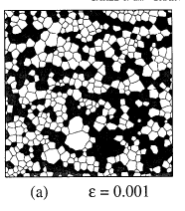 | Fits well with SEM images of films obtained at a deposition temperature of -50C (ΔT=70C)
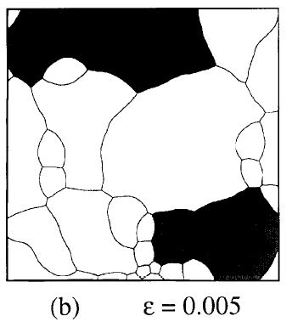 | Fits well with SEM images of films obtained at a deposition temperature of -80C (ΔT=100C)
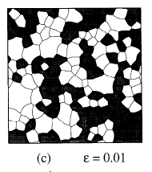 | Fits well with SEM images of films obtained at a deposition temperature of -120C (ΔT=140C)
* grains (111) are colored gray, while grains (001) are not shaded.

The result with the largest size of the formed grains corresponds to the mean stress value.

Section 3.2. Anomalous grain growth caused by stress free surface anisotropy
Thompson et al studied film growth with stress over time [S12]. Fig. S4 shows the grain structures and surface fraction of grains (001) and grains (111) as a function of time for a thick film h=150 nm under deformation ε=0.65.
Growth stage 0-1. At the beginning, most of the grains are still in the elastic regime, and the (001) grains have an advantage due to their low strain energy density. At the first moment, most of the grains are still in the elastic mode, and (001) grains have an advantage due to their low strain energy density. These (001) grains consume the (111) grains that are still elastically deformed, and the surface fraction of the (001) grains increases dramatically.
Some of the (111) grains, which are larger than the average size grains at the time τ = 0.1, have a significant contribution to the simulation due to their large accumulated stresses. As their size is increased, they rapidly decrease their strain energy density. It happens because the energy of the surface and interface favored their growth.

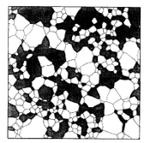 | 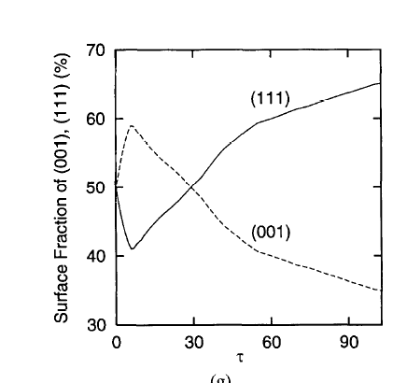  0  1
а) | б)
Figure S4. a) Film structure and b) ratio between grain orientations at the growth stage 0-1

At the growth stage 0-1 growth of the (001) grains dominates. It is caused by the fact that most of the grains are still in elastic mode, and (001) grains have an advantage due to their low strain energy density. The deformation energy is calculated as:
$$F=k+Г+F_{ε}$$

$v_{gb}=M\frac{2πhγ_{gb}dx}{(2πh/k)dx}=Mγ_{gb}k$- velocity, cause by grain force
$v_{S}=M\frac{2(\frac{2πdxdγ}{k})}{(2πh/k)dx}=M\frac{2dγ}{h}=μ\frac{2dγ}{hγ_{gb}}$ - velocity, cause by free energy force
Table S3. Estimation of the forces causing the growth of the (001) and (111) orientations of the film at the growth stage 0-1.
Growth stage 0-1.
(100)  F_{e}  Г  к | (111)  F_{e}  Г  к
*Red color - weak contribution, yellow color - medium contribution, green color - strong contribution
As can be seen from the balance of forces, an increase in the (100) orientation is preferable

Growth stage 1-2
At the growth stage 1-2, the grains (001) already become soft when the grains (111) are already large enough to continue to grow at the expense of the grains (001). At the stagnation moment 65% of the structure consists of (111) -textured grains, thus minimizing surface energy (Fig. S5). The strain energy driving force and the stagnation condition are present, but neither the surface energy driving force nor the grain energy force is influencing growth (Table S3).

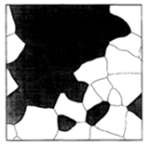 | 1  2
а) | б)
Figure S5. a) Film structure and b) ratio between grain orientations at the growth stage 1-2.

Table S4. Estimation of the forces causing the growth of the (001) and (111) orientations of the film at the growth stage 1-2
Growth stage 0-1.
(100)  F_{e}  Г  к | (111)  F_{e}  Г  к

Growth of (111) grain is preferable. There is a critical grain radius above which the size-independent energy advantage of (111) grains is greater than the strain energy driving force.

Section 4. Experimentally considered conditions for the growth of giant grains
In [S13], the growth of abnormal large silver grains on single-crystal alumina and kapton substrates is considered. The authors conclude that abnormal grain growth requires the following conditions: the presence of a driving force, the stagnation of “normal” matrix grains, and a criterion for selecting anomalous grains. If the driving force is already selective, the unfavorably oriented grains stagnate and thus these three conditions are reduced to one. This often occurs in the case of face-centered cubic films. According to the Carl, Thompson, and Frost (CTF) model [S12, S14], the anisotropy of surface and interface energies, on the one hand, and the strain energy density, on the other hand, control the growth process. The surface and interface energies dominate when the film thickness and the temperature difference between deposition and annealing are small. In this case, (1110 grains grow at the expense of (001) grains. In contrast, the strain energy density dominates when the film thickness and thermal strain are large. In this case, the growth of (001) grains prevails over the growth of (111) grains. One consequence of the CTF model is that the growth mode should be affected by stress and should not be sensitive to the original texture (as long as there are (111) and (001) grains). The results obtained by the authors does not agree with the following these predictions:
1. Stress-free stand-alone films also showed abnormal growth of giant grains with (001) texture
2. Even when the film thickness and the difference between the deposition temperature and the annealing temperature were constant, different grain growth patterns were observed. The films differed only in the initial texture, which depended on the average deposition angle to the substrate (inset 1).
Inset S1.
Deposition angle influence. FIB microimage showed the effect of the substrate angle on grain growth after the post-deposition annealing process in a 2.4 µm thick film. The normal growth of grains with the (111) orientation was found at the edge of the substrate or near it; the average grain size was 2–3 μm. Anomalous growth of grains with (001) orientation (dark) is observed only in the center of the plate. In this case, the growth of (111)-oriented matrix grains stopped at a level of about 1 μm. To rule out that stagnation near the edge of the plate is caused by a change in thickness, the film thickness was measured using FIB in cross sections. Within the surface roughness (less than 50 nm), the film thickness was constant over the entire length of the film surface.
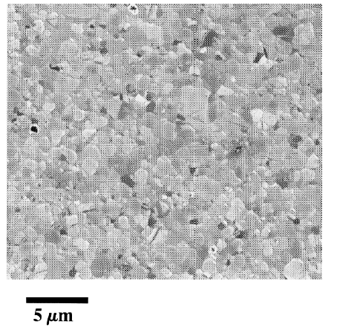 | 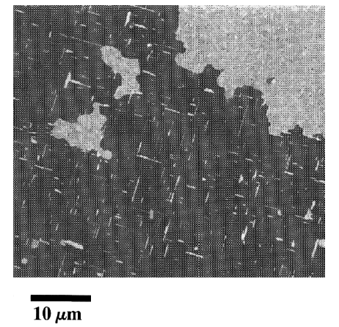
Edge | Center

In order to understand the difference between the anomalous grain growth regime according to the CTF model and the growth regime discussed above, the authors consider the forces that lead to the growth and stagnation of film crystallites (see also "Fundamental thin film growth forces" section in the main article). The fundamental reason for grain growth is the reduction in grain boundary area. In thin films, two-dimensional (columnar) and three-dimensional (noncolumnar) grain growth can be distinguished, driven by F_{Gb2D} and F_{Gb3D} respectively [S12, S14].
The authors compared the driving forces for annealing in the temperature range from 200°C to 700°C (Figure S6) and the following parameters: initial grain size d=170 nm, film thickness h=1.5 µm, grain boundary energy γ_{Gb}= 0.8 J/m2 [S15], difference between surface and interface energy γ_{gb}=0.3 J/m2 [S14], difference between biaxial moduli in planes (111) and (001) ∆M=98 GPa [S12], difference of thermal expansion coefficients ∆α=16∙10⁻⁶ K⁻¹ [S16, S17]. Fε is given for deposition temperatures of 30°C and 200°C. In addition, ∆F_{Gb2D} is given for d=2h=3 µm. Insets show a cross section of a 3D grain structure (top), a 2D grain structure with d<<h (middle), and a 2D grain structure with d≈2h.

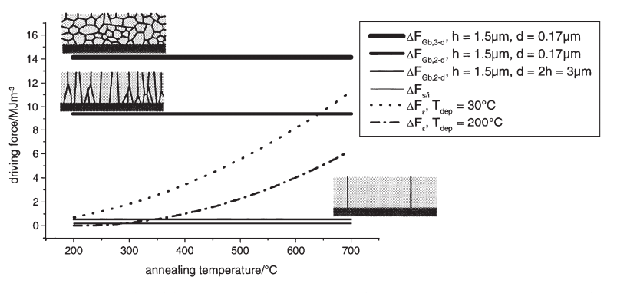
Figure S6. Driving thin film crystallization forces for annealing in the temperature range from 200°C to 700°C [S13].
The films studied by the authors always showed three-dimensional grain growth after deposition. According to fig. S6, the strain energy density does not significantly contribute to the driving force for annealing temperatures below 600°C. This also agrees with the authors observation that the same growth process occurs in stress-free alone-standing films. Therefore, it should be concluded that the choice of orientation, which leads to a change in the texture, cannot be explained by considerations of the driving force of the strain energy. The interfacial and surface energies also cannot be the cause of selection, since their difference is too small (Fig. S7). This agrees with the experimental data that the choice of interfaces (different substrates and capping layer) does not affect the growth process. Therefore, it is currently unclear why the (001) texture develops as a result of anomalous grain growth.
We also estimated the driving forces for our case (Table S5).

Table S5. Crystallization driving forces estimation
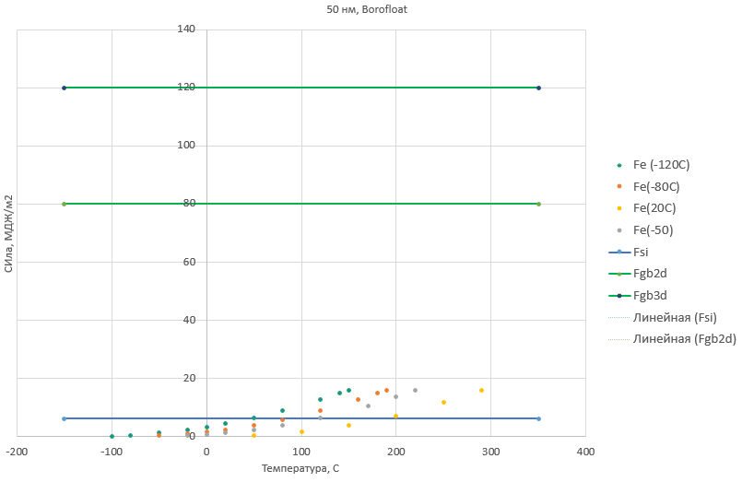 | 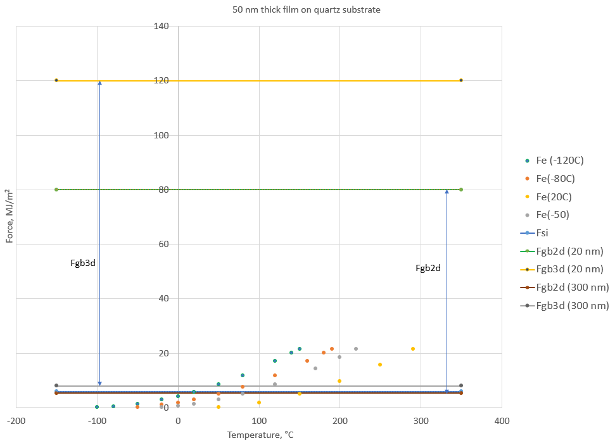
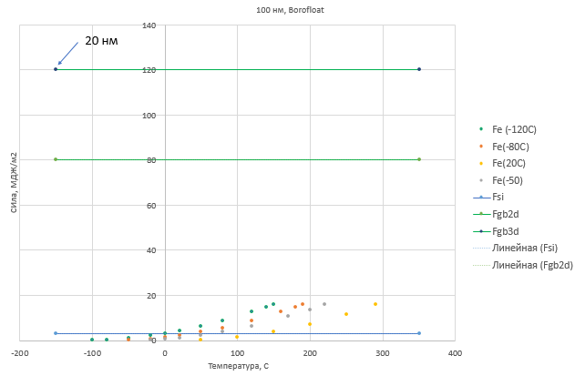 | 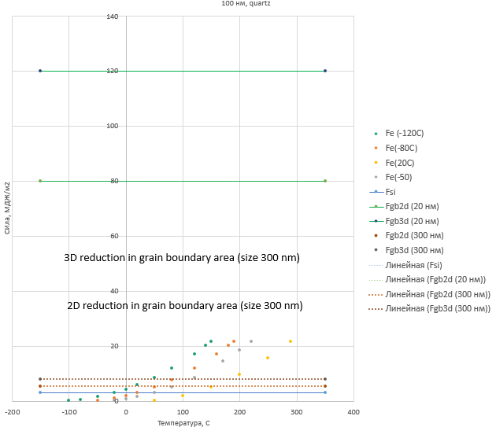
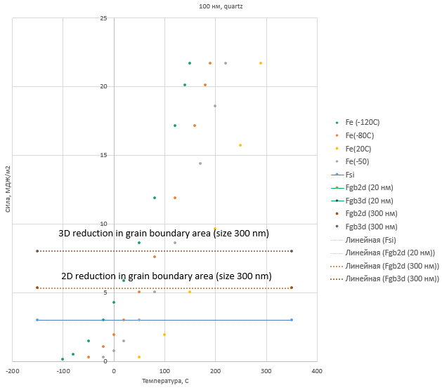
Figure S7. Acting film crystallization forces for annealing at temperatures from -100°C to 400°C for an initial crystallite size of 300 nm

According to our estimates in the observed parameters range, the strain energy density does not make a significant contribution to the driving force. However, if we take into consideration the forces not in the initial position, but also during the change in the crystallite size, then it turns out that from values of about 300 nm, the stress forces turn out to be comparable with the forces of enough for grain boundaries movement (Fig. S17).

Extra drawings.
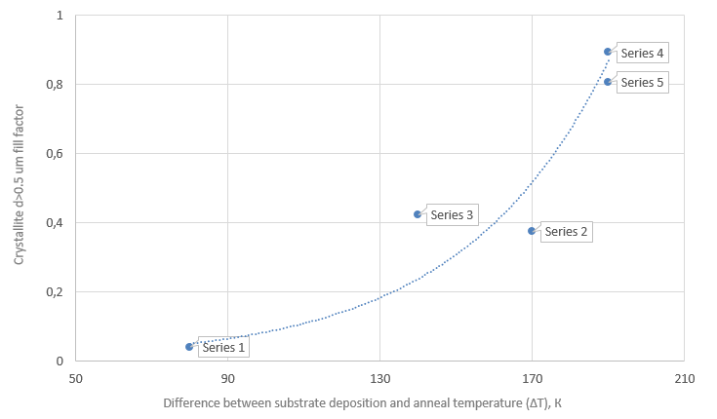
Fig. S8. Relationship between the crystallite fill factor (d>0.5 um) and the difference between the annealing temperature and the substrate temperature during deposition
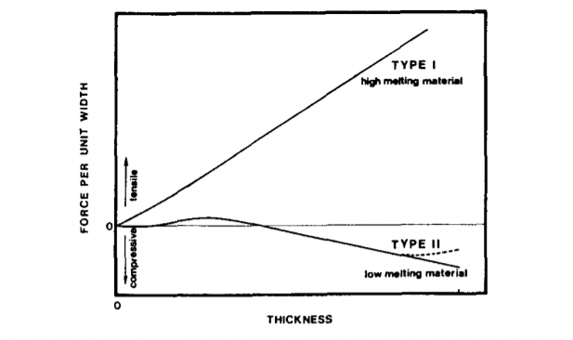
Fig. S9. Type I and Type II metals
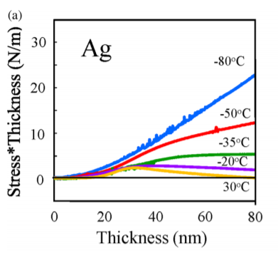
Fig. S9. Stress in Ag dependence on the thickness and temperature of deposition

References
S1. Mullins, William W. "Theory of thermal grooving" Journal of Applied Physics 28.3 (1957): 333-339.
S2. Mullins, William W. "Two‐dimensional motion of idealized grain boundaries." Journal of Applied Physics 27.8 (1956): 900-904.
S3. Mullins, W. W. "The effect of thermal grooving on grain boundary motion" Acta metallurgica 6.6 (1958): 414-427.
S4. Mullins, William W. "Two‐dimensional motion of idealized grain boundaries." Journal of Applied Physics 27.8 (1956): 900-904.
S5. Thompson, C. V., H. J. Frost, and F. Spaepen. "The relative rates of secondary and normal grain growth." Acta Metallurgica 35.4 (1987): 887-890.
S6. Thompson, Carl V. "Grain growth in thin films." Annual review of materials science 20.1 (1990): 245-268.
S7. Frost, H. J., C. V. Thompson, and D. T. Walton. "Simulation of thin film grain structures—I. Grain growth stagnation." Acta Metallurgica et Materialia 38.8 (1990): 1455-1462.
S8. Frost, H. J., C. V. Thompson, and D. T. Walton. "Simulation of thin film grain structures—II. Abnormal grain growth." Acta metallurgica et materialia 40.4 (1992): 779-793.
S9. P. A. Beck, M. L. Holtzworth and P. R. Sperry, Trans.A.I.M.E. 180, 163 (1949)., S11 J. E. Palmer, C. V. Thompson and H. I. Smith, J. appl. Phys. 62, 2492 (1987)
S10. C. V. Thompson, H. J. Frost and F. Spaepen, Acta metall. 35, 887 (1987).
S11. W. A. Johnson and R. F. Mehl, Trans. Am. Inst. Min. Engrs 135, 416 (1939).
S12. Carel, R., C. V. Thompson, and H. J. Frost. "Computer simulation of strain energy effects vs surface and interface energy effects on grain growth in thin films." Acta materialia 44.6 (1996): 2479-2494.
S13. Greiser, J., P. Müllner, and E. Arzt. "Abnormal growth of “giant” grains in silver thin films." Acta materialia 49.6 (2001): 1041-1050.
S14. Thompson, C. V., and R. Carel. "Grain growth and texture evolution in thin films." Materials Science Forum. Vol. 204. Trans Tech Publications Ltd, 1996.
S15. Inman, M. C., and H. R. Tipler. "Interfacial energy and composition in metals and alloys." Metallurgical Reviews 8.1 (1963): 105-166.
S16. Ibach, Harald. "The role of surface stress in reconstruction, epitaxial growth and stabilization of mesoscopic structures." Surface science reports 29.5-6 (1997): 195-263.
S17. EA, BRANDES, and G. B. Brook. "Smithells metals reference Book." Butterworth-Henemann, 1992) p 22 (1992): 22.
S18. Lu, K. "Grain growth processes in nanocrystalline materials studied by differential scanning calorimetry." Scripta metallurgica et materialia 25.9 (1991): 2047-2052.
S19. Ganapathi, S. K., D. M. Owen, and A. H. Chokshi. "The kinetics of grain growth in nanocrystalline copper." Scripta metallurgica et materialia 25.12 (1991): 2699-2704.
S20. Krill III, C. E., H. Ehrhardt, and R. Birringer. "Thermodynamic stabilization of nanocrystallinity." International Journal of Materials Research 96.10 (2005): 1134-1141.

