Identification of ADP-ribosylation factor 6 as the cellular target of withangulatin A against TNBC cells by ferroptosis
Dejuan Sun,ª Yueying Yang,ª Yang Liu,ª Xiaoxin Ma,ª Hua Li,^{a,b,}* Lixia Chen^{a,}*

ª Wuya College of Innovation, Key Laboratory of Structure-Based Drug Design & Discovery, Ministry of Education, Shenyang Pharmaceutical University, Shenyang, 110016, China.
^{b} College of Pharmacy, Fujian University of Traditional Chinese Medicine, Fuzhou 350122, China.
.

*Corresponding author: Lixia Chen & Hua Li
E-mail: syzyclx@163.com (Lixia Chen)
li_hua@hust.edu.cn (Hua Li)

- Supplementary Results

Scheme S1. Synthesis of Biotin-WA.

Figure S1. WA induced cell death in MDA-MB-231 cells. (A) Cells were treated with different concentrations of WA for 24h. Representative images were shown. (B) Apoptosis ratios were determined by flow cytometry analysis of Annexin-V/PI double staining.

Figure S2. WA inhibits the proliferation of TNBC in vivo. The antitumor activities of WA in representative. MDA-MB-231 tumors from mice after vehicle and WA treatment: (A) The images of isolated tumors derived from mice, (B) tumor volume and (C) tumor weight (n = 7), **, p < 0.01, ***, p < 0.001. Statistical significance compared with respective control groups.
Figure S3. Probing of the human protein microarray to identify WA targeting ARF6 protein. (A) Frequency histogram for the probed protein microarray showing the range of Z-scores obtained. Protein with a Z-score greater than three were considered significant. Cy5 signals were measured at 635 nm. (B) Microscale thermophoresis binding curve of several candidate proteins with WA.

Figure S4. mRNA expression of Foxc2, Ttk, Arhgdib, Ambra 1, Homx-1, PTRRR, NE01, PDZKIP and POLO from mice treated with WA (40 mg/Kg), as evaluated by qPCR.

Figure S5. KEGG pathway annotation of up-regulated and down-regulated proteins, respectively. Diagram of KEGG analysis classifying DEGs into biological process groups.

Figure S6. Cells were transfected with control or ARF6 shRNA. Then, the mRNA and protein expression levels of ARF6 were determined.

Figure S7. The binding sites of ARF6 were predicted by ICM-Pro. (A) The interaction sites were predicted by Optimal Docking Areas. It identified optimal surface patches with the lowest docking desolvation energy values as calculated by atomic solvation parameters. (B) Three predicted sites were shown on the surface of ARF6 protein.

Table S1. The proteome microarray of 9 potential targets.
Block | Column | Row | Name | F635 Median | F635 Mean | B635 Median | B635 Mean | SNR 635 | I | Z-Score
4 | 1 | 2 | IFT22 | 365 | 465 | 61 | 118 | 2.551 | 5.98 | 21.087
4 | 16 | 2 | ARF6 | 327 | 385 | 67 | 125 | 1.733 | 4.88 | 16.337
23 | 8 | 57 | AVEN | 228 | 303 | 71 | 122 | 1.361 | 3.21 | 9.146
10 | 7 | 19 | SF3B4 | 205 | 263 | 47 | 102 | 1.309 | 4.36 | 14.102
24 | 27 | 55 | SRRT | 201 | 256 | 61 | 114 | 1.127 | 3.30 | 9.507
7 | 24 | 54 | LIMCH1 | 175 | 253 | 61 | 113 | 1.085 | 2.87 | 7.672
1 | 23 | 43 | HNRNPK | 143 | 215 | 51 | 103 | 0.957 | 2.80 | 7.392
12 | 10 | 13 | CCDC9 | 138 | 227 | 60 | 112 | 0.885 | 2.30 | 5.221
5 | 1 | 59 | DDX4 | 163 | 212 | 59 | 111 | 0.802 | 2.76 | 7.214

- NMR Spectral Data
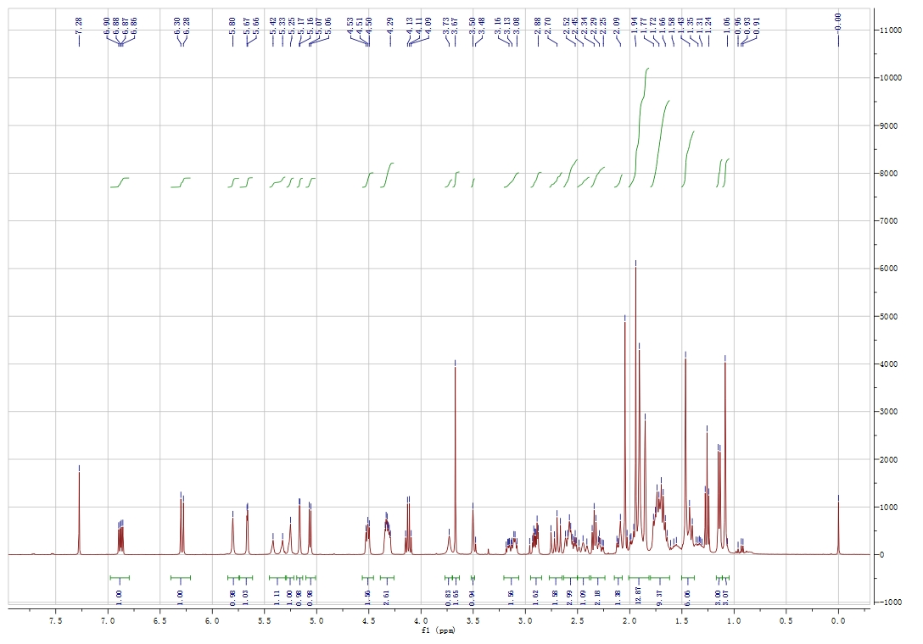
¹H-NMR spectrum of Biotin-WA
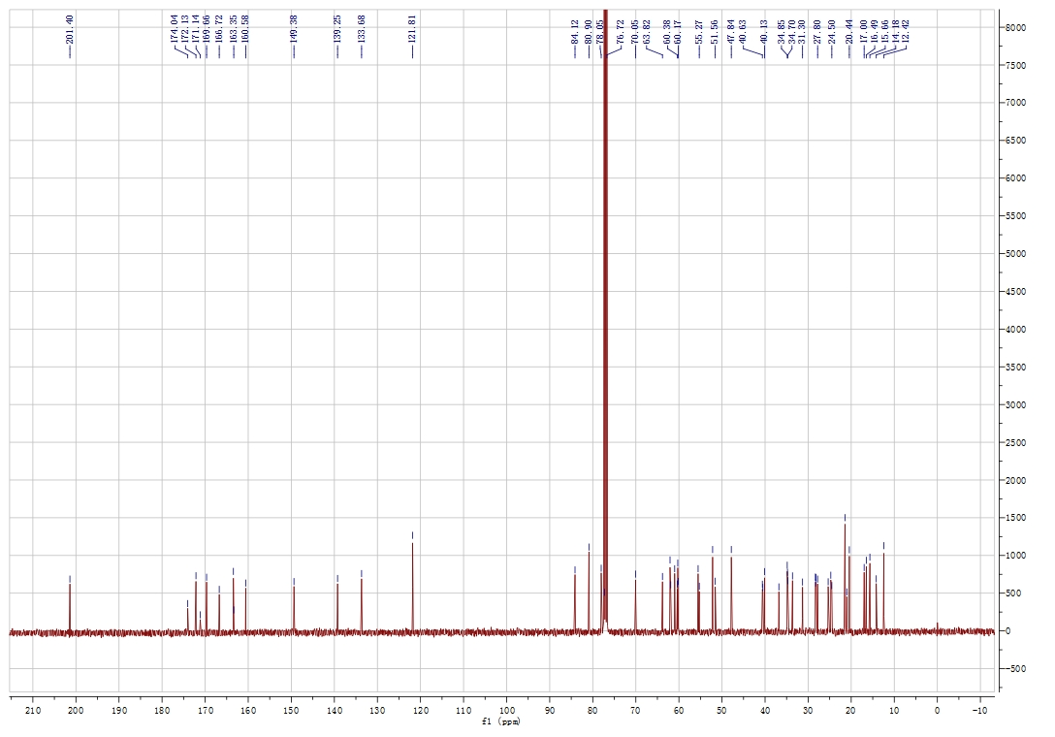
¹³C-NMR spectrum of Biotin-WA

