Metamorphic and post-settlement success of Holothuria scabra reared on microalgal concentrates compared with live microalgae
Journal of Applied Phycology
Tomilyn Jan S. Garpa*¹, Olivier Josh C. Caasi¹, Marie Antonette Juinio-Meñez¹

¹The Marine Science Institute, University of the Philippines Diliman, Quezon City 1101, Philippines
*Corresponding author: tsgarpa@up.edu.ph

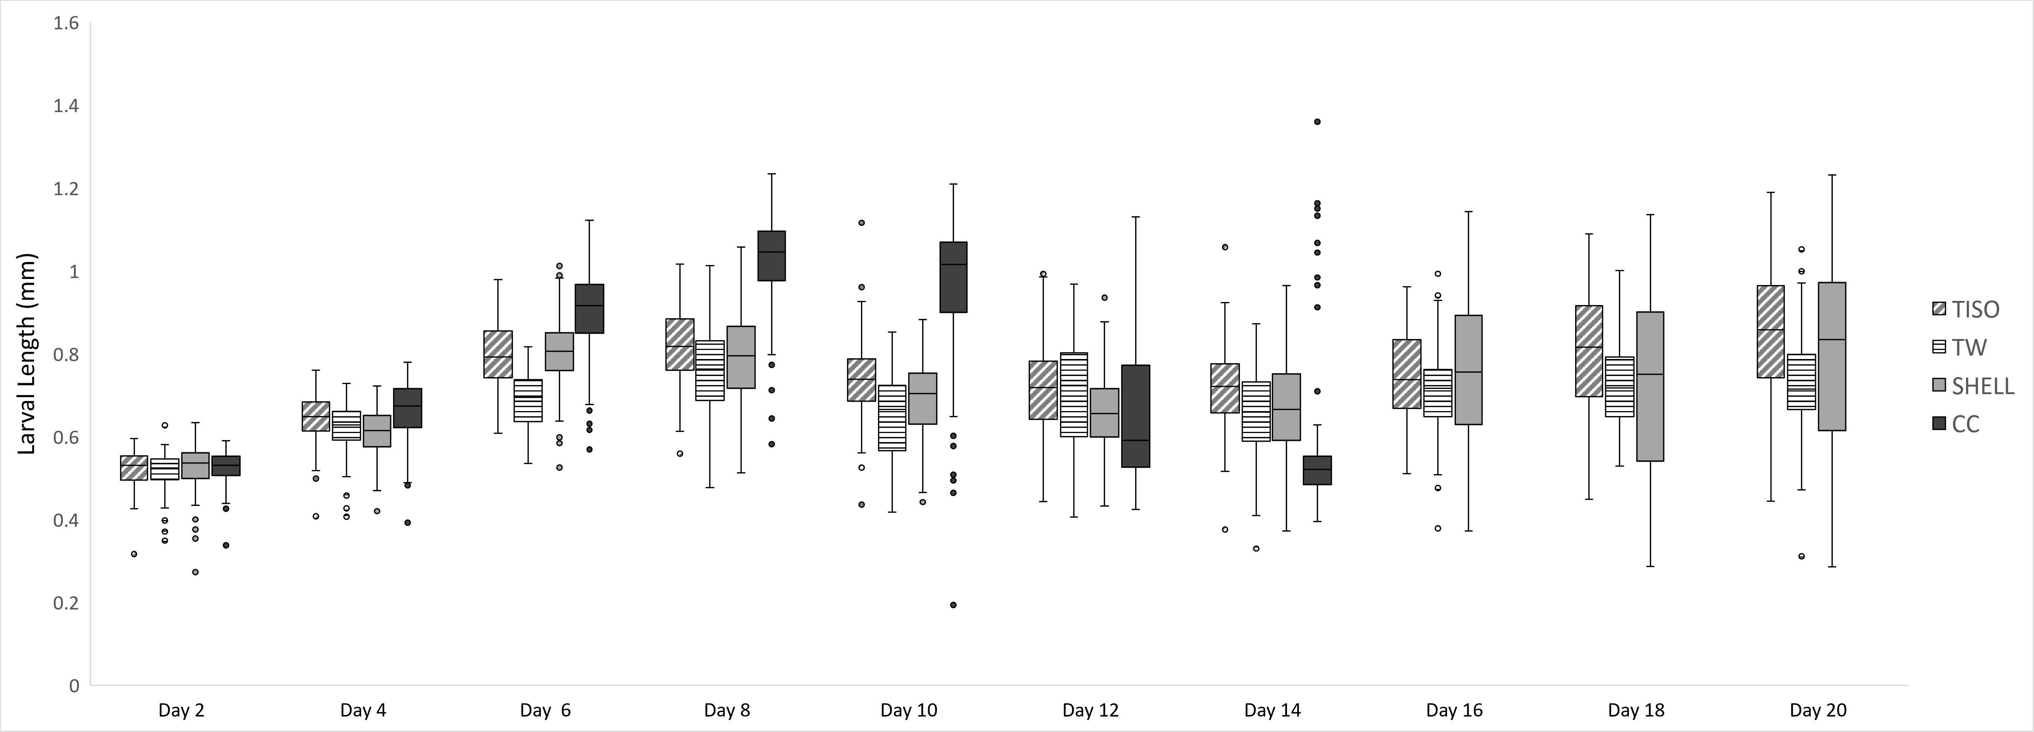
Supplemental Figures Captions
Supplemental Figure 1. Daily size distribution of Holothuria scabra larvae fed with microalgae concentrates and live microalgae. The relative proportion of larval stages is shown in Figure 1.
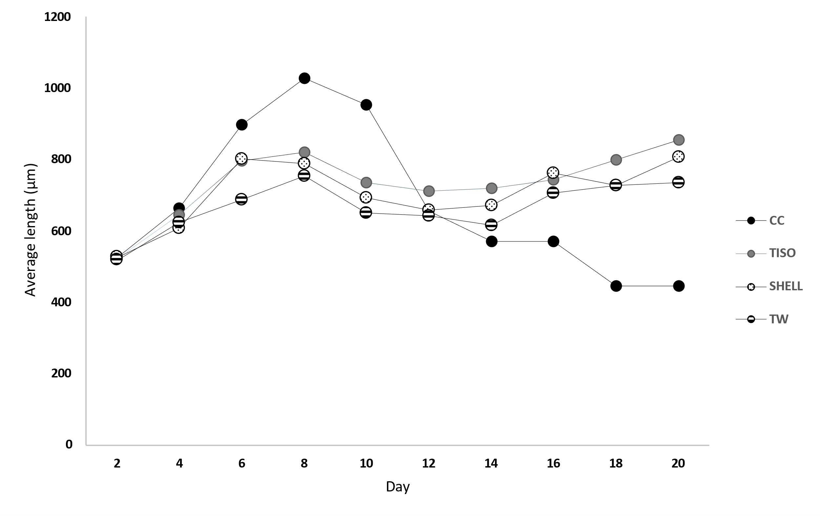
Supplemental Figure 2. Total body length means per monitoring period fed with microalgae concentrates (TISO, TW, SHELL) and live microalgae (CC).

