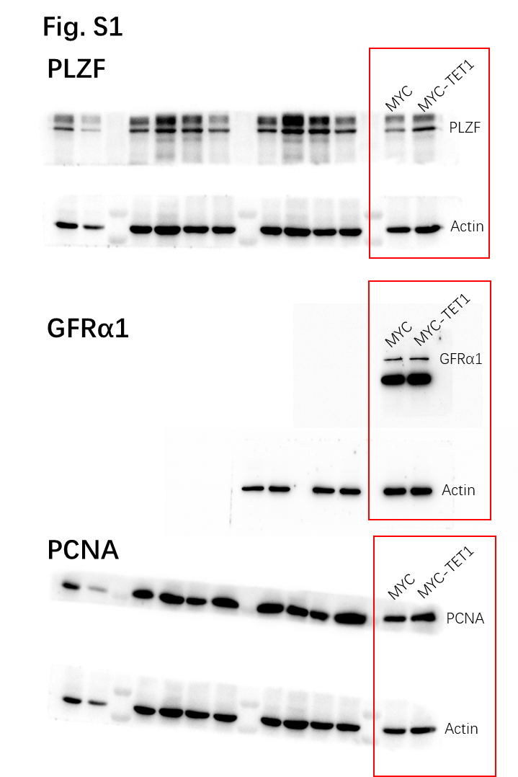
Fig. S1. Original image of protein expression of PLZF, GFRα1 and PCNA in SSCs with two different treatments. Original Western Blot images of PLZF, GFRα1, and PCNA protein expression in MYC and MYC-TET1 SSCs. MYC, control group; MYC-TET1, TET1 overexpression group.

