Supporting Information
Materials synthesis and test methods
Synthesis and characterization of the designed phosphate solvents
The following procedure is typical for synthesizing compounds EBFP, FEBFP, and DEBFP. A solution of 2-(2-methoxyethoxy) ethanol (1.1 equiv) and triethylamine (3.5 equiv) in dichloromethane was added dropwise over the course of 3 hours to a stirred solution of phosphoryl chloride (1.0 equiv) in dichloromethane held at 0 °C by an ice bath. Immediately after the completion of the first dropwise addition, trifluoroethanol (2.1 equiv) was added slowly via syringe, and the mixture was allowed to warm slowly to room temperature while being stirred overnight. The mixture was filtered to remove precipitated triethylamine hydrochloride. Then the obtained solution was washed with 5% HCl and deionized water for three times. The combined aqueous layers were back-extracted with dichloromethane. The combined organic layers were dried over MgSO₄ and stirred over alumina (acidic) to adsorb pyrophosphates. The mixture was filtered and distilled under vacuum to yield clear colorless oil.
The synthesis process of compound BFEFP is as follows. A solution of 2-(trifluoroethoxy) ethanol (2.0 equiv), triethylamine (3.5 equiv), and 4-dimethyl aminopyridine (0.1 equiv) in dichloromethane was added dropwise over the course of 2 h to a stirred solution of phosphoryl chloride (1.0 equiv) in dichloromethane held at 0 °C by an ice bath. Immediately after completion of the first dropwise addition, trifluoroethanol (1.2 equiv) was added in one portion, and the mixture was allowed to warm slowly to room temperature while being stirred overnight. The separation and purification process of this product is almost the same as mentioned above.
The synthesized compounds were characterized by nuclear magnetic resonance spectroscopy (NMR Bruker 500M, ¹H, ¹³C, ¹⁹F, and ³¹P), and mass spectroscopy (MS Bruker impact II) and shown in Supplementary Fig. 1. EBFP (2-methoxyethyl bis(2,2,2-trifluoroethyl) phosphate): ¹H NMR (500 MHz, CDCl₃, ppm) δ 4.48-4.37 (m, 4H), 4.34-4.25 (m, 2H), 3.64 (tt, 2H), 3.41 (d, 3H). DEBFP (2-(2-methoxyethoxy) ethyl bis(2,2,2-trifluoroethyl) phosphate): ¹H NMR (500 MHz, CDCl₃, ppm) δ 4.49-4.39 (m, 4H), 4.36-4.29 (m, 2H), 3.75 (ddd, 2H), 3.70-3.65 (m, 2H), 3.60-3.54 (m, 2H), 3.39 (d, 3H). FEBFP (2-(2,2,2-trifluoroethoxy) ethyl bis(2,2,2-trifluoroethyl) phosphate): ¹H NMR (500 MHz, CDCl₃, ppm) δ 4.54 (p, 4H), 4.37-4.25 (m, 2H), 4.02 (q, 2H), 3.90-3.84 (m, 2H). ¹⁹F NMR (471 MHz, CDCl₃, ppm) δ -74.29 (d), -75.44 (s). ³¹P NMR (202 MHz, CDCl₃, ppm) δ -2.56 (s). ¹³C NMR (126 MHz, CDCl₃, ppm) δ 117.31 (s), 70.66 (d,), 68.78-66.75 (m), 63.64 (qd). BFEFP (2-(2-methoxyethoxy) ethyl bis(2,2,2-trifluoroethyl) phosphate): ¹H NMR (500 MHz, CDCl₃, ppm) δ 4.40 (dt, 2H), 4.32-4.27 (m, 4H), 3.92 (q, 4H), 3.89-3.86 (m, 4H). All these compounds were collected and stored with 3A molecular sieves for 72 hours in an argon-filled glove box before use.
Synthesis and characterization of the LiFNFSI salt
Lithium (ﬂuorosulfonyl)(nonaﬂuorobutanesulfonyl)imide (Li[(FSO₂)(n-C₄F₉SO₂)N], LiFNFSI), was synthesized in a glove box (MIKROUNA) containing less than 0.5 ppm H₂O and O₂ by a metathesis reaction between KFNFSI and lithium perchlorate in acetonitrile with nearly quantitative yield. The synthesis process of compound KFNFSI is as follows¹. A solution of nonafluorobutyl sulfonamide (1.0 equiv), dichlorosulfoxide (1.5 equiv), and chlorosulfonic acid (1.5 equiv) was mixed and heated to 120 ~ 130 ℃ for 24 h. The mixture was distilled under vacuum to yield white solid product (H[(ClSO₂)(n-C₄F₉SO₂)N]). Then, this compound was fluorinated by SbF₃ at room temperature for 12 h. After the separation process by vacuum distillation and neutralization reaction with potassium carbonate, the crude product of KFNFSI was obtained. Finally, it was purified by the recrystallization in propanol/toluene mixed solvents to yield white KFNFSI powder. The synthesized LiFNFSI was characterized by ¹⁹F NMR (acetone-d₆; CCl₃F; ppm) (Supplementary Fig. 2): 57.5 (1F), −80.8 (3F), −113 (2F), −121.5 (2F), −126.3 (2F). Analysis Calculated for C₄F₁₀LiNO₄S₂: C, 12.41; N, 3.62; S, 16.57. Found: C, 12.38; N, 3.54; S, 16.48. Impurities (ppm): water content, 45; Cl⁻, 2.0; F⁻, 0.5; HF, 0.3.
Preparation of the electrolytes
Lithium hexafluorophosphate (LiPF₆), dimethyl carbonate (DMC), ethylene carbonate triethyl phosphate (TEP), and bis(2,2,2-trifluoroethyl) ether (BTFE) (all in battery-grade purity) were obtained from Capchem. or Shangfluoro. and used as-received. The designed phosphate solvents and LiFNFSI salt were synthesized and purified. Before preparing the electrolytes, these solvents were dried over an activated molecular sieve (4 Å). The electrolytes of 1 M LiPF₆ in EC-DMC (1:1, by volume) and LiFNFSI with different concentrations in the single or mixed solvents were obtained by blending adequate amounts of salts and solvents in a PP flask, and further stirring for 12 h at room temperature. A Karl Fisher titrator (Metrohm 831 Coulometer) was utilized to measure the water content of the electrolytes, which was lower than 10ppm in all prepared electrolytes. The experimental work was carried out and the materials were stored in an Ar-filled dry glove box (MIKROUNA) containing less than 0.5ppm H₂O and O₂.
Characterization of the electrolytes
For the measurements of impurities that existed in the electrolyte, the water content was determined by Karl-Fischer titration (Metrohm KF 831 Coulometer), and the content of F⁻ or Cl⁻ was measured by ion chromatography (DIONEX ICS-1000). The electrolyte viscosity was measured on a programmable rheometer (DV-III Ultra, Brookfield) at room temperature. The ionic conductivity of the electrolyte solutions was measured by a conductivity meter (DDS-301A, Shanghai INESA Scientific Instrument Co., Ltd.). The electrolyte flammability was tested by burning an electrolyte-soaked PE Celgard separator. The thermogravimetric tests were carried out using a Thermogravimetric Analyzer (TA Instruments, Q5000IR) with a heating rate of 10 °C min⁻¹ under Ar protection. The flash point was investigated using a SETA closed-cup flash-point tester following the ASTM D3278 standard method. The Raman spectrometer was LabRAM HR800 (HORIBA Jobin Yvon Ltd.) with an exciting laser of 633 nm.
Preparation of cathodes
The transition metal oxide cathodes (LiNi_{0.8}Mn_{0.1}Co_{0.1}O₂, LiNi_{0.5}Mn_{1.5}O₄ and LiFePO₄) were prepared by mixing active materials, Super P conductive carbon and PVDF with a mass ratio 8:1:1 in N-methyl pyrrolidone solvent to form homogeneous slurry. The slurry was coated onto Al current collector via a typical doctor-blade coating method. After drying in a vacuum oven (120 ℃/2 h), the electrode film was cut into small disks with a diameter of 1.2 cm and then pressed by a pressure of 3 MPa. The mass loadings of these prepared electrodes were weighed separately before using, which are about 3-4 mg cm⁻².
Assembly of cells
The as-prepared electrodes were assembled into 2032-coin cells of a two-electrode configuration with Celgard polyethylene separator in an Ar-filled dry glove box (MIKROUNA) containing less than 0.5ppm water and O₂. The electrolyte contained LiPF₆ or LiFNFSI salt in the commercial carbonate solvents or synthesized phosphate solvents. The pouch cells were fabricated in Shanghai Institute of Space Power-Sources, and the used NCM811 cathode and Li metal anode were all commercial electrodes.
Electrochemical measurements
Cyclic voltammetric studies of the electrolyte solutions were conducted in a half-cell using a CHI760A electrochemical workstation. Stainless steel or Al foil served as working electrodes, and Li metal foil was used as both the counter and reference electrodes. The Li||Cu half-cells were used to investigate the cycling stability of Li plating/stripping in different electrolytes. The Coulombic efficiency (CE) of Li plating and stripping was calculated from the ratio of the Li removed from the Cu substrate to that deposited in the same cycle. The detailed procedure was as followed: ten pre-cycles between 0 and 1 V at 0.1 mA cm⁻² were initialized to clean the Cu electrode surface, and then cycling was done by depositing 0.5 mAh cm⁻² of Li onto the Cu electrode followed by stripping to 1 V under 0.5 mA cm⁻² current density. The average CE is calculated by dividing the total stripping capacity by the total deposition capacity after the formation cycle. For the average CE test^{2, 3}, a standard protocol was followed: (1) perform one initial formation cycle with Li deposition of 5 mAh cm⁻² on Cu under 0.5 mA cm⁻² current density and stripping to 1 V; (2) deposit 5 mAh cm⁻² Li on Cu under 0.5 mA cm⁻² as a Li reservoir; (3) repeatedly strip/deposit Li of 1 mAh cm⁻² under 0.5 mA cm⁻² for 10 cycles; (4) strip all Li to 1 V. The Li-ion transference number (t_{Li}⁺) was measured and calculated in accordance with the Bruce-Vincent-Evans equation⁴. The anodic stability of the electrolyte was investigated using LSV test in Li||Al coin-typed cells. The corrosion behavior of the electrolyte on Al current collector was performed by using chronoamperometry test at 4.5 V in Li||Al coin-typed cells. The AC impedance spectroscopy of cells at different cycles was measured in Autolab (PGSTAT302N, Metrohm) in the frequency range from 1 MHz to 0.01 Hz, respectively. To evaluate electrochemical performance, we carried out a galvanostatic charge-discharge cycling test at different operating temperature on LAND-CT 2001A (Wuhan, China) and NEWARE-CT 4008 (Shenzhen, China) Battery Test Systems. Li symmetric cells were assembled with Li metal as the working and counter electrodes with Celgard separators in different electrolytes. The as-prepared transition metal oxide cathodes were assembled into 2032-coin full cells of a two-electrode configuration in an Ar-filled dry glove box (MIKROUNA) containing less than 0.5ppm H₂O and O₂. The electrolyte contained 1 mol L⁻¹ LiPF₆/EC-DMC, or 0.8 mol L⁻¹ LiFNFSI/phosphate. The specific capacities calculations were based on the mass of cathode active materials. Meanwhile, all the related cells would be activated by a small current before cycling, and the capacity retention was calculated against the second cycle.
Characterization of electrodes
The morphologies of cycled cathodes and anodes were observed by FEI Nova Nano-scanning electron microscope (SEM). Firstly, cells were disassembled in the glove box and then the obtained electrodes were immersed in EC-DMC mixed solvents and then washed by anhydrous DMC to remove any electrolyte salt residuals. To avoid exposure to air, the dried samples were sealed in an air-isolating container and transferred quickly into the SEM equipment under the protection of Ar flow. The X-ray photoelectron spectroscopy (XPS) analysis was performed using a Kratos Axis UltraDLD spectrometer (Kratos Analytical-A Shimadzu Group Company) with monochromatic Al Ka source (1486.6 eV). The electrode samples after cycling were pretreated in the same way as the SEM measurement. Before transferring the samples to the equipment, an air-isolating container with protective Ar flow was used to avoid moisture/air exposure. Under slot mode, the analysis area was 700 ×300 μm and analysis chamber pressure was less than 5 × 10⁻⁹ Torr. The binding energy was calibrated according to the C 1s peak (284.8 eV) of adventitious carbon on the analyzed sample surface. The contents of different species in the SEI and CEI layers were obtained by fitting the whole XPS spectra using CasaXPS software. The structure and distribution of the constituent elements at different depths of the cycled NCM cathodes were characterized by XRD (D8 Advance, Bruker Corp., Germany) with Cu-Kα radiation (λ = 0.15418 nm) at 40 kV and the time-of-flight secondary ion mass spectrometry (TOF-SIMS) (GAIA3 GMU Model 2016, Czech). These cathode samples after cycling were pretreated as the SEM measurement. The thermal stability of SEI layers on cycled Li electrodes in different electrolytes was tested by Differential Scanning Calorimeter (TA Instruments, DSC 8000) with a heating rate of 10 °C min⁻¹ under Ar protection.
Computation details
The optimizing simulations of LiPF₆, C₃H₄O₃ (EC), C₃H₆O₃ (DMC), LiC₄O₂F₁₀S₂N (LiFNFSI), C₆H₁₅O₄P (TFP), C₄H₄F₆O (BTFE), and C₈O₅F₉H₁₀P (BFP) molecular are all performed by the first-principle-method implemented in the DMol³ code. In this section, the Generalized gradient approximation (GGA) and the Perdew Burke-Ernerhof (PBE) function as well as DFT-D method are used to describe the exchange correlation functions. The convergence criteria of self-consistent field energy were l.0×l0⁻⁶ eV, the MAX force was 0.002Ha/ A, and the MAX displacement is set as 0.005 Å. And the Brillouin zone is sampled using a 5×5×1 Monkhorst-Pack k-point grid and Methfessel-Paxton smearing is set as 0.005Ha. In addition, Molecular dynamics (MD) and geometry optimizations of these molecular chain models were performed using Forcite package module of Materials Studio⁵. The molecular structures of three kinds of electrolytes were built using the Materials Visualizer module, with the application of the COMPASS II force field throughout. In the first kind of electrolytes, the molar concentration ratio of LiPF₆/EC/DMC is 1/7.386/5.555, in the second electrolytes, the molar concentration ratio of LiFNFSI/TEP/BTFE is 0.8/3.022/3.846, and in the third electrolytes, the molar concentration ratio of LiFNFSI/BFP is 0.8/3.09, respectively. To simulate the radial distribution function (RDF, g-r) of these solution models, the NVT dynamics followed by 50 ps NPT dynamics are calculated, where the number of particles N, volume V, pressure P, and temperature T in the system were all held constant.

Supplementary Table 1. The flash points of electrolytes.
Sample | Solvent 1a | Solvent 1b | Electrolyte 1 | Solvent 2a | Solvent 2b | Electrolyte 2
Composition | EC | DMC | 1.0 M LiPF₆/EC-  DMC (1:1) | TFEP | FEMC | 0.95 M LiFSI/TFEP-  FEMC (1:3)
Flash point/℃ | 160 | 17 | 25.3 | None | 38 | 37

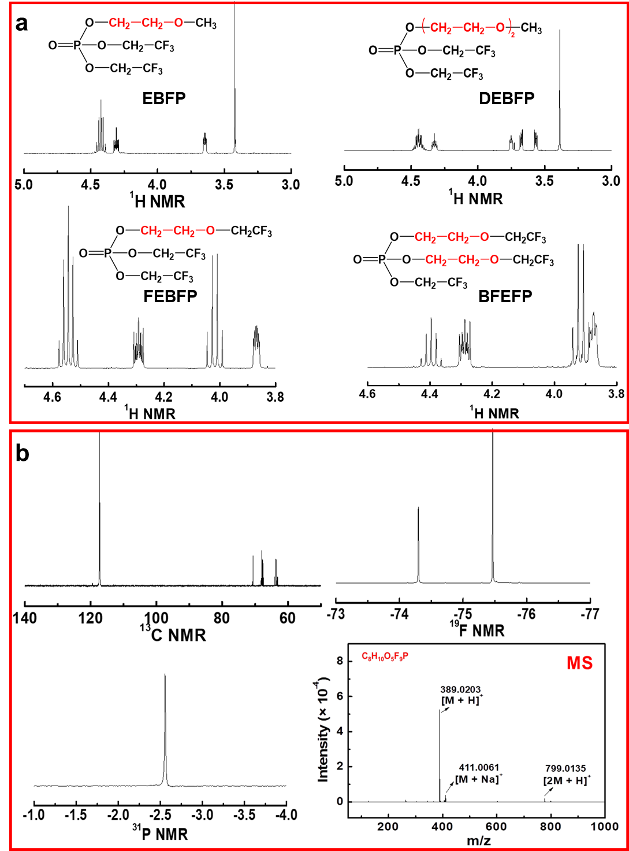
Supplementary Fig. 1. Characterization of the synthesized phosphate solvents. (a) ¹H NMR of these phosphate solvents. (b) ¹³C, ¹⁹F, and ³¹P NMR and MS of the FEBFP solvent.
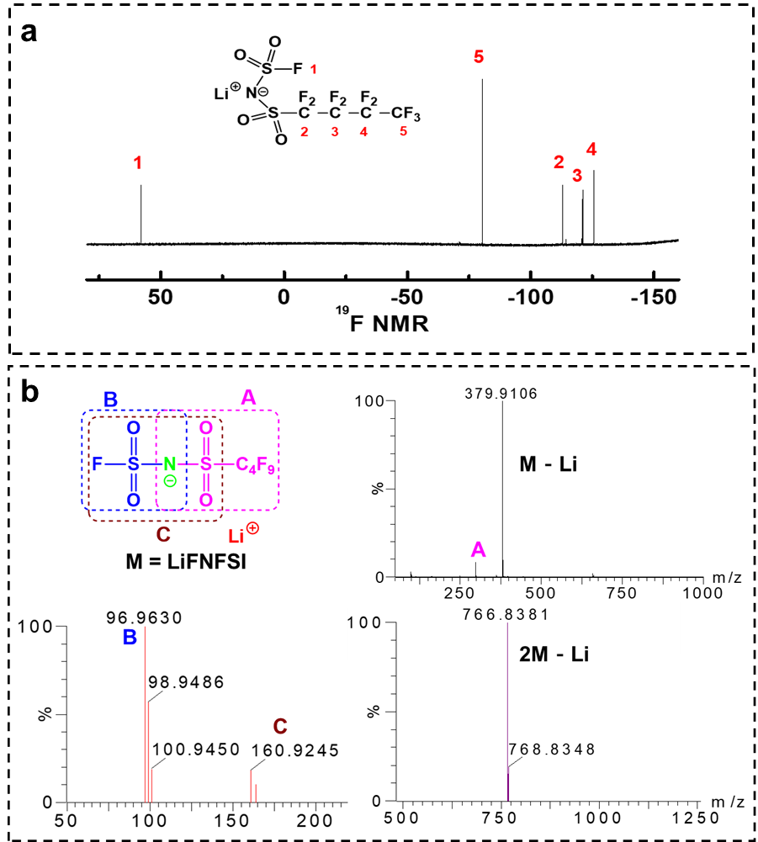
Supplementary Fig. 2. Characterization of the synthesized salt LiFNFSI. (a) ¹⁹F NMR. (b) MS.

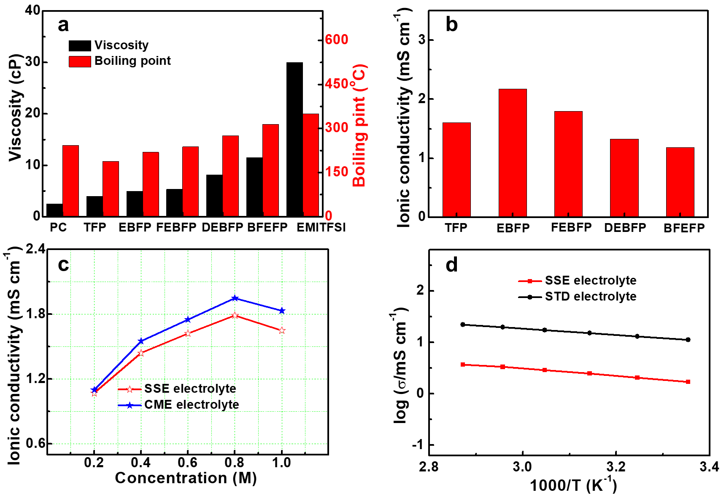
Supplementary Fig. 3. Comparison of the basic physical properties. (a) Viscosity and boiling point of various solvents, the initial decomposition temperature of ionic liquid EMITFSI is 350 ℃. (b) Ionic conductivities of LiFNFSI electrolytes. (c) Ionic conductivities of SSE and CME based electrolytes with different LiFNFSI concentration. (d) Temperature-dependent ionic conductivities of the SSE and STD electrolytes.

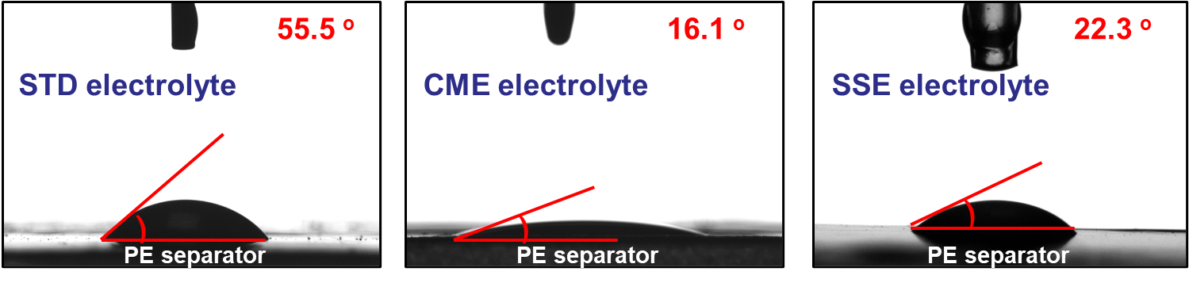
Supplementary Fig. 4. Contact angles of STD (left), CME (middle) and SSE (right) electrolytes on separators.

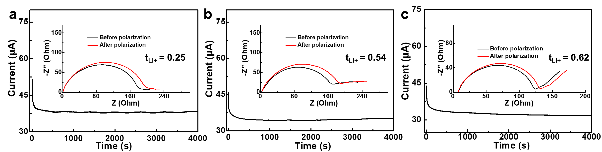
Supplementary Fig. 5. Current variation with time during polarization of Li symmetrical cells with total applied potential difference of 0.01V in (a) STD; (b) CME; and (c) SSE electrolytes, respectively. The insets are the AC impedance spectra of the corresponding cells before and after polarization.

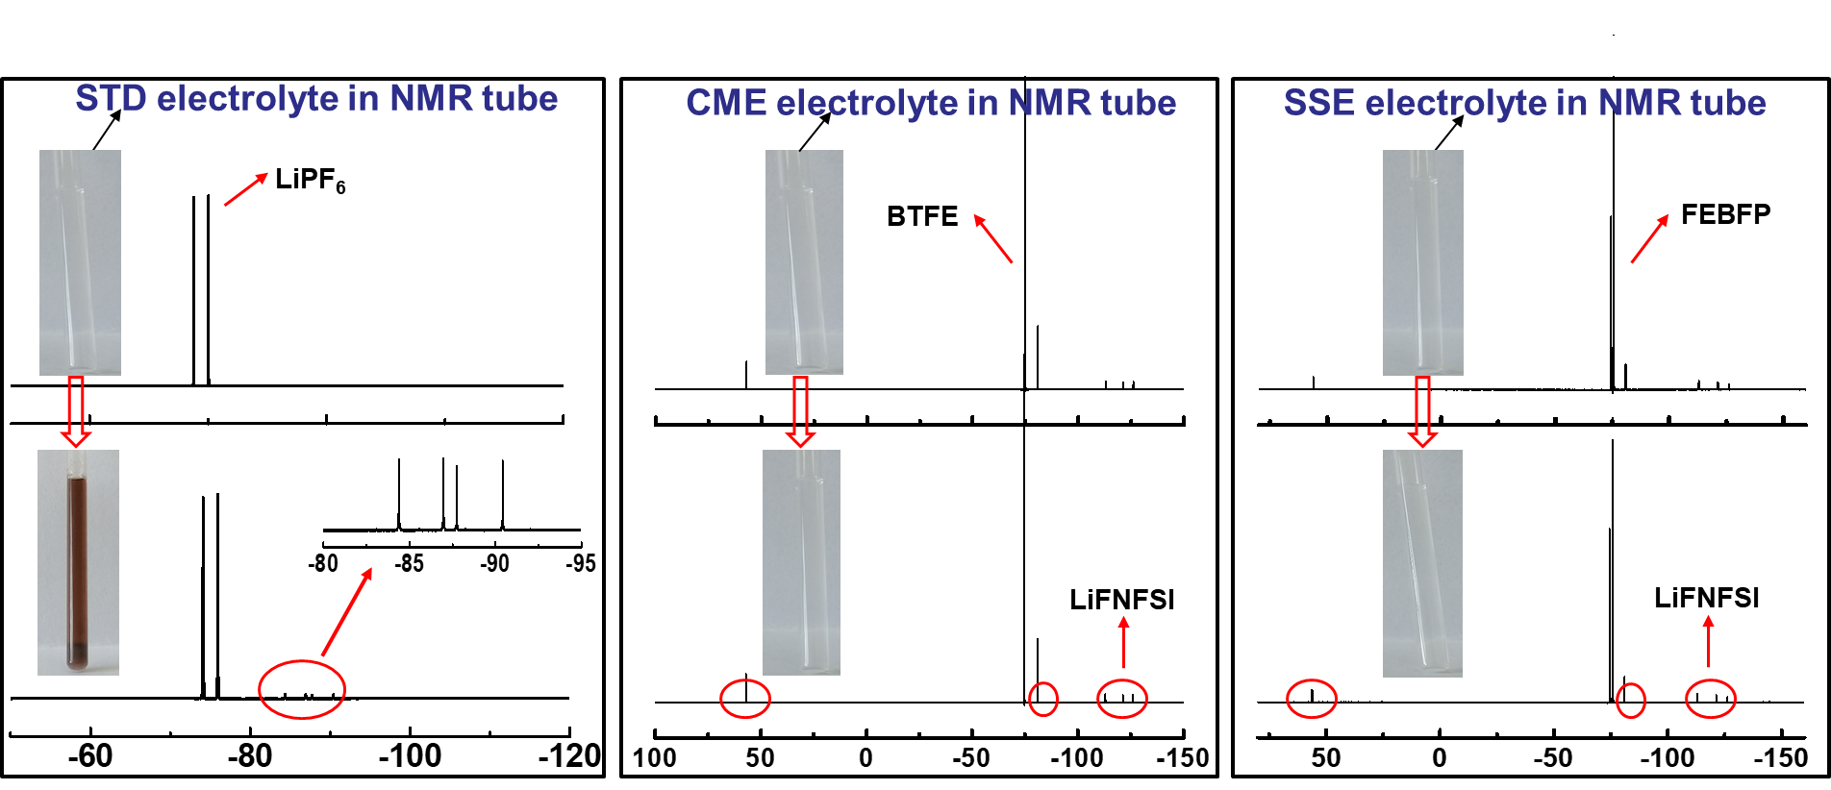
Supplementary Fig. 6. The ¹⁹F NMR of STD (left), CME (middle) and SSE (right) electrolytes before (up) and after (bottom) storing at 50 °C for two weeks.

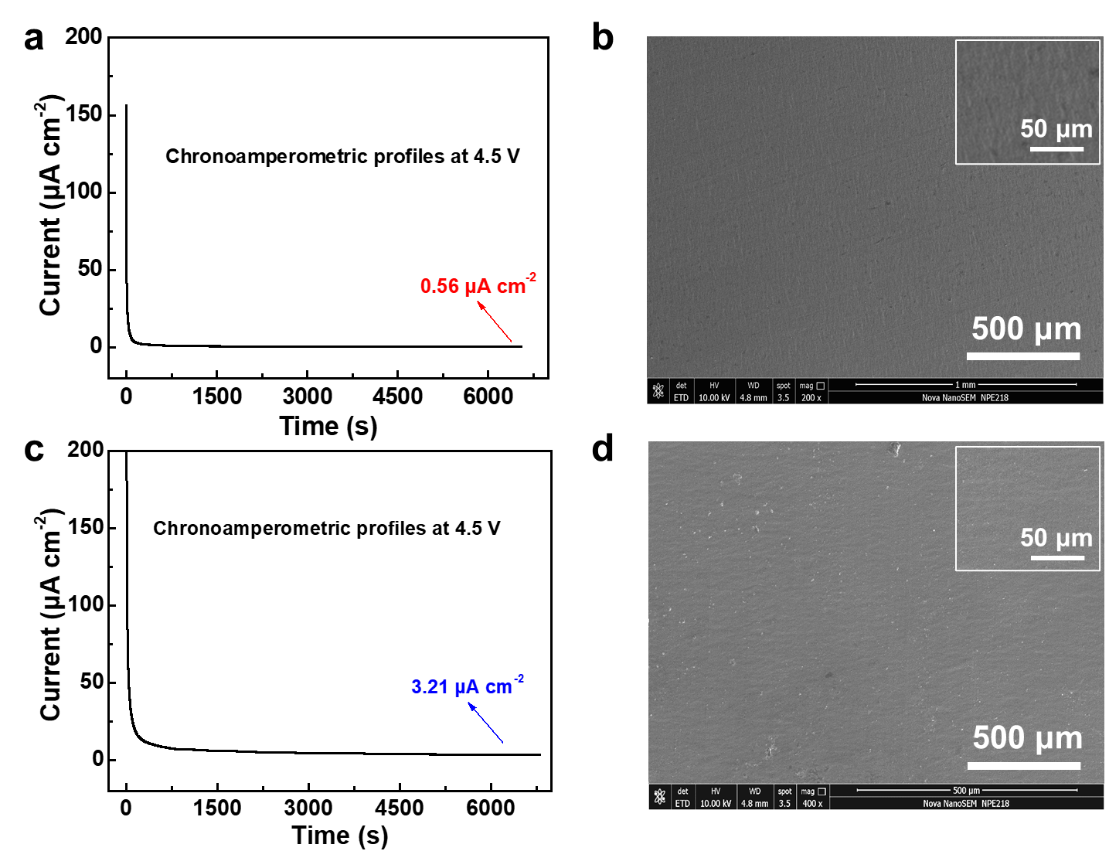
Supplementary Fig. 7. The electrochemical corrosion behaviors of SSE and CME electrolytes on Al current collector. (a, c) Chronoamperometric profiles recorded on Al electrode in SSE and CME electrolytes at 4.5V (vs. Li⁺/Li), respectively. (b, d) SEM images of Al electrode after the polarization test in (a) and (c), respectively.

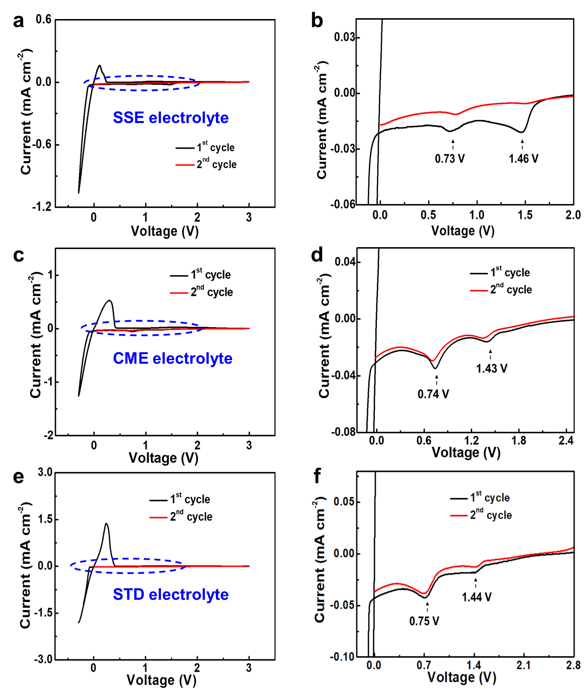
Supplementary Fig. 8. The CV profiles of different electrolytes as evaluated in Li||SS half-cell at a scanning rate of 1 mV s⁻¹ between -0.3 V and 3 V. (a) SSE; (c) CME; (e) STD. (b), (d) and (f) are the magnified area of the blue boxes in (a), (c) and (e), respectively.

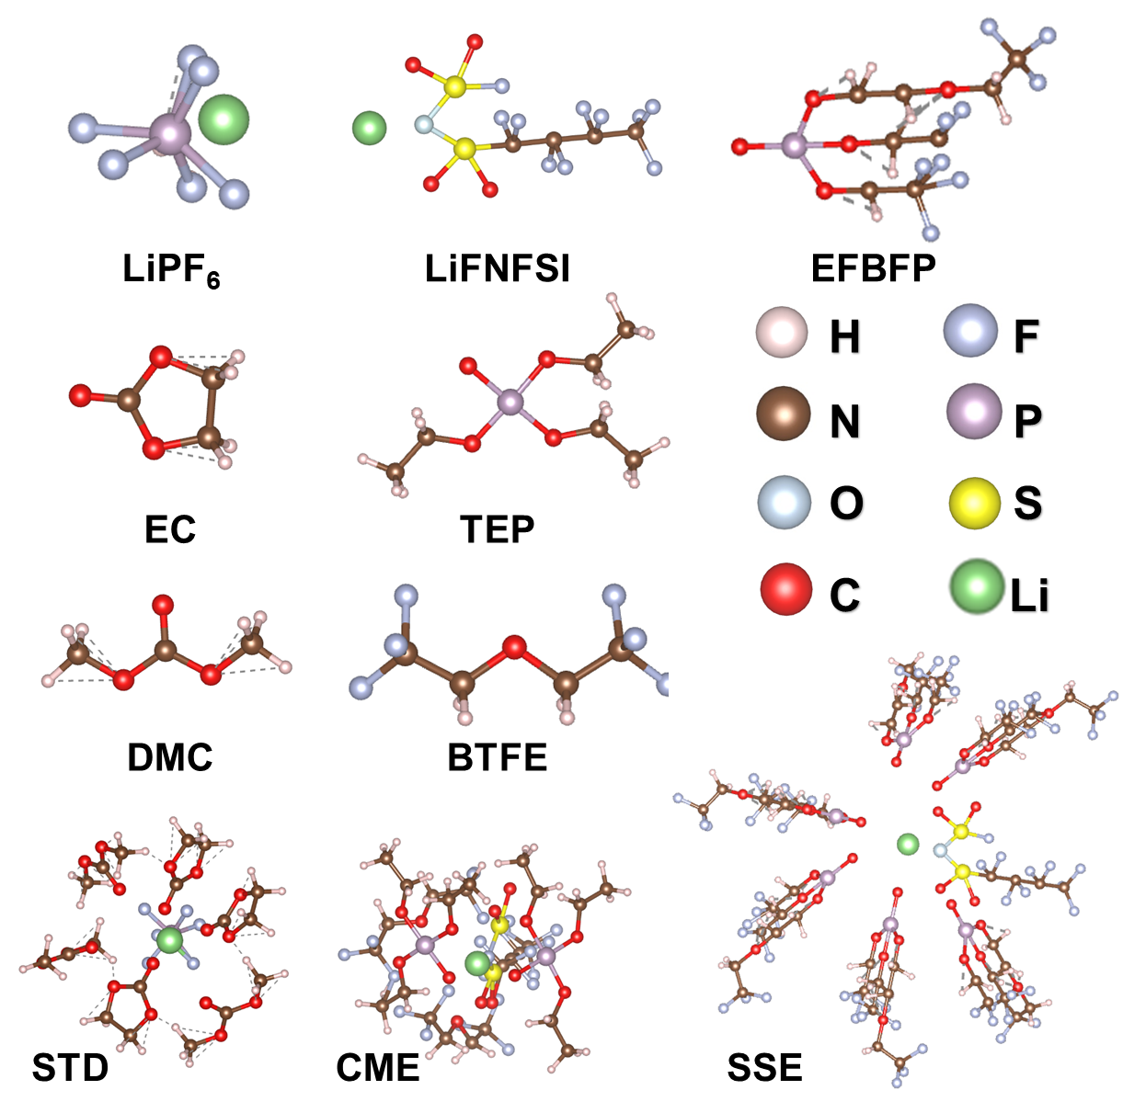
Supplementary Fig. 9. MD simulation of molecular structures and the representative solvation structures.

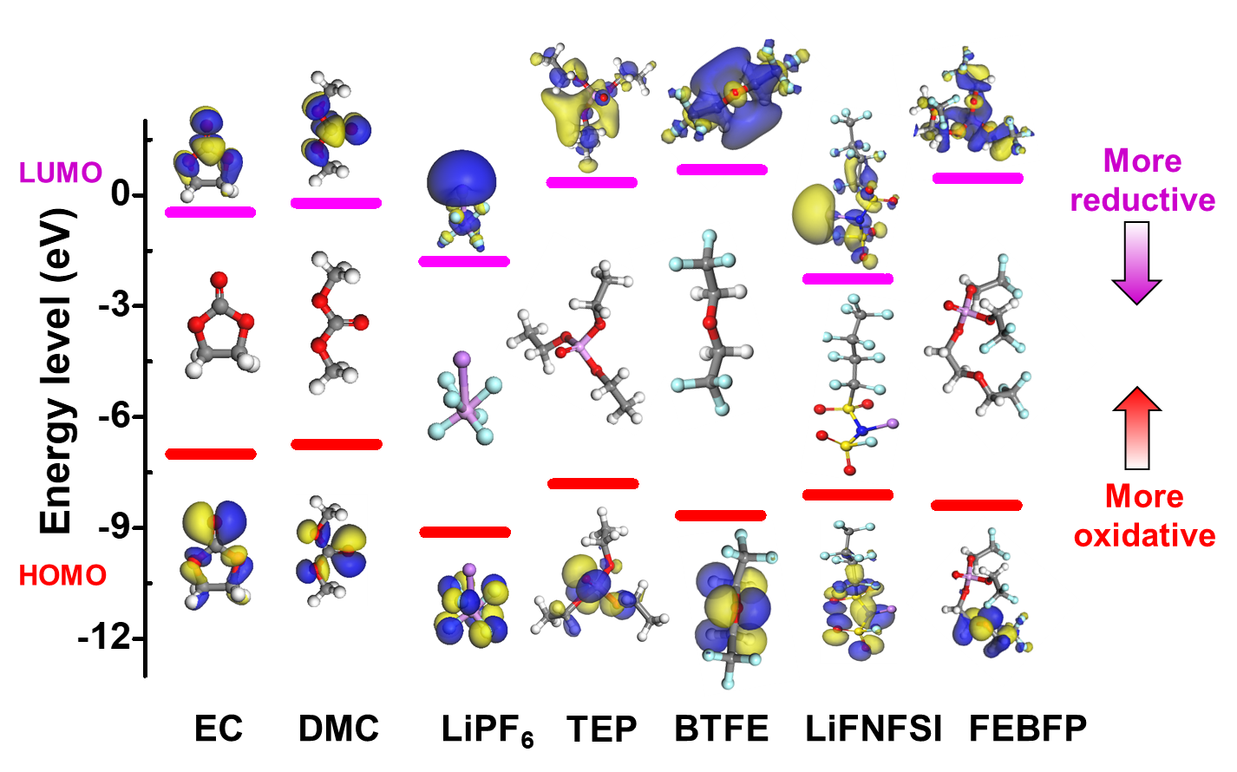
Supplementary Fig. 10. The LUMO and HOMO energy values of the composition in STD, CME, and SSE electrolytes.

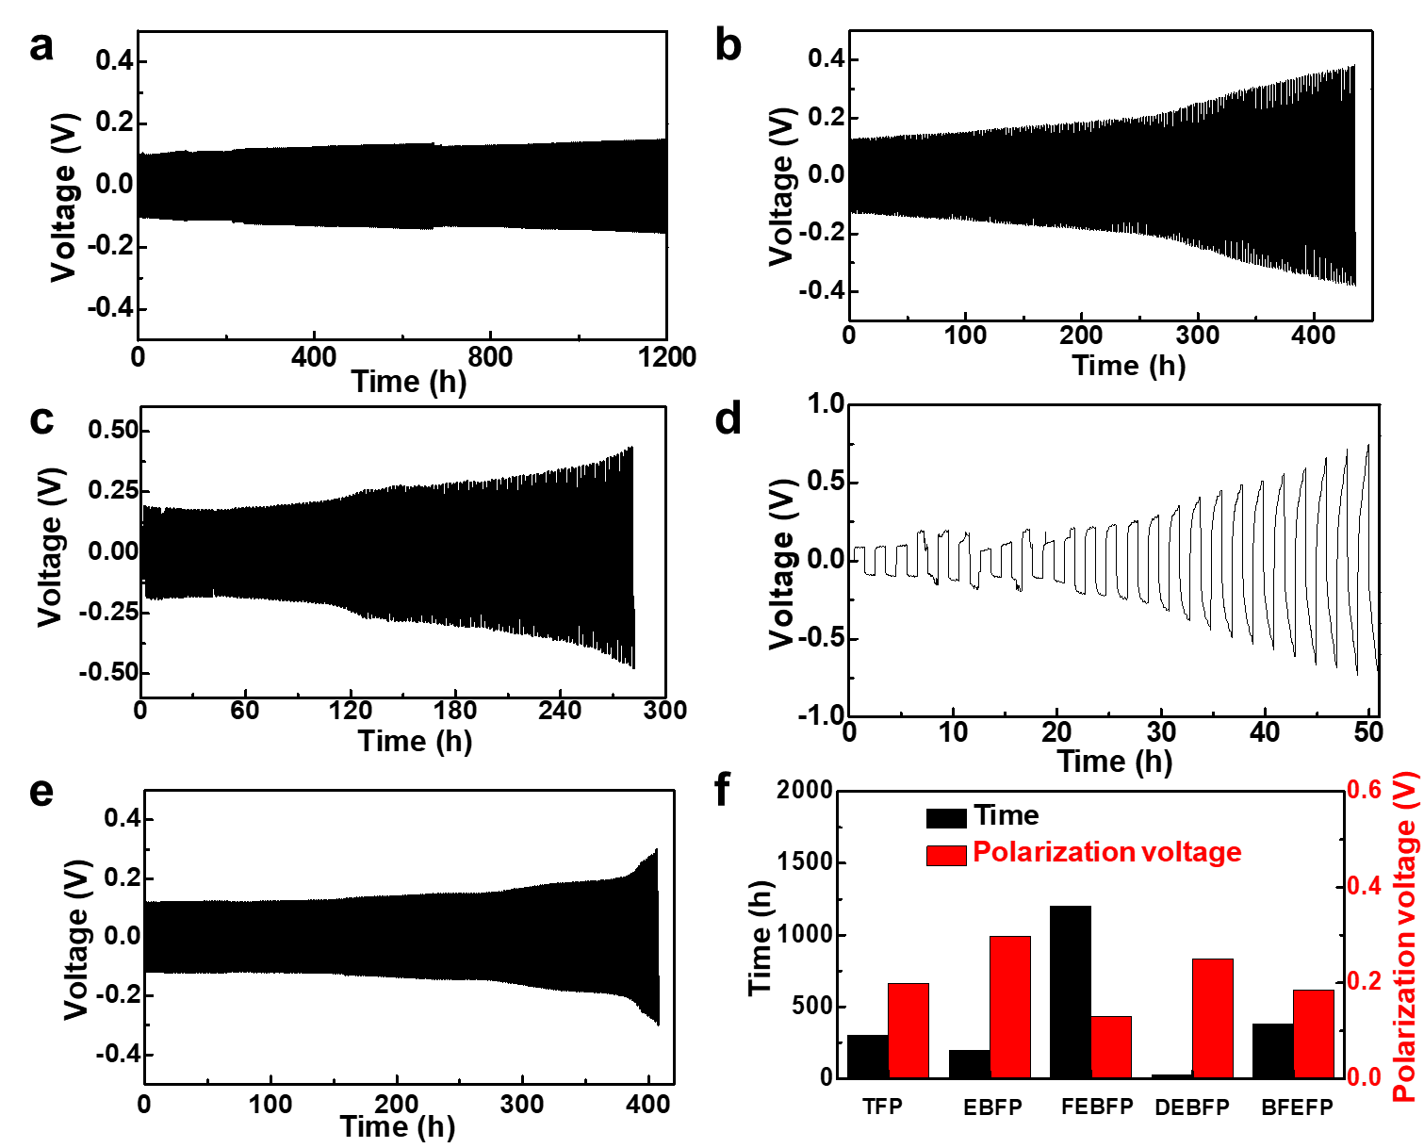
Supplementary Fig. 11. Galvanostatic time-overvoltage curves of symmetric Li||Li cells using 0.8 M LiFNFSI electrolytes with current density of 0.5 mA cm⁻² at 30 ℃. Solvents: (a) FEBFP; (b) TFP; (c) EBFP; (d) DEBFP; (e) BFEFP; (f) The life-time and polarization voltage of these electrolytes before their cycle-curves’ ﬂuctuation.

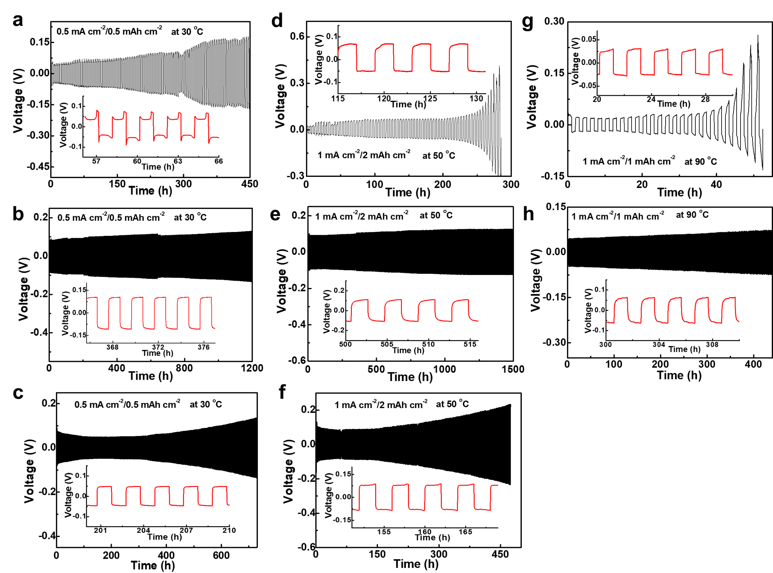
Supplementary Fig. 12. Galvanostatic time-voltage curves of symmetric Li||Li cells. (a, d, g), (b, e, h) and (c, f) are the cycling profiles of symmetric Li cells using STD, SSE and CME electrolytes, respectively. (a, b, c), (d, e, f) and (g, h) are tested at 30 ℃, 50 ℃ and 90 ℃, respectively.

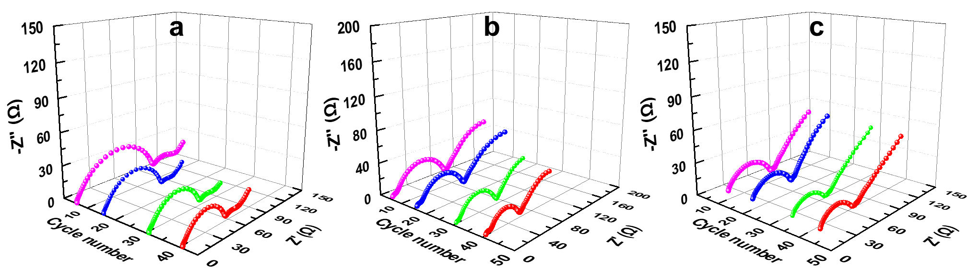
Supplementary Fig. 13. The EIS of symmetric Li cells in (a) STD, (b) CME and (c) SSE electrolytes with different cycles (5th, 15th, 30th, and 40th) at 30 ℃.

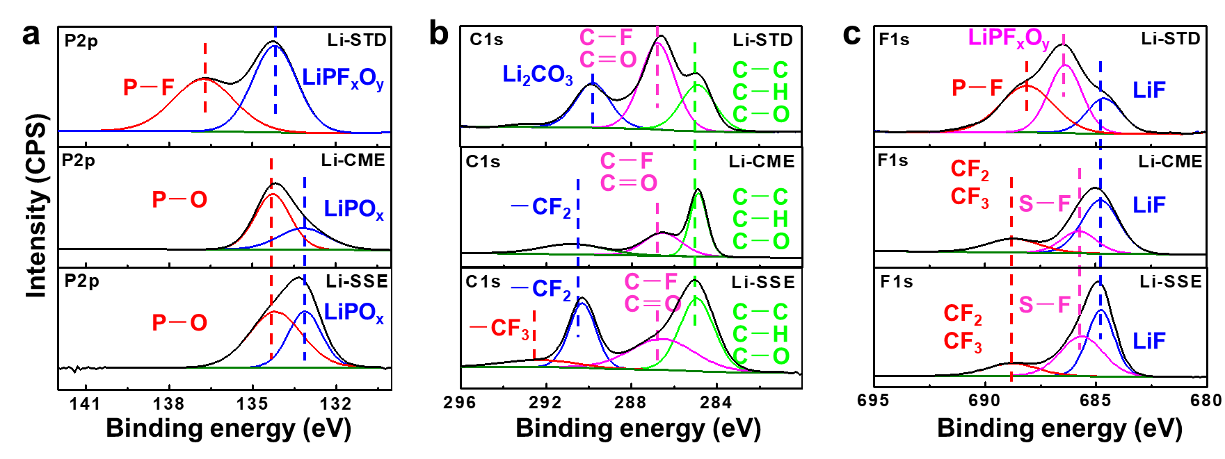
Supplementary Fig. 14. The XPS for the cycled Li anode. (a) P2p, (b) C1s, and (c) F1s XPS spectra for the Li anodes cycled in STD (top row), CME (middle row) and SSE (bottom row) electrolytes, respectively.

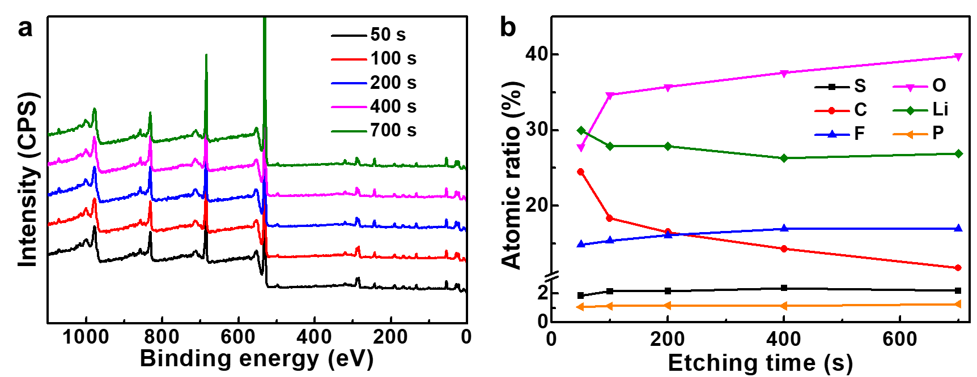
Supplementary Fig. 15. The XPS characterization of Li electrode cycled in SSE electrolyte for 100 times. (a) The XPS spectra with different sputter time from 50 to 700s. (b) Depth-dependent elemental distributions.

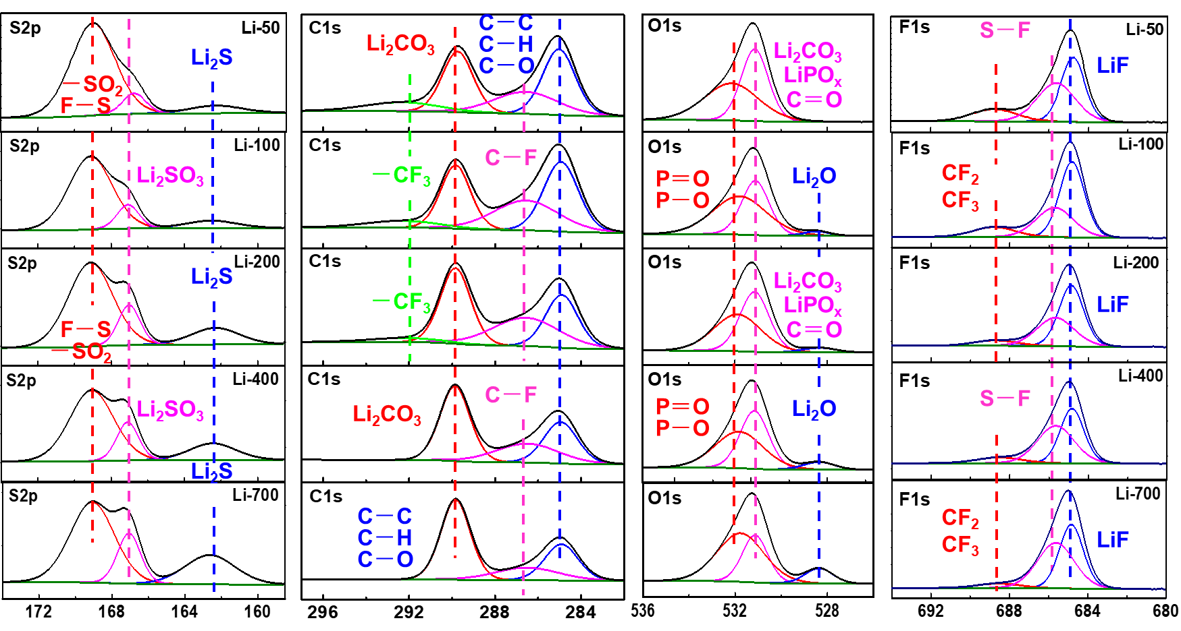
Supplementary Fig. 16. Characterization of the SEI components on Li anode after 100 cycles in SSE electrolyte by XPS. The XPS depth profiles of S2p, C1s, O1s and F1s after sputtering for 50, 100, 200, 400 and 700 s.

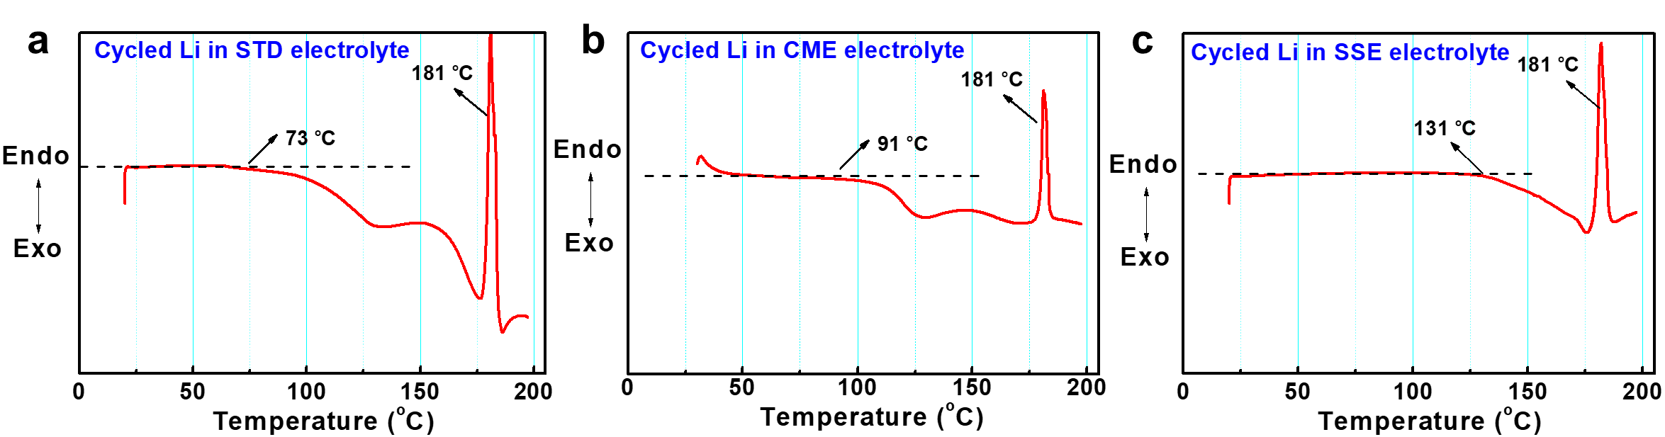
Supplementary Fig. 17. The DSC tests of Li electrodes, cycled in (a) STD, (b) CME and (c) SSE electrolytes for 100 times, with a heating rate of 5 °C min⁻¹ under Ar protection. The cycled Li electrodes samples were pretreated in the same way as the SEM measurement.

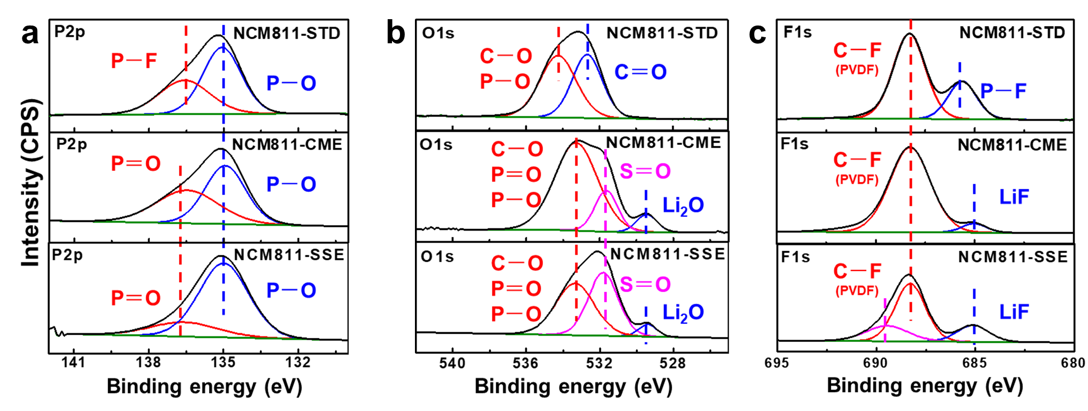
Supplementary Fig. 18. The XPS for the cycled NCM811 cathode. The XPS of (a) P2p, (b) O1s, and (c) F1s spectra for the cycled NCM811 cathode in STD (top row), CME (middle row) and SSE (bottom row) electrolytes, respectively.

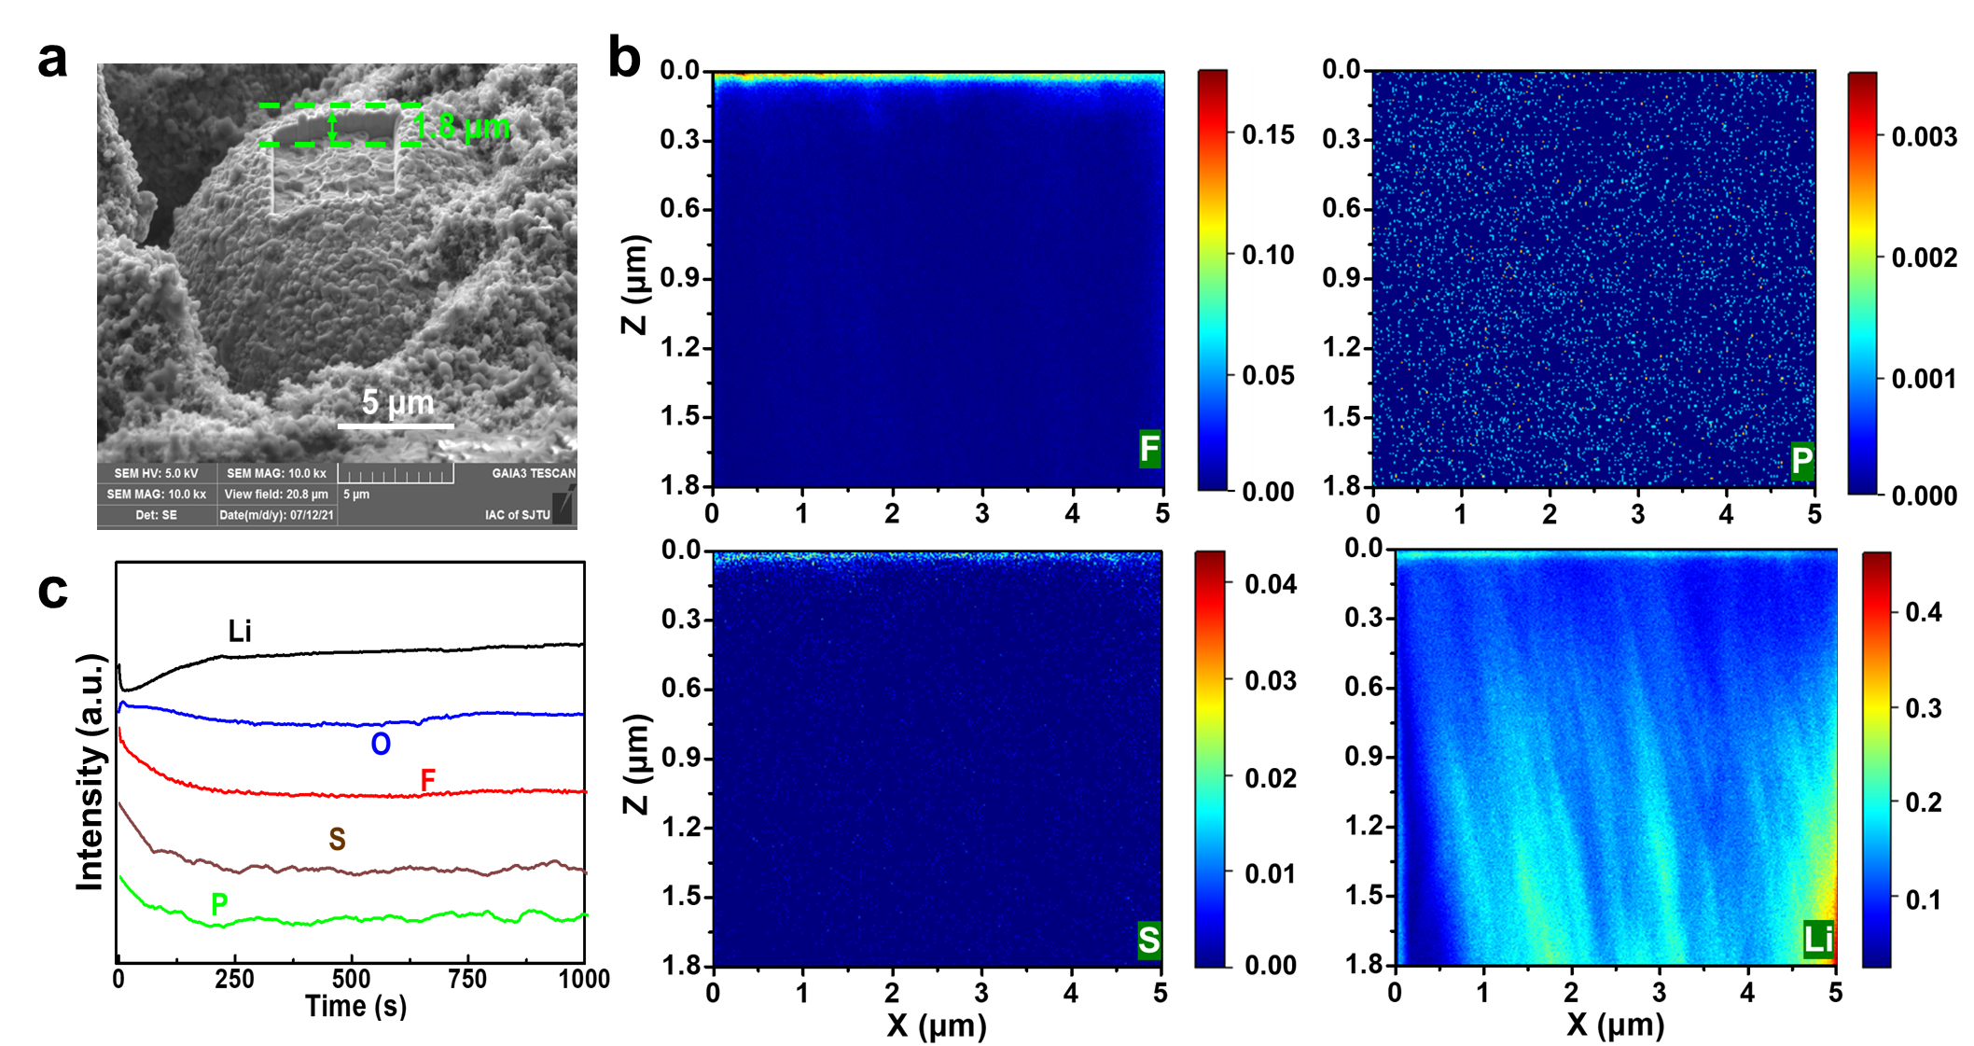
Supplementary Fig. 19. Characterization of the CEI layer of cycled NCM811 cathode. (a) Surface morphology of NCM811 particle after 100 cycles in SSE electrolyte for time-of-flight secondary ion mass spectrometry (TOF-SIMS) and the crater is sputtered by Ga⁺ ion beam. (b) The top-view, and depth profiles of TOF-SIMS analysis for boron (B), phosphorus (P), lithium (Li), and fluorine (F) elements on the cycled active particles. (c) The corresponding Li, O, F, B and P element distributions in the sputtered active particle.

Supplementary Fig. 20. The proposed decomposition processes of SSE electrolyte in the Li||NCM811 cell during cycling. Its reductive decomposition on the anode (up), and its oxidative decomposition on the cathode (bottom). (Rf = -CH₂CF₃ or -CH₂CH₂-O-CH₂CF₃)

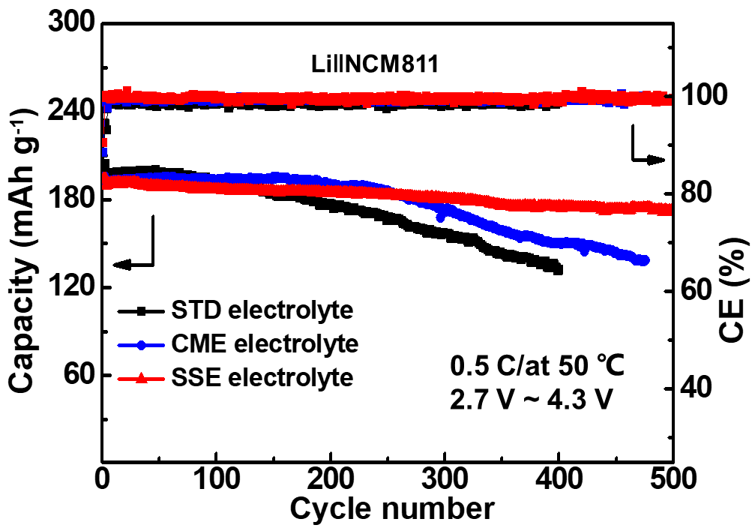

Supplementary Fig. 21. Cycle performance of Li||NCM811 cells at 50 ℃ up to 4.3 V with different electrolytes.

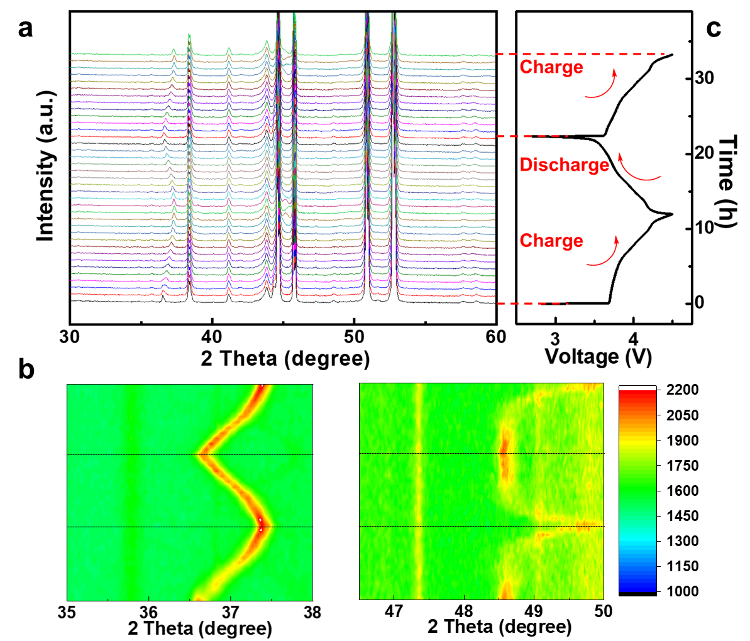
Supplementary Fig. 22. (a, b) In-situ XRD spectra of NCM811 cathode and (c) Galvanostatic charge/discharge curves during the 1st charge/discharge and the 2nd charge using SSE electrolyte at 0.1 C.

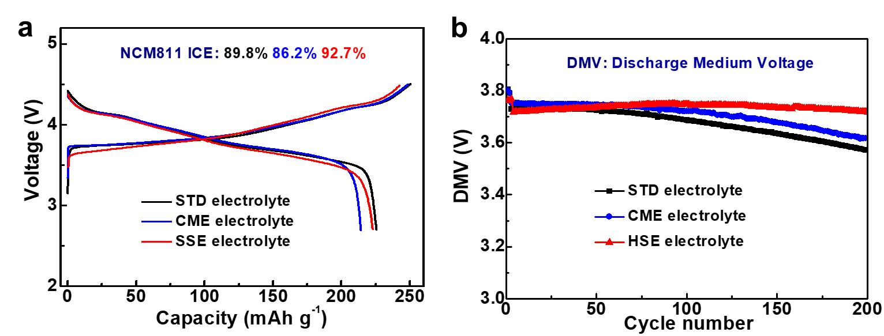
Supplementary Fig. 23. (a) The initial columbic efficiencies and charge-discharge profiles of the Li||NCM811 cells using different electrolytes up to 4.5 V. (b) The discharge medium voltage of Li||NCM811 cells from Fig.5b.

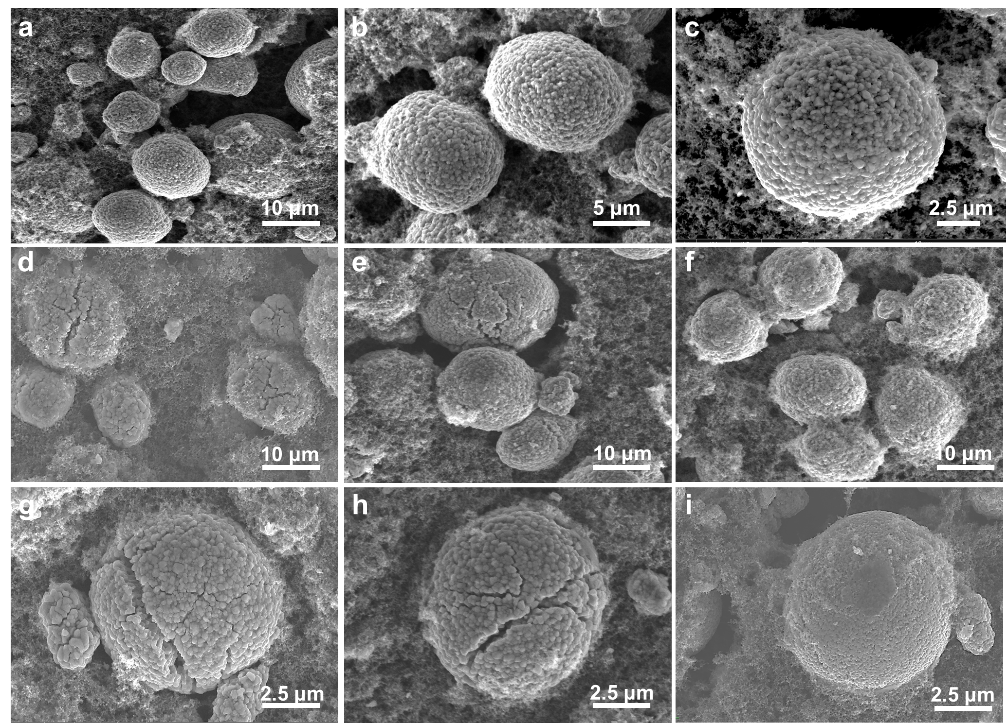
Supplementary Fig. 24. SEM images of NCM811cathodes before and after cycling. (a, b, c) Pristine NCM811cathodes. (d, g), (e, h) and (f, i) NCM811cathodes cycled in STD, CME, and SSE electrolytes up to 4.5 V for 200 times, respectively.

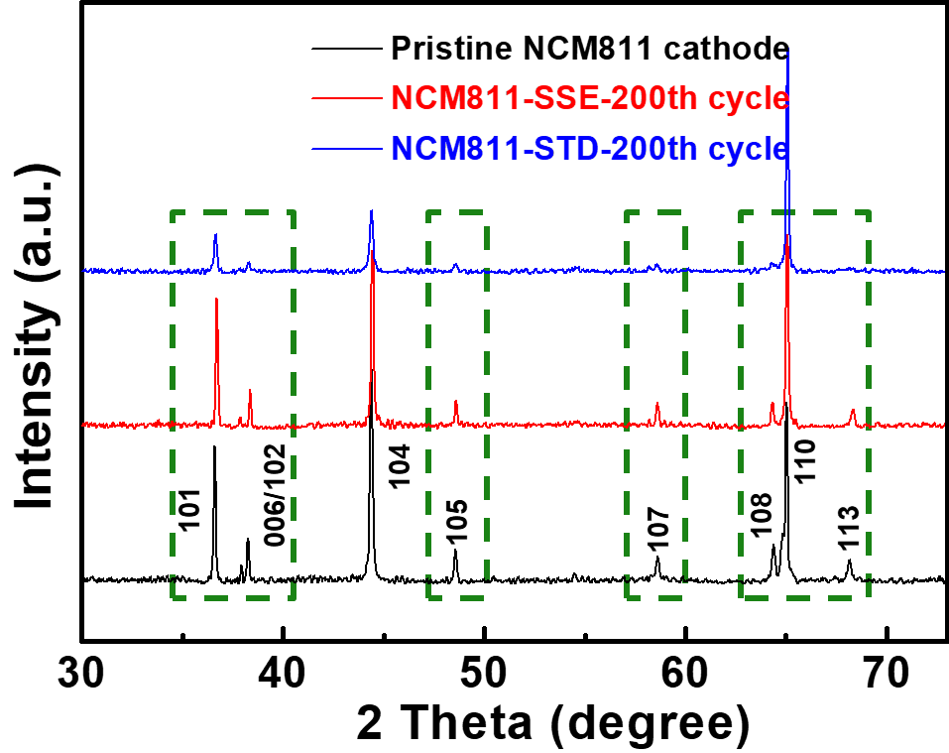
Supplementary Fig. 25. The XRD patterns of NCM811 cathode before and after cycling in different electrolytes.

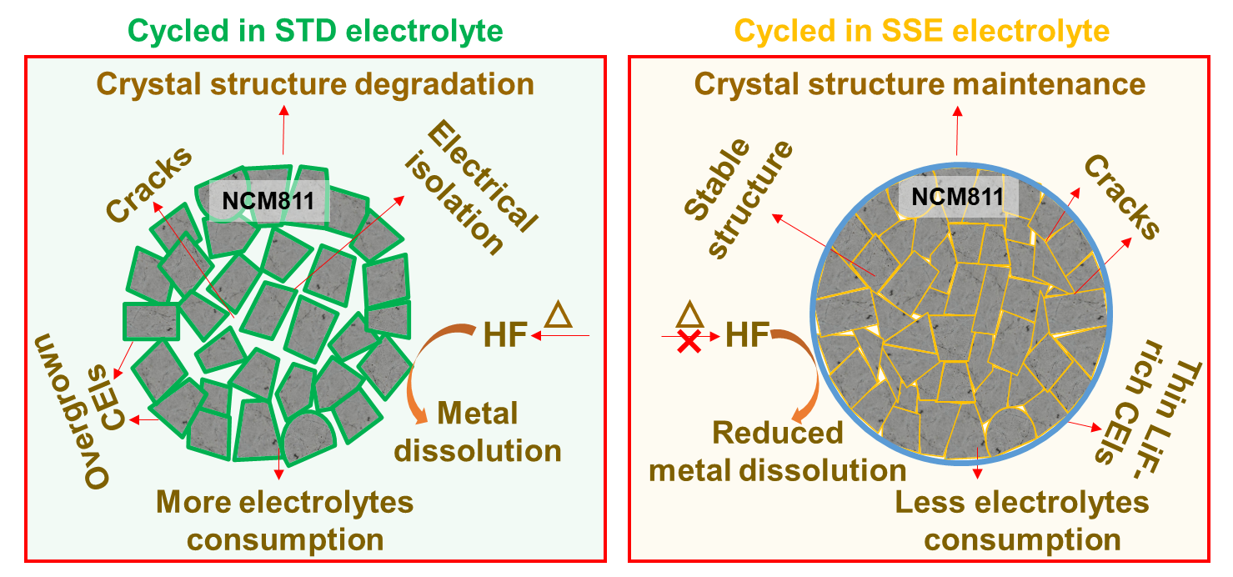
Supplementary Fig. 26. Proposed schematic of NCM811 secondary particles and interfaces cycled in STD (left) and SSE (right) electrolytes.

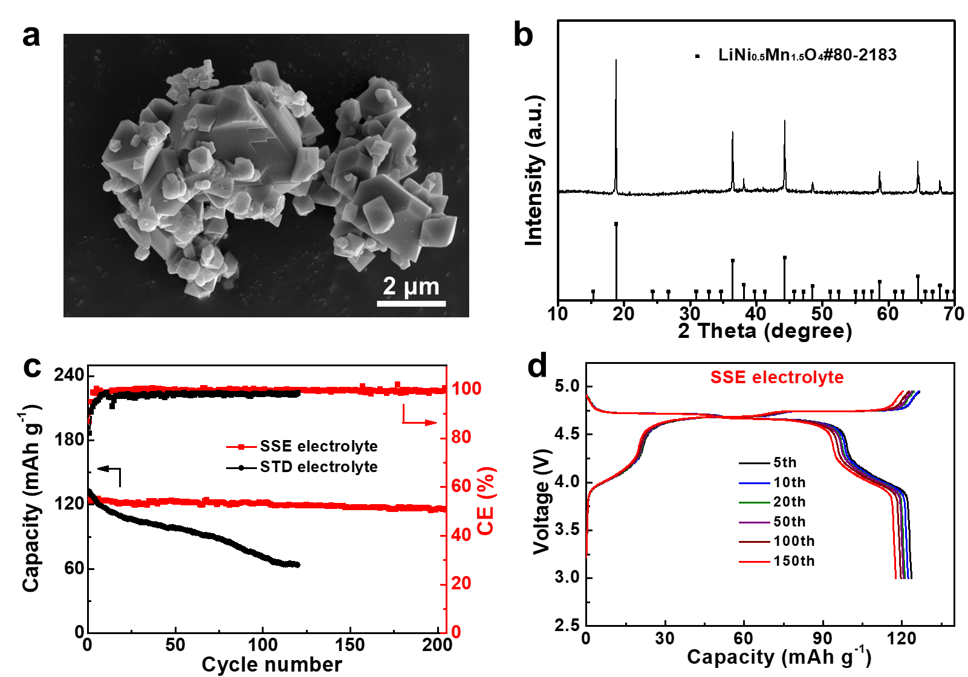
Supplementary Fig. 27. The characterization of LNMO material. (a) SEM. (b) XRD. (c) The cycle performance of Li|| LNMO cells cycled in different electrolytes at 50 ℃. (d) The selected discharge-charge curves (5th, 10th, 20th, 50th and 100th, and 150th).

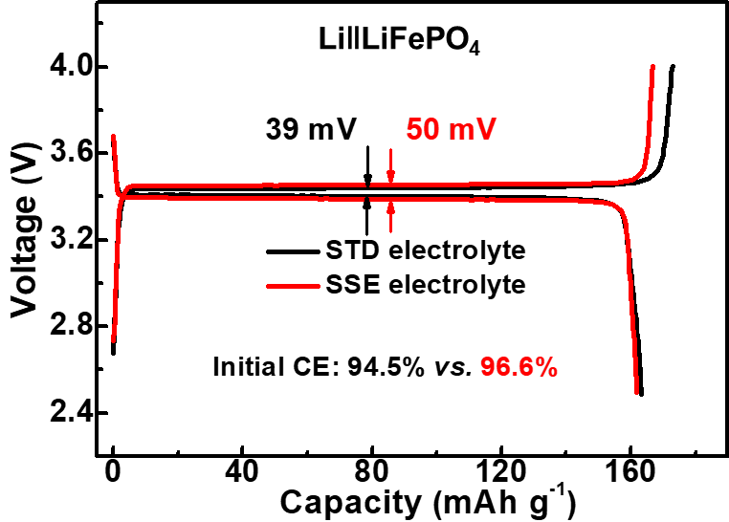
Supplementary Fig. 28. The initial CEs and charge-discharge profiles of the Li||LiFePO₄ cells using different electrolytes at 0.5 C.

References
- Han, H., Guo, J., Zhang, D., Feng, S., Feng, W., Nie, J. & Zhou, Z. Lithium (fluorosulfonyl)(nonafluorobutanesulfonyl)imide (LiFNFSI) as conducting salt to improve the high-temperature resilience of lithium-ion cells. Electrochem. Commun. 13, 265-268 (2011).
- Yu. Z. et al. Molecular design for electrolyte solvents enabling energy-dense and long-cycling lithium metal batteries. Nat. Energy, 5, 526-533 (2020).
- Adams, B. D., Zheng, J., Ren, X., Xu W. & Zhang, J.-G. Accurate determination of Coulombic efficiency for lithium metal anodes and lithium metal batteries. Adv. Energy Mater. 8, 1702097 (2018).
- Zugmann, S. et al. Measurement of transference numbers for lithium-ion electrolytes via four different methods, a comparatives study. Electrochim. Acta 56, 3926-3933 (2011).
- Xu, Z. et al. Enhanced performance of a lithium-sulfur battery using a carbonate-based electrolyte. Angew.Chem. Int. Ed., 55,10372-10375 (2016).

