Appendix A

Increasing Level of Community Involvement, Impact, Trust and Communication Flow

Outreach | Consultation | Involvement | Collaboration | Shared leadership
Some community involvement  Communication flows from one to the other to inform  Provides community with information  Entities coexist  Outcomes: optimally establishes communication channels and channels for outreach | More community involvement  Communication flows to the community and then back, answer seeking  Gets information or feedback from the community  Entities share information  Outcomes: develops connections | Better community involvement  Communication flows both ways, participatory form of communication  Involves more participation with community or issues  Entities cooperate with each other  Outcomes: visibility of partnership established with increased cooperation | Community involvement  Communication flow bidirectional  Forms partnership with community on each aspect of project from development to solution  Entities form bidirectional communication channels  Outcomes: partnership building, trust building | Strong bidirectional relationship  Final decision-making at community level  Entities have formed strong partnership structures  Outcomes: broader health outcomes affecting broader community, strong bidirectional trust built
Community Engagement Continuum, Clinical and Translational Science Awards Consortium, 2011.

Appendix B

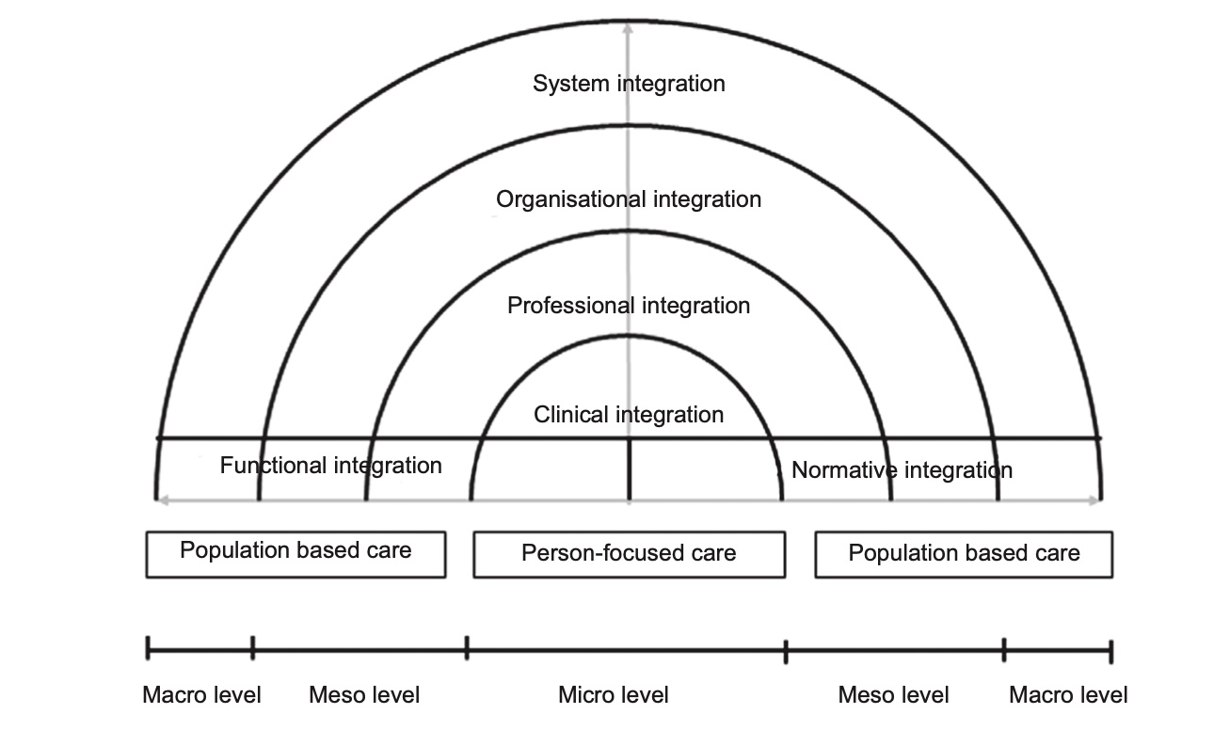
The Rainbow Model for Integrated Care by P.P. Valentijn, 2015. Copyright 2017 by Essenburgh Group, Harderwijk, the Netherlands. Reproduced with permission.

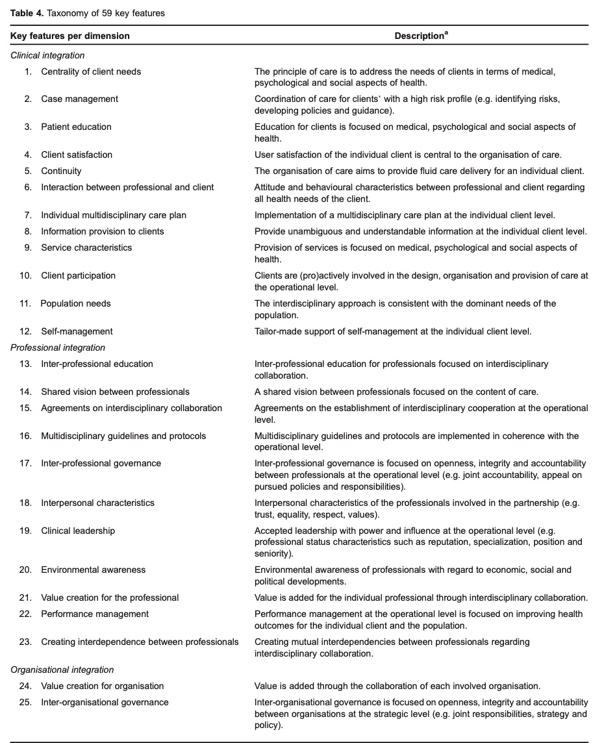
(Valentijn et al., 2015)

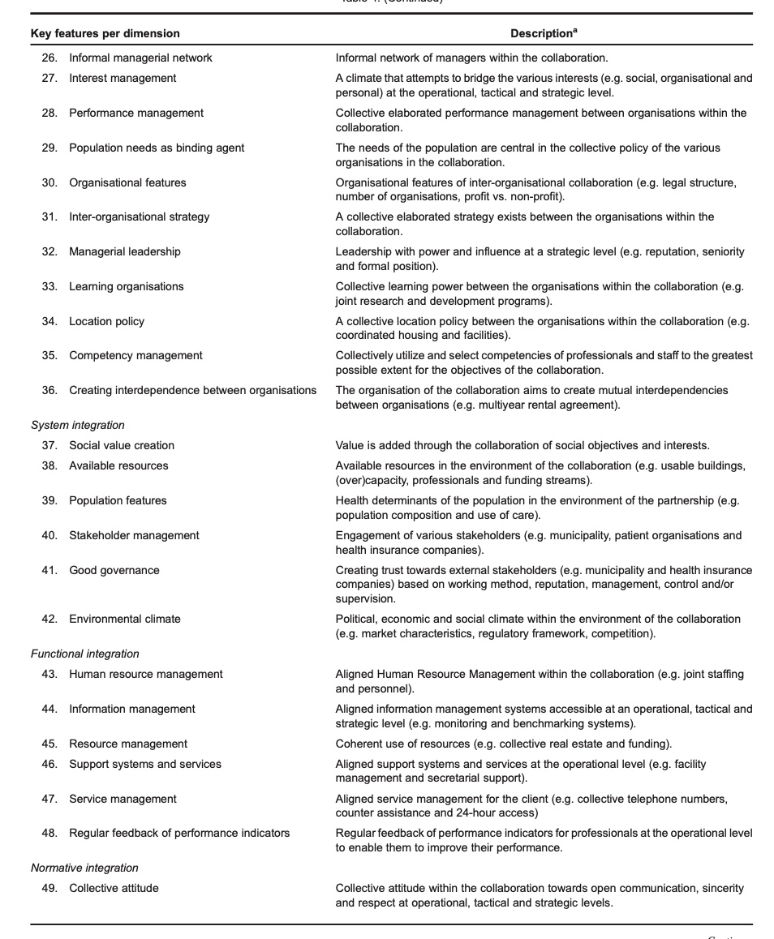
(Valentijn et al., 2015)

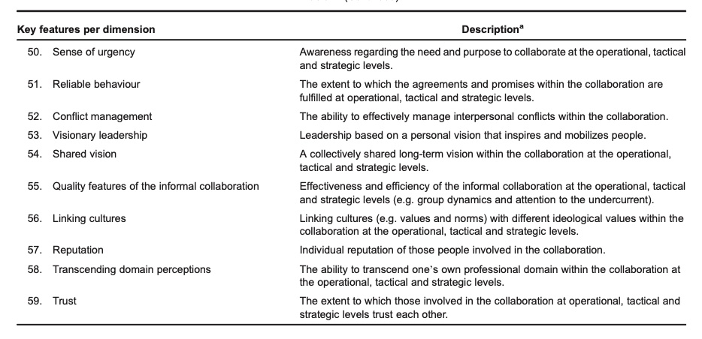
(Valentijn et al., 2015)

Appendix C

2521 studies imported for screening

8 duplicates removed

2410 studies irrelevant
2513 studies screened

90 studies excluded
- 25 Perspectives not shared from all stakeholders
- 20 Wrong study design
- 19 Not community engagement focused
- 16 Perspectives/Beliefs not reviewed
- 10 Focused on CBPR process
103 full-text studies assessed for eligibility

13 studies included

Appendix D

Author/Year/  Country of study | Level of Community Engagement | Type of Integration | Aim(s)/Purpose | Design/Method | Context/Setting/  Sample | Key Findings
Cicognani et al. (2020), Italy | Collaboration | Clinical  Professional  Organizational  System  Normative | To test influence of quality of collaboration within partnership: empowerment, sense of community, perceived effectiveness and trust for future | Quantitative  Cross-sectional survey | Regional community health partnership, across 6 sites  N=238 | Higher perceived quality of collaboration enhances outcomes of partnership  -feeling of belonging predicts efficacy, commitment and trust
Connaughton-Espino et al. (2021)  USA | Outreach | Clinical  Professional  Organization  System  Functional  Normative | Community mobilization strategy, cross-sector collaboration to reduce teen pregnancy | Qualitative  Survey, focus group | Community Advisory Council N=22 | Cross-sector collaborations take time and commitment to be effective.  -power dynamic evident and hinderance
Crooks et al. (2017)  USA | Shared leadership | Clinical  Professional  Organizational  System  Functional  Normative | Multi-sectoral agencies plan, implement and evaluate a multi-focus domestic violence health education program | Qualitative  Semi-structured interviews | Collaborative partners  N=5 | Collaboration essential for outcomes:  -shared mission/vision  -trust  -distributive leadership
Enard et al. (2021)  USA | Outreach | Clinical  Professional  Organizational  System  Normative | CBPR guided partnership to improve breast and prostate cancer outcomes in community | Qualitative  Semi-structured interviews | Key academic, community informants, community collaborators  N=26 | Mutually beneficial relationship improved access to services, however:  -power dynamic evident  -participatory decision making impacted
Lee et al. (2020)  USA | Involvement | Clinical  Professional  Organizational  System  Functional  Normative | Identify factors in multi-site obesity project that contribute to project sustainability | Qualitative  Semi-structured interviews | Key informants and investigators from three project sites  N=27 | Benefits sustained through strong partnerships and evidenced based strategies, facilitated through institutionalization and policy
Middleton et al. (2014)  UK | Consultation | Clinical  Professional  Organizational  System  Functional  Normative | Experiences of stakeholders in large community based obesity prevention program | Qualitative  Semi-structured interviews  Focus groups | Three stakeholder groups  N=28 | Quality of program shaped and constrained by partnership and integration of services  -takes time to establish working partnerships
Provan et al. (2003)  USA | Involvement | Clinical  Professional  Organizational  System  Normative | Explore evolution of network of health and service organizations in a rural community: chronic disease education | Mixed methods:  Survey  Focus groups  Longitudinal (over two years) | Representatives from organizations in community  N=25 | Efforts to build community capacity through local organizations can be successful through shared information  -trust variable as new relationships develop
Pursell & Kearns (2012)  Europe | Outreach | Clinical  Professional  Organizational  System  Normative | Evaluation of health impact assessment on community participation, intersectoral and interagency partnerships | Qualitative  Semi-structured interviews | Community representatives and service organizations  N=21 | Dimensions of intersectoral working need attention  -power imbalances noted between sectors
Schulz et al. (2001)  USA | Outreach/  consultation | Clinical  Professional  Organizational  System  Normative | Health worker partnership (CBPR) to reduce health disparities in a community | Qualitative  Semi-structured interviews | Steering committee and Village Health Workers  N=41 | Modest success of program – group divided, and power differential felt
Shan et al. (2012).  Canada | Collaboration | Clinical  Professional  Organizational  System  Functional  Normative | Early childhood intervention program created to enhance community social capital and social cohesion | Qualitative  Semi-structured interviews  Focus groups | Home visitor team  N = 87  Provincial government stakeholders  N=155 | Community collaboration enhanced, institutional social capital developed and improved agency among clients/families  Noted government commitment, local ownership, and leadership
Skivington et al. (2018)  UK | Consultation | Clinical  Professional  Organizational  System  Functional  Normative | Investigate issues related to social prescribing in order to improve intersectoral working | Qualitative  Semi-structured interviews | Community organization representatives and practitioners  N=36 | Practitioners acted as a bridge between organizations, but not within program, siloed work  -capacity and funding acted as barriers
van Dijk et al. (2016)  Europe | Consultation | Clinical  Professional  Organizational  System  Functional  Normative | Explore experiences of stakeholders involved in integrated neighbourhood approaches. | Qualitative  Semi-structured interviews | Integrated Neighbourhood Partners  N=21 | Integrated care through neighbourhood approaches achieved at personal service level and occasionally at professional level  Bottom-up initiatives, not aligned with top-down incentives
Zhu et al. (2019)  USA | Consultation/  involvement |  | Examine types and forms of cross-sector collaboration in rural communities, barriers and facilitators to support community health | Qualitative  Semi-structured interviews | Key informants from multi-sector health organizations  N=22 | Rural communities use cross-sector collaborations to address community health issues, facilitated by shared governance, but lasting partnerships are rare

