Table 1. The time spent on training in immersive 360°VR by the three groups and the time spent on the physical examination in dyads or triads. The graduation of the students’ performance of the clinical tests (2 = the performance reaches the objective learning requirements, 1 = the students perform the test and do not reach the objective learning requirements, 0 = the students perform the test incorrectly, - = the students do not perform the test)
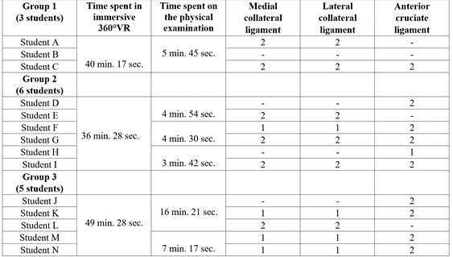
Table 2. A record of the groups use of the software tools and communicative strategies to solve the problem of performing the physical test.
