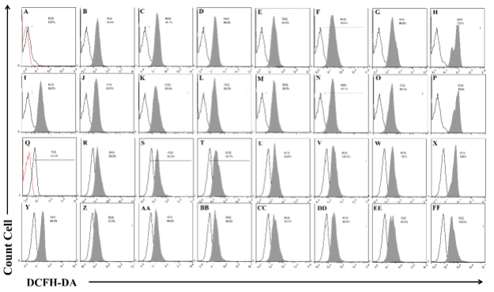 | Fig S1a: Reactive oxygen species generation was determined by DCF-DA flow cytometry for 4T1 cancer cells exposed with different concentration of H₂O₂ or H₂O₂ +HA in normoxia and hypoxia condition for 24h. A: Control Normoxia, B: H₂O₂ 10µM Normoxia, C: H₂O₂ 20µM Normoxia, D: H₂O₂ 50µM Normoxia, E: H₂O₂ 100µM Normoxia, F: H₂O₂ 200µM Normoxia, G: H₂O₂ 500µM Normoxia, H: H₂O₂ 1000µM Normoxia, I: HA Normoxia, J: H₂O₂ 10µM+HA Normoxia, K: H₂O₂ 20µM+HA Normoxia, L: H₂O₂ 50µM+HA Normoxia, M: H₂O₂ 100µM+HA Normoxia, N: H₂O₂ 200µM+HA Normoxia, O: H₂O₂ 500µM+HA Normoxia, P: H₂O₂ 1000µM+HA Normoxia, Q: Control Hypoxia, R: H₂O₂ 10µM Hypoxia, S: H₂O₂ 20µM Hypoxia, T: H₂O₂ 50µM Hypoxia, U: H₂O₂ 100µM Hypoxia, V: H₂O₂ 200µM Hypoxia, W: H₂O₂ 500µM Hypoxia, X: H₂O₂ 1000µM Hypoxia, Y: HA Hypoxia, Z: H₂O₂ 10µM+HA Hypoxia, AA: H₂O₂ 20µM+HA Hypoxia, BB: H₂O₂ 50µM+HA Hypoxia, CC: H₂O₂ 100µM+HA Hypoxia, DD: H₂O₂ 200µM+HA Hypoxia, EE: H₂O₂ 500µM+HA Hypoxia, FF: H₂O₂ 1000µM+HA Hypoxia.

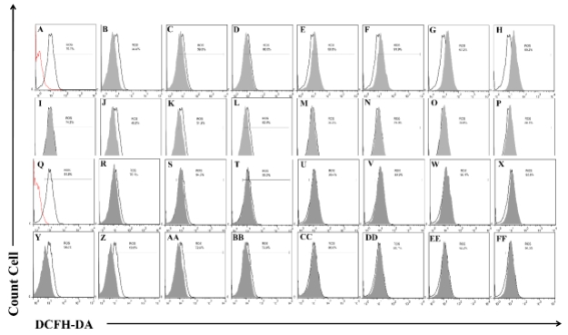 | Fig S1b: Reactive oxygen species generation was determined by DCF-DA flow cytometry for MNCs exposed with different concentration of H₂O₂ or H₂O₂ +HA in normoxia and hypoxia condition for 24h. A: Control Normoxia, B: H₂O₂ 10µM Normoxia, C: H₂O₂ 20µM Normoxia, D: H₂O₂ 50µM Normoxia, E: H₂O₂ 100µM Normoxia, F: H₂O₂ 200µM Normoxia, G: H₂O₂ 500µM Normoxia, H: H₂O₂ 1000µM Normoxia, I: HA Normoxia, J: H₂O₂ 10µM+HA Normoxia, K: H₂O₂ 20µM+HA Normoxia, L: H₂O₂ 50µM+HA Normoxia, M: H₂O₂ 100µM+HA Normoxia, N: H₂O₂ 200µM+HA Normoxia, O: H₂O₂ 500µM+HA Normoxia, P: H₂O₂ 1000µM+HA Normoxia, Q: Control Hypoxia, R: H₂O₂ 10µM Hypoxia, S: H₂O₂ 20µM Hypoxia, T: H₂O₂ 50µM Hypoxia, U: H₂O₂ 100µM Hypoxia, V: H₂O₂ 200µM Hypoxia, W: H₂O₂ 500µM Hypoxia, X: H₂O₂ 1000µM Hypoxia, Y: HA Hypoxia, Z: H₂O₂ 10µM+HA Hypoxia, AA: H₂O₂ 20µM+HA Hypoxia, BB: H₂O₂ 50µM+HA Hypoxia, CC: H₂O₂ 100µM+HA Hypoxia, DD: H₂O₂ 200µM+HA Hypoxia, EE: H₂O₂ 500µM+HA Hypoxia, FF: H₂O₂ 1000µM+HA Hypoxia.

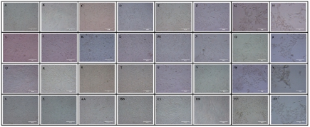 | Fig S2a. Morphological changes of 4T1 cancer cells in treatments with different in normoxia and hypoxia conditions for 24h. A: Control Normoxia, B: H₂O₂ 10µM Normoxia, C: H₂O₂ 20µM Normoxia, D: H₂O₂ 50µM Normoxia, E: H₂O₂ 100µM Normoxia, F: H₂O₂ 200µM Normoxia, G: H₂O₂ 500µM Normoxia, H: H₂O₂ 1000µM Normoxia, I: HA Normoxia, J: H₂O₂ 10µM+HA Normoxia, K: H₂O₂ 20µM+HA Normoxia, L: H₂O₂ 50µM+HA Normoxia, M: H₂O₂ 100µM+HA Normoxia, N: H₂O₂ 200µM+HA Normoxia, O: H₂O₂ 500µM+HA Normoxia, P: H₂O₂ 1000µM+HA Normoxia, Q: Control Hypoxia, R: H₂O₂ 10µM Hypoxia, S: H₂O₂ 20µM Hypoxia, T: H₂O₂ 50µM Hypoxia, U: H₂O₂ 100µM Hypoxia, V: H₂O₂ 200µM Hypoxia, W: H₂O₂ 500µM Hypoxia, X: H₂O₂ 1000µM Hypoxia, Y: HA Hypoxia, Z: H₂O₂ 10µM+HA Hypoxia, AA: H₂O₂ 20µM+HA Hypoxia, BB: H₂O₂ 50µM+HA Hypoxia, CC: H₂O₂ 100µM+HA Hypoxia, DD: H₂O₂ 200µM+HA Hypoxia, EE: H₂O₂ 500µM+HA Hypoxia, FF: H₂O₂ 1000µM+HA Hypoxia.

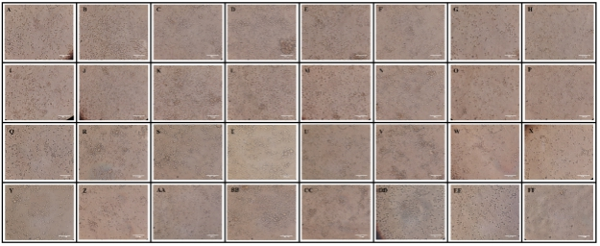 | Fig S2b. Morphological changes of MNCs in treatments with different concentrations in normoxia and hypoxia conditions for 24h. A: Control Normoxia, B: H₂O₂ 10µM Normoxia, C: H₂O₂ 20µM Normoxia, D: H₂O₂ 50µM Normoxia, E: H₂O₂ 100µM Normoxia, F: H₂O₂ 200µM Normoxia, G: H₂O₂ 500µM Normoxia, H: H₂O₂ 1000µM Normoxia, I: HA Normoxia, J: H₂O₂ 10µM+HA Normoxia, K: H₂O₂ 20µM+HA Normoxia, L: H₂O₂ 50µM+HA Normoxia, M: H₂O₂ 100µM+HA Normoxia, N: H₂O₂ 200µM+HA Normoxia, O: H₂O₂ 500µM+HA Normoxia, P: H₂O₂ 1000µM+HA Normoxia, Q: Control Hypoxia, R: H₂O₂ 10µM Hypoxia, S: H₂O₂ 20µM Hypoxia, T: H₂O₂ 50µM Hypoxia, U: H₂O₂ 100µM Hypoxia, V: H₂O₂ 200µM Hypoxia, W: H₂O₂ 500µM Hypoxia, X: H₂O₂ 1000µM Hypoxia, Y: HA Hypoxia, Z: H₂O₂ 10µM+HA Hypoxia, AA: H₂O₂ 20µM+HA Hypoxia, BB: H₂O₂ 50µM+HA Hypoxia, CC: H₂O₂ 100µM+HA Hypoxia, DD: H₂O₂ 200µM+HA Hypoxia, EE: H₂O₂ 500µM+HA Hypoxia, FF: H₂O₂ 1000µM+HA Hypoxia.

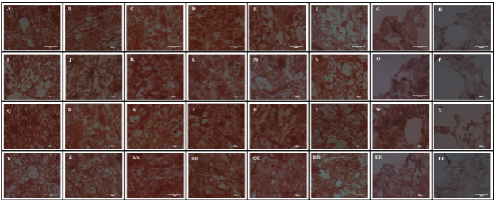 | Fig S3. Rate changes of uptake NR via 4T1 cancer cells in treatments with different concentrations in normoxia and hypoxia conditions for 24h by lysosomal activity by Neutral Red assay. A: Control Normoxia, B: H₂O₂ 10µM Normoxia, C: H₂O₂ 20µM Normoxia, D: H₂O₂ 50µM Normoxia, E: H₂O₂ 100µM Normoxia, F: H₂O₂ 200µM Normoxia, G: H₂O₂ 500µM Normoxia, H: H₂O₂ 1000µM Normoxia, I: HA Normoxia, J: H₂O₂ 10µM+HA Normoxia, K: H₂O₂ 20µM+HA Normoxia, L: H₂O₂ 50µM+HA Normoxia, M: H₂O₂ 100µM+HA Normoxia, N: H₂O₂ 200µM+HA Normoxia, O: H₂O₂ 500µM+HA Normoxia, P: H₂O₂ 1000µM+HA Normoxia, Q: Control Hypoxia, R: H₂O₂ 10µM Hypoxia, S: H₂O₂ 20µM Hypoxia, T: H₂O₂ 50µM Hypoxia, U: H₂O₂ 100µM Hypoxia, V: H₂O₂ 200µM Hypoxia, W: H₂O₂ 500µM Hypoxia, X: H₂O₂ 1000µM Hypoxia, Y: HA Hypoxia, Z: H₂O₂ 10µM+HA Hypoxia, AA: H₂O₂ 20µM+HA Hypoxia, BB: H₂O₂ 50µM+HA Hypoxia, CC: H₂O₂ 100µM+HA Hypoxia, DD: H₂O₂ 200µM+HA Hypoxia, EE: H₂O₂ 500µM+HA Hypoxia, FF: H₂O₂ 1000µM+HA Hypoxia.

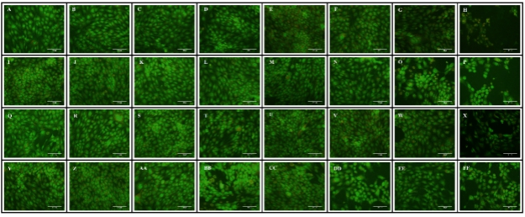 | Fig S4a. Apoptosis activity and morphological change were determined by Acridin orange/ propidium iodide via florescent microscopicfor 4T1 cancer cells treated with different concentration of H₂O₂ or H₂O₂+HA in normoxia and hypoxia condition for 24h. A: Control Normoxia, B: H₂O₂ 10µM Normoxia, C: H₂O₂ 20µM Normoxia, D: H₂O₂ 50µM Normoxia, E: H₂O₂ 100µM Normoxia, F: H₂O₂ 200µM Normoxia, G: H₂O₂ 500µM Normoxia, H: H₂O₂ 1000µM Normoxia, I: HA Normoxia, J: H₂O₂ 10µM+HA Normoxia, K: H₂O₂ 20µM+HA Normoxia, L: H₂O₂ 50µM+HA Normoxia, M: H₂O₂ 100µM+HA Normoxia, N: H₂O₂ 200µM+HA Normoxia, O: H₂O₂ 500µM+HA Normoxia, P: H₂O₂1000µM+HA Normoxia, Q: Control Hypoxia, R: H₂O₂ 10µM Hypoxia, S: H₂O₂ 20µM Hypoxia, T: H₂O₂ 50µM Hypoxia, U: H₂O₂100µM Hypoxia, V: H₂O₂200µM Hypoxia, W: H₂O₂500µM Hypoxia, X: H₂O₂1000µM Hypoxia, Y: HA Hypoxia, Z: H₂O₂10µM+HA Hypoxia, AA: H₂O₂20µM+HA Hypoxia, BB: H₂O₂50µM+HA Hypoxia, CC: H₂O₂100µM+HA Hypoxia, DD: H₂O₂200µM+HA Hypoxia, EE: H₂O₂500µM+HA Hypoxia, FF: H₂O₂1000µM+HA Hypoxia.

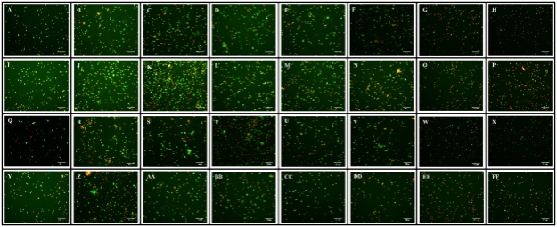 | Fig S4b. Apoptosis activity and morphological change were determined by Acridin orange/ propidium iodide via florescent microscopicfor MNCs treated with different concentration of H₂O₂ or H₂O₂+HA in normoxia and hypoxia condition for 24h. A: Control Normoxia, B: H₂O₂ 10µM Normoxia, C: H₂O₂ 20µM Normoxia, D: H₂O₂ 50µM Normoxia, E: H₂O₂ 100µM Normoxia, F: H₂O₂ 200µM Normoxia, G: H₂O₂ 500µM Normoxia, H: H₂O₂ 1000µM Normoxia, I: HA Normoxia, J: H₂O₂ 10µM+HA Normoxia, K: H₂O₂ 20µM+HA Normoxia, L: H₂O₂ 50µM+HA Normoxia, M: H₂O₂ 100µM+HA Normoxia, N: H₂O₂ 200µM+HA Normoxia, O: H₂O₂ 500µM+HA Normoxia, P: H₂O₂1000µM+HA Normoxia, Q: Control Hypoxia, R: H₂O₂ 10µM Hypoxia, S: H₂O₂ 20µM Hypoxia, T: H₂O₂ 50µM Hypoxia, U: H₂O₂100µM Hypoxia, V: H₂O₂200µM Hypoxia, W: H₂O₂500µM Hypoxia, X: H₂O₂1000µM Hypoxia, Y: HA Hypoxia, Z: H₂O₂10µM+HA Hypoxia, AA: H₂O₂20µM+HA Hypoxia, BB: H₂O₂50µM+HA Hypoxia, CC: H₂O₂100µM+HA Hypoxia, DD: H₂O₂200µM+HA Hypoxia, EE: H₂O₂500µM+HA Hypoxia, FF: H₂O₂1000µM+HA Hypoxia.

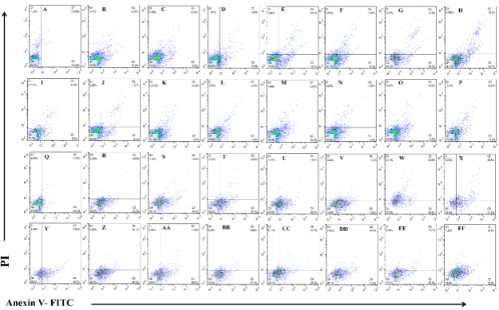 | Fig S5a: Apoptosis activity was determined by AnnexinV-FITC/PI flow cytometry for 4T1 cancer cells treated with different concentration of H₂O₂ or H₂O₂+HA in normoxia and hypoxia condition for 24h. A: Control Normoxia, B: H₂O₂ 10µM Normoxia, C: H₂O₂ 20µM Normoxia, D: H₂O₂ 50µM Normoxia, E: H₂O₂ 100µM Normoxia, F: H₂O₂ 200µM Normoxia, G: H₂O₂ 500µM Normoxia, H: H₂O₂ 1000µM Normoxia, I: HA Normoxia, J: H₂O₂ 10µM+HA Normoxia, K: H₂O₂ 20µM+HA Normoxia, L: H₂O₂ 50µM+HA Normoxia, M: H₂O₂ 100µM+HA Normoxia, N: H₂O₂ 200µM+HA Normoxia, O: H₂O₂ 500µM+HA Normoxia, P: H₂O₂1000µM+HA Normoxia, Q: Control Hypoxia, R: H₂O₂ 10µM Hypoxia, S: H₂O₂ 20µM Hypoxia, T: H₂O₂ 50µM Hypoxia, U: H₂O₂100µM Hypoxia, V: H₂O₂200µM Hypoxia, W: H₂O₂500µM Hypoxia, X: H₂O₂1000µM Hypoxia, Y: HA Hypoxia, Z: H₂O₂10µM+HA Hypoxia, AA: H₂O₂20µM+HA Hypoxia, BB: H₂O₂50µM+HA Hypoxia, CC: H₂O₂100µM+HA Hypoxia, DD: H₂O₂200µM+HA Hypoxia, EE: H₂O₂500µM+HA Hypoxia, FF: H₂O₂1000µM+HA Hypoxia.

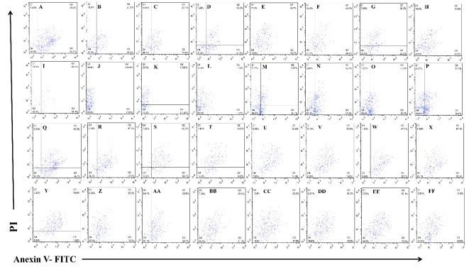 | Fig S5b. Apoptosis activity was determined by AnnexinV-FITC/PI flow cytometry for MNCs treated with different concentration of H₂O₂ or H₂O₂+HA in normoxia and hypoxia condition for 24h.A: Control Normoxia, B: H₂O₂ 10µM Normoxia, C: H₂O₂ 20µM Normoxia, D: H₂O₂ 50µM Normoxia, E: H₂O₂ 100µM Normoxia, F: H₂O₂ 200µM Normoxia, G: H₂O₂ 500µM Normoxia, H: H₂O₂ 1000µM Normoxia, I: HA Normoxia, J: H₂O₂ 10µM+HA Normoxia, K: H₂O₂ 20µM+HA Normoxia, L: H₂O₂ 50µM+HA Normoxia, M: H₂O₂ 100µM+HA Normoxia, N: H₂O₂ 200µM+HA Normoxia, O: H₂O₂ 500µM+HA Normoxia, P: H₂O₂1000µM+HA Normoxia, Q: Control Hypoxia, R: H₂O₂ 10µM Hypoxia, S: H₂O₂ 20µM Hypoxia, T: H₂O₂ 50µM Hypoxia, U: H₂O₂100µM Hypoxia, V: H₂O₂200µM Hypoxia, W: H₂O₂500µM Hypoxia, X: H₂O₂1000µM Hypoxia, Y: HA Hypoxia, Z: H₂O₂10µM+HA Hypoxia, AA: H₂O₂20µM+HA Hypoxia, BB: H₂O₂50µM+HA Hypoxia, CC: H₂O₂100µM+HA Hypoxia, DD: H₂O₂200µM+HA Hypoxia, EE: H₂O₂500µM+HA Hypoxia, FF: H₂O₂1000µM+HA Hypoxia.

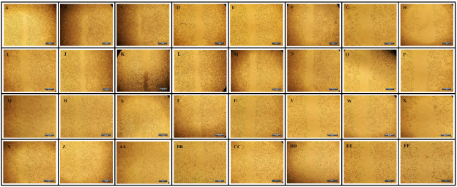 | Fig S6. Effect of H₂O₂ or H₂O₂ + HA metastatic properties via targeting cell migration in different levels of 4T1 cancer cells treated with different concentration of H₂O₂ or H₂O₂ +HA in normoxia and hypoxia condition for 24h. cell migration was quantified using scratch assay. A: Control Normoxia, B: H₂O₂ 10µM Normoxia, C: H₂O₂ 20µM Normoxia, D: H₂O₂ 50µM Normoxia, E: H₂O₂ 100µM Normoxia, F: H₂O₂ 200µM Normoxia, G: H₂O₂ 500µM Normoxia, H: H₂O₂ 1000µM Normoxia, I: HA Normoxia, J: H₂O₂ 10µM+HA Normoxia, K: H₂O₂ 20µM+HA Normoxia, L: H₂O₂ 50µM+HA Normoxia, M: H₂O₂ 100µM+HA Normoxia, N: H₂O₂ 200µM+HA Normoxia, O: H₂O₂ 500µM+HA Normoxia, P: H₂O₂ 1000µM+HA Normoxia, Q: Control Hypoxia, R: H₂O₂ 10µM Hypoxia, S: H₂O₂ 20µM Hypoxia, T: H₂O₂ 50µM Hypoxia, U: H₂O₂ 100µM Hypoxia, V: H₂O₂ 200µM Hypoxia, W: H₂O₂ 500µM Hypoxia, X: H₂O₂ 1000µM Hypoxia, Y: HA Hypoxia, Z: H₂O₂ 10µM+HA Hypoxia, AA: H₂O₂ 20µM+HA Hypoxia, BB: H₂O₂ 50µM+HA Hypoxia, CC: H₂O₂ 100µM+HA Hypoxia, DD: H₂O₂ 200µM+HA Hypoxia, EE: H₂O₂ 500µM+HA Hypoxia, FF: H₂O₂ 1000µM+HA Hypoxia.

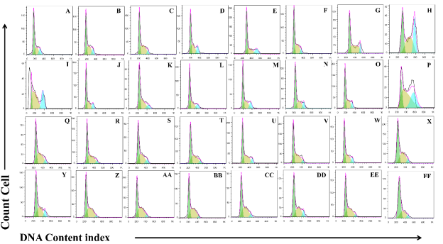 | Fig S7a: Cell cycle analysis of 4T1 cancer cells treated with different concentration of H₂O₂ or H₂O₂ +HA in normoxia and hypoxia condition for 24h. cell cycle was quantified using flow cytometry. A: Control Normoxia, B: H₂O₂ 10µM Normoxia, C: H₂O₂ 20µM Normoxia, D: H₂O₂ 50µM Normoxia, E: H₂O₂ 100µM Normoxia, F: H₂O₂ 200µM Normoxia, G: H₂O₂ 500µM Normoxia, H: H₂O₂ 1000µM Normoxia, I: HA Normoxia, J: H₂O₂ 10µM+HA Normoxia, K: H₂O₂ 20µM+HA Normoxia, L: H₂O₂ 50µM+HA Normoxia, M: H₂O₂ 100µM+HA Normoxia, N: H₂O₂ 200µM+HA Normoxia, O: H₂O₂ 500µM+HA Normoxia, P: H₂O₂ 1000µM+HA Normoxia, Q: Control Hypoxia, R: H₂O₂ 10µM Hypoxia, S: H₂O₂ 20µM Hypoxia, T: H₂O₂ 50µM Hypoxia, U: H₂O₂ 100µM Hypoxia, V: H₂O₂ 200µM Hypoxia, W: H₂O₂ 500µM Hypoxia, X: H₂O₂ 1000µM Hypoxia, Y: HA Hypoxia, Z: H₂O₂ 10µM+HA Hypoxia, AA: H₂O₂ 20µM+HA Hypoxia, BB: H₂O₂ 50µM+HA Hypoxia, CC: H₂O₂ 100µM+HA Hypoxia, DD: H₂O₂ 200µM+HA Hypoxia, EE: H₂O₂ 500µM+HA Hypoxia, FF: H₂O₂ 1000µM+HA Hypoxia.

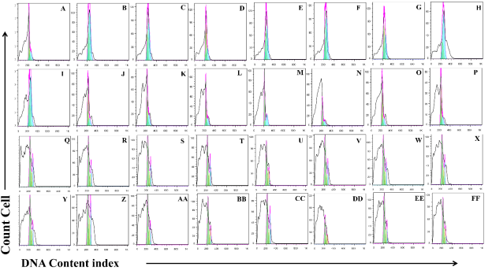 | Fig S7b: Expression of cell cycle regulators in MNCs following H2O2 or H2O2 + HA treatment in normoxia and hypoxia condition for 24h. cell cycle was quantified using flow cytometry. A: Control Normoxia, B: H₂O₂ 10µM Normoxia, C: H₂O₂ 20µM Normoxia, D: H₂O₂ 50µM Normoxia, E: H₂O₂ 100µM Normoxia, F: H₂O₂ 200µM Normoxia, G: H₂O₂ 500µM Normoxia, H: H₂O₂ 1000µM Normoxia, I: HA Normoxia, J: H₂O₂ 10µM+HA Normoxia, K: H₂O₂ 20µM+HA Normoxia, L: H₂O₂ 50µM+HA Normoxia, M: H₂O₂ 100µM+HA Normoxia, N: H₂O₂ 200µM+HA Normoxia, O: H₂O₂ 500µM+HA Normoxia, P: H₂O₂ 1000µM+HA Normoxia, Q: Control Hypoxia, R: H₂O₂ 10µM Hypoxia, S: H₂O₂ 20µM Hypoxia, T: H₂O₂ 50µM Hypoxia, U: H₂O₂ 100µM Hypoxia, V: H₂O₂ 200µM Hypoxia, W: H₂O₂ 500µM Hypoxia, X: H₂O₂ 1000µM Hypoxia, Y: HA Hypoxia, Z: H₂O₂ 10µM+HA Hypoxia, AA: H₂O₂ 20µM+HA Hypoxia, BB: H₂O₂ 50µM+HA Hypoxia, CC: H₂O₂ 100µM+HA Hypoxia, DD: H₂O₂ 200µM+HA Hypoxia, EE: H₂O₂ 500µM+HA Hypoxia, FF: H₂O₂ 1000µM+HA Hypoxia.

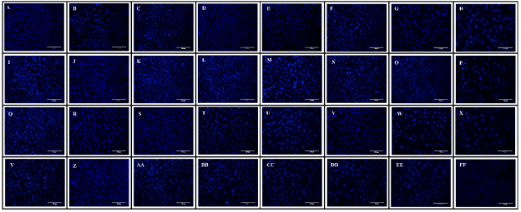 | Fig S7c: Cell cycle analysis of 4T1 cancer cells treated with different concentration of H₂O₂ or H₂O₂ +HA in normoxia and hypoxia condition for 24h. cell cycle was quantified using florescent microscope after staining with DAPI. A: Control Normoxia, B: H₂O₂ 10µM Normoxia, C: H₂O₂ 20µM Normoxia, D: H₂O₂ 50µM Normoxia, E: H₂O₂ 100µM Normoxia, F: H₂O₂ 200µM Normoxia, G: H₂O₂ 500µM Normoxia, H: H₂O₂ 1000µM Normoxia, I: HA Normoxia, J: H₂O₂ 10µM+HA Normoxia, K: H₂O₂ 20µM+HA Normoxia, L: H₂O₂ 50µM+HA Normoxia, M: H₂O₂ 100µM+HA Normoxia, N: H₂O₂ 200µM+HA Normoxia, O: H₂O₂ 500µM+HA Normoxia, P: H₂O₂ 1000µM+HA Normoxia, Q: Control Hypoxia, R: H₂O₂ 10µM Hypoxia, S: H₂O₂ 20µM Hypoxia, T: H₂O₂ 50µM Hypoxia, U: H₂O₂ 100µM Hypoxia, V: H₂O₂ 200µM Hypoxia, W: H₂O₂ 500µM Hypoxia, X: H₂O₂ 1000µM Hypoxia, Y: HA Hypoxia, Z: H₂O₂ 10µM+HA Hypoxia, AA: H₂O₂ 20µM+HA Hypoxia, BB: H₂O₂ 50µM+HA Hypoxia, CC: H₂O₂ 100µM+HA Hypoxia, DD: H₂O₂ 200µM+HA Hypoxia, EE: H₂O₂ 500µM+HA Hypoxia, FF: H₂O₂ 1000µM+HA Hypoxia.

Table1S: Oligonucleotide sequence of primers

Gene | Sequence Primer | Annealing temperature
MMP-2 (104bp) | F – GGACAAGAACCAGATCACATAC  R – CGTCGCTCCATACTTTTAAGG | 60
MMP-9 (180bp) | F – GTGTCTGGAGATTCGACTTG  R – CCTTGTTCACCTCATTTTGG | 58
VEGF (173bp) | F – GGATCAAACCTCACCAAAGC  R – GCAGGAACATTTACACGTCTG | 61
HIF-1α (157bp) | F – ACAGGACAGTACAGGATGC  R – GGGAGAAAATCAAGTCGTGC | 61
HPRT (102bp) | F – CAGGACTGAAAGACTTGCTC  R – AGGTCAGCAAAGAACTTATAGC | 63

