Supplements
Table S1. Information for each KRA
Serial number | Introduce
Ⅰ-1-1 | Key ecological restoration area of Hulunbuir Sandy Land
Ⅰ-2-1 | Key ecological restoration areas of Hunshandake and Uzhumqin sandy land
Ⅰ-3-1 | Ecological restoration area in the upper reaches of Xiliao River
Ⅰ-4-1 | Horqin grassland ecological conservation and restoration area
Ⅰ-5-1 | Daihai and Chahannur key wetland and watershed ecological restoration area
Ⅰ-5-2 | Luanhe River Headwaters area key ecological conservation and restoration area
Ⅰ-6-1 | Key ecological restoration area of desert steppe at the northern foot of Yinshan Mountain
Ⅰ-7-1 | The key ecological restoration area of wind break and sand fixation at the western foot of Helan Mountain
Ⅰ-7-2 | Heihe River downstream river and Juyanhai wetland protection key ecological restoration area
Ⅱ-1-1 | Yinshan south foot and Hetao plain water conservation ecological restoration area
Ⅱ-2-1 | The key restoration area of soil and water conservation in Ordos Plateau
Ⅱ-3-1 | Wuhai and its surrounding ecological restoration area
Ⅲ-2-1 | Nenjiang River north source water conservation and restoration area
Ⅲ-3-1 | Nenjiang River south source water conservation and restoration area
Ⅲ-4-1 | Comprehensive ecological restoration area of black land at the eastern foot of Greater Khingan Mountains

Table S2. Calculation method of the relevant parameters in the PML model
Parameter | Formula | Explanation
P(Atmospheric pressure) | $$P=101.3{\left(\frac{293−0.0065z}{293}\right)}^{5.26}$$ | P: atmospheric pressure [kPa];  z: elevation above sea level [m].
λ(Latent heat of vaporization) | $$λ=2.501−0.002361×T$$ | $λ$: latent heat of vaporization [MJ kg⁻¹];  T: air temperature [℃].
γ(Psychrometric constant) | $$γ=\frac{C_{p}P}{ελ}$$ | g: psychrometric constant [kPa ℃⁻¹];  P: atmospheric pressure [kPa];  l: latent heat of vaporization, 2.45 [MJ kg⁻¹];  C_{p:} specific heat at constant pressure, 1.013 10⁻³ [MJ kg⁻¹℃⁻¹];  $ε$: ratio molecular weight of water vapor/dry air = 0.622.
s(Slope of saturation vapor pressure curve) | $$s=\frac{4098\left[0.6108exp\left(\frac{17.27T}{T+237.3}\right)\right]}{{\left(T+237.3\right)}^{2}}$$ | s: slope of saturation vapor pressure curve at air temperature T [kPa °C⁻¹],  T: air temperature [°C].
ρ(Air density) | $$ρ=\frac{1.293P}{101}×\frac{273.15}{273.15+T}$$ | P: atmospheric pressure [kPa];  T: air temperature [℃].
u_{m}(Instantaneous near-surface (2 m) wind speed) | $$u_{m}=u_{10}\frac{4.87}{ln(67.8z−5.42)}$$ | u_{m}: Wind speed at 2 m near the surface [m/s];  u₁₀: Wind speed at 10 m near the surface [m/s];  z: elevation above sea level [m].
K_{Q}(Extinction coefficient of PAR)  D50(VPD of stomatal conductance up to gsx/2)  Q50(The absorbed PAR) | KQ=0.6  D50=0.5 kPa  Q50=30 W·m⁻² | Participate in operations as insensitive parameters

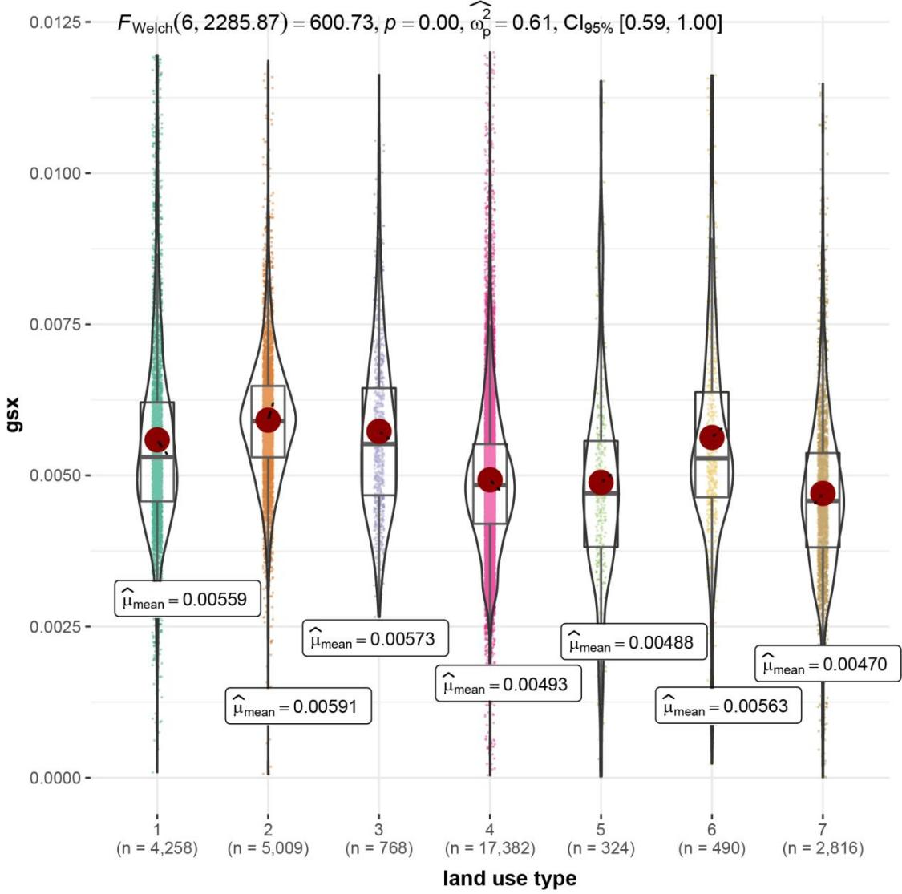
Figure S1. Maximum stomatal conductance of different land use types (1 is cultivated land; 2 is forestland; 3 is shrubland; 4 is grassland; 5 is water; 6 is built-up land; 7 is unused land)
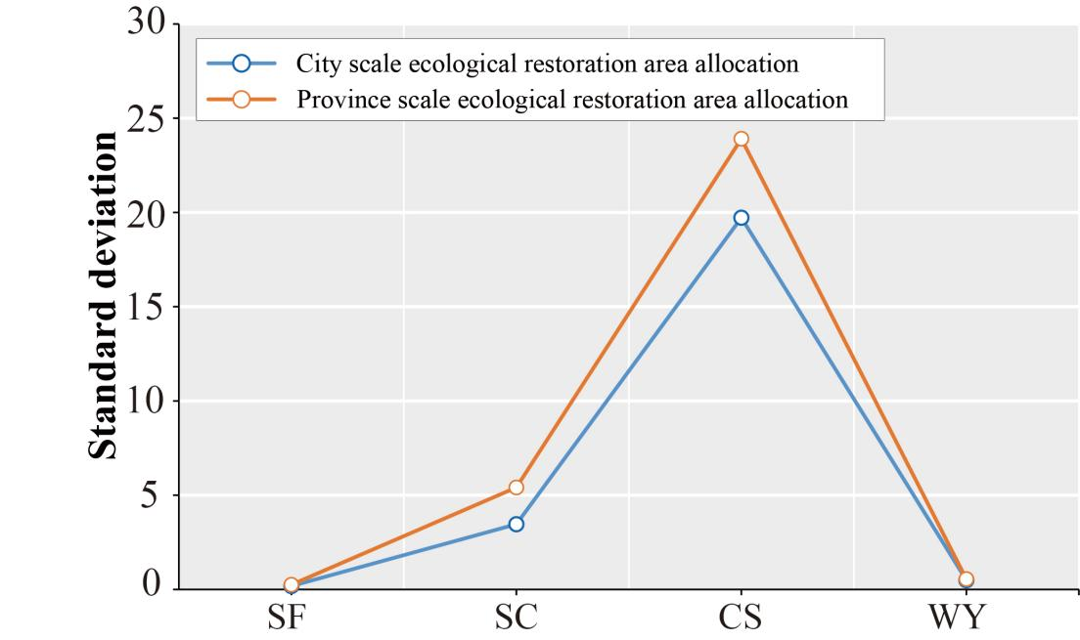
Figure S2. Standard deviation of ES increase. The standard deviation of the ES per capita increase among the KRAs caused by the allocation of the restoration area at the provincial scale and city scale was 0.55 and 0.49 for WY, 5.41 and 3.46 for SC, 0.25 and 0.18 for SF, and 23.91 and 19.72 for CS, respectively (WY. Water yield; SC. Soil conservation; SF. Sand fixation; CS. Carbon sequestration).
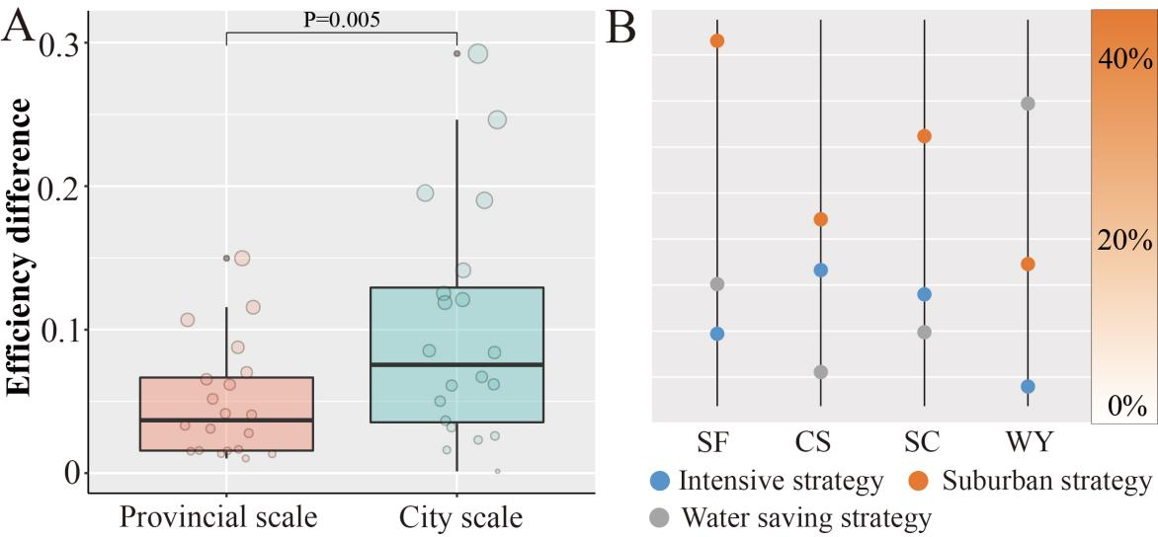
Figure S3. The effect of allocation scale on the realization efficiency of ES (WY. Water yield; SC. Soil conservation; SF. Sand fixation; CS. Carbon sequestration). (A) Significant differences in the realization efficiency of ESs between the provincial and city scales; (B) contribution based on random forest.
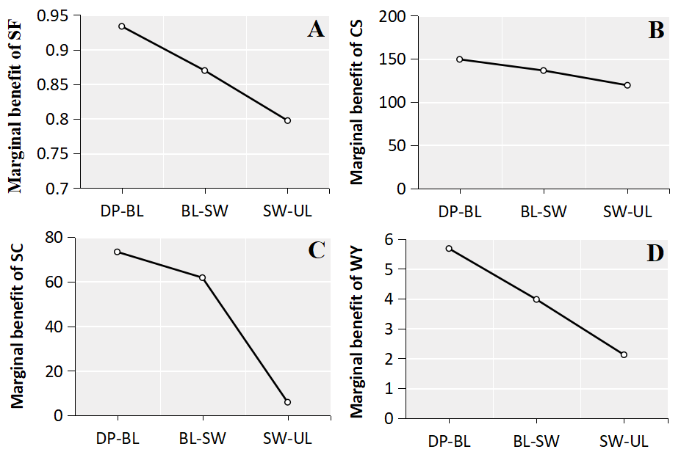
Figure S4. Relationship between water availability and marginal benefits of ecological restoration (DP-BL. From the development scenario to the baseline scenario; BL-SW. From the baseline scenario to the water saving scenario; SW-UL. From the Water Saving Scenario to the Unlimited scenario). (A) Sand fixation service; (B) carbon sequestration service; (C) soil conservation service; (D) water yield service; marginal benefits are the ratio of the increase in water availability to the increase in ES.

