Supplementary Materials

Visualizing field-effects and chemical passivation in efficient 2D/3D heterojunction perovskite solar cells and modules
Weichuang Yang^{1,7,9}, Bin Ding^{2,9}, Zhenhai Yang^{1,3,9}, Zedong Lin^{5,6,9}, Jingsong Sun^{1,8}, YuanYuan Meng¹, Jiang Sheng¹ , Yong Ding^{2,4} , Jichun Ye¹ , Paul J. Dyson², and Mohammad Khaja Nazeeruddin²
¹Zhejiang Provincial Engineering Research Center of Energy Optoelectronic Materials and Devices, Ningbo Institute of Materials Technology and Engineering, Chinese Academy of Sciences (CAS), Ningbo, P. R. China.
²Institute of Chemical Sciences and Engineering, École Polytechnique Fédérale de Lausanne (EPFL), Sion, Switzerland.
³School of Optoelectronic Science and Engineering & Collaborative Innovation Center of Suzhou Nano Science and Technology, Key Lab of Advanced Optical Manufacturing Technologies of Jiangsu Province & Key Lab of Modern Optical Technologies of Education Ministry of China, Soochow University, Suzhou, P. R. China.
⁴State Key Laboratory of Alternate Electrical Power System with Renewable Energy Sources, North China Electric Power University, Beijing, P. R. China.
⁵Guangdong Provincial Key Lab of Nano-Micro Materials Research, School of Chemical Biology and Biotechnology, Shenzhen Graduate School, Peking University, Shenzhen, P. R. China.
⁶Institute of Biomedical Engineering, Shenzhen Bay Laboratory, Shenzhen, P. R. China.
⁷University of Chinese Academy of Sciences, Beijing, P. R. China.
⁸Zhejiang Energy Group R&D 152 Tianmushan Road, Xihu District, Hangzhou City 310003, China.
⁹These authors contributed equally to this work.
*Corresponding authors. Email: shengjiang@nimte.ac.cn; dingy@ncepu.edu.cn; jichun.ye@nimte.ac.cn; mdkhaja.nazeeruddin@epfl.ch

Methods
Materials and reagents
The materials used in the experiments included: lead(ii) iodide (PbI₂; 99.99%, TCI) , tin(ii) chloride dihydrate (SnCl₂·2H₂O; 98%, Acros), titanium(iv) chloride (TiCl₄; 99%, Sigma-Aldrich), hydrochloric acid (HCl; 37 wt% in H₂O, Sigma-Aldrich), methylammonium chloride (MACl, 99.99%, Greatcell solar), formamidinium iodide (FAI; 99.99%, Greatcell solar) N,N-dimethylformamide (DMF; 99.8%, Sigma-Aldrich), dimethyl sulfoxide (DMSO; 99.9%, Sigma-Aldrich), 2-propanol (99.5%, Sigma-Aldrich), chlorobenzene (99.8%, Sigma-Aldrich), Spiro-OMeTAD (Borun Tech.), 4-tert-butylpyridine (tBP; Sigma-Aldrich), bis(trifluoromethane)sulfonimide lithium salt (Li-TFSI; 99.95%, Sigma-Aldrich), FK209 Co(iii) TFSI salt (Sigma-Aldrich), acetonitrile (ACN; 99.8%, Sigma-Aldrich).
Cs_{0.05}MA_{0.05}FA_{0.9}PbI₃ perovskite precursor
The 3D perovskite precursor solution (1.4 M) was prepared by adding 645.4 mg of PbI₂, 216.7 mg of formamidium iodide (FAI), 11.1 mg of methylamonium iodide (MAI), and 11.8 mg of CsCl into 200 μL of N, N'-dimethylsulfoxide (DMSO) and 800 μL of dimethyformamide (DMF) mixture. The solution was then stirred for 2 h at 60 °C and filtered by 0.22 μm PTFE filters before film depositions.
Fabrication of perovskite solar cells
The device with an architecture of FTO glass/compact TiO₂ layer/compact SnO₂ layer/Cs_{0.05}MA_{0.05}FA_{0.9}PbI₃ (PVK)/passivation layer/spiro-OMeTAD (HTM)/Au structure was fabricated. The patterned FTO substrate (Asahi FTO glass, 12-13 Ω cm⁻²) was sequentially cleaned with detergent (5% Hellmanex in water), deionized water, acetone, and isopropanol in the ultrasonic bath for 30 min, respectively. The FTO substrate was then further cleaned with ultraviolet-Ozone surface treatment for 15 min. The compact TiO₂ layer (c-TiO₂) and SnO₂ layer (c-SnO₂) were sequentially deposited on the clean FTO substrate by chemical bath deposition (CBD) method¹. The substrate was annealed on a hotplate at 190 ºC for 60 min. Then, after UV-ozone treatment of the substrates for 15 min, the perovskite precursor solution was spin-coated onto the surface of the FTO/c-TiO₂/c-SnO₂ substrate at 1000 rpm for 10 s, accelerated to 5000 rpm for 5s and maintained at this speed for 20 s. This process was carried out in an N2-filled glove box. Then, the substrate was placed in a home-made rapid vacuum drying equipment, as previously reported². After pumping for 20 s, a brown, transparent perovskite film with a mirror-like surface was obtained. The fresh perovskite layer was annealed at 100°C for 1 h and then at 150°C for 10 min. A hole transporting layer (HTL) was deposited on the perovskite film by depositing a doped spiro-OMeTAD solution at 3000 rpm for 30 s. The doped spiro-OMeTAD solution was prepared by dissolving 105 mg of spiro-OMeTAD and 41 μL of 4-tert-butylpyridine in 1343 μL of chlorobenzene with an additional 25 μL of bis(trifluoromethane)sulfonimide lithium salt solution (517 mg/mL in acetonitrile) and 19 μL of cobalt-complex solution (376 mg/mL in acetonitrile). Finally, a ~70 nm-thick gold layer was evaporated on the spiro-OMeTAD layer as the back electrode.
Fabrication of 3D/2D perovskite heterojunction
Before the HTL deposition, the as-prepared 3D perovskite films were washed by 200 μL 2D perovskite precursor solutions at 5000 rpm and annealed at 110°C for 5 min subsequently. The BAI-based (BABr-based) 2D perovskite precursor solutions used in the post-treatment process were 20 mg BAI (15 mg BAI) dissolved in 4 mL IPA.
Fabrication of perovskite solar modules
Perovskite solar modules, with 8 sub-cells connected in series, were fabricated on FTO glass substrates with a size of 6.5×7.0 cm². The series interconnection of the module was realized by P1, P2, and P3 lines, which were patterned using a laser scribing system with a 1064 nm and a power of 20 W (Trotec). The FTO substrate was pre-patterned for P1 (width of 40 μm) by means of 60% laser power under a speed of 300 mm/s with a frequency of 65 kHz and pulse width of 120 ns. The subsequent processes for the preparation of c-TiO₂/c-SnO₂ substrates are the same as the small-area device procedures. Besides, the perovskite precursor deposition and fabrication procedures were also similar to that of the small-size solar cells except for the concentration of perovskite precursor. 1.35 M of perovskite precursor was employed to do the perovskite layer by using spin-coated method and custom-made gas-induced pump method. The perovskite precursor was spin-coated on the c-TiO₂/c-SnO₂ substrates. The perovskite films were annealed at 100 ºC for 1 h and 150ºC for 10 min. After cooling down to room temperature, the procedures to spin-coat passivation layer and the spiro-OMeTAD layer are similar to those of the small-size devices. The P2 lines (a width of 250 μm) were patterned before the Au evaporation process step with an average laser power of 15% under a speed of 1000 mm/s and frequency of 65 kHz for a pulse duration of 120 ns. When a 70 nm-thick Au layer was deposited, the P3 line (width of 40 μm) was fabricated under the same scribing condition as the P2 line. The distance between P1 and P3 was around 370 μm, and a geometric fill factor (GFF) was around 93.7%.
Characterization
The SEM images were captured by a field-emission SEM (Hitachi, S4800). The absorbance spectra were recorded by an ultraviolet and visible spectrophotometer (Tianjin Tuopu Instrument Co., Ltd, GS54T). The GIWAXS patterns were collected by Xeuss Waxs/Saxs System (Xenocs, France) (1.54 Å). XRD was employed on Bruker AXS D8 Advance with Cu Kα radiation. Atom force microscopy (AFM) and KPFM images were observed on a Scanning probe microscope (Dimension ICON, Bruker, USA). The UPS and XPS measurement were taken by a Kratos AXIS ULTRA DALD, and the UPS was measured under the He I (21.22 eV) emission line under 10 V bias voltage. TrPL decays were induced by using FluoTime 300 (PicoQuant) with a 450 nm laser. TAS was measured by SOL-F-K-HP-T in 800 nm. Steady-state PL spectra were observed by a fluorescence spectrometer (HORIBA, FL3-111) with an excitation wavelength of 470 nm. TrPL measurements were conducted by a FLS1000 (HORIBA), and the excitation wavelength is 475 nm. All the voltage-current measurements were carried out by using a Keysight B2901A Source Meter. For the in-house PCE measurements of solar cells, a simulated one-sun AM 1.5G illumination (100 mW/cm²) with a solar simulator (Enlitech, SS-F5-3A) are used as the light source. The TPV, CV, EIS measurements are conducted on an electrochemical analyzer (Shanghai Chenhua Instrument, CHI600E). Device stability of PSCs was monitored under continuous light soaking (White LED, 100 mW/cm²) at the MPP condition in a nitrogen glovebox (O₂ ≤ 20 ppm, H₂O ≤ 5 ppm). During the measurement, the device temperature is kept at around 50 °C.

Supplementary Text
DFT Calculations
The DFT calculations based on the tool of the Vienna ab initio simulation package (VASP) were carried out³. The core-valence electron interaction was described by the projector-augmented wave (PAW) method⁴. The exchange correlation function was treated by the generalized gradient approximation in Perdew, Burke and Ernzerhof (GGA-PBE)⁵. A plane-wave energy cutoff of 400 eV was used for this simulation. For the electronic self-consistent loop, the convergence of total energy was set as 1×10^{‒5} eV. For the structure optimization, the convergence of ion forces was set as 0.03 eV Å^{‒1}. The Γ-centered k-point mesh was set as 4×4×1. The VASPKIT software was used for work function calculation⁶.
The bulk FAPbI₃ with the symmetry group Pmm2 (a = b = c = 6.36 Å, α = β = γ = 90°) was optimized. Then, it was cut along the (0 -1 0) plane with FA on the surface and expanded as 1×2×1 supercell [FAPbI₃ (0 -1 0)]. The FA molecule in the surface of FAPbI₃ (0 -1 0) was replaced by the BA to construct BA surface modified by FAPbI₃ (0 -1 0) [BA- FAPbI₃ (0 -1 0)]. For 2D Br-doped FAPbI₃, the bulk FAPbI₃ is cleaved along the (0 -1 0) plane with FA on both ends. The FA molecules on the top and bottom-sides were replaced by the BA molecules. We replace the I atom with Br atom to construct the 2D Br-doped FAPbI₃ (number of Br atoms = 0, 1, 2, 3, 4, 5, 7).
The formation energies of I vacancy (V_{I}) and Pb vacancy (V_{Pb}) for FAPbI₃ (0 -1 0) and BA- FAPbI₃ (0 -1 0) were calculated according to equation:^{7,8}
$E^{f}\left[X^{q}\right]=E_{tot}\left[X^{q}\right]-E_{tot}\left[perfect\right]-\sum_{i}{n_{i}μ_{i}}+qE_{F}+E_{coor}$.
Here, $E_{tot}\left[X^{q}\right]$ is the total energy of supercell containing the defect X, $E_{tot}\left[perfect\right]$ is the total energy of supercell without the defect X, $n_{i}$ denotes the atom number of type I that has been added or removed from the supercell to form the defect, $μ_{i}$ denotes the chemical potential of type I atom, $q$ is the charge state of defect X, $E_{F}$ is the Fermi energy, and $E_{coor}$ is the correction term.
Photo-electrical simulations
The simulated structures of PSCs were modeled according to the architecture in Figure 2a, which is composed of a 170 nm-thick FTO, a 10 nm-thick TiO₂, a 10 nm-thick SnO₂, a 600 nm-thick 3D perovskite, a 30 nm-thick 2D perovskite (if exist), a 200 nm-thick spiro-OMeTAD, and a 90 nm-thick Au electrode. The finite-element method by coupling the optical and the electrical modules were used to perform the photo-electrical simulations. Firstly, a rigorous optical simulation was carried out to solve Maxwell’s equations, so that the spatial distributions of carrier concentrations inside the perovskite layers can be obtained. Based on the carrier generation in the optical module, the electrical simulation was then implemented to carrier dynamics processes, including recombination, transport and collection. By addressing the Poisson’s and drift-diffusion equations of the electrical simulation, the electrical parameters of PSCs can be achieved. Here, the simulated parameters used for this simulation, which include optical input, i.e., refractive indexes of the related materials, and electrical input, i.e., electron affinity, bandgap, permittivity, effective conduction/valence band density, doping concentration, mobility as well as various types of recombination coefficients, etc., were extracted from the previous works^{9,10}.

Supplementary Figures and Notes

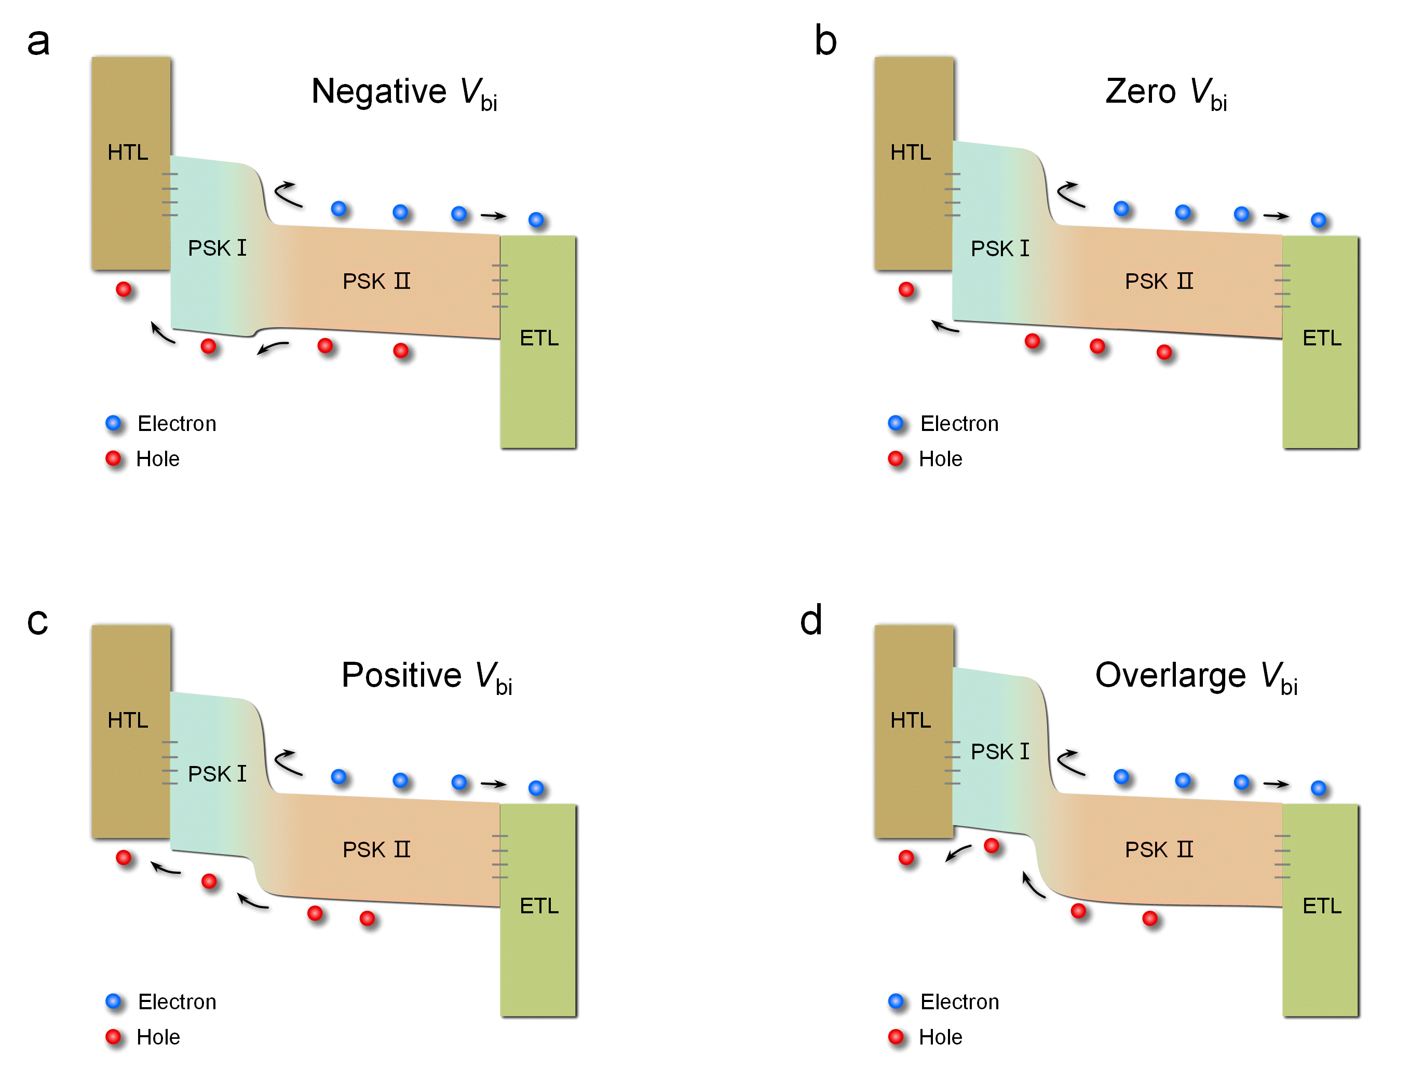

Fig. S1 | Energy band diagrams the dual-heterojunction design in PSCs with different V_{bi}. (a) Zreo V_{bi}. (b) Negative V_{bi}. (c) Positive V_{bi}. (d) Overlarge V_{bi}.

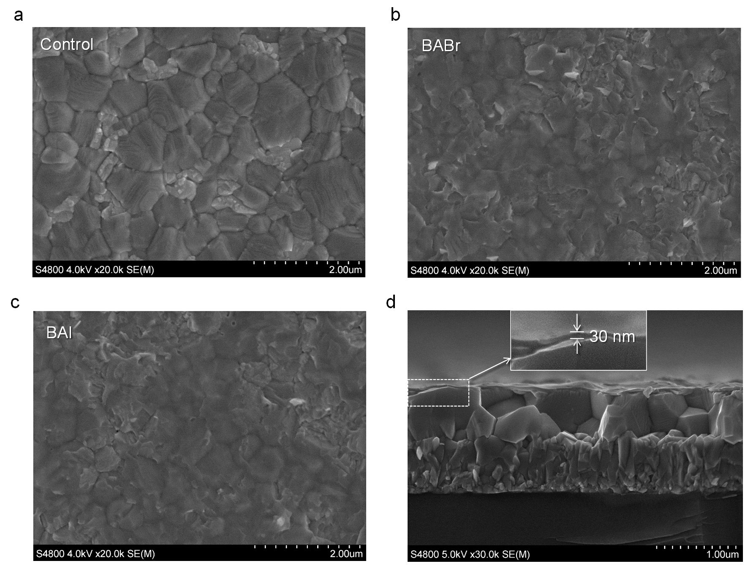

Fig. S2 | Surface morphology of 3D and 2D/3D perovskite. Top-view SEM images of Perovskite films on FTO/ETL substrates for (a) Control, (b) BABr, (c) BAI samples, and (d) cross-sectional SEM image of BAI perovskite sample.

Note S1 | Surface morphology analysis
Surface morphology is a critical indicator for evaluating the surface defect density of perovskite and the performance of the related devices. The top-view SEM image of the control sample in Fig. S2a shows typical polycrystal features of perovskite with the appearance of uniform crystals and compact grains. For both BABr and BAI samples in Figs. S2b and S2c, some of the grain boundaries on the surface of perovskite that were partially covered by the vertically oriented 2D perovskite thin-films, are hard to identify. In detail, the results in Figs. S2b and S2c also suggest that there is no obvious difference in surface morphology of perovskite between the BABr and BAI samples, implying that the post-treatment method that we used to fabricate 2D perovskite is mainly dependent on the BA molecule while it is independent of halide types. Moreover, the cross-sectional SEM image in Fig. S2d shows that a uniform 2D perovskite film with a thickness of ~30 nm, can be well-covered on the 3D perovskite surfaces, which is in good agreement with other relevant studies. It is noted that the smooth surface of 2D perovskite is helpful for the spin-coating of spiro-OMeTAD HTL with good physical contact.

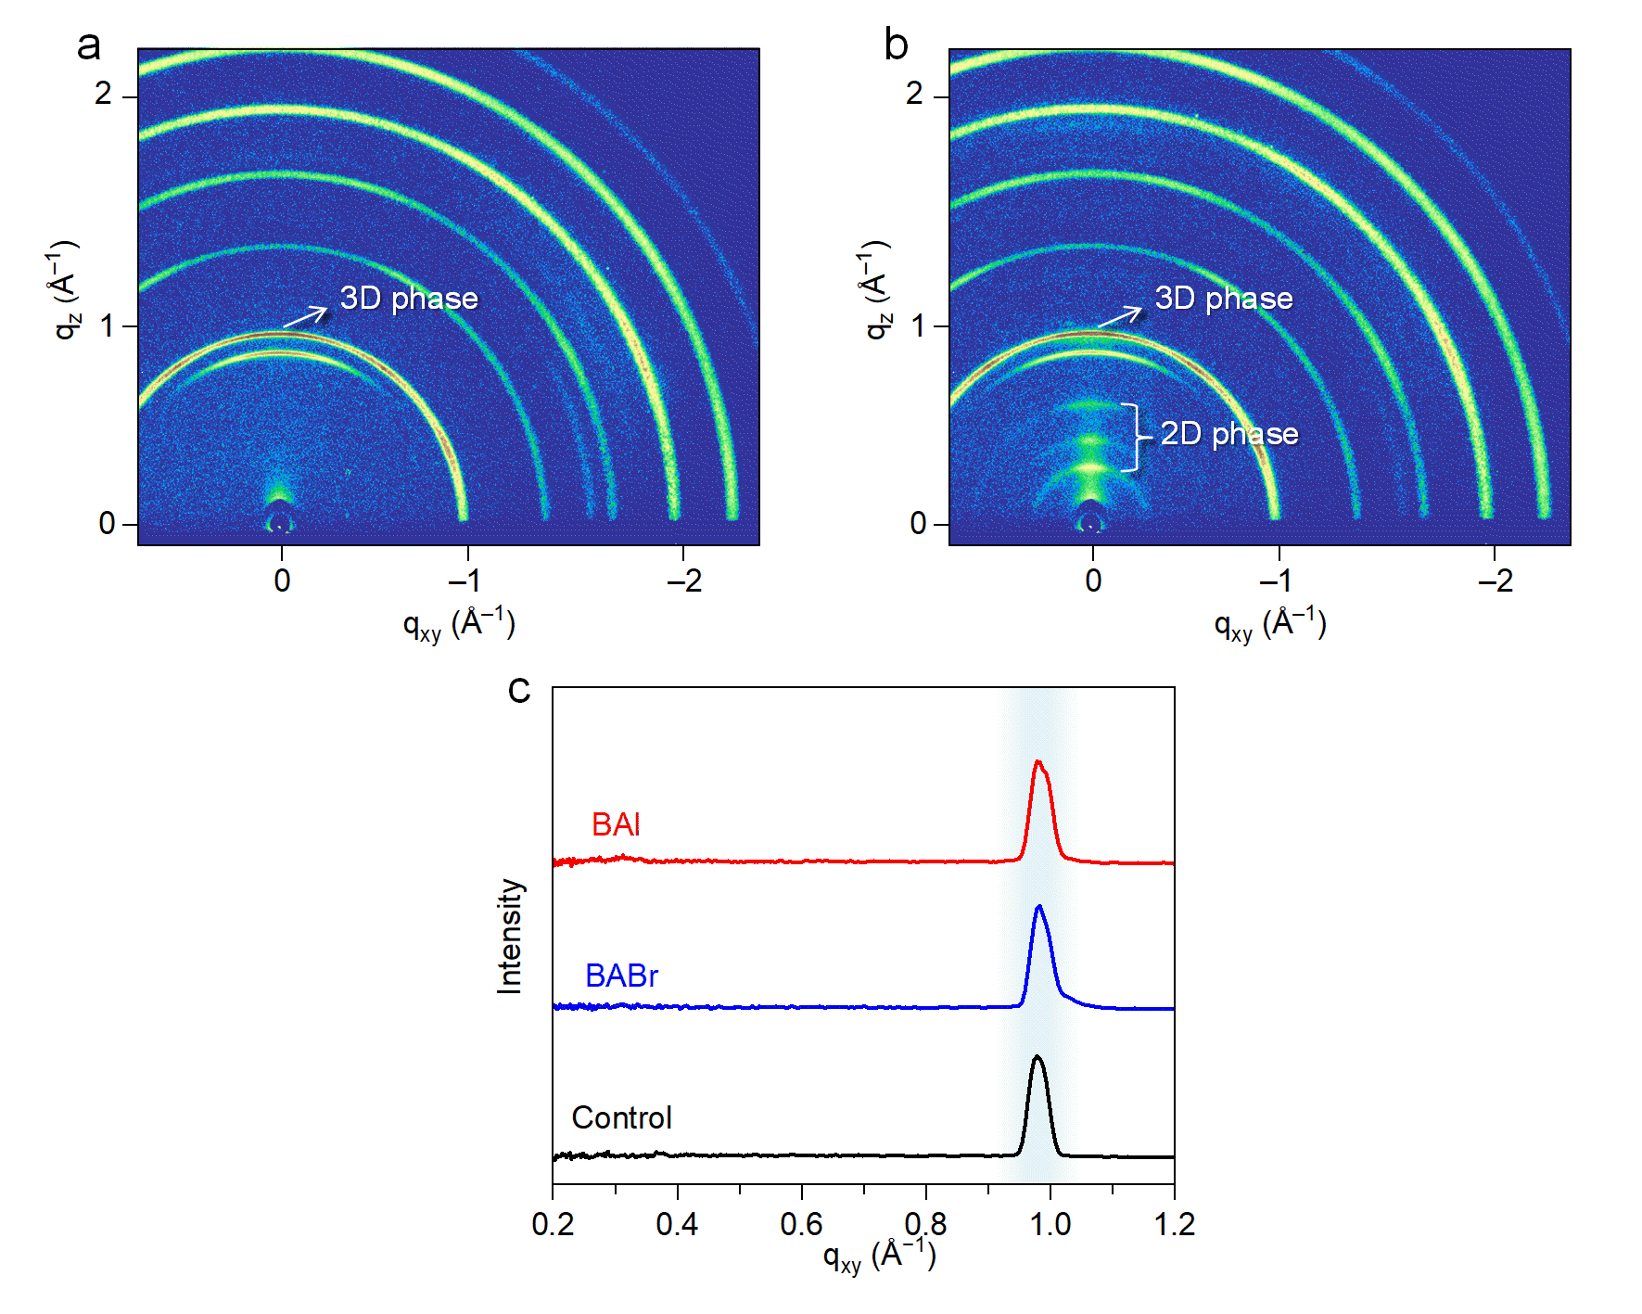

Fig. S3 | GIWAXS patterns of (a) 3D perovskite and (b) 2D/3D perovskite treated by BABr, where the signals representing 2D and 3D perovskite phases were marked in the figures. (c) Cut-lines of GIWAXS intensities along the q_{xy} axis for the control, BABr, and BAI samples.

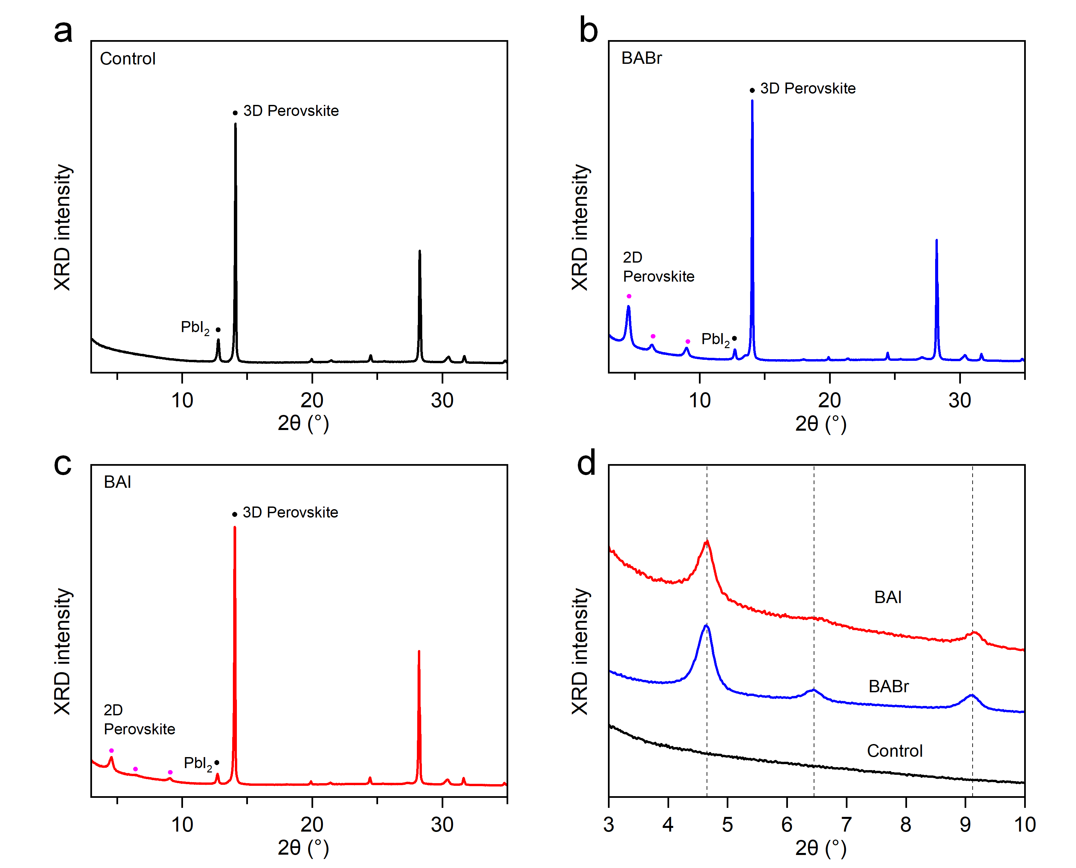

Fig. S4 | XRD results of control, BABr, and BAI perovskite. New diffraction peaks at 4.65°, 6.45° and 9.12° for both BABr and BAI samples can be observed, which suggest a larger interplanar crystal spacing of the 2D-layered perovskite than the pristine 3D bulk perovskite. It is noted that 5% excessed PbI₂ is used during the fabrication of 3D perovskite, which can be confirmed by the XRD results with a quite high intensity of 3D-perovskite sign at 12.78°. The PbI₂ signals for both BABr and BAI samples are weakened, suggesting that the excessed PbI₂ may be partially consumed by reacting with BABr or BAI to form 2D perovskite¹¹.
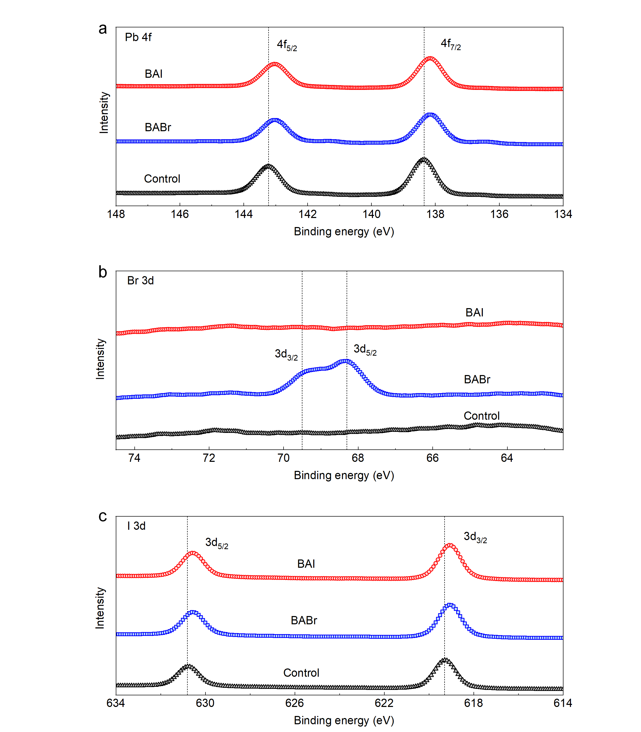

Fig. S5 | X-ray photoelectron spectroscopy (XPS) spectra. XPS spectra of the three related samples for (a) Pb 4f, (b) Br 3d, and (c) I 3d peaks.

Note S2 | XPS analysis.
The XPS spectra of Pb 4f peaks shown in Fig. S5a suggest that two feature peaks of the control sample at the binding energies of 143.22 and 138.35 eV were assigned to Pb 4f_{7/2} and 4f_{5/2}, respectively, which is a signal of Pb²⁺ ions in the Pb–I octahedra. With the presence of BABr and BAI, these two peaks shift towards lower binding energies, indicating the changes in chemical states from ionic bonds to Pb ions. It is known that the binding energy in perovskite can be associated with Pb–I bonding length, which has two distinct Pb–I binding states in the 2D perovskite.¹² The higher one with a shorter bonding length in the horizontal direction is the bonding to the iodide of the corner-sharing PbI₆ octahedra, and the lower one is from the nonbonding iodide in the vertical direction.¹² The similar conclusions can be observed for the I 3d peaks in Fig. S5c, which shift from 630.80 (I 3d_{5/2})/619.30 (I 3d_{3/2}) eV for 3D perovskite to 630.55 (I 3d_{5/2})/619.05 (I 3d_{3/2}) eV for BABr and BAI cases. These results suggest that the presence of BABr and BAI would stretch the PbI₆ octahedra during the phase transformation of 2D perovskite, in good agreement with the previous reports.¹² Additionally, the Br 3d signals plotted in Fig. S5b show that only BABr sample appears the obvious feature peaks, which suggests that these Br ions existing on the surface of 2D/3D perovskite was introduced by BABr precursor during post-treatment.

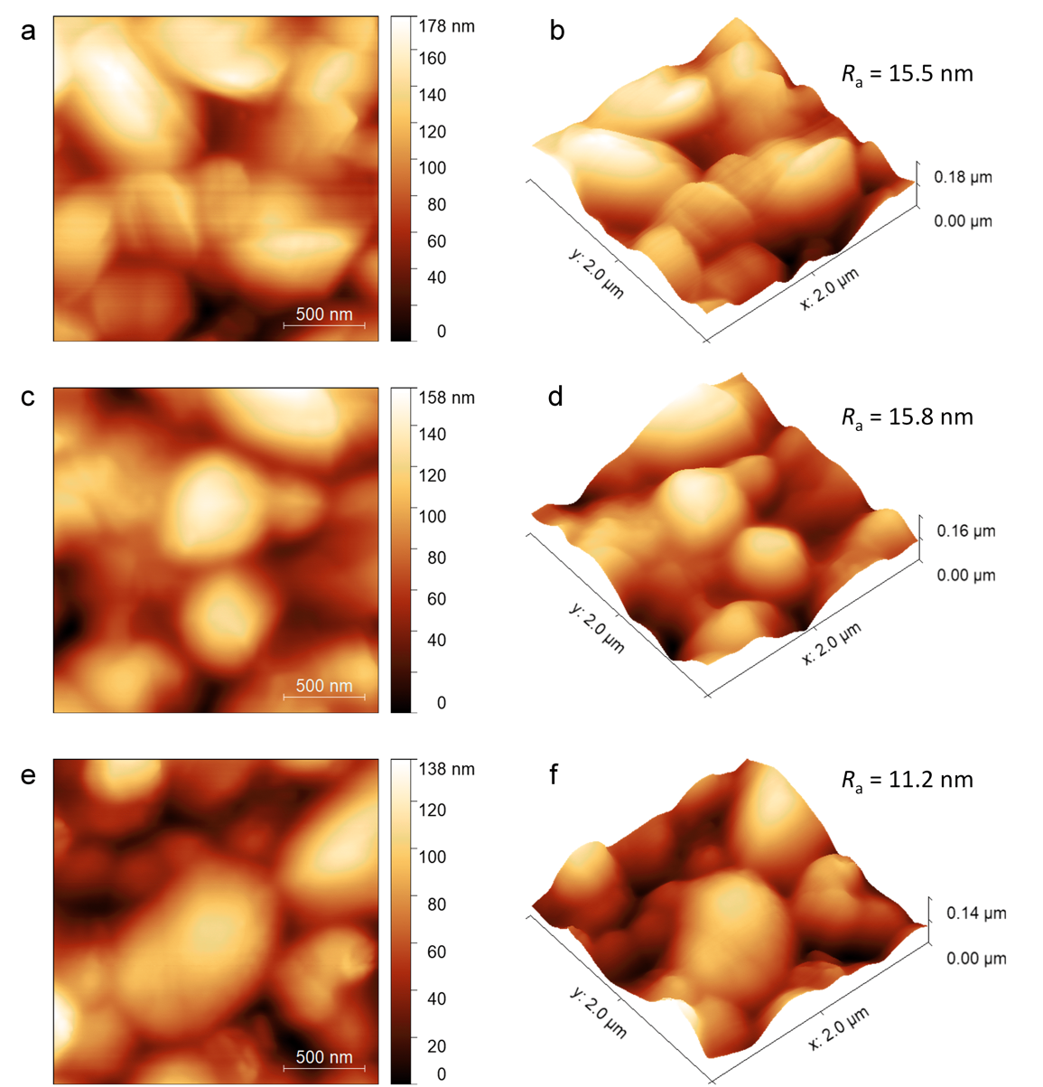

Fig. S6 | 2D/3D surface topography images from the KPFM measurements for the (a/b) Control, (c/d) BABr, (e/f) BAI samples. To ensure the results are reliable, the structure used for this measurement, i.e., 2D/3D perovskite/ETL/FTO, is consistent with that of the PSC. The arithmetic average deviations of height signals R_{a} are similar for the three types of samples, which are 15.5, 15.8, and 11.2 nm for Control, BABr, and BAI cases, respectively. Moreover, the polycrystal features inherent to 3D perovskite can still be observed from these topography images for the cases with 2D perovskite, indicating a good coverage of 2D perovskite upon the 3D perovskite, in line with the SEM results in Fig. S2.

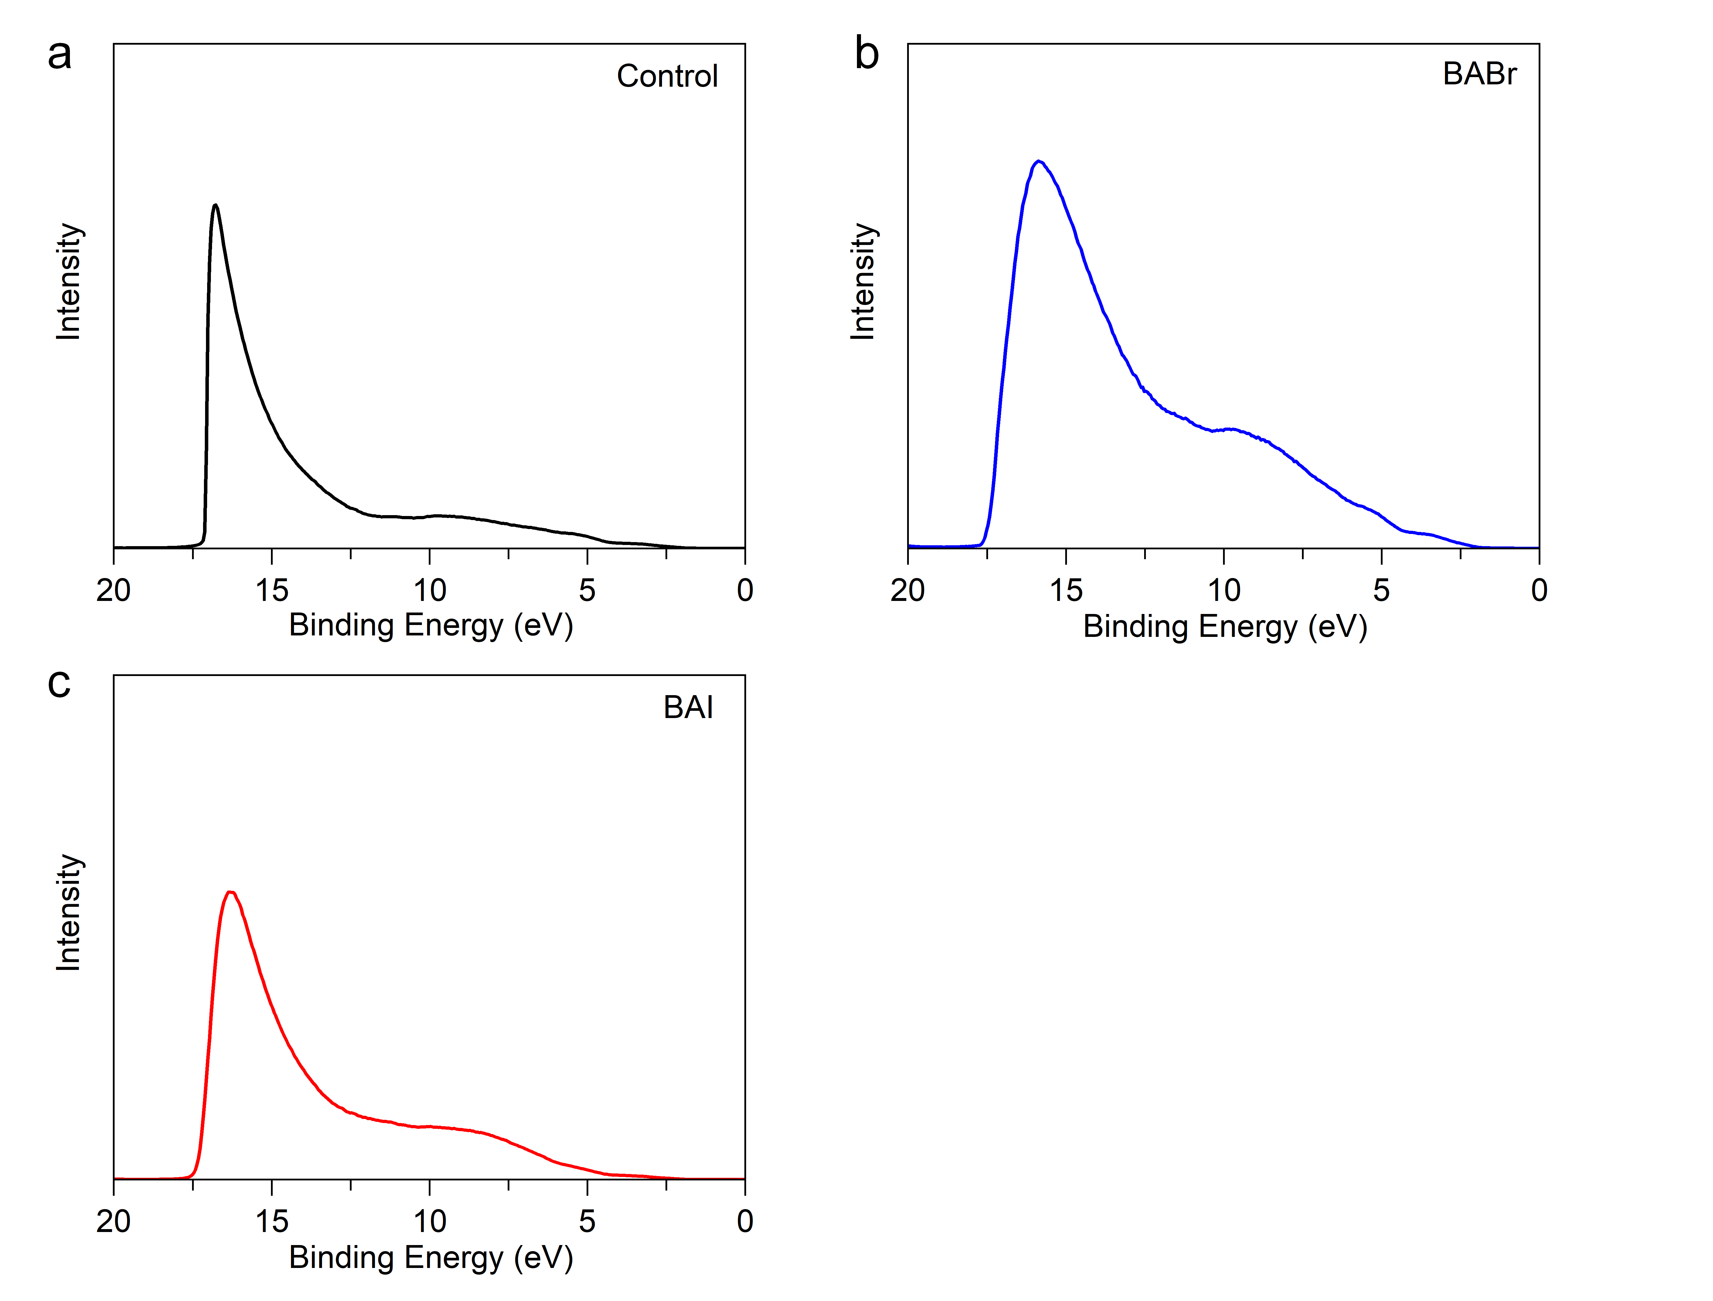

Fig. S7 | UPS spectra for the (a) Control, (c) BABr, (d) BAI samples. UPS measurements for the three related cases are conducted under a bias voltage of 10 V.

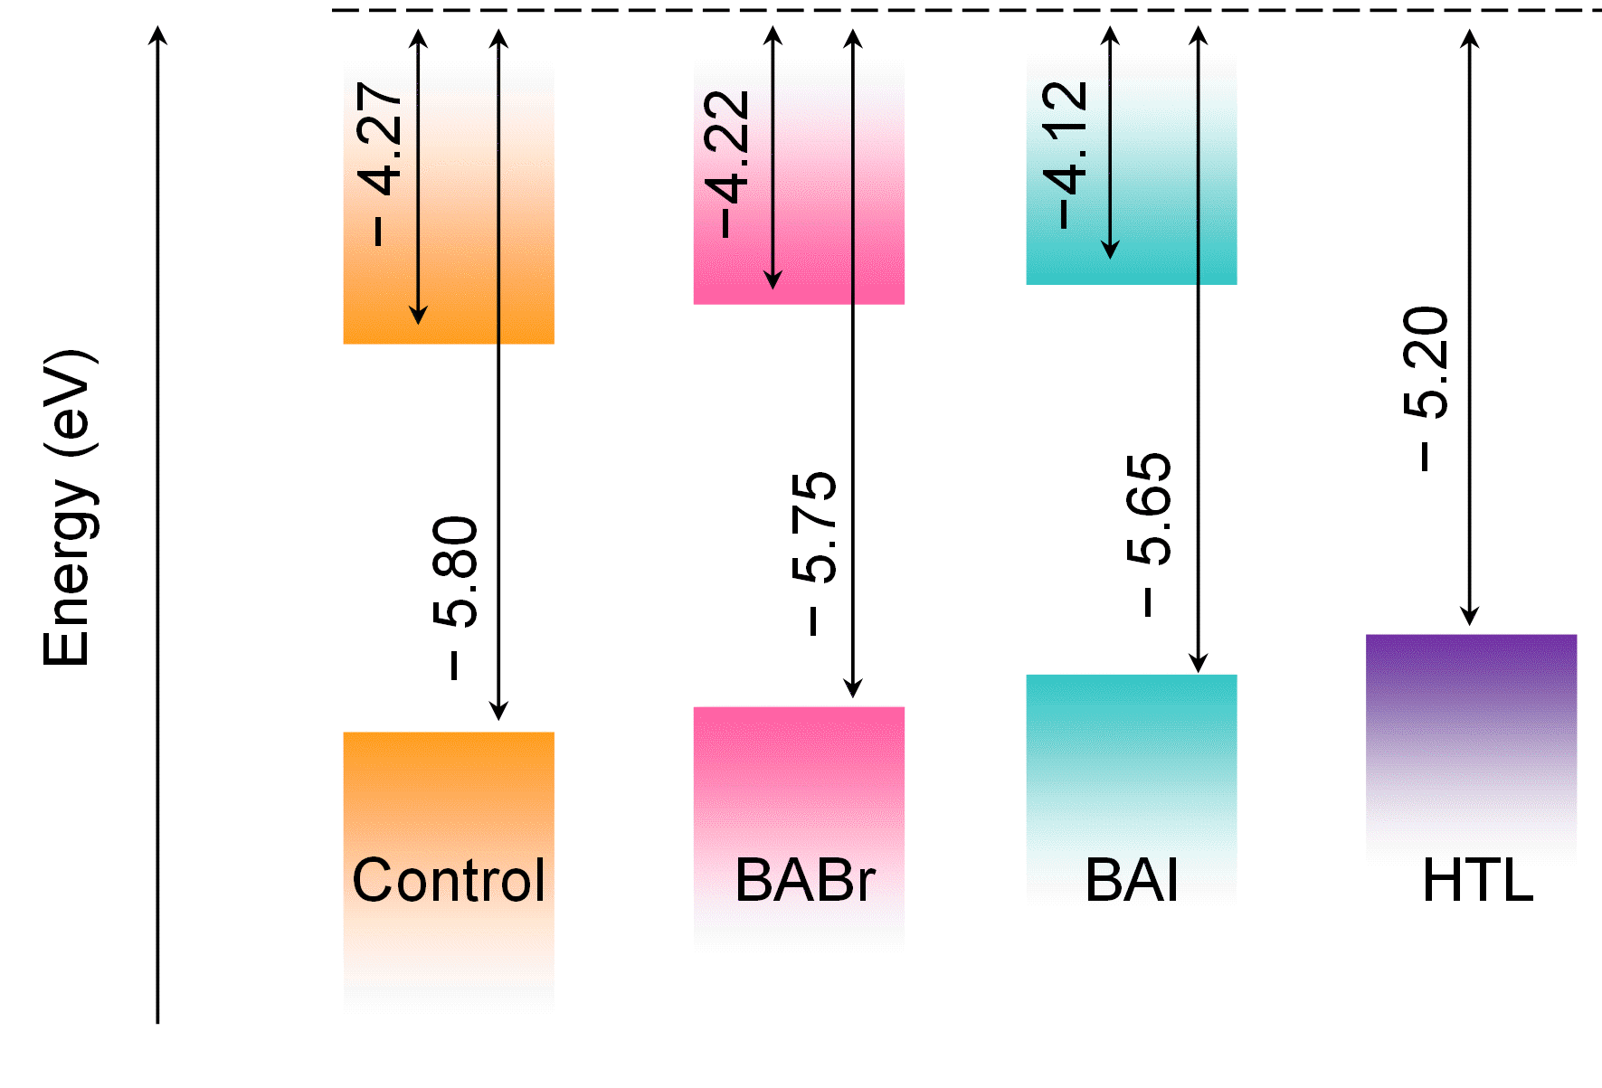

Fig. S8 | Energy structure of PSCs by UPS measurements.

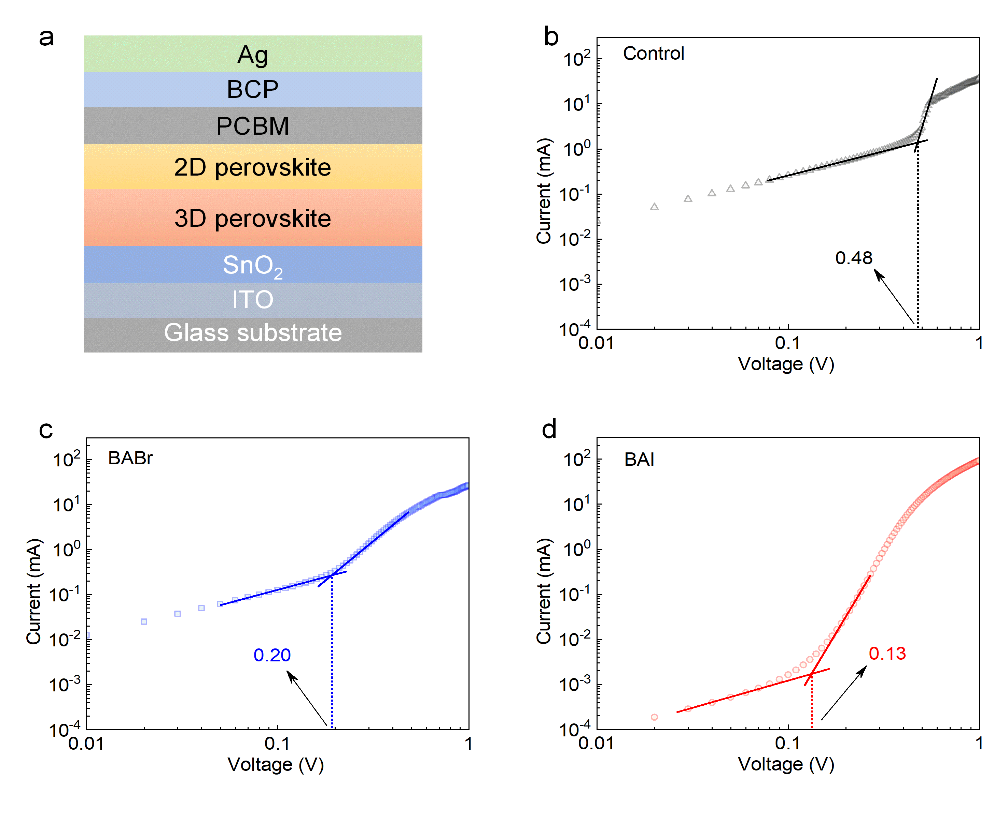

Fig. S9 | Evaluation of defect densities. Dark I–V curves of space-charge-limited current (SCLC) measurements for the ETL-only devices.

Note S3 | Extraction of defect densities of perovskite films.
To extract the trap densities (N_{t}) of the perovskite films, SCLC measurements were performed as shown in Fig. S9. The linear fitting of I–V curves of the initial linear region for Ohmic-type responses and the current injection region for trap fillings are used to obtain the kink point within the intermediate region, which is always identified as the value of V_{TFL}¹³. The N_{t} values can be calculated by the V_{TFL} using Equation (1):
(1)
where ε₀ and ε_{r} are the vacuum and relative dielectric constant, respectively, q is the elementary charge, and L is the thickness of the perovskite films. As a result, V_{TFL} values of the pristine 3D perovskite and BABr, BAI based 2D/3D perovskite samples are determined to be 0.48, 0.20, and 0.13 V, respectively. Accordingly, the trap density of pristine perovskite is calculated as 4.56×10¹⁵ cm^{–3}, which was reduced to 1.90×10¹⁵ and 1.23×10¹⁵ cm^{–3} for the BABr and BAI samples. It is indicated that surface reconstruction of the 3D perovskite film covered by 2D perovskite can effectively reduce the interface and bulk defects.

Table S1 | Photogenerated carrier lifetimes. The fitting results of the TrPL measurement of perovskite films on bare glasses. The fittings are carried out through a bi-exponential decay function.
Samples | τ₁ (ns) | τ₂ (ns)
Control | 177 | 1101
BABr | 108 | 3606
BAI | 46 | 2605

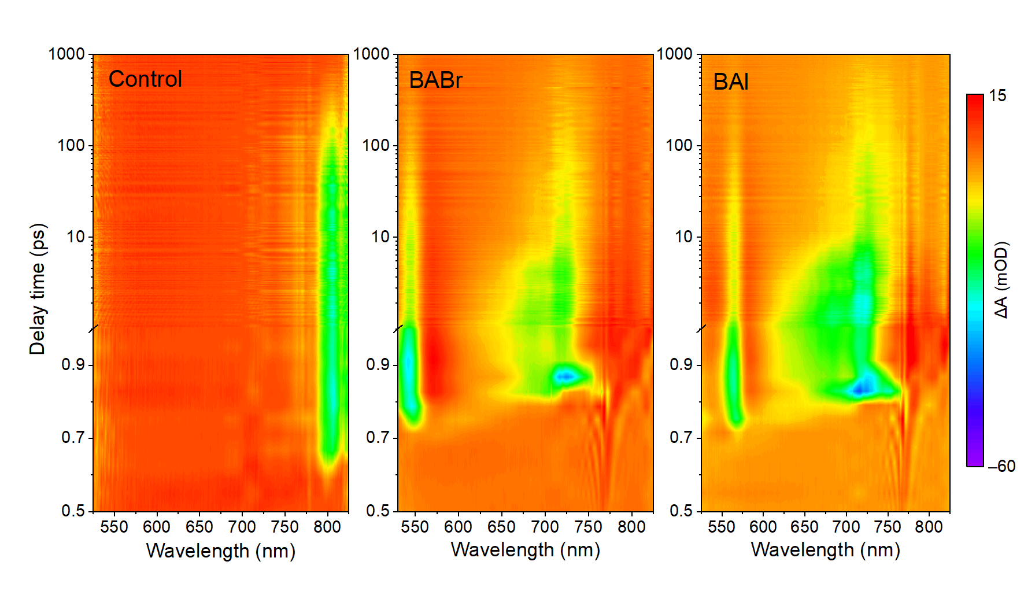

Fig. S10 | 2D contour plots of ultrafast transient absorption spectroscopy. TAS signals as functions of delay time and wavelength for three related cases. The wavelength of the pulsed laser is 800 nm.

Note S4 | TAS analysis
As shown in Fig. S9a, the strip-shaped region with a reduced TAS intensity for 3D perovskite located at around 800 nm can be clearly observed, which should be assigned to the GSB signal due to that the response wavelength of GBS signal is well-matched with the bandgap of 3D perovskite. This GBS signal at 800 nm disappears, and a new emerging signal at near 550 and 570 nm should be assigned to GSB signal for the BABr and BAI cases, respectively, as shown in Fig. S9b and S9c. In the range of 650 to 750 nm, the GSB signals can be attributed to the quasi-2D perovskite with n ＞ 2, which has been widely confirmed by others. Apart from the positions of GBS signals, the opened times of GSB signals that could deduce the transport processes of charge-carriers suggest that the generated charge-carriers in 3D perovskite are firstly transported to 2D perovskite with n = 2, and then are injected to 2D perovskite with n > 2 with the continuous accumulation of charge-carriers in 2D perovskite with (n = 2). Fig. S10 illustrates the TAS spectra at the different delay times. It is noted that to enhance the measured signals with a high noise ratio at a short wavelength range that includes the 2D perovskite response wavelength, a low concentration solution of 0.5 M is used to fabricate the 3D perovskite to reduce the thickness of 3D perovskite.

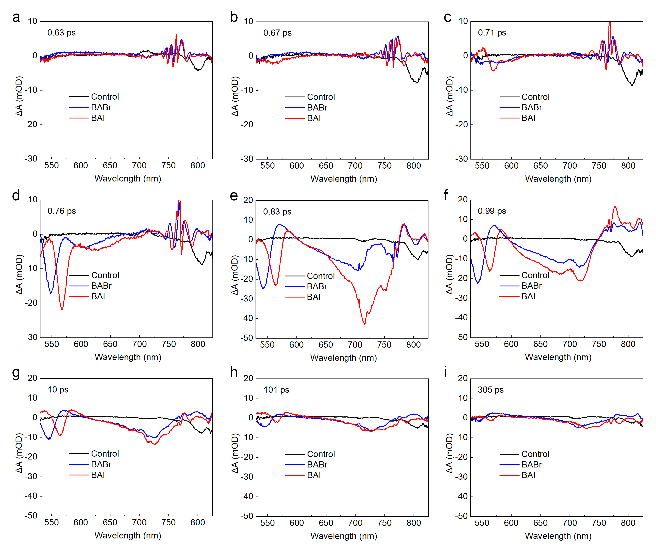

Fig. S11 | Transient absorption spectra at the different delay times.

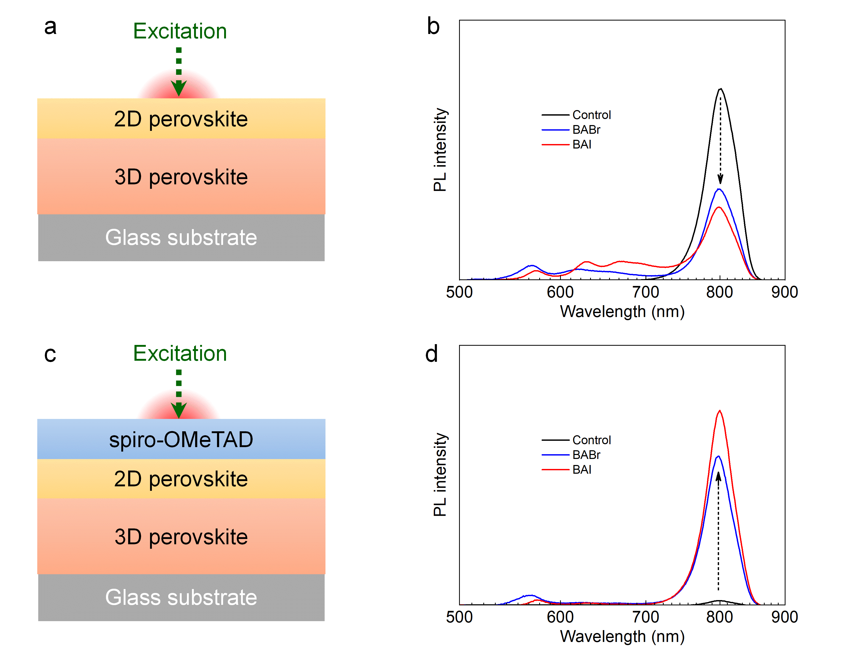

Fig. S12 | Steady-state PL measurements. (a) (c) The schematic diagrams of the measured structures for the cases with and without HTLs, respectively, in which the excitation wavelength is 470 nm, and (b) (d) the corresponding PL spectra. For the case without HTLs, the PL feature peak of 3D perovskite, as shown in Fig. S11b is obviously weakened by the 2D/3D heterojunction. The reduced PL intensity that is usually associated with the lowered radiative recombination is the result of the reduced free carriers in the bulk and an improved carrier transport behavior. With the presence of HTLs, the demonstrated results in Fig. S11d are just the opposite compared with the none HTL cases in Fig. S11b, and the enlarged PL intensities for the 2D/3D cases indicate improved passivation. Therefore, it can be concluded from the steady state PL, TrPL and TAS measurements that carrier dynamics of samples with 2D/3D heterojunction cannot be thoroughly evaluated by a single characterizing method, because the enhancement of surface defect passivation and charge-carrier extraction may co-exist.

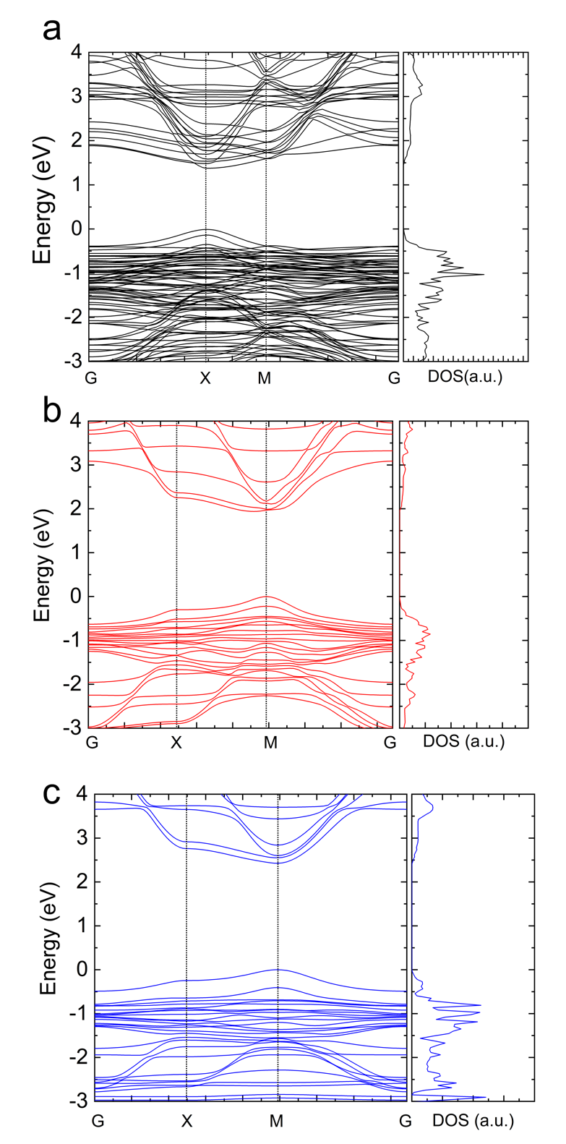

Fig. S13 | Calculated band structures and the corresponding total density of states for (a) FAPbI₃ 3D perovskite, (b) (BA)₂FAPb₂Br₇ 2D perovskite, (c) (BA)₂FAPb₂I₇ 2D perovskite. The absolute values of energies are calculated as –6.25 eV, –5.76 eV, –6.49 eV, respectively, for the three involved cases.

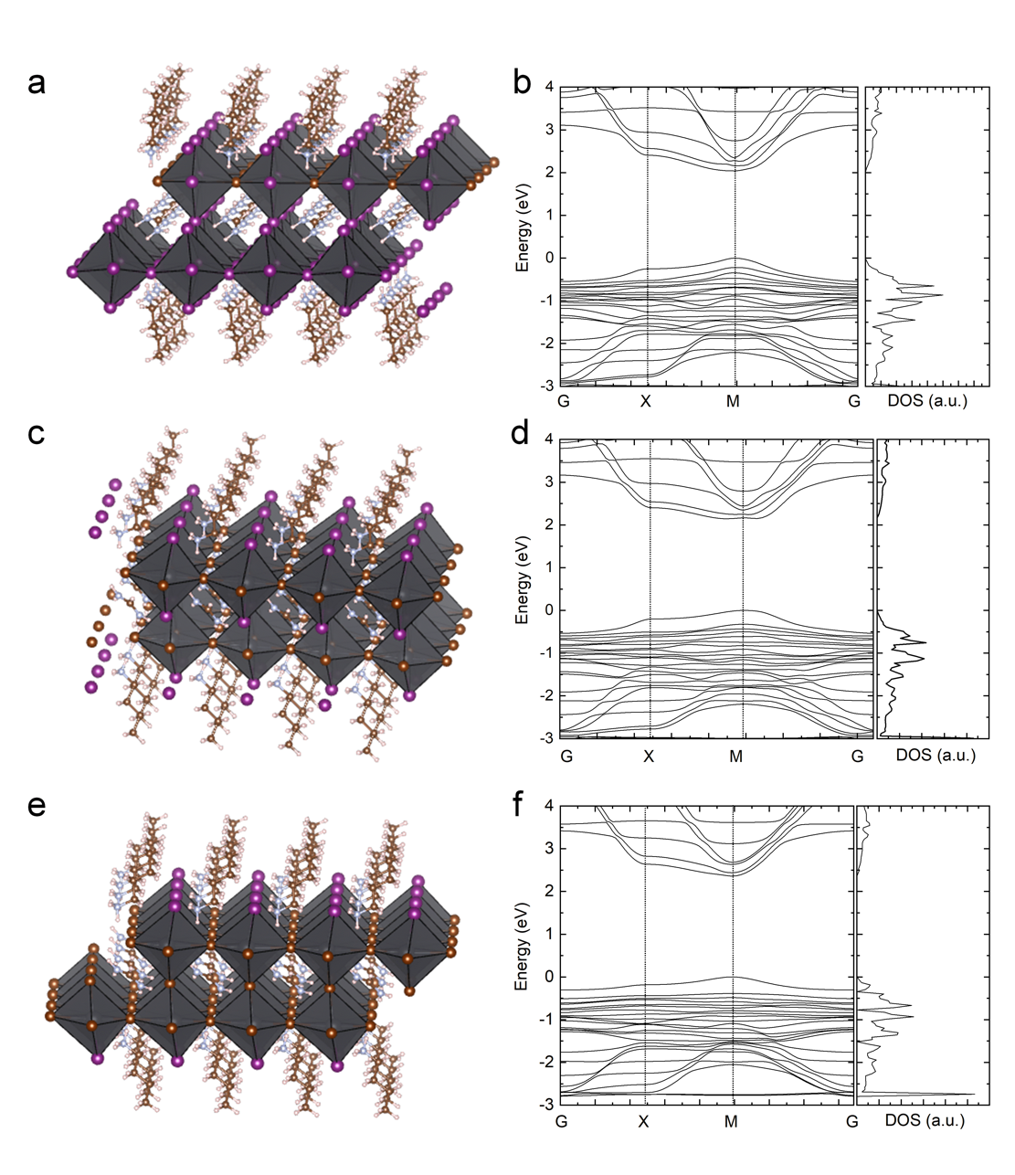

Fig. S14 | Calculated band structures and the corresponding total density of states for (BA)₂FAPb₂Br_{x}I_{7–x}. (a) (b) x = 1, (b) (c) x = 2, (e) (f) x = 4, with the corresponding Br element contents of14%, 29%, and 57%, respectively. The absolute values of energies are adjusted by –6.25 eV, –5.76 eV, and –6.49 eV, respectively.

Fig. S15 | The simulated and experimental J-V curves for three related cases. The simulated VBO was extracted from the UPS results.

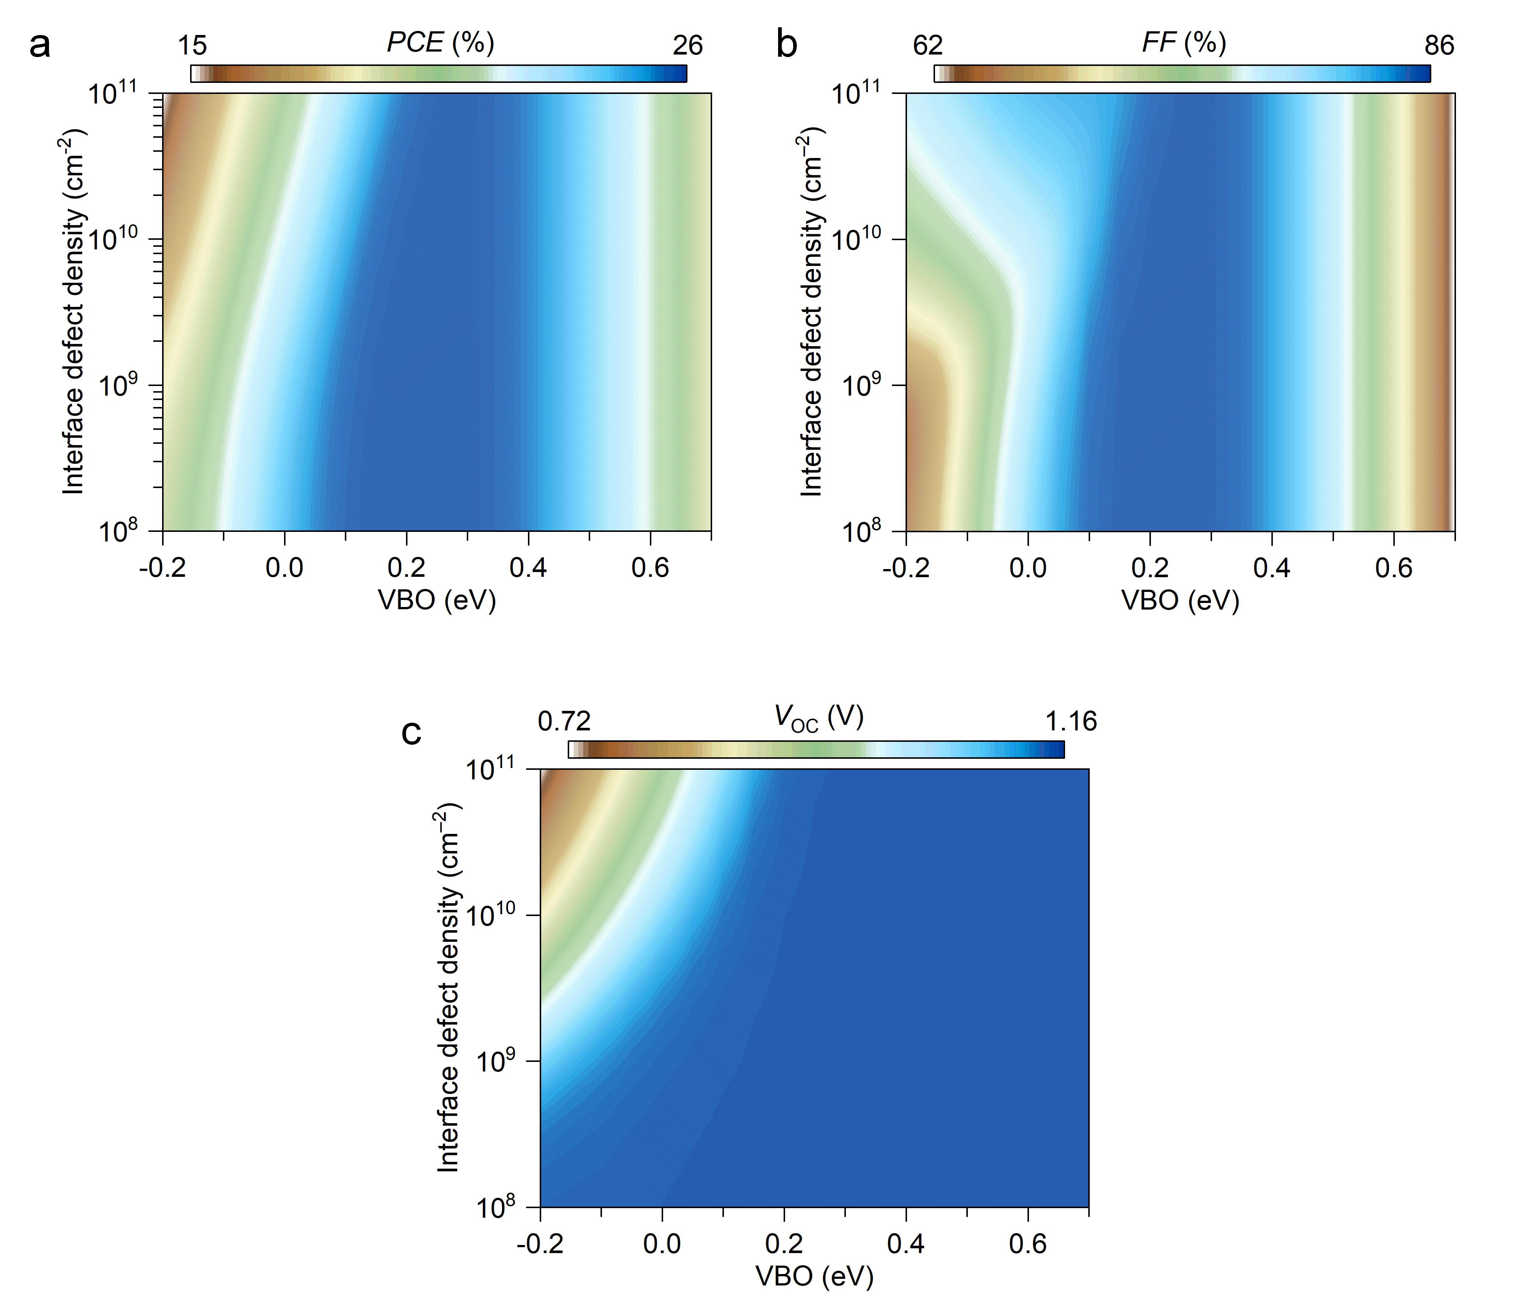

Fig. S16 | Simulated device performance as functions of VBO and interface defects: (a) PCE, (b) FF and (c) V_{OC}. It is noted that the change of Jsc is too small to be ignored so that they are not included in this study.

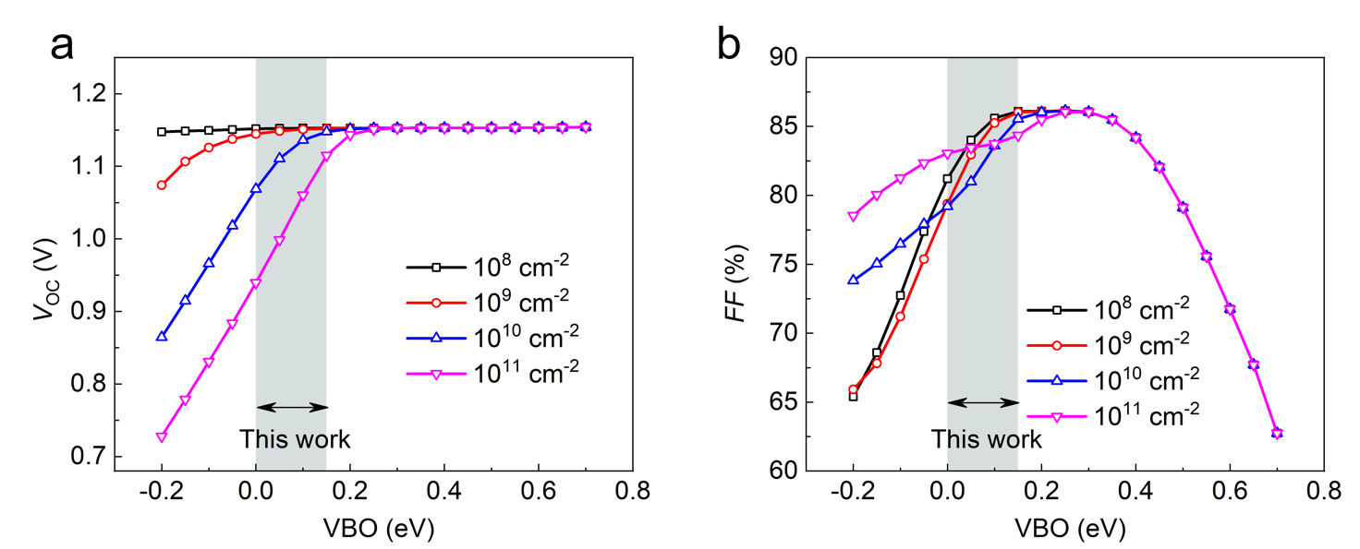

Fig. S17 | Simulated device performance as a function of VBO under the different interface defects extracted from Fig. S15: (a) V_{OC}, (b) FF.

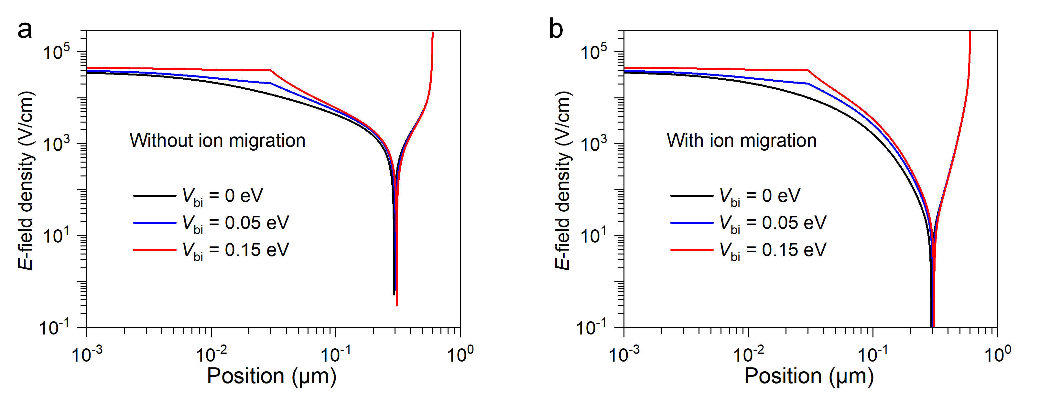

Fig. S18 | Simulated E-field density versus the vertical position of perovskite in PSCs without and with ion migration.
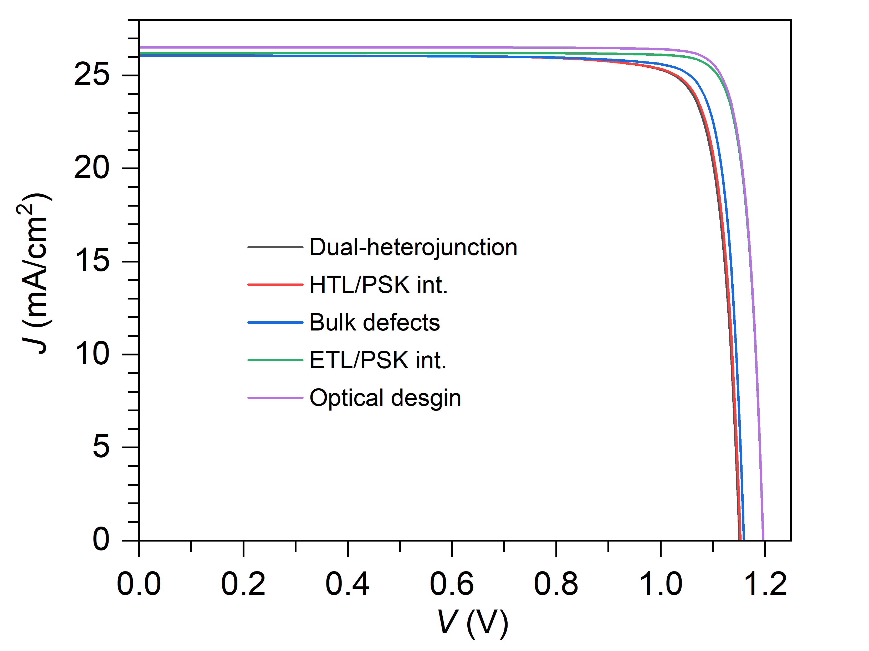

Fig. S19 | Prediction of PSCs performance, i.e., the optimal dual-heterojunction PSCs, ignore the defects at the HTL/perovskite interface, ignore the defects in the perovskite bulk, ignore the defect at ETL/perovskite interface and the optimal optical design.

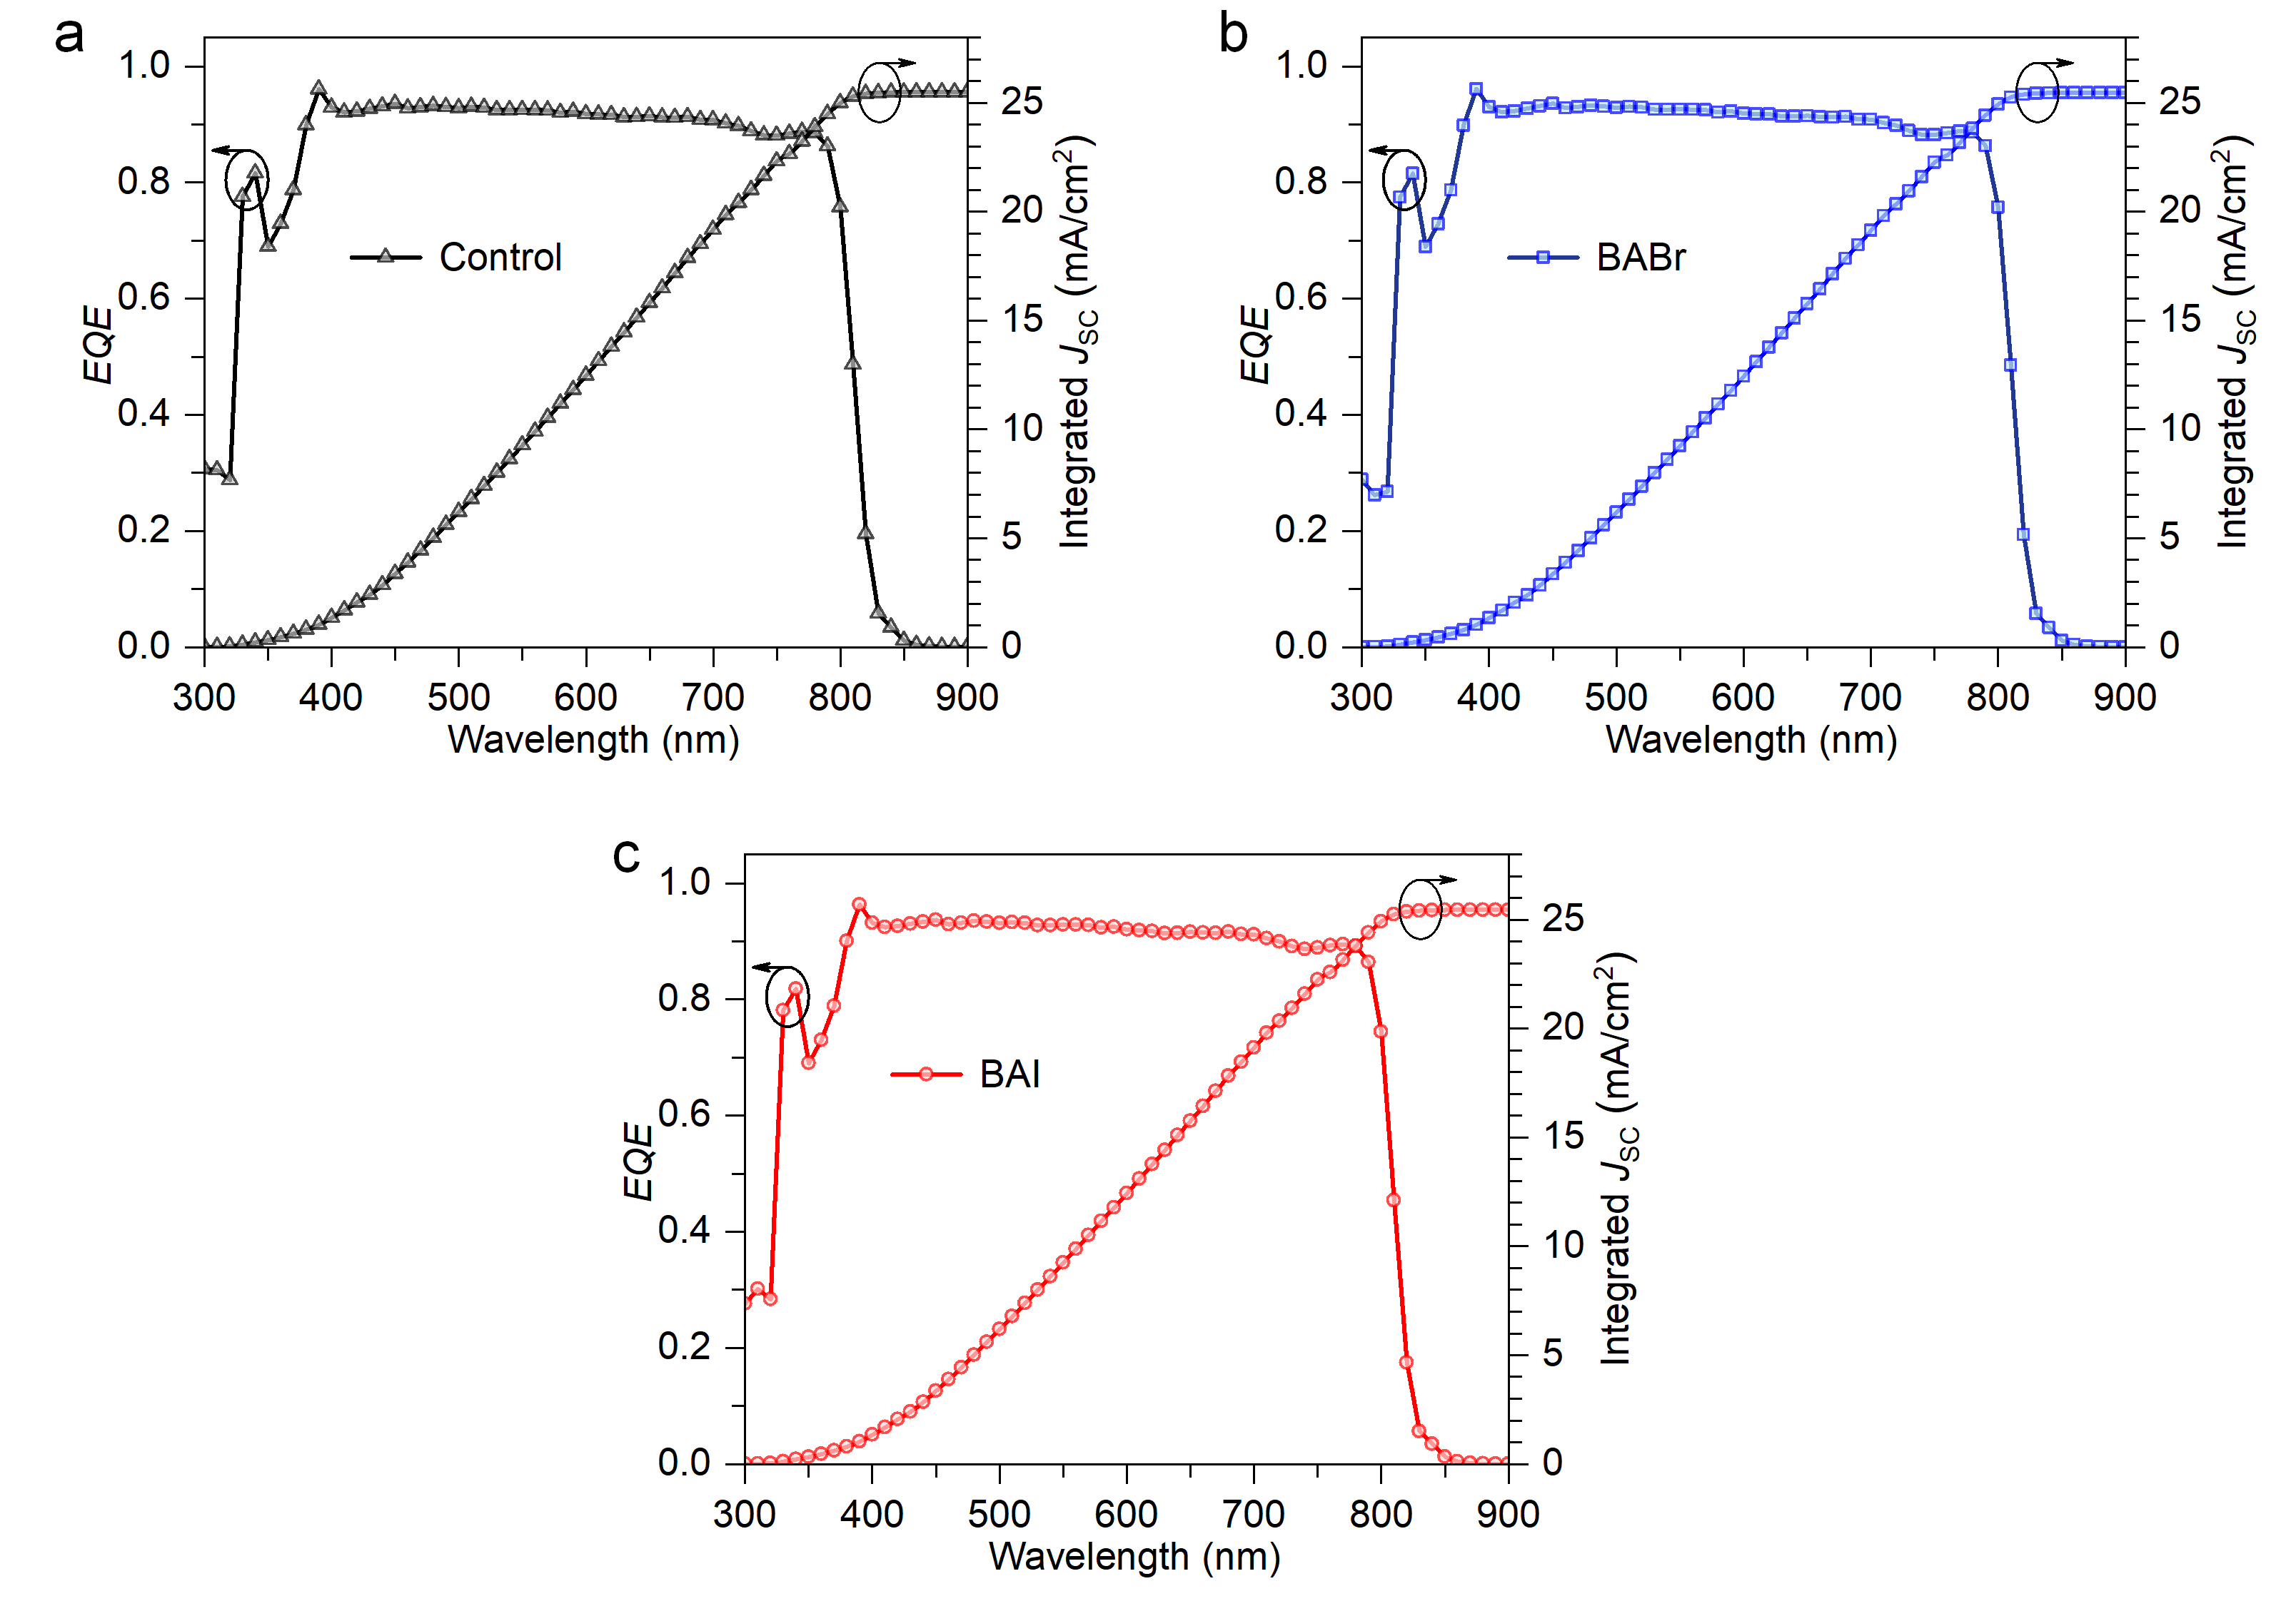

Fig. S20 | The EQE spectra and integrated current densities for the Control, BABr and BAI PSCs. The integrated current densities are determined to be 25.50, 25.48 and 25.46 mA/cm², respectively, in good agreement with the J–V results.

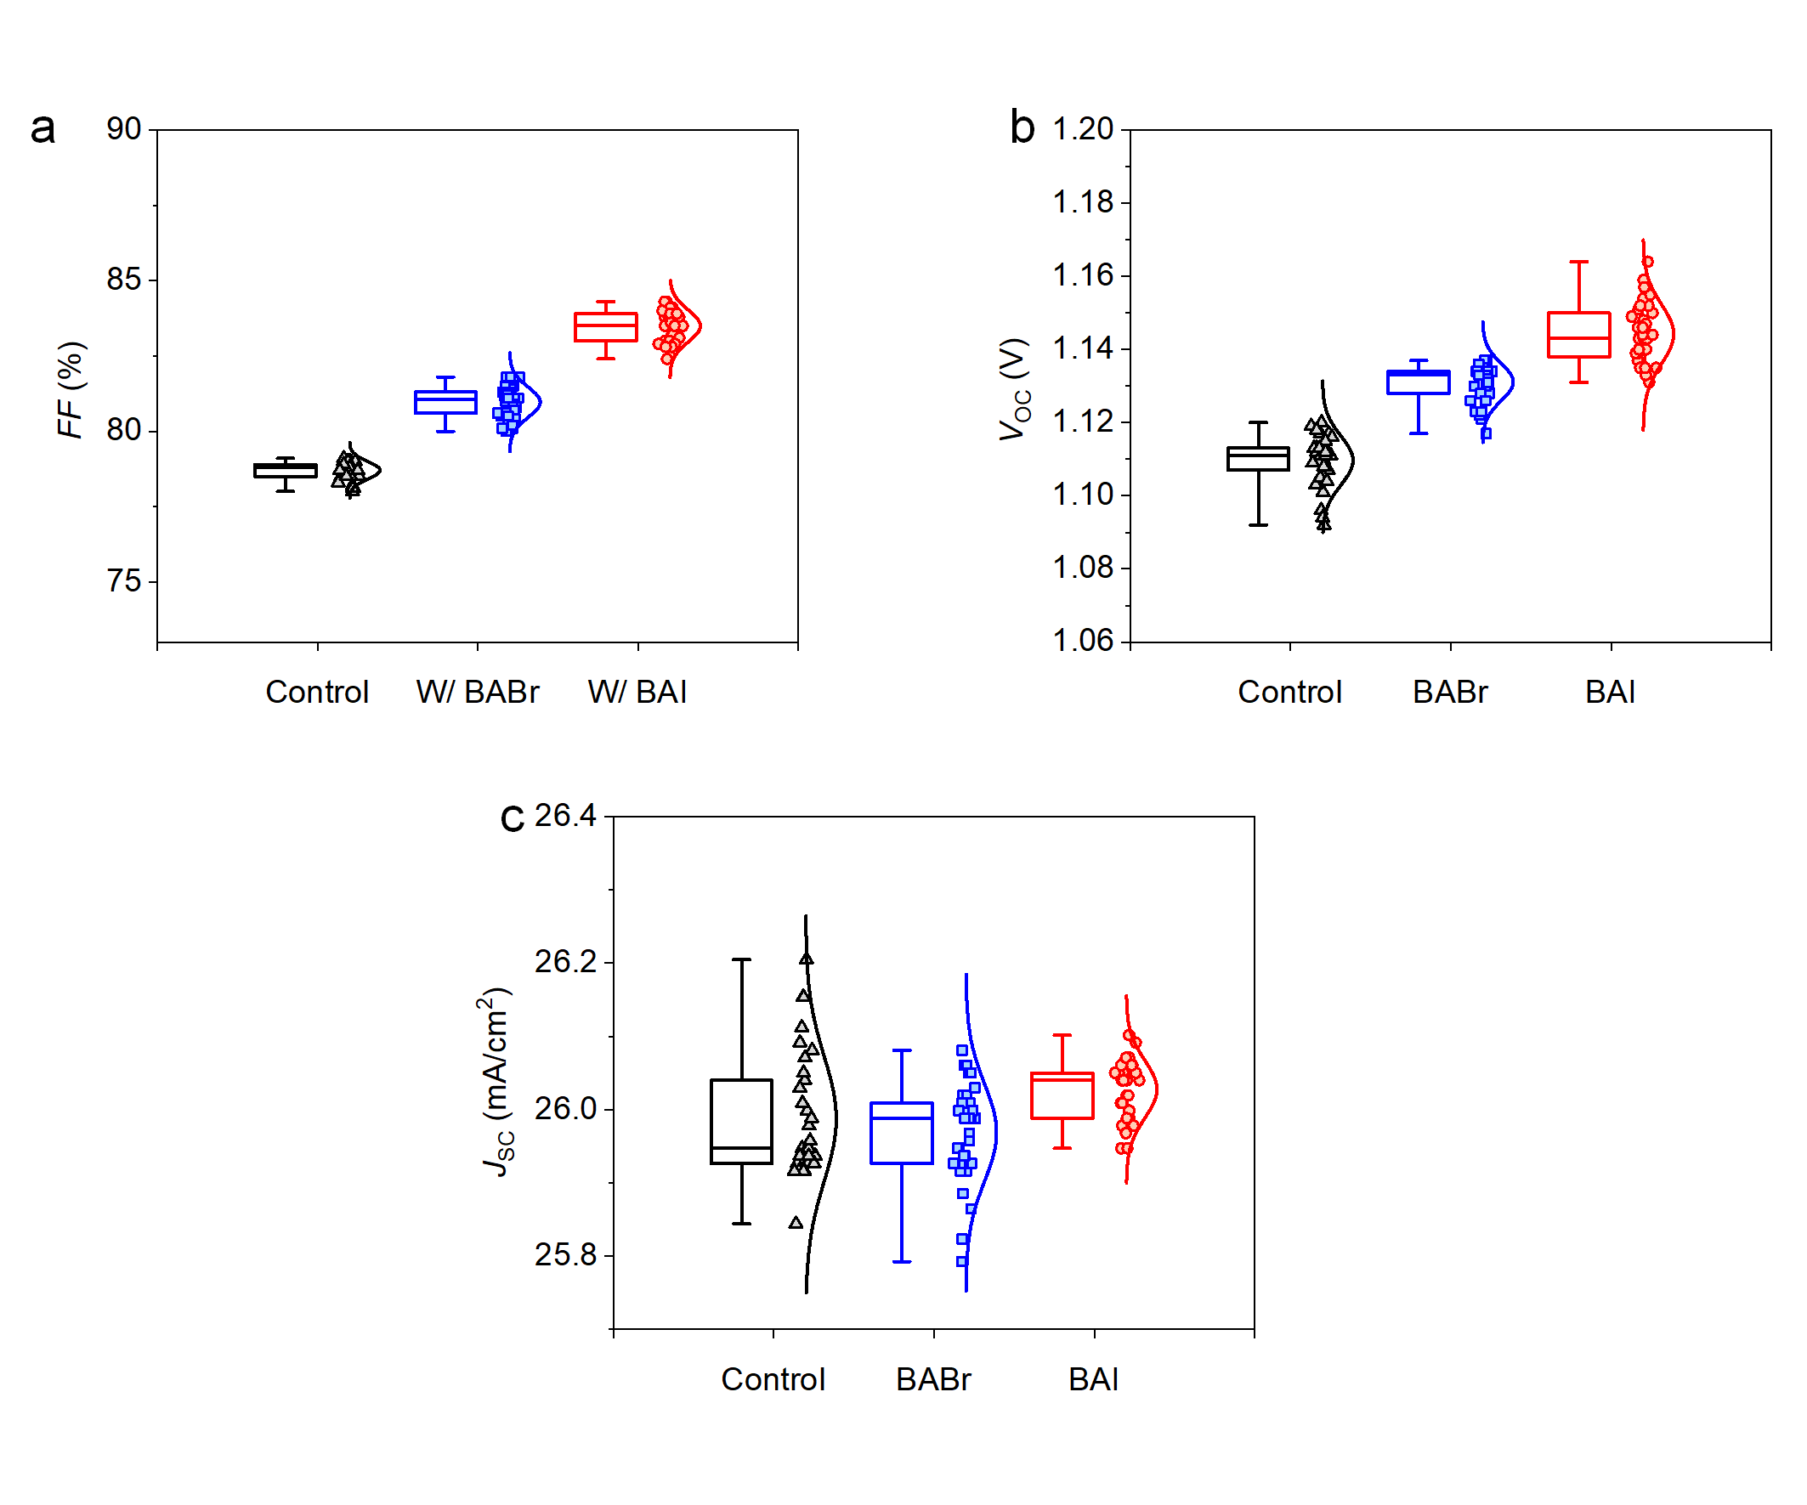

Fig. S21 | The FF, V_{OC} and J_{SC} statistics of 34 cells for the three involved cases. The box contains 50% of the data, the antenna shows the minimum and maximum values, and the bars give the median.

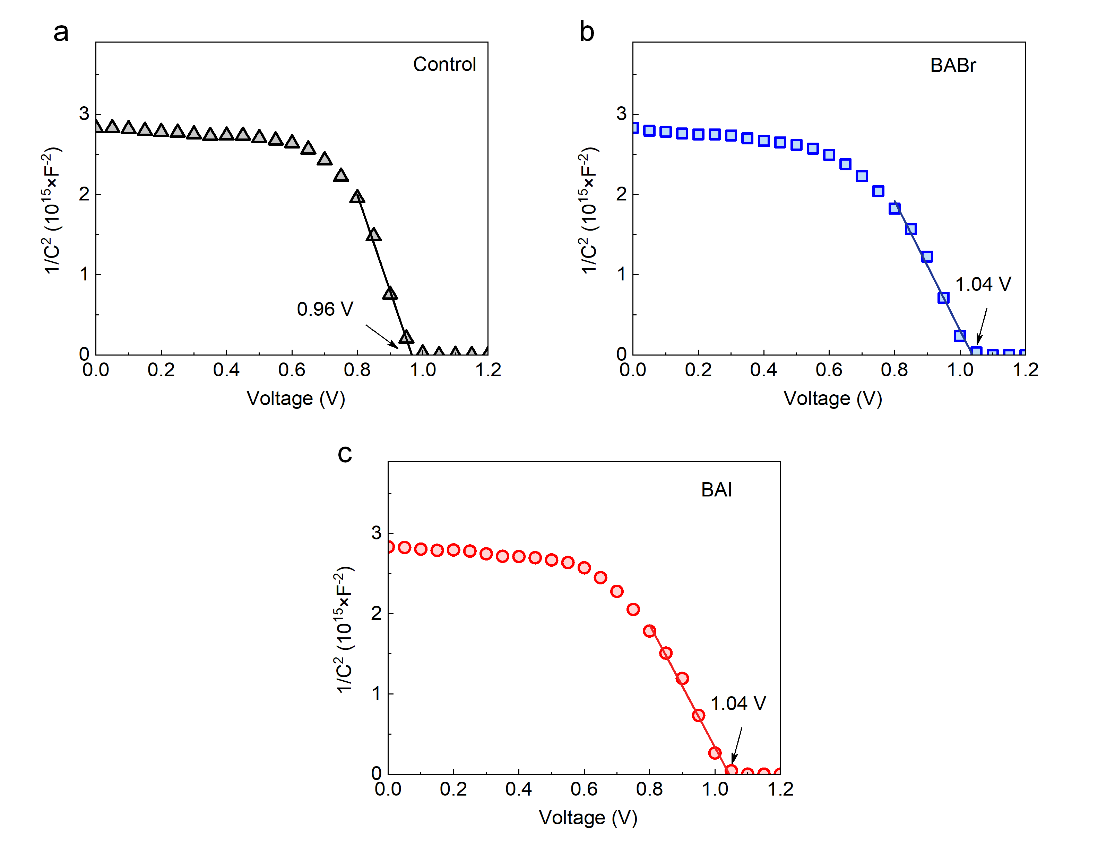

Fig. S22 | Mott-Schottky plots obtained from CV measurements for the control, BABr and BAI cases at 10kHz in the dark. This analysis is used to confirm the built-in potential (V_{bi}) of PSCs that is related to V_{OC} and can be obtained from the intersection of the slope and x-axis. It is shown that the introduction of 2D/3D heterojunction enhances V_{bi} from 0.96 to 1.04 V, in line with the tendency of the device’s V_{OC}.

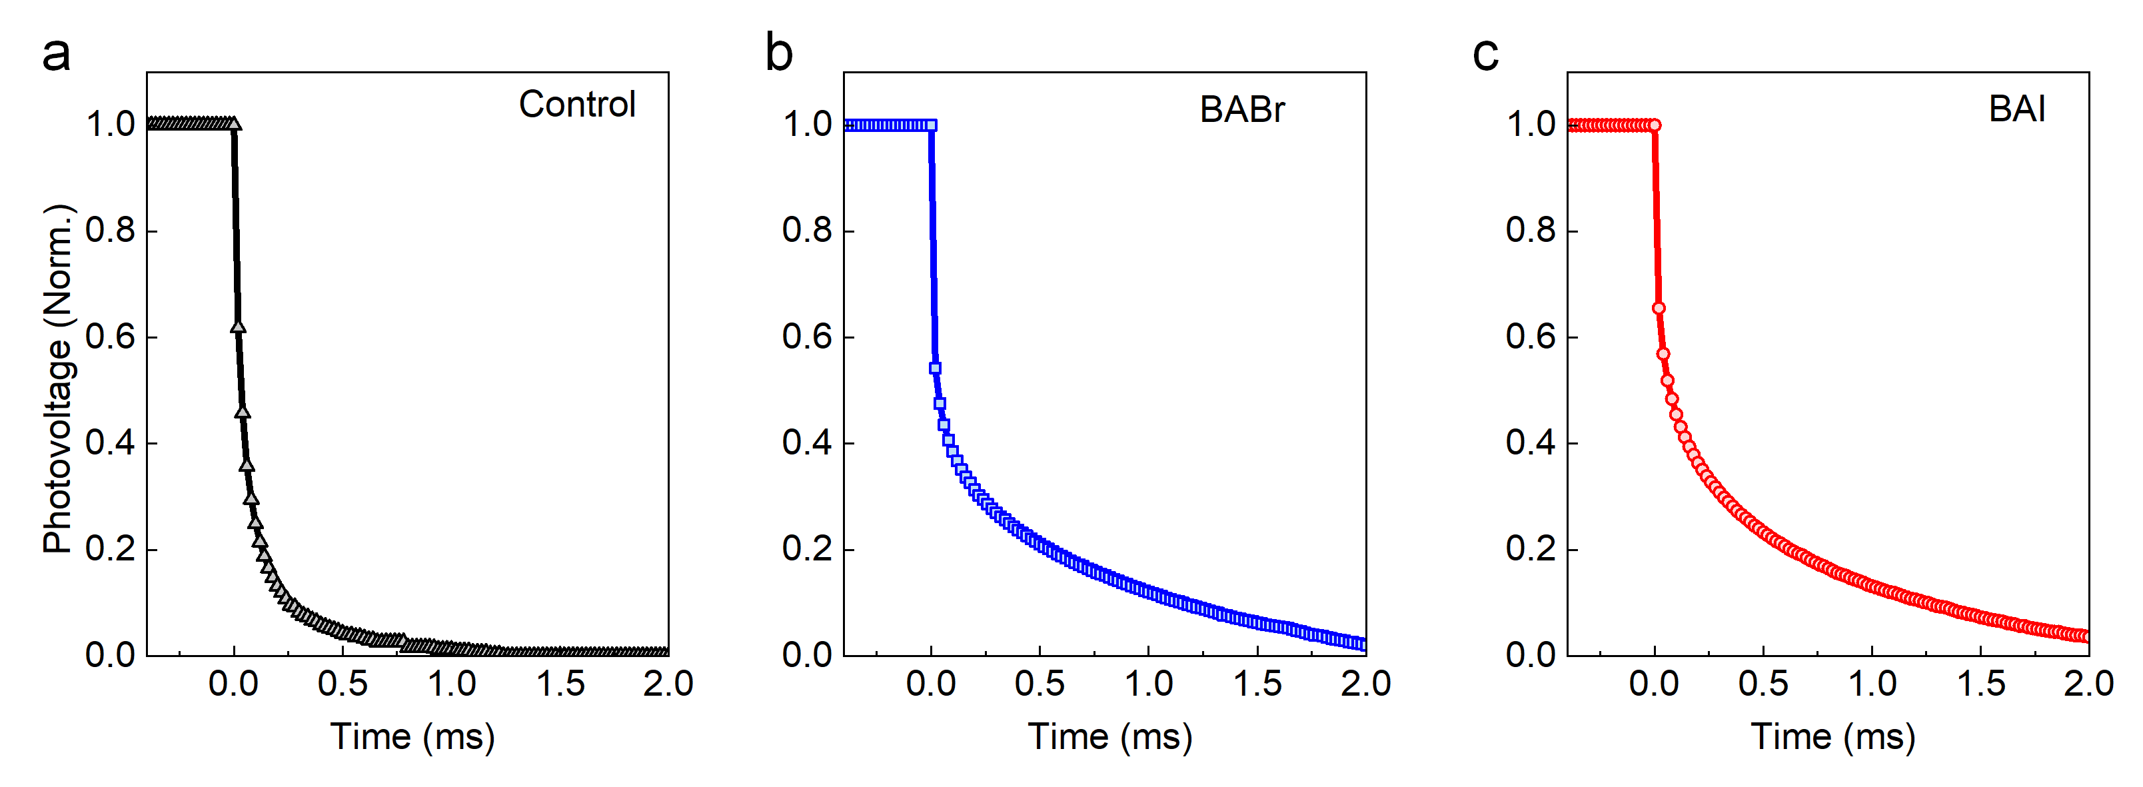

Fig. S23 | TPV decay curves for three related cases. To look into the internal forces of the efficiency increasement, TPV decay curves are employed to explore the charge-carrier recombination properties at the open-circuit conditions under full-sun illumination, with the completed PSC devices. In this condition, since photocurrent is significantly smaller than that of the J_{sc} condition, TPV can give information on non-radiative recombination without the influence of charge injection dynamics. For typical devices in this study, interface recombination is the main donation of non-radiative recombination. When the light pulse is off, a decay of photovoltage by the photoexcited excess carriers that first reach and then recombine near one of the contact interfaces can be observed within several milliseconds. As shown in Figure 1e, W/ BABr and W/ BAI devices show similar TPV decay responses with a longer decay time than the Control condition, indicating a lower interface recombination rate with the BABr and BAI post-treatment.

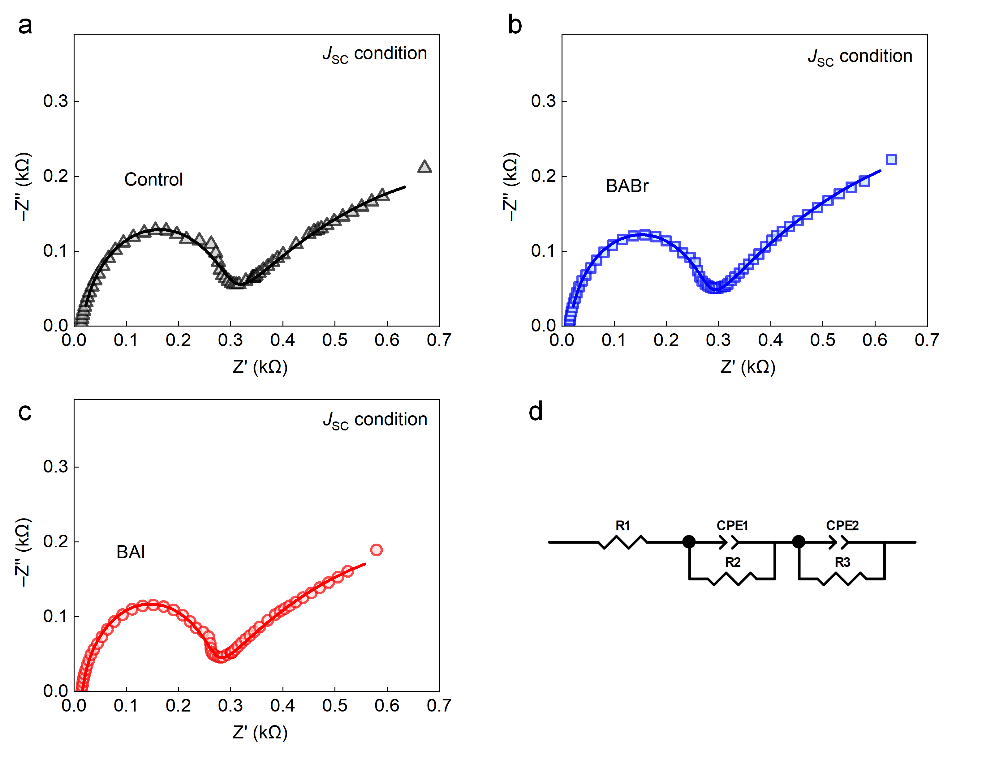

Fig. S24 | EIS measurements under J_{SC} condition. EIS measurements under Jsc condition with one-sun illumination are performed to obtain the transport impedance inherent to the series resistors. The results, shown by Nyquist plots in Fig. S21, exhibit two semi-circles, of which the first one at high-frequency region is assigned to the charge transfer process at the perovskite/spiro-OMeTAD interface (hole extraction or injection), and the later one may be attributed to some slow charge transport process that has no direct relevance to the device physics. An equivalent circuit model in Fig. S21d is used to fit the EIS results. The fitted resistor R₂ for the three devices is determined to be 261.9, 246.5 and 234.7 Ω, respectively.

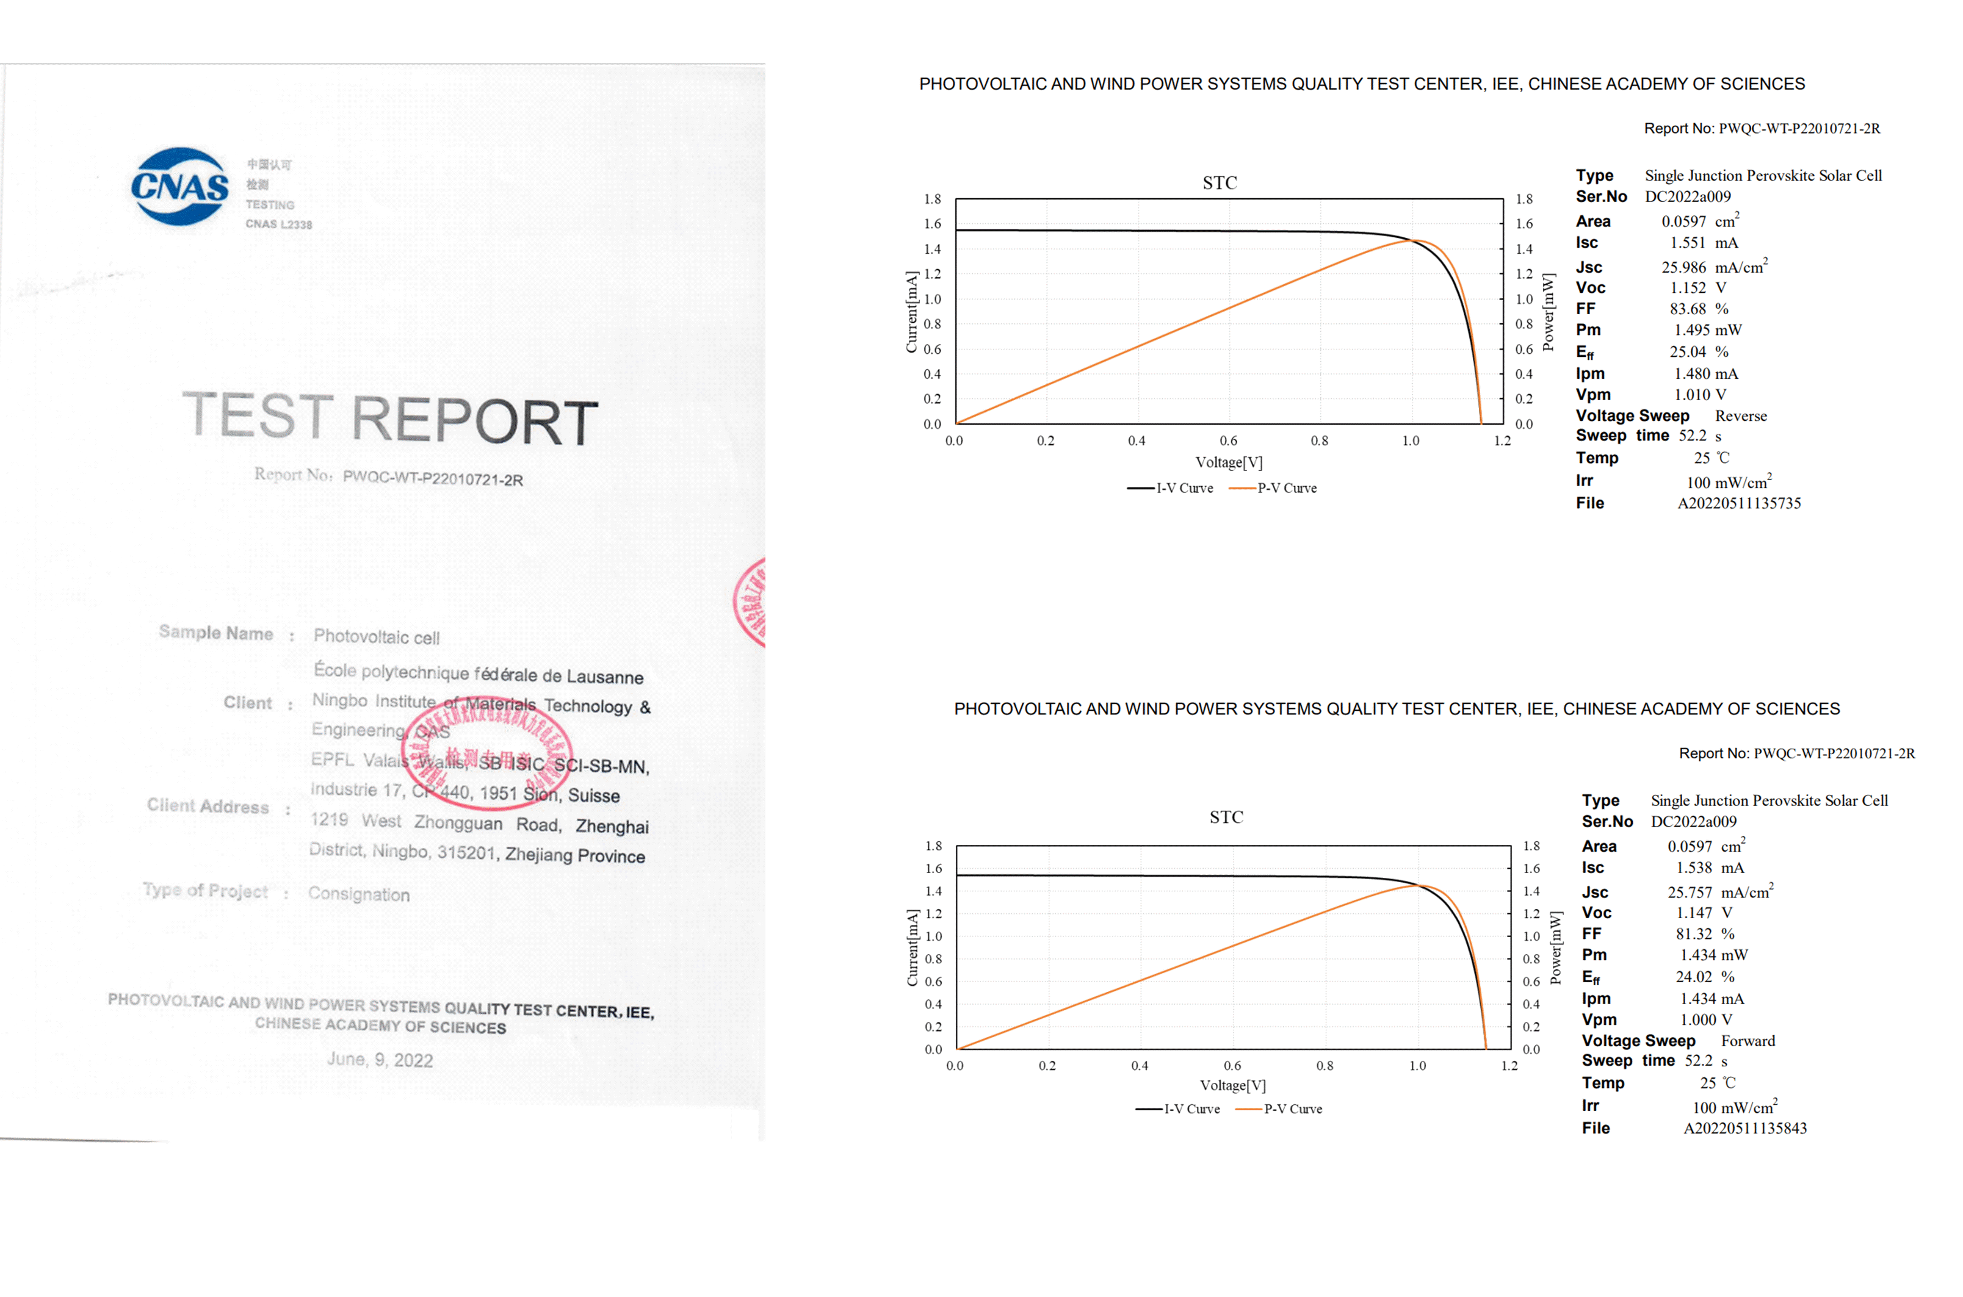

Fig. S25 | Independent efficiency measurement of PSC. The certificated results from accredited photovoltaic certification laboratory Photovoltaic and Wind Power Systems Quality Test Center, IEE, Chinese Academy of Sciences, China. The effective area is determined by an opaque mask with a aperture area of 0.0597 cm². The V_{OC} is 1.147 V, J_{SC} is 25.757 mA/cm², FF is 81.32% and PCE is 24.02% in the forward voltage swept (J_{SC}→V_{OC}) I-V and P-V curve, and the V_{OC} is 1.152 V, J_{SC} is 25.986 mA/cm², FF is 83.68% and PCE is 25.04% in the reverse voltage swept (V_{OC}→J_{SC}) I-V and P-V curves.

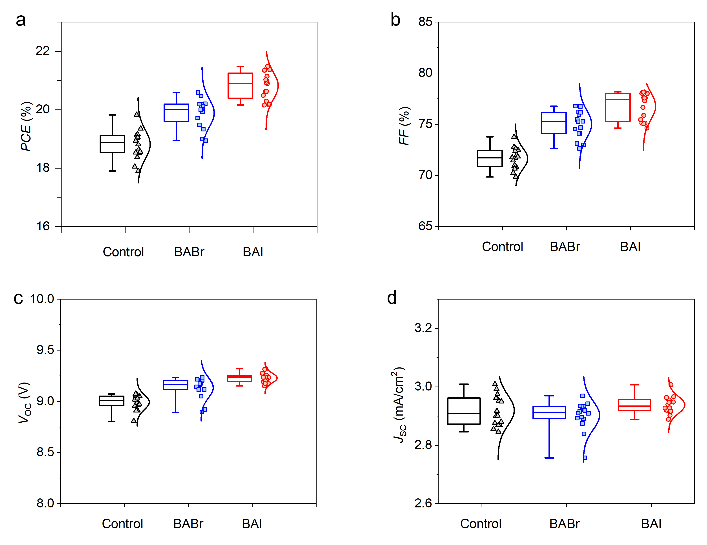

Fig. S26 | The PCE, FF, V_{OC} and J_{SC} statistics of 16 cells for the three involved cases. The box contains 50% of the data, the antenna shows the minimum and maximum values, and the bars give the median.

Table S2 | Performance of efficient perovskite solar cell by 2D/3D heterojunction in Fig. 4C.
Year | Perovskite types | V_{OC} (V) | J_{SC}  (mA/cm²) | FF (%) | PCE (%) | Ref.
2017 | MAPbI₃ | 1.17 | 21.80 | 78 | 19.89 | ¹⁴
2018 | (FAPbI₃)_{0.85}(MAPbBr₃)_{0.15} | \ | \ | \ | 21.7 | ¹⁵
2019 | FAPbI₃ | 1.096 | 25.79 | 78.4 | 22.16 | ¹⁶
2020 | FA_{0.95}Cs_{0.05}PbI₃ | 1.14 | 24.41 | 79.6 | 22.2 | ¹⁷
2021 | FAPbI₃ | 1.141 | 24.83 | 84.25 | 23.91 | ¹²
2022 | FAPbI₃ | 1.17 | 25.16 | 83.52 | 24.48 | ¹⁸
2022 | Cs_{0.05}FA_{0.9}MA_{0.05}PbI₃ | 1.159 | 25.86 | 83.9 | 25.18 | This work

References
1 Ding, B. et al. Low-temperature SnO₂-modified TiO₂ yields record efficiency for normal planar perovskite solar modules. J. Mater. Chem. A 6, 10233-10242, doi:10.1039/C8TA01192C (2018).
2 Gao, L.-L. et al. Preparation of flexible perovskite solar cells by a gas pump drying method on a plastic substrate. J. Mater. Chem. A 4, 3704-3710, doi:10.1039/C6TA00230G (2016).
3 Kresse, G. & Furthmüller, J. Efficiency of ab-initio total energy calculations for metals and semiconductors using a plane-wave basis set. Comput. Mater. Sci. 6, 15-50, doi:https://doi.org/10.1016/0927-0256(96)00008-0 (1996).
4 Binek, A., Hanusch, F. C., Docampo, P. & Bein, T. Stabilization of the Trigonal High-Temperature Phase of Formamidinium Lead Iodide. J. Phys. Chem. Lett. 6, 1249-1253, doi:10.1021/acs.jpclett.5b00380 (2015).
5 Perdew, J. P., Burke, K. & Ernzerhof, M. Generalized Gradient Approximation Made Simple. Phys. Rev. Lett. 77, 3865-3868, doi:10.1103/PhysRevLett.77.3865 (1996).
6 Wang, V., Xu, N., Liu, J.C., Tang, G. & Geng, W.-T. VASPKIT: A user-friendly interface facilitating high-throughput computing and analysis using VASP code. Comput. Phys. Commun. 267, 108033, doi:https://doi.org/10.1016/j.cpc.2021.108033 (2021).
7 Freysoldt, C. et al. First-principles calculations for point defects in solids. Rev. Mod. Phys. 86, 253-305, doi:10.1103/RevModPhys.86.253 (2014).
8 Van de Walle, C. G. & Neugebauer, J. First-principles calculations for defects and impurities: Applications to III-nitrides. J. Appl. Phys. 95, 3851-3879, doi:10.1063/1.1682673 (2004).
9 Yang, Z. et al. Device physics of back-contact perovskite solar cells. Energy Environ. Sci. 13, 1753-1765, doi:10.1039/C9EE04203B (2020).
10 Ding, Y. et al. Single-crystalline TiO2 nanoparticles for stable and efficient perovskite modules. Nat. Nanotechnol. 17, 598-605, doi:10.1038/s41565-022-01108-1 (2022).
11 Yang, G. et al. Stable and low-photovoltage-loss perovskite solar cells by multifunctional passivation. Nat. Photonics 15, 681-689, doi:10.1038/s41566-021-00829-4 (2021).
12 Jeong, S. et al. Cyclohexylammonium-Based 2D/3D Perovskite Heterojunction with Funnel-Like Energy Band Alignment for Efficient Solar Cells (23.91%). Adv. Energy Mater. 11, 2102236, doi:https://doi.org/10.1002/aenm.202102236 (2021).
13 Yang, W. et al. Unlocking Voltage Potentials of Mixed-Halide Perovskite Solar Cells via Phase Segregation Suppression. Adv. Funct. Mater. 32, 2110698, doi:https://doi.org/10.1002/adfm.202110698 (2022).
14 Bai, Y. et al. Dimensional Engineering of a Graded 3D–2D Halide Perovskite Interface Enables Ultrahigh Voc Enhanced Stability in the p-i-n Photovoltaics. Adv. Energy Mater. 7, 1701038, doi:https://doi.org/10.1002/aenm.201701038 (2017).
15 Cho, Y. et al. Mixed 3D–2D Passivation Treatment for Mixed-Cation Lead Mixed-Halide Perovskite Solar Cells for Higher Efficiency and Better Stability. Adv. Energy Mater. 8, 1703392, doi:https://doi.org/10.1002/aenm.201703392 (2018).
16 Liu, Y. et al. Ultrahydrophobic 3D/2D fluoroarene bilayer-based water-resistant perovskite solar cells with efficiencies exceeding 22%. Sci. Adv. 5, eaaw2543, doi:10.1126/sciadv.aaw2543.
17 Yao, Q. et al. Graded 2D/3D Perovskite Heterostructure for Efficient and Operationally Stable MA-Free Perovskite Solar Cells. Adv. Mater. 32, 2000571, doi:https://doi.org/10.1002/adma.202000571 (2020).
18 Zhao, D. et al. Efficient and Stable 3D/2D Perovskite Solar Cells through Vertical Heterostructures with (BA)4AgBiBr8 Nanosheets. Adv. Mater. n/a, 2204661, doi:https://doi.org/10.1002/adma.202204661 (2022).

