Supplementary material

Fig. S1. Phylogenetic relationships of L. plantarum WCP931 and other LAB closely related bacterial based on 16S rRNA sequence. Number above each node are confidence levels (%) generated from 1000 bootrap trees. The scale bar is in fixed nucleotide substitutions per sequences position.

Fig. S2. Multiple sequence alignment of OpdC protein of known 3D structure. Elements of secondary structure for all proteins are denoted as α (α helix), β (β sheet), η (random coil), and Τ (β turn). The sequence alignment was performed using Clustal Omega87, ESPript88 server. The consensus sequences region is indicated by box.

Figure 1S

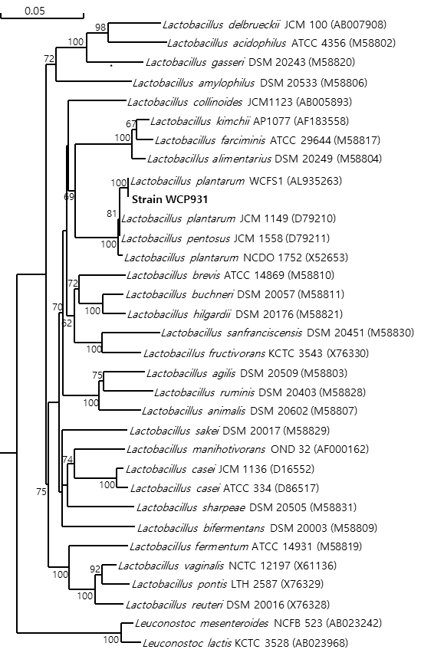

Figure 2S
