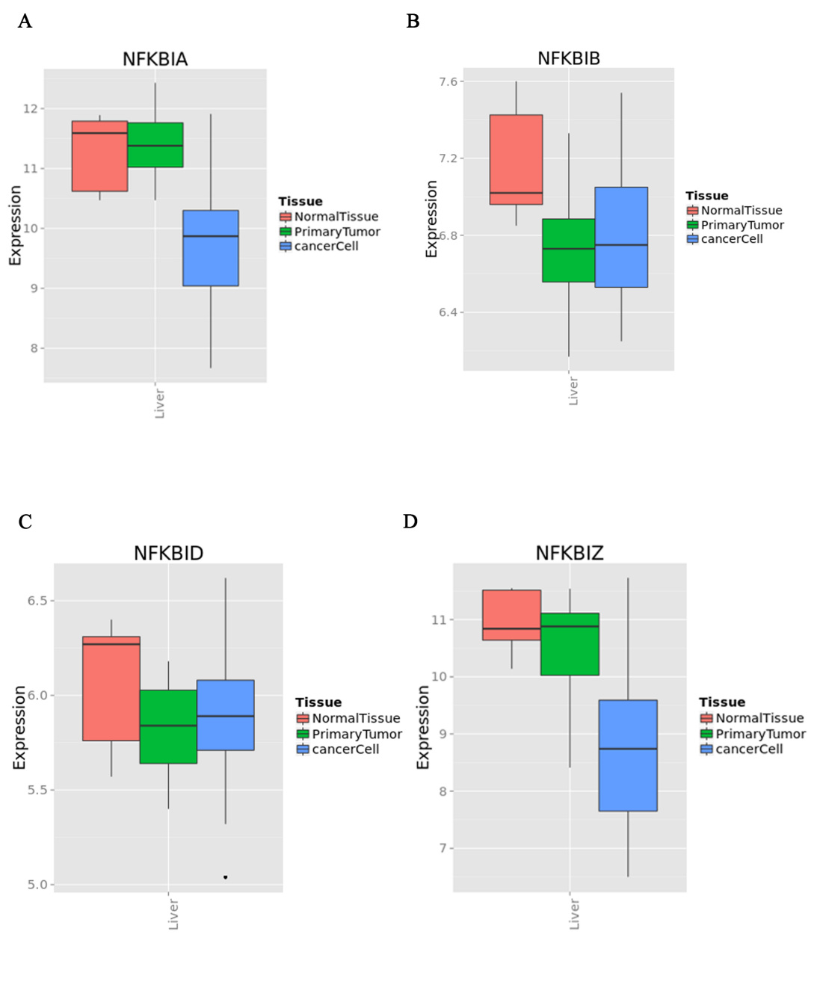
Supplementary Figure 1.
(A) Transcriptional abundances of NFKBIA in MERAV.
(B) Transcriptional abundances of NFKBIB in MERAV.
(C)Transcriptional abundances of NFKBID in MERAV.
(D)Transcriptional abundances of NFKBIZ in MERAV.

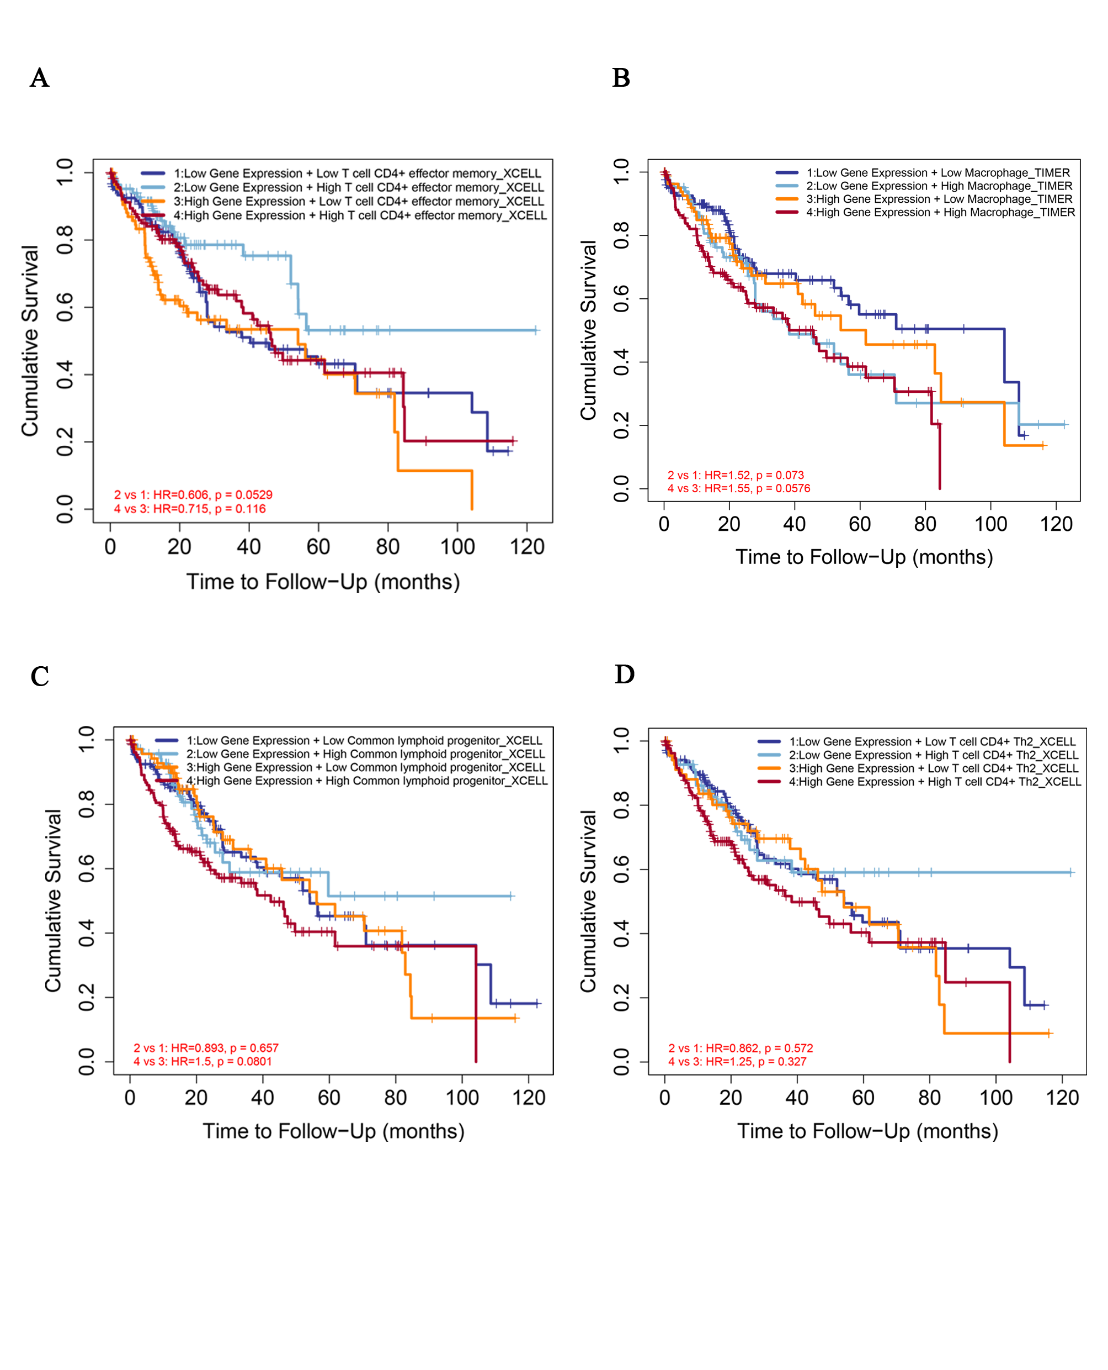
Supplementary Figure 2.
(A) Low NFKBIE expression in conjunction with CD4+EFFECTOR MEMORY has a favorable prognosis.
(B) Patients with low NFKBIE and macrophage expression have a better prognosis.
(C) The combination of low-expression NFKBIE and high-expression common lymphoid progenitor has a better prognosis.
(D) Low NFKBIE expression in conjunction with high CD4+TH2 expression may be associated with a better prognosis.
Supplementary Figure 2.

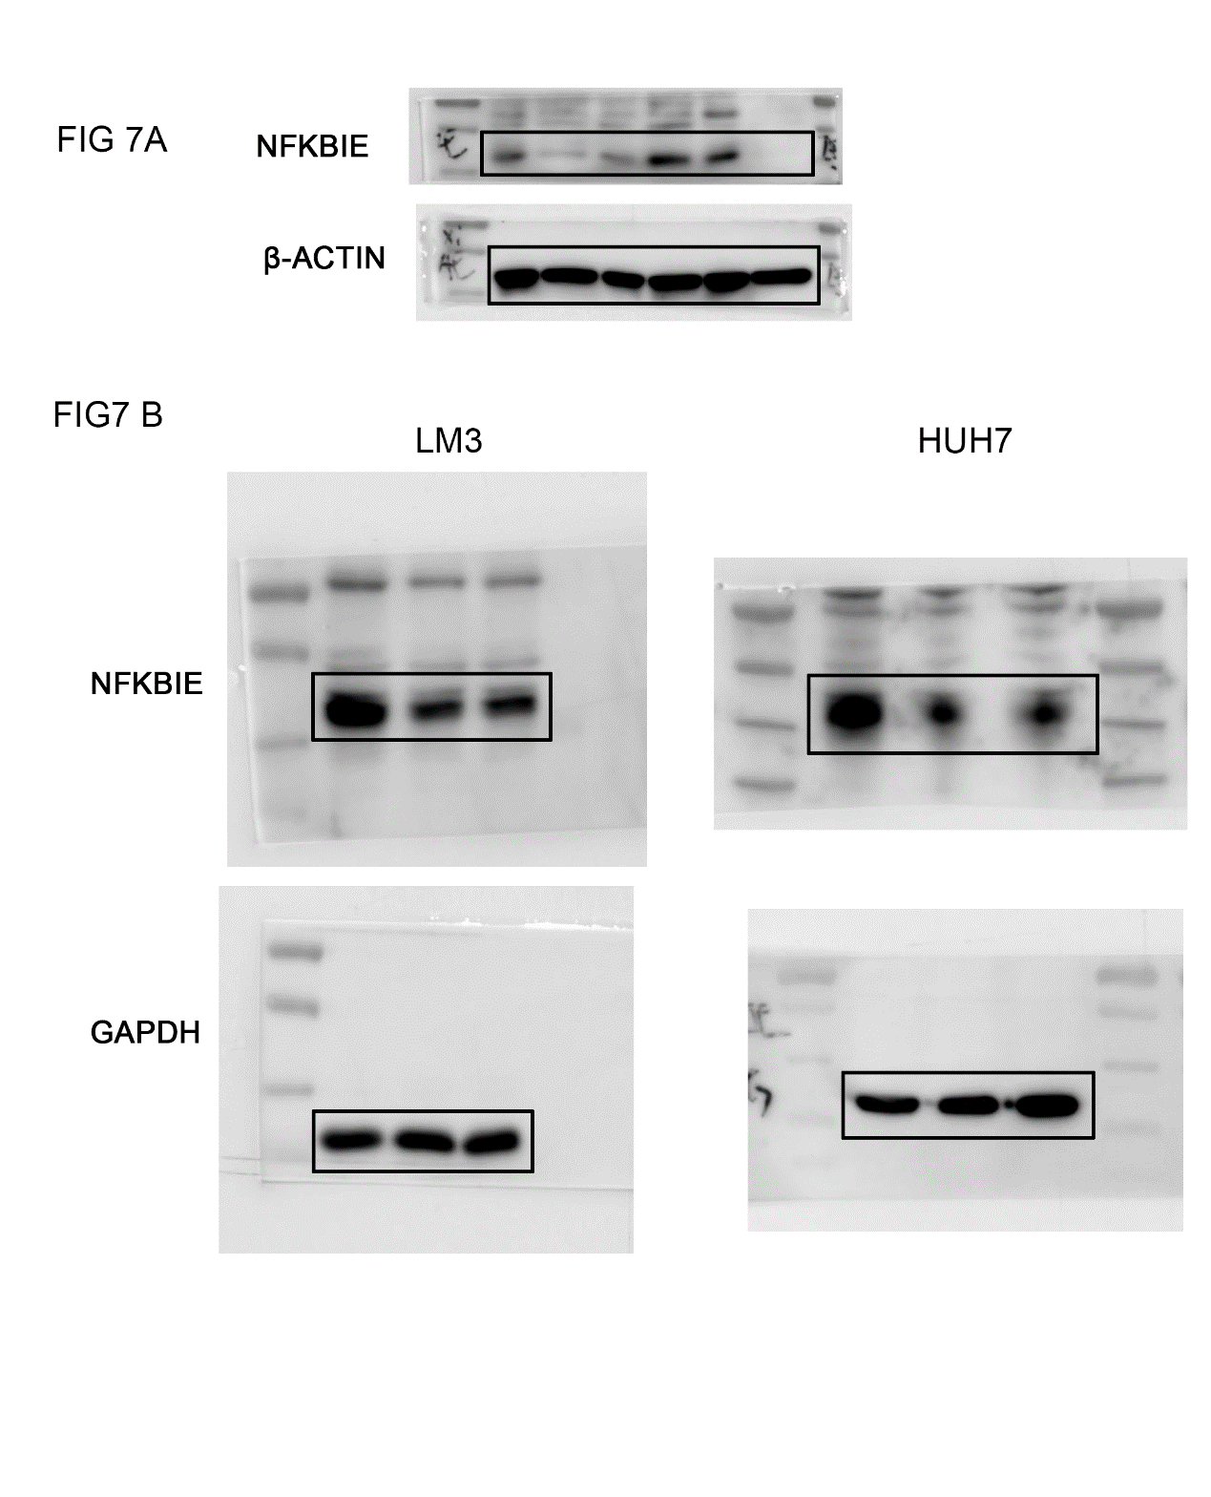
Supplementary Figure 3.
The full length of the western blot of figure 7A and figure 7B.

