Supporting Information A1
ID | Location | Long | Lat | Distance from Gateway (km) | Date | Start Time | Finish Time | EE5E (Flexi-Antennas) | C311 (Silver Antennas, in housing) | 3751 (Brass antennas) | 1653 (Gold antennas) | 643E (Brass antenna, in epoxy)
1 | Kestrel Tower | -8.02931 | 37.73124 | 1.1 | 06/05/2021 | 10:30 | 11:00 | Status and Location Sent | Status and Location Sent | Status and Location Sent | Status and Location Sent | Not working all day
2 | Entradas | -8.013 | 37.7693 | 4.2 | 06/06/2021 | 9:35 | 10:05 | Status and Location Sent | Status and Location Sent | No transmission (Battery Issue) | No transmission | Not working all day
3 | Castro Verde A | -8.079033363 | 37.70283228 | 5.5 | 06/06/2021 | 14:00 | 14:30 | Status and Location Sent | Status and Location Sent | Status and Location Sent | Status and Location Sent | Not working all day
4 | Ermida do Sao Pedro | -8.036109912 | 37.67798892 | 5.8 | 07/06/2021 | 14:50 | 15:20 | Status and Location Sent | Status and Location Sent | Status and Location Sent | Status and Location Sent | Not present as suspected not working
5 | Gateguinha Grande | -7.9813 | 37.69231 | 8 | 06/06/2021 | 13:15 | 13:45 | Status and Location Sent | No transmission | Status and Location Sent | No transmission | Not working all day
6 | Castro Verde B | -8.11996 | 37.72259 | 9.6 | 07/06/2021 | 13:50 | 14:20 | Status and Location Sent | Not present | Status and Location Sent | Status and Location Sent | Not present
7 | Rolão | -7.95425 | 37.66597 | 12.2 | 06/06/2021 | 14:45 | 15:15 | Status and Location Sent | Status and Location Sent | Status and Location Sent | Status and Location Sent | Not working all day
8 | Lancadoiras | -8.00979 | 37.58738 | 17.1 | 06/06/2021 | 15:25 | 15:55 | Status sent | Status sent | Status and Location Sent | Status sent | Not working all day
9 | Trinidade | -7.89594 | 37.87849 | 21.9 | 06/06/2021 | 10:35 | 11:05 | No transmission | Status and Location Sent | Status and Location Sent | No transmission | Not working all day
10 | Navarro | -7.773514 | 37.704042 | 22 | 06/06/2021 | 11:45 | 12:10 | No transmission | Status sent | Status and Location Sent | Status and Location Sent | Not working all day
11 | Almodovar | -8.04661 | 37.51468 | 25 | 07/06/2021 | 16:00 | 16:30 | No transmission | No transmission | Status and Location Sent | Status | Not present
12 | Monte Acharrua | -8.06982 | 37.47419 | 29.7 | 07/06/2021 | 17:15 | 17:45 | No transmission (Had sent status from here during previous test) | No transmission | No transmission | No transmission (Had sent status from here during previous test) | Not present, had not sent anything during previous test.
13 | Mombeja | -8.03513 | 38.02106 | 31.3 | 21/05/2021 | 19:15 | 19:45 | Multiple status and location messages sent succesfully | No transmission | Multiple status and location messages sent succesfully | N/A | N/A
14 | Miro | -8.07578 | 37.39103 | 38.9 | 24/05/2021 | 9:20 | 9:50 | Multiple status and location messages sent succesfully | Multiple status and location messages sent succesfully | Multiple status and location messages sent succesfully | N/A | N/A
15 | Transmission Lines Santa Cruz | -8.04242 | 37.37326 | 40.7 | 24/05/2021 | 10:05 | 10:35 | Status message sent | No transmission | Multiple status and location messages sent succesfully | N/A | N/A
16 | Ameixal | -7.96843 | 37.35752 | 43 | 24/05/2021 | 11:15 | 11:45 | No transmission | No transmission | No transmission | N/A | N/A
17 | Texageiras | -7.95754 | 37.33858 | 45 | 24/05/2021 | 12:00 | 12:30 | No transmission | No transmission | No transmission | N/A | N/A
18 | Pelados | -7.9616 | 37.30718 | 48.7 | 24/05/2021 | 12:50 | 13:20 | No transmission | No transmission | No transmission | N/A | N/A
19 | Vale do Rosa | -7.92825 | 37.2909 | 51 | 31/05/2021 | 18:10 | 18:40 | No transmission | N/A | No transmission | No transmission | N/A
20 | Guadalupe | -7.59355 | 37.92932 | 53.4 | 09/06/2021 | 16:45 | 17:15 | No transmission | No transmission | No transmission | No transmission | Not present
21 | Feiteira | -7.85983 | 37.2742 | 55.2 | 24/05/2021 | 19:10 | 19:40 | No transmission | N/A | No transmission | No transmission | N/A
22 | Mendro - high peak to north overlooking plain. | -7.78385 | 38.24621 | 62.8 | 01/06/2021 | 9:45 | 10:45 | No transmission | No transmission | Welcome Messages Sent | No transmission | N/A
 | Foia_Mountain_Monchique | -8.59644 | 37.3156 | 78 | 17/05/2021 | 15:00 | 15:30 | No transmission | No transmission | No transmission | No transmission | No transmission
Table 1: Detailed description of range test results between the LoRa-GPS devices and the IP67 gateway located at the LPN reserve to the north of Castro Verde (Gateway A9_f6_Castro_Verde).

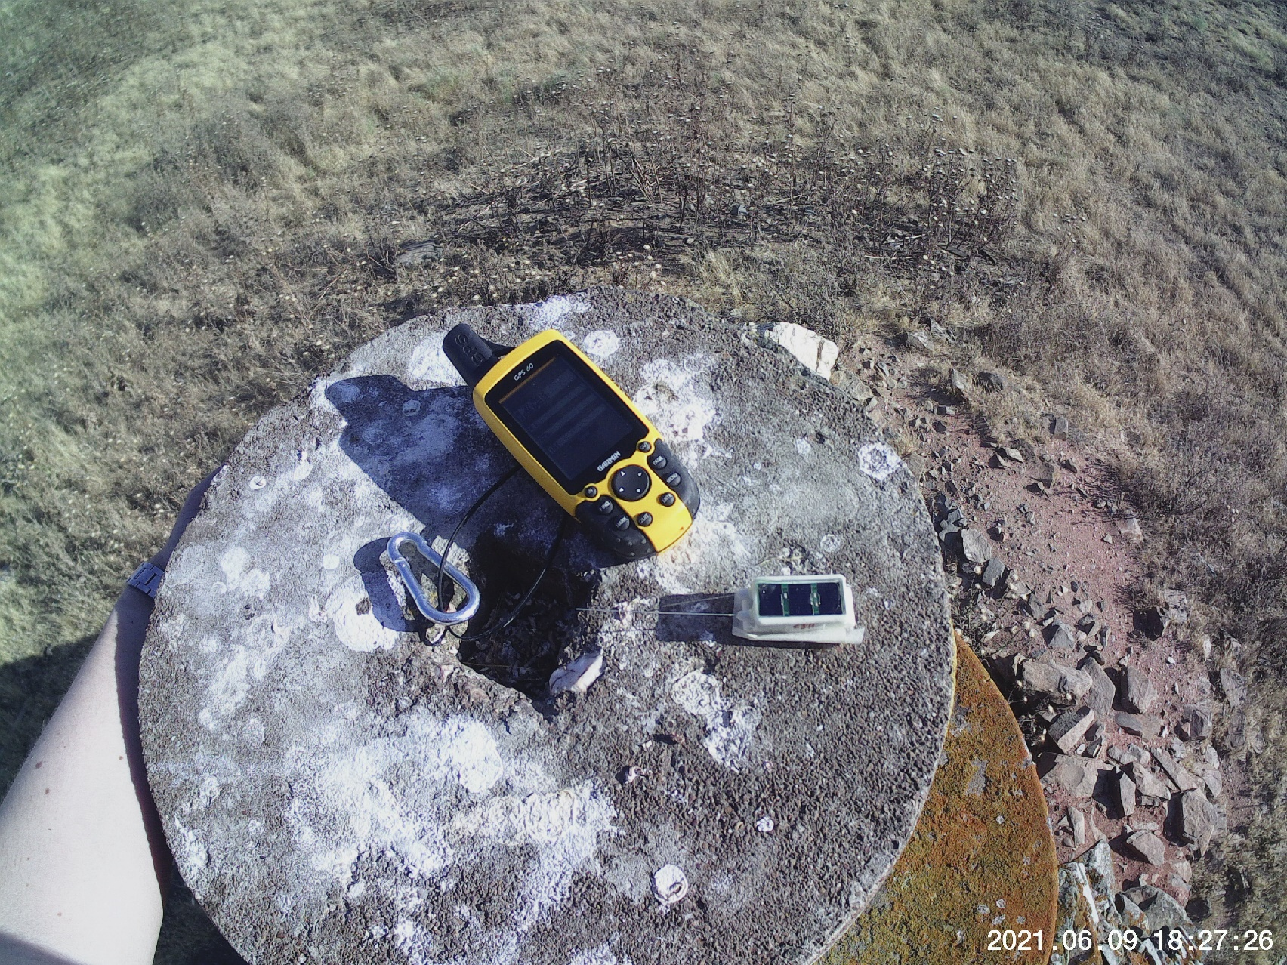
Figure 1: The device on test, Garmin GPS unit used for scale.

