Supporting Information
Effect of the ambient factor over spinel CuMn₂O₄ for toluene catalytic ozonation: Enhancement of the synergy and the generation of ROS
Guanjie Wang ^{a,b}, Bo Zhao ^{c}, Zhiping Ye ^{a,d,e}, Liang Zhao ª, Xiuwen Zhang ª, Jiade Wang ^{a,*}
ª College of Environment, Zhejiang University of Technology, Hangzhou, 310014 China
^{b} Collaborative Innovation Center of Yangtze River Delta Region Green Pharmaceuticals, Zhejiang University of Technology, Hangzhou, 310014, China
^{c} Zhejiang TUNA Environmental Science & Technology Co., Ltd. Shaoxing, 312000, China
^{d} State Environmental Protection Key Laboratory of Sources and Control of Air Pollution Complex, Beijing, 100084, China
^{e} Department of Chemical Engineering, Sichuan University, Chengdu 610065, Sichuan, China
*Corresponding author, Jiade Wang
E-mail: jdwang@zjut.edu.cn
Mailing address: College of Environment, Zhejiang University of Technology, Hangzhou, 310014, China

This Supporting Information provides:
Total number of pages: 5
Total number of Figures: 7
Total number of Tables: 2
Figure
Fig. S1 Schematic experiment of catalyst activity evaluation.
Fig. S2 SEM of CuMn₂O₄ at different O₃ concentrations, (A) 1000 ppm, (B) 1400 ppm, and (C) 2100 ppm.
Fig. S3 SEM of CuMn₂O₄ at different temperatures, (A) 50℃, (B) 100℃, and (C) 150℃.
Fig. S4 XPS of CuMn₂O₄ at different temperatures, (A) Cu 2p, (B) Mn 2p, and (C) O 1s.
Fig. S5 GC-MS spectra.
Fig. S6 SEM of CuMn₂O₄ at different humidity, (A) 0%, (B) 30% and (C) 60%.
Fig. S7 XPS of CuMn₂O₄ at different humidity, (A) Cu 2p, (B) Mn 2p, and (C) O 1s.
Table
Table S1 The relevant data about the post-reaction CuMn₂O₄ (O₃ concentration).
Table S2 The relevant data about the post-reaction CuMn₂O₄ (humidity).

Figure
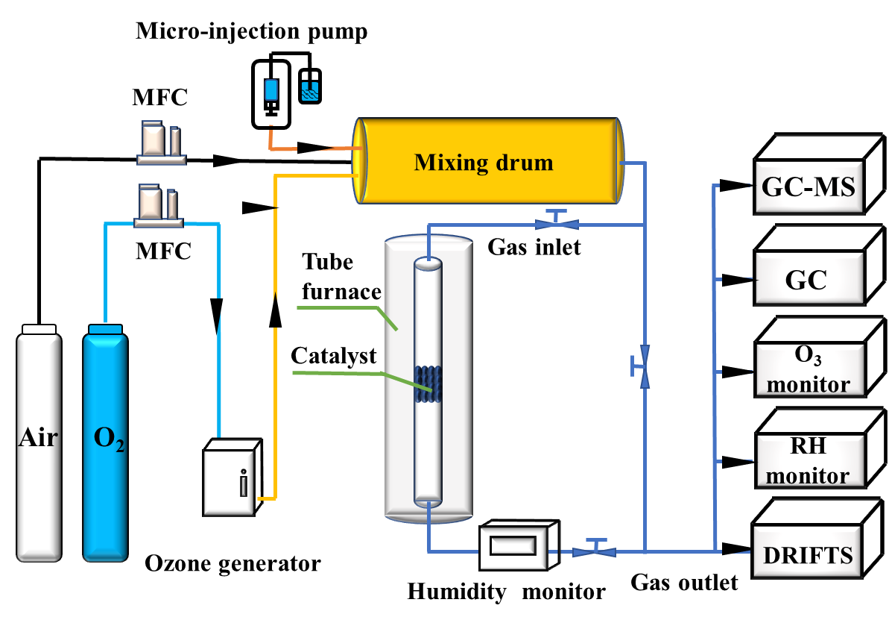 Fig. S1 Schematic experiment of catalyst activity evaluation.

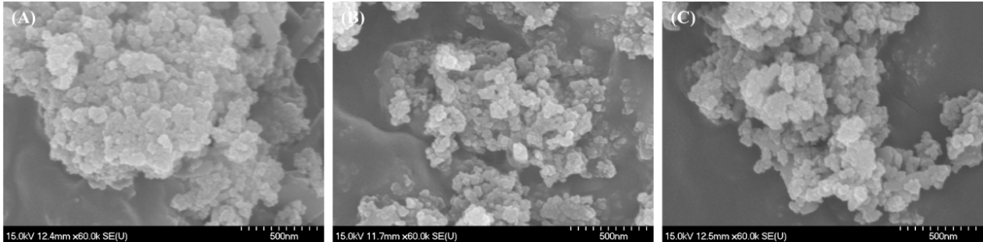
Fig. S2 SEM of CuMn₂O₄ at different O₃ concentrations, (A) 1000 ppm, (B) 1400 ppm, and (C) 2100 ppm.
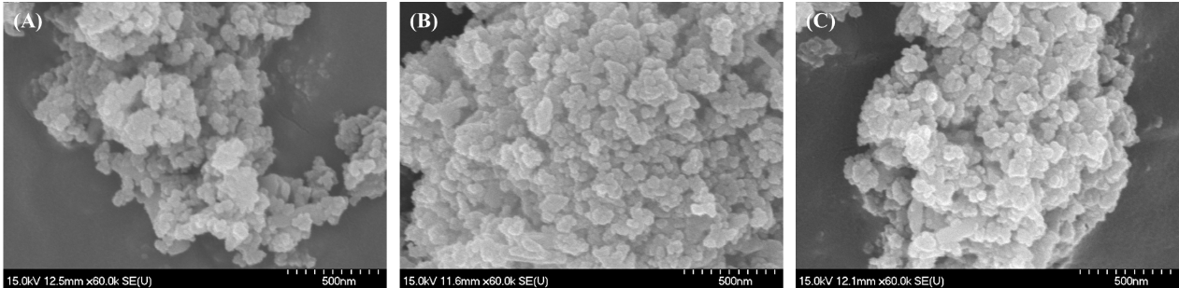
Fig. S3 SEM of CuMn₂O₄ at different temperatures, (A) 50 ℃, (B) 100 ℃, and (C) 150 ℃.
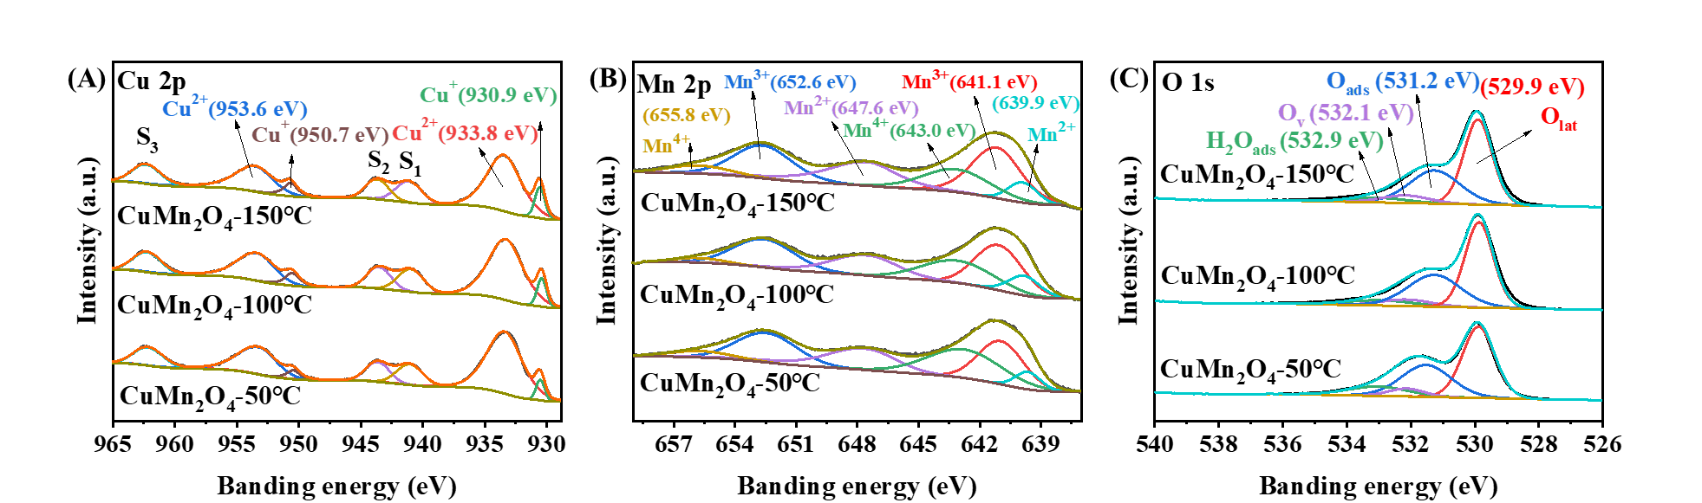
Fig. S4 XPS of CuMn₂O₄ at different temperatures, (A) Cu 2p, (B) Mn 2p, and (C) O 1s.

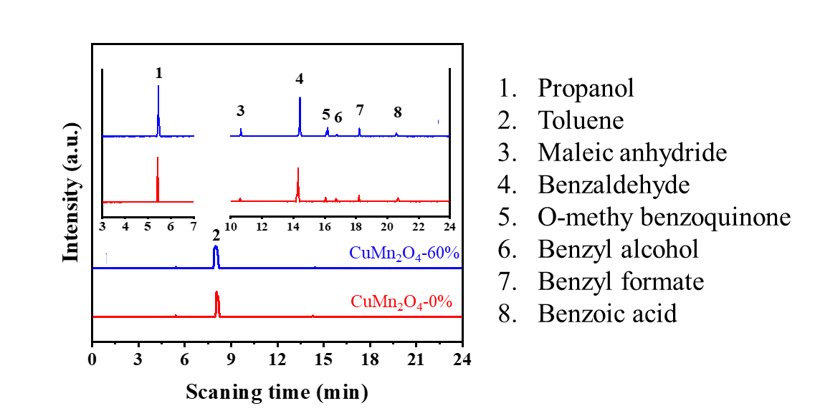
Fig. S5 GC-MS spectra.

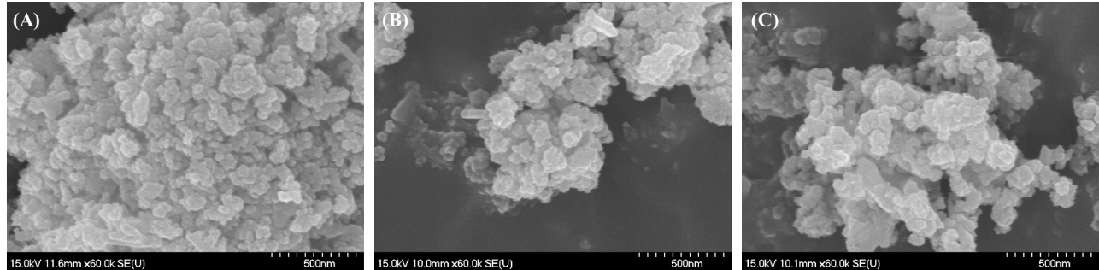
Fig. S6 SEM of CuMn₂O₄ at different humidity, (A) 0%, (B) 30% and (C) 60%.

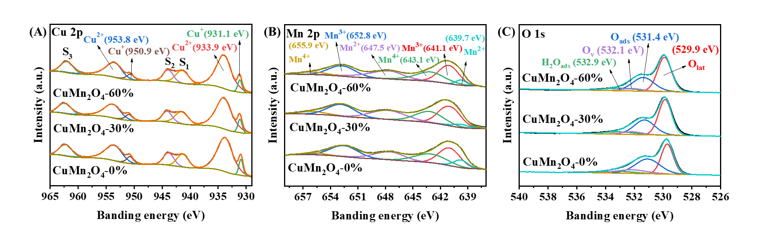
Fig. S7 XPS of CuMn₂O₄ at different humidity, (A) Cu 2p, (B) Mn 2p, and (C) O 1s.

Table
Table S1 The relevant data about the post-reaction CuMn₂O₄ (O₃ concentration).
Samples | S_{BET}ª (m²/g) | V_{p}^{b} (cm³/g) | D_{p}^{c} (nm)
CuMn₂O₄-10 | 27.6 | 0.1 | 19.8
CuMn₂O₄-14 | 23.6 | 0.1 | 15.8
CuMn₂O₄-21 | 17.8 | 0.1 | 14.8
ª Surface Area.
^{b} Desorption cumulative volume of pores.
^{c} Desorption average pore diameter.

Table S2 The relevant data about the post-reaction CuMn₂O₄ (humidity).
Samples | S_{BET}ª (m²/g) | V_{p}^{b} (cm³/g) | D_{p}^{c} (nm)
CuMn₂O₄-0 % | 17.8 | 0.1 | 14.8
CuMn₂O₄-30 % | 24.9 | 0.1 | 18.5
CuMn₂O₄-60 % | 25.2 | 0.1 | 18.3
ª Surface Area.
^{b} Desorption cumulative volume of pores.
^{c} Desorption average pore diameter.

