Additional File: Sensitivity checks and additional analysis
Table 1: The association of self-reported general health with the socio-demographic and lifestyle covariates (N=404,264 surveys from 67,982 individuals)
 |  | Coefficient | P-value | lower 95%CI | Upper 95% CI
Ethnicity | British-white | Ref
Ethnicity | Other-white | -0.039 | 0.012 | -0.070 | -0.009
Ethnicity | Indian | 0.062 | 0.001 | 0.026 | 0.098
Ethnicity | Pakistani/Bangladeshi | 0.174 | 0.000 | 0.141 | 0.208
Ethnicity | Black/African/Caribbean | -0.051 | 0.003 | -0.084 | -0.017
Ethnicity | Mixed ethnicities | 0.086 | 0.000 | 0.041 | 0.132
Ethnicity | Other ethnicities | 0.034 | 0.016 | 0.006 | 0.061
Country of birth | Born in the UK | Ref
Country of birth | Not born in the UK | -0.016 | 0.165 | -0.038 | 0.006
Country of birth | No answer | -0.120 | 0.000 | -0.139 | -0.100
Age | 16-18 | Ref
Age | 19-23 | 0.033 | 0.000 | 0.017 | 0.049
Age | 24-28 | 0.087 | 0.000 | 0.065 | 0.108
Age | 29-33 | 0.164 | 0.000 | 0.140 | 0.187
Age | 34-38 | 0.236 | 0.000 | 0.211 | 0.260
Age | 39-43 | 0.325 | 0.000 | 0.300 | 0.349
Age | 44-48 | 0.421 | 0.000 | 0.396 | 0.446
Age | 49-53 | 0.528 | 0.000 | 0.502 | 0.553
Age | 54-58 | 0.603 | 0.000 | 0.578 | 0.629
Age | 59-63 | 0.653 | 0.000 | 0.626 | 0.679
Age | 64-68 | 0.652 | 0.000 | 0.625 | 0.679
Age | 69-73 | 0.705 | 0.000 | 0.676 | 0.733
Age | 74-78 | 0.824 | 0.000 | 0.794 | 0.855
Age | >78 | 0.983 | 0.000 | 0.950 | 1.015
Gender | Male | Ref
Gender | Female | 0.056 | 0.000 | 0.044 | 0.068
Education | University degree | Ref
Education | High school degree | 0.129 | 0.000 | 0.115 | 0.143
Education | Lower educational levels | 0.237 | 0.000 | 0.187 | 0.288
Education | Other qualifications | 0.314 | 0.000 | 0.298 | 0.330
Education | Still a student | -0.035 | 0.000 | -0.052 | -0.017
Marital status | Married | Ref
Marital status | Living as a couple | 0.055 | 0.000 | 0.042 | 0.068
Marital status | Widowed | 0.075 | 0.000 | 0.055 | 0.095
Marital status | Divorced/separated | 0.103 | 0.000 | 0.087 | 0.119
Marital status | Single never married | 0.064 | 0.000 | 0.050 | 0.079
Marital status | No answer | 0.111 | 0.000 | 0.056 | 0.167
Occupation | Managers/Professionals/employers | Ref
Occupation | Non manual workers | 0.054 | 0.000 | 0.042 | 0.066
Occupation | Manual workers | 0.032 | 0.000 | 0.018 | 0.045
Occupation | Not applicable: Student/ retired/Not working | 0.225 | 0.000 | 0.212 | 0.238
Occupation | No answer | 0.047 | 0.001 | 0.020 | 0.073
Subjective financial situation | Living comfortably/doing alright | Ref
Subjective financial situation | Living difficultly | 0.167 | 0.000 | 0.160 | 0.173
Subjective financial situation | No answer | 0.010 | 0.207 | -0.005 | 0.025
Smoking status | Non smoker | Ref
Smoking status | Smoker | 0.155 | 0.000 | 0.145 | 0.166
Smoking status | No answer | 0.002 | 0.727 | -0.011 | 0.016
Time dummies | 2009 | Ref
Time dummies | 2010 | -0.006 | 0.321 | -0.017 | 0.006
Time dummies | 2011 | -0.004 | 0.507 | -0.016 | 0.008
Time dummies | 2012 | 0.005 | 0.445 | -0.007 | 0.017
Time dummies | 2013 | 0.009 | 0.137 | -0.003 | 0.021
Time dummies | 2014 | -0.005 | 0.396 | -0.018 | 0.007
Time dummies | 2015 | 0.023 | 0.000 | 0.011 | 0.036
Time dummies | 2016 | 0.091 | 0.000 | 0.079 | 0.104
Time dummies | 2017 | 0.133 | 0.000 | 0.120 | 0.146
Time dummies | 2018 | 0.175 | 0.000 | 0.162 | 0.188
Time dummies | 2019 | 0.187 | 0.000 | 0.171 | 0.203

Table 2: The association of self-reported general health as a binary outcome (fair/poor health versus excellent/very good/good health) with each of NO₂, SO₂, PM10, and PM2.5 air pollutants at the LSOAs level (N=404,264 surveys from 67,982 individuals)
 | Model 1 | Model 2
 | OR [95%CI] | OR [95%CI]
Overall pollution effect
NO₂ (µg/m³) | 1.27 [1.22, 1.31]** | 1.15 [1.11, 1.20]**
SO₂ (µg/m³) | 1.87 [1.63, 2.13]** | 1.64 [1.44, 1.86]**
PM10 (µg/m³) | 1.28 [1.17, 1.40]** | 1.15 [1.06, 1.26]**
PM2.5 (µg/m³) | 1.45 [1.29, 1.63]** | 1.27 [1.13, 1.42]**
Between pollution effect
NO₂ (µg/m³) | 1.28 [1.23, 1.34]** | 1.15 [1.10, 1.20]**
SO₂ (µg/m³) | 33.91 [24.25, 47.43]** | 7.80 [5.75, 10.57]**
PM10 (µg/m³) | 1.22 [1.10, 1.35]** | 1.08 [0.98, 1.20]
PM2.5 (µg/m³) | 1.39 [1.21, 1.60]** | 1.17 [1.02, 1.35]*
Within pollution effect
NO₂ (µg/m³) | 1.14 [0.99,1.30] | 1.10 [0.97, 1.26]
SO₂ (µg/m³) | 0.83 [0.67, 1.04] | 0.91 [0.73, 1.13]
PM10 (µg/m³) | 1.39 [1.11, 1.75]** | 1.28 [1.02, 1.61]*
PM2.5 (µg/m³) | 1.25 [0.95, 1.65] | 1.13 [0.86, 1.49]
**P-value <0.01; *P-value<0.05;
ORs and 95%CIs are expressed in terms of 10 µg/m3 increase in the air pollutants;
Model 1: is adjusted for age, gender and year dummies (2009-2019); Model 2 is adjusted for age, gender, ethnicity, country of birth, marital status, education, occupation, subjective financial situation, smoking status and year dummies (2009-2019).

Table 3: The association of self-reported general health as a binary outcome (fair/poor health versus excellent/very good/good health) with each of NO₂, SO₂, PM10, and PM2.5 air pollutants at the local authority level (N=404,264 surveys from 67,982 individuals)
 | Model 1 | Model 2
 | OR [95%CI] | OR [95%CI]
Overall pollution effect
NO₂ (µg/m³) | 1.14 [1.06, 1.23]** | 1.08 [1.03, 1.14]**
SO₂ (µg/m³) | 1.29 [1.03, 1.62]* | 1.37 [1.10, 1.71]**
PM10 (µg/m³) | 1.09 [0.96, 1.24] | 1.04 [0.93, 1.17]
PM2.5 (µg/m³) | 1.20 [1.01, 1.42]* | 1.12 [0.96, 1.31]
Between pollution effect
NO₂ (µg/m³) | 1.16 [1.05, 1.29]** | 1.07 [1.01, 1.14]*
SO₂ (µg/m³) | 29.7 [15.92, 55.52]** | 8.47 [5.01, 14.32]**
PM10 (µg/m³) | 0.98 [0.83, 1.15] | 0.96 [0.84, 1.10]
PM2.5 (µg/m³) | 1.002 [0.80, 1.25] | 0.97 [0.80, 1.17]
Within pollution effect
NO₂ (µg/m³) | 1.07 [0.89,1.27] | 1.08 [0.92, 1.27]
SO₂ (µg/m³) | 1.02 [0.72, 1.44] | 1.04 [0.73, 1.48]
PM10 (µg/m³) | 1.14 [0.89, 1.47] | 1.15 [0.89, 1.48]
PM2.5 (µg/m³) | 0.92 [0.67, 1.26] | 0.93 [0.68, 1.27]
**P-value <0.01; *P-value<0.05;
ORs and 95%CIs are expressed in terms of 10 µg/m3 increase in the air pollutants;
Model 1: is adjusted for age, gender and year dummies (2009-2019); Model 2 is adjusted for age, gender, ethnicity, country of birth, marital status, education, occupation, subjective financial situation, smoking status and year dummies (2009-2019).

Figure 1: The overall effect of air pollution on individuals’ self-reported health as a binary outcome (fair/poor health versus excellent/very good/good health) by ethnicity and country of birth at the LSOAs level (N=404,264 surveys from 67,982 individuals)
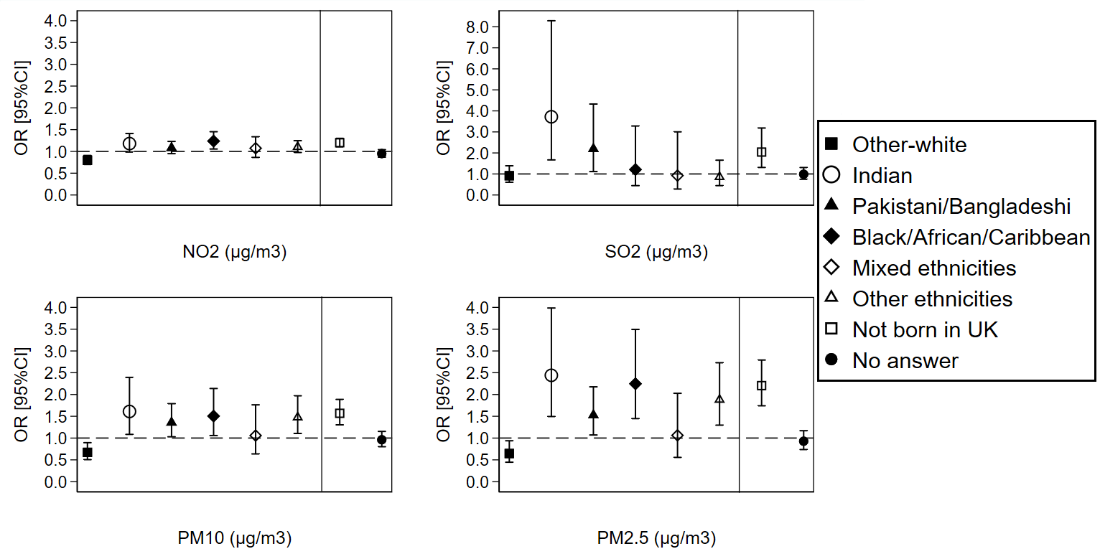ORs and 95%CIs are expressed in terms of 10 µg/m3 increase in the air pollutants;
The dashed line is placed at OR=1 as a cut-off for statistically insignificant results; The solid line separates between the air pollution-ethnicity interaction models and the air pollution-country of birth interaction models; Air pollution-ethnicity interaction models where the reference category is “British-white” are adjusted for country of birth, age, gender, marital status, education, occupation, subjective financial situation, smoking status, and year dummies (2009 to 2019); Air pollution-country of birth interaction models where the reference category is “born in UK” are adjusted for ethnicity, age, gender, marital status, education, occupation, subjective financial situation, smoking status, and year dummies (2009 to 2019).

Figure 2: The between-within (spatial-temporal) effect of air pollution on individuals’ self-reported health as a binary outcome (fair/poor health versus excellent/very good/good health) by ethnicity and country of birth at the LSOAs level (N=404,264 surveys from 67,982 individuals)
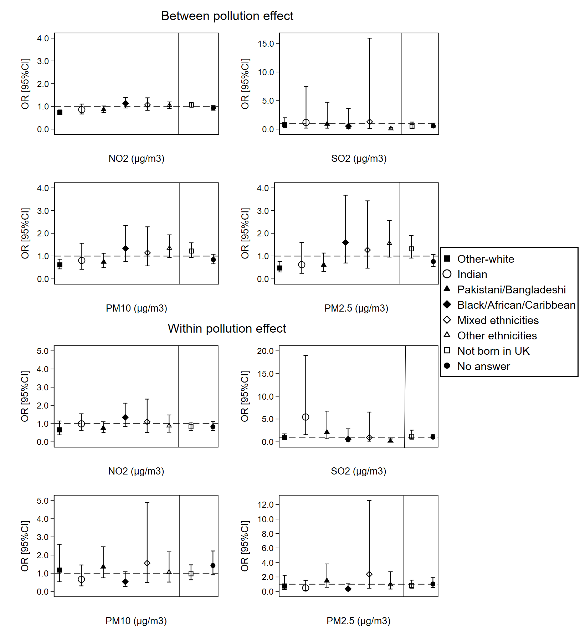
ORs and 95%CIs are expressed in terms of 10 µg/m³ increase in the air pollutants;
The dashed line is placed at OR=1 as a cut-off for statistically insignificant results; The solid line separates between the air pollution-ethnicity interaction models and the air pollution-country of birth interaction models; Air pollution-ethnicity interaction models where the reference category is “British-white” are adjusted for country of birth, age, gender, marital status, education, occupation, subjective financial situation, smoking status, and year dummies (2009 to 2019); Air pollution-country of birth interaction models where the reference category is “born in UK” are adjusted for ethnicity, age, gender, marital status, education, occupation, subjective financial situation, smoking status, and year dummies (2009 to 2019).
Figure 3: The overall effect of air pollution on individuals’ self-reported health as a binary outcome (fair/poor health versus excellent/very good/good health) by ethnicity and country of birth at the local authority level (N=404,264 surveys from 67,982 individuals)
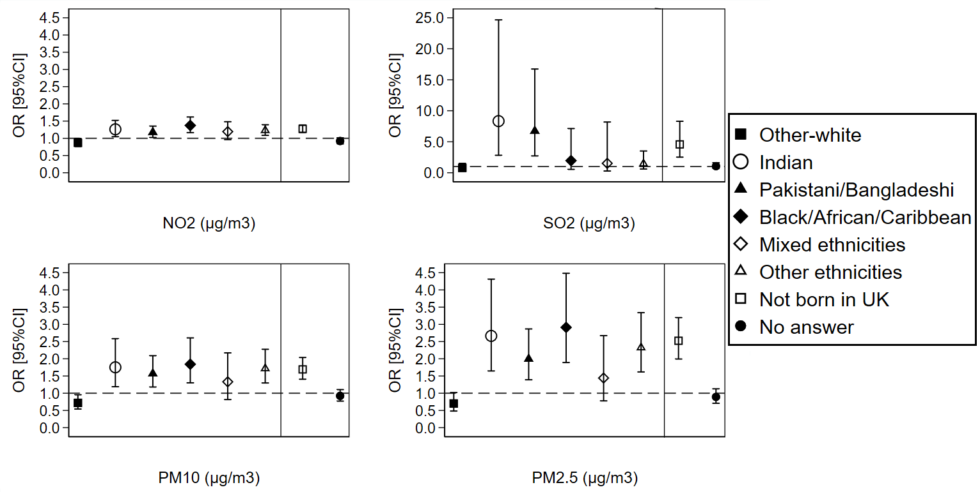ORs and 95%CIs are expressed in terms of 10 µg/m³ increase in the air pollutants;
The dashed line is placed at OR=1 as a cut-off for statistically insignificant results; The solid line separates between the air pollution-ethnicity interaction models and the air pollution-country of birth interaction models; Air pollution-ethnicity interaction models where the reference category is “British-white” are adjusted for country of birth, age, gender, marital status, education, occupation, subjective financial situation, smoking status, and year dummies (2009 to 2019); Air pollution-country of birth interaction models where the reference category is “born in UK” are adjusted for ethnicity, age, gender, marital status, education, occupation, subjective financial situation, smoking status, and year dummies (2009 to 2019).

Figure 4: The between-within (spatial-temporal) effect of air pollution on individuals’ self-reported health as a binary outcome (fair/poor health versus excellent/very good/good health) by ethnicity and country of birth at the local authority level (N=404,264 surveys from 67,982 individuals)
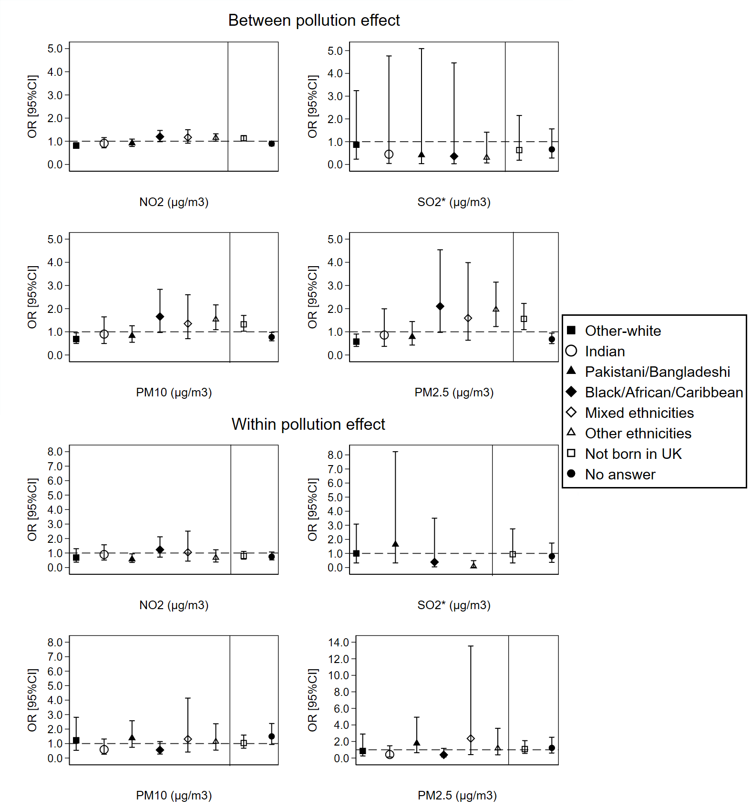 ORs and 95%CIs are expressed in terms of 10 µg/m3 increase in the air pollutants;
The dashed line is placed at OR=1 as a cut-off for statistically insignificant results; The solid line separates between the air pollution-ethnicity interaction models and the air pollution-country of birth interaction models; SO₂*: the Mixed ethnicities group [OR=6.19; 95%CI=0.27-144.66] was removed from the SO₂ between effect graph and the Indian [OR=10.79; 95%CI=1.68-69.19] and Mixed ethnicities [OR=1.94; 95%CI=0.11-35.2] groups were removed from the SO₂ within effect graph because the 95%CIs are too wide to be visualised in a graph; Air pollution-ethnicity interaction models where the reference category is “British-white” are adjusted for country of birth, age, gender, marital status, education, occupation, subjective financial situation, smoking status, and year dummies (2009 to 2019); Air pollution-country of birth interaction models where the reference category is “born in UK” are adjusted for ethnicity, age, gender, marital status, education, occupation, subjective financial situation, smoking status, and year dummies (2009 to 2019).
Table 4: The association of self-reported general health with each of NO₂, SO₂, PM10, and PM2.5 air pollutants for individuals recruited in wave 1 of the Understanding Society study at the LSOAs level (N=261,271 surveys from 39,798 individuals)
 | Model 1 | Model 2
 | Coefficient [95%CI] | Coefficient [95%CI]
Overall pollution effect
NO₂ (µg/m³) | 0.07 [0.06, 0.08]** | 0.05 [0.04, 0.06]**
SO₂ (µg/m³) | 0.13 [0.10, 0.17]** | 0.11 [0.08, 0.15]**
PM10 (µg/m³) | 0.09 [0.06, 0.11]** | 0.07 [0.05, 0.10]**
PM2.5 (µg/m³) | 0.13 [0.09, 0.16]** | 0.10 [0.07, 0.14]**
Between pollution effect
NO₂ (µg/m³) | 0.08 [0.07, 0.09]** | 0.06 [0.05, 0.07]**
SO₂ (µg/m³) | 1.04 [0.94, 1.15]** | 0.67 [0.58, 0.77]**
PM10 (µg/m³) | 0.10 [0.07, 0.13]** | 0.08 [0.05, 0.11]**
PM2.5 (µg/m³) | 0.16 [0.11, 0.20]** | 0.13 [0.09, 0.18]**
Within pollution effect
NO₂ (µg/m³) | 0.01 [-0.02, 0.04] | 0.01 [-0.02, 0.03]
SO₂ (µg/m³) | -0.01 [-0.06, 0.04] | 0.01 [-0.04, 0.06]
PM10 (µg/m³) | 0.03 [-0.02, 0.09] | 0.02 [-0.04, 0.07]
PM2.5 (µg/m³) | 0.00 [-0.06, 0.06] | -0.02 [-0.08, 0.05]
**P-value <0.01; *P-value<0.05;
Coefficients and 95%CIs are expressed in terms of 10 µg/m³ increase in the air pollutants;
Model 1: is adjusted for age, gender and year dummies (2009-2019); Model 2 is adjusted for age, gender, ethnicity, country of birth, marital status, education, occupation, subjective financial situation, smoking status and year dummies (2009-2019).

Table 5: The association of self-reported general health with each of NO₂, SO₂, PM10, and PM2.5 air pollutants for individuals recruited in wave 1 of the Understanding Society study at the local authority level (N=261,271 surveys from 39,798 individuals)
 | Model 1 | Model 2
 | Coefficient [95%CI] | Coefficient [95%CI]
Overall pollution effect
NO₂ (µg/m³) | 0.04 [0.03, 0.06]** | 0.04 [0.02, 0.05]**
SO₂ (µg/m³) | 0.05 [-0.01, 0.10] | 0.06 [0.01, 0.1]*
PM10 (µg/m³) | 0.02 [-0.02, 0.06] | 0.02 [-0.01, 0.05]
PM2.5 (µg/m³) | 0.05 [0.005, 0.10]* | 0.05 [0.004, 0.09]*
Between pollution effect
NO₂ (µg/m³) | 0.05 [0.02, 0.07]** | 0.04 [0.02, 0.06]**
SO₂ (µg/m³) | 1.01 [0.79, 1.23]** | 0.70 [0.53, 0.87]**
PM10 (µg/m³) | 0.02 [-0.04, 0.08] | 0.03 [-0.02, 0.08]
PM2.5 (µg/m³) | 0.04 [-0.04, 0.13] | 0.06 [-0.01, 0.12]
Within pollution effect
NO₂ (µg/m³) | 0.01 [-0.03, 0.05] | 0.01 [-0.02, 0.05]
SO₂ (µg/m³) | 0.01 [-0.06, 0.09] | 0.02 [-0.06, 0.09]
PM10 (µg/m³) | 0.01 [-0.05, 0.07] | 0.01 [-0.05, 0.07]
PM2.5 (µg/m³) | -0.06 [-0.13, 0.01] | -0.06 [-0.13, 0.01]
**P-value <0.01; *P-value<0.05;
Coefficients and 95%CIs are expressed in terms of 10 µg/m³ increase in the air pollutants;
Model 1: is adjusted for age, gender and year dummies (2009-2019); Model 2 is adjusted for age, gender, ethnicity, country of birth, marital status, education, occupation, subjective financial situation, smoking status and year dummies (2009-2019).

Figure 5: The overall effect of air pollution on individuals’ self-reported health by ethnicity and country of birth for individuals recruited in wave 1 of the Understanding Society study at the LSOAs level (N=261,271 surveys from 39,798 individuals)
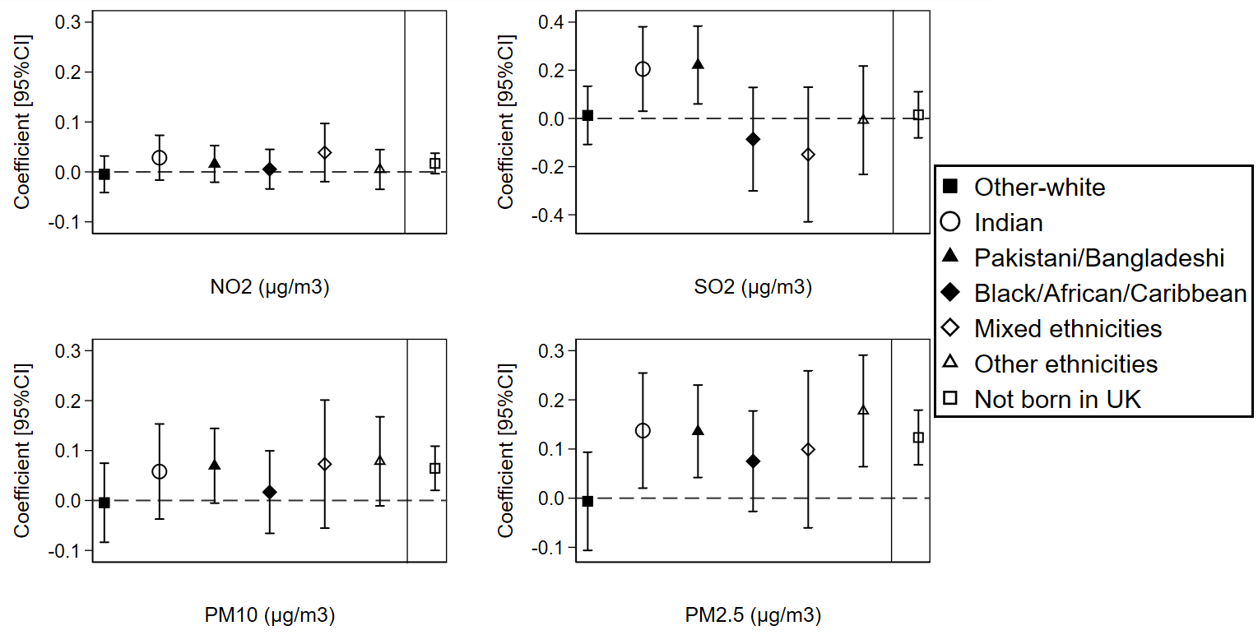
Coefficients and 95%CIs are expressed in terms of 10 µg/m³ increase in the air pollutants;
The dashed line is placed at Coefficient=0 as a cut-off for statistically insignificant results; The solid line separates between the air pollution-ethnicity interaction models and the air pollution-country of birth interaction models; Air pollution-ethnicity interaction models are adjusted for country of birth, age, gender, marital status, education, occupation, subjective financial situation, smoking status, and year dummies (2009 to 2019); Air pollution-country of birth interaction models are adjusted for ethnicity, age, gender, marital status, education, occupation, subjective financial situation, smoking status, and year dummies (2009 to 2019).

Figure 6: The between-within (spatial-temporal) effect of air pollution on individuals’ self-reported health by ethnicity and country of birth for individuals recruited in wave 1 of the Understanding Society study at the LSOAs level (N=261,271 surveys from 39,798 individuals)
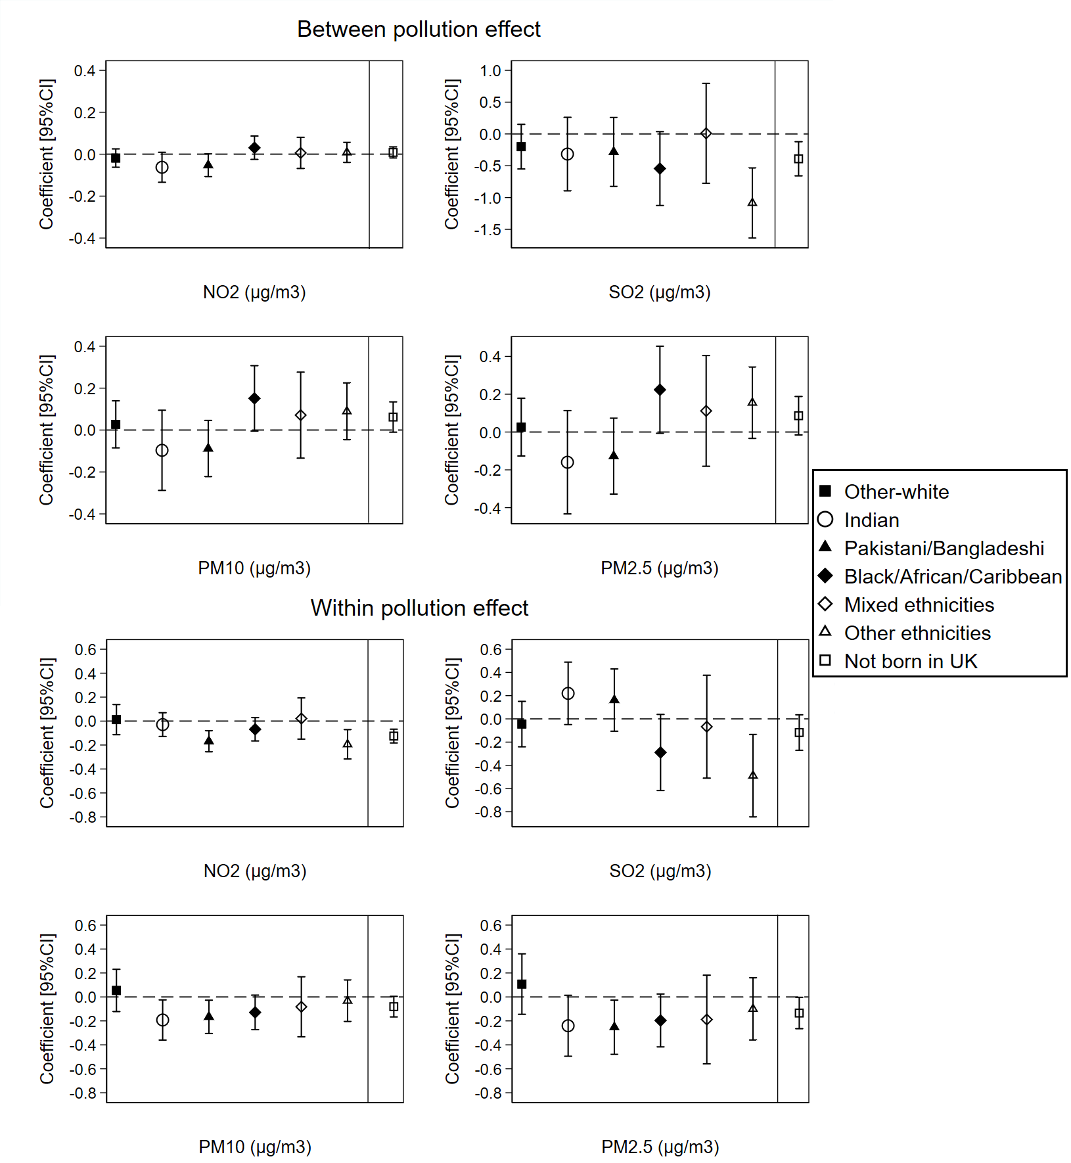
Coefficients and 95%CIs are expressed in terms of 10 µg/m³ increase in the air pollutants;
The dashed line is placed at Coefficient=0 as a cut-off for statistically insignificant results; The solid line separates between the air pollution-ethnicity interaction models and the air pollution-country of birth interaction models; Air pollution-ethnicity interaction models where the reference category is “British-white” are adjusted for country of birth, age, gender, marital status, education, occupation, subjective financial situation, smoking status, and year dummies (2009 to 2019); Air pollution-country of birth interaction models where the reference category is “born in UK” are adjusted for ethnicity, age, gender, marital status, education, occupation, subjective financial situation, smoking status, and year dummies (2009 to 2019).
Figure 7: The overall effect of air pollution on individuals’ self-reported health by ethnicity and country of birth for individuals recruited in wave 1 of the Understanding Society study at the local authority level (N=261,271 surveys from 39,798 individuals)
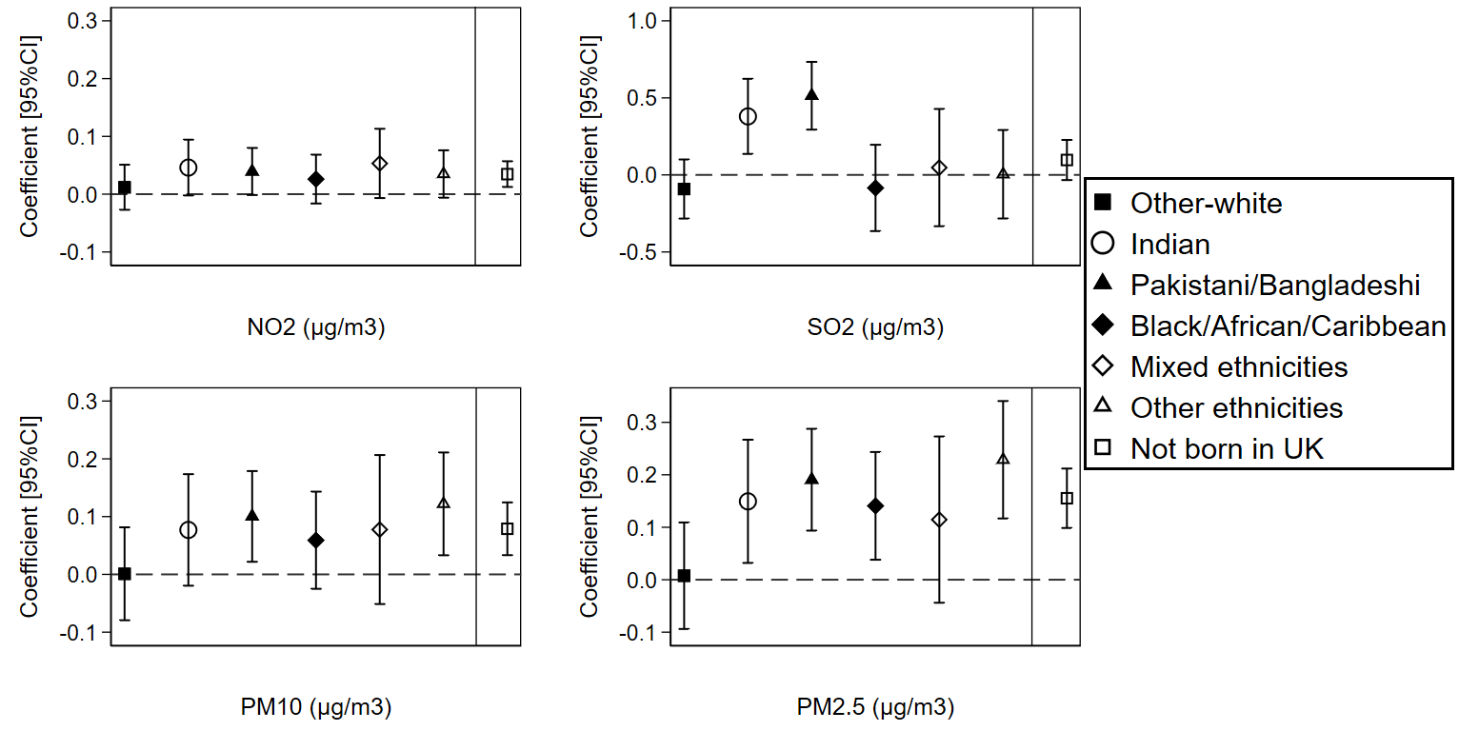
Coefficients and 95%CIs are expressed in terms of 10 µg/m³ increase in the air pollutants;
The dashed line is placed at Coefficient=0 as a cut-off for statistically insignificant results; The solid line separates between the air pollution-ethnicity interaction models and the air pollution-country of birth interaction models; Air pollution-ethnicity interaction models where the reference category is “British-white” are adjusted for country of birth, age, gender, marital status, education, occupation, subjective financial situation, smoking status, and year dummies (2009 to 2019); Air pollution-country of birth interaction models where the reference category is “born in UK” are adjusted for ethnicity, age, gender, marital status, education, occupation, subjective financial situation, smoking status, and year dummies (2009 to 2019).

Figure 8: The between-within (spatial-temporal) effect of air pollution on individuals’ self-reported health by ethnicity and country of birth for individuals recruited in wave 1 of the Understanding Society study at the local authority level (N=261,271 surveys from 39,798 individuals)
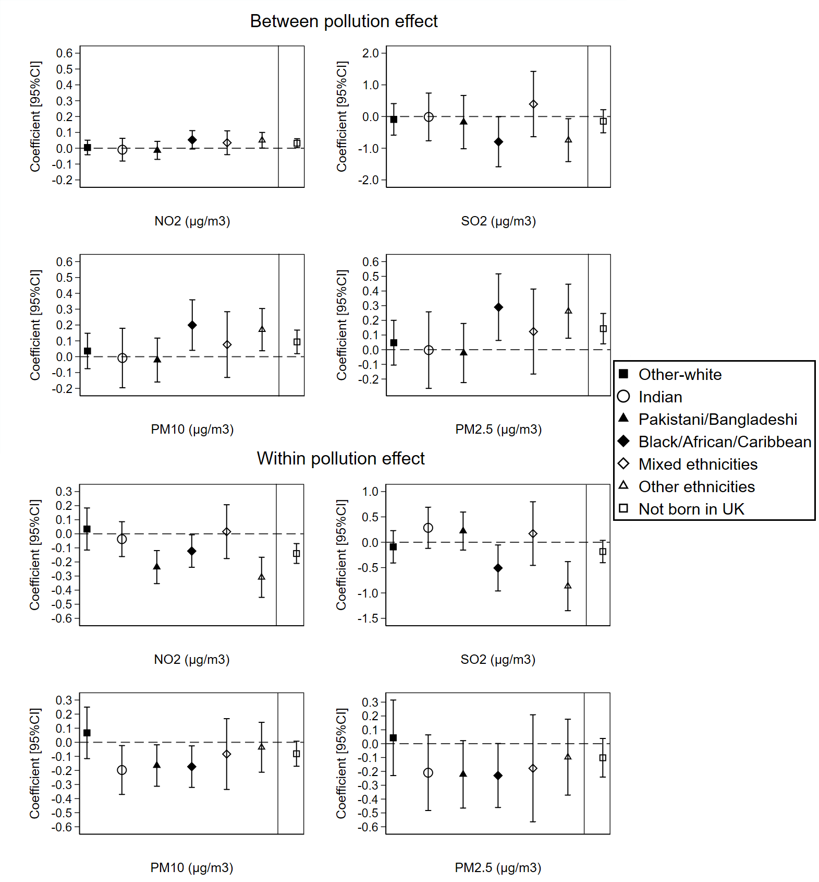
Coefficients and 95%CIs are expressed in terms of 10 µg/m³ increase in the air pollutants;
The dashed line is placed at Coefficient=0 as a cut-off for statistically insignificant results; The solid line separates between the air pollution-ethnicity interaction models and the air pollution-country of birth interaction models; Air pollution-ethnicity interaction models where the reference category is “British-white” are adjusted for country of birth, age, gender, marital status, education, occupation, subjective financial situation, smoking status, and year dummies (2009 to 2019); Air pollution-country of birth interaction models where the reference category is “born in UK” are adjusted for ethnicity, age, gender, marital status, education, occupation, subjective financial situation, smoking status, and year dummies (2009 to 2019).
Table 6: Description of the area of residence (urban or rural) for ethnic groups and country of birth in the “Understanding Society” data using Chi2 test tabulation (N=404,264 surveys from 67,982 individuals)
 |  | Urban area | Rural area | Total
Ethnicity (Chi2 test P-value=0.000)
British-white | Count | 221,221 | 88,371 | 309,592
British-white | % | 71.46 | 28.54 | 100
Other-white | Count | 14,071 | 5,679 | 19,750
Other-white | % | 71.25 | 28.75 | 100
Indian | Count | 13,715 | 218 | 13,933
Indian | % | 98.44 | 1.56 | 100
Pakistani/Bangladeshi | Count | 18,539 | 82 | 18,621
Pakistani/Bangladeshi | % | 99.56 | 0.44 | 100
Black/African/Caribbean | Count | 15,952 | 172 | 16,124
Black/African/Caribbean | % | 98.93 | 1.07 | 100
mixed ethnicities | Count | 6,249 | 372 | 6,621
mixed ethnicities | % | 94.38 | 5.62 | 100
other ethnicities | Count | 16,488 | 3,135 | 19,623
other ethnicities | % | 84.02 | 15.98 | 100
Total | Count | 306,235 | 98,029 | 404,264
Total | % | 75.75 | 24.25 | 100
Country of birth (Chi2 test P-value=0.000)
Born in the UK | Count | 207,803 | 70,493 | 278,296
Born in the UK | % | 74.67 | 25.33 | 100
Not born in the UK | Count | 52,203 | 3,650 | 55,853
Not born in the UK | % | 93.46 | 6.54 | 100
No answer | Count | 46,229 | 23,886 | 70,115
No answer | % | 65.93 | 34.07 | 100
Total | Count | 306,235 | 98,029 | 404,264
Total | % | 75.75 | 24.25 | 100

Table 7: For people living in urban areas, description of the air pollution exposures by ethnic groups and country of birth (N=306,235 surveys)
 | British white | Other white | Indian | Pakistani/Bangladeshi | Black/African/Caribbean | Mixed ethnicities | Other ethnicities | Born in UK | Not born in UK
NO₂ (µg/m³) | 14.094 | 16.998 | 21.742 | 22.510 | 24.495 | 21.345 | 19.306 | 15.326 | 21.650
SO₂ (µg/m³) | 1.848 | 1.843 | 1.914 | 1.984 | 1.744 | 1.786 | 1.789 | 1.869 | 1.800
PM10 (µg/m³) | 13.989 | 14.933 | 16.510 | 16.361 | 17.754 | 16.547 | 15.809 | 14.440 | 16.593
PM2.5 (µg/m³) | 9.497 | 10.162 | 11.463 | 11.343 | 12.325 | 11.445 | 10.919 | 9.833 | 11.486

