Supporting Information

Green synthesis of ferrocenyl chalcones against triple negative breast cancer
Wenqiang Tang ¹, Yanrong Gao ¹, Hongjuan Tong ¹, Xiaona Xu ², Zhoujing Zhu ², Bin Liu ^{1*}

1. Xianyang Key Laboratory of Molecular Imaging and Drug Synthesis, School of Pharmacy, Shaanxi Institute of International Trade & Commerce, Xianyang, Shaanxi 712046, PR China
2. School of pharmaceutical & Chemical Engineering，Xianyang Vocational Technical College，Xianyang, Shaanxi 712000, PR China

* Corresponding author: Liu Bin, E-mail address: lb125lb@163.com

¹H NMR for 1a
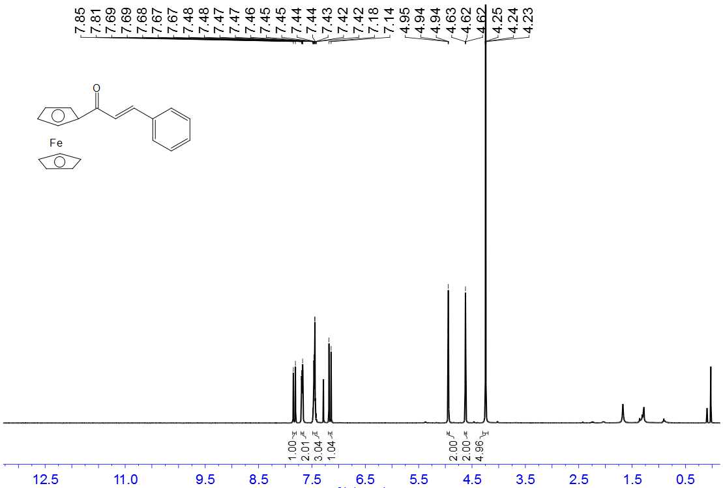

¹H NMR for 1b
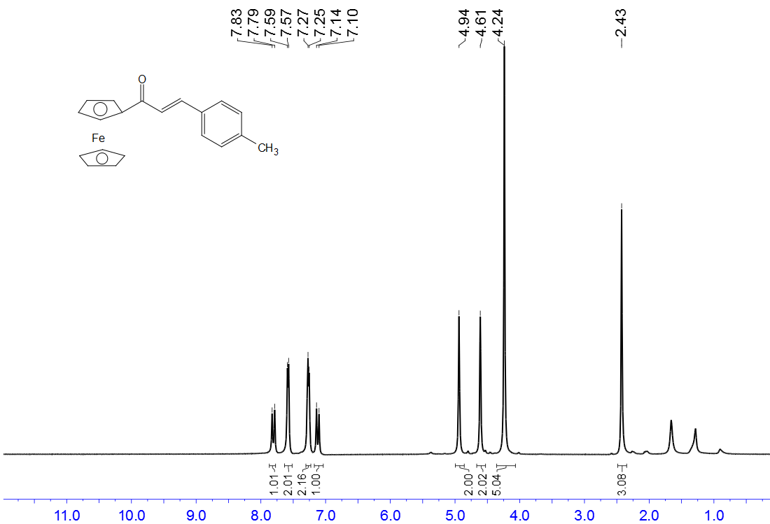

¹H NMR for 1c
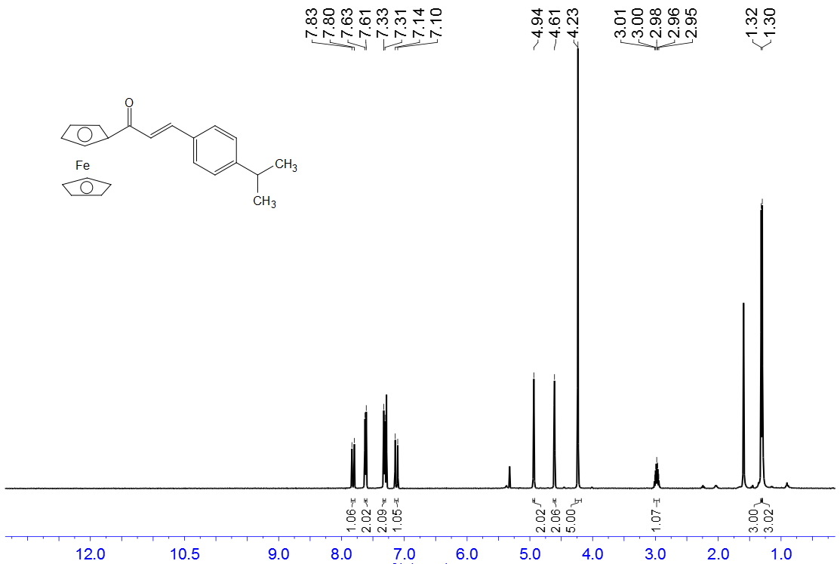

¹H NMR for 1d
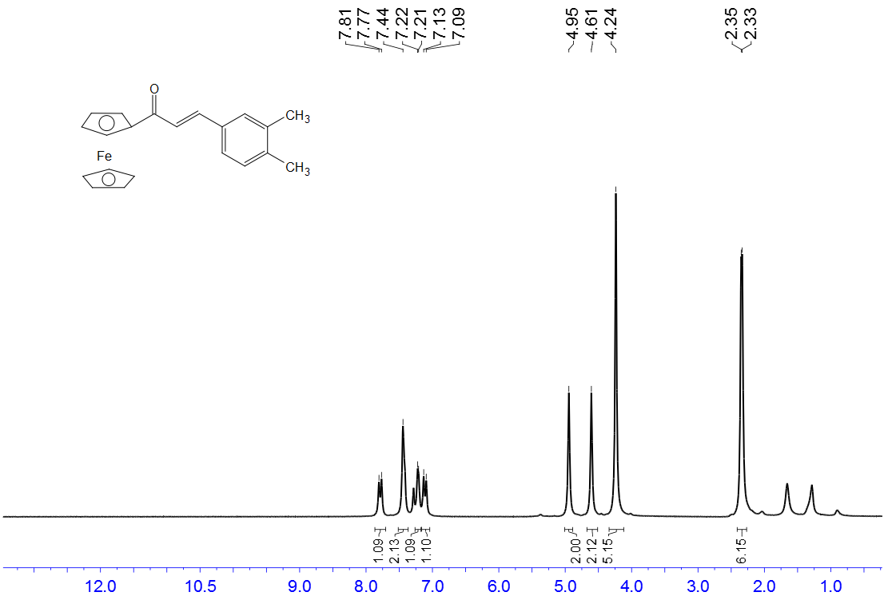

¹H NMR for 1e
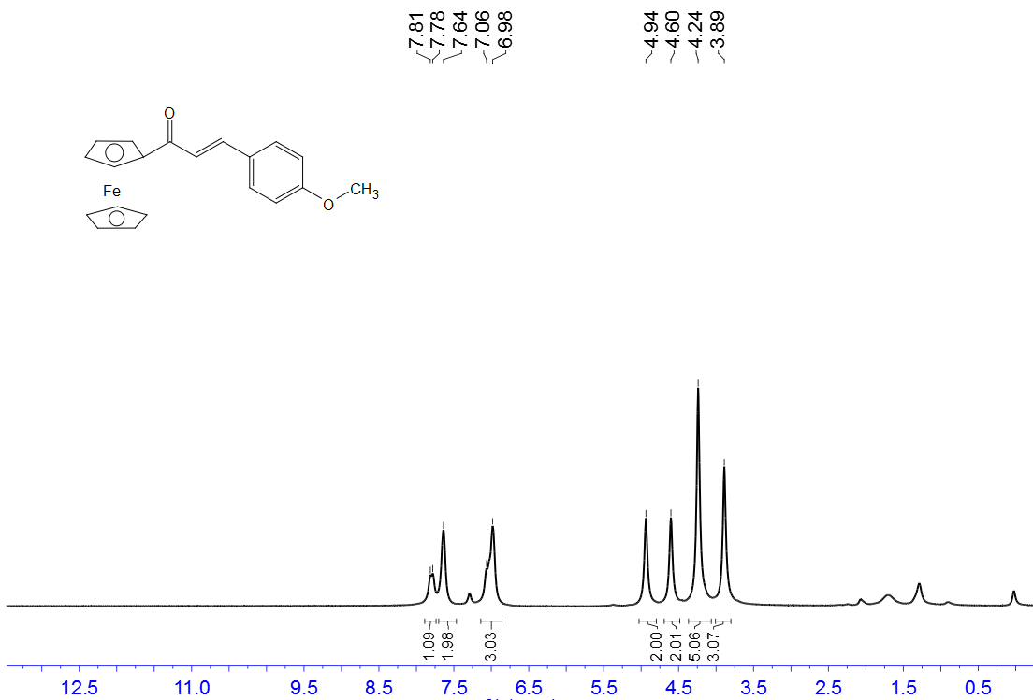

¹H NMR for 1f
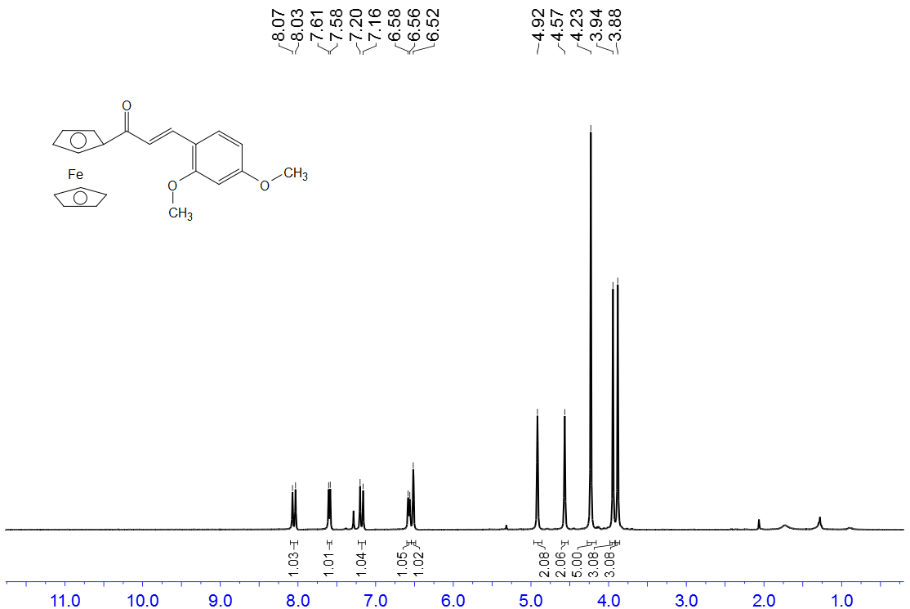

¹H NMR for 1g
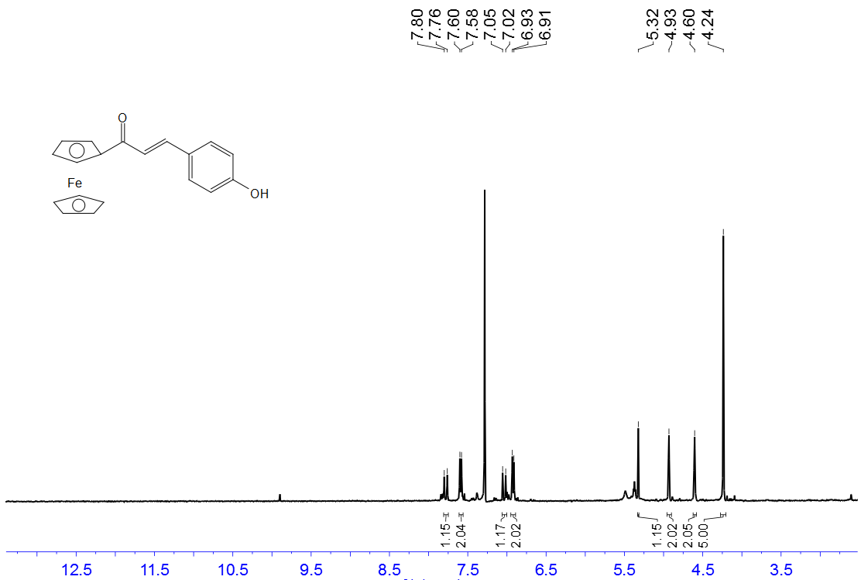
‘

¹H NMR for 1h
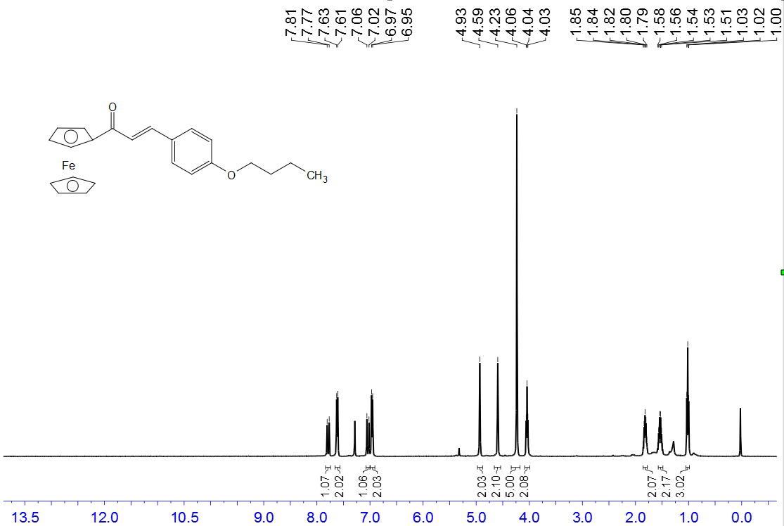

¹H NMR for 1i
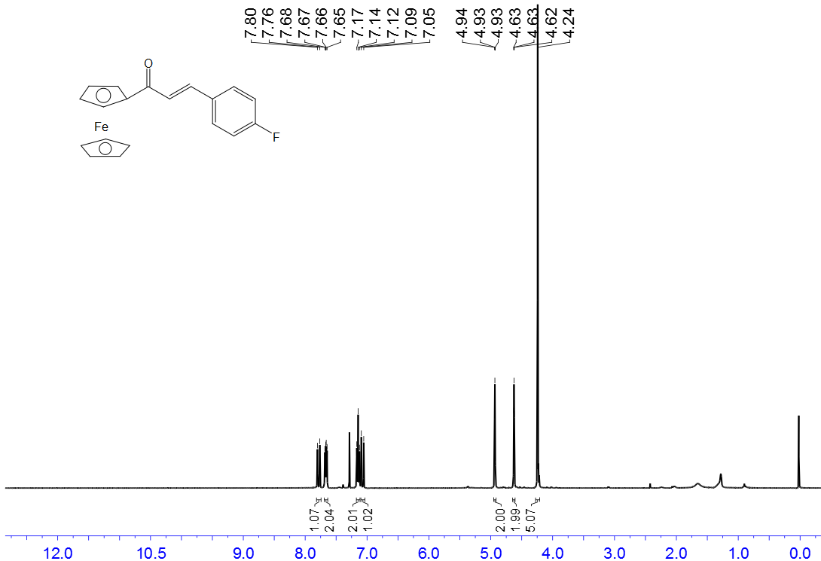

¹H NMR for 1j
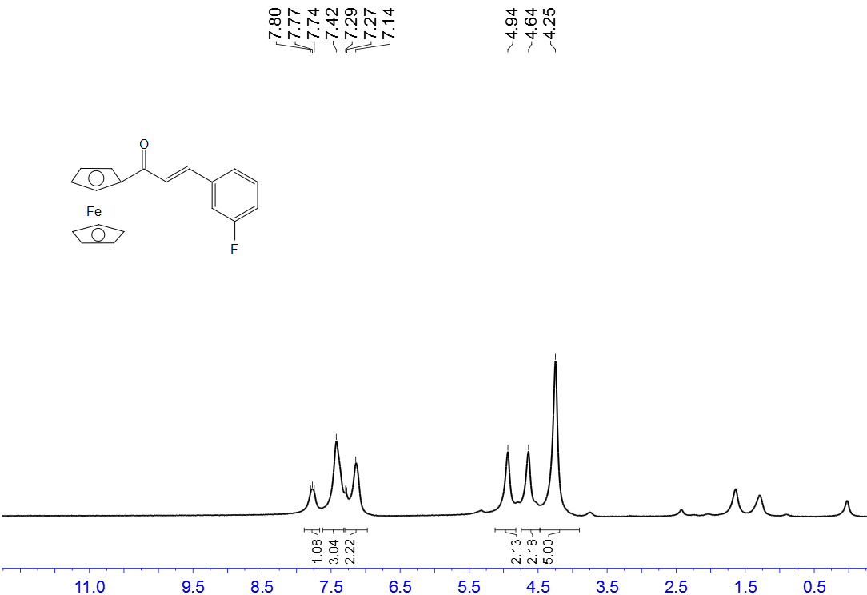

¹H NMR for 1k
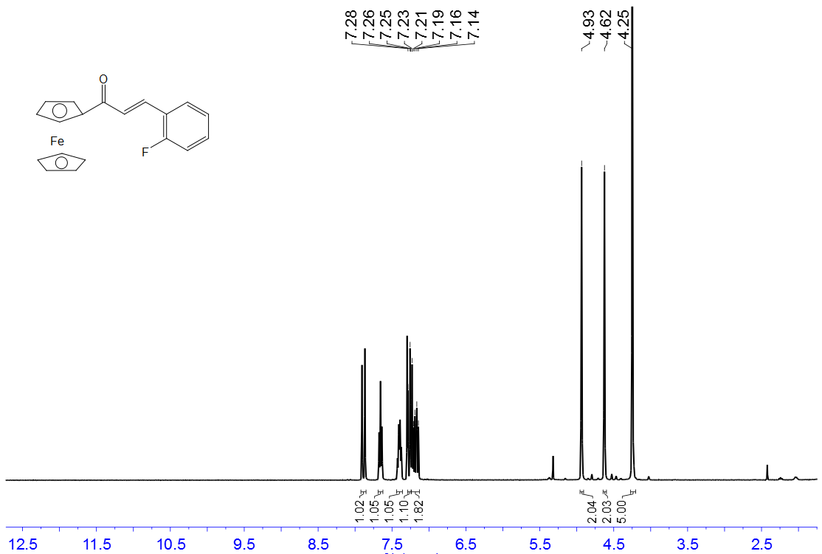

¹H NMR for 1l
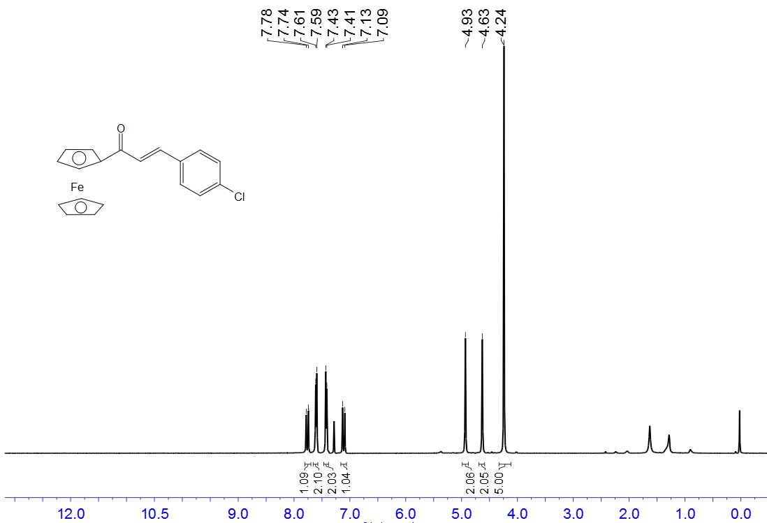

¹H NMR for 1m
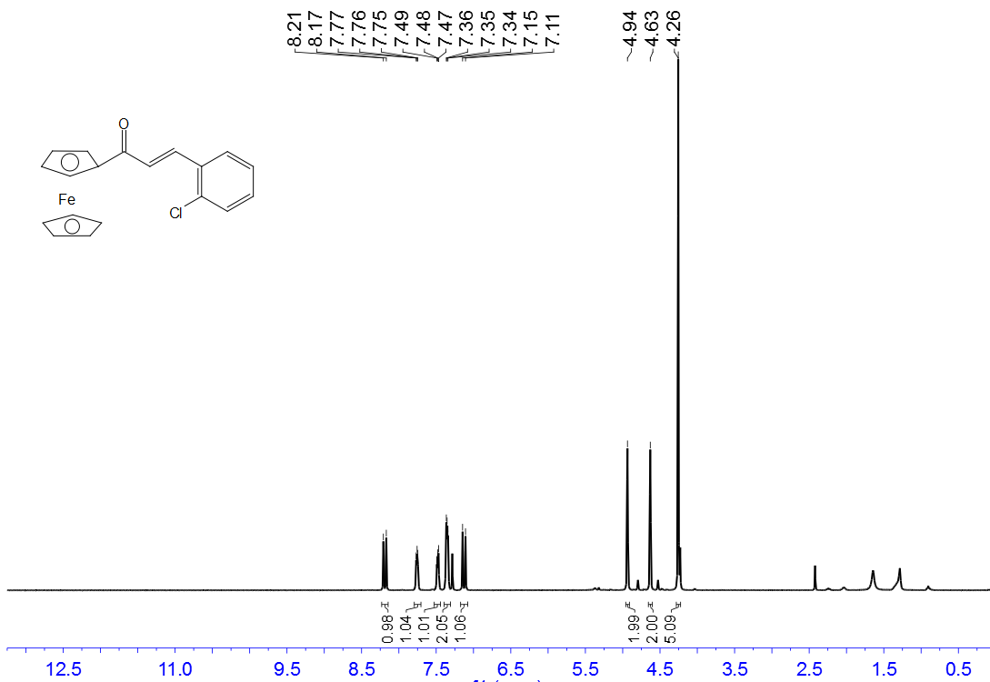

¹H NMR for 1n
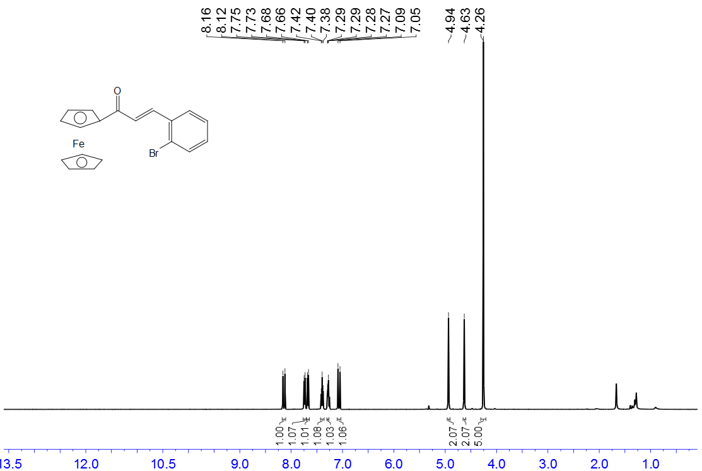

¹H NMR for 1o
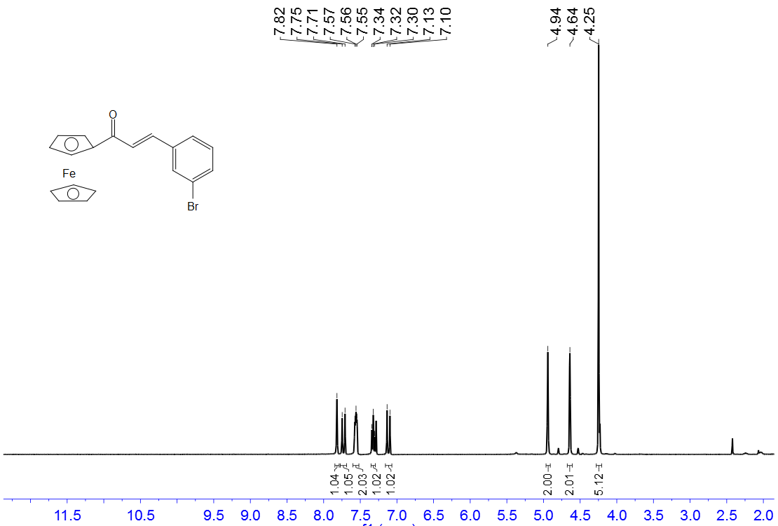

¹H NMR for 1p
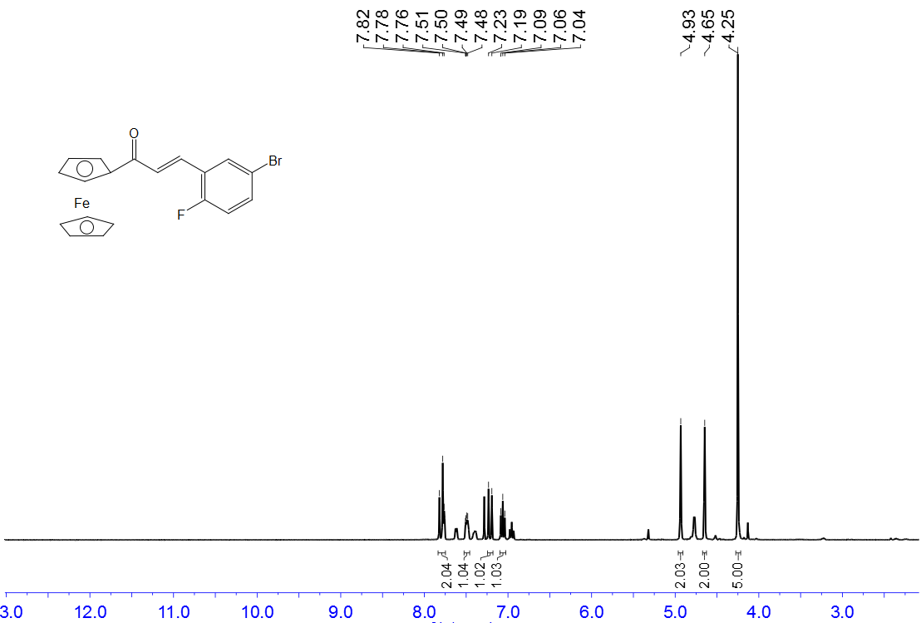

¹H NMR for 1q
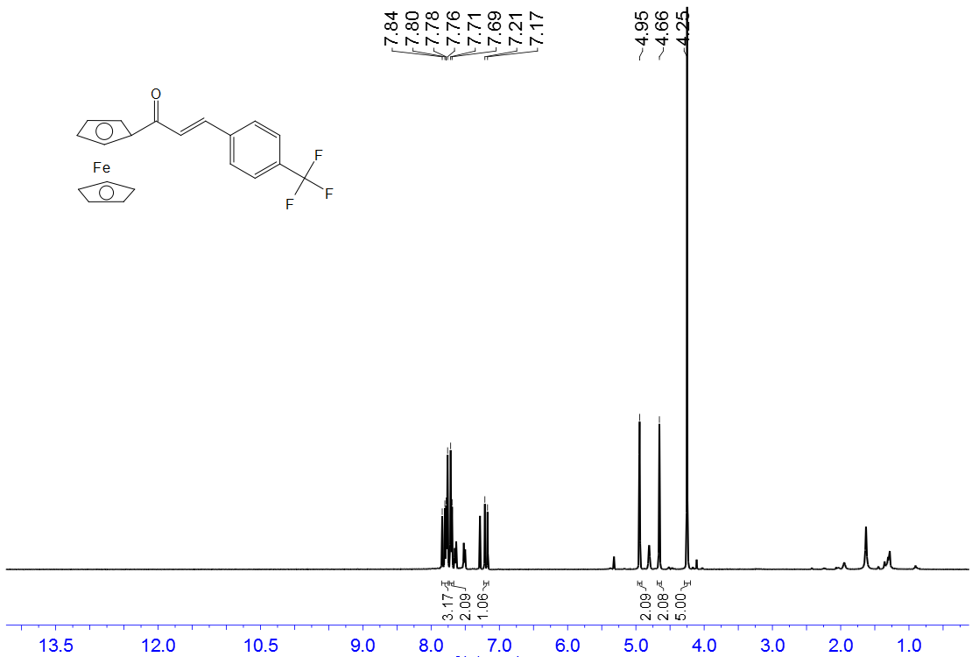

¹H NMR for 1r
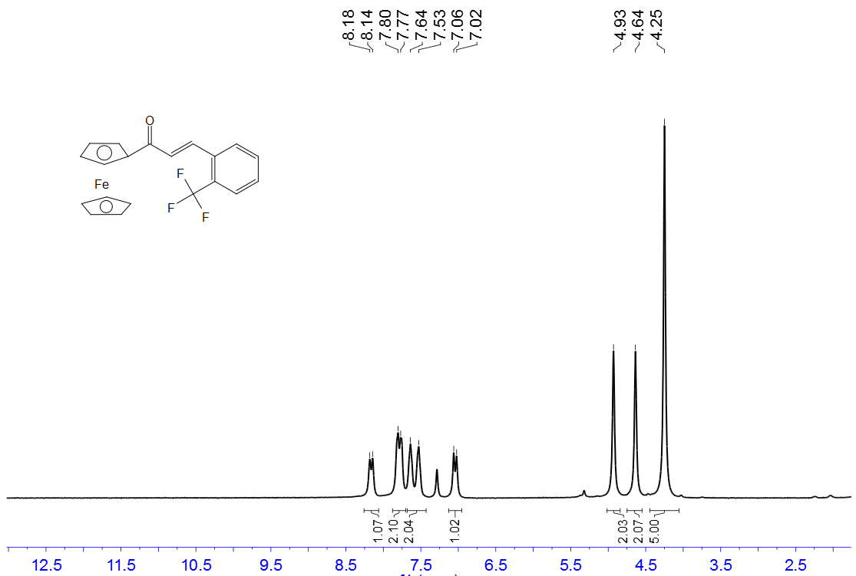

¹H NMR for 1s
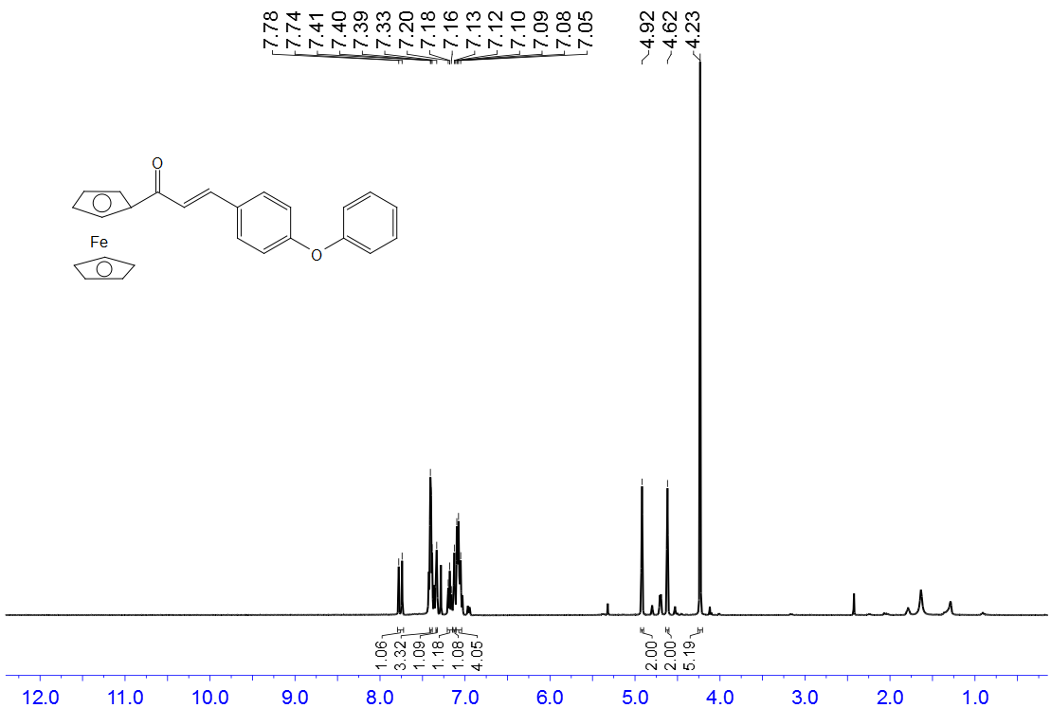

¹H NMR for 1t
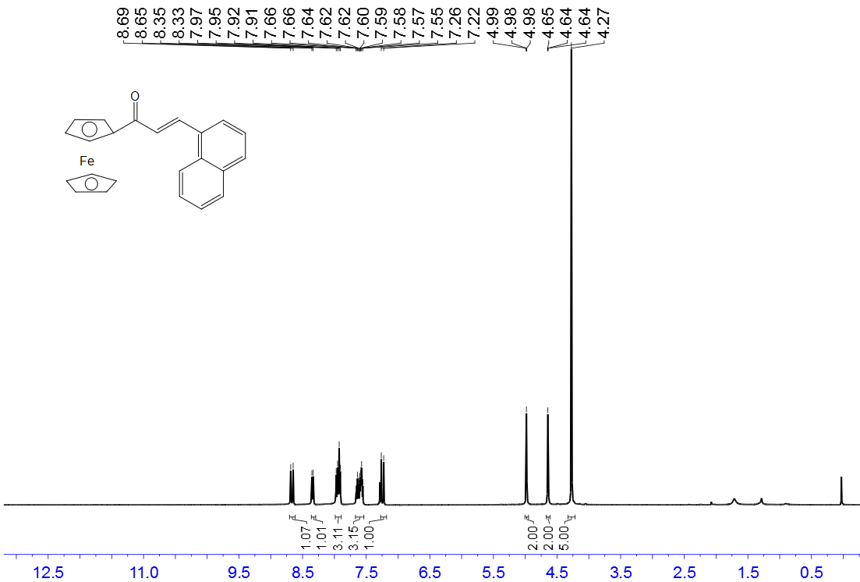
¹H NMR for 1u
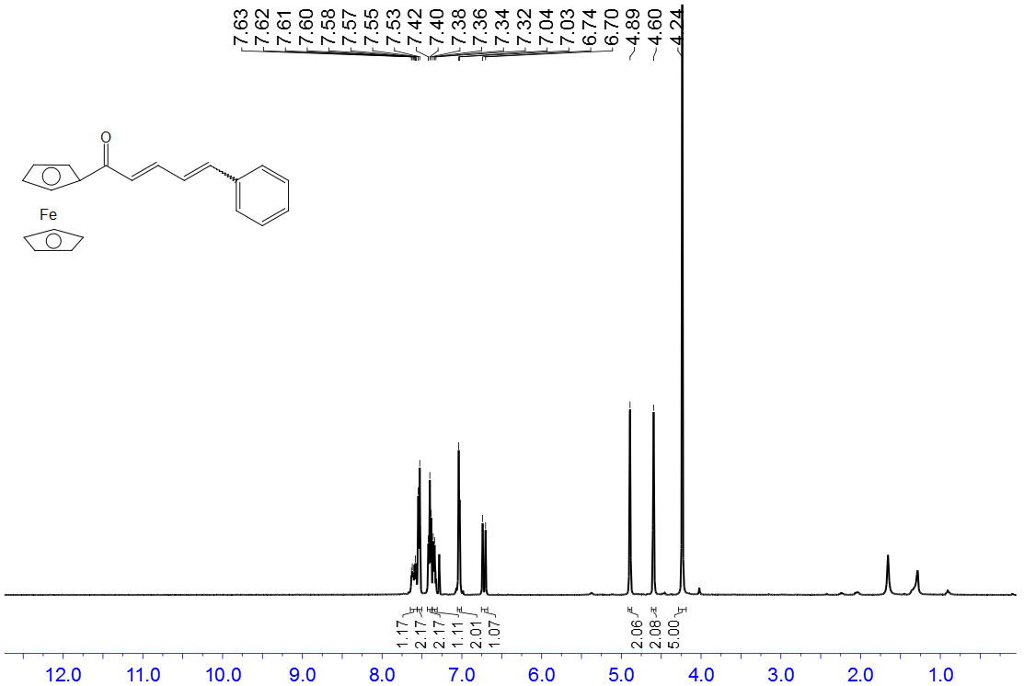

¹H NMR for 1v
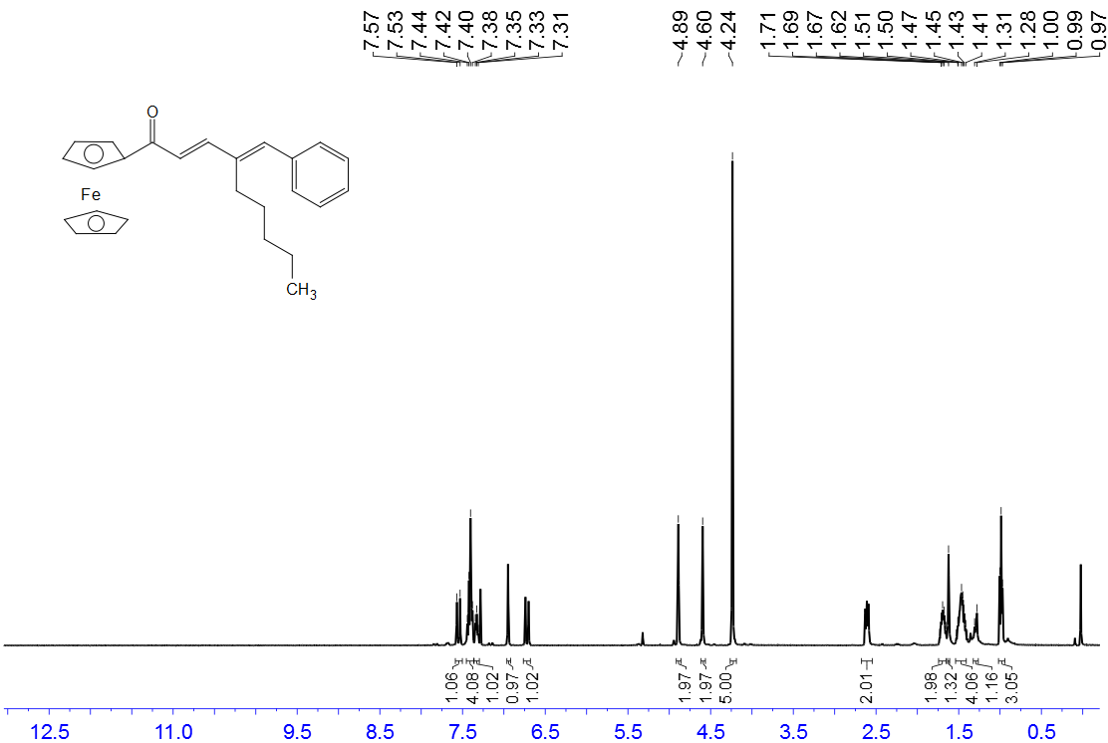

¹H NMR for 1w

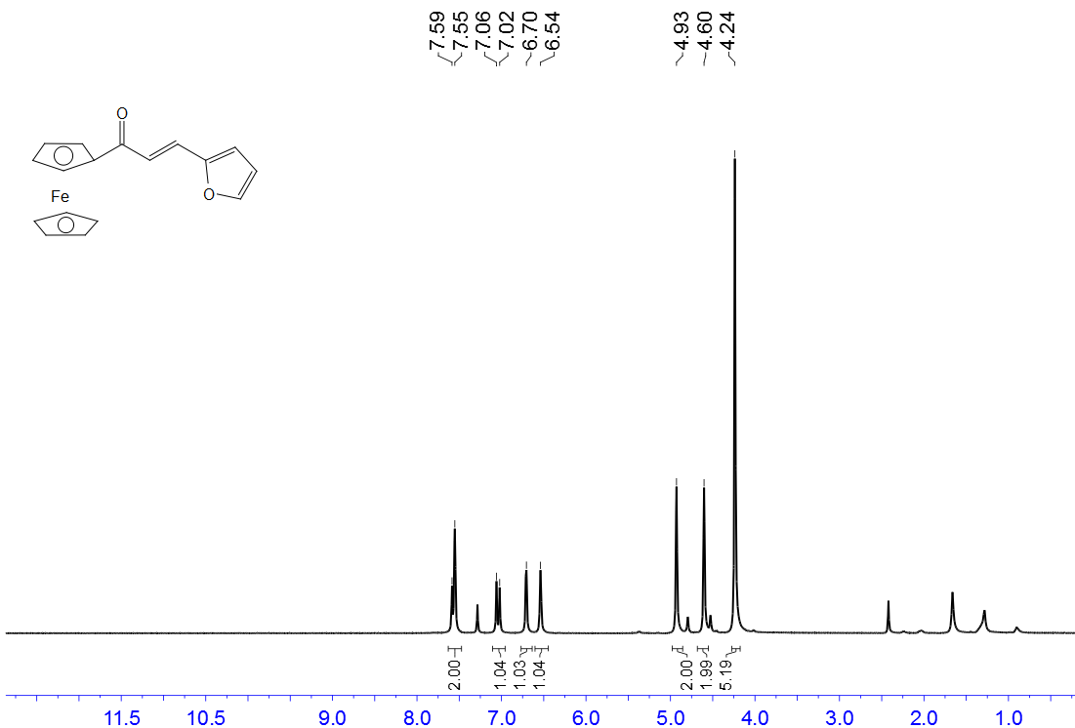

¹H NMR for 1x
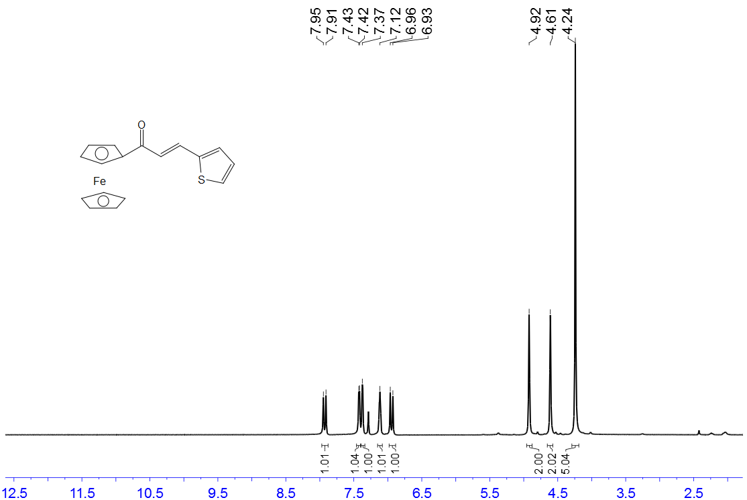

¹H NMR for 1y
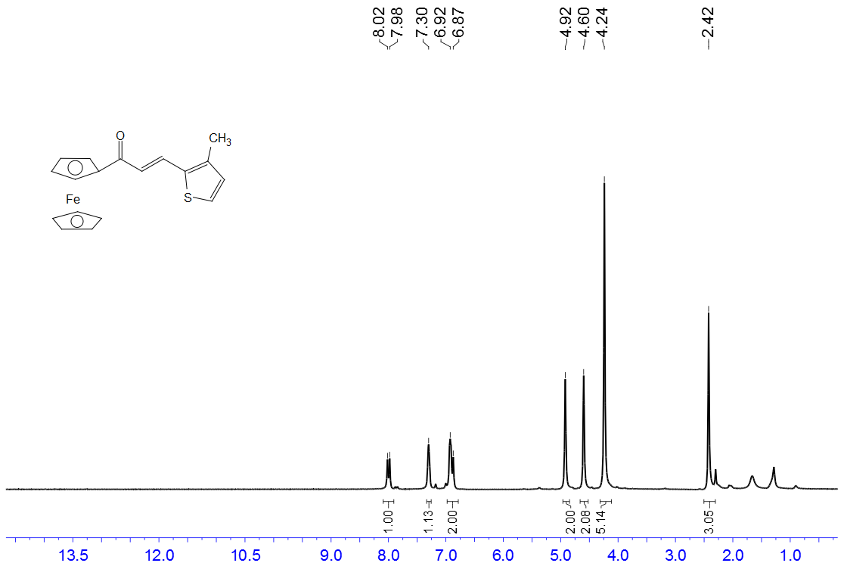

¹H NMR for 1z
