Table S1 Optimization of the action conditions of compound bacterial flora.
number | temperature | pH | inoculation amount | salt concentration | time
 | 25℃ | 7 | 2% | 1% | 12h
 | 28℃ | 7 | 2% | 1% | 12h
1 | 30℃ | 7 | 2% | 1% | 12h
 | 32℃ | 7 | 2% | 1% | 12h
 | 35℃ | 7 | 2% | 1% | 12h
 | 30℃ | 5 | 2% | 1% | 12h
 | 30℃ | 6 | 2% | 1% | 12h
2 | 30℃ | 7 | 2% | 1% | 12h
 | 30℃ | 8 | 2% | 1% | 12h
 | 30℃ | 9 | 2% | 1% | 12h
 | 30℃ | 7 | 1% | 1% | 12h
 | 30℃ | 7 | 2% | 1% | 12h
3 | 30℃ | 7 | 3% | 1% | 12h
 | 30℃ | 7 | 4% | 1% | 12h
 | 30℃ | 7 | 5% | 1% | 12h
 | 30℃ | 7 | 2% | 1% | 12h
 | 30℃ | 7 | 2% | 2% | 12h
4 | 30℃ | 7 | 2% | 3% | 12h
 | 30℃ | 7 | 2% | 4% | 12h
 | 30℃ | 7 | 2% | 5% | 12h

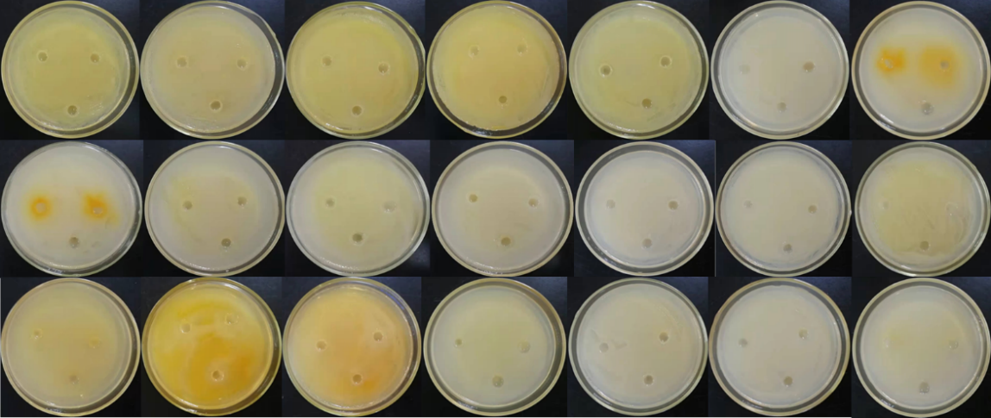

Fig S1. The antagonism among the seven strains was from left to right in each row: 1)C1-h+C4-h、C1-h+C8-h、C1-h+M1-h、C1-h+M3-h、C1-h+P2-h、C1-h+P3-h、P2-h+C8-h; 2) C4-h+C8-h、C4-h+M1-h、C4-h+M3-h、C4-h+P2-h、C4-h+P3-h、M3-h+P2-h、M3-h+P3-h; 3) C8-h+M1-h、C8-h+M3-h、C8-h+P3-h、M1-h+M3-h、M1-h+P2-h、M1-h+P3-h、P2-h+P3-h.

Table S2 The heavy metals removal rate of 12 h, 24 h and 48 h at 8 different ratios.
12 h | 1-1 | 2-1 | 3-1 | 4-1 | 5-1 | 6-1 | 7-1 | 8-1
Mn | 55.31% | 51.15% | 50.98% | 52.46% | 52.92% | 52.92% | 51.98% | 52.26%
Cd | 65.07% | 58.83% | 58% | 54.88% | 52.18% | 52.18% | 55.92% | 60.29%
Pb | 78.42% | 74.12% | 69.9% | 53.98% | 56.33% | 56.33% | 52.16% | 53.77%
24 h | 1-2 | 2-2 | 3-2 | 4-2 | 5-2 | 6-2 | 7-2 | 8-2
Mn | 54.03% | 46.92% | 51.69% | 53.30% | 49.46% | 52.7% | 52.75% | 48.47%
Cd | 43.46% | 31.47% | 38.07% | 38.32% | 43.21% | 40.52% | 38.81% | 43.56%
Pb | 47.95% | 33.15% | 64.13% | 13.46% | 26.05% | 5.37% | 33.52% | 42.83%
48 h | 1-3 | 2-3 | 3-3 | 4-3 | 5-3 | 6-3 | 7-3 | 8-3
Mn | 52.56% | 49.63% | 46.12% | 48.08% | 47.05% | 44.66% | 42.39% | 47.43%
Cd | 56.67% | 35.63% | 54.23% | 39.05% | 57.66% | 44.43% | 39.3% | 43.94%
Pb | 75.78% | 74.6% | 44.5% | 75.59% | 68.07% | 75.78% | 74.97% | 72.56%
Eight columns in the table represent eight proportions.(1-) 1:1:1:1:1:1:1; (2-) 2:1:1:1:1:1:1; (3-) 1:2:1:1:1:1:1; (4-) 1:1:2:1:1:1:1; (5-) 1:1:1:2:1:1:1; (6-) 1:1:1:1:2:1:1; (7-) 1:1:1:1:1:2:1 and (8-) 1:1:1:1:1:1:2. The losses rate of Mn, Cd and Pb measured on the ICP-MS of Lanzhou Jiaotong University were 1.01%, 37.01% and 94.08% respectively. The results were the same after three tests.

Table S3 The removal rate of heavy metals under the best ratio and optimal conditions.
Heavy metals | Content of control (mg/kg) | Content under optimum conditions (mg/kg) | Heavy metals removal rate
Mn | 989.836 | 388.770 | 60.7%
Cd | 9.448 | 2.680 | 71.6%
Pb | 147.990 | 14.105 | 90.5%

Table S4 Plant heavy metal enrichment coefficients of TMP and HMP treatment groups.
HMs(mg/kg)/Groups | Pb | Cd | Mn
TMP | 77.6 | 1.0 | 690
HMs enrichment factor | 3.54% | 8.47% | 69.77%
HMP | 170 | 1.85 | 876
HMs enrichment factor | 7.75% | 15.68% | 88.57%

Table S5 OTUs analysis of 52 samples.
Samples | Total reads | Valid reads | OTUs Number | Phylum | Class | Order | Family | Genus | Species
TCK | 41100 | 39212 | __ | __ | __ | __ | __ | __ | __
HCK | 51082 | 43386 | 616 | 19 | 40 | 91 | 143 | 279 | 437
TM1 | 37056 | 34577 | 148 | 6 | 7 | 21 | 39 | 83 | 119
TM2 | 36911 | 34241 | 138 | 6 | 7 | 22 | 40 | 80 | 113
TM3 | 39886 | 37719 | 196 | 8 | 9 | 36 | 55 | 115 | 157
TM4 | 41789 | 39040 | 186 | 7 | 8 | 30 | 47 | 107 | 150
TMP1 | 39302 | 36939 | 122 | 5 | 6 | 20 | 36 | 74 | 98
TMP2 | 36413 | 34339 | 153 | 5 | 6 | 23 | 43 | 93 | 123
TMP3 | 48672 | 44108 | 211 | 11 | 13 | 41 | 68 | 130 | 175
TMP4 | 41978 | 34509 | 187 | 9 | 10 | 35 | 60 | 116 | 160
HM1 | 48647 | 41962 | 702 | 21 | 44 | 98 | 151 | 284 | 467
HM2 | 45757 | 40158 | 733 | 23 | 47 | 103 | 167 | 310 | 500
HM3 | 49522 | 43912 | 723 | 24 | 47 | 108 | 169 | 302 | 495
HM4 | 51753 | 45432 | 831 | 23 | 46 | 110 | 173 | 329 | 546
HMP1 | 48514 | 42293 | 763 | 23 | 50 | 111 | 173 | 311 | 522
HMP2 | 52981 | 46516 | 830 | 25 | 52 | 114 | 183 | 330 | 566
HMP3 | 59188 | 50625 | 923 | 23 | 51 | 119 | 182 | 334 | 580
HMP4 | 43538 | 35051 | 860 | 20 | 49 | 106 | 161 | 280 | 489
52 Samples | 2,620,238 | 2,360,069 | 5558 | 39 | 124 | 285 | 485 | 951 | 2019
OTUs Number indicates the number of OTUs were annotated; Phylum indicates the number of OTUs belonged to Phylum; Class, Order, Family, Genus, Species were the same as Phylum.
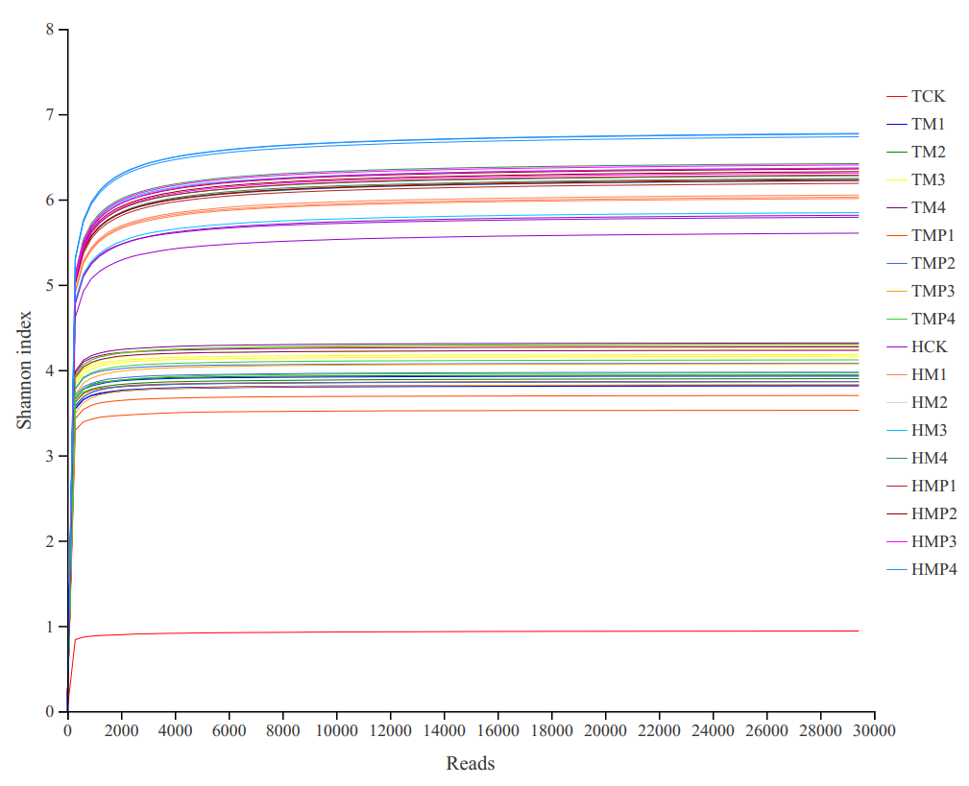

Fig.S2. Rarefaction curves.

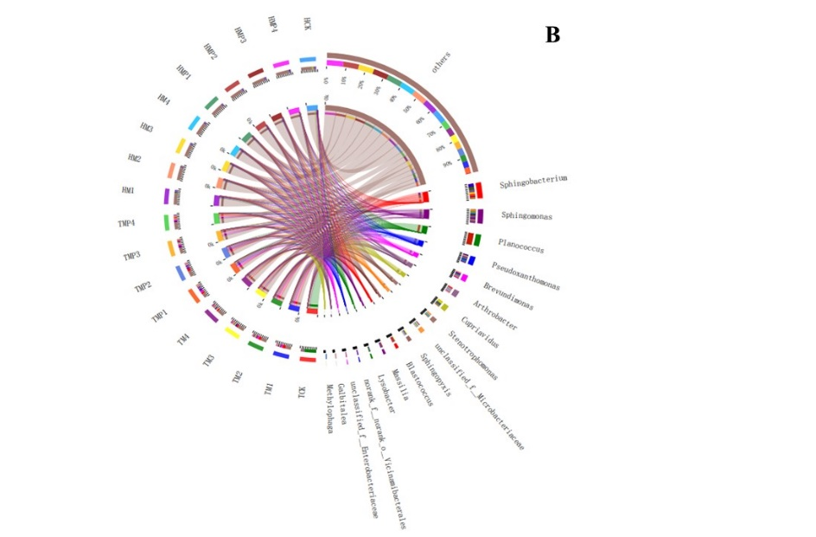
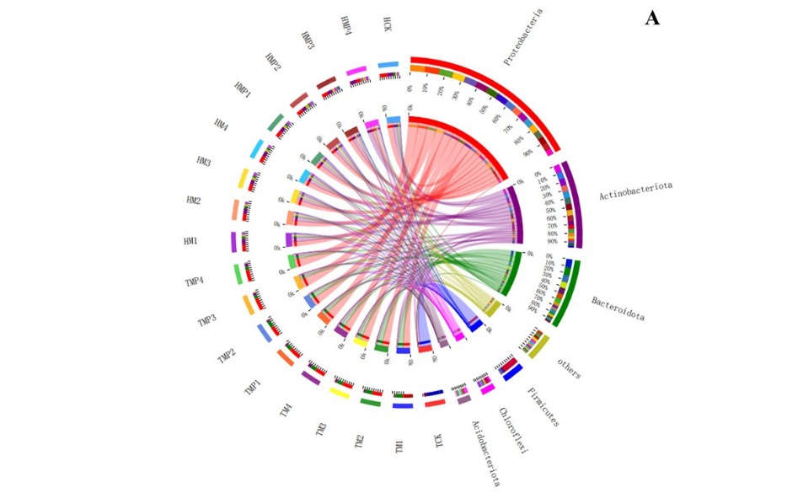

Fig.S3. Different proportion of soil bacterial community composition in different groups with relative abundance > 5% at the phylum (A) and genus (B) levels.

Table S6 The correlation coefficient and significance test value of each environmental factor to the ranking results.
 | RDA1 | RDA2 | r² | p
pH | -0.9443 | 0.3289 | 0.8214 | 0.049
WHC | 0.9762 | 0.2169 | 0.5312 | 0.008
TEMP | -0.8162 | -0.5777 | 0.4905 | 0.013
EC | -0.9314 | -0.364 | 0.0232 | 0.846
POR | 0.5327 | -0.8463 | 0.4617 | 0.009
Pb | -0.1846 | 0.9828 | 0.8879 | 0.001
Cd | 0.0388 | 0.9992 | 0.9219 | 0.001
Mn | -0.8382 | 0.5454 | 0.6713 | 0.037

Table S7 Interpretation of main components.
Variance | Proportion of Variance
RDA1 | 0.6606
RDA2 | 0.3005
RDA3 | 0.0205
RDA4 | 0.0094
RDA5 | 0.0014
RDA6 | 0.0001
PC1 | 0.0038
PC2 | 0.0026
PC3 | 0.0007
PC4 | 0.0004
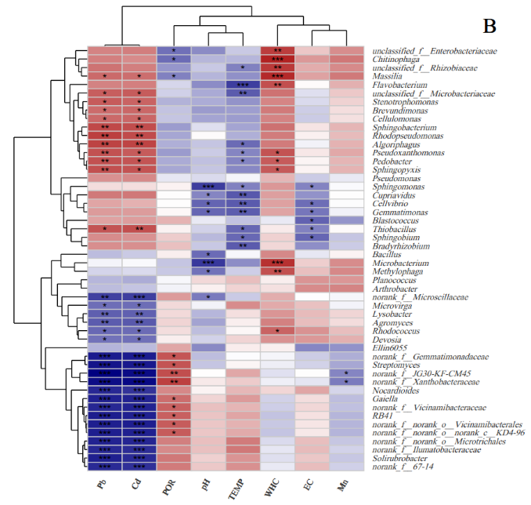
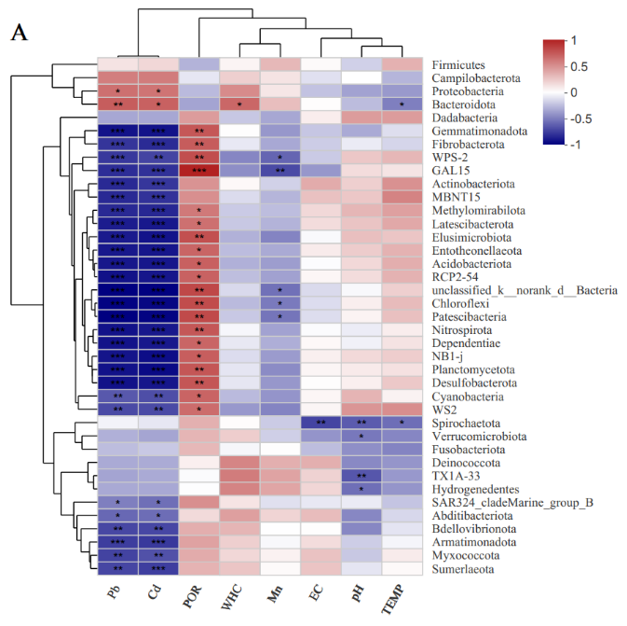

Fig. S4. The effects of environmental factors (Pb, Cd, POR, WHC, Mn, EC, pH, TEMP) on bacterial community structure.(A) at the Phylum level; (B) at the Genus level (* p ≤ 0.05, **p ≤ 0.01, *** p ≤ 0.001).

Table S8 Correlation between phyla and environmental factors (pH, WHC, TEMP, EC, POR, Pb, Cd, Mn).
 | pH | WHC | TEMP | EC | POR | Pb | Cd | Mn
Proteobacteria | -0.38439 | 0.43235 | -0.41679 | -0.26765 | -0.29706 | 0.54706 | 0.52941 | 0.05588
Actinobacteriota | 0.15317 | -0.02059 | 0.40795 | 0.3 | 0.4 | -0.82059 | -0.77353 | -0.21471
Bacteroidota | -0.29161 | 0.58235 | -0.5081 | -0.03824 | -0.37647 | 0.62647 | 0.60882 | 0.22059
Firmicutes | -0.21797 | -0.00294 | 0.27541 | -0.02647 | -0.32353 | 0.06765 | 0.11765 | 0.24706
Acidobacteriota | 0.11193 | -0.33235 | 0.29013 | -0.05882 | 0.61176 | -0.88529 | -0.88824 | -0.4
Chloroflexi | 0.02209 | -0.29706 | 0.2327 | -0.17353 | 0.69412 | -0.95588 | -0.94412 | -0.52647
Gemmatimonadota | -0.35493 | -0.03824 | -0.16789 | -0.25294 | 0.65 | -0.9 | -0.9 | -0.42353
Myxococcota | -0.24797 | 0.11791 | 0.03542 | 0.20486 | 0.30214 | -0.7266 | -0.67649 | 0.01179
Verrucomicrobiota | -0.53608 | 0.15882 | -0.48454 | -0.43529 | 0.25882 | -0.33235 | -0.37353 | -0.22059
Planctomycetota | 0.03976 | -0.14118 | 0.07658 | -0.00588 | 0.65588 | -0.90294 | -0.93235 | -0.46765
unclassified_k__norank_d__Bacteria | -0.07511 | -0.18529 | 0.15169 | -0.18235 | 0.71176 | -0.96765 | -0.96471 | -0.55882
Nitrospirota | -0.1166 | -0.08061 | 0.02541 | -0.06269 | 0.65082 | -0.90159 | -0.8807 | -0.38213
Bdellovibrionota | -0.48192 | 0.26087 | -0.14539 | -0.03832 | 0.29035 | -0.71187 | -0.71039 | -0.05158
Methylomirabilota | 0.25687 | -0.24019 | 0.34596 | 0.11416 | 0.50854 | -0.81989 | -0.82879 | -0.28763
Patescibacteria | 0.00147 | -0.24577 | 0.21518 | -0.16924 | 0.7064 | -0.96689 | -0.95364 | -0.54452
Entotheonellaeota | 0.1618 | -0.28991 | 0.27068 | 0.03473 | 0.59039 | -0.88031 | -0.88937 | -0.35635
NB1-j | 0.1098 | -0.17392 | 0.15978 | 0.01966 | 0.62156 | -0.89377 | -0.91948 | -0.40984
Cyanobacteria | 0.2618 | -0.29602 | 0.00737 | -0.01178 | 0.59647 | -0.64949 | -0.6863 | -0.43446
RCP2-54 | 0.09799 | -0.28383 | 0.27078 | -0.01195 | 0.6065 | -0.90676 | -0.88734 | -0.3884
Latescibacterota | 0.19658 | -0.24763 | 0.31151 | 0.09815 | 0.5451 | -0.86521 | -0.88031 | -0.32313
Deinococcota | -0.47376 | 0.45757 | -0.4309 | 0.28487 | 0.01624 | -0.35425 | -0.35129 | 0.28487
Desulfobacterota | 0.0172 | -0.13893 | 0.17878 | -0.04183 | 0.6543 | -0.90676 | -0.88734 | -0.42425
Fibrobacterota | -0.11925 | -0.13059 | -0.20079 | -0.23199 | 0.63146 | -0.77588 | -0.81275 | -0.36105
Armatimonadota | -0.22772 | 0.15057 | -0.08463 | 0.09833 | 0.33954 | -0.74822 | -0.76359 | -0.07528
Sumerlaeota | -0.14233 | 0.19205 | -0.02462 | 0.19512 | 0.2658 | -0.71596 | -0.74515 | -0.02919
Dependentiae | -0.09887 | -0.13266 | 0.06797 | -0.02005 | 0.5939 | -0.89933 | -0.88082 | -0.34091
Elusimicrobiota | 0.21588 | -0.32885 | 0.19146 | -0.06923 | 0.6813 | -0.87484 | -0.89844 | -0.49092
WPS-2 | 0.18274 | -0.48497 | 0.25096 | -0.24005 | 0.68771 | -0.76719 | -0.72339 | -0.60337
MBNT15 | 0.1831 | -0.1781 | 0.46721 | 0.20962 | 0.41767 | -0.81957 | -0.78648 | -0.31522
Abditibacteriota | -0.47969 | 0.34919 | -0.19342 | 0.22867 | 0.10507 | -0.59332 | -0.57478 | 0.12979
TX1A-33 | -0.65833 | 0.49536 | -0.41794 | 0.13911 | -0.06277 | -0.37491 | -0.35455 | 0.33589
GAL15 | 0.097 | -0.45741 | 0.06521 | -0.42485 | 0.87087 | -0.80413 | -0.79273 | -0.70158
Hydrogenedentes | -0.56829 | 0.46482 | -0.42983 | 0.12214 | -0.05598 | -0.35795 | -0.36134 | 0.32571
WS2 | 0.39078 | -0.41885 | 0.42036 | -0.00537 | 0.56204 | -0.70166 | -0.70166 | -0.49223
SAR324_cladeMarine_group_B | -0.1205 | 0.06465 | -0.26078 | -0.13289 | 0.41663 | -0.51001 | -0.56748 | -0.16162
Campilobacterota | -0.04969 | 0.15101 | -0.31542 | -0.15964 | -0.13806 | 0.48754 | 0.49617 | 0.06903
Spirochaetota | -0.63817 | -0.03616 | -0.57028 | -0.7231 | 0.2802 | -0.09039 | -0.13558 | -0.23501
Fusobacteriota | -0.45162 | -0.08199 | -0.49268 | -0.28697 | 0.24598 | -0.28697 | -0.24598 | -0.041
Dadabacteria | 0.36461 | -0.25205 | 0.36461 | 0.02801 | 0.36407 | -0.36407 | -0.36407 | -0.36407

Table S9 Significant p-value of correlation at the phylum level, p < 0.05 was significant correlation.
 | pH | WHC | TEMP | EC | POR | Pb | Cd | Mn
Proteobacteria | 0.14156 | 0.09442 | 0.10827 | 0.31625 | 0.26386 | 0.0283 | 0.03495 | 0.83714
Actinobacteriota | 0.57117 | 0.93967 | 0.11674 | 0.25894 | 0.12475 | 0.0001 | 0.00044 | 0.42456
Bacteroidota | 0.27315 | 0.01793 | 0.04449 | 0.8882 | 0.15065 | 0.00941 | 0.01232 | 0.41167
Firmicutes | 0.41738 | 0.99137 | 0.30188 | 0.92248 | 0.22157 | 0.80342 | 0.66434 | 0.35628
Acidobacteriota | 0.67983 | 0.2085 | 0.27569 | 0.82868 | 0.01179 | 1.00E-05 | 0 | 0.12475
Chloroflexi | 0.93528 | 0.26386 | 0.38579 | 0.52041 | 0.00285 | 0 | 0 | 0.03617
Gemmatimonadota | 0.17734 | 0.8882 | 0.53425 | 0.34456 | 0.00642 | 0 | 0 | 0.10211
Myxococcota | 0.35445 | 0.66364 | 0.89637 | 0.44659 | 0.25539 | 0.00143 | 0.00401 | 0.96543
Verrucomicrobiota | 0.03231 | 0.55686 | 0.05716 | 0.09195 | 0.33307 | 0.2085 | 0.15412 | 0.41167
Planctomycetota | 0.88375 | 0.602 | 0.77802 | 0.98275 | 0.0058 | 0 | 0 | 0.06776
unclassified_k__norank_d__Bacteria | 0.78219 | 0.49206 | 0.57492 | 0.49907 | 0.00198 | 0 | 0 | 0.02444
Nitrospirota | 0.66716 | 0.76666 | 0.92557 | 0.81758 | 0.00633 | 0 | 1.00E-05 | 0.14411
Bdellovibrionota | 0.05872 | 0.32913 | 0.5911 | 0.88795 | 0.27532 | 0.00198 | 0.00204 | 0.84952
Methylomirabilota | 0.33686 | 0.37024 | 0.18933 | 0.67376 | 0.04427 | 0.0001 | 7.00E-05 | 0.28004
Patescibacteria | 0.99568 | 0.35887 | 0.42351 | 0.53092 | 0.00222 | 0 | 0 | 0.02919
Entotheonellaeota | 0.54939 | 0.27607 | 0.31059 | 0.8984 | 0.01605 | 1.00E-05 | 0 | 0.17549
NB1-j | 0.68561 | 0.51947 | 0.55445 | 0.94239 | 0.01016 | 0 | 0 | 0.1149
Cyanobacteria | 0.32734 | 0.26561 | 0.97838 | 0.96546 | 0.01473 | 0.00647 | 0.00333 | 0.09265
RCP2-54 | 0.71807 | 0.28673 | 0.3104 | 0.96496 | 0.01274 | 0 | 0 | 0.1371
Latescibacterota | 0.46556 | 0.35512 | 0.2402 | 0.71764 | 0.02899 | 2.00E-05 | 1.00E-05 | 0.22218
Deinococcota | 0.06377 | 0.07473 | 0.09566 | 0.28488 | 0.95241 | 0.17824 | 0.18214 | 0.28488
Desulfobacterota | 0.94958 | 0.60786 | 0.50767 | 0.87776 | 0.00596 | 0 | 0 | 0.10147
Fibrobacterota | 0.66003 | 0.62975 | 0.45587 | 0.38726 | 0.0087 | 0.00041 | 0.00013 | 0.16946
Armatimonadota | 0.39631 | 0.5778 | 0.75534 | 0.71713 | 0.19822 | 0.00086 | 0.00058 | 0.7817
Sumerlaeota | 0.59902 | 0.47612 | 0.92789 | 0.46895 | 0.31974 | 0.00181 | 0.00092 | 0.91454
Dependentiae | 0.71563 | 0.62429 | 0.80249 | 0.94124 | 0.01528 | 0 | 1.00E-05 | 0.1963
Elusimicrobiota | 0.42197 | 0.21363 | 0.47751 | 0.7989 | 0.00366 | 1.00E-05 | 0 | 0.0535
WPS-2 | 0.49815 | 0.05691 | 0.34848 | 0.37052 | 0.00324 | 0.00052 | 0.00154 | 0.01334
MBNT15 | 0.49729 | 0.50931 | 0.06805 | 0.43587 | 0.10746 | 0.0001 | 0.0003 | 0.23435
Abditibacteriota | 0.06007 | 0.18495 | 0.47291 | 0.39429 | 0.69857 | 0.01541 | 0.01986 | 0.63189
TX1A-33 | 0.00556 | 0.05105 | 0.10721 | 0.60739 | 0.81737 | 0.15248 | 0.17784 | 0.2034
GAL15 | 0.72082 | 0.07484 | 0.81039 | 0.10093 | 1.00E-05 | 0.00017 | 0.00025 | 0.00245
Hydrogenedentes | 0.02163 | 0.06967 | 0.09658 | 0.65225 | 0.83685 | 0.17343 | 0.1691 | 0.21829
WS2 | 0.1345 | 0.10636 | 0.10498 | 0.98425 | 0.02345 | 0.00245 | 0.00245 | 0.05276
SAR324_cladeMarine_group_B | 0.65667 | 0.81198 | 0.3293 | 0.62369 | 0.10842 | 0.04356 | 0.02186 | 0.54984
Campilobacterota | 0.855 | 0.57667 | 0.23403 | 0.55482 | 0.61011 | 0.05541 | 0.05061 | 0.79947
Spirochaetota | 0.00781 | 0.89425 | 0.02108 | 0.00155 | 0.2932 | 0.73921 | 0.61661 | 0.38095
Fusobacteriota | 0.07908 | 0.76275 | 0.05252 | 0.28119 | 0.35845 | 0.28119 | 0.35845 | 0.88018
Dadabacteria | 0.16499 | 0.34632 | 0.16499 | 0.918 | 0.16566 | 0.16566 | 0.16566 | 0.16566

Table S10 Correlation between genus and environmental factors (pH, WHC, TEMP, EC, POR, Pb, Cd, Mn).
 | pH | WHC | TEMP | EC | POR | Pb | Cd | Mn
Planococcus | 0.08008 | -0.00762 | 0.18532 | 0.35486 | -0.10356 | -0.32745 | -0.36247 | 0.34572
Sphingomonas | -0.74963 | 0.34412 | -0.51252 | -0.50588 | -0.02353 | 0.06176 | 0.05588 | -0.09118
Arthrobacter | -0.0162 | 0.05 | 0.10162 | 0.39118 | -0.12059 | -0.30882 | -0.27941 | 0.42059
Pseudoxanthomonas | -0.25479 | 0.61765 | -0.49926 | 0.02059 | -0.42353 | 0.62353 | 0.58235 | 0.27353
unclassified_f__Microbacteriaceae | -0.36993 | 0.49007 | -0.64407 | -0.18543 | -0.23841 | 0.57248 | 0.57984 | 0.14422
Sphingobacterium | -0.18557 | 0.49706 | -0.39028 | 0.03235 | -0.41765 | 0.65588 | 0.64118 | 0.22059
Cupriavidus | -0.49926 | 0.31176 | -0.65685 | -0.45294 | -0.06471 | 0.46471 | 0.46765 | -0.06765
Blastococcus | -0.15169 | -0.15294 | -0.28719 | -0.62059 | 0.22941 | 0.29706 | 0.32059 | -0.44706
Brevundimonas | -0.42415 | 0.45882 | -0.4109 | -0.24706 | -0.28235 | 0.51765 | 0.53529 | 0.05588
Nocardioides | -0.02504 | 0.08824 | 0.21355 | 0.28529 | 0.40294 | -0.82353 | -0.78529 | -0.22059
Pedobacter | -0.29455 | 0.58235 | -0.50221 | -0.02941 | -0.36765 | 0.62353 | 0.61176 | 0.22059
Sphingopyxis | -0.27541 | 0.58824 | -0.48895 | -0.02647 | -0.37941 | 0.62941 | 0.61471 | 0.22941
norank_f__norank_o__Vicinamibacterales | 0.15373 | -0.26716 | 0.23356 | 0.031 | 0.5786 | -0.85462 | -0.85905 | -0.33358
Stenotrophomonas | -0.3623 | 0.41471 | -0.44919 | -0.20294 | -0.34412 | 0.58529 | 0.55294 | 0.10588
Microbacterium | -0.76731 | 0.75294 | -0.46981 | 0.12059 | -0.27647 | -0.11176 | -0.09412 | 0.38824
Methylophaga | -0.56444 | 0.62885 | -0.24404 | 0.18237 | -0.26569 | -0.22481 | -0.2028 | 0.40246
Lysobacter | -0.32842 | 0.35 | 0.05449 | 0.19706 | 0.07941 | -0.63235 | -0.62647 | 0.09412
Agromyces | -0.39425 | 0.42973 | -0.00663 | 0.18837 | 0.0986 | -0.64312 | -0.65195 | 0.06475
norank_f__Vicinamibacteraceae | 0.17699 | -0.24448 | 0.2205 | 0.08689 | 0.55965 | -0.82769 | -0.84094 | -0.29455
norank_f__JG30-KF-CM45 | -0.07069 | -0.18235 | 0.27982 | -0.06471 | 0.63529 | -0.96176 | -0.92353 | -0.5
Algoriphagus | -0.2777 | 0.45428 | -0.58937 | -0.12094 | -0.35398 | 0.68142 | 0.67552 | 0.23599
Pseudomonas | -0.20177 | 0.22059 | -0.10898 | -0.25588 | -0.15882 | 0.36765 | 0.4 | -0.15
Bacillus | -0.58806 | 0.40471 | -0.10317 | -0.15747 | -0.00736 | -0.30758 | -0.26049 | -0.02796
Chitinophaga | -0.33014 | 0.81236 | -0.32867 | 0.33848 | -0.5872 | 0.43709 | 0.38999 | 0.47241
unclassified_f__Rhizobiaceae | -0.26657 | 0.72059 | -0.51399 | 0.25882 | -0.44118 | 0.48529 | 0.43824 | 0.39412
norank_f__norank_o__norank_c__KD4-96 | 0.15265 | -0.27982 | 0.26549 | 0.0162 | 0.58174 | -0.85567 | -0.85125 | -0.33579
Flavobacterium | -0.47605 | 0.63135 | -0.74576 | -0.05887 | -0.21781 | 0.42826 | 0.43709 | 0.2443
Sphingobium | -0.31785 | 0.11193 | -0.60103 | -0.60825 | 0.12813 | 0.38586 | 0.36083 | -0.27541
Bradyrhizobium | -0.2651 | 0.08529 | -0.64654 | -0.46765 | 0.17647 | 0.37941 | 0.37647 | -0.25588
norank_f__Gemmatimonadaceae | -0.30457 | -0.10898 | -0.08407 | -0.25331 | 0.60678 | -0.86745 | -0.86745 | -0.35788
Gaiella | 0.09608 | -0.23321 | 0.3289 | 0.06347 | 0.5107 | -0.84576 | -0.83986 | -0.30259
Massilia | -0.33284 | 0.78529 | -0.4595 | 0.3 | -0.51471 | 0.52353 | 0.50882 | 0.46471
Solirubrobacter | 0.11382 | -0.18746 | 0.35625 | 0.15055 | 0.4679 | -0.85462 | -0.81624 | -0.27011
Streptomyces | -0.27802 | -0.13549 | -0.03392 | -0.2327 | 0.61267 | -0.89102 | -0.87334 | -0.38144
Ellin6055 | -0.48601 | -0.00882 | -0.00295 | -0.49412 | 0.28235 | -0.33529 | -0.31176 | -0.45294
Cellvibrio | -0.613 | 0.30089 | -0.64697 | -0.58407 | -0.0649 | 0.28614 | 0.23894 | -0.08555
norank_f__67-14 | 0.14763 | -0.15112 | 0.37093 | 0.19112 | 0.45483 | -0.81632 | -0.7941 | -0.23704
Gemmatimonas | -0.60678 | 0.29118 | -0.6377 | -0.55294 | -0.04706 | 0.32647 | 0.32353 | -0.12353
Cellulomonas | -0.39057 | 0.42384 | -0.41857 | -0.25607 | -0.27815 | 0.52833 | 0.53716 | 0.05151
unclassified_f__Enterobacteriaceae | -0.47826 | 0.70346 | -0.26382 | 0.14864 | -0.57248 | 0.42237 | 0.44297 | 0.38116
Thiobacillus | -0.23619 | 0.00896 | -0.60245 | -0.51349 | -0.0209 | 0.61201 | 0.62992 | -0.05374
norank_f__Microscillaceae | -0.53909 | 0.25626 | -0.25811 | -0.07658 | 0.32842 | -0.7408 | -0.74227 | -0.10604
Rhodococcus | -0.30185 | 0.55122 | -0.04428 | 0.36404 | 0.06338 | -0.60133 | -0.59101 | 0.1857
Microvirga | -0.11635 | 0.26471 | 0.38733 | 0.17353 | 0.07647 | -0.57941 | -0.58235 | -0.11471
Rhodopseudomonas | -0.05712 | 0.45038 | -0.35164 | -0.0163 | -0.38371 | 0.69632 | 0.64743 | 0.20001
norank_f__norank_o__Microtrichales | 0.18387 | -0.20301 | 0.45595 | 0.18808 | 0.43885 | -0.84487 | -0.83293 | -0.27466
norank_f__Xanthobacteraceae | 0.01325 | -0.12941 | 0.13402 | -0.16471 | 0.69118 | -0.91765 | -0.93529 | -0.53235
Devosia | -0.23083 | 0.36819 | 0.09808 | 0.33726 | -0.00589 | -0.56554 | -0.5729 | 0.243
norank_f__Ilumatobacteraceae | 0.17789 | -0.16121 | 0.4679 | 0.19704 | 0.39407 | -0.82397 | -0.80606 | -0.22988
RB41 | 0.16247 | -0.28445 | 0.28636 | 0.04593 | 0.56446 | -0.86076 | -0.85039 | -0.33186

Table S11 Significant p-value of correlation at the genus level, p < 0.05 was significant correlation.
 | pH | WHC | TEMP | EC | POR | Pb | Cd | Mn
Planococcus | 0.76815 | 0.97767 | 0.492 | 0.17744 | 0.7027 | 0.21571 | 0.16766 | 0.18966
Sphingomonas | 0.00083 | 0.19186 | 0.04237 | 0.04558 | 0.93107 | 0.82024 | 0.83714 | 0.737
Arthrobacter | 0.95252 | 0.8541 | 0.70805 | 0.13407 | 0.65642 | 0.2445 | 0.29462 | 0.10477
Pseudoxanthomonas | 0.34093 | 0.01079 | 0.04897 | 0.93967 | 0.10211 | 0.00986 | 0.01793 | 0.30532
unclassified_f__Microbacteriaceae | 0.15844 | 0.05397 | 0.00709 | 0.49173 | 0.37389 | 0.02047 | 0.01856 | 0.5941
Sphingobacterium | 0.49141 | 0.05013 | 0.13504 | 0.90532 | 0.10747 | 0.0058 | 0.00743 | 0.41167
Cupriavidus | 0.04897 | 0.2398 | 0.0057 | 0.0781 | 0.81182 | 0.06974 | 0.06776 | 0.80342
Blastococcus | 0.57492 | 0.57174 | 0.28081 | 0.01031 | 0.39272 | 0.26386 | 0.22605 | 0.08254
Brevundimonas | 0.10155 | 0.07384 | 0.11387 | 0.35628 | 0.28935 | 0.04 | 0.03262 | 0.83714
Nocardioides | 0.92667 | 0.74522 | 0.42712 | 0.28414 | 0.12175 | 9.00E-05 | 0.00031 | 0.41167
Pedobacter | 0.26811 | 0.01793 | 0.04744 | 0.9139 | 0.16123 | 0.00986 | 0.01179 | 0.41167
Sphingopyxis | 0.30188 | 0.01654 | 0.0546 | 0.92248 | 0.14723 | 0.00899 | 0.01128 | 0.39272
norank_f__norank_o__Vicinamibacterales | 0.56973 | 0.31717 | 0.38399 | 0.90927 | 0.01887 | 2.00E-05 | 2.00E-05 | 0.20672
Stenotrophomonas | 0.16789 | 0.11023 | 0.08091 | 0.45096 | 0.19186 | 0.01723 | 0.02631 | 0.69633
Microbacterium | 0.00052 | 0.00076 | 0.06633 | 0.65642 | 0.29994 | 0.68027 | 0.72881 | 0.13728
Methylophaga | 0.02274 | 0.00907 | 0.36237 | 0.49904 | 0.31994 | 0.40253 | 0.45127 | 0.12223
Lysobacter | 0.21426 | 0.18387 | 0.84114 | 0.46446 | 0.77003 | 0.00858 | 0.00941 | 0.72881
Agromyces | 0.13077 | 0.09666 | 0.98055 | 0.48476 | 0.71638 | 0.0072 | 0.00621 | 0.81169
norank_f__Vicinamibacteraceae | 0.51199 | 0.36148 | 0.41186 | 0.74898 | 0.02418 | 8.00E-05 | 4.00E-05 | 0.26811
norank_f__JG30-KF-CM45 | 0.79474 | 0.49907 | 0.29388 | 0.81182 | 0.00818 | 0 | 0 | 0.04858
Algoriphagus | 0.29772 | 0.07711 | 0.01628 | 0.65547 | 0.17859 | 0.00365 | 0.00408 | 0.37891
Pseudomonas | 0.45364 | 0.41167 | 0.68785 | 0.33879 | 0.55686 | 0.16123 | 0.12475 | 0.57925
Bacillus | 0.01658 | 0.11996 | 0.70378 | 0.56027 | 0.97842 | 0.2465 | 0.32987 | 0.91813
Chitinophaga | 0.21173 | 0.00013 | 0.2139 | 0.19971 | 0.01678 | 0.09047 | 0.13536 | 0.06464
unclassified_f__Rhizobiaceae | 0.31828 | 0.00164 | 0.04168 | 0.33307 | 0.08715 | 0.05672 | 0.08953 | 0.13091
norank_f__norank_o__norank_c__KD4-96 | 0.57247 | 0.29388 | 0.32033 | 0.95252 | 0.01808 | 2.00E-05 | 3.00E-05 | 0.20355
Flavobacterium | 0.06232 | 0.00872 | 0.00091 | 0.82856 | 0.41774 | 0.09794 | 0.09047 | 0.36185
Sphingobium | 0.23026 | 0.67983 | 0.0138 | 0.01242 | 0.63628 | 0.13991 | 0.16975 | 0.30188
Bradyrhizobium | 0.32106 | 0.75347 | 0.0068 | 0.06776 | 0.51325 | 0.14723 | 0.15065 | 0.33879
norank_f__Gemmatimonadaceae | 0.25139 | 0.68785 | 0.7569 | 0.34383 | 0.01269 | 1.00E-05 | 1.00E-05 | 0.17352
Gaiella | 0.72336 | 0.38471 | 0.21356 | 0.81536 | 0.04323 | 4.00E-05 | 5.00E-05 | 0.25465
Massilia | 0.20779 | 0.00031 | 0.07336 | 0.25894 | 0.04135 | 0.03741 | 0.04414 | 0.06974
Solirubrobacter | 0.67469 | 0.48693 | 0.17563 | 0.57783 | 0.06759 | 2.00E-05 | 0.00011 | 0.31165
Streptomyces | 0.29712 | 0.61684 | 0.90074 | 0.38579 | 0.01163 | 0 | 1.00E-05 | 0.14489
Ellin6055 | 0.0563 | 0.97413 | 0.99136 | 0.05172 | 0.28935 | 0.20425 | 0.2398 | 0.0781
Cellvibrio | 0.01157 | 0.25746 | 0.00675 | 0.01752 | 0.81127 | 0.28266 | 0.3728 | 0.75276
norank_f__67-14 | 0.58533 | 0.5764 | 0.15724 | 0.47831 | 0.07671 | 0.00011 | 0.00024 | 0.37672
Gemmatimonas | 0.01269 | 0.27389 | 0.00787 | 0.02631 | 0.8626 | 0.21716 | 0.22157 | 0.64854
Cellulomonas | 0.13473 | 0.10183 | 0.10662 | 0.33842 | 0.2969 | 0.0354 | 0.0319 | 0.84974
unclassified_f__Enterobacteriaceae | 0.06095 | 0.00236 | 0.32349 | 0.58274 | 0.02047 | 0.10315 | 0.08572 | 0.14522
Thiobacillus | 0.37848 | 0.97374 | 0.01352 | 0.04191 | 0.93877 | 0.01175 | 0.00892 | 0.84332
norank_f__Microscillaceae | 0.03117 | 0.33805 | 0.33445 | 0.77802 | 0.21426 | 0.00103 | 0.00099 | 0.69591
Rhodococcus | 0.25587 | 0.02689 | 0.87065 | 0.1657 | 0.81563 | 0.01374 | 0.01591 | 0.49108
Microvirga | 0.66785 | 0.3218 | 0.13828 | 0.52041 | 0.77834 | 0.01866 | 0.01793 | 0.67229
Rhodopseudomonas | 0.83357 | 0.08001 | 0.18168 | 0.95223 | 0.14232 | 0.00273 | 0.0067 | 0.45768
norank_f__norank_o__Microtrichales | 0.49544 | 0.45081 | 0.0759 | 0.48545 | 0.08903 | 4.00E-05 | 6.00E-05 | 0.30325
norank_f__Xanthobacteraceae | 0.96114 | 0.63288 | 0.62071 | 0.54215 | 0.00302 | 0 | 0 | 0.03377
Devosia | 0.38973 | 0.16057 | 0.71782 | 0.20145 | 0.98273 | 0.02242 | 0.02036 | 0.36447
norank_f__Ilumatobacteraceae | 0.5098 | 0.55087 | 0.06759 | 0.46451 | 0.13096 | 9.00E-05 | 0.00016 | 0.39174
RB41 | 0.54773 | 0.28562 | 0.28227 | 0.86588 | 0.02274 | 2.00E-05 | 3.00E-05 | 0.20922

