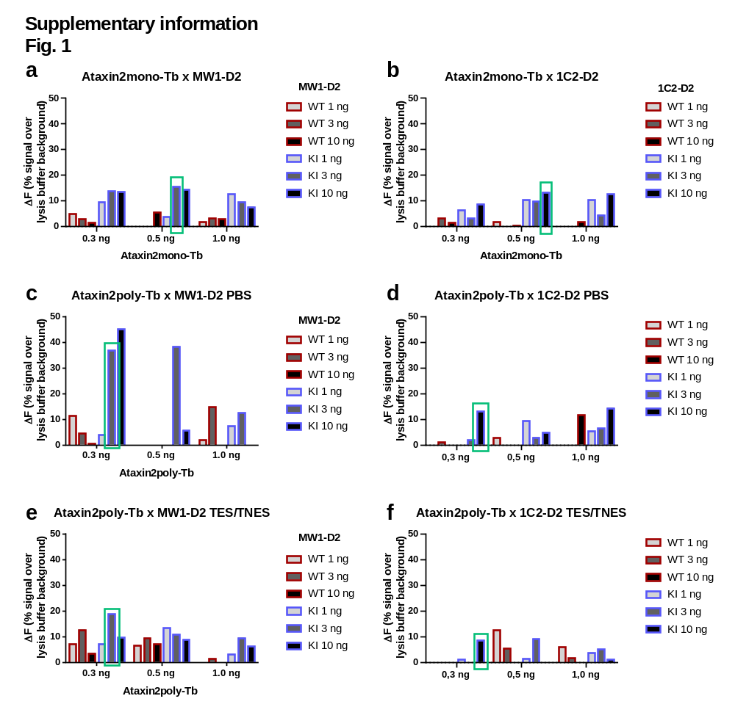
Supplementary information Fig. 1: Establishment of antibody combination and determination of the optimal antibody concentrations: a+b) Combination of the antibodies Ataxin2mono-Tb and MW1-D2 (a) or Ataxin2mono-Tb and 1C2-D2 (b) each in three different concentrations: Ataxin2poly-Tb with 0.3 ng, 0.5 ng and 1 ng/µl, MW1- D2 or 1C2-D2 with 1 ng, 3 ng and 10 ng/µl. Conduction of the TR-FRET measurement with homogenates from wildtype mouse liver (red; WT) and Atxn2-CAG100 knock-in mouse liver (blue; KI), a total protein concentration of 1 µg/µl in RIPA buffer. The highest discrimination between WT and KI (green box) was achieved with the concentrations of Ataxin2mono-Tb 0.5 ng/µl x MW1-D2 3 ng/µl (a) and Ataxin2mono-Tb 0.3 ng/µl x 1C2-D2 10 ng/µl (b). Comparison of different lysis buffers: c-f) Combination of the antibodies Ataxin2poly-Tb and MW1-D2 (c+e) or Ataxin2poly-Tb and 1C2-D2 (e+f) each in three different concentrations: Ataxin2poly-Tb with 0.3 ng, 0.5 ng and 1 ng/µl, MW1- D2 or 1C2-D2 with 1 ng, 3 ng and 10 ng/µl. Conduction of the TR-FRET measurement with homogenates from wildtype mouse liver (red; WT) and Atxn2-CAG100 knock-in mouse liver (blue; KI), a total protein concentration of 1 µg/µl in PBS buffer (c+d) or in TES/TNES buffer (e+f). The highest discrimination between WT and KI is illustrated by a green box.
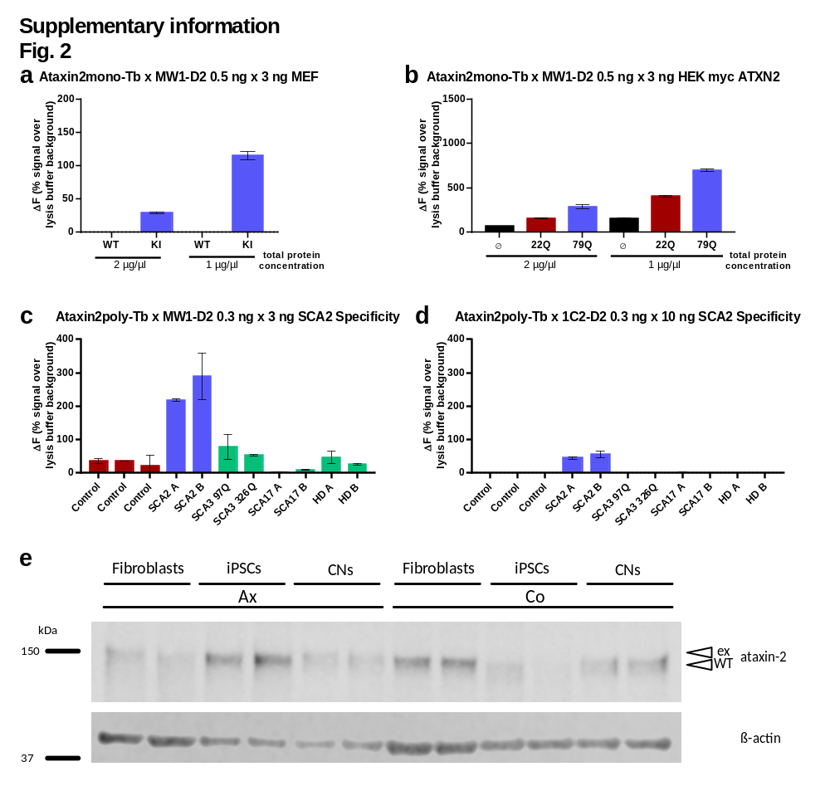
Supplementary information Fig. 2: a+b) Testing of different protein concentrations. Homogenates from mouse embryonic fibroblasts (MEF) isolated from wildtype mice (red; WT) or Atxn2-CAG100 knock-in mice (blue; KI) (a) or homogenates from HEK293T (HEK) cells, which were either transfected with myc ATXN2 plasmids with a length of 22 glutamines (red; 22Q), a length of 79 glutamines (blue; 79Q) or empty myc plasmids (black; Ø) (b) were diluted in RIPA buffer to a total protein concentration of 2 µg/µl or 1 µg/µl and measured with the antibody combination Ataxin2mono-Tb 0.5 ng/µl x MW1-D2 3 ng/µl using TR-FRET. c+d) The SCA2 specificity was determined with the antibody combinations Ataxin2poly-Tb x MW1-D2 (c) and Ataxin2poly-Tb x 1C2-D2 (d). For this purpose, homogenates from wildtype mouse cerebellum (red; control), SCA3, SCA17 or HD mouse cerebellum homogenates (all green) compared to SCA2 Atxn2-CAG100 knock-in mouse cerebellar samples (blue; SCA2) were measured with the indicated antibody combination and concentrations. Both antibody combinations can specifically distinguish the SCA2 samples. e) Western Blot of human material: lysates of human fibroblasts, human induced pluripotent stem cells (iPSCs) and human cortical neurons (CNs) from SCA2 patients (Ax) and matching controls (Co) detected with the polyclonal Ataxin2poly antibody. β-Actin is shown as loading control. The protein ATXN2 can be detected at 150 kDa (Western Blot analysis with 20 µg of total protein and 10% Bis-Tris gel; ex = expanded ataxin-2, WT = wildtype ataxin-2).

