Lipid Nanoparticle Mediated Delivery of Docetaxel Prodrug for Exploiting Full Potential of Gold Radiosensitizers in the Treatment of Pancreatic Cancer

Abdulaziz Alhussan¹, Nolan Jackson¹, Sarah Eaton¹, Nancy Dos Santos², Ingrid Barta³, Josh Zaifman⁴, Sam Chen⁴, Yuen Yi C.Tam⁴, Sunil Krishnan⁵, Devika B. Chithrani^{1,6,7, 8, 9,10*}
¹Department of Physics and Astronomy, University of Victoria, Victoria, BC V8P 5C2, Canada; alhussan@uvic.ca (A. A.); nolanjackson12@uvic.ca (N.J.); seaton@uvic.ca (S.E.); devikac@uvic.ca (D. B. C.)
² Department of Experimental Therapeutics, British Columbia Cancer-Vancouver, Vancouver, BC V5Z IL3, Canada; ndossantos@bccrc.ca (N. D. S.)
³ Centre for Comparative Medicine, Animal Care Services, University of British Columbia, Vancouver, BC V6T 1W5, Canada ingrid.barta@ubc.ca (I. B.)
⁴ Integrated Nanotherapeutics Inc., Burnaby, BC V5G 4X4, Canada; jzaifman@integratedntx.com (J. Z.); samchen@integratedntx.com (S. C.); christam@integratedntx.com (C. T.)
⁵ Department of Radiation Oncology, Mayo Clinic, Jacksonville, FL 32224, USA. krishnan.sunil@mayo.edu (S. K.)
⁶ Radiation Oncology, British Columbia Cancer-Victoria, Victoria, BC V8R 6V5, Canada
⁷ Centre for Advanced Materials and Related Technologies, Department of Chemistry, University of Victoria, Victoria, BC V8P 5C2, Canada
⁸ Centre for Biomedical Research, Department of Biology, University of Victoria, Victoria, BC V8P 5C2,
Canada
⁹ Department of Medical Sciences, University of Victoria, Victoria, BC V8P 5C2, Canada
¹⁰ Department of Computer Science, Mathematics, Physics and Statistics, Okanagan Campus,
University of British Columbia, Kelowna, BC V1V 1V7, Canada
*Correspondence: devikac@uvic.ca

Supplementary Section S1: GNPs and LNPs Characterization

Figure S1. Characterization of gold nanoparticles (GNPs) and lipid nanoparticles (LNPs). (A-B) Hydrodynamic diameter and ζ-potential measurements of pure GNPs, GNP_{PEG}, and GNP_{PEG-RGD}, respectively. (C-D) Hydrodynamic diameter and ζ-potential measurements of GNP_{PEG-RGD}, LNP_{DTX-P}, and LNP_{DTX-P}/ GNP_{PEG-RGD}, respectively. (E) UV–Visible absorption spectra of GNP_{PEG-RGD} and LNP_{DTX-P}/ GNP_{PEG-RGD}. (F) Summary of peak absorption wavelength, hydrodynamic diameter, and mean ζ-potential for pure GNPs, GNP_{PEG}, GNP_{PEG-RGD}, LNP_{DTX} and LNP_{DTX-P}/ GNP_{PEG-RGD}.

Supplementary Section S2: Darkfield Tumour Tissue
Figure S2. Darkfield images of 4 µm sections of tumour tissues treated with LNP_{DTX-2}. Scale bar: 40 µm.

Supplementary Section S3: Images of Organs H&E
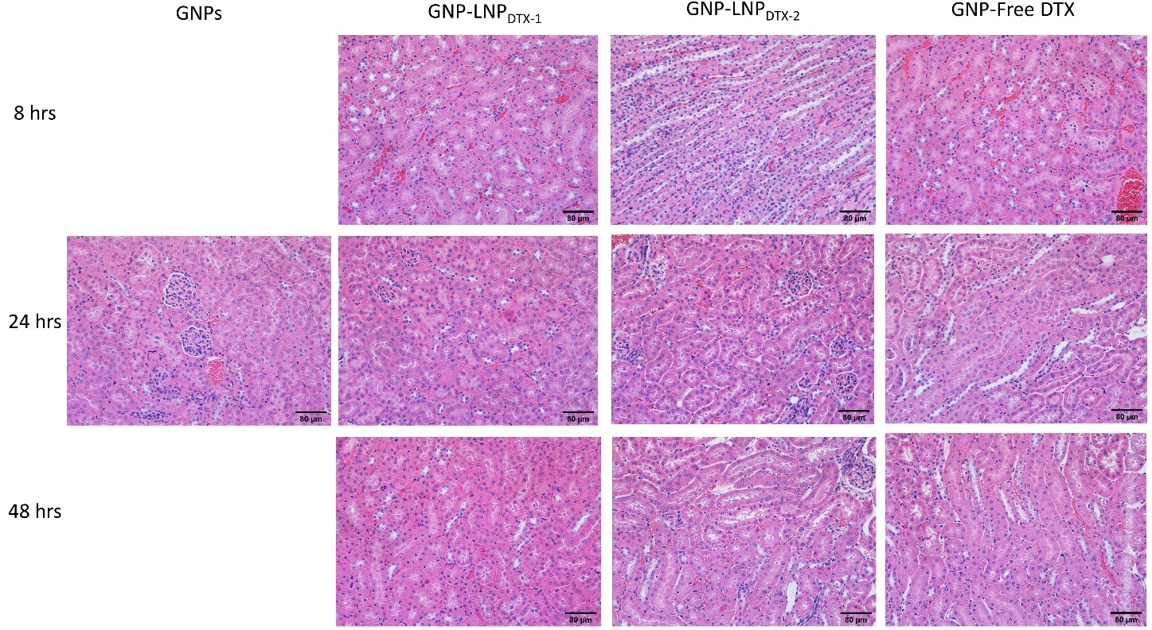
Figure S3 A. Hematoxylin and eosin-stained sections of kidneys 0 h, 24 h, and 48 h after dosing with the drugs and GNPs. Scale bar: 80 µm.

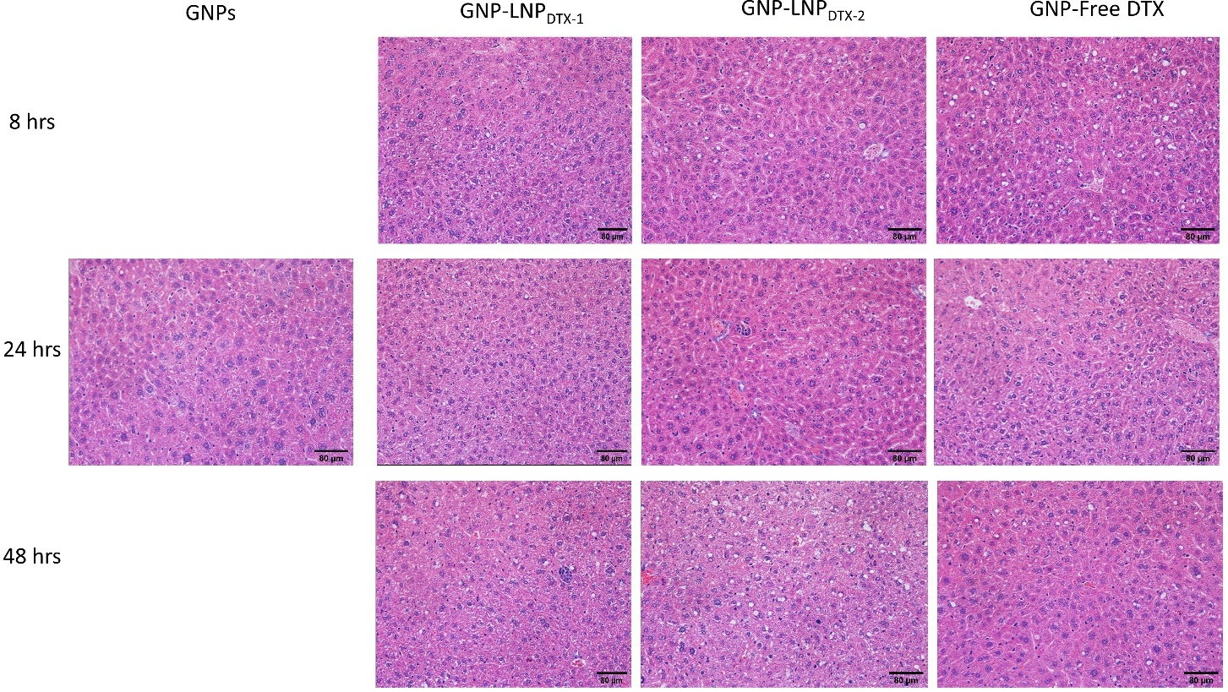
Figure S3 B. Hematoxylin and eosin-stained sections of liver 0 h, 24 h, and 48 h after dosing with the drugs and GNPs. Scale bar: 80 µm.

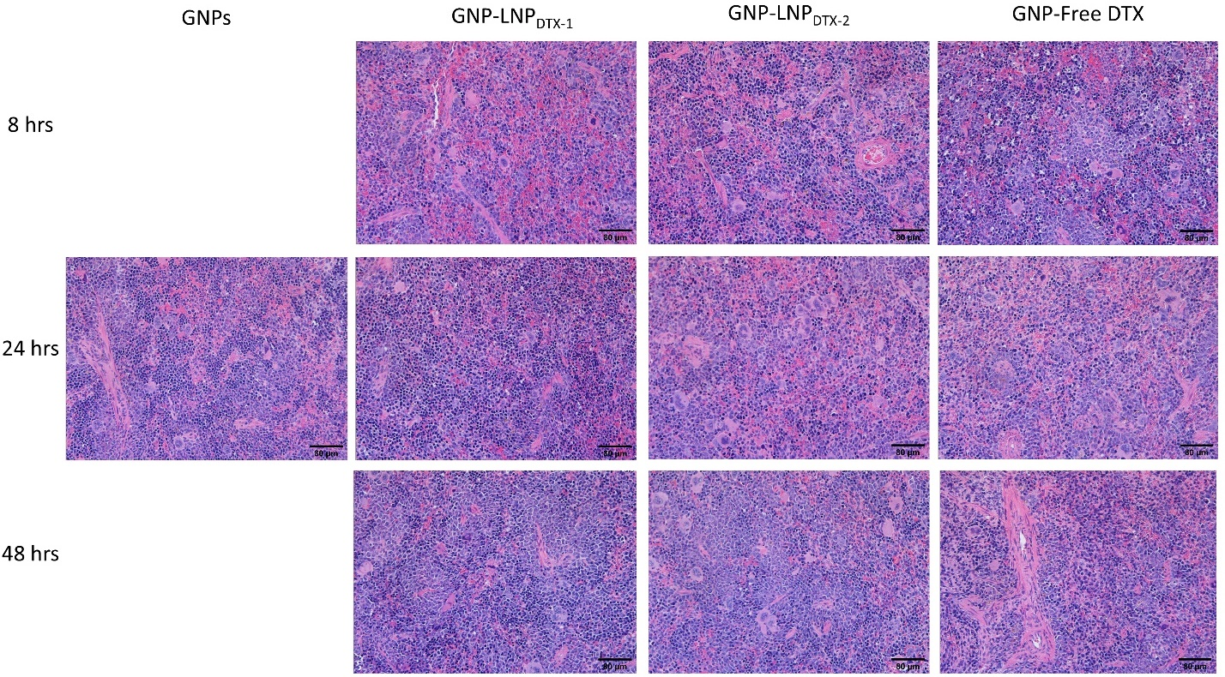
Figure S3 C. Hematoxylin and eosin-stained sections of spleen 0 h, 24 h, and 48 h after dosing with the drugs and GNPs. Scale bar: 80 µm.

Supplementary Section S4: Organs Darkfield Images

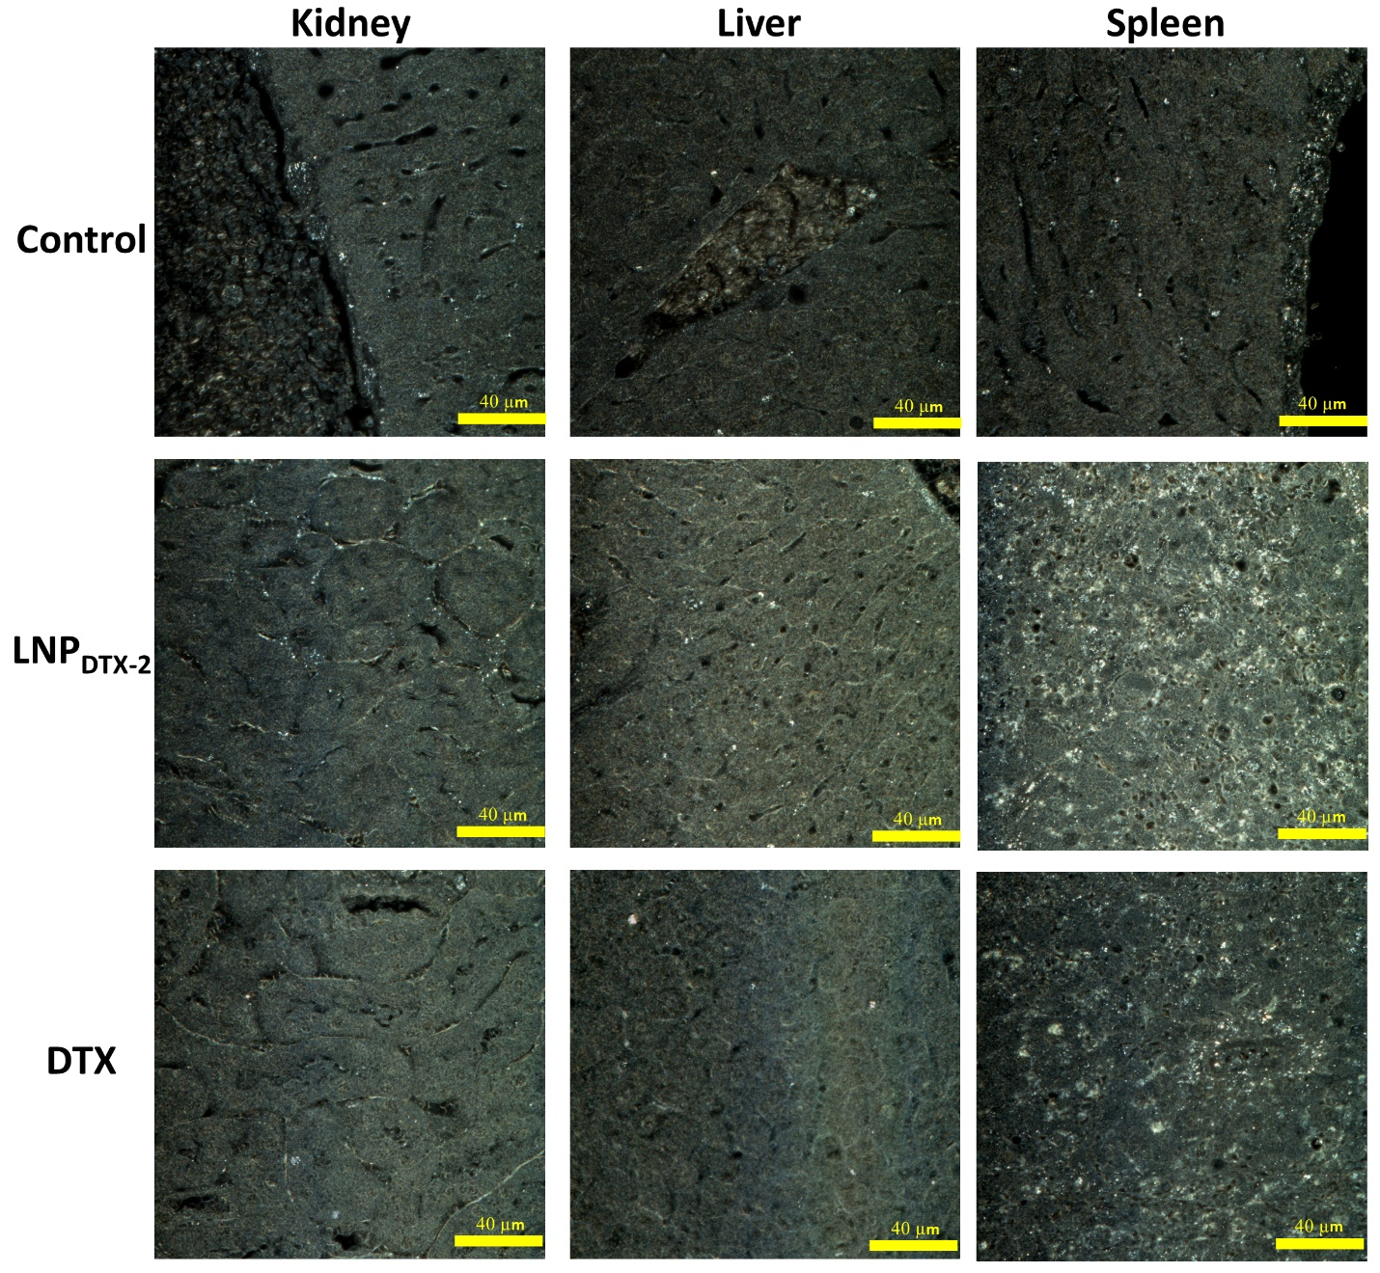
Figure S4. Darkfield images of 4 µm sections of kidney, liver, and spleen, for control samples, LNP_{DTX-2} treated samples, and free DTX treated samples, 24 h post treatment, respectively. Scale bar: 40 µm.

Supplementary Section S5: DTX Prodrug Synthesis

Figure 5S. Synthetic scheme for Docetaxel (DTX) prodrug.
Methyl (R,Z)-12-(butyryloxy)octadec-9-enoate (S1)
Butanoic acid (1.22 mL, 13.2 mmol) was added to an ice-cold CH₂Cl₂ (24 mL) solution of DCC (2.72 g, 13.2 mmol) in a round bottom flask under argon and the ice bath was removed. After 20 min, the ice bath was replaced, methyl ricinoleate (3.75 g, 12.0 mmol) and DMAP (2.20 g, 18.0 mmol) were added and the resultant was allowed to warm up over 14 h. The reaction mixture was diluted with hexanes, filtered through Celite® and concentrated on a rotary evaporator. The crude was resuspended in hexanes, washed with aqueous 1 M HCl (2 × 50 mL), aqueous 1 M NaOH (2 × 50 mL), H₂O (1 × 50 mL), brine, dried over Na₂SO₄ and concentrated on a rotary evaporator to afford a clear, colourless oil as desired diester S1 (4.31 g, 94% yield), which was used without further purification.
(R,Z)-12-(Butyryloxy)octadec-9-enoic acid (S2)
Aqueous 2.0 M KOH (5.35 mL, 10.7 mmol) was added to a room temperature t-BuOH (35 mL) solution of methyl ester S1 (4.30 g, 11.2 mmol) in a round bottom flask under argon and stirred for 14 h. The reaction mixture was adjusted to pH <2 by addition of aqueous 6 M HCl and extracted with hexanes (3 × 50 mL). The combined organic extracts were washed with aqueous 1 M HCl (1 × 50 mL), brine, dried over Na₂SO₄ and concentrated on a rotary evaporator. The crude was purified by flash column chromatography (95:5:0→80:15:5→60:30:10 hexanes-EtOAc-MeOH) to afford a clear, colourless oil as desired carboxylic acid S2 (3.02 g, 77% yield based on KOH).
Docetaxel Prodrug
Triethylamine (0.17 mL, 1.25 mmol), followed by Mukaiyama reagent (166 mg, 0.65 mmol), was added to a CH₂Cl₂ (5 mL) suspension of docetaxel (404 mg, 0.50 mmol) and carboxylic acid S2 (0.55, 1.10 mmol) and the resultant stirred for 14 h. The reaction mixture was concentrated on a rotary evaporator and purified by flash column chromatography (80:20→50:50 hexanes-EtOAc) to afford a clear, colourless oil as desired docetaxel prodrug (262 mg, 45% yield). Analytic TLC was carried out with Merck silica gel 60 plates with fluorescent indicator; spots were visualized with UV light, iodine vapour or permanganate stain. The structure and purity of all final compounds were ascertained by NMR spectroscopy (¹H at 300 MHz, ¹³C at 75 MHz, recorded at ambient temperature in CDCl₃).

