Supplemental Figure source results for “The spatiotemporal matching pattern of Ezrin/Periaxin involved in myoblast differentiation and fusion and Charcot-Marie-Tooth-associated muscle atrophy”

Figure 2. Ezrin was specifically expressed in myoblasts and their skeletal muscle fibers
Ezrin expression was detected by Western blotting at 0, 2, 4 and 6 days after myoblast differentiation. A quantitative assay for Ezrin expression was performed 2, 4 and 6 days after myoblast differentiation. Three independent experiments were performed, n=3, *P<0.05 vs. 0 days; #P<0.05 vs. 2 days; &P<0.05 vs. 4 days.
Figure 2F for Ezrin:

To generate this image, Lysates of myoblasts were analyzed at 2, 4 and 6 days of differentiation. First, samples (20 μg proteins) were run on an 10 % SDS-PAGE gel then transferred onto a PVDF membrane (Millipore). Membranes were blocked in 5% nonfat milk in TBS-0.1 % Tween® 20 (TBS-T) before incubation with rabbit anti--mouse Ezrin (1:1000, ab270442,ABCAM,USA) or mouse-anti mouse α-Tubulin (1:5000, ab7291, ABCAM,USA) antibody overnight at 4 ℃, respectively. Blots were washed four times in TBS-T, incubated with secondary antibodies for 90 min at room temperature, washed again four times then imaged. Secondary antibodies used were goat anti-rabbit IgG H&L (ANT020, antgene.CN) or goat anti-mouse IgG H&L(ANT019, antgene.CN) preabsorbed at 1/1000 dilution.
In order to save samples and workload, we divide the glue and film into several partial, unfortunately, partial membrane have been lost. As shown in the figure. Observed band size:α-Tubulin, 50 kDa; Ezrin: 80 kD.
https://www.abcam.cn/ezrin-antibody-epr23353-55-ab270442.html
https://www.abcam.cn/alpha-tubulin-antibody-dm1a-loading-control-ab7291.html

Figure 6. Ezrin promoted myoblast differentiation and fusion through the PKA-MyoG/MEF2C signaling pathway
Western blot for the indicated proteins in myoblasts treated with Ezrin overexpression or knockdown for 6 days. Quantitative assays for the indicated proteins were performed 6 days after myoblast differentiation following Ezrin overexpression or knockdown. Three independent experiments were performed, n=3, *P<0.05 vs. Ad-Null; #P<0.05 vs. Ad-Null.

Figure 6B for PKA-γ cat : the result of three replicates.

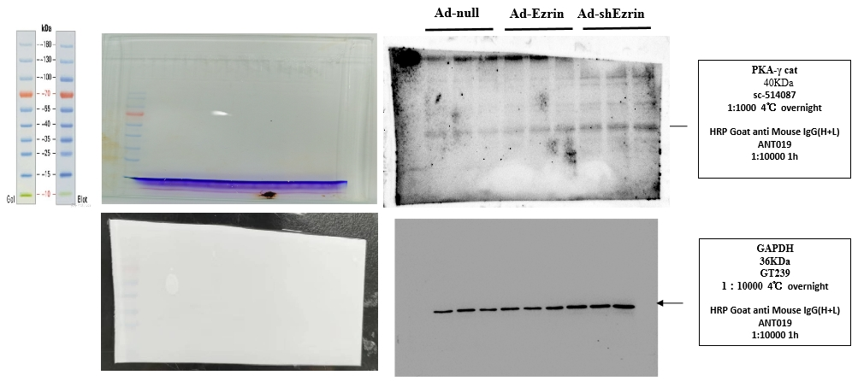

To generate this image, Lysates of myoblasts were analyzed at 2, 4 and 6 days of differentiation. First, samples (20 μg proteins) were run on an 10 % SDS-PAGE gel then transferred onto a PVDF membrane (Millipore). Membranes were blocked in 5% nonfat milk in TBS-0.1 % Tween® 20 (TBS-T) before incubation with mouse anti--mouse PKA-γ cat (1:1000, sc-514087, Santa Cruze,USA) or mouse-anti mouse GAPDH (1:1000, GT239, ABCAM,USA) antibody overnight at 4 ℃, respectively. Blots were washed four times in TBS-T, incubated with secondary antibodies for 90 min at room temperature, washed again four times then imaged. Secondary antibodies used goat anti-mouse IgG H&L(ANT019, antgene.CN) preabsorbed at 1/1000 dilution.
Observed band size:GAPDH, 36 kDa; PKA-γ cat: 40 kD.
https://www.genetex.cn/Product/Detail/GAPDH-antibody-GT239-VetSignal/GTX635013
https://datasheets.scbt.com/sc-514087.pdf

Figure 6B for PKA-α cat : the result of three replicates.

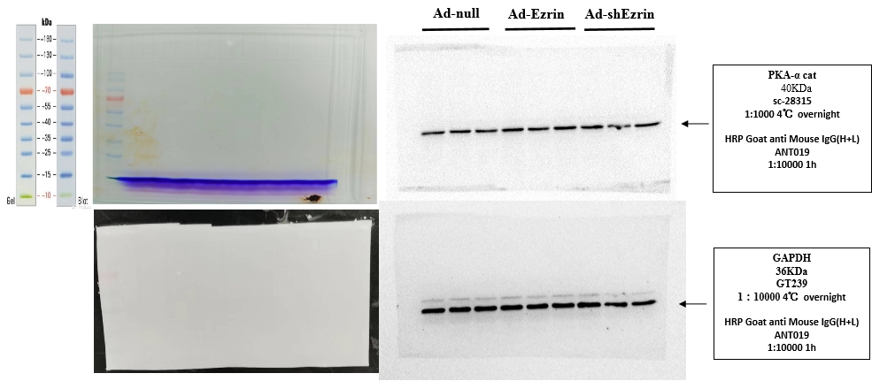

To generate this image, Lysates of myoblasts were analyzed at 2, 4 and 6 days of differentiation. First, samples (20 μg proteins) were run on an 10 % SDS-PAGE gel then transferred onto a PVDF membrane (Millipore). Membranes were blocked in 5% nonfat milk in TBS-0.1 % Tween® 20 (TBS-T) before incubation with mouse anti--mouse PKA-α cat (1:1000, sc-28315, Santa Cruze,USA) or mouse-anti mouse GAPDH (1:1000, GT239, ABCAM,USA) antibody overnight at 4 ℃, respectively. Blots were washed four times in TBS-T, incubated with secondary antibodies for 90 min at room temperature, washed again four times then imaged. Secondary antibodies used goat anti-mouse IgG H&L(ANT019, antgene.CN) preabsorbed at 1/1000 dilution.
Observed band size:GAPDH, 36 kDa; PKA-α cat: 40 kD.
https://www.genetex.cn/Product/Detail/GAPDH-antibody-GT239-VetSignal/GTX635013
https://datasheets.scbt.com/sc-28315.pdf

Figure 6B for PKA-α/β/γ cat : the result of three replicates.

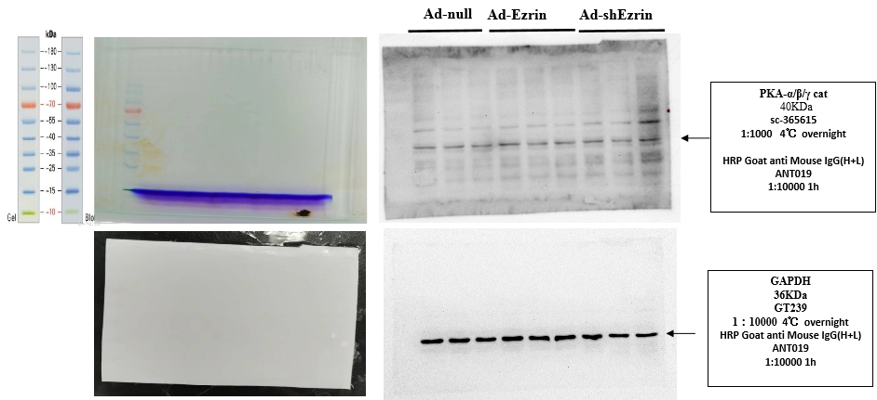
To generate this image, Lysates of myoblasts were analyzed at 2, 4 and 6 days of differentiation. First, samples (20 μg proteins) were run on an 10 % SDS-PAGE gel then transferred onto a PVDF membrane (Millipore). Membranes were blocked in 5% nonfat milk in TBS-0.1 % Tween® 20 (TBS-T) before incubation with mouse anti--mouse PKA-α/β/γ cat (1:1000, sc-365615, Santa Cruze,USA) or mouse-anti mouse GAPDH (1:1000, GT239, ABCAM,USA) antibody overnight at 4 ℃, respectively. Blots were washed four times in TBS-T, incubated with secondary antibodies for 90 min at room temperature, washed again four times then imaged. Secondary antibodies used goat anti-mouse IgG H&L(ANT019, antgene.CN) preabsorbed at 1/1000 dilution.
Observed band size:GAPDH, 36 kDa; PKA-α/β/γ cat: 40 kD.
https://www.genetex.cn/Product/Detail/GAPDH-antibody-GT239-VetSignal/GTX635013
https://datasheets.scbt.com/sc-365615.pdf

Figure 6B for PKA-regⅠα : the result of three replicates.

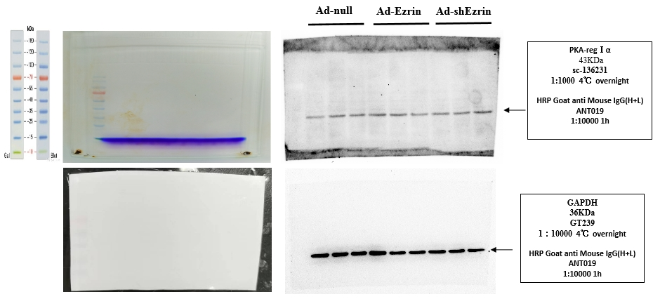

To generate this image, Lysates of myoblasts were analyzed at 2, 4 and 6 days of differentiation. First, samples (20 μg proteins) were run on an 10 % SDS-PAGE gel then transferred onto a PVDF membrane (Millipore). Membranes were blocked in 5% nonfat milk in TBS-0.1 % Tween® 20 (TBS-T) before incubation with mouse anti--mouse PKA-regⅠα (1:1000, sc-136231, Santa Cruze,USA) or mouse-anti mouse GAPDH (1:1000, GT239, ABCAM,USA) antibody overnight at 4 ℃, respectively. Blots were washed four times in TBS-T, incubated with secondary antibodies for 90 min at room temperature, washed again four times then imaged. Secondary antibodies used goat anti-mouse IgG H&L(ANT019, antgene.CN) preabsorbed at 1/1000 dilution.
Observed band size:GAPDH, 36 kDa; PKA-regⅠα: 43 kD.
https://www.genetex.cn/Product/Detail/GAPDH-antibody-GT239-VetSignal/GTX635013
https://datasheets.scbt.com/sc-136231.pdf

Figure 6B for PKA-regⅠβ : the result of three replicates.
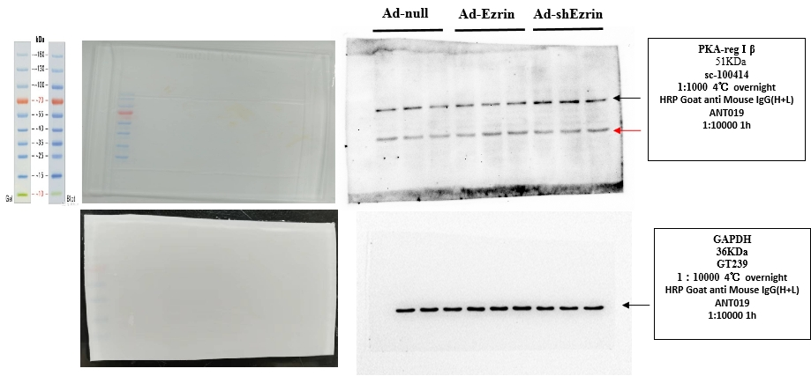

To generate this image, Lysates of myoblasts were analyzed at 2, 4 and 6 days of differentiation. First, samples (20 μg proteins) were run on an 10 % SDS-PAGE gel then transferred onto a PVDF membrane (Millipore). Membranes were blocked in 5% nonfat milk in TBS-0.1 % Tween® 20 (TBS-T) before incubation with mouse anti--mouse PKA-regⅠβ (1:1000, sc-100414, Santa Cruze,USA) or mouse-anti mouse GAPDH (1:1000, GT239, ABCAM,USA) antibody overnight at 4 ℃, respectively. Blots were washed four times in TBS-T, incubated with secondary antibodies for 90 min at room temperature, washed again four times then imaged. Secondary antibodies used goat anti-mouse IgG H&L(ANT019, antgene.CN) preabsorbed at 1/1000 dilution.
The red arrow is the residue of GAPDH development, after three times of film washing, the PKA-regⅠβ is developed. Although the species origin is the same as the mouse origin antibody, Lamin B1 is slightly developed again when the PKA-regⅠβ is developed.
Observed band size:GAPDH, 36 kDa; PKA-regⅠβ: 51 kD.
https://www.genetex.cn/Product/Detail/GAPDH-antibody-GT239-VetSignal/GTX635013
https://datasheets.scbt.com/sc-100414.pdf

Figure 6B for PKA-regⅡα : the result of three replicates.

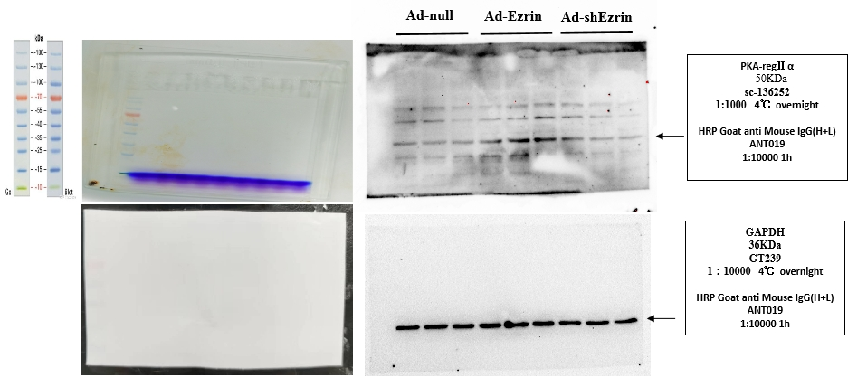

To generate this image, Lysates of myoblasts were analyzed at 2, 4 and 6 days of differentiation. First, samples (20 μg proteins) were run on an 10 % SDS-PAGE gel then transferred onto a PVDF membrane (Millipore). Membranes were blocked in 5% nonfat milk in TBS-0.1 % Tween® 20 (TBS-T) before incubation with mouse anti--mouse PKA-regⅡα (1:1000, sc-136252, Santa Cruze,USA) or mouse-anti mouse GAPDH (1:1000, GT239, ABCAM,USA) antibody overnight at 4 ℃, respectively. Blots were washed four times in TBS-T, incubated with secondary antibodies for 90 min at room temperature, washed again four times then imaged. Secondary antibodies used goat anti-mouse IgG H&L(ANT019, antgene.CN) preabsorbed at 1/1000 dilution.
Observed band size:GAPDH, 36 kDa; PKA-regⅡα: 50 kD.
https://www.genetex.cn/Product/Detail/GAPDH-antibody-GT239-VetSignal/GTX635013
https://datasheets.scbt.com/sc-136252.pdf

Figure 7. NFAT signaling was involved in the regulation of myoblast differentiation/fusion mediated by Ezrin
Western blot of NFATc1-c4 proteins in myoblasts treated with Ezrin overexpression or knockdown for 6 days. (C-F) Quantitative analysis of NFATc1-c4 protein expression was performed 6 days after myoblast differentiation following Ezrin overexpression or knockdown. Three independent experiments were performed, n=3, *P<0.05 vs. Ad-Null; #P<0.05 vs. Ad-Null.
Figure 7B for NFATc1 : the result of three replicates.
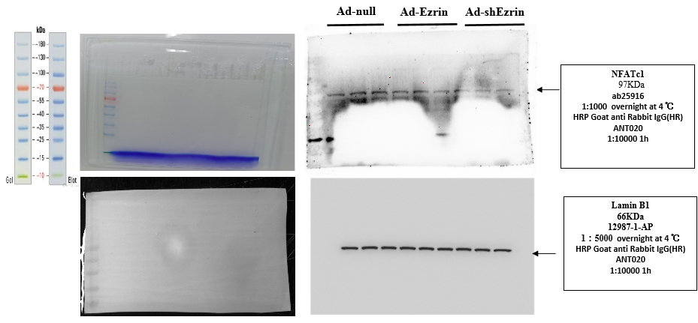

To generate this image, Lysates of myoblasts were analyzed at 6 days of differentiation. First, samples (20 μg proteins) were run on an 10 % SDS-PAGE gel then transferred onto a PVDF membrane (Millipore). Membranes were blocked in 5% nonfat milk in TBS-0.1 % Tween® 20 (TBS-T) before incubation with NFATc1-mouse anti-mouse (1:1000, ab2796,ABCAM,USA) antibody, or Lamin B1 rabbit anti-mouse (1:5000, ab16048, ABCAM, USA) antibody overnight at 4 ℃, respectively. Blots were washed four times in TBS-T, incubated with secondary antibodies for 90 min at room temperature, washed again four times then imaged. Secondary antibodies used were goat anti-mouse IgG H&L(ANT019, antgene.CN) preabsorbed at 1/2000 dilution.
NFATc1 (NFAT2) Predicted band size: 90 kDa. Observed band size: 75,80,90 kDa.
Lamin B1Observed band size: 66 kDa.
https://www.abcam.cn/nfat2-antibody-7a6-ab2796.html
https://www.abcam.cn/lamin-b1-antibody-nuclear-envelope-marker-ab16048.html

Figure 7B for NFATc2 : the result of three replicates.
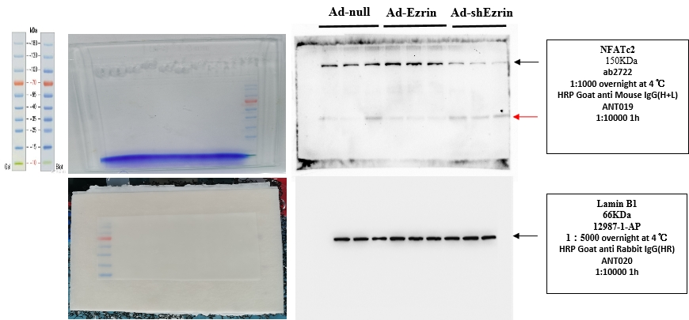

To generate this image, Lysates of myoblasts were analyzed at 6 days of differentiation. First, samples (20 μg proteins) were run on an 10 % SDS-PAGE gel then transferred onto a PVDF membrane (Millipore). Membranes were blocked in 5% nonfat milk in TBS-0.1 % Tween® 20 (TBS-T) before incubation with NFATc2-mouse anti-mouse (1:1000, ab2722,ABCAM,USA) antibody, or Lamin B1 rabbit anti-mouse (1:5000, ab16048, ABCAM, USA) antibody overnight at 4 ℃, respectively. Blots were washed four times in TBS-T, incubated with secondary antibodies for 90 min at room temperature, washed again four times then imaged. Secondary antibodies used were goat anti-mouse IgG H&L(ANT019, antgene.CN) or goat anti-rabbit IgG H&L (ANT020, antgene.CN) preabsorbed at 1/10000 dilution.
The red arrow is the residue of Lamin B1 development, after three times of film washing, the NFATc2 is developed. Although the species origin is not the same as the mouse or rabbit origin antibody, Lamin B1 is slightly developed again when the NFATc2 is developed.
NFATc2 (NFAT1) Predicted band size: 115 kDa; Observed band size: 150 kDa.
Lamin B1 Observed band size: 66 kDa.
https://www.abcam.cn/nfat1-antibody-25a10d6d2-ab2722.html
https://www.abcam.cn/lamin-b1-antibody-nuclear-envelope-marker-ab16048.html

Figure 7B for NFATc3 : the result of three replicates.

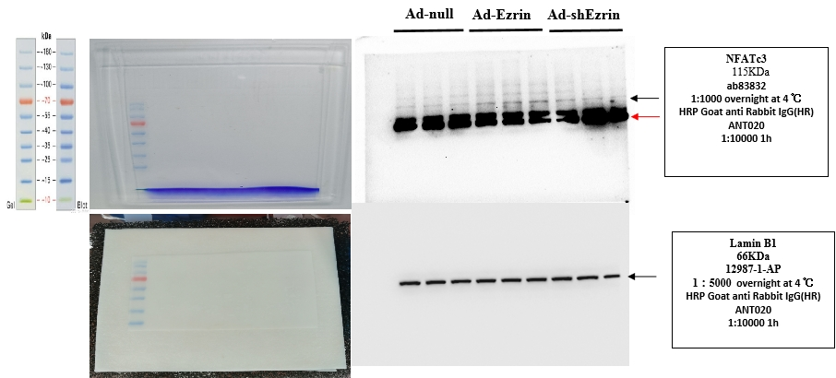

To generate this image, Lysates of myoblasts were analyzed at 6 days of differentiation. First, samples (20 μg proteins) were run on an 10 % SDS-PAGE gel then transferred onto a PVDF membrane (Millipore). Membranes were blocked in 5% nonfat milk in TBS-0.1 % Tween® 20 (TBS-T) before incubation with NFATc3 rabbit anti-mouse/human (1:1000, ab83832,ABCAM,USA), or Lamin B1 rabbit anti-mouse (1:5000, ab16048, ABCAM, USA) antibody overnight at 4 ℃, respectively. Blots were washed four times in TBS-T, incubated with secondary antibodies for 90 min at room temperature, washed again four times then imaged. Secondary antibodies used were goat anti-mouse IgG H&L(ANT019, antgene.CN) or goat anti-rabbit IgG H&L (ANT020, antgene.CN) preabsorbed at 1/10000 dilution.
The red arrow is the residue of Lamin B1 development, after three times of film washing, the NFATc3 is developed. Although the species origin is not the same as the mouse or rabbit origin antibody, NFATc3 development time is more longer than Lamin B1 development, leading to the strong Lamin B1 development again.
Observed band size for NFATc3: 115 kDa.
Lamin B1 Observed band size: 66 kDa. Additional bands: 46 kDa.
https://www.abcam.cn/nfat4nf-atc3-antibody-ab83832.html
https://www.abcam.cn/lamin-b1-antibody-nuclear-envelope-marker-ab16048.html

Figure 7B for NFATc4 : the result of three replicates.
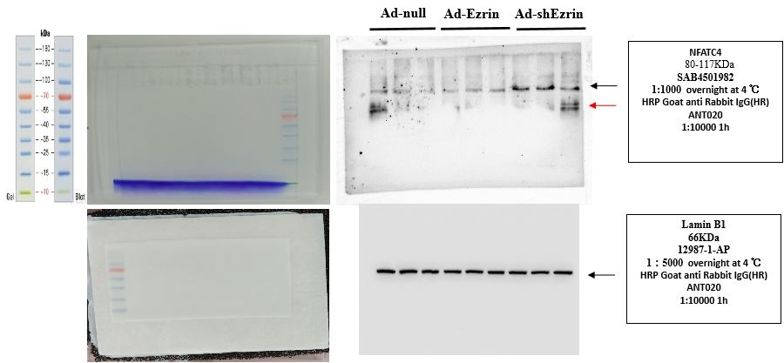

To generate this image, Lysates of myoblasts were analyzed at 6 days of differentiation. First, samples (20 μg proteins) were run on an 10 % SDS-PAGE gel then transferred onto a PVDF membrane (Millipore). Membranes were blocked in 5% nonfat milk in TBS-0.1 % Tween® 20 (TBS-T) before incubation with NFATc4 rabbit anti-mouse/human (1:1000, SAB4501982, SIGMA, USA) or Lamin B1 rabbit anti-mouse (1:5000, ab16048, ABCAM, USA) antibody overnight at 4 ℃, respectively. Blots were washed four times in TBS-T, incubated with secondary antibodies for 90 min at room temperature, washed again four times then imaged. Secondary antibodies used were goat anti-mouse IgG H&L(ANT019, antgene.CN) or goat anti-rabbit IgG H&L (ANT020, antgene.CN) preabsorbed at 1/10000 dilution.
The red arrow is the residue of Lamin B1 development, after three times of film washing, the NFATc4 is developed. Although the species origin is not the same as the mouse or rabbit origin antibody, Lamin B1 is slightly developed again when the NFATc4 is developed.
Observed band size for NFATc4: 95 kDa.
Lamin B1 Observed band size: 66 kDa.
https://www.sigmaaldrich.cn/CN/zh/product/sigma/sab4501982
https://www.abcam.cn/lamin-b1-antibody-nuclear-envelope-marker-ab16048.html

